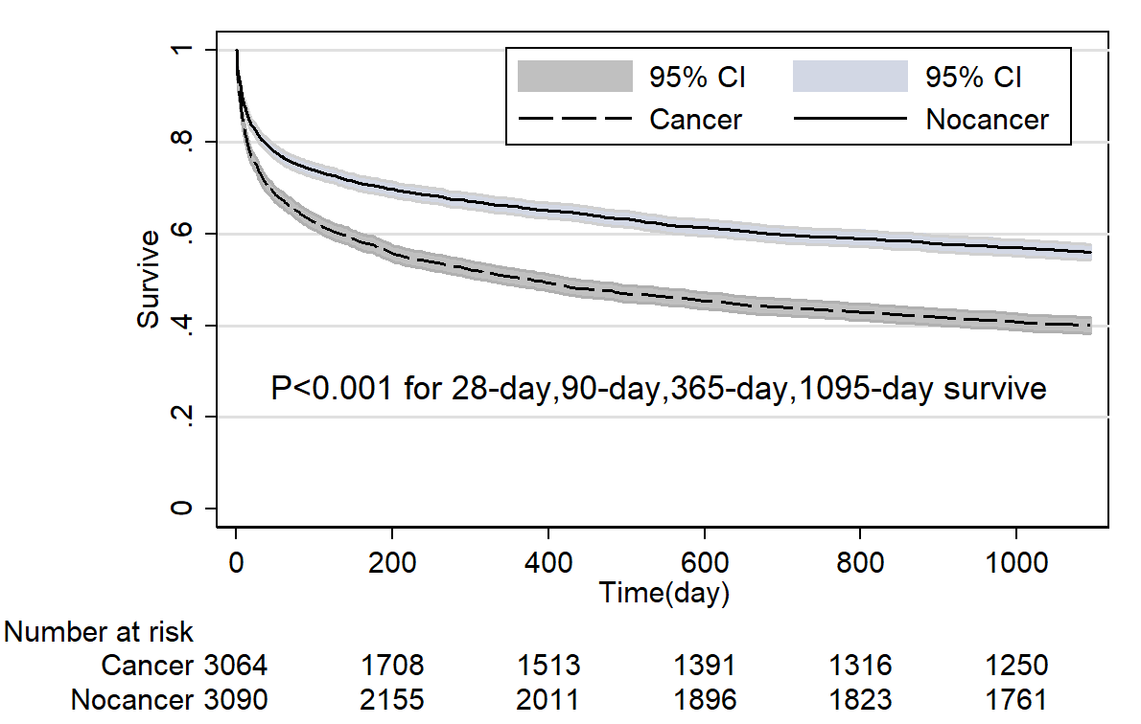
Supp. Figure 1 Comparison of Kaplan-Meier survival curves between critical care subjects with and without cancer in MICU after propensity score matching. (Medical intensive care unit, MICU)

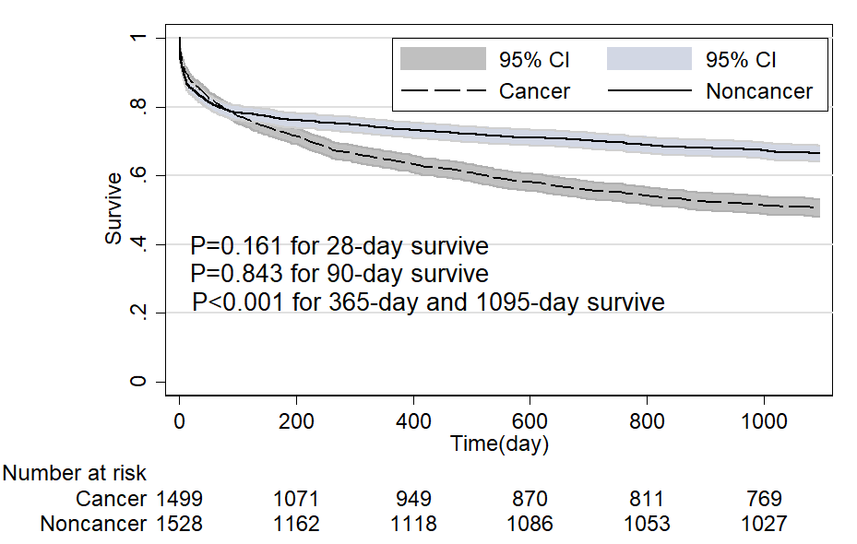

Supp. Figure 2 Comparison of Kaplan-Meier survival curves between critical care subjects with and without cancer in SICU after propensity score matching. (Surgical intensive care unit, SICU)

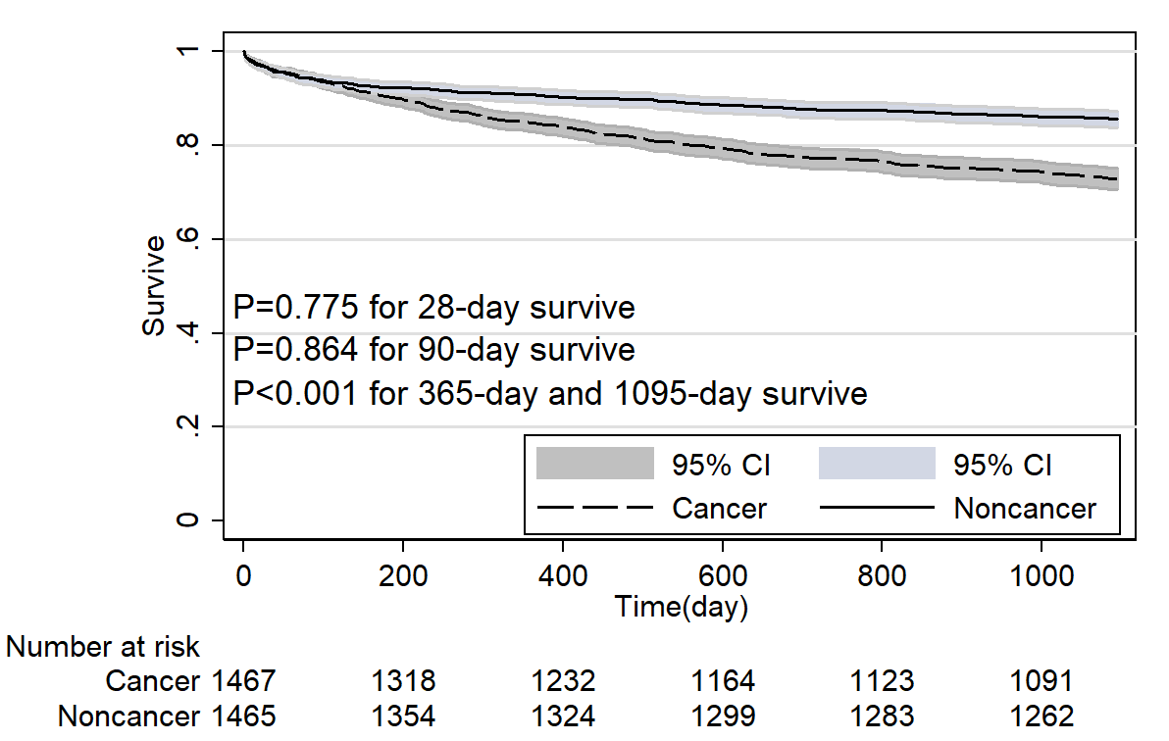
Supp. Figure 3 Comparison of Kaplan-Meier survival curves between critical care subjects with and without cancer in elective admissions after propensity score matching.

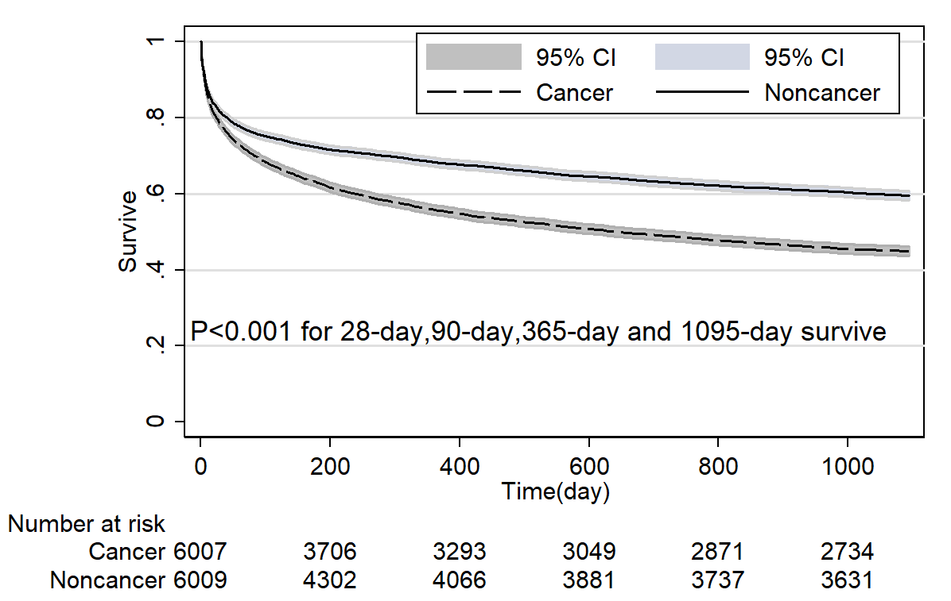
Supp. Figure 4 Comparison of Kaplan-Meier survival curves between critical care subjects with and without cancer in emergency admissions after propensity score matching.

