Supplementary information
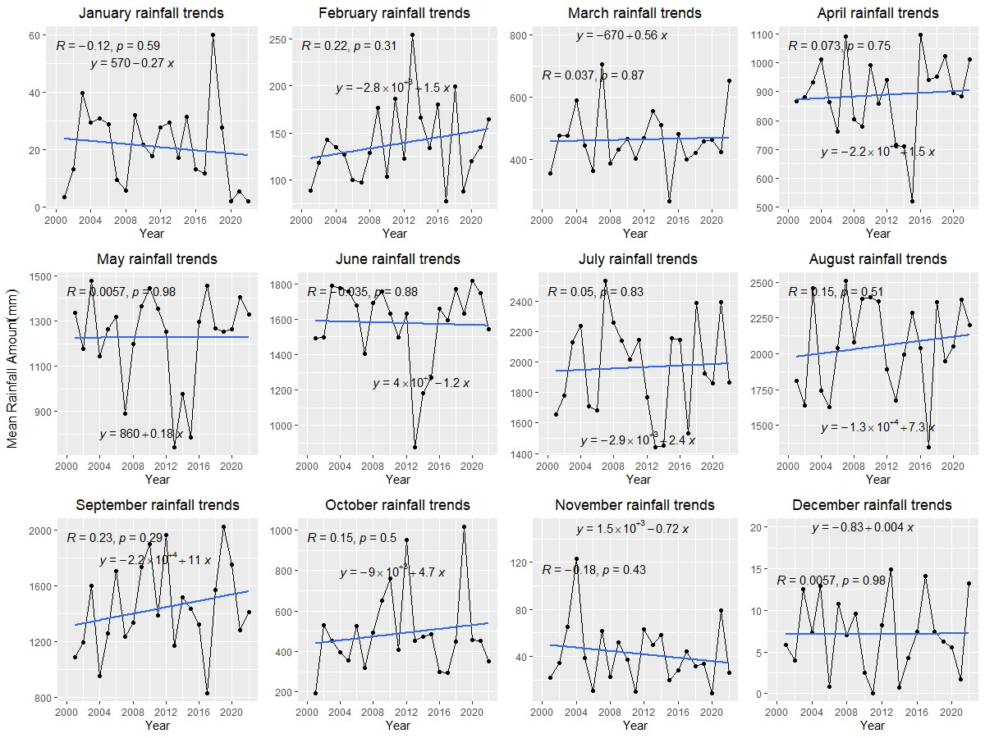
Fig. 1 Monthly trends of mean rainfall patterns in Northern Ghana between 2001 and 2022

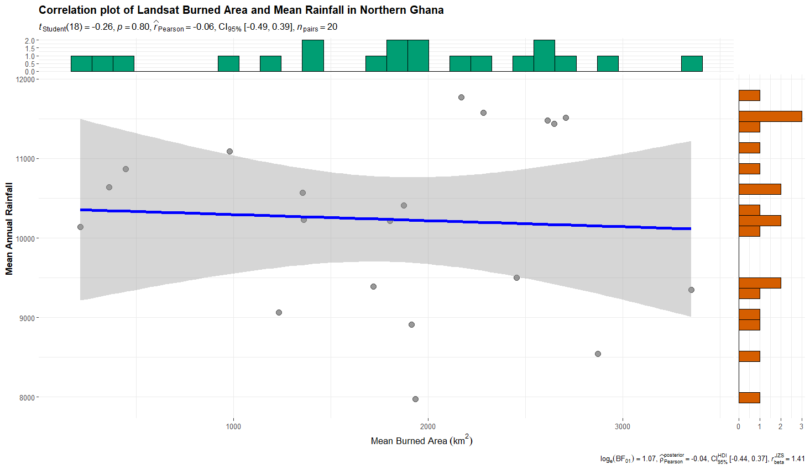
Fig 2: Correlation plot of Rainfall and Landsat burned area for Northern Ghana. A weak negative, but not statistically significant correlation was observed between rainfall and Landsat burned area (r = -0.06, p = 0.80)

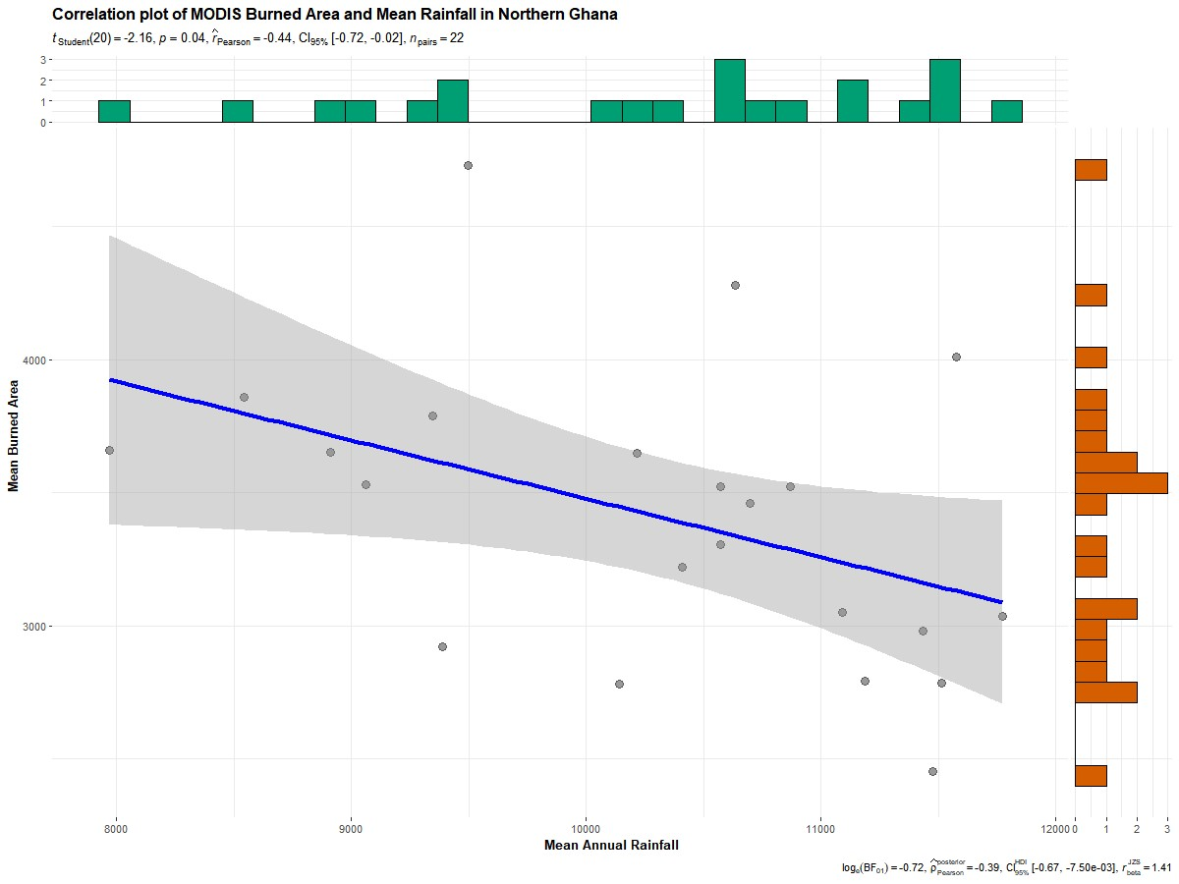
Fig. 3: Correlation plot of Rainfall and MODIS Burned for Northern Ghana. A statistically significant but weak negative correlation was observed between rainfall and MODIS Burned Areas (r = -0.44, p = 0.04)

