Table S1 The information of clean reads identified in present study
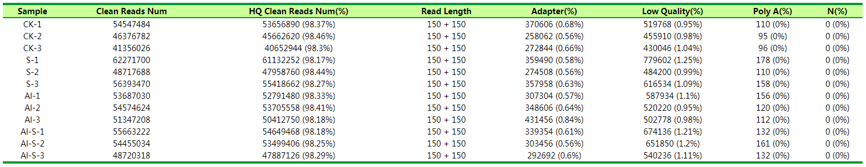
The numbers of clean reads for each sample are obtained after sequencing by illumina HiSeqTM and more than 98% of them belong to high quality clean reads.

Table S2 The numbers of genes identified in present study
Totally 35667 genes obtained in present study, 30509 (85.54%) of them belong to known gene and 897 of them belong to new gene (Table S2).

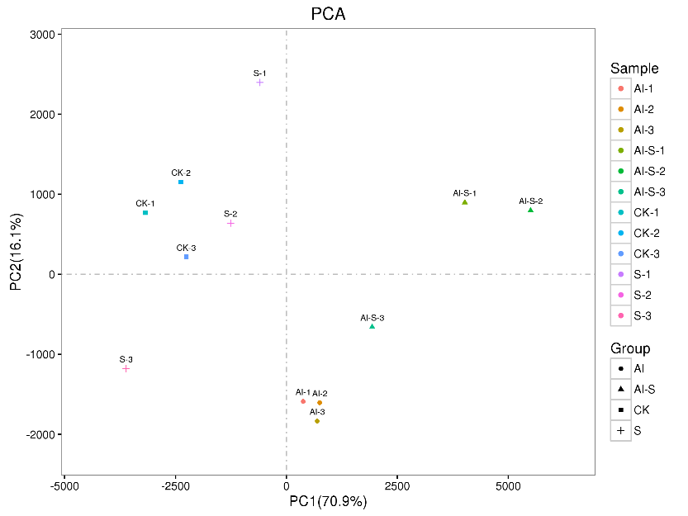
Fig. S1 The result of principal components analysis (PCA).
In the PCA plot, three CK samples were clustered tightly among themselves and distanced with the Al and Al+H₂S treatments, indicating the different gene response under treatments. However, the distance between CK and H₂S groups in modeling was small, implying that exposure to NaHS under no Al conditions caused significant but not extensive changes to the gene profiles. It should be pointed out that the spread of replicates in H₂S groups indicated a high degree of biological variation.

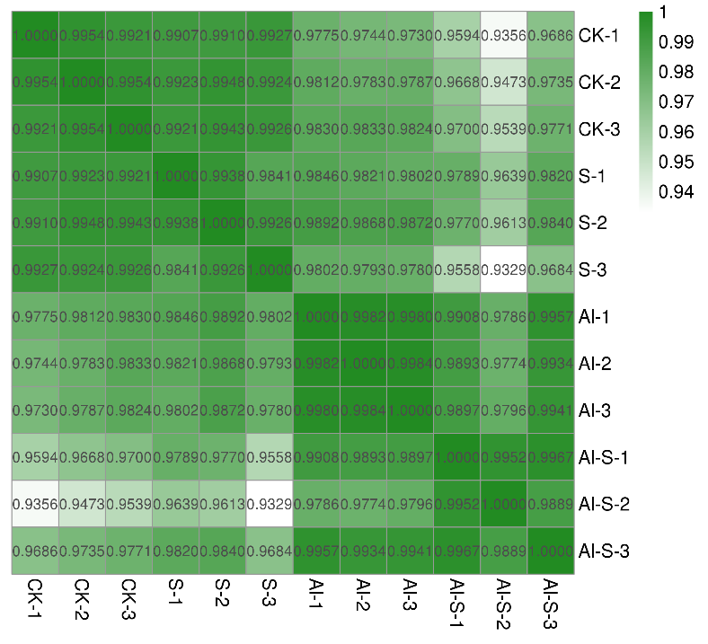
Fig. S2 Pearson’s correlation coefficient analysis
The results of pearson correlation coefficient analysis showed that the correlation between any two samples was higher than 0.90, indicating that the results of replication were reliable.

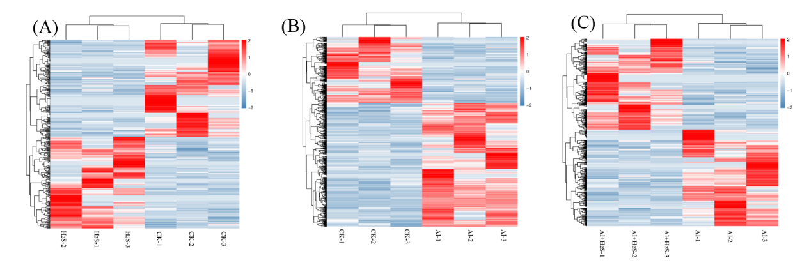
Fig. S3 Hierarchical clustering analysis for each sample

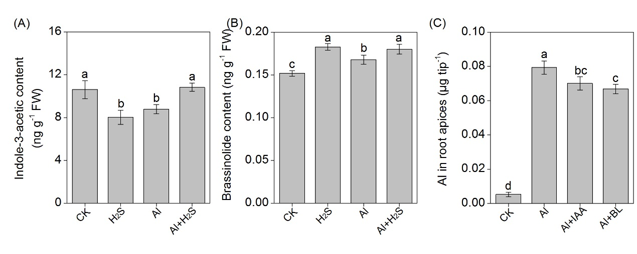
Fig. S4 The content of indole-3-acetic content (A), brassinolide content (B) and Al in root apices (C) under different treatment. The concentration of IAA in the solution is 0.5 μM, the concentration in the solution is 0.0001% (w/w). IAA: indole-3-acetic, BL: brassinolide.

