Decoding Neurodegenerative Disease with High-Sensitivity Plasma Proteomics: Disease-Specific Biomarkers and Predictive Signatures
Katherine Gong^{1,2}, Jigyasha Timsina^{1,2}, Muhammad Ali^{1,2}, Yike Chen^{1,2}, Menghan Liu^{1,2}, Cyril Pottier^{2,4}, Ciyang Wang^{1,2,3}, Gyujin Heo^{1,2}, Tammie L. S. Benzinger^{6,7,8}, Cyrus A. Raji^{7,8}, Beau Ances^{6,7}, Brian A. Gordon^{6,7}, Julie K. Wisch⁶, Suzanne E. Schindler^{4,6,7}, John C. Morris^{4,7}, David M. Holtzman^{4,6,7}, Laura Ibanez^{*1,2,4}, Carlos Cruchaga^{1,2,4,5,6,7,*,#}
Author Affiliations:
¹Department of Psychiatry, Washington University School of Medicine, St. Louis, MO 63110
²NeuroGenomics and Informatics Center, Washington University School of Medicine, St. Louis, MO 63110
³Division of Biology and Biomedical Sciences, Washington University School of Medicine, St. Louis, MO, USA
⁴Department of Neurology, Washington University School of Medicine, St. Louis, MO 63110
⁵Department of Genetics, Washington University School of Medicine, St. Louis, 63110, MO, USA
⁶Hope Center for Neurologic Diseases, Washington University, St. Louis, 63110, MO, USA
⁷Knight Alzheimer Disease Research Center, Washington University School of Medicine, St. Louis, MO 63110
⁸Department of Radiology, Washington University School of Medicine, St. Louis, MO 63110

*Co-last authors
#Correspondence to: Carlos Cruchaga, PhD
4444 Forest Park Ave, St. Louis, MO 63110, USA
Washington University School of Medicine
E-mail: cruchagac@wustl.edu

Running title: Plasma Proteomics Unveils Biomarkers for Neurodegenerative Diseases
Keywords: Plasma assays; Neurodegeneration diagnostics; Plasma-based diagnostics; CNS protein profiling
Supplementary Figure 1. Upset Plot Analysis of Shared Proteins in Disease and AD phenotypes. (A) The upset plot demonstrates the overlap of significant analytes (FDR < 0.05) across various disease datasets, specifically Alzheimer’s Disease (AD), Dementia with Lewy Bodies (DLB), Frontotemporal Dementia (FTD), and Parkinson’s Disease (PD). This visualization reveals 78 significant proteins that are consistently identified across these neurodegenerative conditions. (B) The upset plot illustrates the overlap of significant analytes (FDR < 0.05) associated with the phenotypes Amyloid-PET, Tau PET, Aβ42/Aβ40, and Clinical Dementia Rating (CDR). This analysis highlights a total of 77 significant proteins identified through a comprehensive differential abundance analysis, emphasizing their relevance across these key neurodegenerative biomarkers.

Supplementary Figure 2. Plasma Protein Distribution Across Single and Multiple Diseases. (A-B) We selected proteins that passed the FDR threshold in AD and had p < 0.05 in other diseases. Plasma protein levels (rows) were averaged across individuals within each disease (columns). The proteins (N = 67) in (A) are specific to a single disease, while the proteins in (B) could be abundant in more than one disease. Proteins abundant in more than one disease were assigned to the first disease in which they appeared.
Supplementary Figure 3. Scatter Plots of Effect Sizes Across AD Phenotypes. (A – F) Scatter plots comparing effect sizes of significant proteins from either endophenotype dataset. Proteins are selected if they are significant in at least one analysis. Red points indicate significance in both datasets, blue points indicate significance in the first disease, green points indicate significance in the second disease, and grey points indicate no significance in either dataset. The dark dashed grey line represents the regression line, while the light grey dashed line outlines the confidence interval ribbon, indicating the confidence bounds of the prediction.

Supplementary Figure 4. Biomarker Ratios for AD Prediction and Amyloid-PET statuses. To evaluate the predictive potential of novel biomarkers, we analyzed p-tau217, p-tau217/Aβ42, p-tau217/BDNF, and p-tau217/NPTXR ratios to assess their ability to distinguish between Alzheimer’s disease (AD) and cognitively unimpaired controls (CO), as well as to predict Amyloid-PET. The whisker plot compares the Area Under the Curve (AUC) values along with their corresponding 95% confidence intervals (CI) for each biomarker.

Supplementary Figure 5. p-tau217 as a Predictor of Tau PET and Amyloid-PET. (A) The scatterplot shows a positive correlation between p-tau217 and Tau PET, with Spearman's rho = 0.39 and p = 2.36×10⁻¹⁰. The vertical black dashed line marks Youden’s Index single cutoff for plasma p-tau217. The intermediate range of plasma p-tau217 is highlighted by the lower and upper vertical red dashed lines, representing the thresholds corresponding to 95% sensitivity (lower line) and 95% specificity (upper line) for differentiating high from low Tau PET levels. Spearman r = 0.39, p = 2.36×10⁻¹⁰ (B) The ROC curve demonstrates the performance of p-tau217 in differentiating between high and low Tau PET levels (Threshold = 1.5), adjusted for age and sex. The blue line represents the ROC curve, with the dashed gray line indicating random chance. The Area Under the Curve (AUC) is 0.93, with a 95% confidence interval ranging from 0.886 to 0.975. (C - D) Comparison of the ROC curve for p-tau217 in distinguishing between Tau PET levels and Amyloid-PET (Centiloid Threshold = 20), with and without adjustment for age and sex.
Supplementary Figure 6. Correlation of p-tau217 with Amyloid Imaging and Tau PET Across Distinct Groups. (A-C) The scatter plots illustrate the correlation between NULISAseq p-tau217 levels (x-axis) and Amyloid Imaging across three distinct groups, with both variables log10-transformed from their raw values. The three groups include: (1) all samples, (2) amyloid imaging-negative samples, and (3) amyloid imaging-positive samples. A Spearman correlation line is overlaid in each plot to highlight the strength and direction of the non-parametric relationship between p-tau217 and amyloid imaging in each group. (D-F) A similar scatter plot is generated to explore the correlation between Tau PET imaging and p-tau217 levels across the same three groups, with the x-axis again representing log10-transformed p-tau217 values. The Spearman correlation line is included in each graph to illustrate the association between p-tau217 and Tau PET.

Supplementary Figure 7. Pathway Analysis. (A-C) Dot and Tile plot illustrating shared pathways and across patients expressed genes (DEGs) within each pathway with Alzheimer’s disease (AD), Dementia with Lewy Bodies (DLB), Frontotemporal Dementia (FTD), and Parkinson’s disease (PD), categorized by Molecular Function, Cellular Component, and Biological Process. The pathways displayed represent the union of the top 10 most significant pathways for each disease, ordered by false discovery rate (FDR). The size of each dot corresponds to the number of genes identified in the respective pathway, while the color gradient reflects the level of FDR-corrected significance, with lighter colors indicating stronger statistical significance.

Supplementary Figure 8. Correlation between multiple Alamar runs. (A) The correlation distribution between Alamar Run 1 and Alamar Run 2 (B) A comparison of correlations for each protein between EDTA vs. Sodium Citrate and Alamar Run 1 vs. Alamar Run 2 (C) The relationship between correlation (r) and interquartile range (IQR) across the four runs. (D) The correlation distribution between EDTA and Sodium Citrate

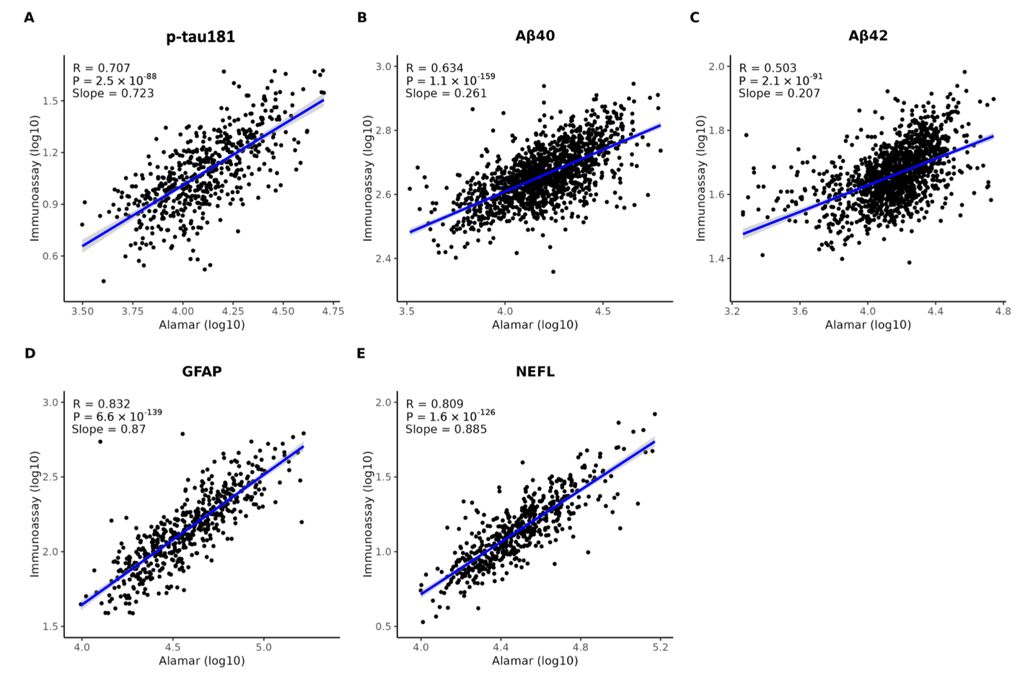

Supplementary Figure 9. Comparison of NULISAseq and Immunoassay Measurements. Scatter plots comparing NULISAseq and immunoassay measurements in plasma for various biomarkers, with Spearman correlation lines to highlight the strength of association. The specific biomarkers compared are (A) p-tau181, (B) Aβ42, (C) Aβ40, (D) GFAP, and (E) NFL.

Supplementary Figure 10. Comparison between NULISAseq and SomaScan. (A-F) Scatter plots displaying the correlations between Alamar and SomaScan measurements, along with their distribution in plasma, for various biomarkers. Each plot includes a Spearman correlation line to visualize the strength and direction of the relationship. The biomarkers analyzed are (A) TREM2 (X5635.66), (B) TREM2 (X11851.21), (C) Neurogranin (X18303.39), (D) TREM2 (X16300.4), (E) CHI3L1(X11104.13), and (F) VSNL1(X20197.14). These scatter plots provide insights into the concordance of measurements across platforms for these plasma biomarkers. (G) Correlation distribution between Alamar and SomaScan

