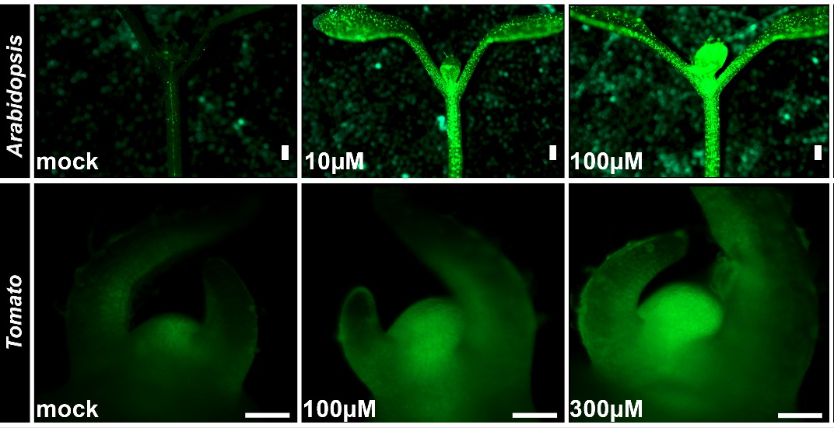

Supplemental Figure 1
TCSv2:3XVENUS responds to CK treatment in a dose dependent manner
Arabidopsis (top, Columbia seedlings are depicted) and tomato (bottom, M82 shoots are depicted) were treated with mock or indicated concentrations of BA (6-benzylaminopurine) for 24-48 hours. Images were taken with a Nikon stereomicroscope. Bars=100uM.

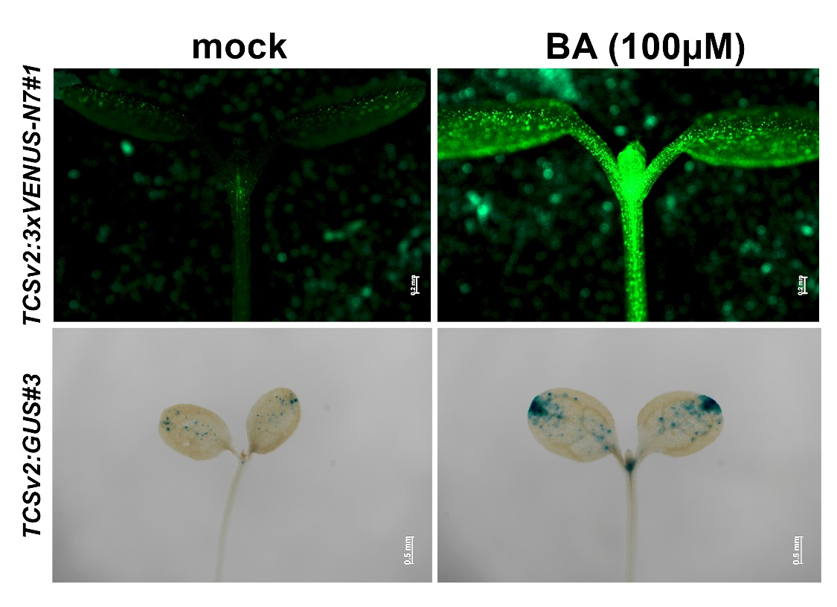

Supplemental Figure 2
TCSv2 driven expression in arabidopsis in the Ler background
Arabidopsis seedlings in the Ler background expressing TCSv2 driven VENUS (top) or GUS (bottom), with or without (mock) BA (6-benzylaminopurine) treatment, were photographed 24 hours after CK treatment or subjected to GUS staining 24 hours after CK treatment. Images were taken with a Nikon stereomicroscope. Bars=100uM.

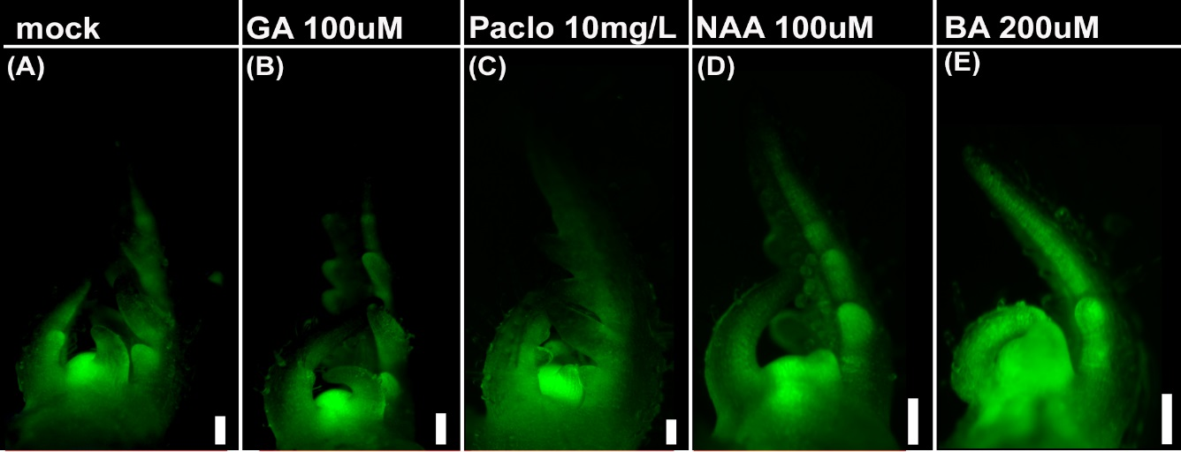

Supplemental Figure 3
TCSv2 does not respond to additional hormones
Characterization of TCS driven VENUS expression in wild type tomato shoot apexes following treatment with indicated hormones. Images were captured with a Nikon stereomicroscope. Bars=100uM.

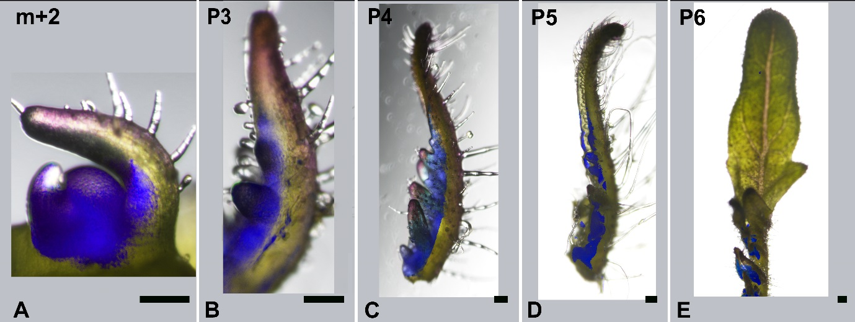

Supplemental Figure 4
Stereomicroscope analysis of TCSv2 driven expression in tomato leaves
Tomato seedlings expressing TCSv2 driven VENUS at various stages of leaf development as indicated. Images were taken with a Nikon stereomicroscope. The VENUS channel was hue-masked using Adobe photoshop to a dark blue color in order to better visualize it when superimposed on white light images of the young developing leaves. Bars=100uM.

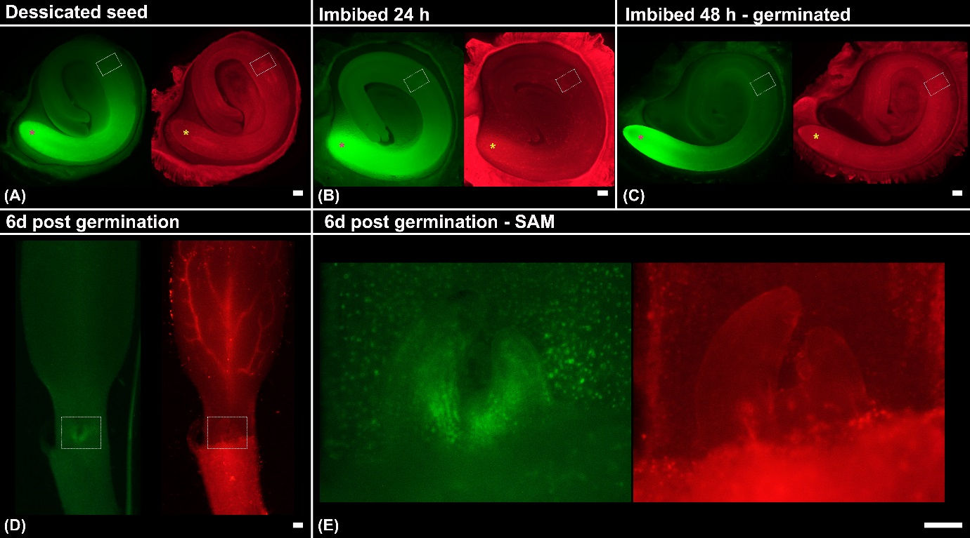

Supplemental Figure 5
TCSv2 driven expression in the tomato embryo
TCSv2 driven expression in mature tomato embryos. Images were taken with a Nikon stereomicroscope. The root apical meristem is indicated with an asterisk (A-C) and the shoot apical meristem is marked with a dotted box (A-D). The area in the dotted box in D is enlarged in E. Bars=100uM.

Supplemental Table 1
Primer pairs used in this work.

Name | Sequence | Use
EXP RT-F | TGGGTGTGCCTTTCTGAATG | qRT-PCR tomato
EXP RT-R | GCTAAGAACGCTGGACCTAATG | qRT-PCR tomato
TRR3/4 F | CGTCCCCTAAAGCATTCTCA | qRT-PCR tomato
TRR3/4 R | CGTCTTGTTGGTGATGTTGG | qRT-PCR tomato
TRR5/6/7 F | GGGATTGATGGTTTGAAGGT | qRT-PCR tomato
TRR 5/6/7 R | ATCTTGCTCAACACCGATGA | qRT-PCR tomato
TRR 16b F | CATCAATGCATGGAAGAAGG | qRT-PCR tomato
TRR 16b R | GCATTGCATTATTTGGCATC | qRT-PCR tomato
B-TUB F | AAACTCACTACCCCCAGCTTT | qRT-PCR arabidopsis
B-TUB R | GAGAGGAGCAAAACCAACCA | qRT-PCR arabidopsis
ARR5 F | GAAGTTCATCGAGCGGTTACTC | qRT-PCR arabidopsis
ARR5 R | TTAATCTTCAGATCCTCAAATCCA | qRT-PCR arabidopsis
ARR7 F | CAATGCCAGGACTTTCAGGA | qRT-PCR arabidopsis
ARR7 R | TTTGATTCGCTTTACATCTGC | qRT-PCR arabidopsis
ARR16 F | TGCAAAGTGACAACAGCAGA | qRT-PCR arabidopsis
ARR16 R | CCAGGCATACAGTAATCGGA | qRT-PCR arabidopsis
GUS F | ACAGCCAAAAGCCAGACAGA | qRT-PCR tomato and arabidopsis
GUS R | TGACGACCAAAGCCAGTAAAG | qRT-PCR tomato and arabidopsis

