Supplementary Information

The role of the globus pallidus subregions in the schizophrenia spectrum continuum
Supplementary Fig. S1: Associations between the volumes of the left and right globus pallidus externus (GPe) and internus (GPi) and the subscales of the Brief Psychiatric Rating Scale (BPRS). Adjusted GPe/GPi volumes (the vertical axis) were calculated as residuals after regressing out the effects of age, sex, and intracranial volume in patients with schizophrenia (N = 45) for visual purposes.

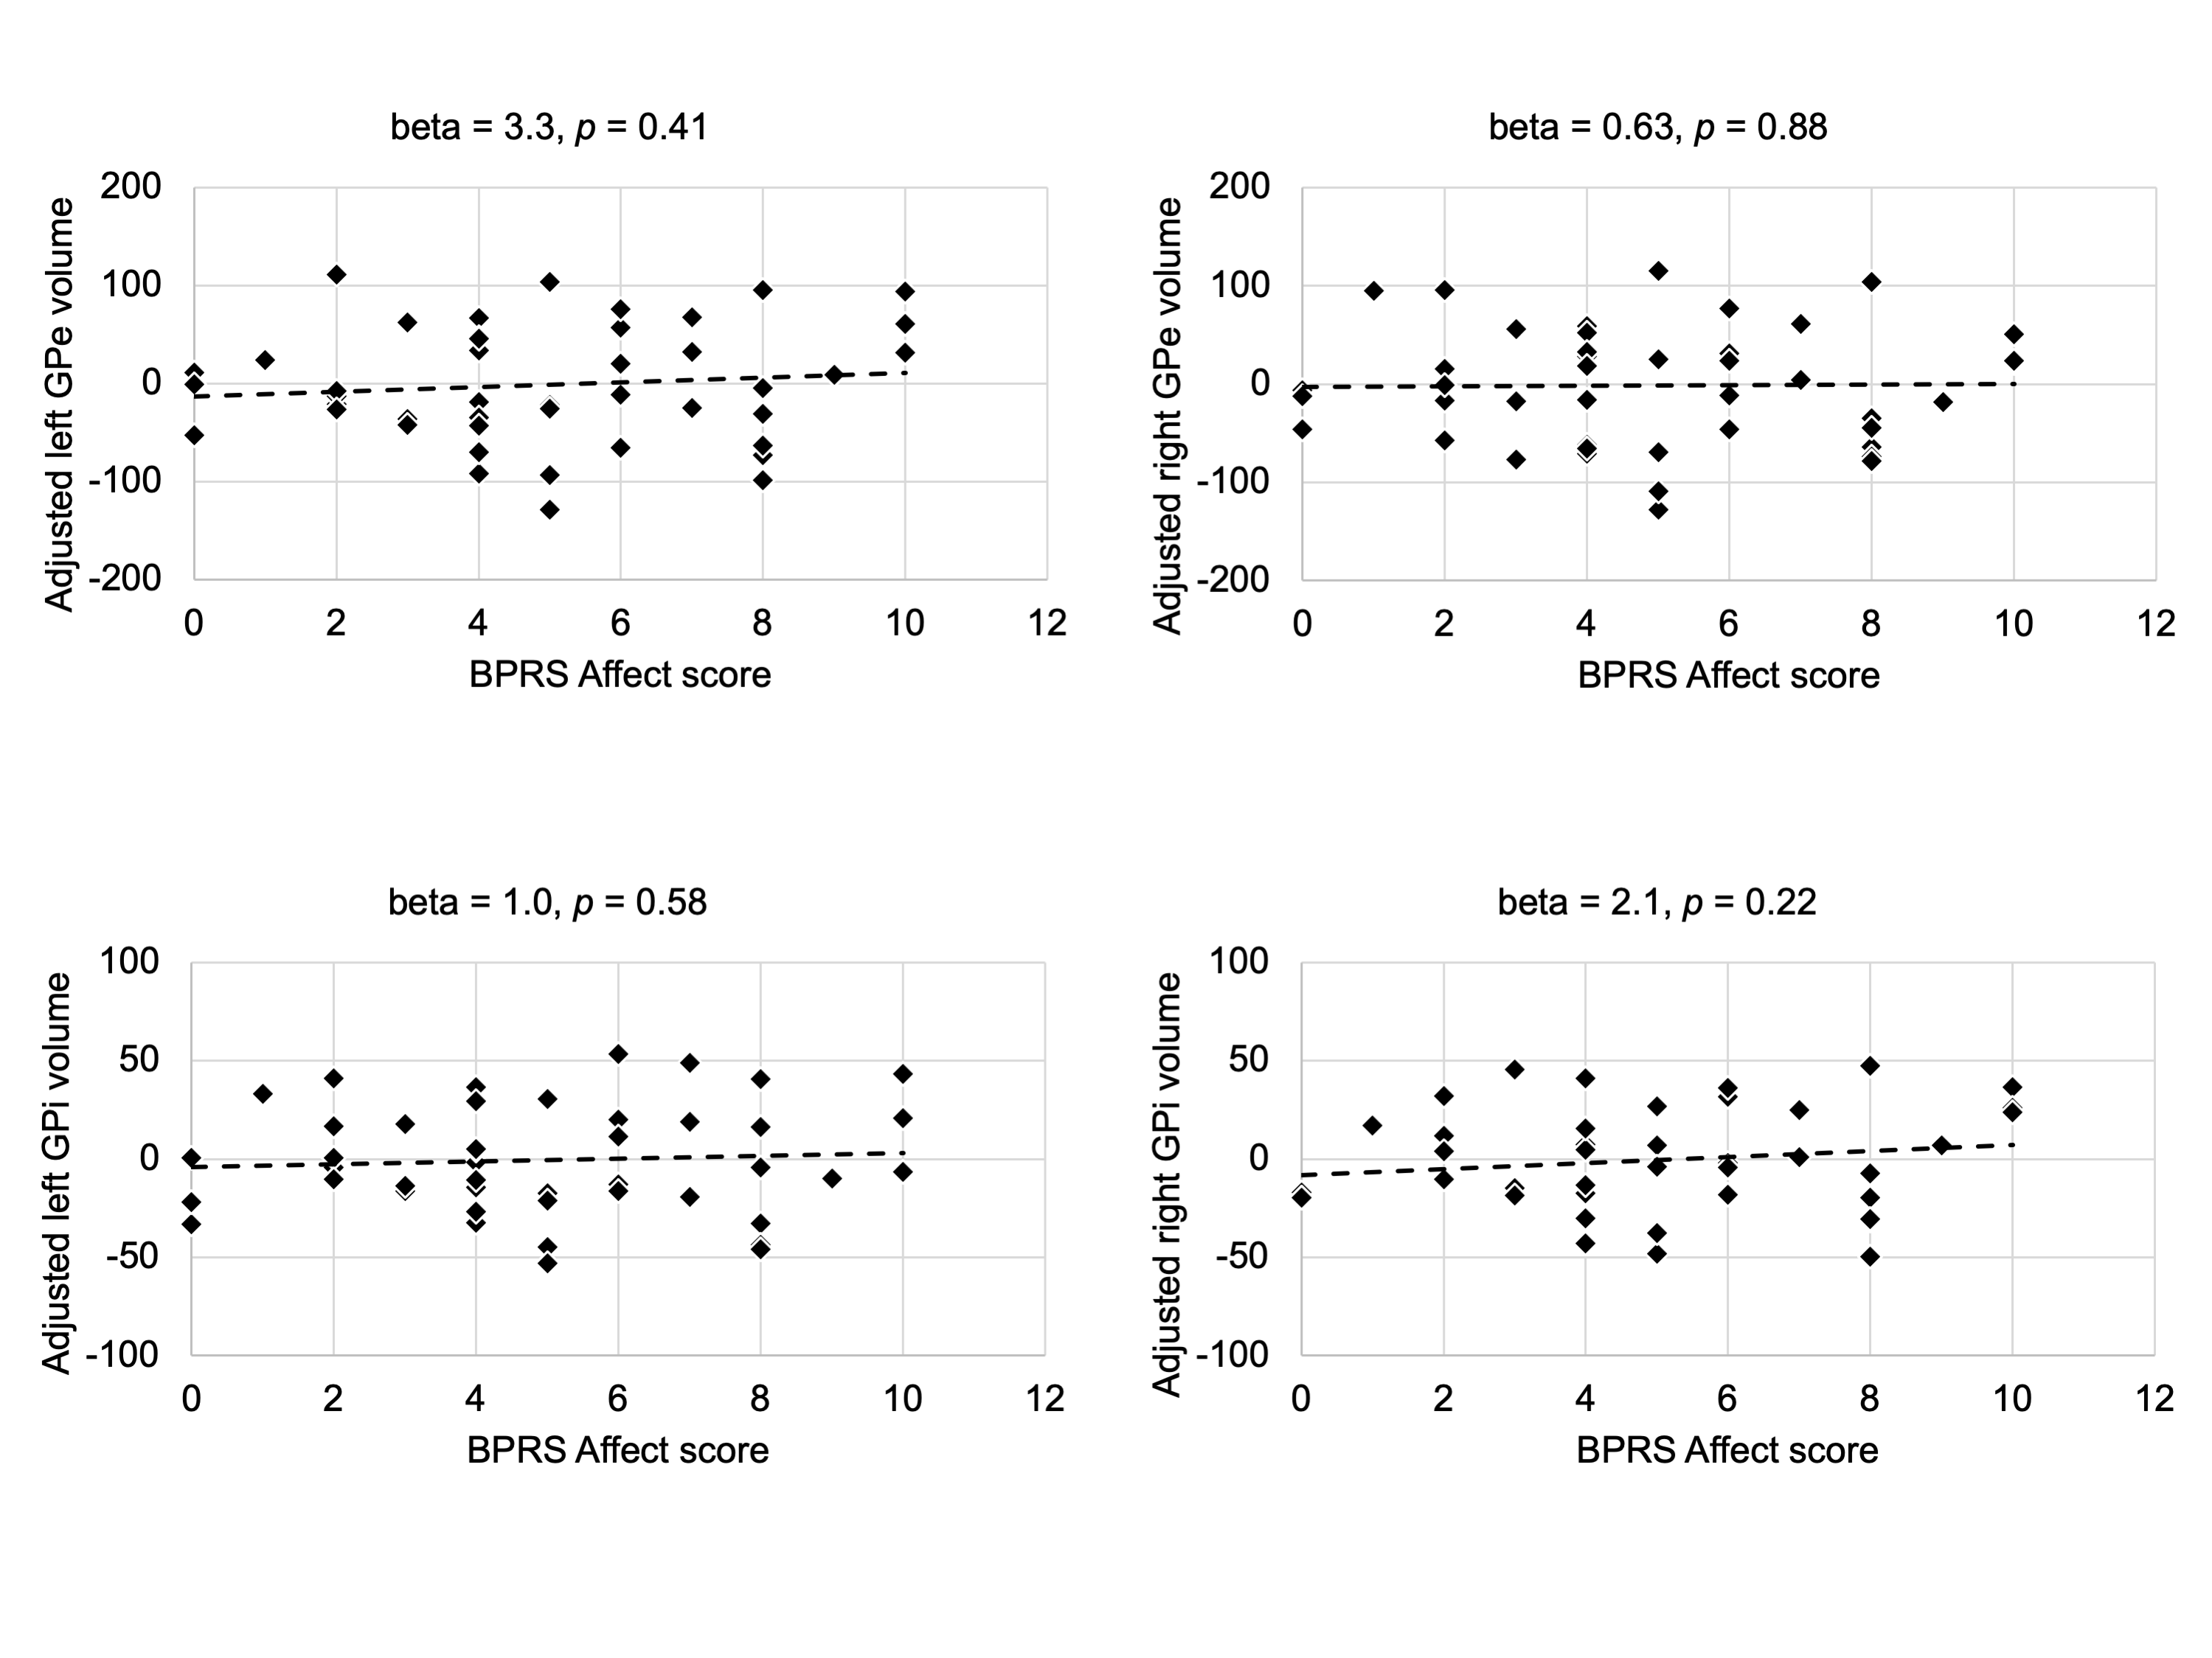
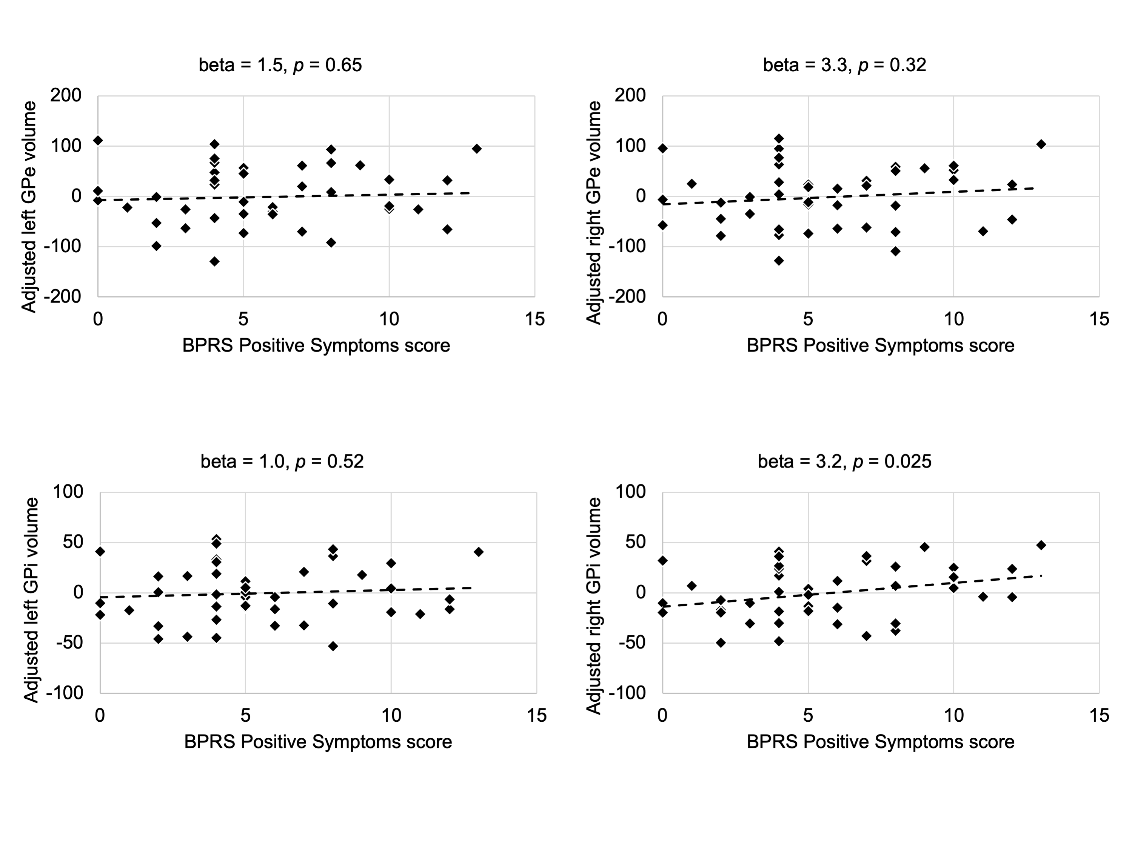
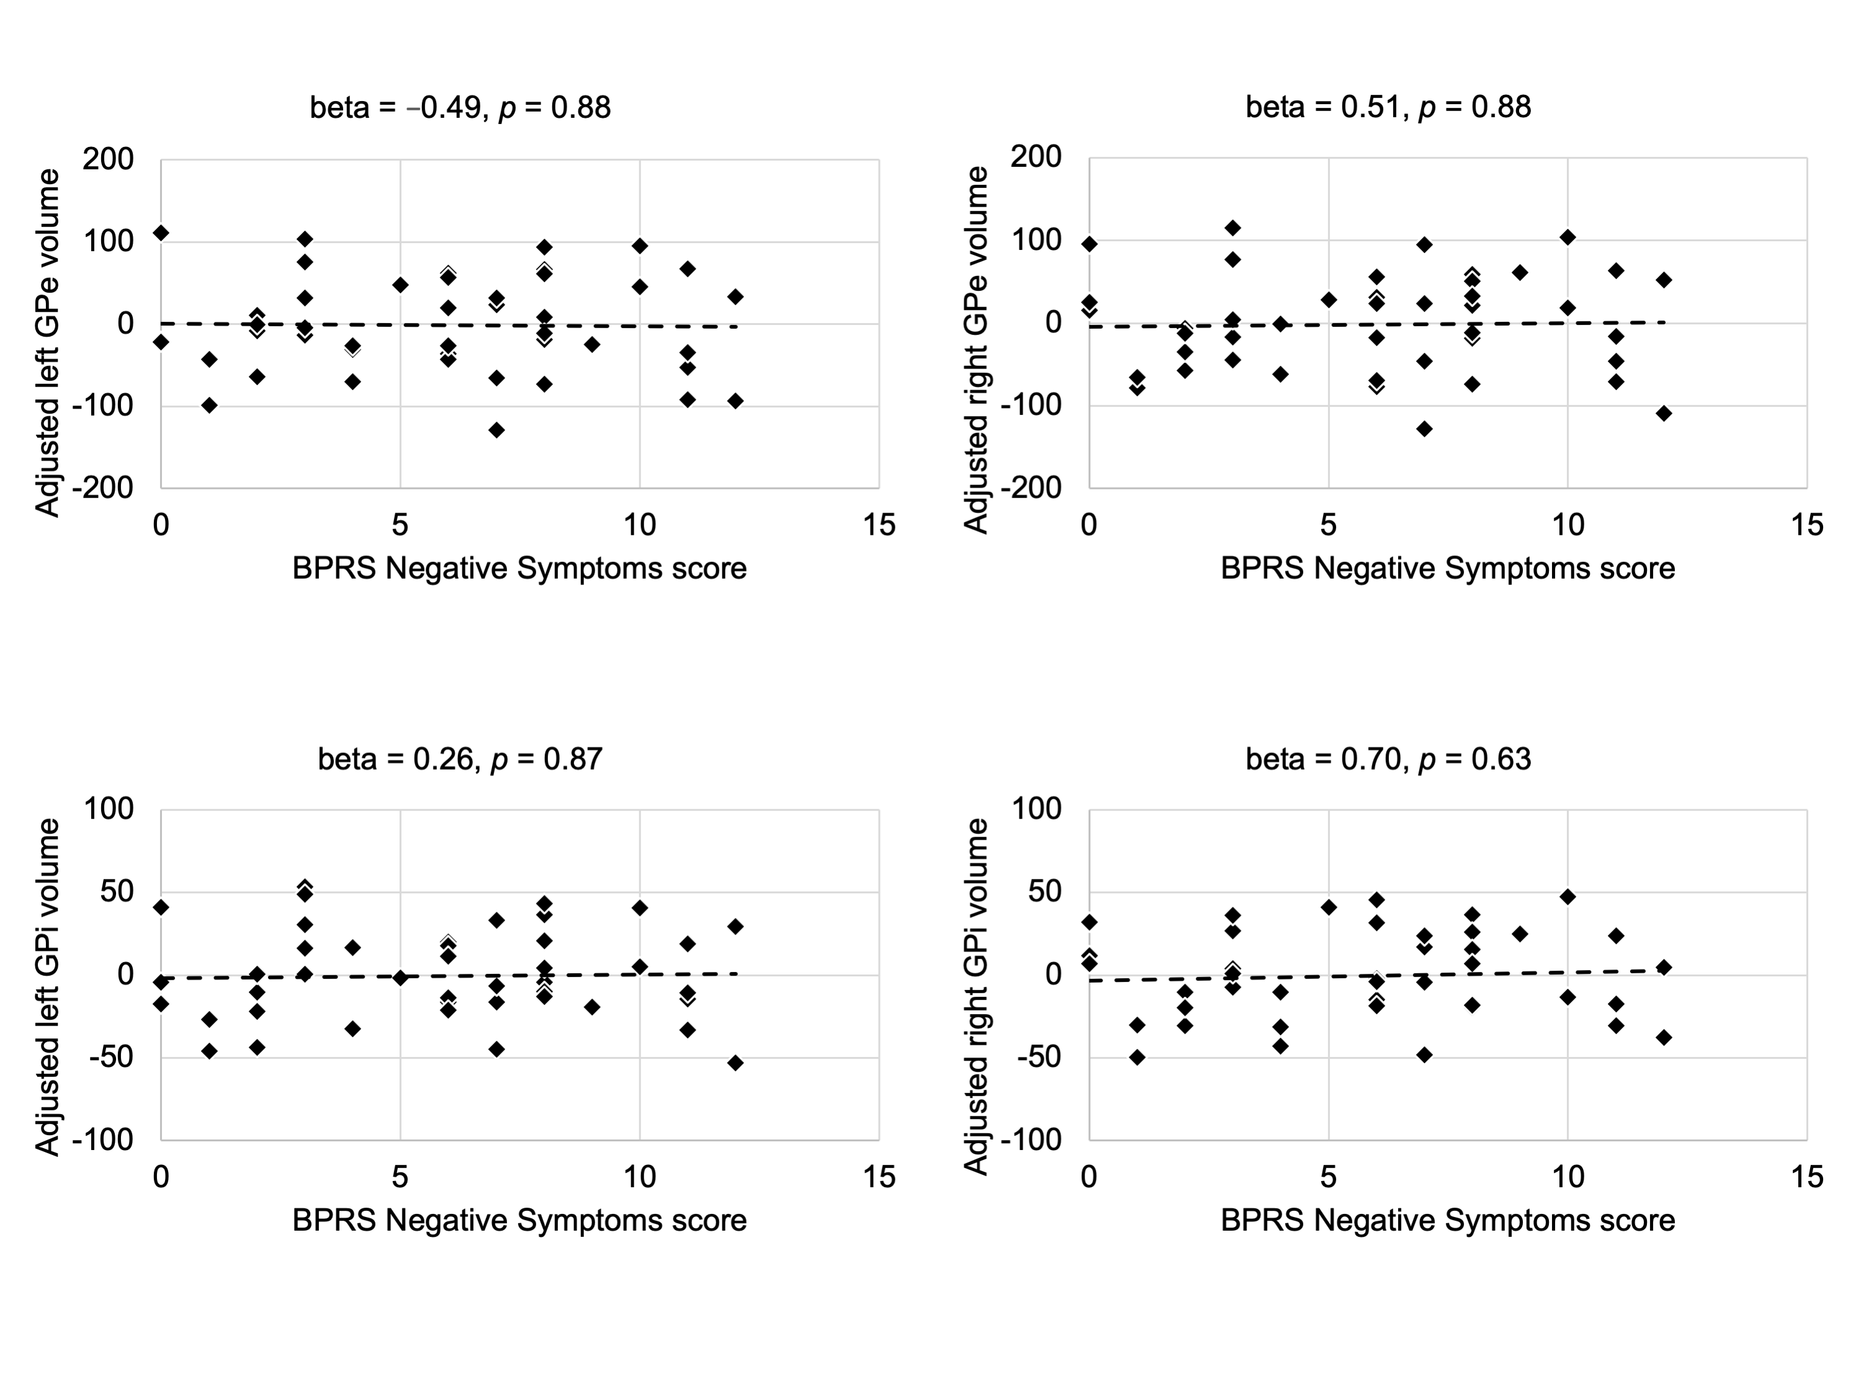
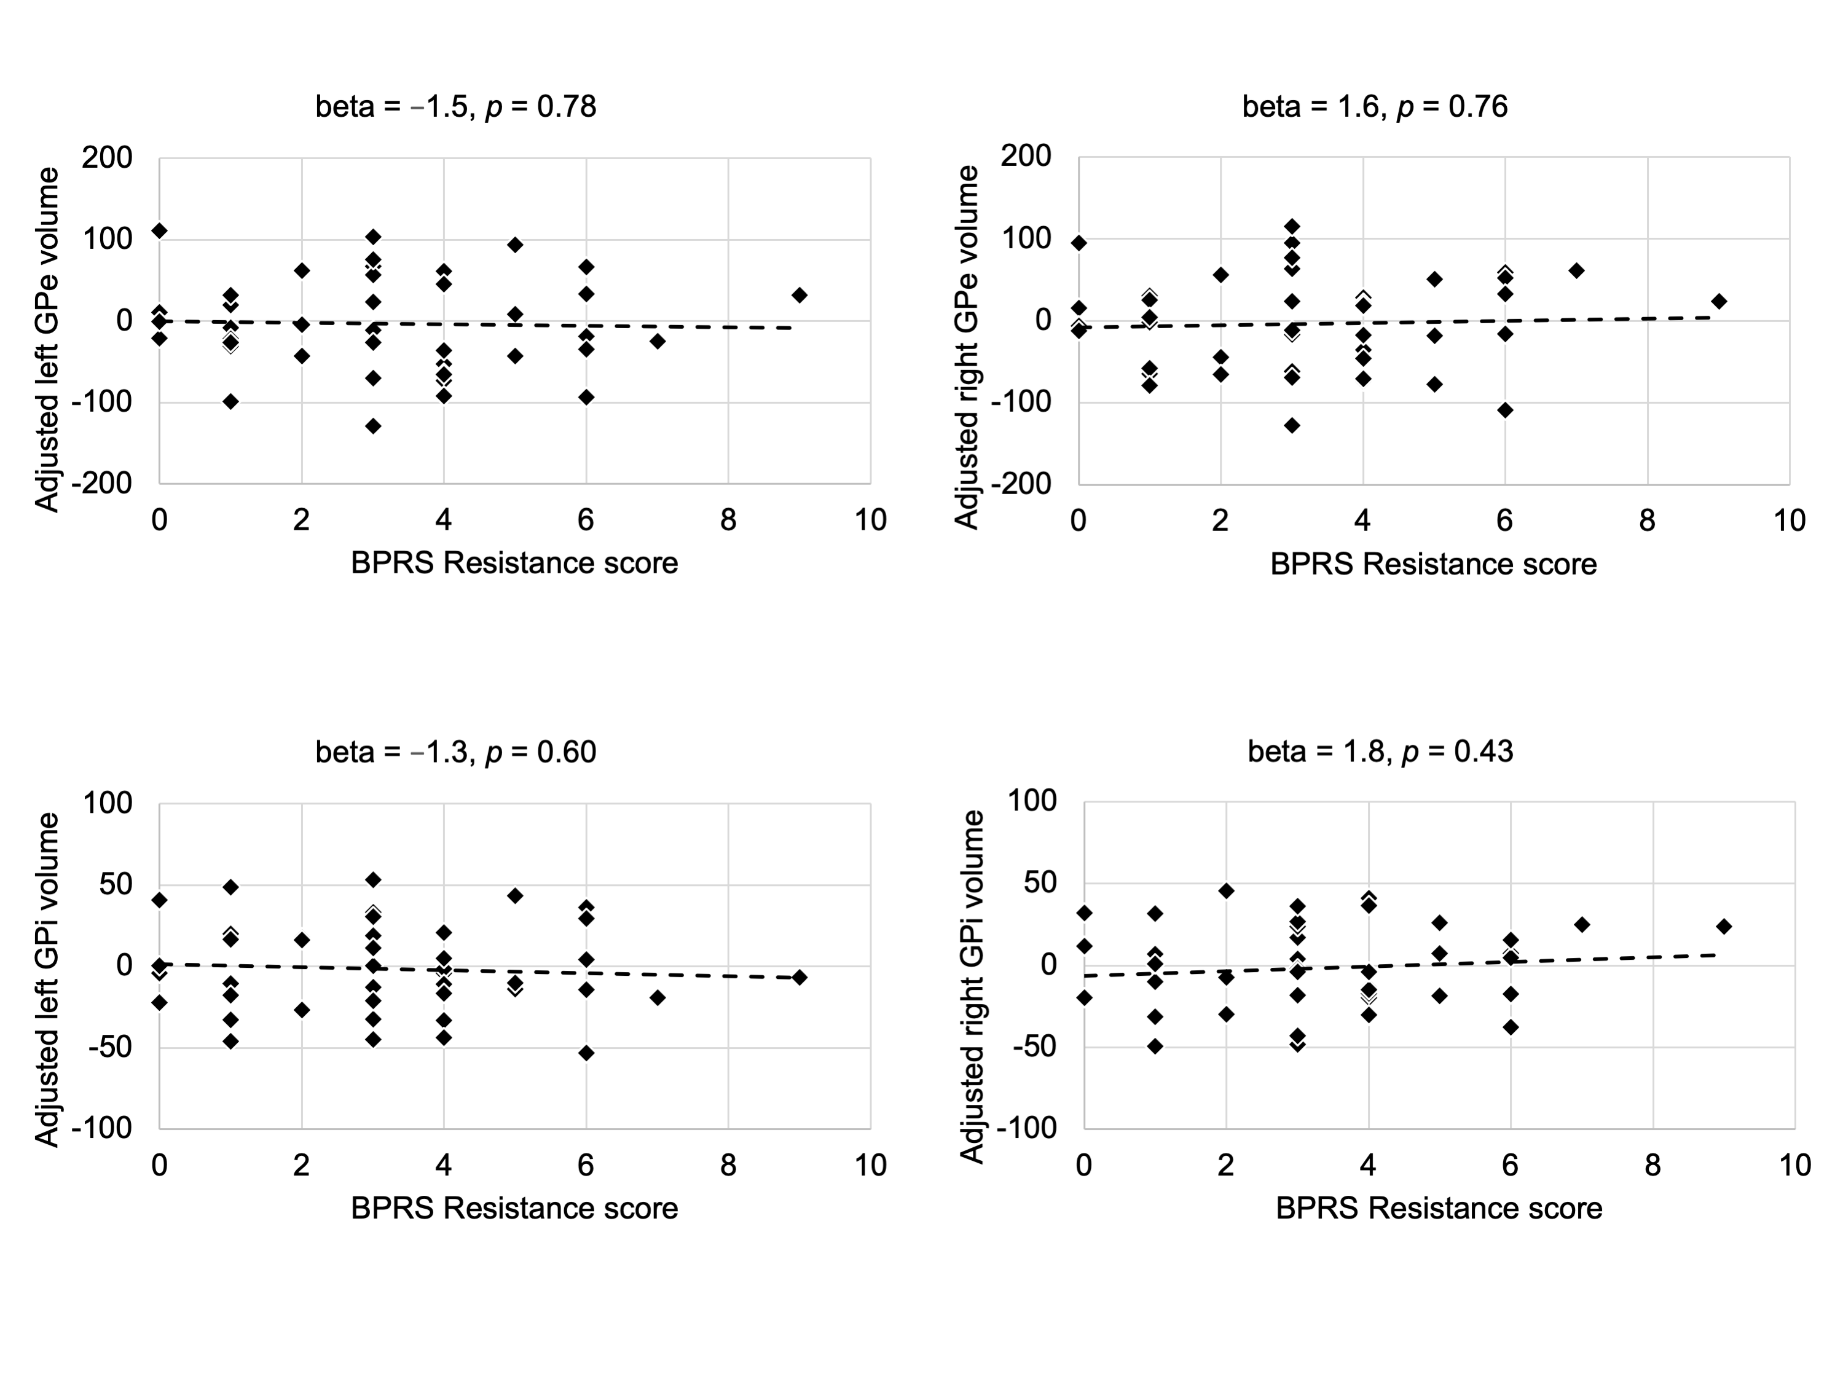
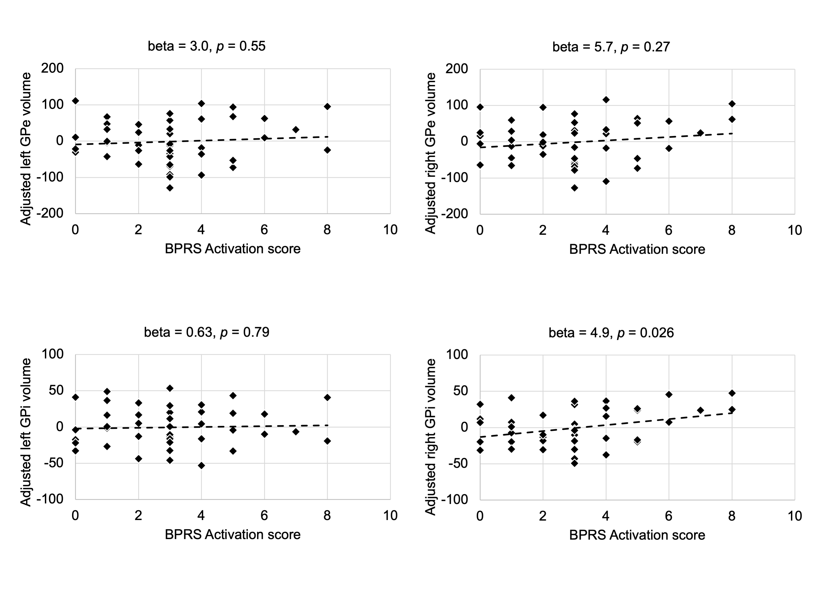
Supplementary Fig. S2: Associations between the functional connectivity of the left and right globus pallidus externus (GPe) and internus (GPi) and the subscales of the Brief Psychiatric Rating Scale (BPRS).

