eFigure 1. Flow chart of patients' selection.
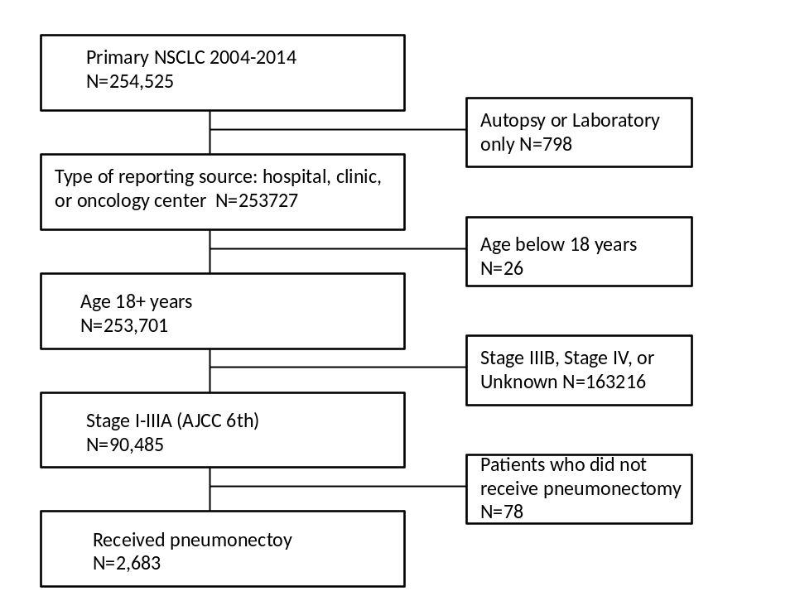

eFigure 2. Overall Survival and Cancer-specific Survival among Stage I-IIIA NSCLC Patients with Pneumonectomy in the Original Data Set. (A) Overall Survival. (B) Cancer-specific Survival.

eFigure3. Propensity score distributions (A) before matching, and (B) after matching.

eFigure4. Overall Survival and Cancer-specific Survival among Stage I-IIIA NSCLC Patients with Pneumonectomy in Left-sided Lung in the Original Data Set. (A) Overall Survival. (B) Cancer-specific Survival.

eFigure5. Overall Survival and Cancer-specific Survival among Stage I-IIIA NSCLC Patients with Pneumonectomy in Right-sided Lung in the Original Data Set. (A) Overall Survival. (B) Cancer-specific Survival.

