In situ imaging for multiplex tumor microbiome interactions via imaging mass cytometry on single-cell level
Supplemental Materials
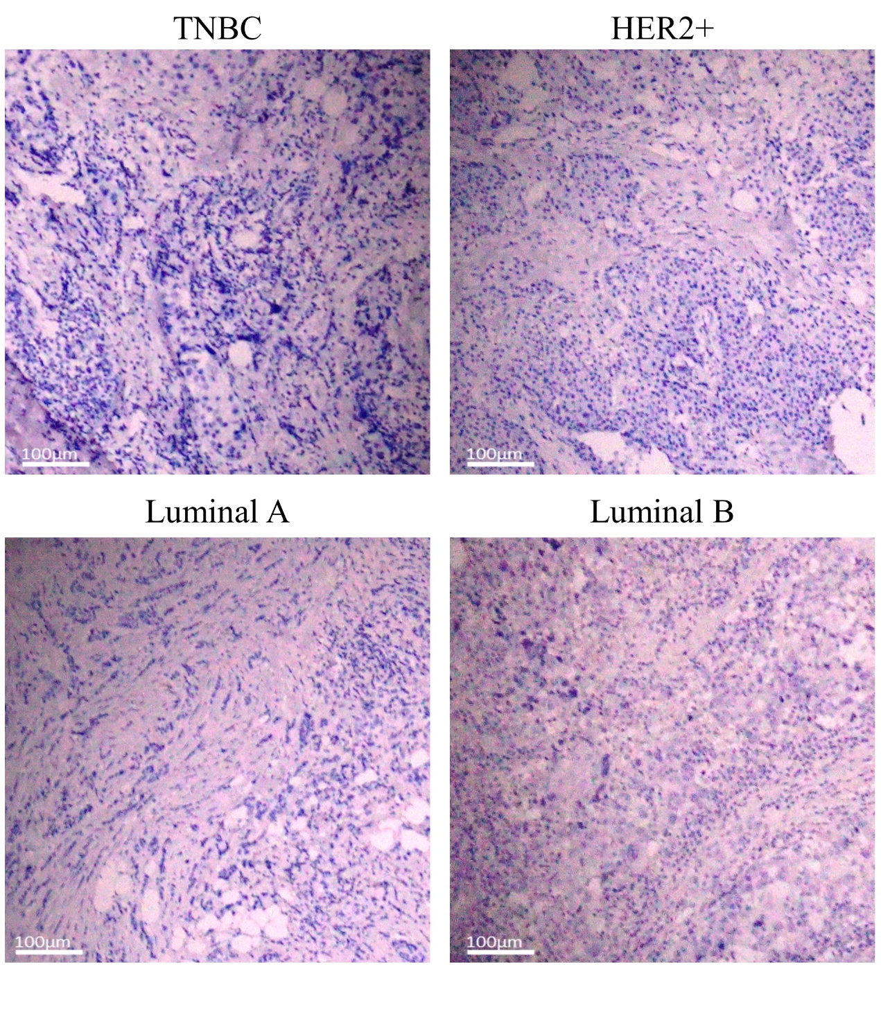
Supplemental Fig. 1 IHC images (brown for LTA, violet for nuclei) of breast cancer tissue section
Supplemental Fig. 2 The t-SNE maps reflect the distribution of the selected ROI in each case of the four types of breast cancer (TNBC, HER2+, Luminal A, Luminal B).

Supplemental Fig. 3 Differences in marker expression in cell clusters with different relevance to bacterial-enriched cells (a-d) Plots showing the comparison of the expression intensity of markers in cell clusters (CD19 for TNBC; PKCD for HER2+; ISG15 for Luminal A; IFI6 and ISG15 for Luminal B) that are interaction or avoidance to bacterial-enriched cell clusters. To facilitate comparison of the percentage change in intensity, the dimensionless expression intensity was normalized, where the higher one was set to 1.

Supplemental Table 1. The IMC staining panel based on PEHPSI.
Antibody/Marker | Clone | Vendor | Metal Tag
CD45 | HI30 | Biolegend | Pr141
PKCD | EPR17075 | Abcam | Nd144
PR | YR85 | Abcam | Nd145
IFI6 | / | Abcam | Sm147
HER2 | EP1045Y | Abcam | Nd148
Ki67 | SP6 | Abcam | Sm152
ISG15 | / | Abcam | Eu153
ER | EPR4097 | Abcam | Dy163
LPS | WN1 222-5 | HycultBiotech | Ho165
ZC3HV1 | / | Abcam | Er168
LTA | mAb 55 | HycultBiotech | Tm169
CD68 | / | Abcam | Yb174
CD8a | CAL66 | Abcam | Lu175
CD19 | 6OMP31 | Invitrogen | Yb176

Supplemental Table 2. The staining concentration of antibodies/markers.
Antibody/Marker | Staining concentration (µg/ml)
CD45 | 0.15
PKCD | 5
PR | 1
IFI6 | 5
HER2 | 0.25
Ki67 | 0.15
ISG15 | 5
ER | 3
LPS | 1
ZC3HV1 | 5
LTA | 0.5
CD68 | 5
CD8a | 1
CD19 | 2.5

