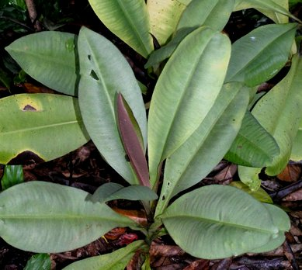
Labisia pumila
High fat diet formulation
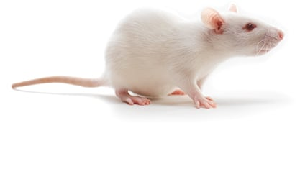
PCOS rats were divided into 4 groups which consisted of control, placebo (water), LP25 (LP 25mg/kg) and LP50 (LP 50 mg/kg) respectively
Polycystic ovary syndrome rats

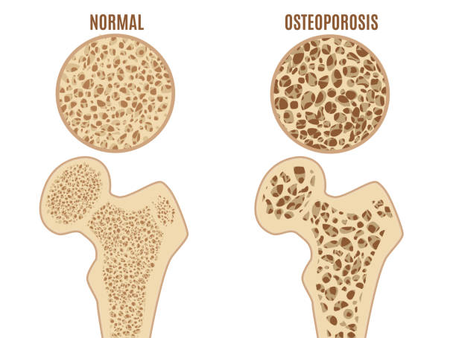
RESULTS:

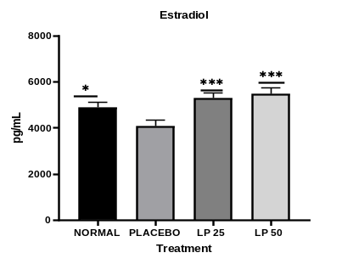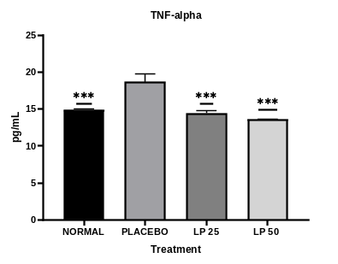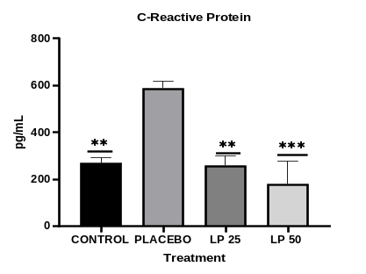
Conclusion: Phytoestrogenic effect of LP extract might reduce the inflammatory cytokine related to the formation of osteoporosis and loss of bone mass.
Inflammatory cytokine of TNF-α and C-reactive proteins significantly decrease
Estradiol significantly increase

