Contents
Appendix A PRISMA checklist 2
Appendix A1 PRISMA 2020 checklist 2
Appendix B Search strategy 5
Appendix B1 Initial search strategy 5
Appendix C Ranking of SUCRA probabilities 15
Appendix D Publication Bias Test 16
Appendix D1 Begg's and Egger's test results for inhibitory control 16
Appendix D2 Begg's and Egger's test results for working memory 16
Appendix D3 Begg's and Egger's test results for cognitive flexibility 17
Appendix E Sensitivity analysis 18
Appendix E1 Results of sensitivity analysis on inhibitory control 18
Appendix E2 Results of sensitivity analysis on working memory 18
Appendix E3 Results of sensitivity analysis on cognitive flexibility 18

Appendix A PRISMA checklist

Appendix A1 PRISMA 2020 checklist
Section and Topic | Item # | Checklist item | Location where item is reported
TITLE
Title | 1 | Identify the report as a systematic review. | Page 1
ABSTRACT
Abstract | 2 | See the PRISMA 2020 for Abstracts checklist. | Page 2-3
INTRODUCTION
Rationale | 3 | Describe the rationale for the review in the context of existing knowledge. | Page 3-4
Objectives | 4 | Provide an explicit statement of the objective(s) or question(s) the review addresses. | Page 5-6
METHODS
Eligibility criteria | 5 | Specify the inclusion and exclusion criteria for the review and how studies were grouped for the syntheses. | Page 7-8
Information sources | 6 | Specify all databases, registers, websites, organisations, reference lists and other sources searched or consulted to identify studies. Specify the date when each source was last searched or consulted. | Page 6-7
Search strategy | 7 | Present the full search strategies for all databases, registers and websites, including any filters and limits used. | Page 6-7
Selection process | 8 | Specify the methods used to decide whether a study met the inclusion criteria of the review, including how many reviewers screened each record and each report retrieved, whether they worked independently, and if applicable, details of automation tools used in the process. | Page 8
Data collection process | 9 | Specify the methods used to collect data from reports, including how many reviewers collected data from each report, whether they worked independently, any processes for obtaining or confirming data from study investigators, and if applicable, details of automation tools used in the process. | Page 8
Data items | 10a | List and define all outcomes for which data were sought. Specify whether all results that were compatible with each outcome domain in each study were sought (e.g. for all measures, time points, analyses), and if not, the methods used to decide which results to collect. | Page 8
Data items | 10b | List and define all other variables for which data were sought (e.g. participant and intervention characteristics, funding sources). Describe any assumptions made about any missing or unclear information. | Page 8
Study risk of bias assessment | 11 | Specify the methods used to assess risk of bias in the included studies, including details of the tool(s) used, how many reviewers assessed each study and whether they worked independently, and if applicable, details of automation tools used in the process. | Page 9
Effect measures | 12 | Specify for each outcome the effect measure(s) (e.g. risk ratio, mean difference) used in the synthesis or presentation of results. | Page 9-10
Synthesis methods | 13a | Describe the processes used to decide which studies were eligible for each synthesis (e.g. tabulating the study intervention characteristics and comparing against the planned groups for each synthesis (item #5)). | Page 9-10
Synthesis methods | 13b | Describe any methods required to prepare the data for presentation or synthesis, such as handling of missing summary statistics, or data conversions. | Page 9-10
Synthesis methods | 13c | Describe any methods used to tabulate or visually display results of individual studies and syntheses. | Page 9-10
Synthesis methods | 13d | Describe any methods used to synthesize results and provide a rationale for the choice(s). If meta-analysis was performed, describe the model(s), method(s) to identify the presence and extent of statistical heterogeneity, and software package(s) used. | Page 9-10
Synthesis methods | 13e | Describe any methods used to explore possible causes of heterogeneity among study results (e.g. subgroup analysis, meta-regression). | Page 9-10
Synthesis methods | 13f | Describe any sensitivity analyses conducted to assess robustness of the synthesized results. | Page 9-10
Reporting bias assessment | 14 | Describe any methods used to assess risk of bias due to missing results in a synthesis (arising from reporting biases). | Page 9-10
Certainty assessment | 15 | Describe any methods used to assess certainty (or confidence) in the body of evidence for an outcome. | Page 9-10
RESULTS
Study selection | 16a | Describe the results of the search and selection process, from the number of records identified in the search to the number of studies included in the review, ideally using a flow diagram. | Page 10-11
Study selection | 16b | Cite studies that might appear to meet the inclusion criteria, but which were excluded, and explain why they were excluded. | Page 10-11
Study characteristics | 17 | Cite each included study and present its characteristics. | Page 11-12
Risk of bias in studies | 18 | Present assessments of risk of bias for each included study. | Page 12
Results of individual studies | 19 | For all outcomes, present, for each study: (a) summary statistics for each group (where appropriate) and (b) an effect estimate and its precision (e.g. confidence/credible interval), ideally using structured tables or plots. | Page 12-15
Results of syntheses | 20a | For each synthesis, briefly summarise the characteristics and risk of bias among contributing studies. | Page 12-13
Results of syntheses | 20b | Present results of all statistical syntheses conducted. If meta-analysis was done, present for each the summary estimate and its precision (e.g. confidence/credible interval) and measures of statistical heterogeneity. If comparing groups, describe the direction of the effect. | Page 12-15
Results of syntheses | 20c | Present results of all investigations of possible causes of heterogeneity among study results. | Page 12-15
Results of syntheses | 20d | Present results of all sensitivity analyses conducted to assess the robustness of the synthesized results. | Page 15
Reporting biases | 21 | Present assessments of risk of bias due to missing results (arising from reporting biases) for each synthesis assessed. | Page 15
Certainty of evidence | 22 | Present assessments of certainty (or confidence) in the body of evidence for each outcome assessed. | Page 15
DISCUSSION
Discussion | 23a | Provide a general interpretation of the results in the context of other evidence. | Page 15-21
Discussion | 23b | Discuss any limitations of the evidence included in the review. | Page 22-23
Discussion | 23c | Discuss any limitations of the review processes used. | Page 22-23
Discussion | 23d | Discuss implications of the results for practice, policy, and future research. | Page 22-23
OTHER INFORMATION
Registration and protocol | 24a | Provide registration information for the review, including register name and registration number, or state that the review was not registered. | Page 6
Registration and protocol | 24b | Indicate where the review protocol can be accessed, or state that a protocol was not prepared. | Page 6
Registration and protocol | 24c | Describe and explain any amendments to information provided at registration or in the protocol. | Page 6
Support | 25 | Describe sources of financial or non-financial support for the review, and the role of the funders or sponsors in the review. | Page 24
Competing interests | 26 | Declare any competing interests of review authors. | Page 24
Availability of data, code and other materials | 27 | Report which of the following are publicly available and where they can be found: template data collection forms; data extracted from included studies; data used for all analyses; analytic code; any other materials used in the review. | Page 24

Appendix B Search strategy

Appendix B1 Initial search strategy

Search strategy
Database | PubMed
#1 | "Exercise"[Mesh]
#2 | "Exercise"[Title/Abstract] OR "Physical Exercise"[Title/Abstract] OR "Physical Activity"[Title/Abstract] OR "Aerobic Exercise"[Title/Abstract] OR "Isometric Exercise"[Title/Abstract] OR "Acute Exercise"[Title/Abstract] OR "Exercise Training"[Title/Abstract] OR "Running"[Title/Abstract] OR "Jogging"[Title/Abstract] OR "Marathon Running"[Title/Abstract] OR "Swimming"[Title/Abstract] OR "Walking"[Title/Abstract] OR "Nordic Walking"[Title/Abstract] OR "Stair Climbing"[Title/Abstract] OR "Exergaming"[Title/Abstract] OR "Aerobic Training"[Title/Abstract] OR "Dancing"[Title/Abstract] OR "Cycling"[Title/Abstract] OR "Endurance Training"[Title/Abstract] OR "Qigong"[Title/Abstract] OR "Taichi"[Title/Abstract] OR "Baduanjin"[Title/Abstract] OR "Wuqinxi"[Title/Abstract] OR "Yijinjing"[Title/Abstract] OR "Yoga"[Title/Abstract] OR "Ball"[Title/Abstract] OR "soccer ball"[Title/Abstract] OR "Soccer"[Title/Abstract] OR "Football"[Title/Abstract] OR "Basketball"[Title/Abstract] OR "ping pong"[Title/Abstract] OR "Badminton"[Title/Abstract] OR "Tennis"[Title/Abstract] OR "Baseball"[Title/Abstract] OR "Volleyball"[Title/Abstract] OR "Softball"[Title/Abstract] OR "Softball" OR "racket sport"[Title/Abstract] OR "Lacrosse"[Title/Abstract] OR "Racquetball”[Title/Abstract]
#3 | #1 OR #2
#4 | "Executive Function"[Mesh]
#5 | "Executive Function"[Title/Abstract] OR "Executive Control"[Title/Abstract] OR "Cognitive Function"[Title/Abstract] OR "Cognitive Performance"[Title/Abstract] OR "Inhibitory Control"[Title/Abstract] OR "Shifting"[Title/Abstract] OR "Working Memory"[Title/Abstract] OR (("refresh"[All Fields] OR "refreshable"[All Fields] OR "refreshed"[All Fields] OR "refresher"[All Fields] OR "refreshers"[All Fields] OR "refreshes"[All Fields] OR "refreshing"[All Fields] OR "refreshment"[All Fields] OR "refreshments"[All Fields]) AND "function"[Title/Abstract]) OR "cognitive flexibility"[Title/Abstract] OR "Updating"[Title/Abstract] OR "Inhibition"[Title/Abstract]
#6 | #4 OR #5
#7 | "Attention Deficit Disorder with Hyperactivity"[Mesh]
#8 | "Attention Deficit Hyperactivity Disorder"[Title/Abstract] OR "Attention Deficit Disorder with Hyperactivity"[Title/Abstract] OR "ADHD"[Title/Abstract] OR "ADDH"[Title/Abstract] OR "Attention Deficit Disorder"[Title/Abstract] OR "Hyperkinetic Syndrome"[Title/Abstract]
#9 | #7 OR #8
#10 | "Child"[Mesh]
#11 | "Adolescent"[Mesh]
#12 | "Children"[Title/Abstract] OR "Adolescent"[Title/Abstract] OR "Child"[Title/Abstract] OR "Teenager"[Title/Abstract] OR "Adolescence"[Title/Abstract]
#13 | #10 OR #11 OR #12
#14 | #3 AND #6 AND #9 AND #13
amount | 144

Search strategy
Database | Embase
#1 | Executive Function'/exp OR 'Executive Function'
#2 | 'Executive Function':ab,ti,kw OR 'Executive Control':ab,ti,kw OR 'Cognitive Function':ab,ti,kw OR 'Cognitive Performance':ab,ti,kw OR 'Inhibitory Control':ab,ti,kw OR 'Shifting':ab,ti,kw OR 'Working Memory':ab,ti,kw OR 'Refresh Function':ab,ti,kw OR 'Cognitive Flexibility':ab,ti,kw OR 'Updating':ab,ti,kw OR 'Inhibition':ab,ti,kw
#3 | #1 OR #2
#4 | 'Exercise'/exp OR 'Exercise'
#5 | 'Exercise':ab,ti,kw OR 'Physical Activity':ab,ti,kw OR 'Aerobic Exercise':ab,ti,kw OR 'Isometric Exercise':ab,ti,kw OR 'Acute Exercise':ab,ti,kw OR 'Exercise Training':ab,ti,kw OR 'Running':ab,ti,kw OR 'Jogging':ab,ti,kw OR 'Marathon Running':ab,ti,kw OR 'Swimming':ab,ti,kw OR 'Walking':ab,ti,kw OR 'Nordic Walking':ab,ti,kw OR 'Stair Climbing':ab,ti,kw OR 'Exergaming':ab,ti,kw OR 'Aerobic Training':ab,ti,kw OR 'Dancing':ab,ti,kw OR 'Cycling':ab,ti,kw OR 'Endurance Training':ab,ti,kw OR 'Qigong':ab,ti,kw OR 'Taichi':ab,ti,kw OR 'Baduanjin':ab,ti,kw OR 'Wuqinxi':ab,ti,kw OR 'Yijinjing':ab,ti,kw OR 'Yoga':ab,ti,kw OR 'Ball':ab,ti,kw OR 'Soccer ball':ab,ti,kw OR 'Soccer':ab,ti,kw OR 'Football':ab,ti,kw OR 'Basketball':ab,ti,kw OR 'Ping Pong':ab,ti,kw OR 'Badminton':ab,ti,kw OR 'Tennis':ab,ti,kw OR 'Baseball':ab,ti,kw OR 'Volleyball':ab,ti,kw OR 'Softball':ab,ti,kw OR 'Racket sport':ab,ti,kw OR 'Lacrosse':ab,ti,kw OR 'Racquetball':ab,ti,kw
#6 | #4 OR #5
#7 | 'Attention Deficit Hyperactivity Disorder'/exp OR 'Attention Deficit Hyperactivity Disorder'
#8 | 'Attention Deficit Hyperactivity Disorder':ab,ti,kw OR 'Attention Deficit Disorder with Hyperactivity':ab,ti,kw OR 'ADHD':ab,ti,kw OR 'ADDH':ab,ti,kw OR 'Attention Deficit Disorder':ab,ti,kw OR 'Hyperkinetic Syndrome':ab,ti,kw
#9 | #7 OR #8
#10 | 'Children':ab,ti,kw OR 'Adolescent':ab,ti,kw OR 'Child':ab,ti,kw OR 'Teenager':ab,ti,kw OR 'Adolescence':ab,ti,kw
#11 | #3 AND #6 AND #9 AND #10
amount | 285

Search strategy
Database | ProQuest
#1 | AB,TI("Exercise" OR "Physical Activity" OR "Aerobic Exercise" OR "Isometric Exercise" OR "Acute Exercise" OR "Exercise Training" OR "Running" OR "Jogging" OR "Marathon Running" OR "Swimming" OR "Walking" OR "Nordic Walking" OR "Stair Climbing" OR "Exergaming" OR "Aerobic Training" OR "Dancing" OR "Cycling" OR "Endurance Training" OR "Qigong" OR "Taichi" OR "Baduanjin" OR "Wuqinxi" OR "Yijinjing" OR "Yoga" OR "Ball" OR "Soccer Ball" OR "Soccer" OR "Football" OR "Basketball" OR "Ping Pong" OR "Badminton" OR "Tennis" OR "Baseball" OR "Volleyball" OR "Softball" OR "Softball" OR "Racket Sport" OR "Lacrosse" OR "Racquetball")
#2 | AB,TI("Executive Function" OR "Executive Control" OR "Cognitive Function" OR "Cognitive Performance" OR "Inhibitory Control" OR "Shifting" OR "Working memory" OR "Refresh Function" OR "Cognitive Flexibility" OR "Updating" OR "Inhibition")
#3 | AB,TI("Attention Deficit Disorder with Hyperactivity" OR "Attention Deficit Hyperactivity Disorder" OR "Attention Deficit Disorder with Hyperactivity" OR "ADHD" OR "ADDH" OR "Attention Deficit Disorder" OR "Hyperkinetic Syndrome")
#4 | AB,TI("Child" OR "Adolescent" OR "Children" OR "Adolescent" OR "Child" OR "Teenager" OR "Adolescence")
#5 | #1 AND #2 AND #3 AND #4
amount | 85

Search strategy
Database | Scopus
#1 | AB,TI("Exercise" OR "Physical Activity" OR "Aerobic Exercise" OR "Isometric Exercise" OR "Acute Exercise" OR "Exercise Training" OR "Running" OR "Jogging" OR "Marathon Running" OR "Swimming" OR "Walking" OR "Nordic Walking" OR "Stair Climbing" OR "Exergaming" OR "Aerobic Training" OR "Dancing" OR "Cycling" OR "Endurance Training" OR "Qigong" OR "Taichi" OR "Baduanjin" OR "Wuqinxi" OR "Yijinjing" OR "Yoga" OR "Ball" OR "Soccer Ball" OR "Soccer" OR "Football" OR "Basketball" OR "Ping Pong" OR "Badminton" OR "Tennis" OR "Baseball" OR "Volleyball" OR "Softball" OR "Softball" OR "Racket Sport" OR "Lacrosse" OR "Racquetball")
#2 | AB,TI("Executive Function" OR "Executive Control" OR "Cognitive Function" OR "Cognitive Performance" OR "Inhibitory Control" OR "Shifting" OR "Working memory" OR "Refresh Function" OR "Cognitive Flexibility" OR "Updating" OR "Inhibition")
#3 | AB,TI("Attention Deficit Disorder with Hyperactivity" OR "Attention Deficit Hyperactivity Disorder" OR "Attention Deficit Disorder with Hyperactivity" OR "ADHD" OR "ADDH" OR "Attention Deficit Disorder" OR "Hyperkinetic Syndrome")
#4 | AB,TI("Child" OR "Adolescent" OR "Children" OR "Adolescent" OR "Child" OR "Teenager" OR "Adolescence")
#5 | #1 AND #2 AND #3 AND #4
amount | 346

Search strategy
Database | Web of Science
#1 | TS=(Exercise OR Exercise OR Physical Activity OR Aerobic Exercise OR Isometric Exercise OR Acute Exercise OR Exercise Training OR Running OR Jogging OR Marathon Running OR Swimming OR Walking OR Nordic Walking OR Stair Climbing OR Exergaming OR Aerobic Training OR Dancing OR Cycling OR Endurance Training OR Qigong OR Taichi OR Baduanjin OR Wuqinxi OR Yijinjing OR Yoga OR Ball OR Soccer Ball OR Soccer OR Football OR Basketball OR Ping Pong OR Badminton OR Tennis OR Baseball OR Volleyball OR Softball OR Softball OR Racket Sport OR Lacrosse OR Racquetball)
#2 | TS=(Attention Deficit Disorder with Hyperactivity OR Attention Deficit Hyperactivity Disorder OR Attention Deficit Disorder with Hyperactivity OR ADHD OR ADDH OR Attention Deficit Disorder OR Hyperkinetic Syndrome)
#3 | TS=(Executive Function OR Executive Function OR Executive Control OR Cognitive Function OR Cognitive Performance OR Inhibitory Control OR Shifting OR Working Memory OR Refresh Function OR Cognitive Flexibility OR Updating OR Inhibition)
#4 | TS=(Child OR Adolescent OR Children OR Adolescent OR Child OR Teenager OR Adolescence)
#5 | #1 AND #2 AND #3 AND #4
amount | 689

Search strategy
Database | Cochrane
#1 | MeSH descriptor: [Exercise] explode all trees
#2 | (Exercise) OR (Physical Activity) OR (Aerobic Exercise) OR (Isometric Exercise) OR (Acute Exercise) OR (Exercise Training) OR (Running) OR (Jogging) OR (Marathon Running) OR (Swimming) OR (Walking) OR (Nordic Walking) OR (Stair Climbing) OR (Exergaming) OR (Aerobic Training) OR (Dancing) OR (Cycling) OR (Endurance Training) OR (Qigong) OR (Taichi) OR (Baduanjin) OR (Wuqinxi) OR (Yijinjing) OR (Yoga) OR (Ball) OR (Soccer ball) OR (Soccer) OR (Football) OR (Basketball) OR (Ping Pong) OR (Badminton) OR (Tennis) OR (Baseball) OR (Volleyball) OR (Softball) OR (Softball) OR (Racket Sport) OR (Lacrosse) OR (Racquetball)
#3 | #1 OR #2
#4 | MeSH descriptor: [Executive Function] explode all trees
#5 | (Executive Function) OR (Executive Control) OR (Cognitive Function) OR (Cognitive Performance) OR (Inhibitory Control) OR (Shifting) OR (Working memory) OR (Refresh Function) OR (Cognitive Flexibility) OR (Updating) OR (Inhibition)
#6 | #4 OR #5
#7 | MeSH descriptor: [Attention Deficit Disorder with Hyperactivity] explode all trees
#8 | (Attention Deficit Disorder with Hyperactivity) OR (Attention Deficit Hyperactivity Disorder) OR (Attention Deficit Disorder with Hyperactivity) OR (ADHD) OR (ADDH) OR (Attention Deficit Disorder) OR (Hyperkinetic Syndrome)
#9 | #7 OR #8
#10 | MeSH descriptor: [Child] explode all trees
#11 | MeSH descriptor: [Adolescent] explode all trees
#12 | (Child) OR (Adolescent) OR (Children) OR (Adolescent) OR (Child) OR (Teenager) OR (Adolescence)
#13 | #9 OR #10 OR #11
#14 | #3 AND #6 AND #9 AND #13
amount | 274

Search strategy
Database | CNKI
#1 | （运动Exercise + 身体活动Physical Activity + 有氧运动Aerobic Exercise + 等长运动Isometric Exercise + 急性运动Acute Exercise + 运动训练Exercise Training + 跑步Running + 慢跑Jogging + 马拉松跑Marathon Running + 游泳Swimming + 步行Walking + 北欧步行Nordic Walking + 爬楼梯Stair Climbing + 运动游戏Exergaming + 有氧训练Aerobic Training + 舞蹈Dancing + 骑行Endurance + 耐力训练Endurance Training + 气功Qigong + 太极Taichi + 八段锦Baduanjin + 五禽戏Wuqinxi + 易筋经Yijinjing + 瑜伽Yoga + 球类Ball + 足球Soccer + 美式足球Football + 篮球Basketball + 乒乓球Ping Pong + 羽毛球Badminton + 网球Tennis + 棒球Baseball + 排球Volleyball + 垒球Softball + 球拍运动Racket Sport + 长曲棍球Lacrosse + 壁球Racquetball）
#2 | （执行功能Executive Function + 执行控制Executive Control + 认知功能Cognitive Function + 认知表现Cognitive Performance + 抑制控制Inhibitory Control + 抑制Inhibition + 工作记忆Working memory + 刷新Updating + 认知灵活性Cognitive Flexibility + 转换Shifting）
#3 | （注意力缺陷多动障碍Attention Deficit Hyperactivity Disorder + ADHD + 注意力缺陷障碍Attention Deficit Disorder + 多动综合征Hyperkinetic Syndrome）
#4 | （儿童Children + 青少年Adolescent）
#5 | #1 AND #2 AND #3 AND #4
amount | 36

Search strategy
Database | Wanfang
#1 | （运动Exercise OR 身体活动Physical Activity OR 有氧运动Aerobic Exercise OR 等长运动Isometric Exercise OR 急性运动Acute Exercise OR 运动训练Exercise Training OR 跑步Running OR 慢跑Jogging OR 马拉松跑Marathon Running OR 游泳Swimming OR 步行Walking OR 北欧步行Nordic Walking OR 爬楼梯Stair Climbing OR 运动游戏Exergaming OR 有氧训练Aerobic Training OR 舞蹈Dancing OR 骑行Endurance OR 耐力训练Endurance Training OR 气功Qigong OR 太极Taichi OR 八段锦Baduanjin OR 五禽戏Wuqinxi OR 易筋经Yijinjing OR 瑜伽Yoga OR 球类Ball OR 足球Soccer OR 美式足球Football OR 篮球Basketball OR 乒乓球Ping Pong OR 羽毛球Badminton OR 网球Tennis OR 棒球Baseball OR 排球Volleyball OR 垒球Softball OR 球拍运动Racket Sport OR 长曲棍球Lacrosse OR 壁球Racquetball）
#2 | （执行功能Executive Function OR 执行控制Executive Control OR 认知功能Cognitive Function OR 认知表现Cognitive Performance OR 抑制控制Inhibitory Control OR 抑制Inhibition OR 工作记忆Working memory OR 刷新Updating OR 认知灵活性Cognitive Flexibility OR 转换Shifting）
#3 | （注意力缺陷多动障碍Attention Deficit Hyperactivity Disorder OR ADHD OR 注意力缺陷障碍Attention Deficit Disorder OR 多动综合征Hyperkinetic Syndrome）
#4 | （儿童Children OR 青少年Adolescent）
#5 | #1 AND #2 AND #3 AND #4
amount | 13

Search strategy
Database | VIP
#1 | （运动Exercise or 身体活动Physical Activity or 有氧运动Aerobic Exercise or 等长运动Isometric Exercise or 急性运动Acute Exercise or 运动训练Exercise Training or 跑步Running or 慢跑Jogging or 马拉松跑Marathon Running or 游泳Swimming or 步行Walking or 北欧步行Nordic Walking or 爬楼梯Stair Climbing or 运动游戏Exergaming or 有氧训练Aerobic Training or 舞蹈Dancing or 骑行Endurance or 耐力训练Endurance Training or 气功Qigong or 太极Taichi or 八段锦Baduanjin or 五禽戏Wuqinxi or 易筋经Yijinjing or 瑜伽Yoga or 球类Ball or 足球Soccer or 美式足球Football or 篮球Basketball or 乒乓球Ping Pong or 羽毛球Badminton or 网球Tennis or 棒球Baseball or 排球Volleyball or 垒球Softball or 球拍运动Racket Sport or 长曲棍球Lacrosse or 壁球Racquetball）
#2 | （执行功能Executive Function or 执行控制Executive Control or 认知功能Cognitive Function or 认知表现Cognitive Performance or 抑制控制Inhibitory Control or 抑制Inhibition or 工作记忆Working memory or 刷新Updating or 认知灵活性Cognitive Flexibility or 转换Shifting）
#3 | （注意力缺陷多动障碍Attention Deficit Hyperactivity Disorder or ADHD or 注意力缺陷障碍Attention Deficit Disorder or 多动综合征Hyperkinetic Syndrome）
#4 | （儿童Children or 青少年Adolescent）
#5 | #1 AND #2 AND #3 AND #4
amount | 3

Appendix C Ranking of SUCRA probabilities

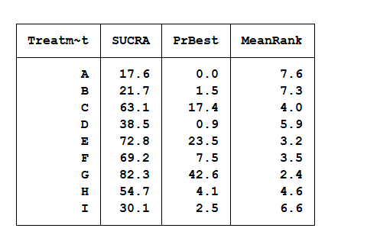

Appendix D Publication Bias Test

Appendix D1 Begg's and Egger's test results for inhibitory control
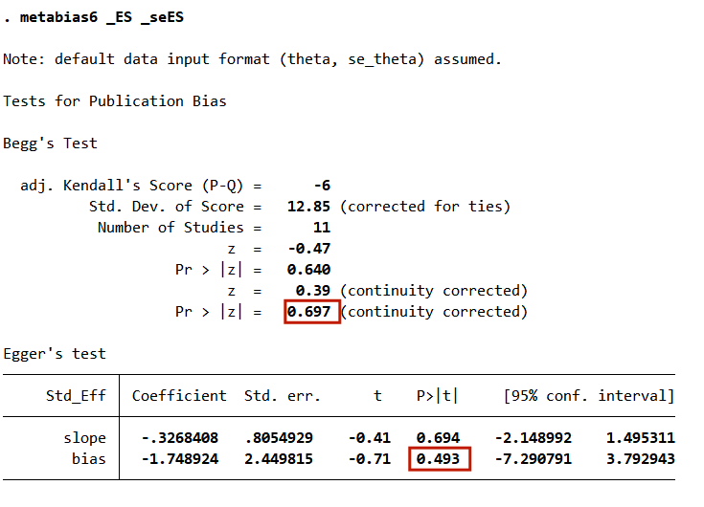

Appendix D2 Begg's and Egger's test results for working memory
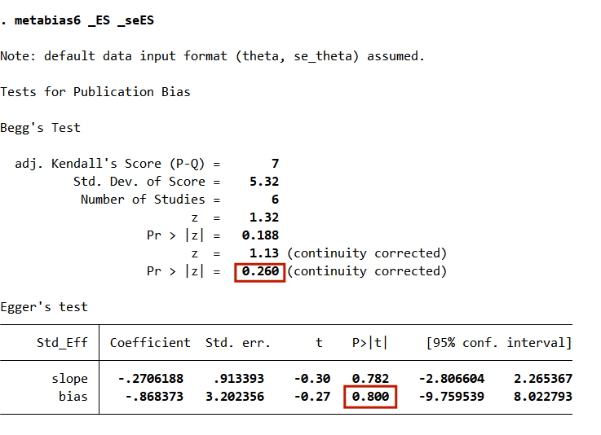

Appendix D3 Begg's and Egger's test results for cognitive flexibility
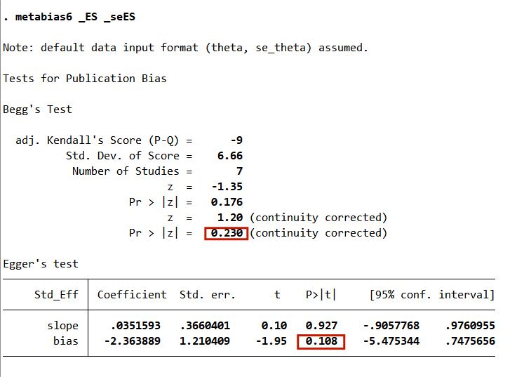

Appendix E Sensitivity analysis
Appendix E1 Results of sensitivity analysis on inhibitory control
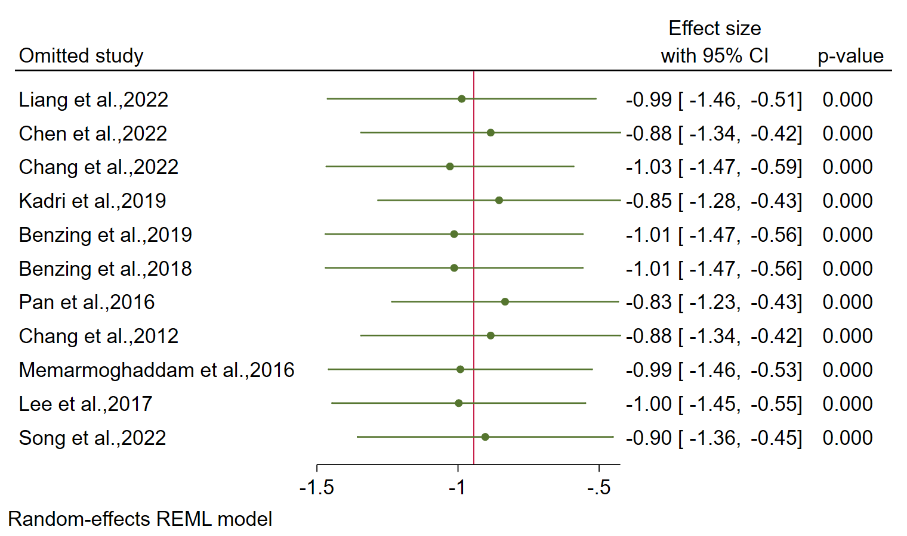
Appendix E2 Results of sensitivity analysis on working memory
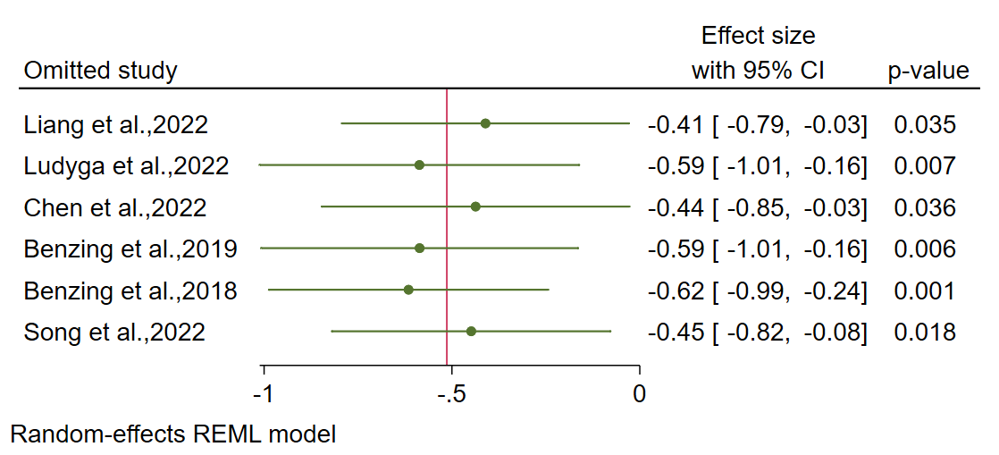
Appendix E3 Results of sensitivity analysis on cognitive flexibility
