BMC Microbiology
Supplementary materials
Enhanced nutrient uptake in side-row maize and improved microbial community diversity in wide-strip intercropping of maize and peanut
Xinhua Zhao¹†, Qiqi Dong¹†, Yi Han¹, Kezhao Zhang¹, Xiaolong Shi¹, Xu Yang¹, Yang Yuan¹, Dongying Zhou¹, Kai Wang¹, Xiaoguang Wang¹, Chunji Jiang¹, Xibo Liu¹, He Zhang¹, Zhimeng Zhang², Haiqiu Yu¹*
¹ Peanut Research Institute, Shenyang Agricultural University, Shenyang 110161, China;
² Shandong Peanut Research Institute, Qingdao 266100, Shandong, China;
† Xinhua Zhao and Qiqi Dong contributed equally to this work.
* Address Correspondence to Haiqiu Yu: yuhaiqiu@syau.edu.cn
Table S1 Effect of intercropped maize and peanut on the yield and yield components of maize and peanut in 2018 and 2019
Year | Plant |  | Ear length | Ear diameter | Number of grains per spike | Weight of 100 grains | Yield
2018 | Maize | IM | 20.40a | 17.38a | 760.60a | 191.13a | 15750.08a
2018 | Maize | MIM | 18.22b | 16.60a | 667.70b | 178.01ab | 15750.08a
2018 | Maize | SM | 18.66b | 16.80a | 653.60b | 171.21b | 12083.39b
2018 |  |  | Number of fruits per plant | Number of full fruit per plant | 100 kernel weight | Weight of 100 grains | Yield
2018 | Peanut | IP | 7.00a | 11.64b | 132.17a | 63.61b | 2239.59a
2018 | Peanut | MIP | 8.21a | 13.79b | 135.44a | 63.59a | 2239.59a
2018 | Peanut | SP | 12.00a | 17.60a | 136.94a | 65.52a | 2989.60a
2019 |  |  | Ear length | Ear diameter | Number of grains per spike | Weight of 100 grains | Yield
2019 | Maize | IM | 21.90a | 17.10a | 734.20ab | 183.76a | 16250.08a
2019 |  | MIM | 20.46b | 16.90a | 744.40a | 181.95ab | 16250.08a
2019 |  | SM | 18.20c | 16.20b | 666.00b | 166.03b | 13020.90b
2019 |  |  | Number of fruits per plant | Number of full fruit per plant | 100 kernel weight | Weight of 100 grains | Yield
2019 | Peanut | IP | 6.20a | 9.79a | 129.89b | 64.12 b | 1902.79a
2019 |  | MIP | 8.67a | 10.36a | 133.39a | 64.14 b | 1902.79a
2019 |  | SP | 7.27a | 8.08a | 134.59a | 66.76a | 1947.93a
Different letters indicate significant difference at 0.0, the following is the same.
Table S2 Changes of soil TN content under intercropping (mg/kg)
Stage | trumpeting stage | heading stage/ | anthesis and silking stage/ | grain filling stage/ | mature stage
Sample | trumpeting stage | seedling stage | flowering stage | podding stage | mature stage
IM | 7.39±0.15a | 6.63±0.37a | 5.62±0.19a | 4.93±0.54b | 2.31±0.7a
IP | 6.98±0.5a | 6.4±0.31a | 7.13±0.22a | 9.67±0.29a | 3.38±0.05a
II | 7.26±0.16a | 6.51±0.2a | 6.99±0.52a | 5.07±1.03b | 3.04±0.47a

Table S3 Changes of soil enzyme activities under intercropping
Sample | NR/(U/L) | Pro/(IU/L) | POD/(U/L) | DHO/(IU/L)
IM | 59.48±5.7a | 195.89±10.83a | 387.91±62.16a | 51.77±8.69a
IP | 57.3±1.89a | 193.62±3.32a | 375.83±19.86a | 50.79±1.88a
II | 58.76±7.35a | 195.99±2.69a | 376.82±34.86a | 67.23±2.61a
Table S4 Sowing and harvest dates of maize and peanuts
Year | Maize |  |  | Peanut
Year | Sowing | Harvest |  | Sowing | Harvest
2018 | 5.15 | 9.27 |  | 5.15 | 9.24
2019 | 5.12 | 9.25 |  | 5.12 | 9.20
Table S5 The initial soil properties of the experimental field
AN | AP | AK | SOC | PH
2100.7mg/kg | 27.5mg/kg | 117.9mg/kg | 15170mg/kg | 6.5
Table S6 Fertilizer application to sole and intercropping model
Fertilizer application of maize (kg/hm²) |  |  |  | Fertilizer application of peanut (kg/hm²)
N | P₂O₅ | K₂O |  | N | P₂O₅ | K₂O
202.5 | 97.5 | 112.5 |  | 105 | 129 | 112.5

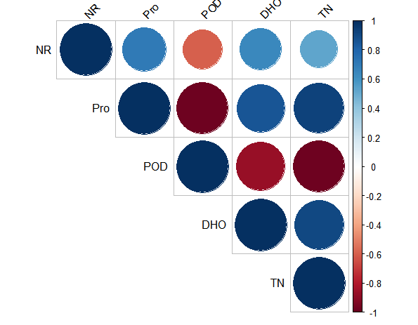
Figure S1. Correlation analysis of soil enzyme activity and soil TN
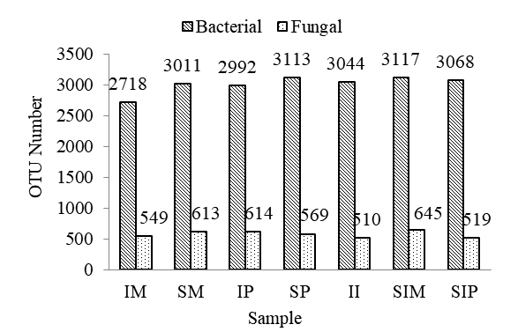
Figure S2. Number of observed operational taxonomic units (OTUs) of rhizosphere soil
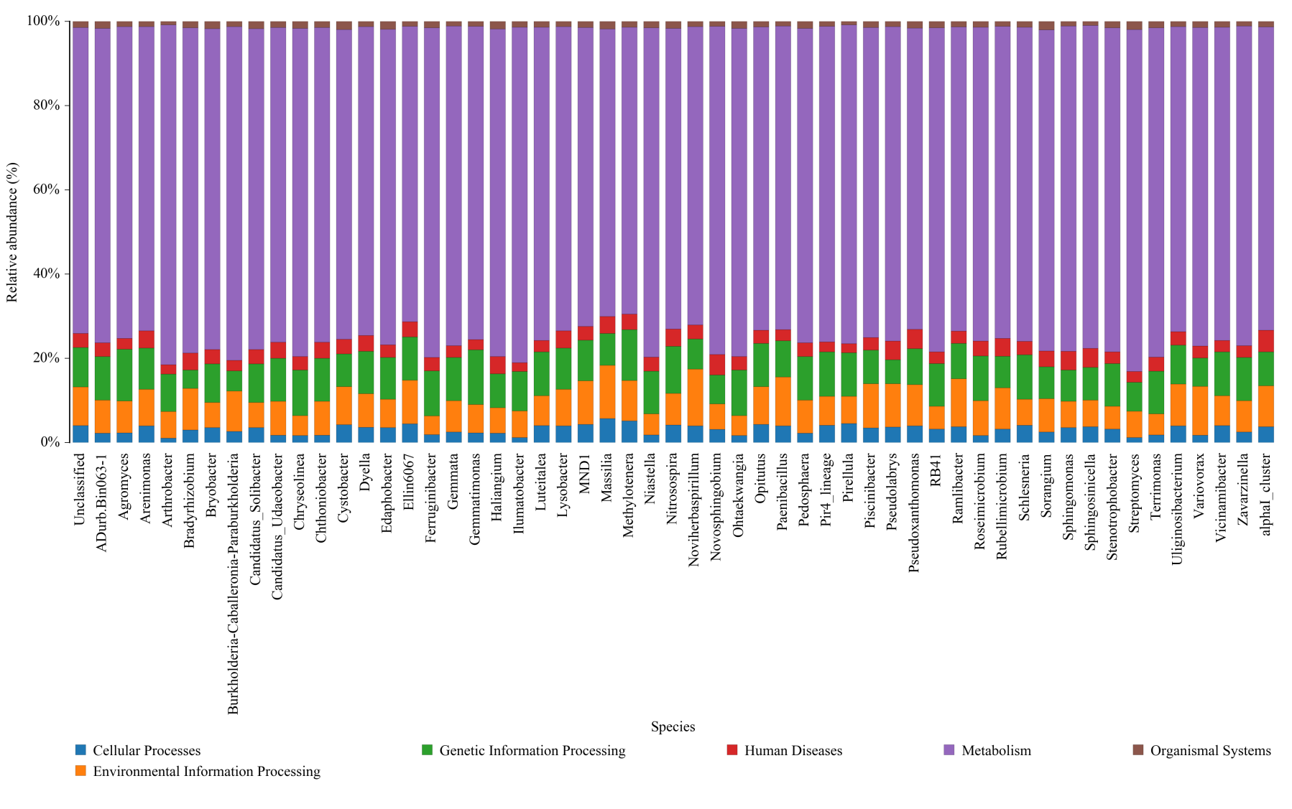

Figure S3 KEGG functional annotation of the first level bacterial community

