Original Images for Figure 2

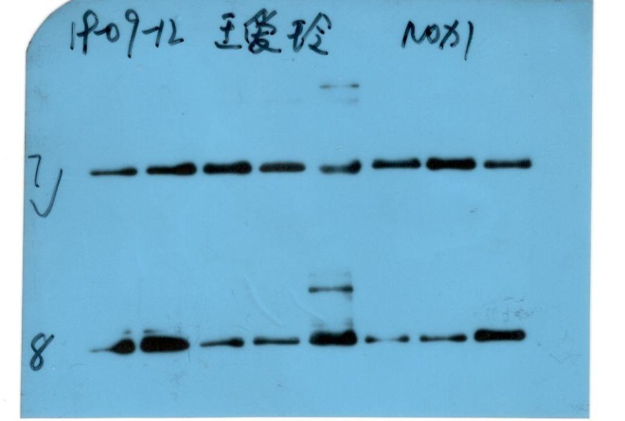
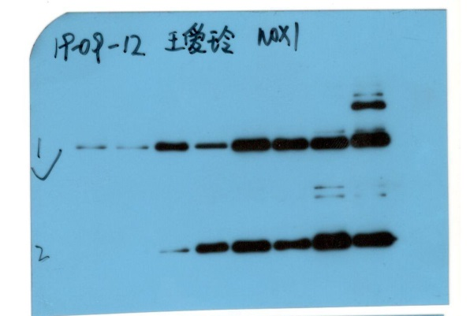

NOX2
NOX1

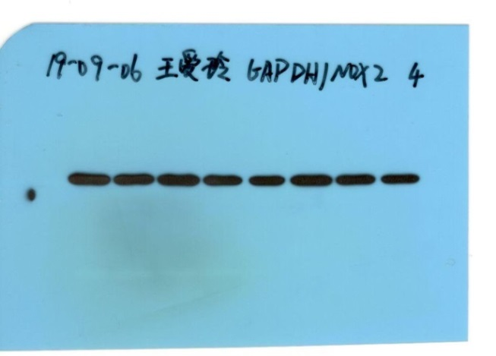
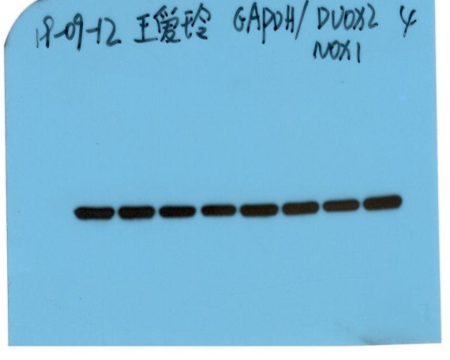

GAPDH
GAPDH

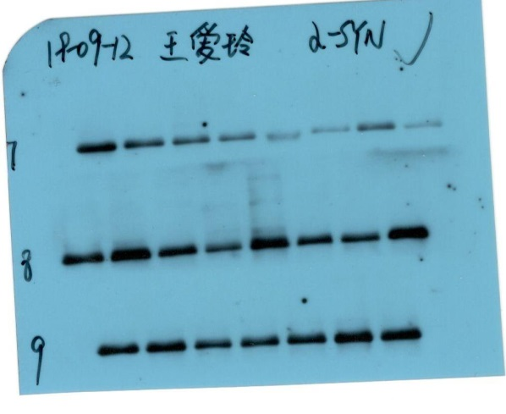
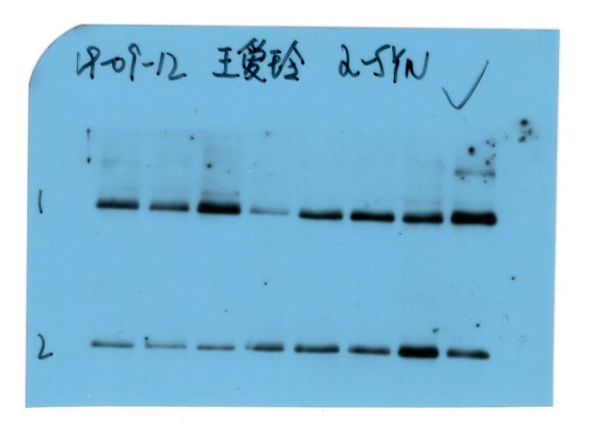

NOX4
DUOX2
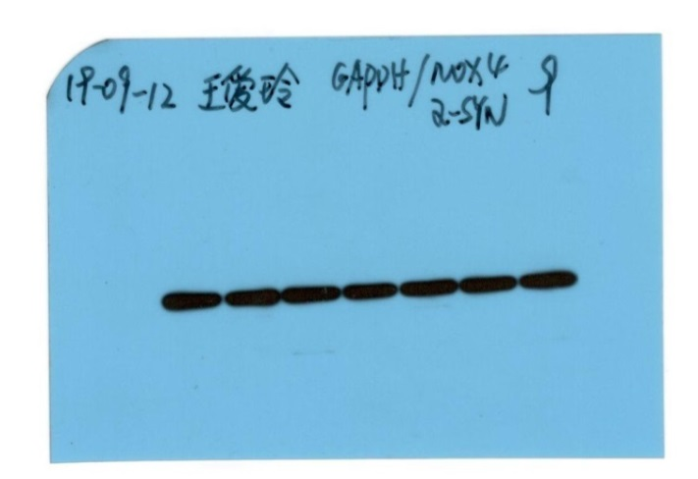

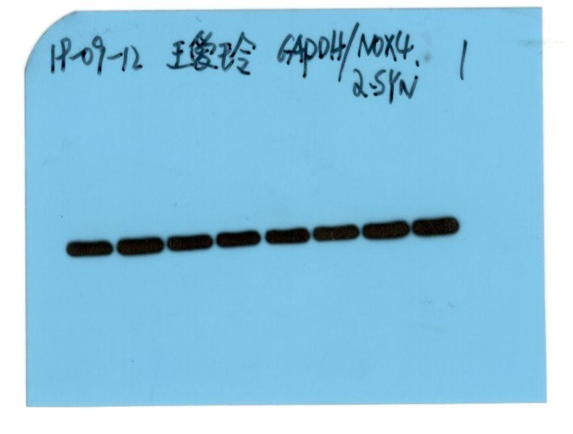

GAPDH
GAPDH

Figure 2. Western analysis of the protein levels of NADPH oxidases in colonic biopsies.
NOX1, DOUX2, NOX2 and NOX4 protein levels were analyzed in the colonic mucosa of constipation patients and control subjects. Representative images of eight samples were analyzed for each protein from both groups except seven samples were done for NOX4.

Note: In target protein images there were two or three line blot images on one picture because technician who performed the experiments put two or three jel images together after took the image one by one in order to quantify them easily, then not aware of the requirements of journal while publishing the results.

