Supplementary materials
Article title: Using optical sensors to assess the impact of infrequent sampling on the uncertainty of stream annual mean turbidity and total phosphorus concentrations, and how this can affect the water quality status
Journal name: Environmental Monitoring and Assessment
Authors:
Eva Skarbøvik^{(a)}, Anastasija Isidorova^{(a)}, Maria Kämäri^{(b)}, Pasi Valkama^{(b)}, Sofie G.M. van’t Veen^{(c)}, Emma E. Lannergård^{(d)}, Jens Fölster^{(d)}, and Brian Kronvang^{(e)}
Affiliations:
ªNorwegian Institute of Bioeconomy Research (NIBIO), Division of Environment and Natural Resources, P.O. Box 115, 1431 As, Norway
^{b}Finnish Environment Institute (Syke), Marine and freshwater solutions, Latokartanonkaari, 11, FI-00790 Helsinki, Finland
^{c}Aarhus University, Department of Ecoscience, C.F. Møllers Allé, DK-8000 Aarhus C, Denmark and Envidan A/S, Vejlsøvej, 23, DK-8600 Silkeborg, Denmark
^{d}Swedish University of Agricultural Sciences, Department of Aquatic Sciences and Assessment, PO Box 7050, 750 07 Uppsala, Sweden
^{e}Aarhus University, Department of Ecoscience, C.F. Møllers Allé 3, DK-8000 Aarhus C, Denmark

Corresponding author: Eva Skarbøvik, Norwegian Institute of Bioeconomy Research (NIBIO), Division of Environment and Natural Resources, P.O. Box 115, 1431 As, Norway
Mail address corresponding author: eva.skarbovik@nibio.no
Mail addresses to the co-authors:
Anastasija Isidorova: anastasija.isidorova@nibio.no
Maria Kämäri: maria.kamari@syke.fi
Pasi Valkama: Pasi.Valkama@syke.fi
Sofie Gyritia Madsen van't Veen: svv@ecos.au.dk
Emma Lannergård: emma.lannergard@slu.se
Jens Fölster: Jens.Folster@slu.se
Brian Kronvang: bkr@bios.au.dk

Supplementary tables

Table S-I Sensors used in the study, with measuring technique and range used
 | Sensor brand and type | Measuring technique | Range  (NTU/FNU)
SE | YSI 600OMV-VS, YSI EXO2, In Situ Aquatroll600 | Infrared light, 90° | 0-1000;  0-4000
NO | SEBA, MPS-D8 | Infrared light 90° | 0-3200
FI | S::CAN Spectrolyser 2mm and 5 mm | UV-VIS | 0-4000
DK | Hach, Solitax | Infrared light, 90° | 0.001-4000

Table S-II Methods for collecting water samples for calibration. NA: Not applicable
Country | Institute/data series | Automatic sampler (ISCO) | Hand grab samples | Event sampling (high water discharges) | Sampling at regular intervals (indicate interval) | Sampling site: High turbulence of water | Sampling site: Low turbulence of water | Good routines/site to avoid that ISCO draws bed/saltation sediments | Depth of sampling below surface | Sensor is placed in a monitoring shed, water is pumped in
DK | Lyby-Grønning | X | X | X | Monthly |  | X | yes | Ca. 15 cm | no
DK | Horndrup | X | X | X | Monthly |  | X | yes | Ca. 15 cm | no
FI | Aurajoki |  | X | X | No regular interval¹ |  | X | NA | 40 cm | no
FI | Hirvijoki |  | X | X | Monthly + event |  | X | NA | 40 cm | no
FI | Lepsämänjoki |  | X | X | Event based |  | X | NA | 15-50 cm from sensor depth | no
NO | Mørdre | X |  | X | Event samples | (x)* |  | yes | Ca 40 cm | no
NO | Skuterud | X |  | X | Event samples | (x)* |  | yes | Ca 30 cm | no
SE | Hågaån |  | X | X | 14 days + events | X |  | NA |  | No
SE | Skivarpsån |  | X | X | 14 days + events | X |  | NA |  | No
SE | Sävjaån |  | X |  | Monthly |  | X | NA |  | No
* Sampled near V-weir at the most turbulent site.

Table S-III Number of samples used to calibrate TP from turbidity in each stream
Country | Name | No of samples
DK | Horndrup | 113
DK | Lyby-Grønning | 86
Fi | Aurajoki | 107
FI | Hirvijoki | 65
FI | Lepsämänjoki | 211
NO | Mørdre | 155
NO | Skuterud | 214
SE | Hagaån | 137
SE | Skivarp | 125
SE | Sävjaån | 100

Table S-IV Analytical methods for determining TP
Rivers | Reference for analytical method TP (and uncertainty if available)
Horndrup  Lyby-Grønning | Danish standard DS/EN ISO 6878:2004
Aurajoki,  Hirvijoki  Lepsämänjoki | SFS 3026 mod. DA (uncertainty 15 %)
Mørdre  Skuterud | Norwegian standard NS-EN ISO 15681-2:2018 (Uncertainty 20-40 %).
Hågaån  Skivarpsån  Sävjaån | SS-EN ISO 6878:2005

Table S-V Estimated regression parameters, standard errors, t-values and p-values for Model 1
Independent variable | Slope | Std. error | t-value | Probability
n | -0.008413 | 0.001151 | -7.313 | <0.001
log10(Catchment area) | -0.101920 | 0.042909 | -2.375 | 0.02
Agricultural area% | 0.005200 | 0.001451 | 3.583 | <0.001
log10(Discharge per area) | 0.089529 | 0.104507 | 0.857 | 0.40
RBI | -0.206540 | 0.153381 | -1.347 | 0.19
log10(98 Cl turbidity) | 0.064381 | 0.064824 | 0.993 | 0.33
Intercept | 1.391436 | 0.250008 | 5.566 | <0.001
Multiple R2 | 0.79
Adjusted R2 | 0.75
F-statistic | 23.16
SEE | 0.1265
Observations | 45
Probability (p-value) | <0.001

Table S-VI Estimated regression parameters, standard errors, t-values and p-values for Model 2
Independent variable | Slope | Std. error | t-value | Probability
n | -0.00945164 | 0.00124997 | -7.562 | <0.001
Agricultural area % | 0.00660639 | 0.00101061 | 6.537 | <0.001
Catchment area | -0.00030467 | 0.00007724 | -3.944 | <0.001
Intercept | 1.38116544 | 0.07322614 | 18.862 | <0.001
Multiple R2 | 0.8013
Adjusted R2 | 0.7868
F-statistic | 55.11
SEE | 0.1337
Observations | 45
Probability (p-value) | <0.001

Table S-VII Correlations (R² and p-values) between turbidity and TP for the 10 streams. Streams with R²s in italic were not used in the assessment of the impact on sampling frequency on annual mean TP. Data for three years in each stream
Country | Name | R² | p-value
DK | Horndrup | 0.92 | 7,9 E-63
DK | Lyby-Grønning | 0.81 | 4,7 E-32
FI | Aurajoki | 0,77 | 1.1 E-35
FI | Hirvijoki | 0.82 | 4,4 E-25
FI | Lepsämänjoki | 0.85 | 5,6 E-87
NO | Mørdre | 0.53 | 7,5 E-27
NO | Skuterud | 0.66 | 3.2 E-51
SE | Hågaån | 0.40 | 2.0 E-16
SE | Sävjaån | 0.65 | 2,4 E-24
SE | Skivarp | 0.25 | 3,7 E-09

Table S-VIII Mean, maximum and standard deviation (StDev)of water discharge (Q), flashiness index (RBI); mean, maximum, standard deviation (StDev), outliers, 95 and 98 percentiles of turbidity (turb); and mean and maximum TP concentration in the water samples used for calibration. Data shown per year
 |  | Water discharge factors |  |  |  | Turbidity factors |  |  |  |  |  | TP in water samples
Name | Year | Mean  Q  l/s | Max  Q | StDev  Q | RBI | Mean  turb | Max  turb | StDev  turb | Outliers  turb | q95  turb | q98  turb | Mean  TP  µg/l | Max  TP  µg/l
Horndrup | 2020 | 55 | 1732 | 95 | 0.29 | 18 | 1343 | 57 | 1209 | 57 | 127 | 93 | 4196
Horndrup | 2021 | 48 | 835 | 51 | 0.28 | 17 | 821 | 40 | 1220 | 67 | 138 | 90 | 2581
Horndrup | 2022 | 46 | 1187 | 66 | 0.24 | 12 | 511 | 26 | 817 | 36 | 77 | 75 | 1620
Lyby-Grønning | 2020 | 80 | 1406 | 124 | 0.26 | 20 | 824 | 39 | 1046 | 77 | 128 | 164 | 3923
Lyby-Grønning | 2021 | 42 | 446 | 50 | 0.26 | 38 | 1109 | 112 | 1168 | 143 | 383 | 250 | 5260
Lyby-Grønning | 2022 | 45 | 700 | 77 | 0.26 | 20 | 963 | 46 | 1272 | 82 | 151 | 167 | 4577
Hirvijoki | 2018 | 890 | 17310 | 1471 | 0,25 | 13 | 170 | 16 | 614 | 43 | 63 | 84 | 564
Hirvijoki | 2019 | 2220 | 38200 | 4426 | 0.38 | 16 | 498 | 22 | 684 | 44 | 71 | 94 | 1564
Hirvijoki | 2021 | 1932 | 26240 | 3045 | 0.32 | 28 | 828 | 26 | 686 | 68 | 87 | 130 | 2567
Lepsämänjoki | 2018 | 162 | 2551 | 264 | 0.26 | 35 | 489 | 35 | 2045 | 101 | 150 | 81 | 630
Lepsämänjoki | 2019 | 253 | 3643 | 374 | 0.29 | 34 | 1033 | 31 | 1061 | 84 | 111 | 79 | 1290
Lepsämänjoki | 2020 | 343 | 3223 | 393 | 0.35 | 53 | 1022 | 52 | 1411 | 134 | 208 | 102 | 1277
Aurajoki | 2018 | 3719 | 57521 | 6969 | 0.31 | 22 | 216 | 19 | 616 | 63 | 76 | 135 | 560
Aurajoki | 2019 | 9062 | 112031 | 14325 | 0.32 | 28 | 436 | 32 | 637 | 91 | 120 | 149 | 1041
Aurajoki | 2021 | 6971 | 64186 | 8641 | 0.32 | 34 | 215 | 23 | 338 | 75 | 91 | 163 | 557
Mørdre | 2019 | 97 | 2257 | 209 | 0.63 | 167 | 3210 | 383 | 1101 | 594 | 1428 | 381 | 1881
Mørdre | 2021 | 62 | 1466 | 116 | 0.48 | 138 | 3210 | 291 | 1083 | 521 | 1246 | 367 | 1881
Mørdre | 2022 | 27 | 2212 | 100 | 0.74 | 110 | 2905 | 179 | 709 | 360 | 630 | 353 | 1731
Skuterud | 2020 | 111 | 3339 | 238 | 0.68 | 62 | 2292 | 113 | 900 | 210 | 379 | 140 | 2038
Skuterud | 2021 | 54 | 3059 | 162 | 0.52 | 41 | 1610 | 67 | 1258 | 156 | 199 | 122 | 1457
Skuterud | 2022 | 49 | 3146 | 170 | 0.74 | 28 | 744 | 49 | 873 | 96 | 160 | 111 | 721
Hågaån | 2019 | 1110 | 8199 | 1749 | 0.11 | 62 | 1291 | 84 | 479 | 183 | 305 | 89 | 847
Hågaån | 2020 | 547 | 3285 | 559 | 0.10 | 35 | 460 | 30 | 613 | 99 | 129 | 73 | 334
Hågaån | 2023 | 1759 | 14541 | 2510 | 0.13 | 39 | 386 | 40 | 749 | 109 | 179 | 75 | 289
Skivarp | 2019 | 949 | 5824 | 1206 | 0.18 | 12 | 162 | 17 | 787 | 48 | 71 | 124 | 422
Skivarp | 2020 | 671 | 5815 | 964 | 0.15 | 14 | 300 | 22 | 568 | 43 | 83 | 129 | 694
Skivarp | 2022 | 900 | 7807 | 1452 | 0.16 | 17 | 620 | 36 | 849 | 62 | 124 | 134 | 1327
Sävjaån | 2016 | 1928 | 7324 | 1922 | 0.05 | 17 | 449 | 27 | 356 | 37 | 62 | 58 | 609
Sävjaån | 2017 | 2935 | 13550 | 3350 | 0.04 | 14 | 126 | 13 | 598 | 41 | 49 | 54 | 197
Sävjaån | 2019 | 4585 | 31160 | 6488 | 0.06 | 11 | 76 | 15 | 997 | 50 | 62 | 50 | 133

Supplementary figures

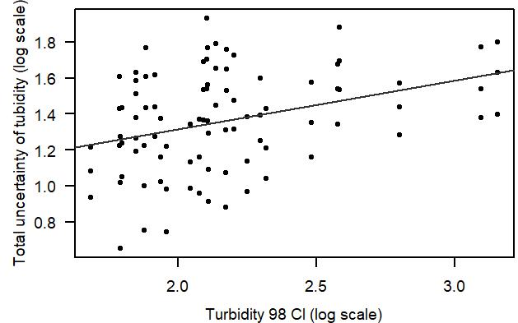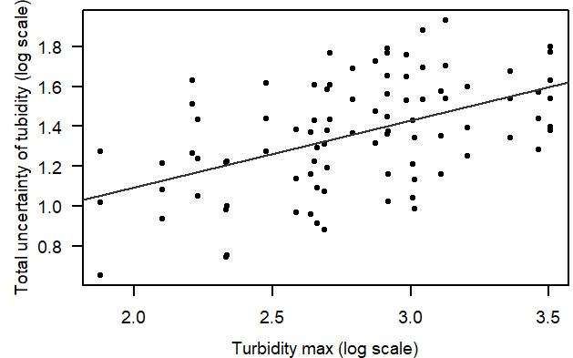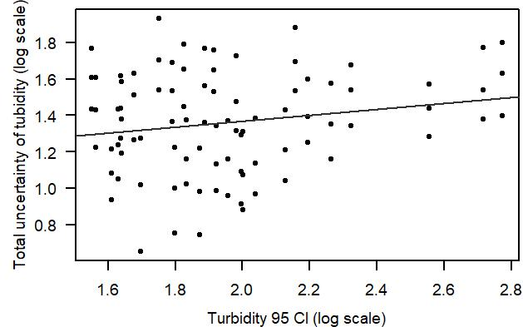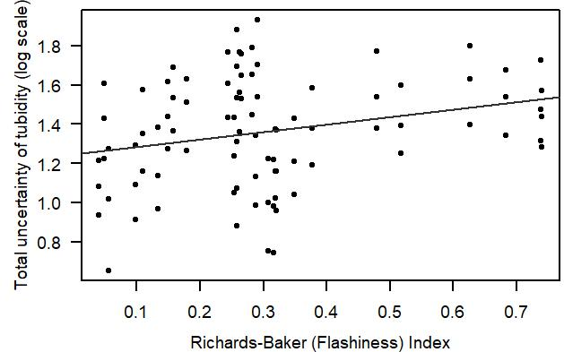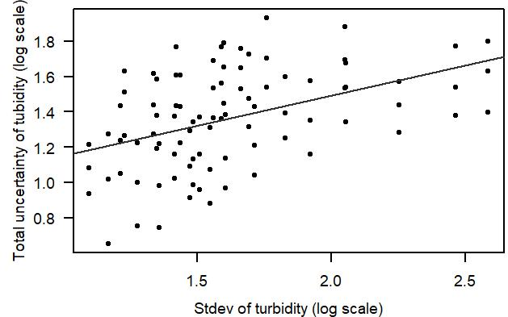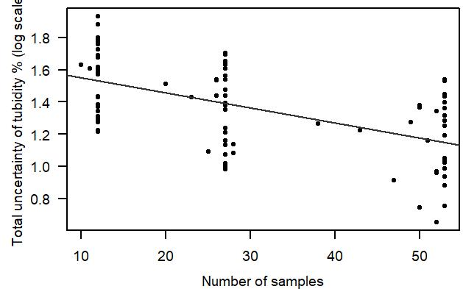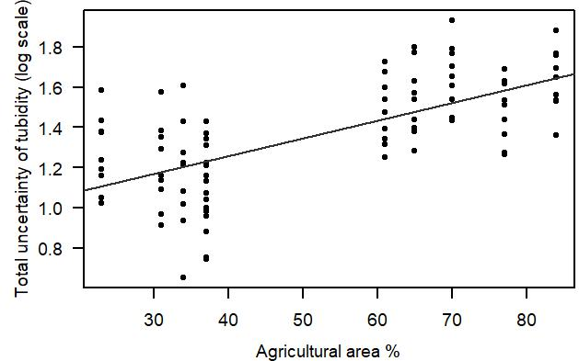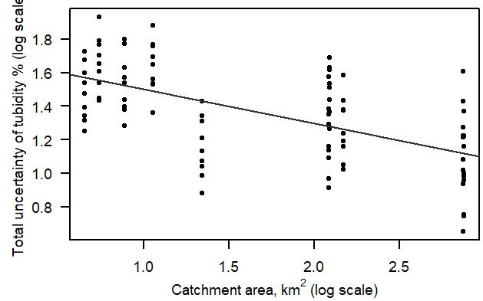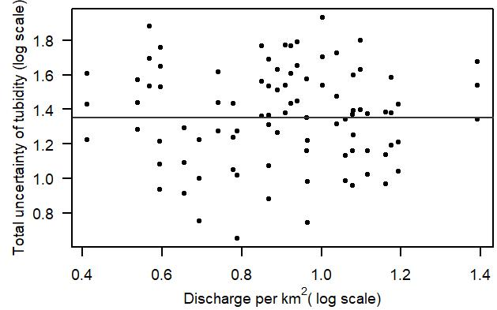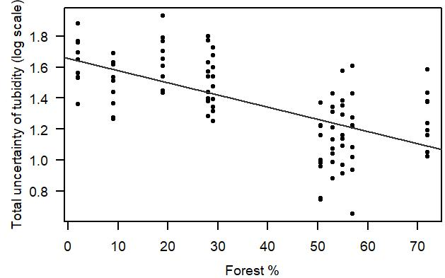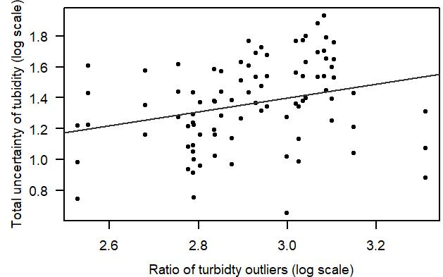
Figure S-I Calibrations between total uncertainty and tested possible explanatory factors

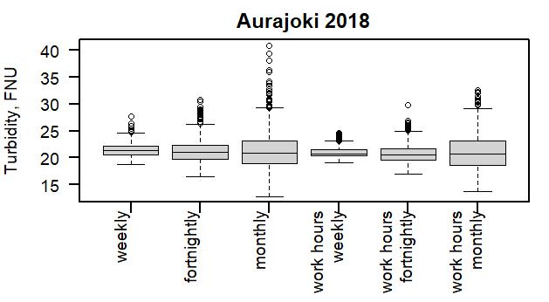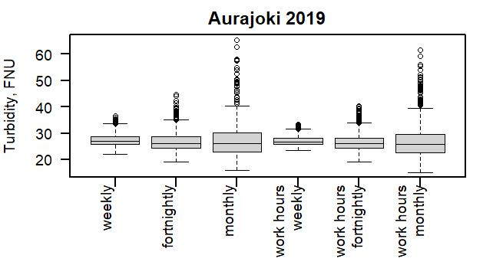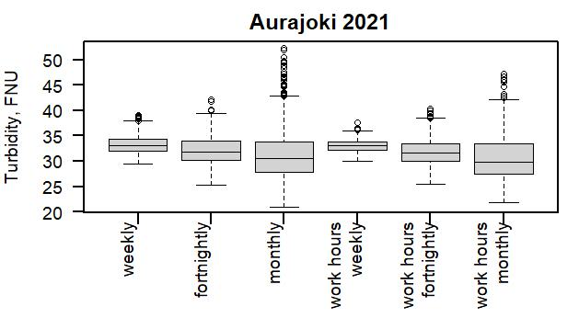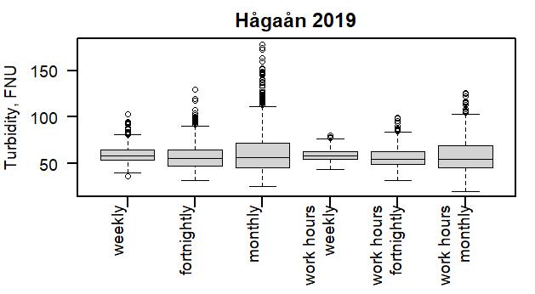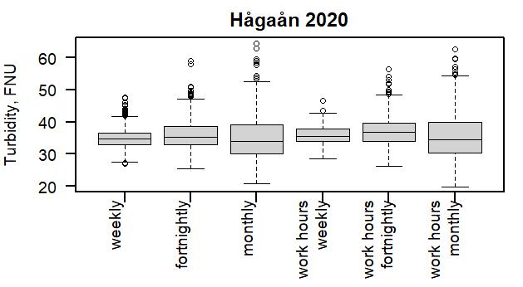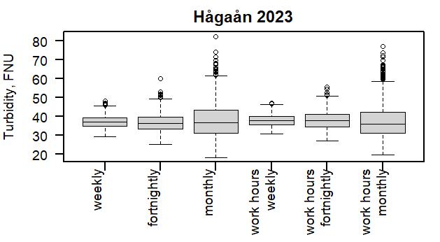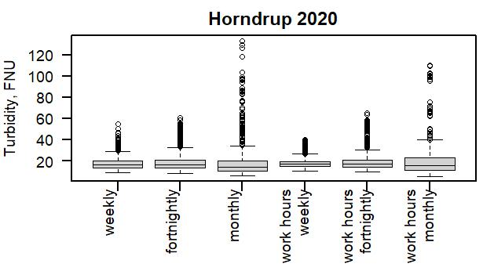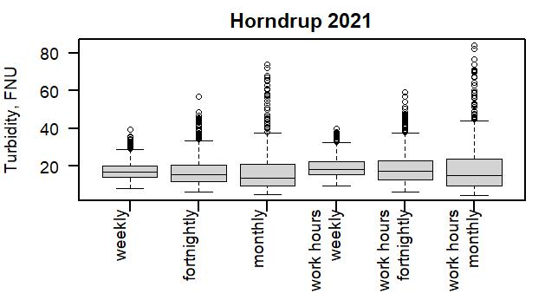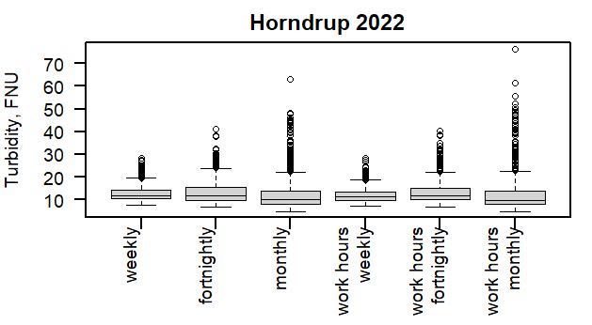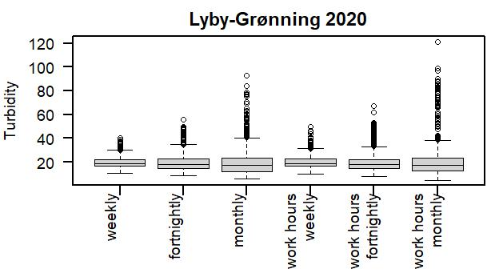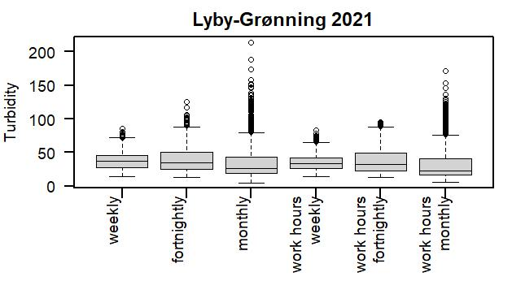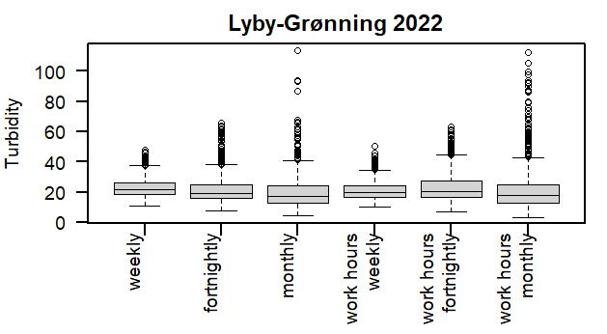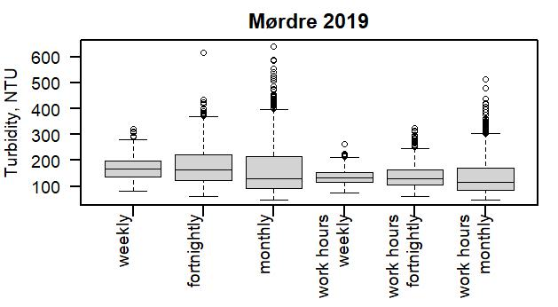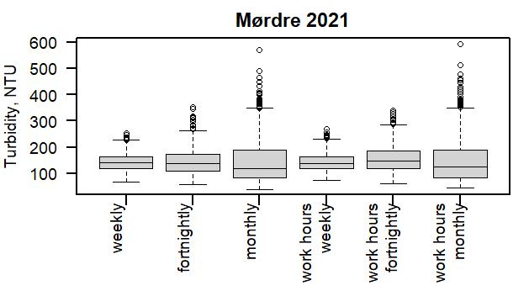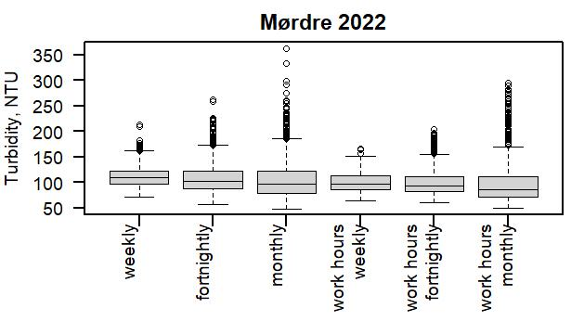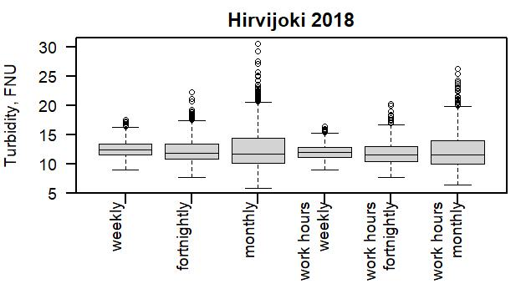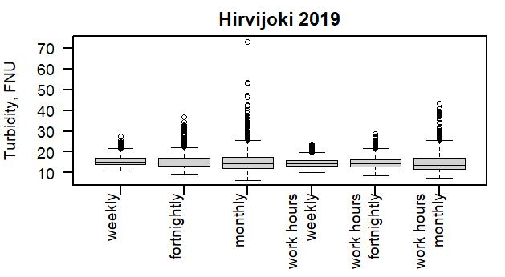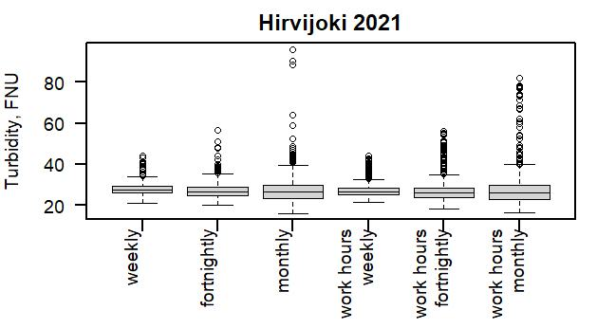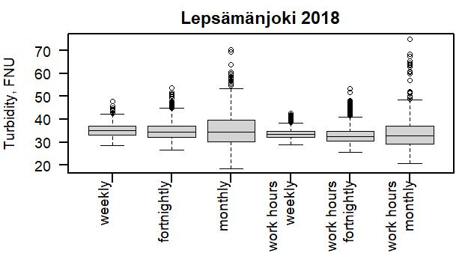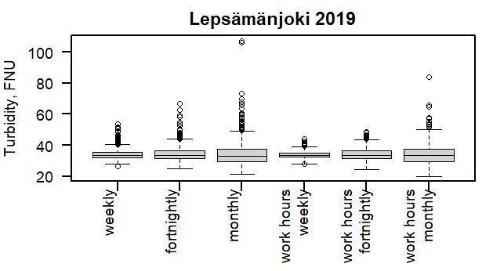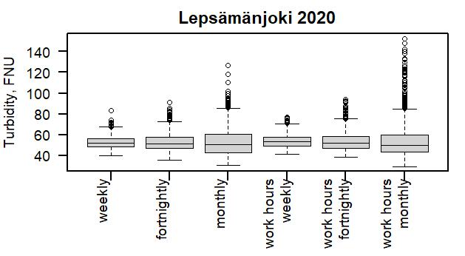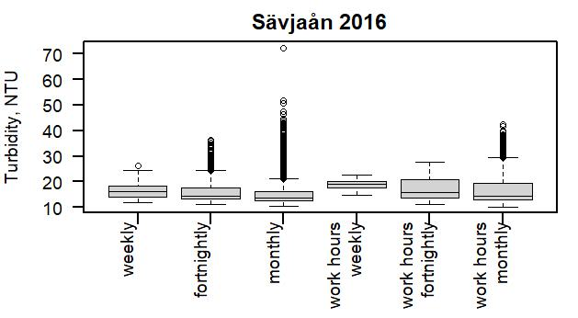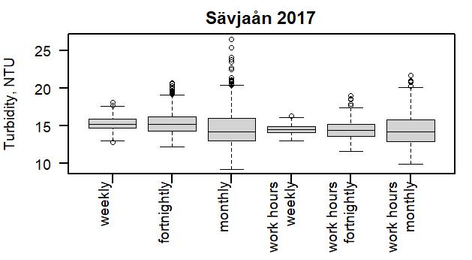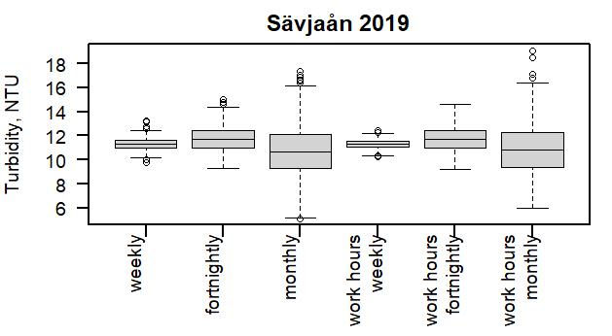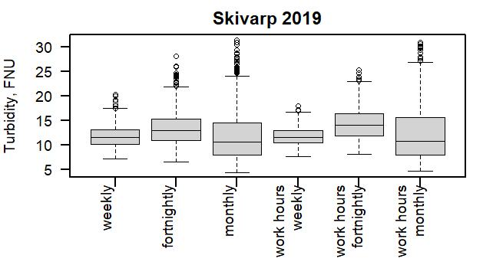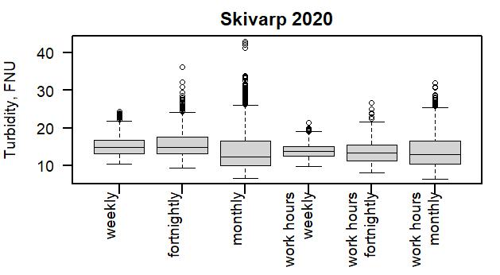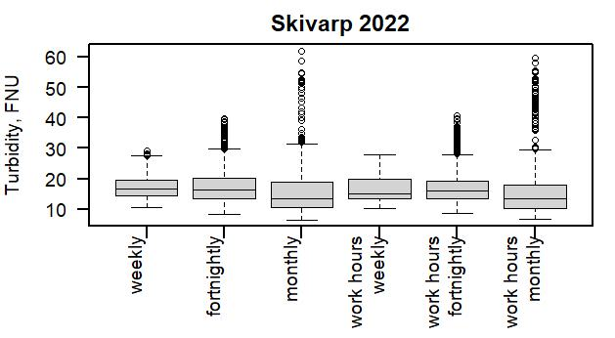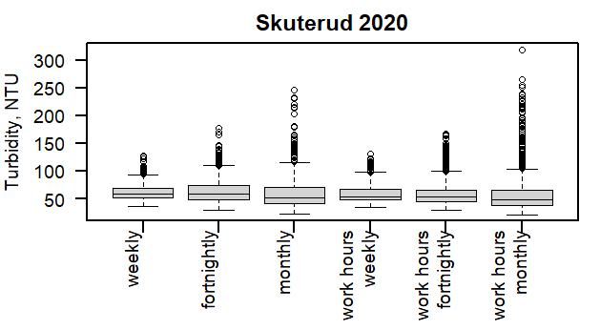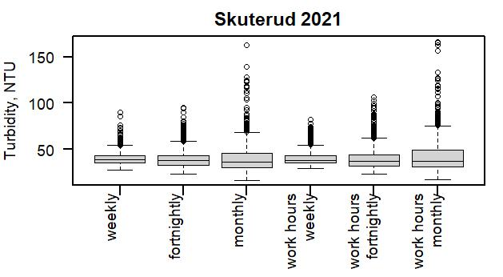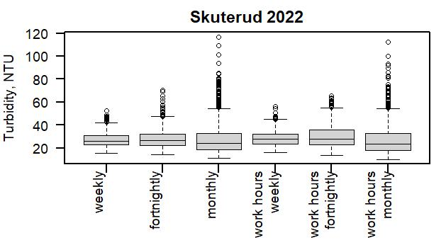
Figure S-II Mean turbidity, range for all streams and years. The grey boxes show the standard deviation, the horizontal line within the grey boxes represents the median value, and the vertical dashed lines show the maximum and minimum values
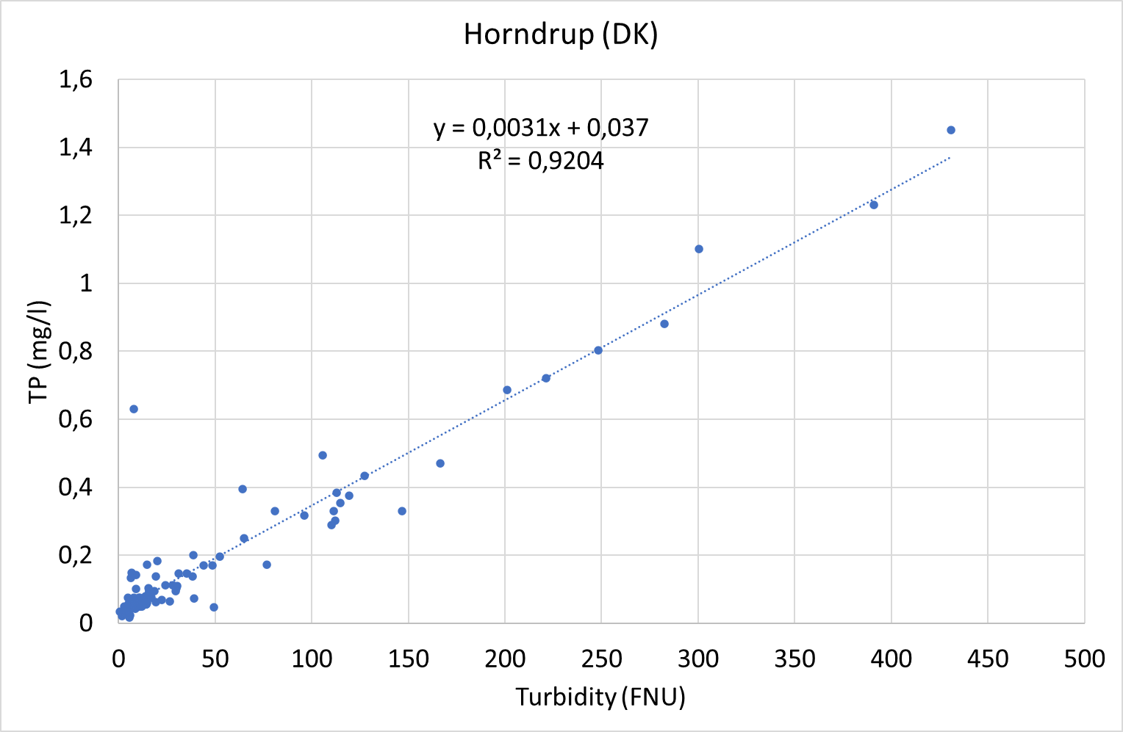 | 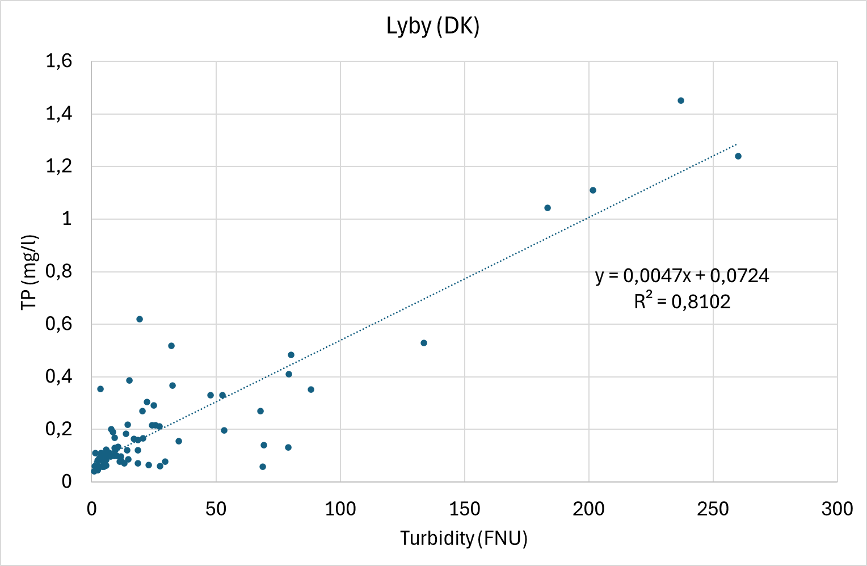
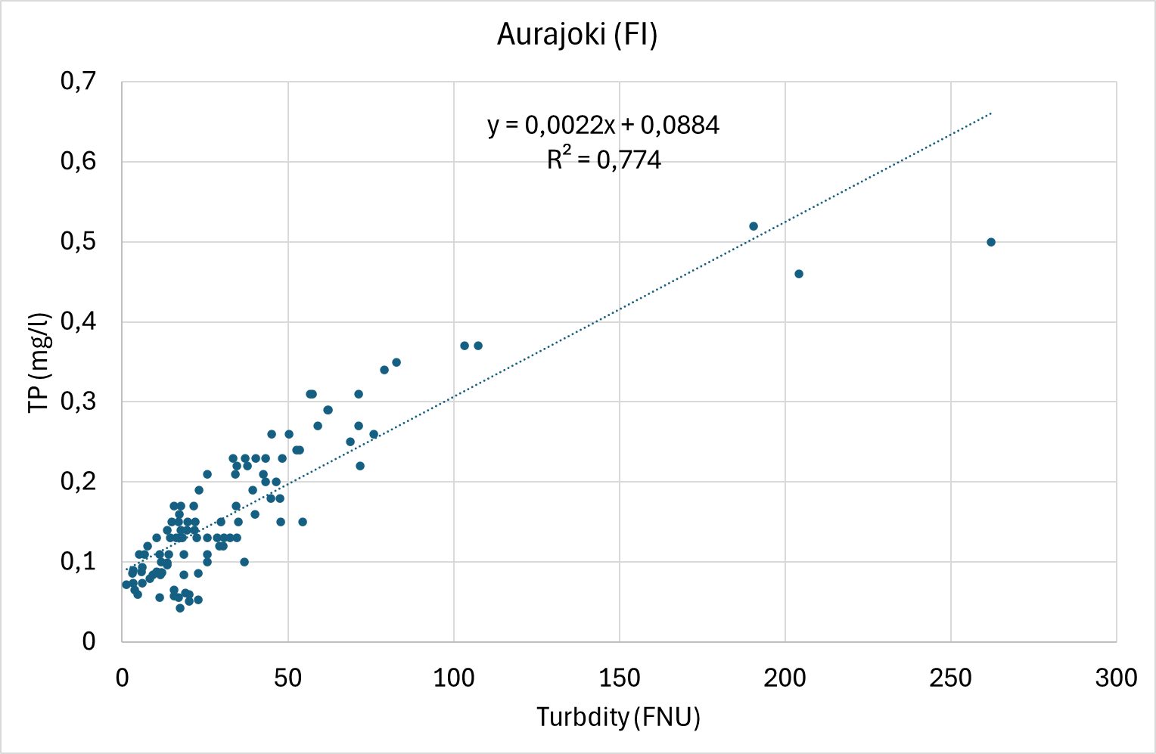 | 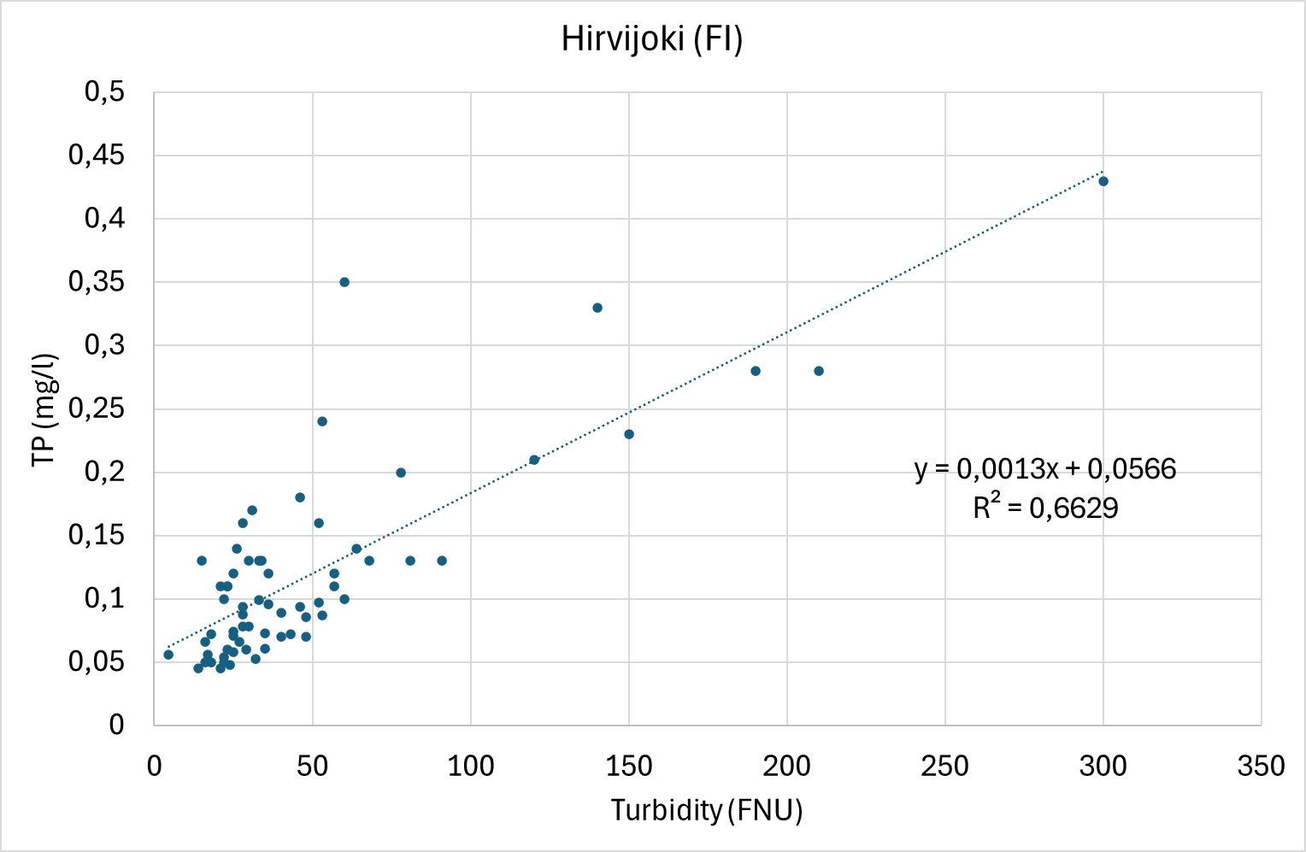
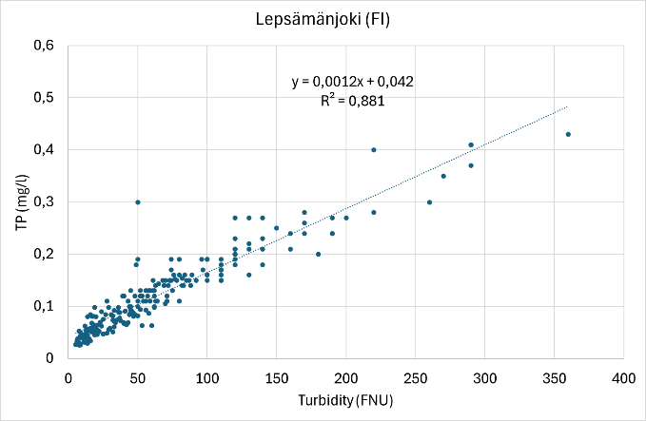 | 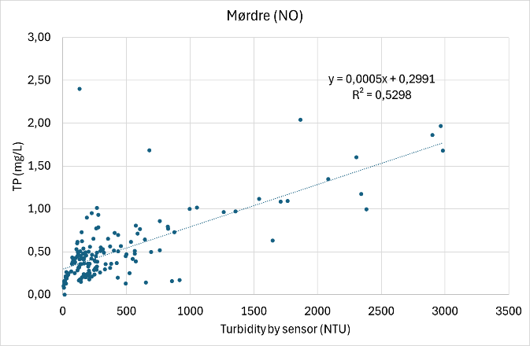
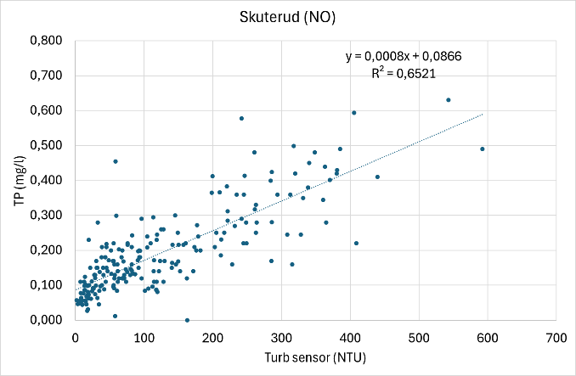 | 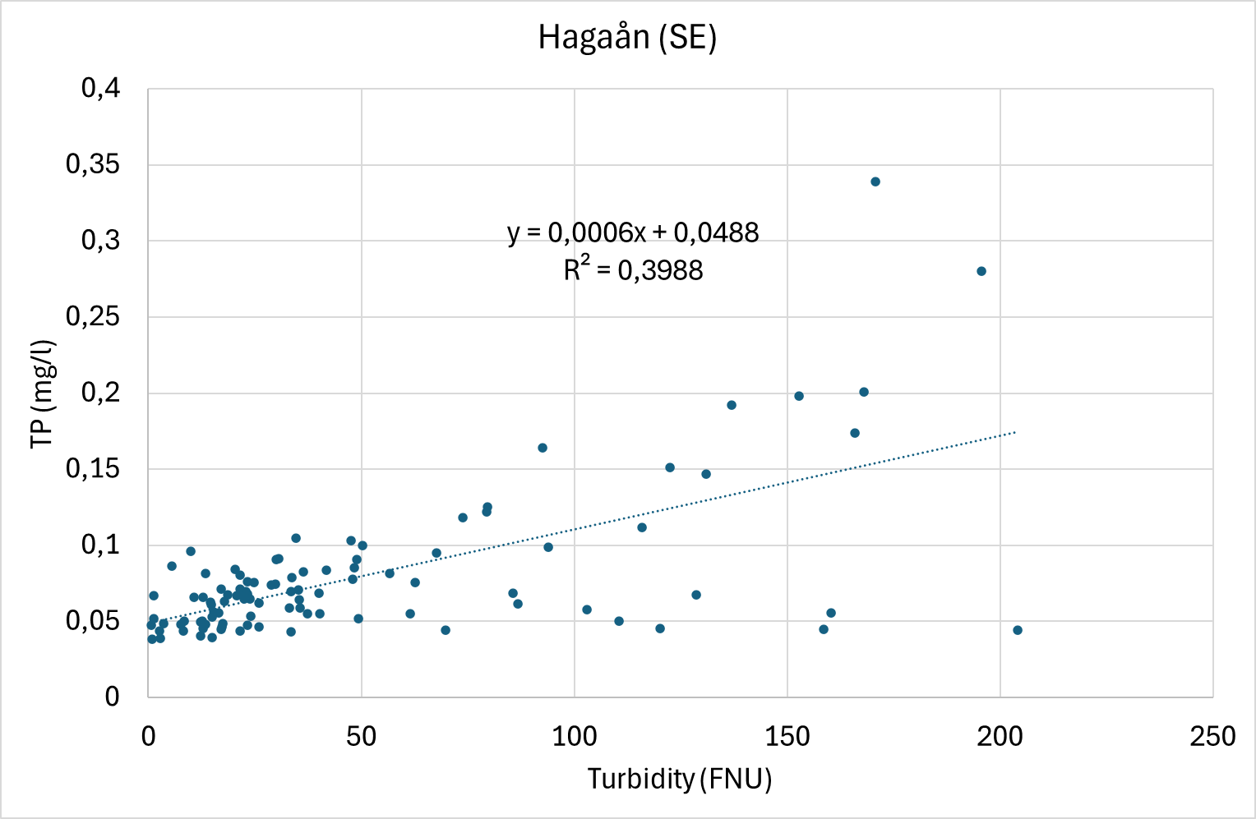
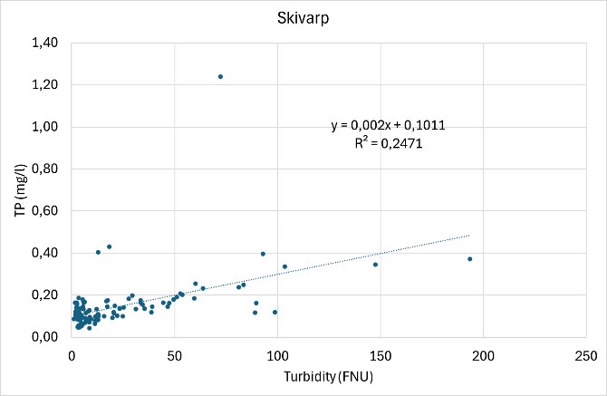 | 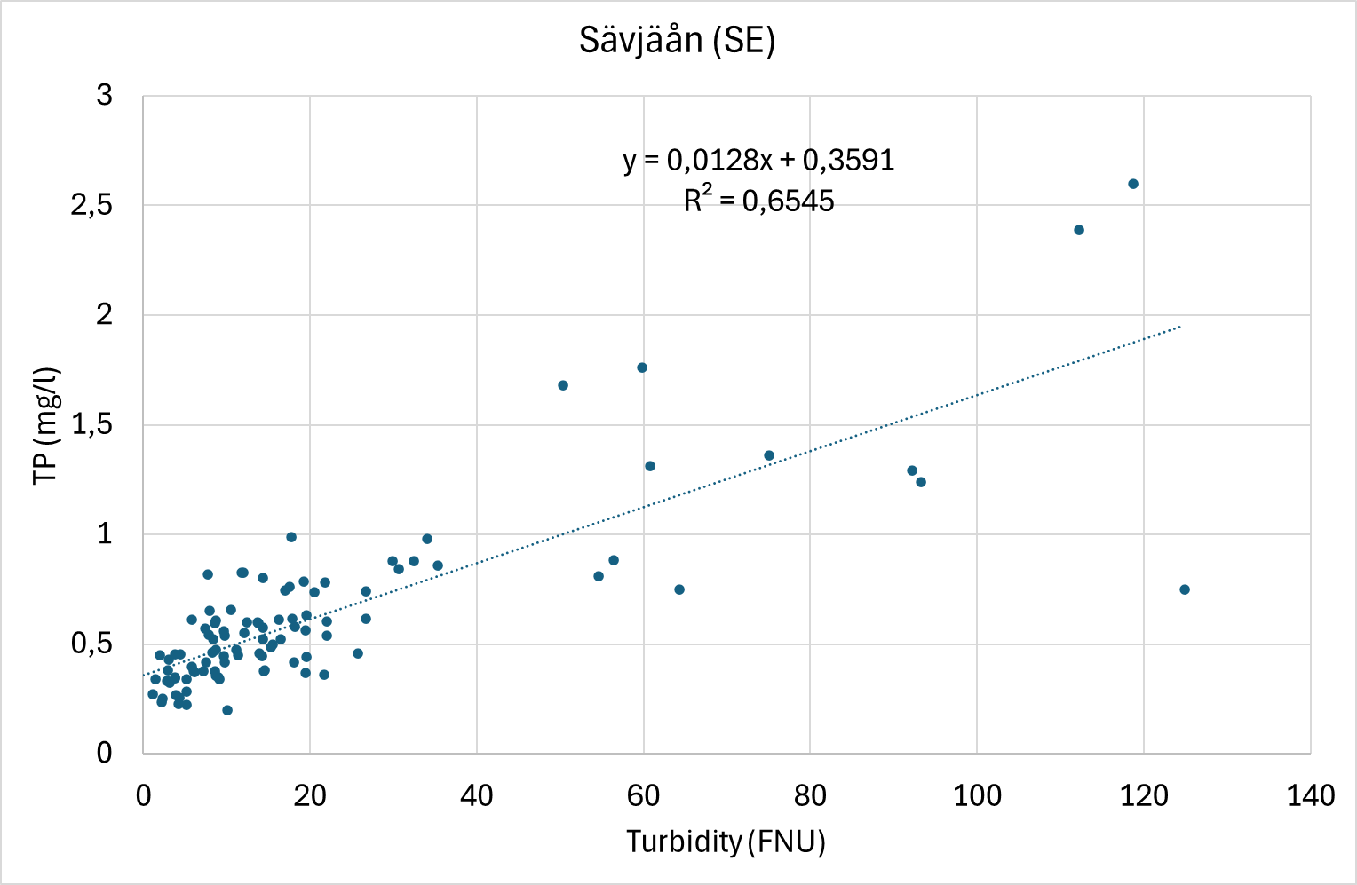

Figure S-III Calibrations, equations and R²s between turbidity by sensor (x-axis) and TP-concentrations from grab samples (y-axis) for the 10 case streams

