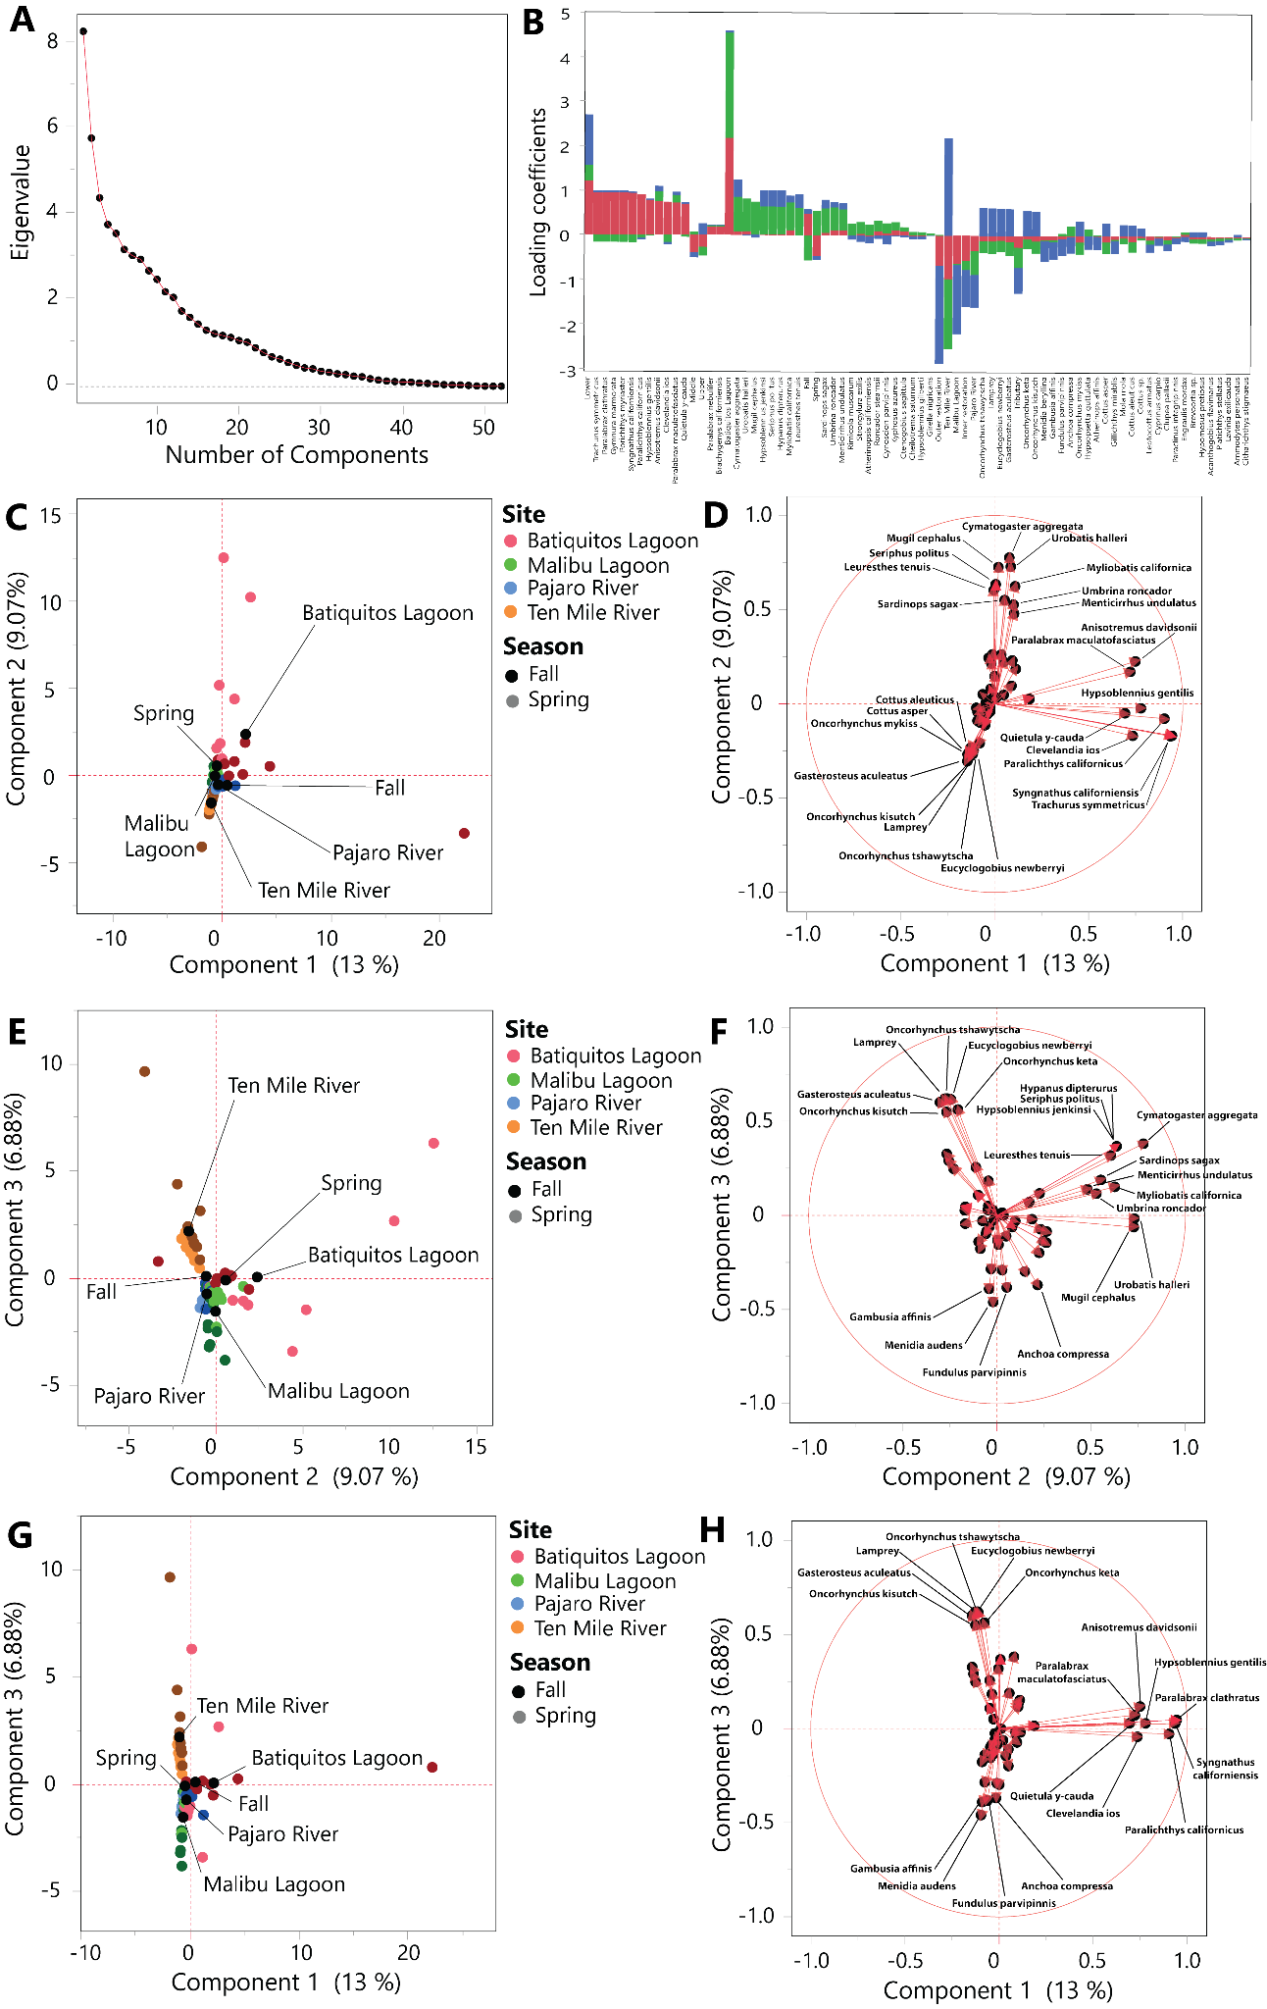

Sup 4 Figure 1. Principal components analysis (PCA) of eDNA species data (on previous page). A shows a scree plot, with dots representing eigenvalues at various numbers of principal components. B is a stacked bar graph displaying the loading coefficients for each species on the first three components, with Component 1 represented in red, Component 2 represented in green, and Component 3 represented in blue. C, E, and G plot the location of eDNA samples in relation to Components 1 and 2, Components 2 and 3, and Components 1 and 3, respectively. Colors separate samples by site, while values (darker and lighter) separate samples by season. Labeled points in black correspond to the values of two supplementary (Z) variables, site, station, and season. D, F, and G display the loadings of species on biplots for Components 1 and 2, Components 2 and 3, and Components 1 and 3, respectively.

We used JMP to run a PCA on our eDNA species data using default settings, adding sample site and season as supplementary variables. We focused on the first three components of this analysis according to the appearance of our scree plot (Sup 4 Fig 1A). Component 1 appeared to relate to latitude, contrasting more southern-associated species in our data (e.g. Anisotremus davidsonii, Hypsoblennius gentilis, Syngnathus californiensis) with more northern ones (e.g. Cottus asper, Cottus aleuticus, Oncorhynchus spp.) (Sup 4 Fig 1B, D, H). Supplementary variable plots support this, with samples from Batiquitos Lagoon and Ten Mile River being most opposed on Component 1 (Sup 4 Fig 1C, G). Component 2 appeared to relate to a combination of latitude and season, contrasting southern, spring-associated species (e.g. Mugil cephalus, Cymatogaster aggregata, Urobatis halleri) against northern, fall-associated species (e.g. Eucyclogobius newberryi, Oncorhynchus spp., lamprey) (Sup 4 Fig 1B, D, F). Consistent with this, supplementary variable plots separate spring Batiquitos samples from Ten Mile samples generally. Component 3 appeared to relate to Ten Mile’s differences from Pajaro River and Malibu Lagoon, contrasting northern taxa (e.g. Oncorhynchus spp., lamprey, E. newberryi) to those more associated with the mid or southern coast (e.g. Gambusia affinis, Menidia audens, Fundulus parvipinnis) (Sup 4 Fig 1B, F, H). This difference may reflect that Ten Mile is less impacted by human activity than Pajaro and Malibu, as it has MPA protection and low levels of eutrophication compared to the latter two sites. While Batiquitos has similar protections, its urban location makes it more impacted than Ten Mile, potentially explaining why it does not load as positively on the same axis (Sup 4 Fig 1G).

Species | NMDS1 | NMDS2 | NMDS3 | NMDS4
Acanthogobius flavimanus | -0.180023329 | -0.35486424 | 1.431521051 | -0.524771434
Ammodytes personatus | -1.780429715 | 0.805806736 | 0.306787195 | 1.106332819
Anchoa compressa | 0.688797538 | -0.310754703 | -0.98802972 | 0.377621769
Anisotremus davidsonii | 1.404267469 | 1.49342145 | 0.297964807 | 0.067715518
Atherinops affinis | 0.276284499 | -0.632904843 | 0.393461057 | 0.504242352
Atherinopsis californiensis | 0.547867605 | -0.558842168 | 0.076656587 | -0.559691744
Brachygenys californiensis | 1.859325642 | 1.740724954 | 0.437210815 | 0.683292519
Brevoortia sp. | -1.66311356 | 1.020562688 | 0.219915002 | -0.769479225
Cheilotrema saturnum | 1.579011399 | 0.198909834 | -0.774037363 | -0.336944734
Citharichthys stigmaeus | 0.994875273 | 0.410631521 | 0.025162227 | -1.833771203
Clevelandia ios | -0.234588582 | -0.711390953 | 0.587281122 | 0.523105617
Clupea pallasii | -0.363098147 | -0.552127833 | 1.23586457 | -0.413961606
Cottus aleuticus | -1.348523223 | 0.583608535 | -0.065915461 | -0.655875171
Cottus asper | -1.403781142 | 0.481468785 | -0.043040462 | -0.475558154
Cottus sp. | -0.966979799 | 1.012411107 | -0.538175344 | 0.706714259
Ctenogobius sagittula | 1.575477455 | 1.646214757 | -0.702563262 | 0.070649304
Cymatogaster aggregata | -0.032372244 | 0.343877337 | 0.369754414 | -0.068627183
Cynoscion parvipinnis | 1.144121947 | 0.415478296 | -0.724497573 | 0.792161996
Cyprinus carpio | 0.644050427 | -0.727091493 | -0.016277997 | -0.256603645
Lamprey | -1.323888157 | 0.644598359 | -0.476994493 | 0.33050994
Engraulis mordax | 0.585189975 | -0.339416747 | 0.444793294 | 0.379112708
Eucyclogobius newberryi | -0.618978689 | 0.411405009 | -0.479336844 | 0.817382763
Fundulus parvipinnis | 0.417800897 | -0.566868297 | -0.879635202 | -0.262201389
Gambusia affinis | 0.13154566 | -0.69910457 | -1.186915378 | -0.085577731
Gasterosteus aculeatus | -1.390228942 | 0.350227987 | -0.086874255 | 0.143862305
Gillichthys mirablis | 0.281411176 | -0.657388814 | -0.72782789 | 0.04540951
Girella nigricans | 0.512569359 | 1.513426057 | 0.131978208 | 0.385290832
Gymnura marmorata | 0.592863575 | 1.202554526 | 0.727785273 | 1.012120251
Hypanus dipterurus | 0.867549185 | 0.92348098 | -0.118808504 | -1.133855106
Hypomesus pretiosus | -1.66311356 | 1.020562688 | 0.219915002 | -0.769479225
Hypsoblennius gentilis | 1.626521782 | 1.179486712 | 0.929561902 | 0.083597303
Hypsoblennius gilberti | 1.579011399 | 0.198909834 | -0.774037363 | -0.336944734
Hypsoblennius jenkinsi | 0.867549185 | 0.92348098 | -0.118808504 | -1.133855106
Hypsopsetta guttulata | 0.775495977 | -0.234086481 | -1.065015551 | 0.333108693
Kyphosus azureus | 1.48097879 | 0.917384497 | -0.048297658 | -0.112203442
Lavinia exilicauda | -0.489862077 | -0.871958301 | 1.568346322 | -0.432701494
Leptocottus armatus | -0.13303322 | -0.685445438 | 0.708646624 | -0.174016544
Leuresthes tenuis | 0.289455931 | -0.44606416 | 0.174504729 | -0.308625803
Menidia audens | 0.290834121 | -0.667104816 | -0.924960457 | -0.215469296
Menticirrhus undulatus | 0.660234389 | 1.356125648 | 0.106583007 | 0.103914427
Mola mola | -1.136136688 | 0.634099583 | -0.529334101 | 1.19568747
Mugil cephalus | 0.841752363 | -0.243144299 | -0.232259276 | -0.136975161
Myliobatis californica | 1.139958686 | 0.490594084 | -0.234752485 | -0.144195307
Oncorhynchus keta | -1.409051067 | 0.534997572 | -0.327586862 | 1.399667312
Oncorhynchus kisutch | -1.53835849 | 0.322814282 | -0.262287881 | 0.334380835
Oncorhynchus mykiss | -1.400890765 | 0.531017898 | -0.146474917 | -0.356230822
Oncorhynchus tshawytscha | -1.361802624 | 0.698221496 | -0.126484171 | 0.786695747
Paraclinus integripinnis | 0.624070828 | -0.968544509 | 0.031393039 | -0.142265973
Paralabrax clathratus | 0.592863575 | 1.202554526 | 0.727785273 | 1.012120251
Paralabrax maculatofasciatus | 1.595547729 | 1.740299897 | 0.287906994 | 0.151714519
Paralabrax nebulifer | 1.859325642 | 1.740724954 | 0.437210815 | 0.683292519
Paralichthys californicus | 0.848632983 | 0.837371825 | 0.053964171 | 0.910065397
Platichthys stellatus | -0.008744818 | -0.135853592 | 0.989822801 | 0.590939489
Porichthys myriaster | 0.592863575 | 1.202554526 | 0.727785273 | 1.012120251
Quietula y-cauda | 1.38473188 | 0.958490233 | 0.303680173 | 0.462190303
Sup 4 Table 1. Loadings for each species on NMDS axes.

Species | NMDS1 | NMDS2 | NMDS3 | NMDS4
Rimicola muscarum | 1.202279547 | 0.202573771 | -0.177993401 | -1.060982069
Roncador stearnsii | 1.420186856 | 0.696824387 | -0.462408756 | 0.030396958
Syngnathus californiensis | 0.401929647 | 0.071668502 | 0.430248263 | 1.236112068
Sardinops sagax | 1.37678655 | 0.180170852 | 0.240413238 | -0.525437355
Seriphus politus | 0.867549185 | 0.92348098 | -0.118808504 | -1.133855106
Strongylura exilis | 1.334395378 | 0.222269855 | -0.557698528 | 0.69776499
Trachurus symmetricus | 0.592863575 | 1.202554526 | 0.727785273 | 1.012120251
Umbrina roncador | 1.109585422 | 0.502846864 | -0.222885108 | 0.101724614
Urobatis halleri | 1.246337413 | 0.576040606 | -0.147368802 | -0.145464622
Sup 4 Table 1. Loadings for each species on NMDS axes (continued from previous page). Higher loadings, both positive and negative, are listed in darker, bolder font.

