Supplementary Table 1 – Marker genes corresponding to immune cell-types
PBMC cell-type | Corresponding marker genes (genes with evidence for possible intermittent expression in parentheses)
Monocyte | LYZ, FCN1, CD14, SERPINA1, CD4 (BATF3)
Dendritic cell | CD4, LILRA4 (IGHM, LYZ, FCN1, SERPINA1, BATF3, SPON2)
B cell | PAX5, CD19, IGHM, IGHD, CD79a, EBF1, FCER2, CCR7
NK cell | GATA3, TBX21, IL32, KLRF1, EOMES, GLNY, SPON2 (CD3E, TRAC, CCR7)
CD4 T cell | CD3D, CD3E, CD3G, CD4, GATA3, IL32, TRAC, CCR7 (EOMES, GLNY)
CD8 T cell | CD3D, CD3E, CD3G, CD8B, GATA3, TBX21, IL32, TRAC, CCR7 (CD79a, EOMES, GLNY, SPON2)

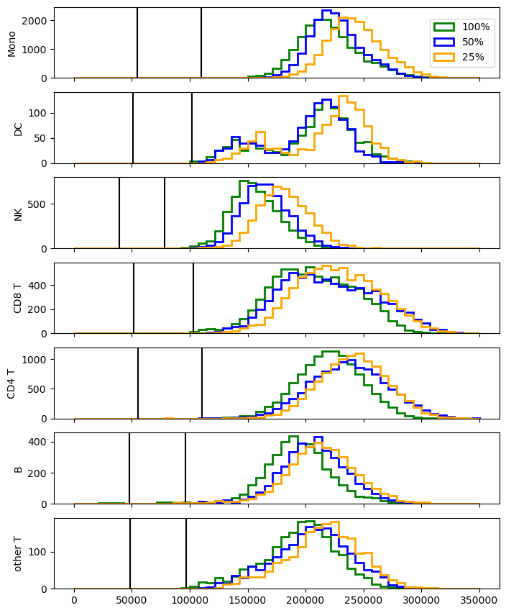
Supplementary Figure 1 – Downsampling PBMC reads

We randomly downsampled the reads from a deeply sequenced (target of 110,000 reads per cell) PBMC dataset. This involved randomly deleting 50% or 75% of the reads from the original FASTQ file. The downsampled FASTQ files were then re-processed using Cellranger, along with the original FASTQ file, producing three filtered count matrices of the deduplicated UMI counts. We then processed each of these count matrices independently with HyperCell, recovering estimates of the transcriptome sizes for the measured cells. The distribution of estimates for each dataset for each cell-type are shown. The black vertical lines marking the 25% and 50% of the median transcriptome size estimate of the estimate for the count matrix that was not downsampled. We found that despite a large difference in the number of initial reads, the recovered estimates were similar, providing evidence that the model is able to find a stable optimum that is robust to experimental downsampling.

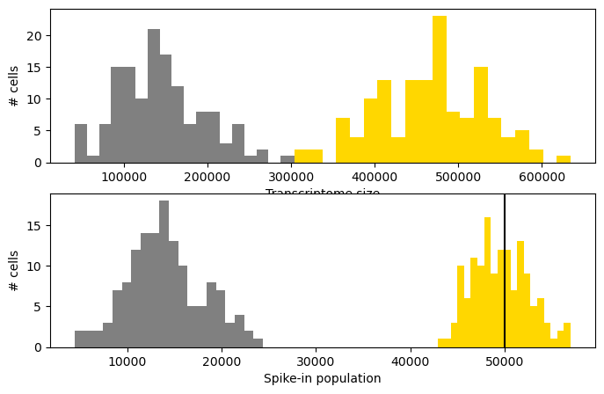
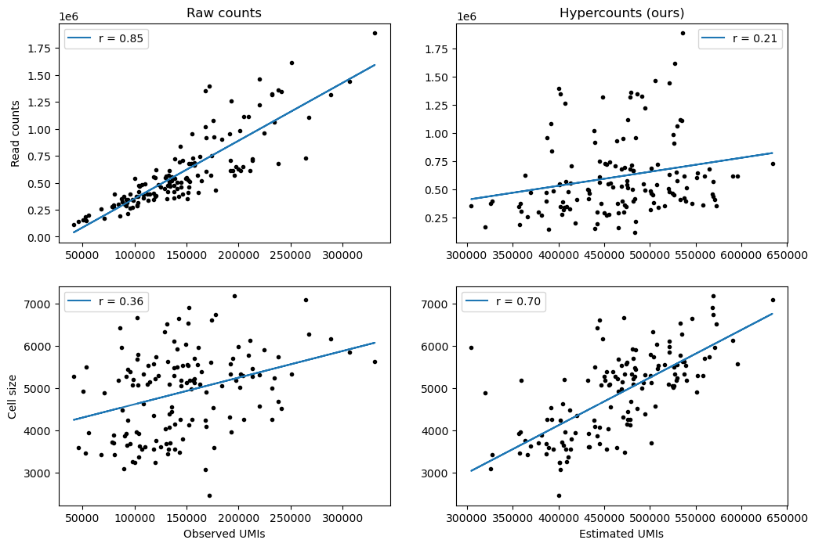
Supplementary Figure 2 – Spike-ins
A (top) – Distribution of counts for HEK cells with additional spike-in molecules, with raw (measured) counts in grey and estimated counts (gold). Top histogram is transcriptome size (cellular RNA only), and bottom histogram is of spike-in molecules only. The black vertical line marks the known amount of spike-in molecules added alongside each cell.
B (bottom) – Top row of scatterplots shows the association between total counts (left: measured, right: estimated) and the original read counts before deduplication of the UMIs. This relationship is partially a result of unwanted technical effects, and we observed that the estimated transcriptomes sizes have a weaker association with the read counts. Bottom row of scatterplots shows the association between the total counts (left: measured, right: estimated) and the measurement of cell diameter obtained during the cell sorting procedure. We found that our estimated transcriptome size had a stronger association with cell size, which aligns with the expectation of larger cells containing more RNA.

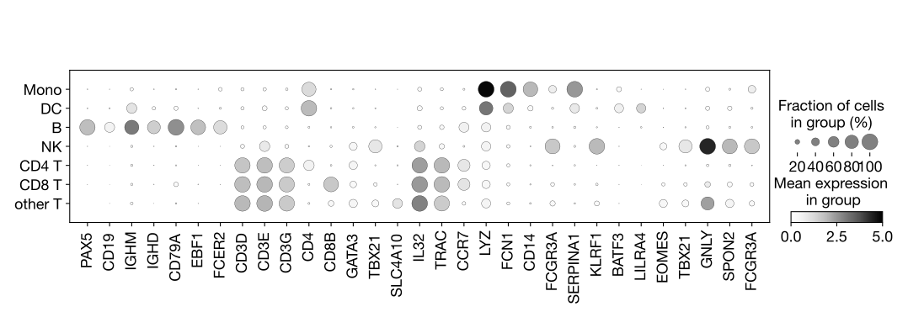
Supplementary Figure 3 – Raw PBMC marker gene dotplot

Dotplot corresponding to the expression distribution across cell-types for the raw (measured) count matrix. The recovered counts are shown in Figure 2a, where we found that the cell-type specific pattern of marker gene expression is correctly preserved.

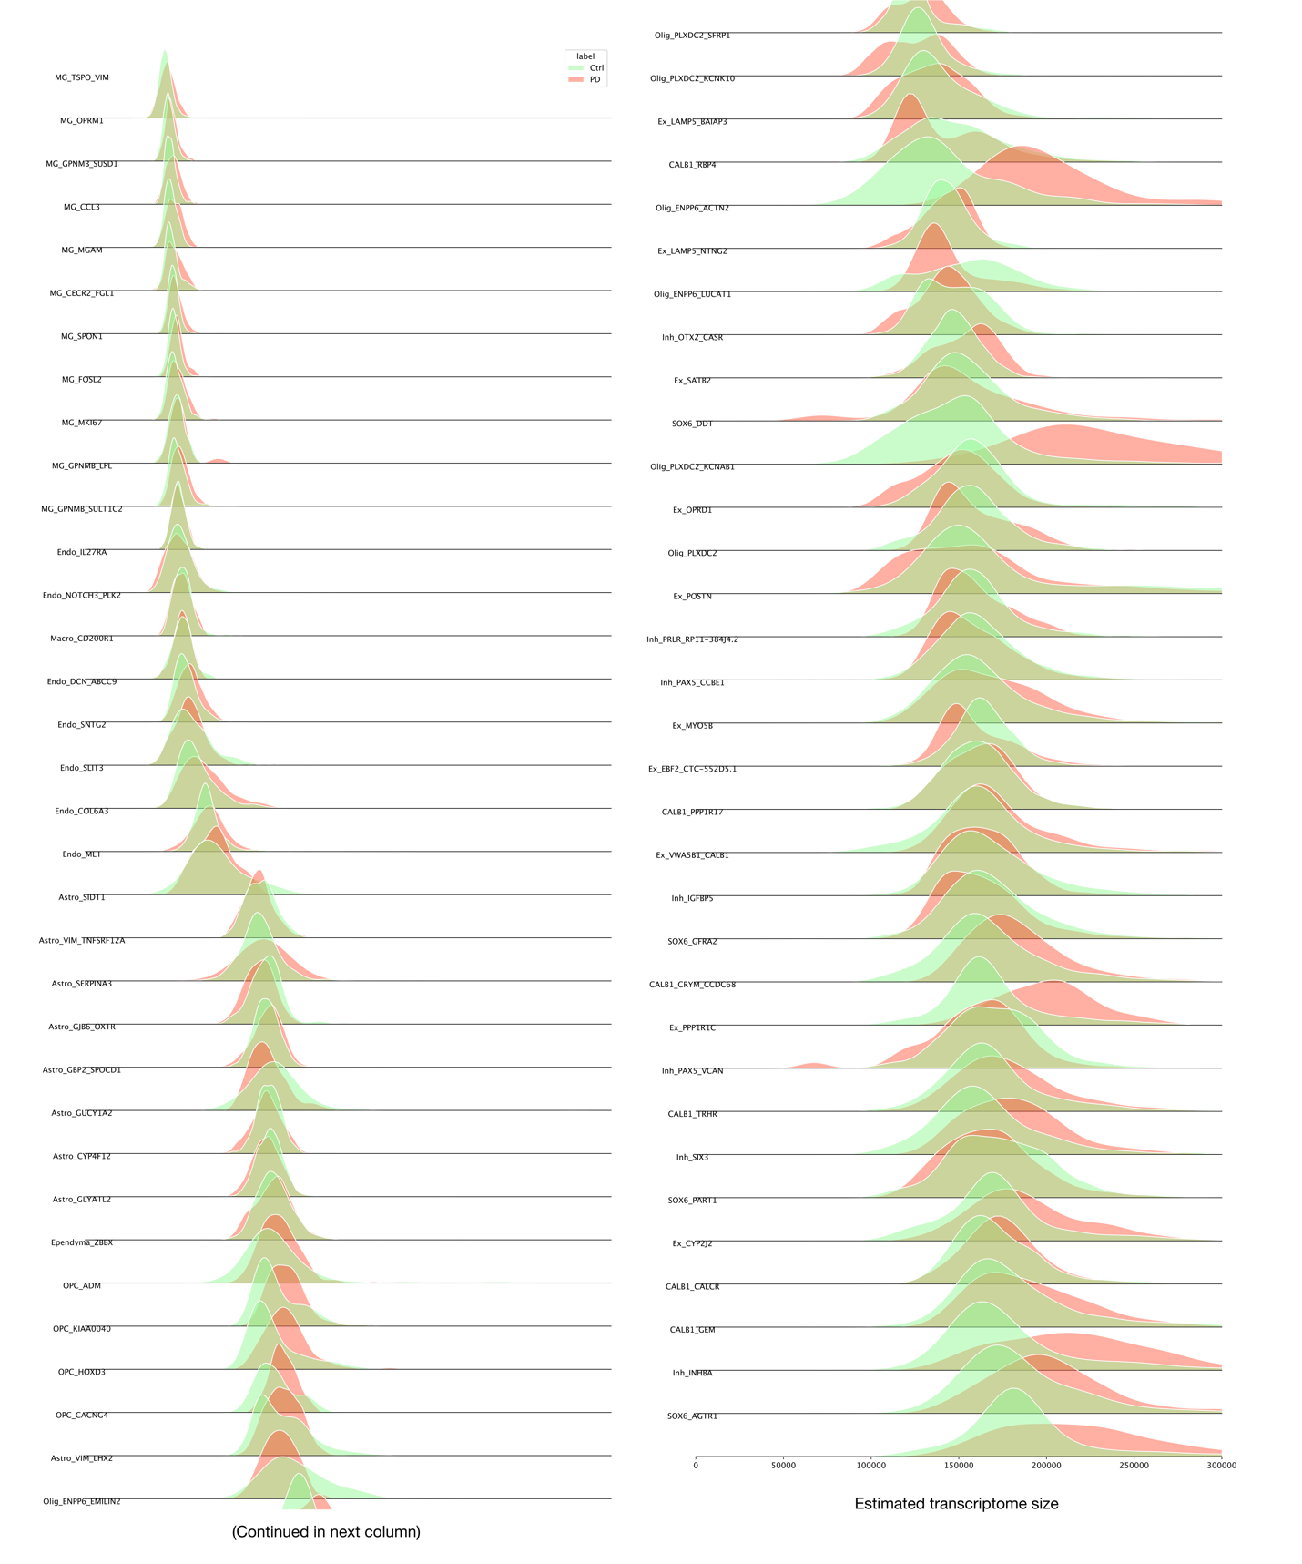
Supplementary Figure 4 – Parkinson’s census full

The transcriptome census of the Parkinson’s dataset corresponding to Figure 3b, but with all cell-type subgroups present in the original study presented as separate distributions. Figure 3b combined the distributions for glial cells, however the transcriptome size distributions of the dopamine neurons, excitatory/inhibitory neurons, and oligodendrocytes are the same.

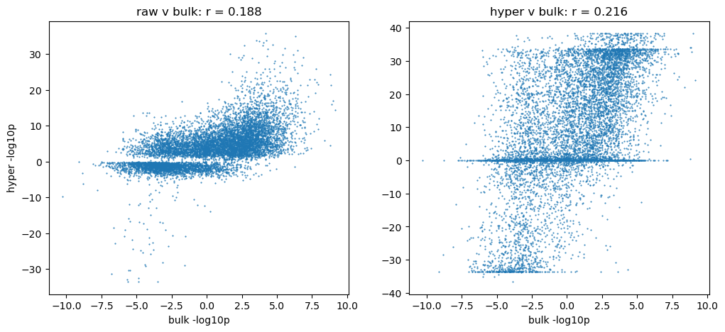
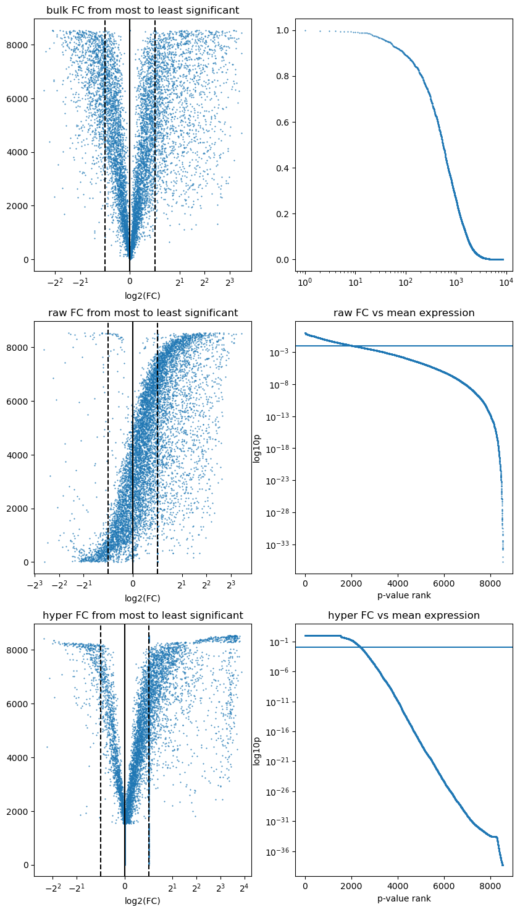
Supplementary Figure 5 – Ghost DEG
Comparison between raw, HyperCell estimate, or pseudobulk differential expression results and differential expression results for bulk measurement (purified cell-type). We found that the estimated counts had an increased agreement with the bulk measurements, which are used as a groundtruth by (Squair et al., 2021).
A (top) – Association between single-cell and bulk differential expression log10 fold-change. Correlation is calculated only for significantly differentially expressed genes.
B (bottom) – Visualization of differential expression results for raw counts, HyperCell estimate, and bulk measurement. We found that the estimated counts corrected the unwanted

