Mechanism insights into the regulation of the LuxS/AI-2 quorum sensing system on the formation of viable but nonculturable state in biofilm cells of beer-spoilage Lactiplantibacillus plantarum
Supplementary materials

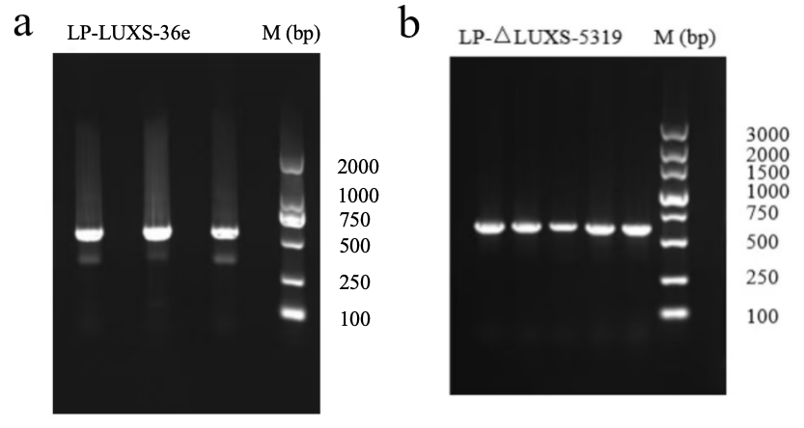
Fig. S1 Agrose gel electrophoresis of PCR validation result of LP-LUXS-36e (a) and LP-△LUXS-5319 (b) strains using validation primer.
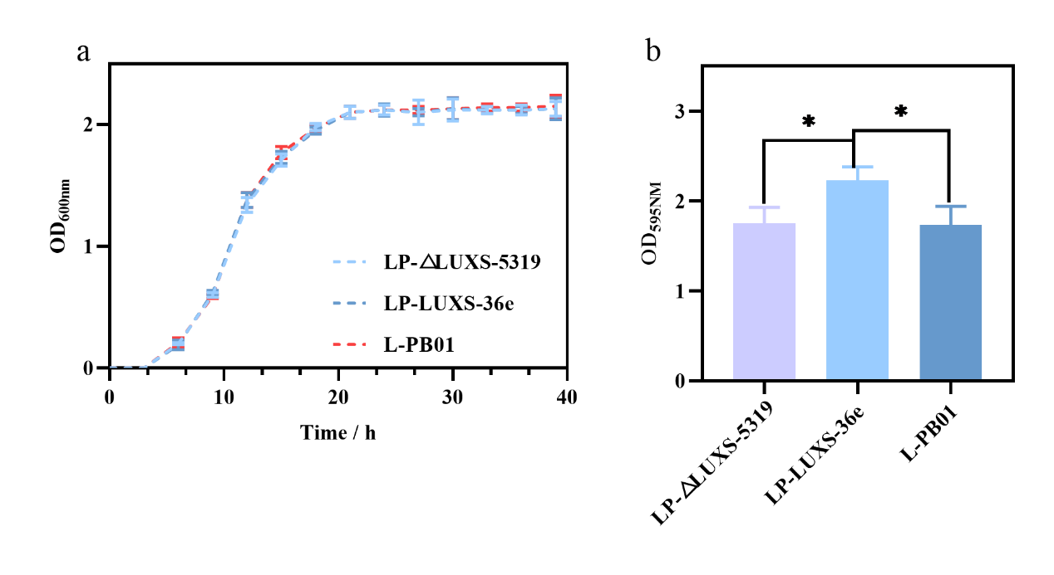
Fig. S2 Growth curves of LP-LUXS-36e, LP-△LUXS-5319 and wild-type strains (a). Biofilm formation of LP-LUXS-36e, LP-△LUXS-5319 and wild-type strains (b). Data are presented as mean ± SEM. n ≥ 3. *p < 0.05 compared with the control.

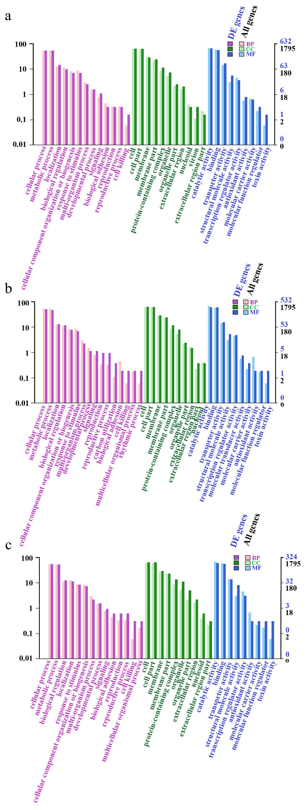
Fig. S3 Bar chart of GO analysis. (a) Normal state. (b) Biofilm state. (c) Biofilm VBNC state.
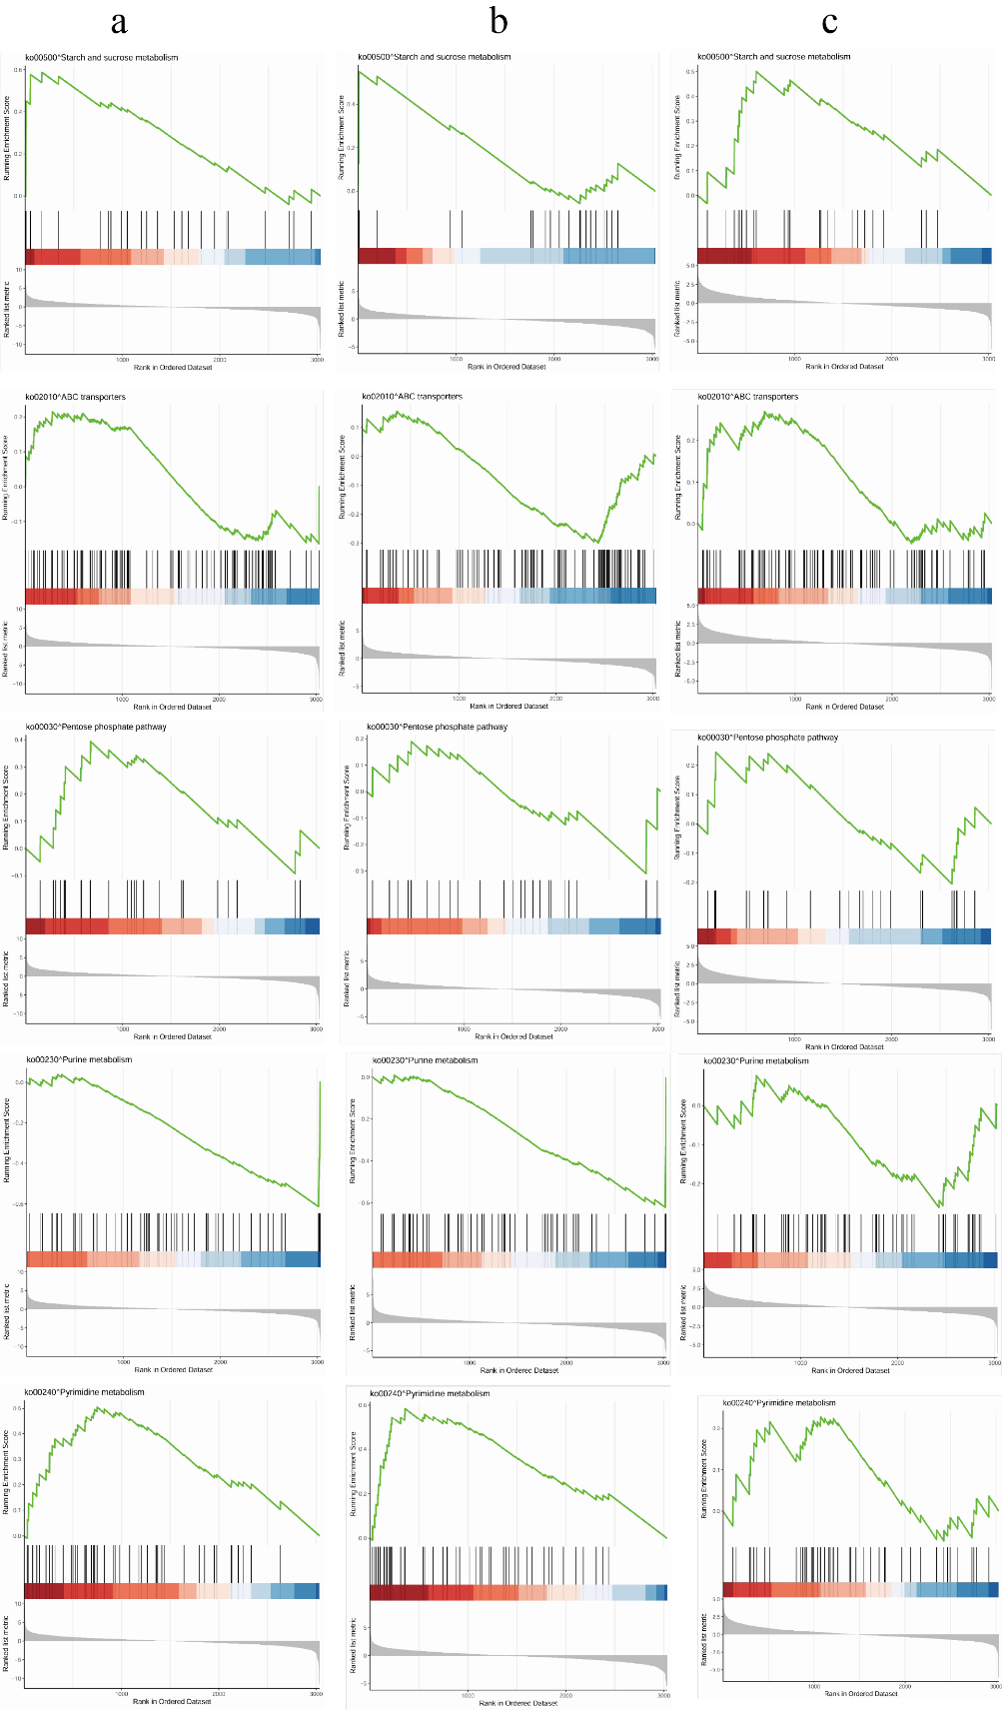
Fig. S4 GSEA enrichment curves of KEGG pathways. (a) Normal state. (b) Biofilm state. (c) Biofilm VBNC state.

