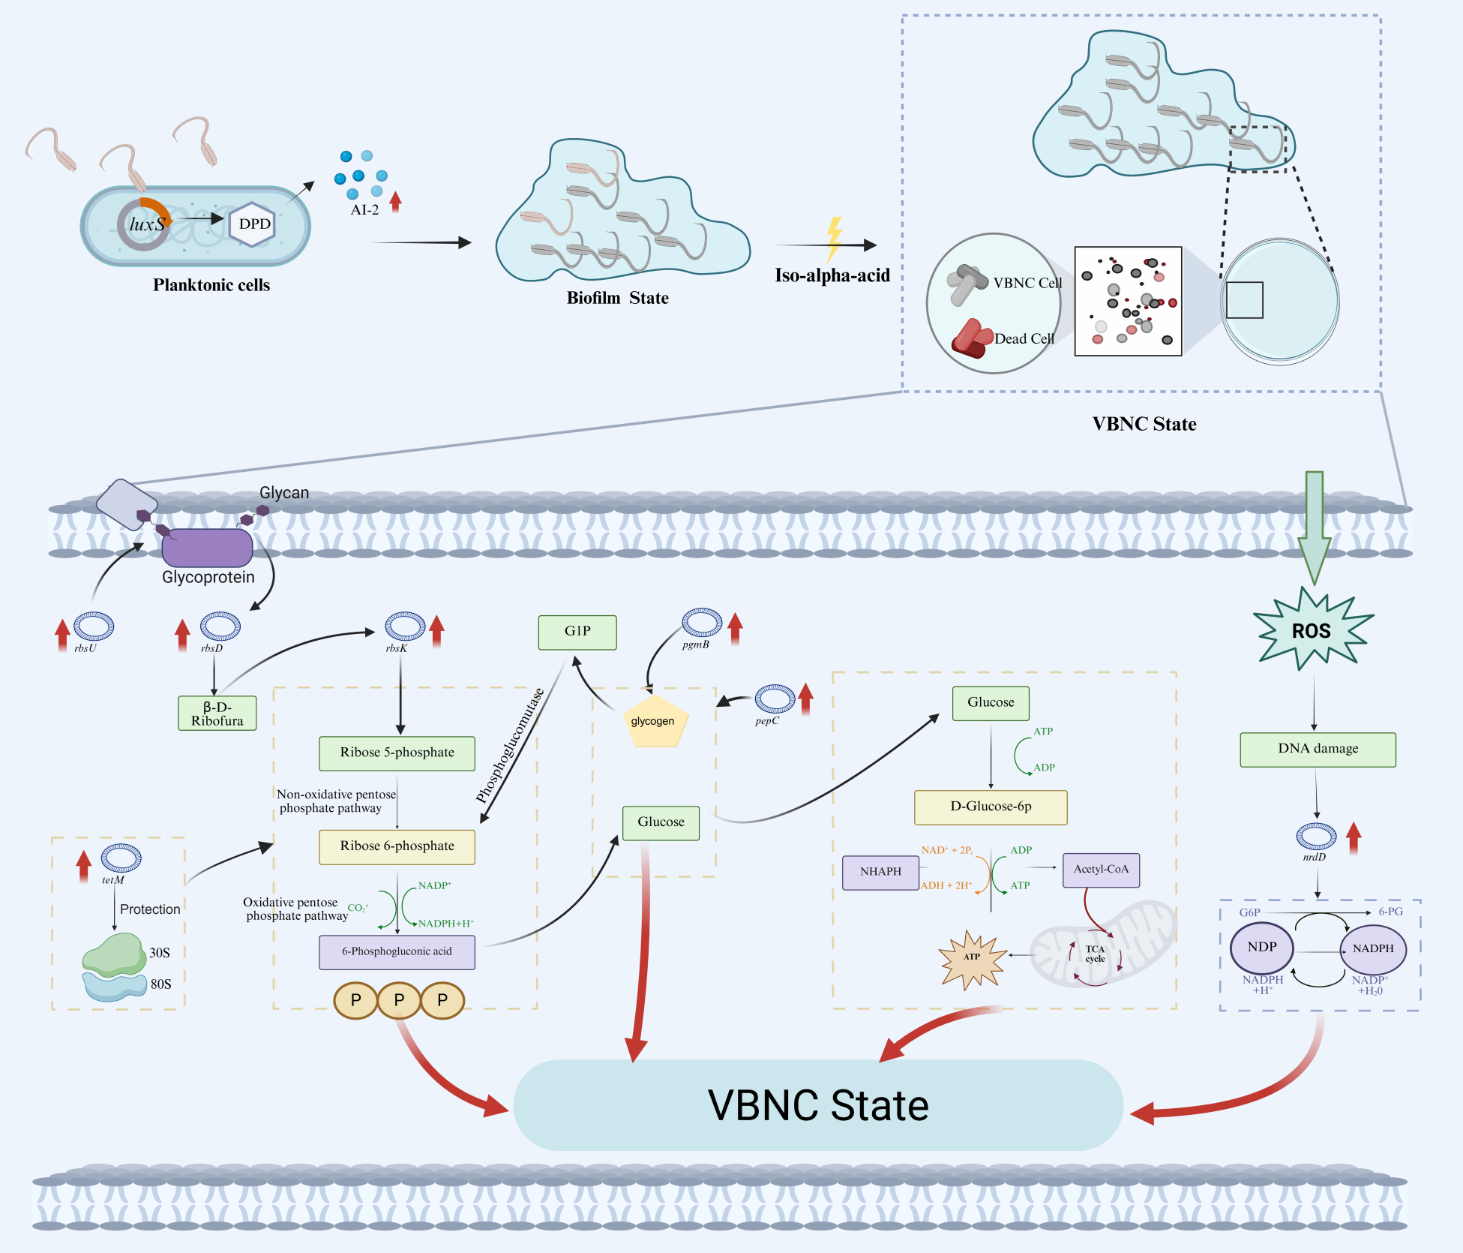
Graphic Abstract. Mechanism insights into the regulation of the LuxS/AI-2 quorum sensing system on the formation of viable but nonculturable state in biofilm cells of beer-spoilage Lactiplantibacillus plantarum.

