Supplementary Notes for

Chiral multi-curved shell metamaterials integrating compression-torsion and buckling mechanisms for ideal energy absorption

Chen-Xu Liu¹, Yizhi Zhang¹, Xinghao Wang¹, Gui-Lan Yu², Zhuo Zhuang¹, and Zhanli Liu^{1*}

1 Applied Mechanics Lab., Department of Engineering Mechanics, School of Aerospace, Tsinghua University, 100084 Beijing, China
2 School of Civil Engineering, Beijing Jiaotong University, Beijing 100044, China

*Corresponding author, email: liuzhanli@mail.tsinghua.edu.cn

This PDF file includes:
Supplementary Text
Supplementary Figures 1 to 12
Supplementary Tables 1 to 3

Supplementary Note 1. The main structure of the chiral multi-curved shell (CMCS) metamaterial.
As shown in Supplementary Figure 1, given the shape of the bottom plane and the rotation angle as well as location of the top plane, the main structural configuration can be determined. Each line segment of the bottom polygon, when swept along the rotating ascending path, namely the line from $p_{i}$ to ${\hat{p}}_{i}$ ($i=1,2,3···$), forms the curved surface of the metamaterial. The construction method for the multiple curved surfaces of the outer and inner ring polygons is identical. The area enclosed by these generated curved surfaces forms the main structure of the chiral multi-curved shell (CMCS) metamaterial.

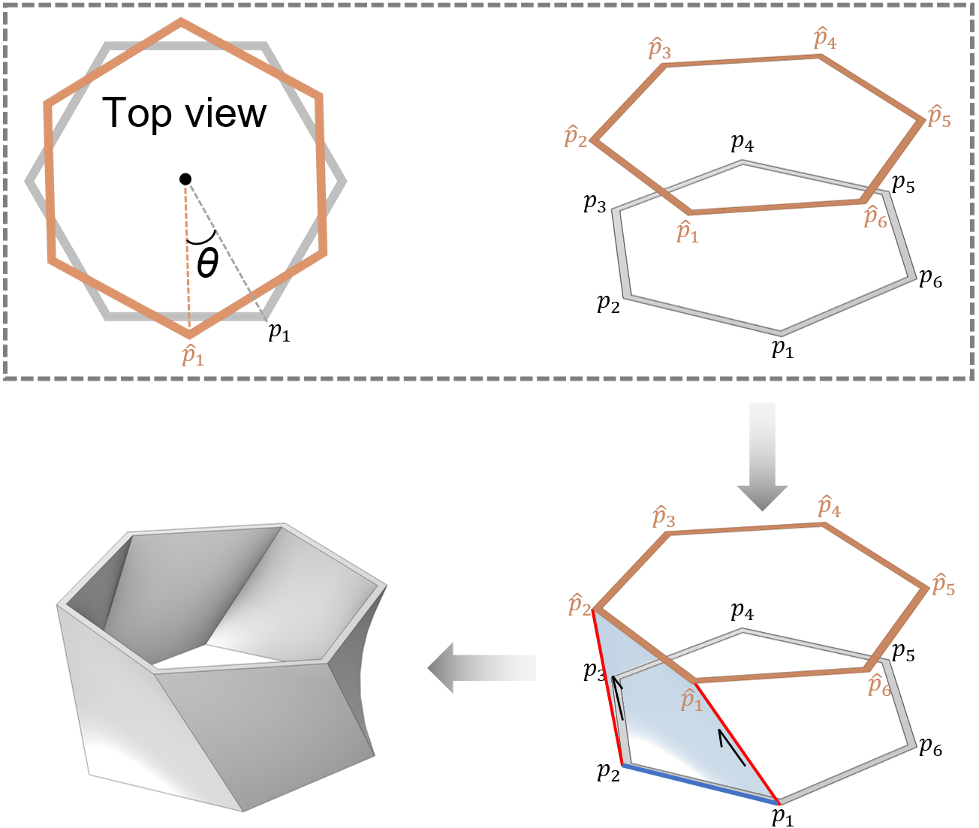
Supplementary Figure 1. Geometry construction method for the main structure of the chiral multi-curved shell (CMCS) metamaterial. $θ$ is the rotation angle of the top plane relative to the bottom plane; $p_{i}$ ($i=1,2,3···$) is the vertex of the polygon on the bottom plane, and ${\hat{p}}_{i}$ ($i=1,2,3···$) is that on the top plane.
Building on the above operations, the main structure of the CMCS metamaterial can be described by analytical equations.
Assume that the center of the bottom polygon is at the coordinate origin, and the two endpoints of an outermost bottom line are represented by $\left(x_{1},y_{1},0\right)$ and $\left(x_{2},y_{2},0\right)$, respectively. These coordinates are known quantities, determined by the geometric parameters $n$, $a$, and $t$ of the main structure, as illustrated in Fig. 1a. The two endpoints of other lines on the bottom surface that are parallel to the outermost bottom line can be expressed as$\left({\left(1-2\cos\left(π/n\right)\tilde{t}/a\right)x}_{1},{\left(1-2\cos\left(π/n\right)\tilde{t}/a\right)y}_{1},0\right)$ and $\left({\left(1-2\cos\left(π/n\right)\tilde{t}/a\right)x}_{2},{\left(1-2\cos\left(π/n\right)\tilde{t}/a\right)y}_{2},0\right)$, respectively, $0<\tilde{t}≤t$, where $\tilde{t}$ is the distance from the current line to its corresponding outermost line. Hence, the lines on the bottom that parallel to the outermost bottom line can be described by the following equations:

$\left\{\begin{aligned}x∈\left[\min\left({\left(1-\frac{2\cos\left(\frac{π}{n}\right)\tilde{t}}{a}\right)x}_{1},{\left(1-\frac{2\cos\left(\frac{π}{n}\right)\tilde{t}}{a}\right)x}_{2}\right),\max\left({\left(1-\frac{2\cos\left(\frac{π}{n}\right)\tilde{t}}{a}\right)x}_{1},{\left(1-\frac{2\cos\left(\frac{π}{n}\right)\tilde{t}}{a}\right)x}_{2}\right)\right] \\ y=\frac{y_{1}-y_{2}}{x_{1}-x_{2}}\left(x-\frac{a-2\cos\left(\frac{π}{n}\right)\tilde{t}}{a}x_{1}\right)+\frac{a-2\cos\left(\frac{π}{n}\right)\tilde{t}}{a}y_{1}, 0≤\tilde{t}≤t\end{aligned}\right.$
(S1)
As a bottom line sweeps from the bottom to the top, its height can be expressed as:
$\tilde{b}=\frac{b}{θ}\tilde{θ}$ (S2)
where $b$ and $θ$ are known geometric parameters of the main structure, as shown in Fig. 1a, corresponding to the ultimate height and rotation angle of a bottom line, respectively; $\tilde{b}$ is the height variable corresponding to the change of the rotation angle variable $\tilde{θ}$.
The coordinates of the two endpoints of a line on the main structure parallel to the bottom plane can be expressed as $\left({\left(1-2\cos\left(π/n\right)\tilde{t}/a\right)(x}_{1}cos\tilde{θ}-y_{1}sin\tilde{θ}), \left(1-2\cos\left(π/n\right)\tilde{t}/a\right)(x_{1}sin\tilde{θ}+y_{1}cos\tilde{θ}),\tilde{b}\right)$ and $\left(\left(1-2\cos\left(π/n\right)\tilde{t}/a\right)(x_{2}cos\tilde{θ}-y_{2}sin\tilde{θ}),\left(1-2\cos\left(π/n\right)\tilde{t}/a\right)(x_{2}sin\tilde{θ}+y_{2}cos\tilde{θ}),\tilde{b}\right)$, respectively. Hence, the line can be described by the following equations:
$\left\{\begin{aligned}x∈\left(1-\frac{2\cos\left(\frac{π}{n}\right)\tilde{t}}{a}\right)\left[\min\left(x_{1}cos\tilde{θ}-y_{1}sin\tilde{θ},x_{2}cos\tilde{θ}-y_{2}sin\tilde{θ}\right),\max\left(x_{1}cos\tilde{θ}-y_{1}sin\tilde{θ},x_{2}cos\tilde{θ}-y_{2}sin\tilde{θ}\right)\right] \\ y=\frac{\left(x_{1}-x_{2}\right)sin\tilde{θ}+\left(y_{1}-y_{2}\right)cos\tilde{θ}}{\left(x_{1}-x_{2}\right)cos\tilde{θ}+\left(y_{2}-y_{1}\right)sin\tilde{θ}}\left(x-{\left(1-\frac{2\cos\left(\frac{π}{n}\right)\tilde{t}}{a}\right)(x}_{1}cos\tilde{θ}-y_{1}sin\tilde{θ})\right)+\left(1-\frac{2\cos\left(\frac{π}{n}\right)\tilde{t}}{a}\right)\left(x_{1}sin\tilde{θ}+y_{1}cos\tilde{θ}\right) \\ z=\tilde{b}=\frac{b}{θ}\tilde{θ}\end{aligned}\right.$
(S3)
By traversing each line corresponding to each $\tilde{t}$ and each $\tilde{θ}$, a curved shell is formed, which is governed by the following equations:
$\left\{\begin{aligned}\begin{matrix}\tilde{t}∈\left[0,t\right] \\ \tilde{θ}∈\left[0,θ\right]\end{matrix} \\ \begin{matrix}x∈\left(1-\frac{2\cos\left(\frac{π}{n}\right)\tilde{t}}{a}\right)\left[\min\left(x_{1}cos\tilde{θ}-y_{1}sin\tilde{θ},x_{2}cos\tilde{θ}-y_{2}sin\tilde{θ}\right),\max\left(x_{1}cos\tilde{θ}-y_{1}sin\tilde{θ},x_{2}cos\tilde{θ}-y_{2}sin\tilde{θ}\right)\right] \\ y=\frac{\left(x_{1}-x_{2}\right)sin\tilde{θ}+\left(y_{1}-y_{2}\right)cos\tilde{θ}}{\left(x_{1}-x_{2}\right)cos\tilde{θ}+\left(y_{2}-y_{1}\right)sin\tilde{θ}}\left(x-{\left(1-\frac{2\cos\left(\frac{π}{n}\right)\tilde{t}}{a}\right)(x}_{1}cos\tilde{θ}-y_{1}sin\tilde{θ})\right)+\left(1-\frac{2\cos\left(\frac{π}{n}\right)\tilde{t}}{a}\right)\left(x_{1}sin\tilde{θ}+y_{1}cos\tilde{θ}\right)\end{matrix} \\ z=\tilde{b}=\frac{b}{θ}\tilde{θ}\end{aligned}\right.$
(S4)
Based on Eq. (S4), a curved shell is determined, then rotated $n-1$ times around the origin at an angle of $2π/n$ each time, resulting in the formation of the main structure.

Supplementary Note 2. The reason for attaching stiffeners to the CMCS metamaterial.
Supplementary Figure 2 shows the force-displacement curves and deformation processes of two CMCS metamaterials with or without stiffeners. It can be seen that the middle plane of the latter undergoes a out-of-plane instability during the compression, resulting in a significant drop in plateau phase, which reduces efficiency of energy absorption (EEA). However, this phenomenon does not occur in the former since the stiffeners enhance the vertical stiffness of the rotation plane. Hence, attaching stiffeners to CMCS metamaterials is essential to prevent the reduction of EEA caused by the instability of the middle plane.
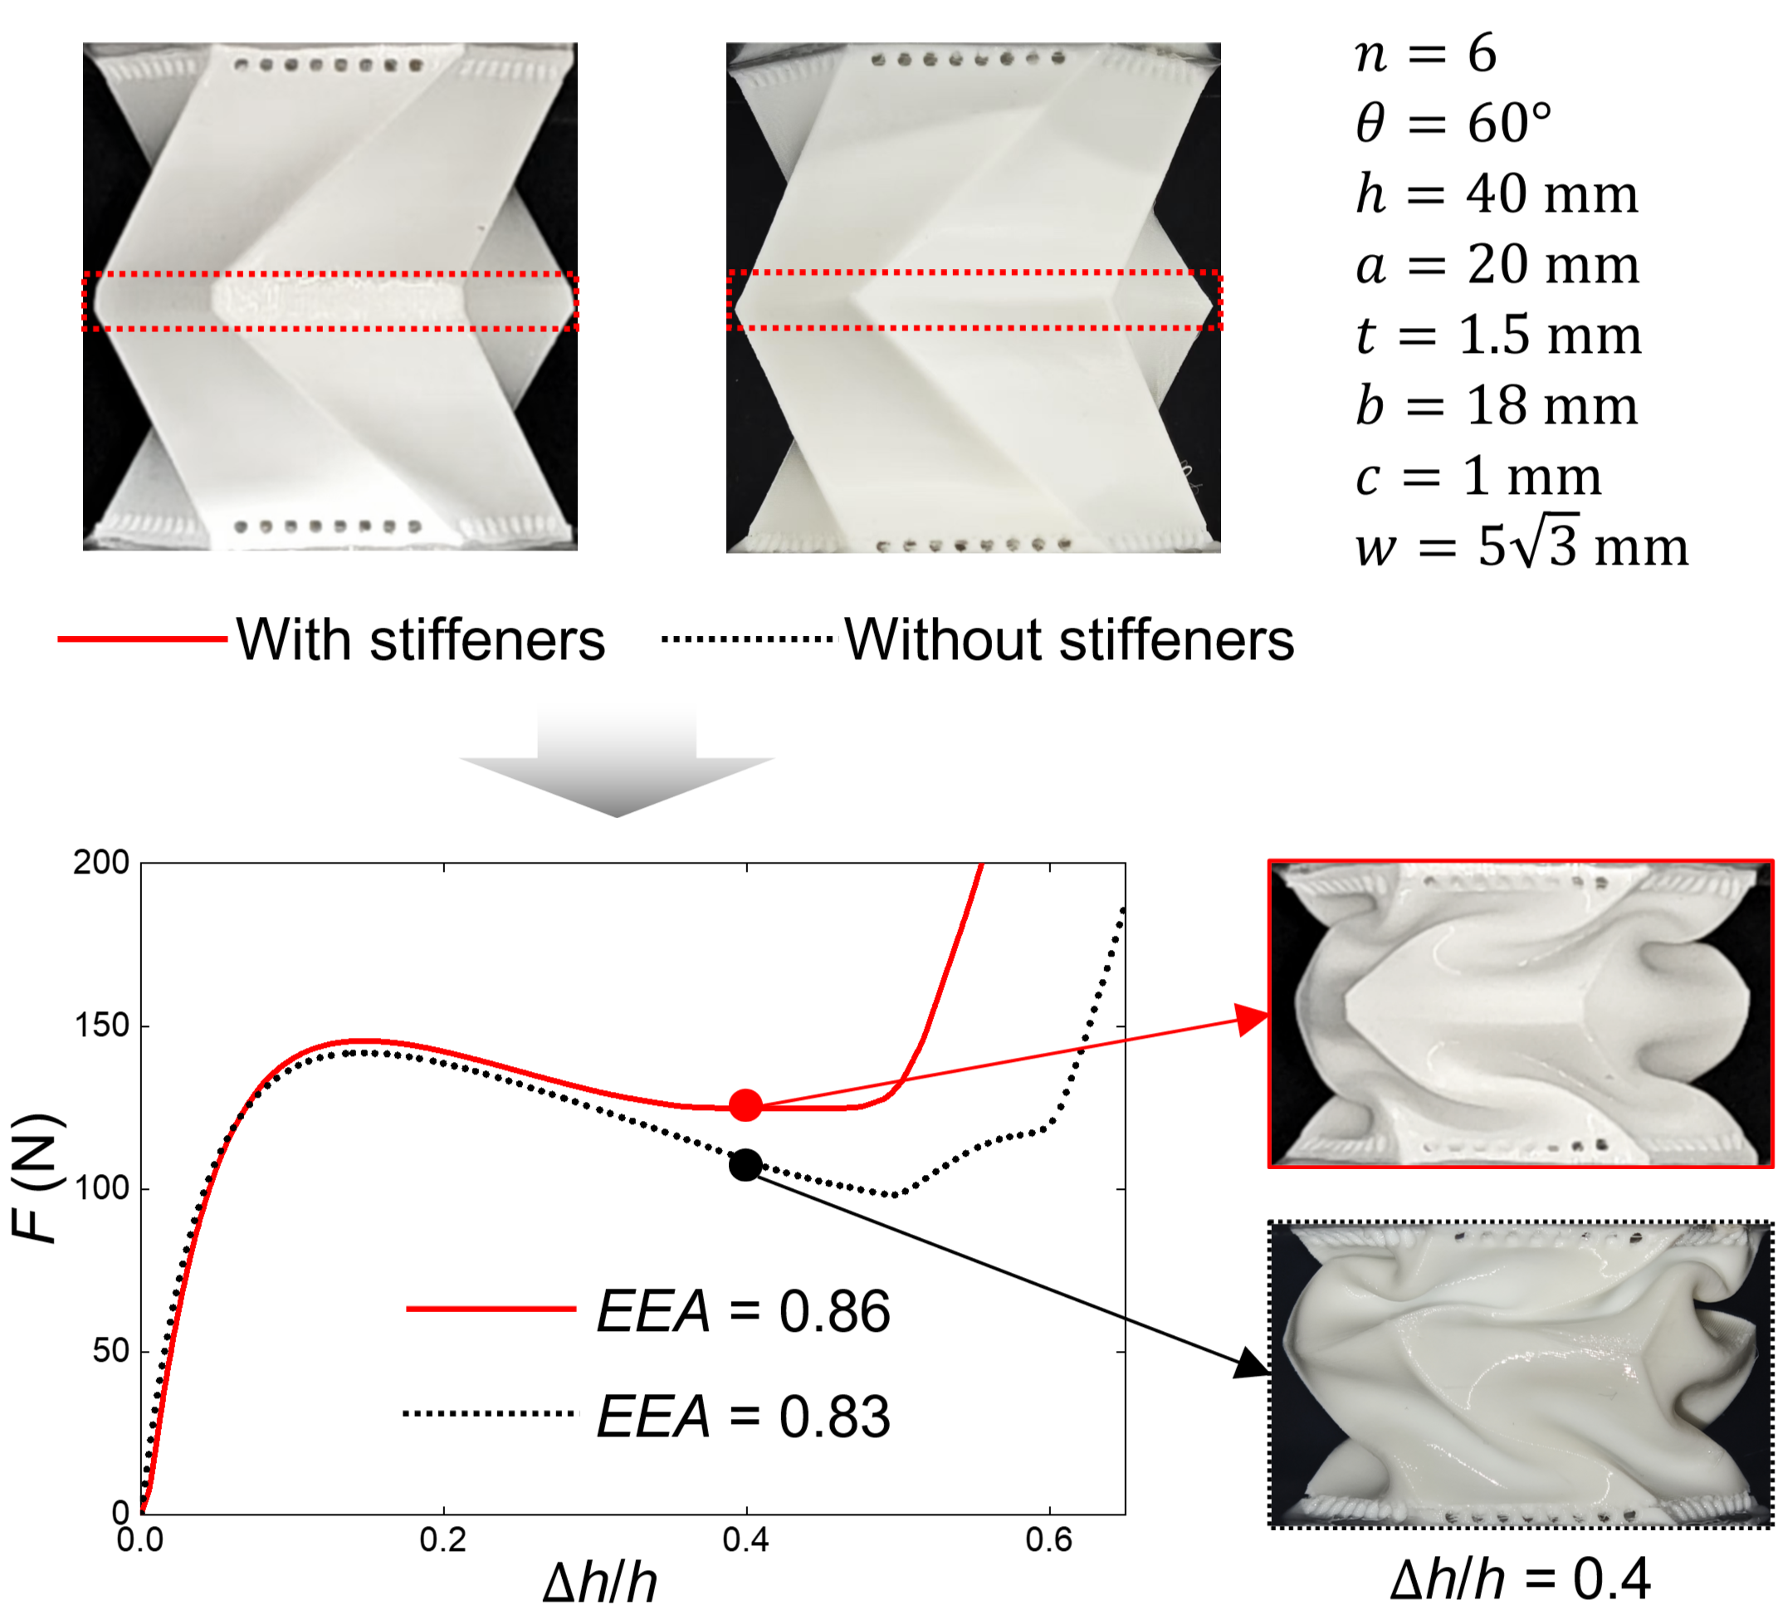
Supplementary Figure 2. Experimental force-displacement curves of CMCS metamaterials with or without stiffeners. The red solid line is the result with stiffeners, and the black dotted line is that without stiffeners; the efficiency of energy absorption (EEA) with or without stiffeners is 0.86 or 0.83, respectively.

Supplementary Note 3. The hexagon, Kresling, and CMCS metamaterials for the comparison.
Supplementary Figure 3 shows the details of the hexagon, Kresling, and CMCS metamaterials. The former two metamaterials are identical to the CMCS metamaterial in terms of $n$, $a$, $h$, $c$, $w$, and anticipated mass with 7.75 g, where $t$ can be adjusted to make their anticipated mass equal and the corresponding values of the Kresling and hexagon metamaterials are set to be 1.27 mm and 0.826 mm. The rotation angle of the Kresling metamaterial is also the same with that of the CMCS metamaterial, and the construction way of the Kresling pattern can be found in Supplementary Reference [1]. The two stiffeners of the hexagon metamaterial on the middle plane are moved to bottom and top planes, respectively.

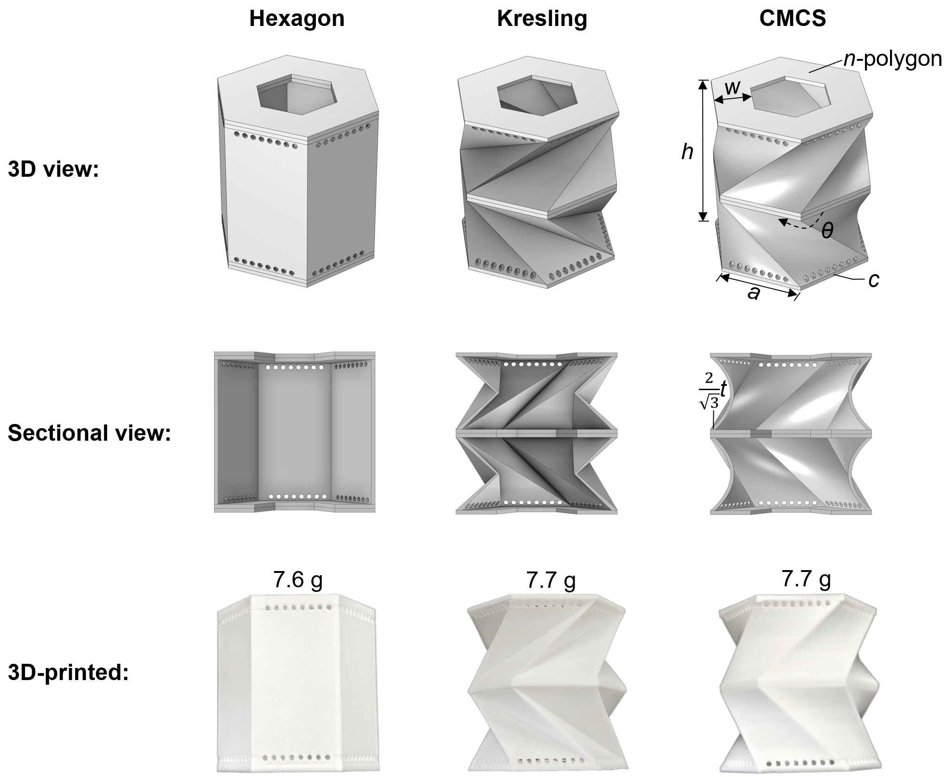
Supplementary Figure 3. Configurations of the hexagon, Kresling, and CMCS metamaterials for the comparison.
Supplementary Note 4. Quasi-static compression experiments.
In real engineering applications, energy-absorbing materials are typically sandwiched between a pair of rigid shells, forming the core, and are securely bonded to them. Accordingly, AB glue is used to attach the upper and lower surfaces of a metamaterial to two steel plates, as shown in Supplementary Figure 4. Each steel plate is 50×50×0.6 mm (length × width × thickness). A Universal Testing Machine (UTM) is used to measure force-displacement curves. To simulate quasi-static compression, a loading speed of 0.4 mm/s is applied.

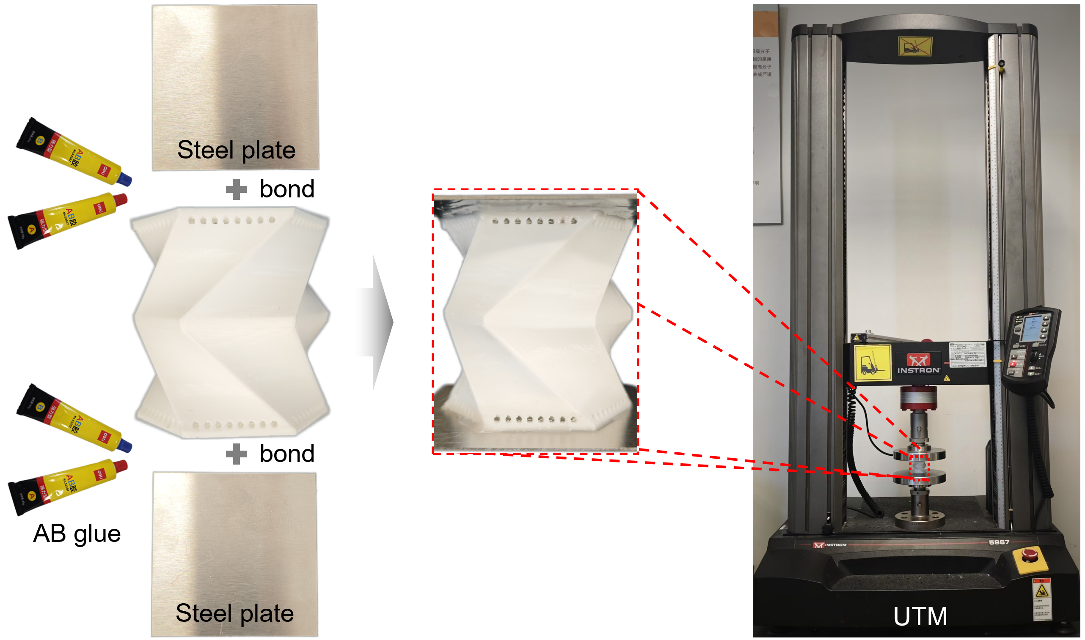
Supplementary Figure 4. Specimen and Universal Testing Machine (UTM) for quasi-static compression experiments.

Supplementary Note 5. Indices for evaluating energy absorption performance.
Plateau force is the average force from yield to compaction during compression, which is as follows:
$F_{pl}=\frac{1}{D_{P}}\int_{D_{y}}^{D_{D}}{F\left(D\right)dD}$ (S5)
where $F_{pl}$ is the plateau force; $D$ is the displacement; $D_{D}$ is the densification displacement; $D_{y}$ is the yield displacement; $D_{P}$ is the plateau period which is equal to $D_{D}-D_{y}$.
Average force refers to the average force from the beginning to the densification displacement, and it can be expressed as:
$F_{avg}=\frac{1}{D_{D}}\int_{0}^{D_{D}}{F\left(D\right)dD}$ (S6)
Undulation of load-carrying (ULC) can quantify the relative fluctuation of force in the compression process, which can be calculated as:
$χ_{ULC}=\frac{\int_{0}^{D_{D}}{\left|F\left(D\right)-F_{avg}\right|dD}}{\int_{0}^{D_{D}}{F\left(D\right)dD}}$ (S7)
Specific energy absorption (SEA) reflects the amount of energy absorbed per unit mass, and it is calculated when $D{=D}_{D}$ in this study. Hence, SEA can be expressed as:
$SEA=\frac{1}{{mD}_{D}}\int_{0}^{D_{D}}{F\left(D\right)dD}$ (S8)
where $m$ is the mass.
EEA is the ratio of the amount of energy absorbed prior to densification displacement to the product of the peak force before compaction and the densification displacement. It can be calculated by the following equation:
$EEA=\frac{1}{{F_{peak}D}_{D}}\int_{0}^{D_{D}}{F\left(D\right)dD}$ (S9)
where $F_{peak}$ is the peak force during the compression from the beginning to the densification displacement.
In addition, the densification displacement is the displacement at which the maximum of the energy absorption efficiency function occurs in this study, where the function is as follows:
$η\left(D_{a}\right)=\frac{1}{F\left(D_{a}\right)}\int_{0}^{D_{a}}{F\left(D\right)dD}$ (S10)
where $η\left(D_{a}\right)$ and $F\left(D_{a}\right)$ refer to the energy absorption efficiency function value and force at $D=D_{a}$, respectively.

Supplementary Note 6. Ideal energy absorption curve.
Supplementary Figure 5 shows the schematic diagram of an ideal energy absorption curve, and the standards are as follows:
- EEA approaches 1. To achieve this goal, ULC must be close to 0, the plateau force should be equal to the yield force, and the displacement interval of the linear stage is as small as possible, which normally refers to $D_{y}$.
- The plateau phase, namely $D_{D}$-$D_{y}$, is long enough.
- The plateau force is close to the damage threshold of a protected structure.

Supplementary Figure 5. Ideal energy absorption curve. $F_{y}$ is the yield force; $F_{pl}$ is the plateau force; $D_{y}$ is the yield displacement; $D_{D}$ is the densification displacement.

Supplementary Note 7. Hyperelastic parameters of the TPU material used in 3D-printing.
Hyperelastic Yeoh model is used to describe the nonlinear material behavior of the TPU in 3D-printing, of which function is as follows:
$W=C_{1}\left(I_{1}-3\right)+C_{2}{\left(I_{1}-3\right)}^{2}+C_{3}{\left(I_{1}-3\right)}^{3}$ (S11)
where $W$ is the strain energy density; $C_{1}$, $C_{2}$, and $C_{3}$ are the material coefficients; $I_{1}$ is the first invariant.
Assume the material is stretched along an axis with a stretch ratio or strain $ε$. To maintain incompressibility (constant volume), the stretches in the other two perpendicular directions are $ε^{-\frac{1}{2}}$. Thus, the first invariant $I_{1}$​ becomes:
$I_{1}=ε^{2}+2ε^{-1}$ (S12)
The Cauchy stress $σ$ in the direction of stretching can be obtained by differentiating the strain energy function with respect to $ε$:
$σ=\frac{1}{ε}\left(2\frac{∂W}{∂I_{1}}\frac{∂I_{1}}{∂ε}\right)$ (S13)
where
$\frac{∂W}{∂I_{1}}=C_{1}+2C_{2}\left(I_{1}-3\right)+3C_{3}{\left(I_{1}-3\right)}^{2}$ (S14)
$\frac{∂I_{1}}{∂ε}=2ε-2ε^{-2}$ (S15)
Substitute Eqs. (S12), (S14), and (S15) into the stress expression, namely Eq. (S13), and the stress-strain equation can be obtained as follows:
$σ=2\left[C_{1}+2C_{2}\left(ε^{2}+2ε^{-1}-3\right)+3C_{3}{\left(ε^{2}+2ε^{-1}-3\right)}^{2}\right]\left(1-ε^{-3}\right)$ (S16)
As shown in Supplementary Figure 6a, a set of tensile and compressive specimens are printed to determine the constitutive parameters of the TPU. Supplementary Figure 6b shows the experimental and fitting stress-strain curves of the 3D-printed specimens with TPU, where $C_{1}=5.1$ MPa, $C_{2}=-2.5$ MPa, and $C_{3}=0.8$ MPa.

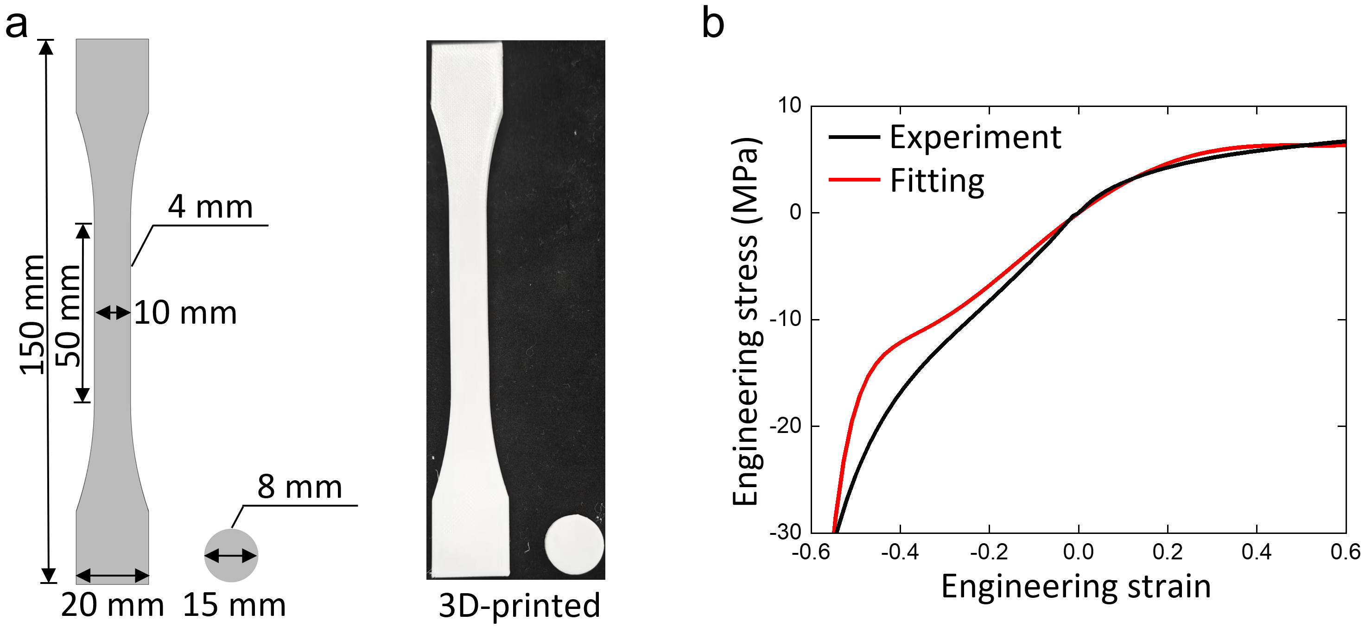
Supplementary Figure 6. Identifying Yeoh model parameters of the TPU material used in 3D-printing. a 3D-printed tensile and compressive specimens with TPU. b Stress-strain curves, where the black line is experimental results and the red line is from Yeoh model with $C_{1}=5.1$ MPa, $C_{2}=-2.5$ MPa, and $C_{3}=0.8$ MPa.

Supplementary Note 8. Finite element models of the hexagon, Kresling, and CMCS metamaterials.
ABAQUS is used to build the finite element models of the hexagon, Kresling, and CMCS metamaterials under quasi-static compression. The finite element mesh division of the three metamaterials is given in Supplementary Figure 7a, where the maximum size of elements is lower than 0.5 mm. Eight-node linear brick with reduced integration (element type C3D8R) is adopted for hexahedral elements, and ten-node modified quadratic tetrahedron (element type C3D10M) is used for tetrahedral elements. The lower surface is a fixed boundary condition, and a displacement load is applied to the upper surface. The hyperelastic parameters of their TPU is the same with those in Supplementary Note 7. It can be seen from Supplementary Figure 7b that the force-displacement curves obtained from ABAQUS are generally consistent with those from experiments. Hence, the results from numerical simulations are credible.

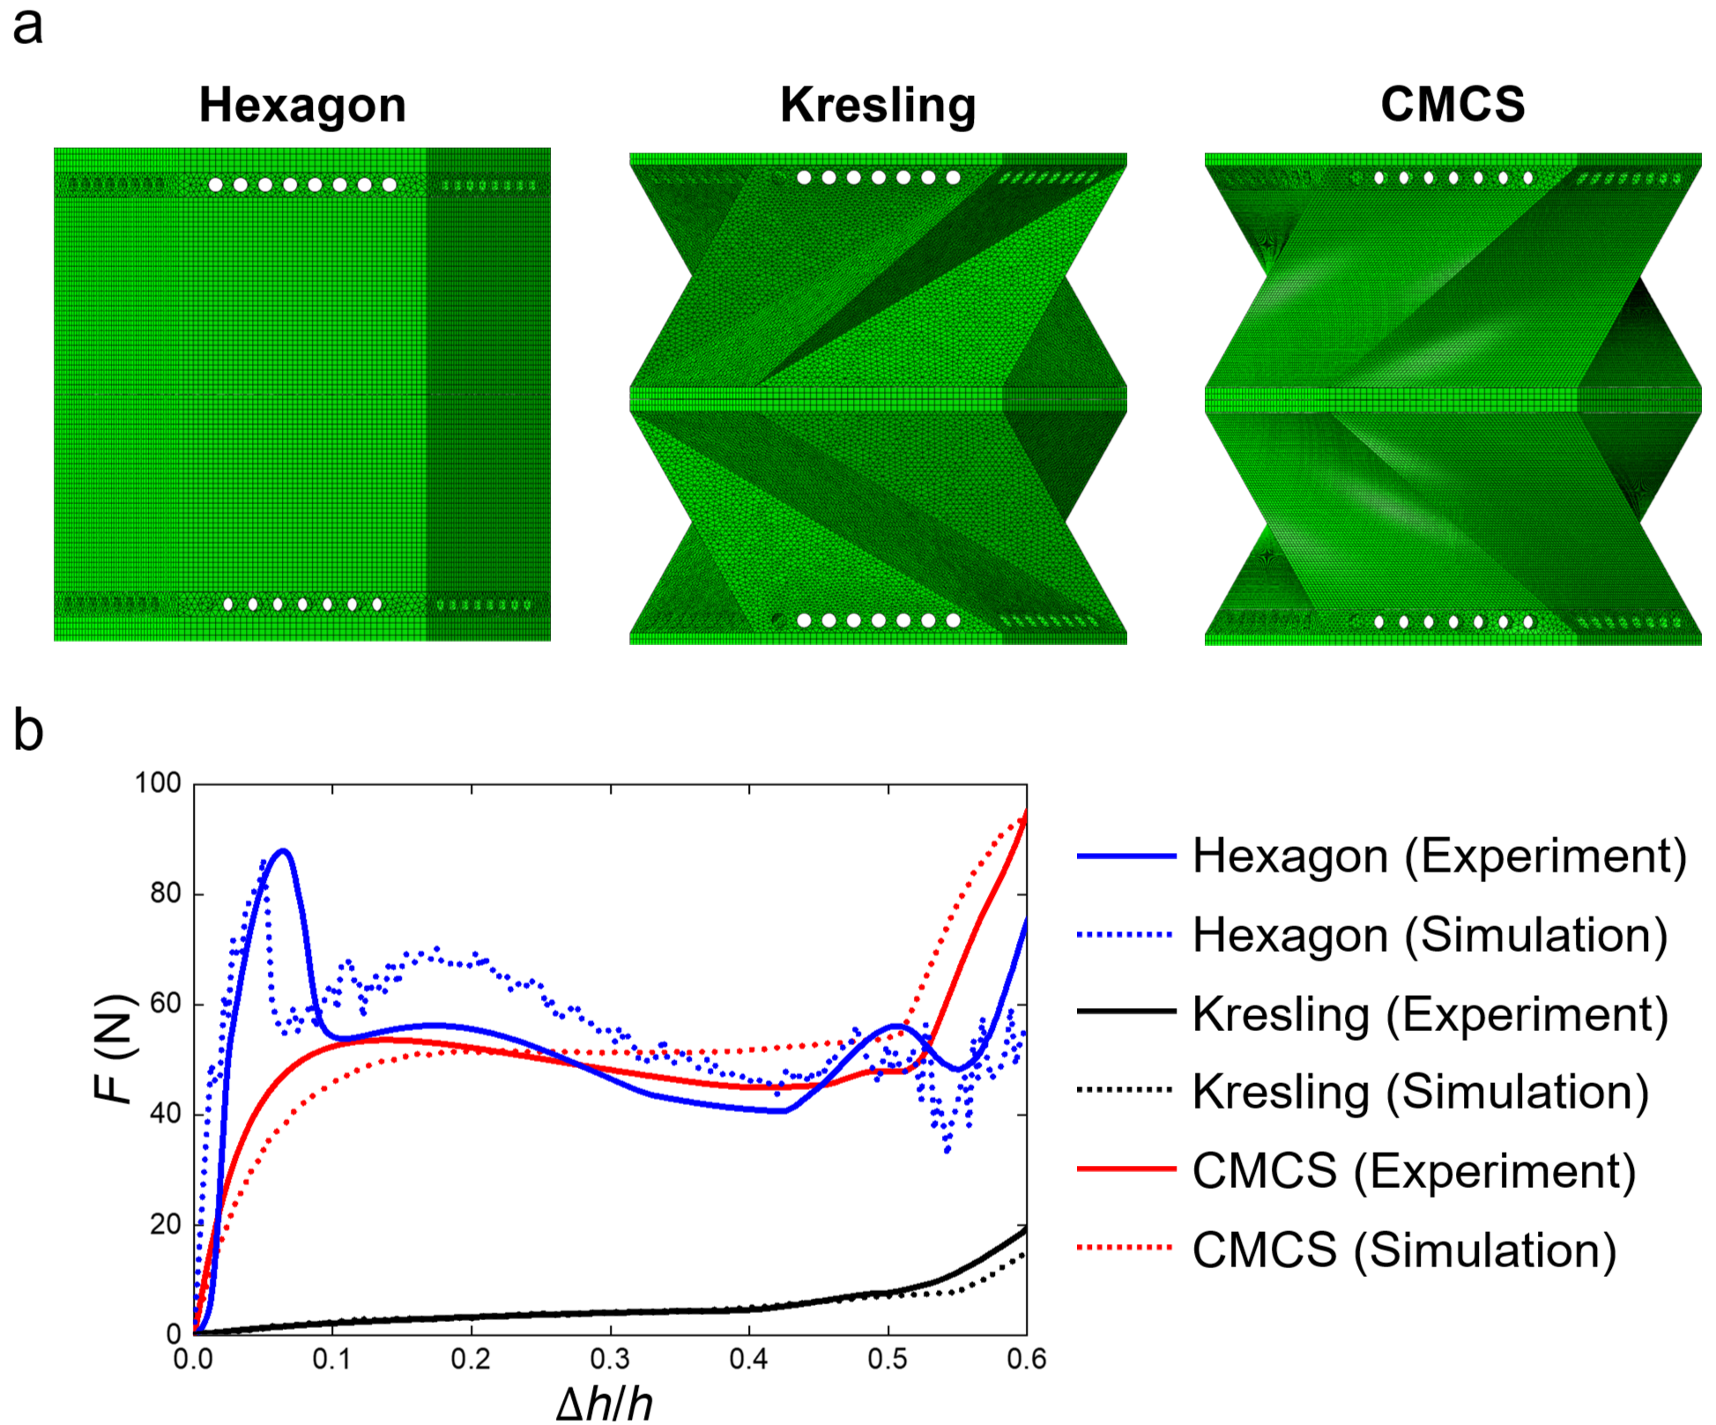
Supplementary Figure 7. Finite element models of the hexagon, Kresling, and CMCS metamaterials under quasi-static compression. a. Finite element mesh division of the hexagon, Kresling, and CMCS metamaterials. b. Force-displacement curves by experiments (solid lines) and simulations (dotted lines).

Supplementary Note 9. Experimental force-displacement curves for investigating the relationship of geometry parameters, EEA, and SEA.
To find an optimal metamaterial, dozens of experiments are conducted to discover the influence of geometry parameters, including the thickness $t$, the side number $n$, and the rotation angle $θ$, on force-displacement curves. In these experiments, only one geometry parameter is varied, while all other parameters remain unchanged, where $t=$ 1 mm, $θ=$ 60°, $n=$ 6, $h=$ 40 mm, $a$ = 20 mm, $b=$ 18 mm, $c=$ 1 mm, and $w=5\sqrt{3}$ mm. Supplementary Figure 8 presents all experimental force-displacement curves for $t=$ 1 mm to 1.8 mm, $n=$ 4 to 8, and , $θ=$ 30° to 90°, with the corresponding sample masses provided in Supplementary Table 1. The plateau force is observed to increase significantly with an increase in $t$, while the overall shapes of the curves remain similar. $n$ and $θ$ have a considerable effect on the shape of the force-displacement curve.
Supplementary Figure 8. Experimental force-displacement curves of CMCS metamaterials. Only one parameter varies while the others remain constant with the following values: $t=$ 1 mm, $θ=$ 60°, $n=$ 6, $h=$ 40 mm, $a$ = 20 mm, $b=$ 18 mm, $c=$ 1 mm, and $w=5\sqrt{3}$ mm. a. $t$ varies between 1 mm and 1.8 mm. b. $n$ varies between 4 and 8. c. $θ$ varies between 30° and 90°.

Supplementary Table 1. Masses of 3D-printed CMCS metamaterials in Supplementary Figure 8.
 | Number | Geometrical parameters |  |  | Anticipated mass (g) | Real mass (g) | Error (%)
 | Number | $t$ (mm) | $θ$ (°) | $$n$$ | Anticipated mass (g) | Real mass (g) | Error (%)
 | 1 | 1.0 | 60 | 6 | 7.75 | 7.71 | 0.52
 | 2 | 1.1 | 60 | 6 | 8.14 | 7.98 | 1.97
 | 3 | 1.2 | 60 | 6 | 8.52 | 8.45 | 0.82
 | 4 | 1.3 | 60 | 6 | 8.9 | 8.77 | 1.46
 | 5 | 1.4 | 60 | 6 | 9.29 | 9.16 | 1.4
 | 6 | 1.5 | 60 | 6 | 9.67 | 9.4 | 2.79
 | 7 | 1.6 | 60 | 6 | 10.04 | 9.86 | 1.79
 | 8 | 1.7 | 60 | 6 | 10.42 | 10.76 | 3.26
 | 9 | 1.8 | 60 | 6 | 10.79 | 10.92 | 1.2
 | 10 | 1.0 | 30 | 6 | 8.35 | 8.37 | 0.24
 | 11 | 1.0 | 60 | 4 | 5.96 | 6.11 | 2.52
 | 12 | 1.0 | 60 | 5 | 7.08 | 6.94 | 1.98
 | 13 | 1.0 | 60 | 7 | 8.15 | 8.05 | 1.23
 | 14 | 1.0 | 60 | 8 | 8.44 | 8.34 | 1.18
15 |  | 1.0 | 45 | 6 | 8.09 | 8.06 | 0.37
16 |  | 1.0 | 70 | 6 | 7.49 | 7.31 | 2.4
17 |  | 1.0 | 72 | 6 | 7.43 | 7.25 | 2.42
18 |  | 1.0 | 73 | 6 | 7.4 | 7.21 | 2.57
19 |  | 1.0 | 74 | 6 | 7.38 | 7.23 | 2.03
20 |  | 1.0 | 75 | 6 | 7.34 | 7.23 | 1.5
21 |  | 1.0 | 76 | 6 | 7.32 | 7.2 | 1.64
22 |  | 1.0 | 90 | 6 | 6.91 | 7.01 | 1.45

Supplementary Note 10. Take the cantilever beam as an example to illustrate that increasing thickness significantly enhances SEA of CMCS metamaterials.
Increasing the thickness $t$ of the CMCS metamaterial will greatly improve its SEA as illustrated in Figure 2a. To explain this phenomenon, we use a cantilever beam as an example, as both the cantilever beam and the curved shell of the CMCS metamaterial have one end fixed and the other end free. As shown in Supplementary Figure 9, the cross section of the cantilever beam is a square with $R_{1}$ and $R_{2}$, the length is $L$, a force is vertically applied at the free end, the material is assumed to be linearly elastic, isotropic, and homogeneous, and the small deformation is considered.

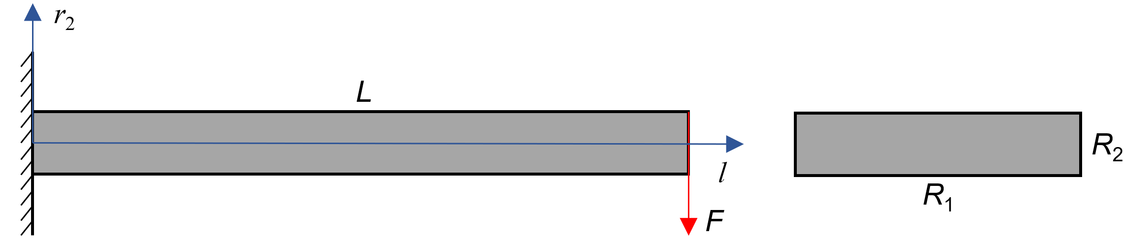
Supplementary Figure 9. Cantilever beam schematic diagram.

The second moment of inertia is as follows:
$I=\frac{R_{1} R_{2}^{3}}{12}$ (S17)
The relation of the force and displacement at the free end is the following equation:
$F\left(D\right)=\frac{3EID}{L^{3}}$ (S18)
where $D$ is the displacement at the free end.
The bending moment on a cross section can be expressed as:
$M\left(D,l\right)=F\left(D\right)l$ (S19)
The normal stress in a cross section can be calculated by the following equation:
$σ_{1}\left(r_{2},D,l\right)=\frac{M\left(D,l\right)r_{2}}{I}=\frac{3EDlr_{2}}{L^{3}}$ (S20)
where $r_{2}$ is the absolute distance from the center line of the cross section.
The bending strain energy is as follows:
$W_{1}=\int_{0}^{L}{\int_{-\frac{R_{2}}{2}}^{\frac{R_{2}}{2}}{\frac{σ_{1}^{2}\left(r_{2},D,l\right)}{2E}}}R_{1}dr_{2}dl=\frac{ED^{2}R_{1}}{8L^{3}}R_{2}^{3}$ (S21)
Hence, the SEA of the cantilever beam can be expressed as follows:
$SEA=\frac{W_{1}}{ρLR_{1}R_{2}}=\frac{ED^{2}}{8ρL^{2}}R_{2}^{2}$ (S22)
where $ρ$ is the density.
It can be seen from Eq. (S22) that increasing the thickness $R_{2}$ can significantly improve the SEA under the same deformation or displacement $D$. Therefore, increasing the thickness of curved shells will greatly enhance the SEA of CMCS metamaterials.

Supplementary Note 11. The EEA and SEA values for CMCS metamaterials with varying $w$
To absorb more energy per unit mass while keeping the EEA as high as possible—in other words, to increase the SEA—we discuss the effect of $w$ on the energy absorption curve. Supplementary Figure 10 shows cross-section views of these CMCS metamaterials with varying $w$, which would be fabricated by 3D-printing technology. Their EEA and SEA values by quasi-static compression experiments are given in Supplementary Table 2.

Supplementary Figure 10. Cross-section views of CMCS metamaterials with $w=5\sqrt{3}, 4\sqrt{3},3\sqrt{3},2\sqrt{3}$ and$,\sqrt{3}$ mm in Figure 2g. Other geometry parameters, including $n$, $θ$, $t$, $h$, $a$, $b$, and $c$, are 6, 72°, 1 mm, 40 mm, 20 mm, and 18 mm, respectively.

Supplementary Table 2. EEA and SEA values of CMCS metamaterials in Figure 2g.
$w$ (mm) | EEA | SEA (J/kg)
$$5\sqrt{3}$$ | 0.90 | 65.4
$$4\sqrt{3}$$ | 0.90 | 69.2
$$3\sqrt{3}$$ | 0.91 | 75.7
$$2\sqrt{3}$$ | 0.88 | 83.9
$$\sqrt{3}$$ | 0.87 | 104.7

Supplementary Note 12. Detailed information on the CMCS metamaterial and the re-entrant metamaterial.
Supplementary Figure 10 show the configurations of the CMCS metamaterial and the re-entrant metamaterial in Figure 3b. For the CMCS metamaterial, the values of $n$, $θ$, $t$, $h$, $a$, $b$, $c$, and $w$ are 6, 72°, 1.4 mm, 40 mm, 20 mm, 18 mm, 1 mm, and $3\sqrt{3}$ mm, respectively. Its units are arranged squarely, as shown in Supplementary Figure 10a. The center points of each unit are spaced 42 mm apart in pressure surface direction to prevent collisions between adjacent middle planes during compression and rotation. For the re-entrant metamaterial, its shape is illustrated in Supplementary Figure 10b. It is arranged in a triangular pattern on the plumb plane, and the overall dimensions are 123 mm in length, 42 mm in width, and 40 mm in height, respectively. The CMCS and re-entrant metamaterials have masses of 68.58 g and 55.4 g, respectively. Their pressure areas of them are assumed to be 42×42×9 = 15876 mm² for the CMCS metamaterial and 42×123 = 5166 mm² for the re-entrant metamaterial.
Supplementary Figure 10. Configurations of metamaterials in Figure 3b. a. The CMCS metamaterial. b. The re-entrant metamaterial.

Supplementary Note 13. The comparison of energy absorption indices for the CMCS and re-entrant metamaterials.
EEA, SEA, plateau phase, densification displacement, and ULC for the CMCS and re-entrant metamaterials are compared in Figure 3c, of which values are provided in Supplementary Table 3.

Supplementary Table 3. EEA, SEA, plateau phase, densification displacement, and ULC values for the CMCS and re-entrant metamaterials in Figure 3c.
Energy absorption index | CMCS metamaterial | Re-entrant metamaterial
EEA, EEA | 0.88 | 0.74
SEA, SEA (J/kg) | 200 | 64
Plateau phase, $D_{P}$ (mm) | 0.352 | 0.288
Densification displacement, $D_{D}$ (mm) | 0.463 | 0.342
ULC, $χ_{ULC}$ | 0.13 | 0.14

Supplementary Note 14. Drop hammer test.
As illustrated in Supplementary Figure 11, the drop hammer machine system is mainly composed of a gripper, a pair of slide rails, a hammer body, a hammer head, a sensor, a platform, a main console, and a data acquisition system. To simulate practical protective drop scenarios, the printed CMCS metamaterial is affixed to the bottom of the hammer head using double-sided tape, as shown in Supplementary Figure 12. When either the CMCS metamaterial or the hammer head contacts the platform, an accelerometer records the hammer's response. The hammer has a mass of 1 kg, and the drop height—measured from the bottom of the CMCS metamaterial to the top of the platform—is set to be 1.0 m. Twenty identical drop tests are conducted on the CMCS metamaterial to evaluate its reusability.
Supplementary Figure 11. The drop hammer machine system. It is mainly composed of a gripper, a pair of slide rails, a hammer body, a hammer head, a sensor, a platform, a main console, and a data acquisition system. Additionally, a computer is used for data display and process.

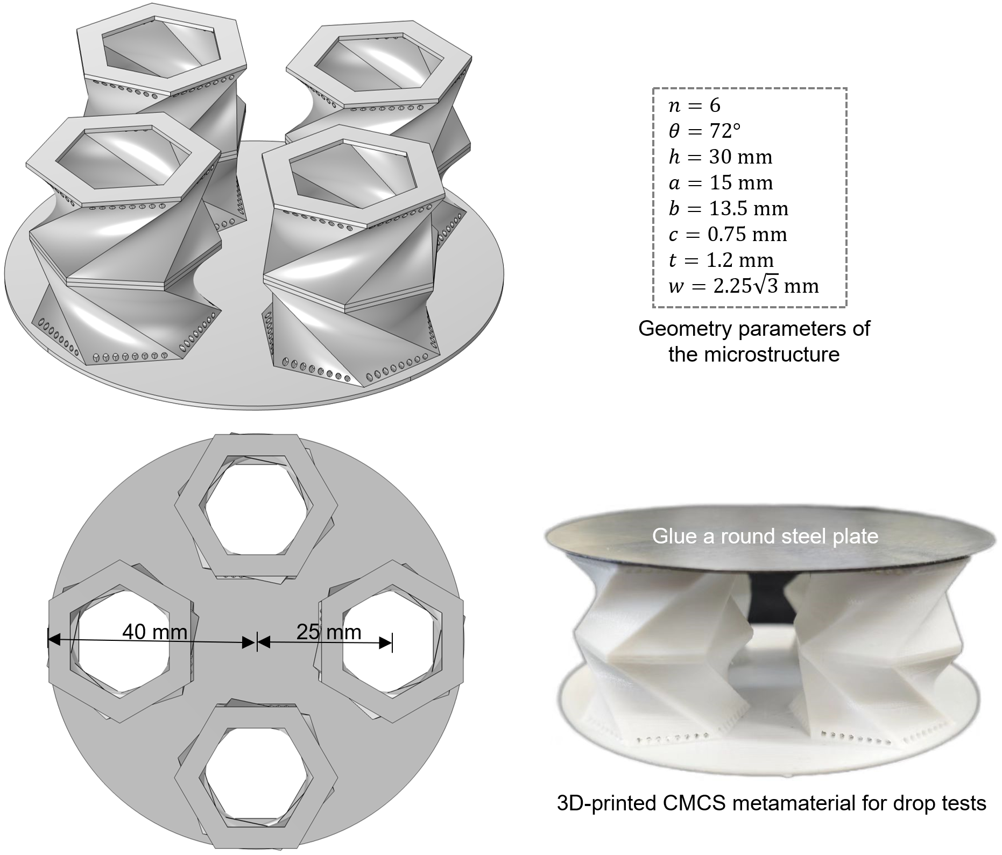
Supplementary Figure 12. The CMCS metamaterial for drop tests. Its shape is proportionally scaled down to 75% of that in Figure 2h, except for the thickness $t$, and its mass is 16.5 g. A round steel plate is affixed to the impact face, of which diameter and thickness are 80 mm and 0.6 mm, respectively.

Supplementary References
[1] Liu, C. X., Wang, X., Liu, W., Yang, Y. F., Yu, G. L., & Liu, Z. (2024). A physics-informed neural network for Kresling origami structures. International Journal of Mechanical Sciences, 269, 109080.

