Supporting Information
The ionic and protonation states of flavin control the activation and recovery of Drosophila cryptochrome
Wenlong Xie#, Mengqi Wan#, Yuting Dai, Yingjun Jiang, Mohan Wang, Lili Zhou, Li Zhang, Linmei Sun, Xiaoyu Feng, Bin Wen, Jun Lv, Xiuxiu Wang*, Lei Xu*
Department of Biochemistry and Molecular Biology, School of Basic Medicine, Wannan Medical College, Wuhu, Anhui, 241002, China.

This PDF file includes the following:
Figures S1 to S10
Tables S1 to S2

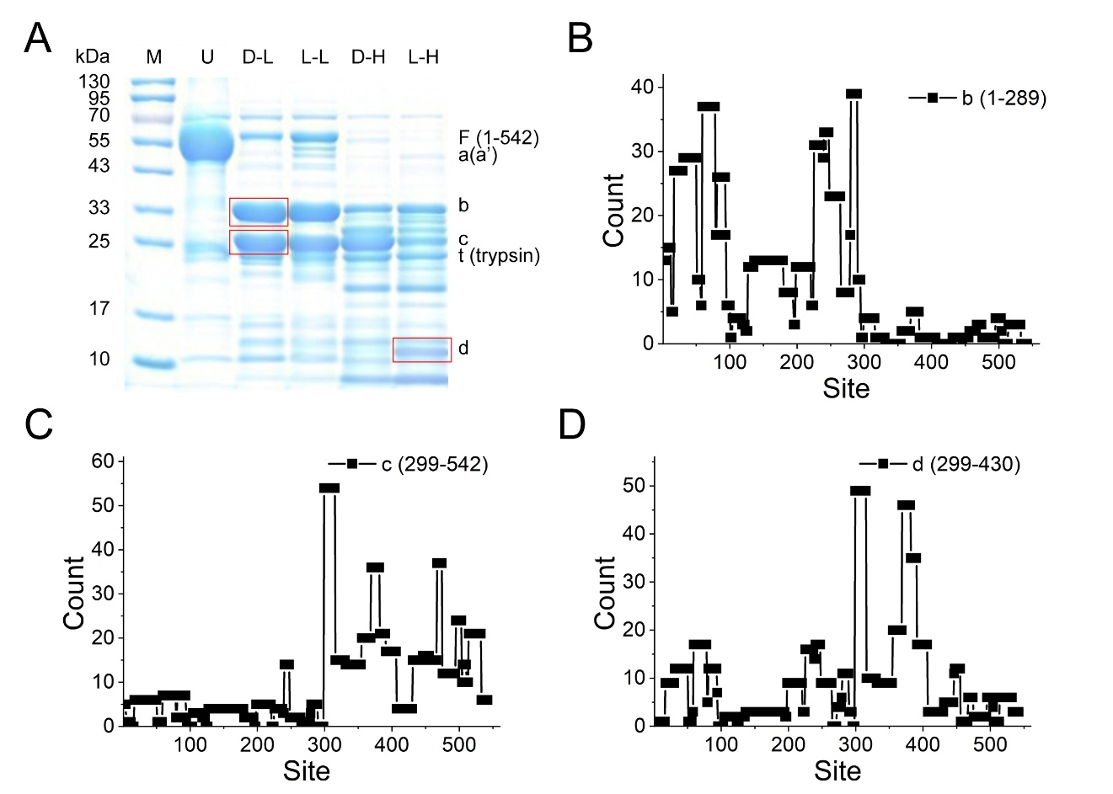
Figure S1. Mass spectroscopy analyses to determine the positions of the proteolysis fragments in dCry. (A) SDS‒PAGE results of proteolysis samples. Lane M was the marker. Lane U represents the untreated dCry protein. Lanes D-L and L-L, a trypsin:dCry molar ratio of 1:50 was used to digest dCry in the dark and light, respectively. Lanes D-H and L-H, a trypsin:dCry molar ratio of 1:1 was used to digest dCry in the dark and light, respectively. The band positions of the analyzed fragments are highlighted with red boxes. (B), (C), and (D) Fragments b, c, and d were cut from the gel and further digested by trypsin. The resulting fragments were analyzed via mass spectrometry. The fragment counts of each site were recorded and plotted. The positions of fragments b, c, and d were determined to be 1-289, 299-542, and 299-430, respectively.

Figure S2. The photoreduction and CTT release of dCry are fundamentally reversible. (A) Absorption spectra and (B) proteolysis analysis of dCry during oxidation after photoreduction at pH 7.5. (C) Kinetics of redox states and CTT redocking of dCry during oxidation. The red line represents the fitted curve of asq oxidation (k_{asqox} ~0.17 min⁻¹). The degree of CTT release is represented by the intensity ratio of fragment d to the sum of fragments c and d (orange stars).

Figure S3. The isolated spectra of (A) C416N in the ox, asq, nsq, and hq states; and (B) L405E/C416N in the ox, nsq, and hq states obtained by manipulation of the photoreduction spectra.

Figure S4. In vivo stability of (A) wild-type dCry, (B) the C416 mutant, and (C) the L405E/C416N mutant under illumination (λ_{max} = 440 nm, irradiance of ~ 9.5 W m⁻²) for various periods of time. (D) Comparison of the protein levels of dCry, C416N, and L405E/C416N under illumination (n = 3). * p < 0.05, ** p < 0.01.

Figure S5. The oxidation rates of dCry are pH dependent. (A) The isolated spectra of dCry in the ox, asq and nsq states obtained by manipulation of the photoreduction spectra at different pH values. (B) Absorption spectra and (C) proteolysis analysis of dCry during oxidation after photoreduction at pH 6.5. (D) Kinetics of redox states and CTT redocking of dCry during oxidation. The red line represents the fitted curve of asq oxidation (k_{asqox} ~0.27 min⁻¹). (E) Absorption spectra and (F) proteolysis analysis of dCry during oxidation after photoreduction at pH 9.0. (G) Kinetics of redox states and CTT redocking of dCry during oxidation. The red line represents the fitted curve of asq oxidation (k_{asqox} ~0.06 min⁻¹). The degree of CTT release is represented by the intensity ratio of fragment d to the sum of fragments c and d (orange stars). (H) Comparison of the oxidation rates of dCry in the asq state at pH 6.5 (black boxes), 7.5 (red circles), and 9.0 (blue triangles).

Figure S6. In vivo stability of (A) the mutant that deleted CTT (dCT), (B) the F534A mutant, (C) the F535A mutant, and (D) the W536A mutant under illumination (λ_{max} = 440 nm, irradiance of ~ 9.5 W m⁻²) for various periods of time. (D) Comparison of the protein levels of wild-type dCry, dCT, F534A, F535A, and W536A under illumination (n = 3). * p < 0.05, ** p < 0.01.

Figure S7. The photoreduction and oxidation of the dCT mutant are pH independent. Illumination of dCT at (A) pH 6.5 and (B) pH 9.0 led to the formation of nearly pure asq. (C), (D), and (E) Absorption spectra of dCT oxidation after photoreduction at pH 6.5, 7.5, and 9.0, respectively. (F) The oxidation rates (k_{ox}) of asq in dCT after photoreduction at different pH values.

Figure S8. The photoreduction, CTT release, and oxidation of the F535A mutant. (A) Absorption spectra and (B) proteolysis analysis of F535A during photoreduction and redocking after oxidation for 120 min. (C) Kinetics of the redox states and CTT release of F535A during photoreduction. The red line represents the fitted curve of asq formation in F535A during photoreduction (k_{pr} ~ 0.04 s⁻¹). The degree of CTT release is represented by the intensity ratio of fragment d to the sum of fragments c and d (orange stars). (D) Absorption spectra of F535A oxidation after photoreduction. The oxidation rate (k_{ox}) of the F535A mutant was ~0.06 min⁻¹.

Figure S9. The oxidation properties of the F534A and W536A mutants. Absorption spectra of (A) F534A and (B) W536A oxidation after photoreduction. The oxidation rates (k_{ox}) of F534A and W536A were ~0.08 min⁻¹ and ~0.09 min⁻¹, respectively. (C) Proteolysis of W536A during oxidation after photoreduction. (D) Kinetics of the redox state and CTT redocking of W536A during oxidation. The red line represents the fitted curve of asq oxidation. The degree of CTT release is represented by the intensity ratio of fragment d to the sum of fragments c and d (orange stars).

Figure S10. In vivo stability of (A) the H378A mutant, (B) the H378K mutant, and (C) the H378D mutant under illumination (λ_{max} = 440 nm, irradiance of ~ 9.5 W m⁻²) for various periods of time. (D) Comparison of the protein levels of wild-type dCry, H378A, H378K, and H378D under illumination (n = 3). * p < 0.05, ** p < 0.01.
Table S1. The nsq fractions of the total semiquinone (asq + nsq) were approximately constant during photoreduction of dCry at each pH.
Time (s) | pH 6.5 |  |  |  | pH 7.5 |  |  |  | pH 9.0
Time (s) | asq | nsq | nsq/(asq + nsq) |  | asq | nsq | nsq/(asq + nsq) |  | asq | nsq | nsq/(asq + nsq)
0 | 0.00 | 0.00 | - |  | 0.00 | 0.00 | - |  | 0.00 | 0.00 | -
10 | 0.28 | 0.16 | 0.36 |  | 0.41 | 0.06 | 0.14 |  | 0.52 | 0.01 | 0.02
30 | 0.42 | 0.23 | 0.36 |  | 0.68 | 0.10 | 0.14 |  | 0.84 | 0.03 | 0.03
60 | 0.50 | 0.27 | 0.36 |  | 0.79 | 0.11 | 0.14 |  | 0.94 | 0.03 | 0.03
120 | 0.53 | 0.27 | 0.34 |  | 0.82 | 0.10 | 0.12 |  | 0.96 | 0.03 | 0.03
180 | 0.53 | 0.28 | 0.34 |  | 0.83 | 0.11 | 0.13 |  | 0.95 | 0.03 | 0.03
300 | 0.54 | 0.28 | 0.34 |  | 0.83 | 0.11 | 0.13 |  | 0.95 | 0.03 | 0.03

Table S2. The nsq fractions of the total semiquinone (asq + nsq) during photoreduction of the His378 mutants at pH 7.5.
Time (s) | H378A |  |  |  | H378K |  |  |  | H378D
Time (s) | asq | nsq | nsq/(asq + nsq) |  | asq | nsq | nsq/(asq + nsq) |  | asq | nsq | nsq/(asq + nsq)
0 | 0.00 | 0.00 | - |  | 0.00 | 0.00 | - |  | 0.00 | 0.00 | -
10 | 0.08 | 0.11 | 0.57 |  | 0.30 | 0.07 | 0.20 |  | 0.28 | 0.02 | 0.07
30 | 0.10 | 0.12 | 0.54 |  | 0.32 | 0.08 | 0.20 |  | 0.79 | 0.04 | 0.05
60 | 0.13 | 0.14 | 0.52 |  | 0.34 | 0.08 | 0.19 |  | 0.91 | 0.04 | 0.05
120 | 0.18 | 0.15 | 0.45 |  | 0.36 | 0.07 | 0.17 |  | 0.94 | 0.05 | 0.05
300 | 0.26 | 0.16 | 0.39 |  | 0.45 | 0.08 | 0.15 |  | 0.95 | 0.05 | 0.05
480 | 0.38 | 0.20 | 0.34 |  | 0.52 | 0.08 | 0.13 |  | 0.95 | 0.06 | 0.06
600 | 0.45 | 0.21 | 0.31 |  | 0.58 | 0.09 | 0.13
900 | 0.52 | 0.21 | 0.29 |  | 0.62 | 0.08 | 0.12
1200 | 0.53 | 0.20 | 0.27 |  | 0.57 | 0.07 | 0.11
1800 | 0.51 | 0.18 | 0.27 |  | 0.45 | 0.06 | 0.11

