Supplementary Information

Nanozyme-based Robots Swarm with Exciton-Engineered Z-Scheme Heterojunctions for Depth-Resolved Tumour Penetration and Therapy
Zhengya Yue¹, Minglu Tang¹, Shuo Wang¹, Xiangwei Liu¹, Tiedong Sun^{1,}*, Li Shang^{2,}*, and Zhiguang Wu^{3,}*
Affiliations
¹ College of Chemistry, Chemical Engineering and Resource Utilization Northeast Forestry University Harbin 150040, P. R. China.
Z. Y., M. T., S. W., X. L., J. L., & Prof. T. S (E-mail: tiedongsun@nefu.edu.cn)
² State Key Laboratory of Solidification Processing, School of Materials Science and Engineering, Northwestern Polytechnical University, Xi'an 710072, P. R. China.
Prof. L. S., (E-mail: li.shang@nwpu.edu.cn)
³ School of Medicine and Healthcare, State Key Laboratory of Robotics and System, Harbin Institute of Technology, Harbin 150080, P. R. China.
Prof. Z. W. (E-mail: zhiguangwu@hit.edu.cn)

Supplementary Figures
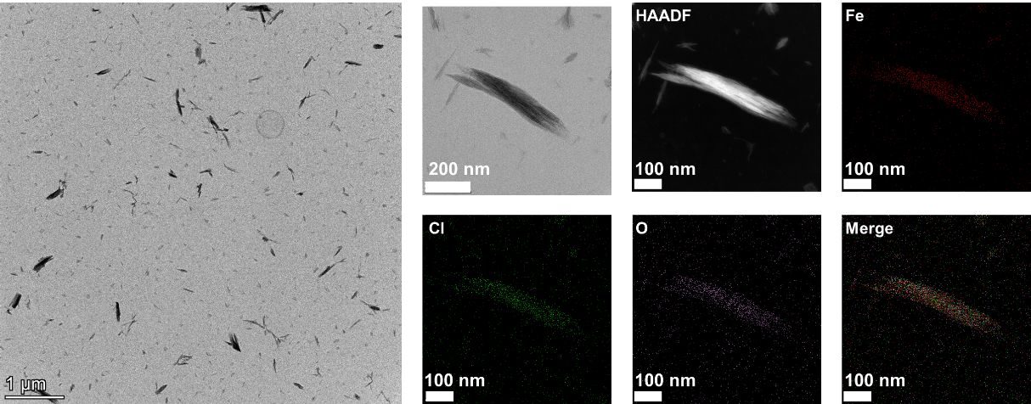
Supplementary Figure 1. Transmission electron microscopy (TEM), and Energy dispersive X-ray spectroscopy (EDS) mapping images of NRs. (HAADF, Fe, Cl, O and Merege)
Supplementary Figure 2. EDS spectroscopy of the NRs (Fe, O, Cl, P, and Mo elements).

Supplementary Figure 3. Histogram of content of different elements in NRs and EDNRs (Fe, O, Cl, P, and Mo elements).

Elements | NRs | EDNRs
O | 68.9% | 65.5%
P | 0% | 0.6%
Cl | 10.4% | 9.1%
Fe | 20.7% | 19.0%
Mo | 0% | 5.8%

Supplementary Figure 4. The different elements content in NRs and EDNRs (Fe, O, Cl, P, and Mo elements).

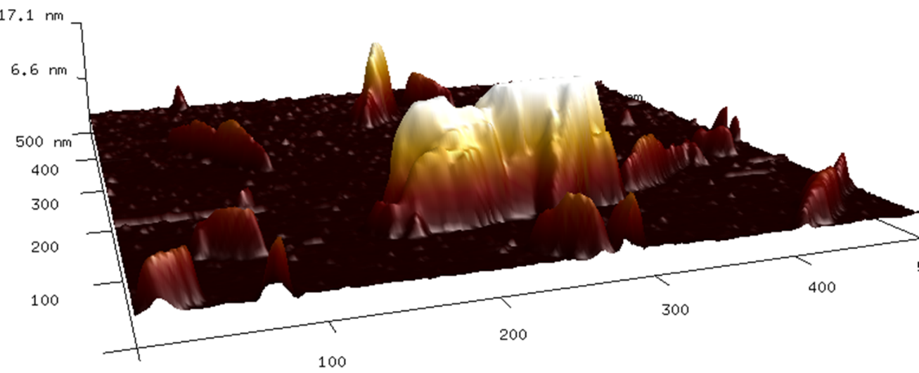
Supplementary Figure 5. 3D Atomic force microscopy (AFM) image of EDNRs.

Supplementary Figure 6. The high-resolution XPS spectra of Fe 2p in NRs and corresponding fitting analysis.

Supplementary Figure 7. The high-resolution XPS spectra of Cl 2p in NRs and EDNRs
Supplementary Figure 8. Nyquist plots of the electrochemical impedance spectrum (EIS) of NRs NSs and EDNRs.

Supplementary Figure 9. UV–vis spectra of TMB at various concentrations of EDNRs.

Supplementary Figure 10. UV–vis spectra of DPBF at various concentrations of EDNRs.

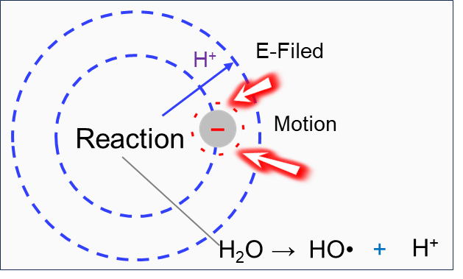
Supplementary Figure 11. The mechanism illustration of light-induced Chemotaxis motion of EDNRs.

Supplementary Figure 12. The corresponding norlarmized intensity of 5(6)-FAM.

Supplementary Figure 13. Relative cell viability of normal L929 cells after incubation with EDNRs for 24 h and 48 h.

Supplementary Figure 14. The quantitative calculations of the corresponding live/dead fluorescence images.

Supplementary Figure 15. The corresponding intensity of DCF.

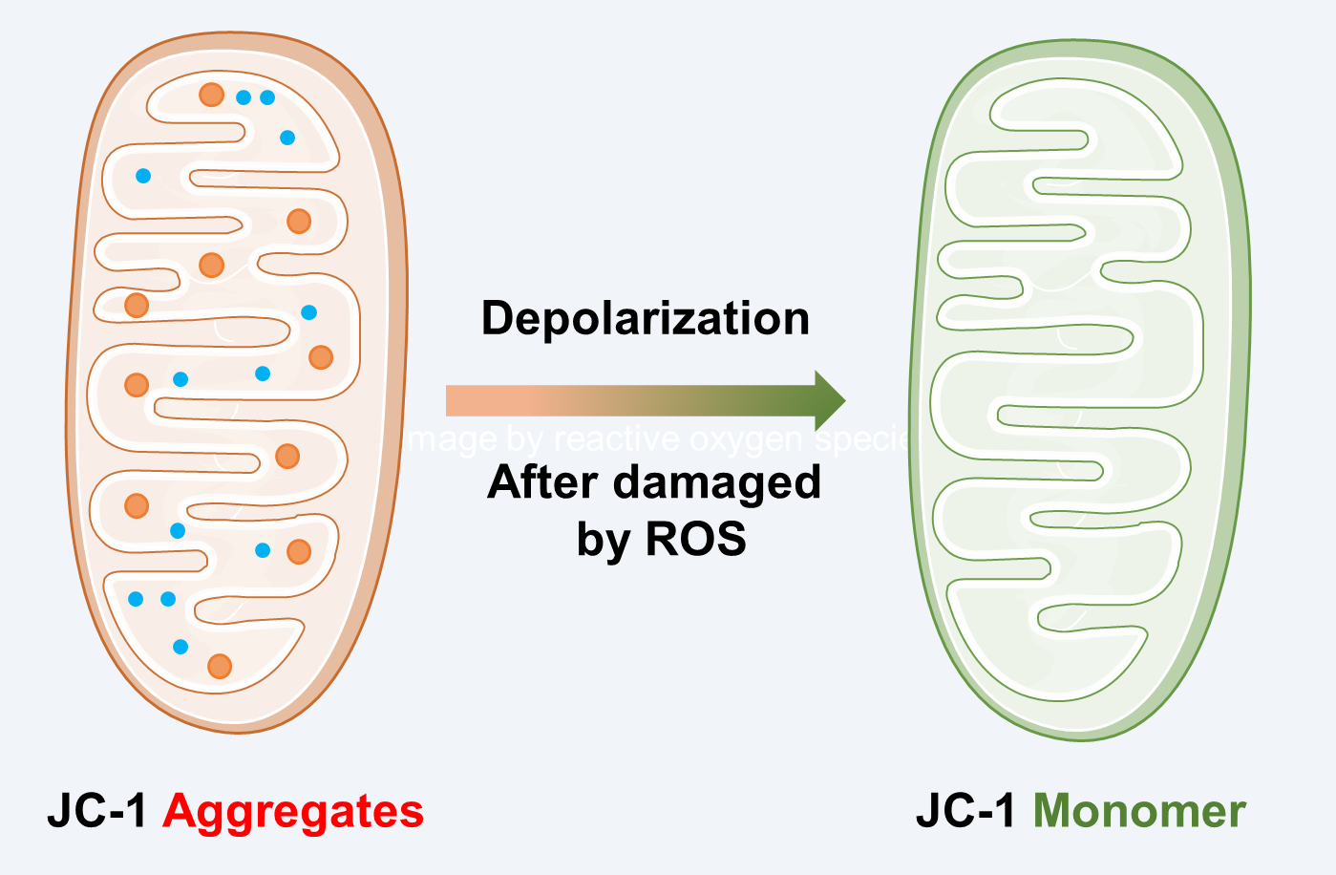
Supplementary Figure 16. Diagram il of the JC-1 assays for the detection of mitochondrial membrane potential (MMP).
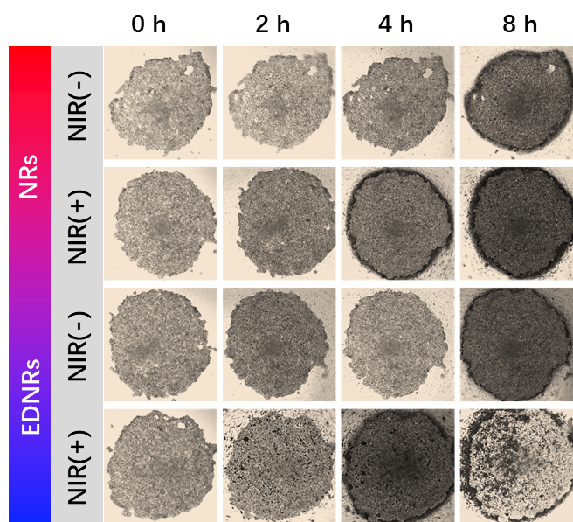
Supplementary Figure 17. Digital images of 3D MTSs after different treatments Motor and Non-Motor with or without NIR irration.

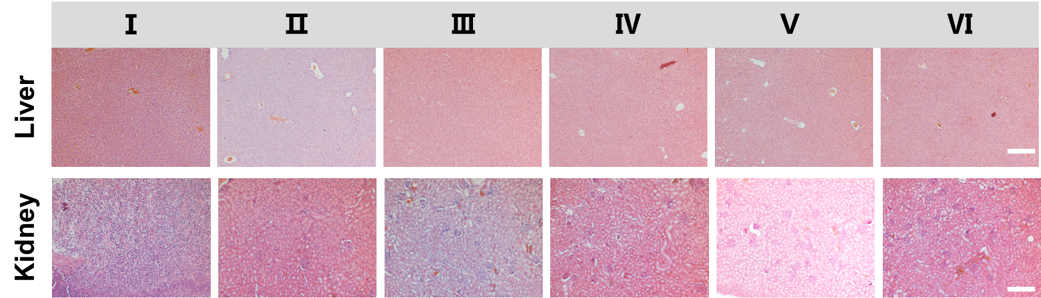
Supplementary Figure 18. H&E staining images of liver and kidney in the various treatments: (Ⅰ) Ctrl, (Ⅱ) NIR, (Ⅲ) NRs, (Ⅳ) NRs+NIR, (Ⅴ) EDNRs and (Ⅵ) EDNRs+NIR. (scale bar: 200 µm).

Information for the supporting videos:
Supplementary Movie.1 The motion trajectories of NRs, NRs+NIR, EDNRs and EDNRs+NIR (NIR 650 nm).
Supplementary Movie.2 The collective swarm motion of the EDNRs.
Supplementary Movie.3 The chemotaxis movement of EDNRs swarms.

