Supplementary Information

CRYβB2 is a biomarker for poor prognosis and response to CDK4/6 inhibitors in breast cancer

Yu Yan et al.

Supplementary Material
Antibody list. Antibodies and conditions used for Western Blot (WB), Immunohistochemistry (IHC) and Immunofluorescence (IF).
Name | Company | Catalog No. |  | Dilution
 |  |  | WB | IHC | IF
CRYβB2 | Thermo Fisher | PA5-60496 | 1:800 | 1:200 | 1:50
 | Santa Cruz | sc-376006 | 1:1000 |  | 1:50
 | Novus | NBP2-13876 | 1:1000 | 1:100 | 1:50
Beta-actin | Sigma | A2228 | 1:3000
CDK4 | Cell Signaling | 12790T | 1:1000 | 1:400
Cdc25a | Cell Signaling | 3652S | 1:1000
ppRb | Cell Signaling | 8516T | 1:1000 | 1:200
Rb | Cell Signaling | 9309 | 1:2000
Nucleolin | Cell Signaling | #14574 | 1:1000 | 1:400 | 1:1000
DYKDDDDK_tag | Cell Signaling | #14793 |  |  | 1:800
Myc_Tag | Cell Signaling | #2278 |  |  | 1:200
p53 (DO-1) | Santa Cruz | SC-126 | 1:2000
GAPDH | Cell Signaling | #97166 | 1:2000
Rabbit IgG | GE lifesciences | NA934V | 1:3000
Mouse IgG | GE lifesciences | NA931 | 1:3000
Rabbit IgG A647 | Thermo Fisher | A-21247 |  |  | 1:2000
Mouse IgG A488 | Thermo Fisher | A-11001 |  |  | 1:2000
Hoechst | Thermo Fisher | H3570 |  |  | 1:1000

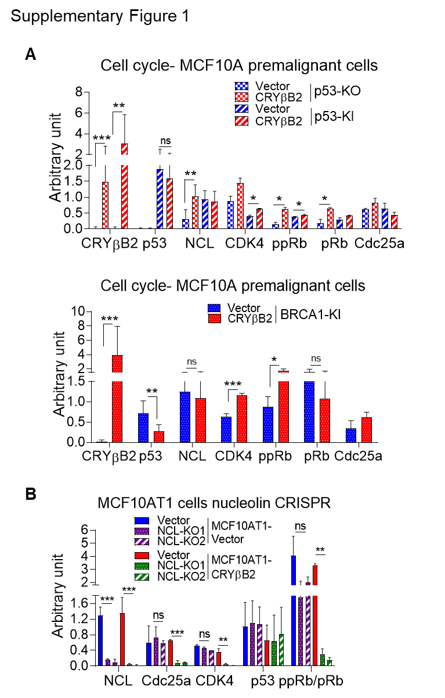

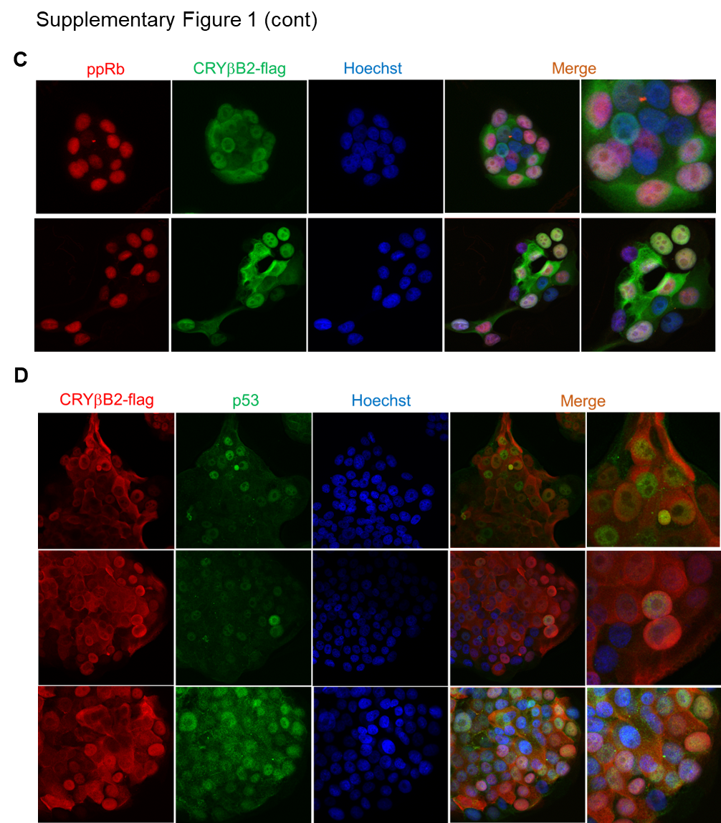
Supplementary Fig. 1. CRYβB2 activates CDK4/ pRb pathway in premalignant tumors and DCIS. Image J quantification of CRYβB2 and cell cycle proteins in premalignant MCF10A-p53 null (KO), p53-R248W knockin (KI) cells, and MCF10A-BRCA1-185delAG KI cells (A) and MCF10AT1- CRYβB2 and vector, containing NCL wild-type or knockout (NCL-KO#1 and #2) (B). Immunofluorescence staining of MCF10AT1- CRYβB2 cells with anti-ppRb (red), anti-CRYβB2-flag (green) (C), anti- CRYβB2-flag (red), anti-p53 (green) (D) and Hoechst (blue). The merge of the fluorescent channels is shown (right). * p < 0.05, ** p< 0.01 and *** p< 0.001.

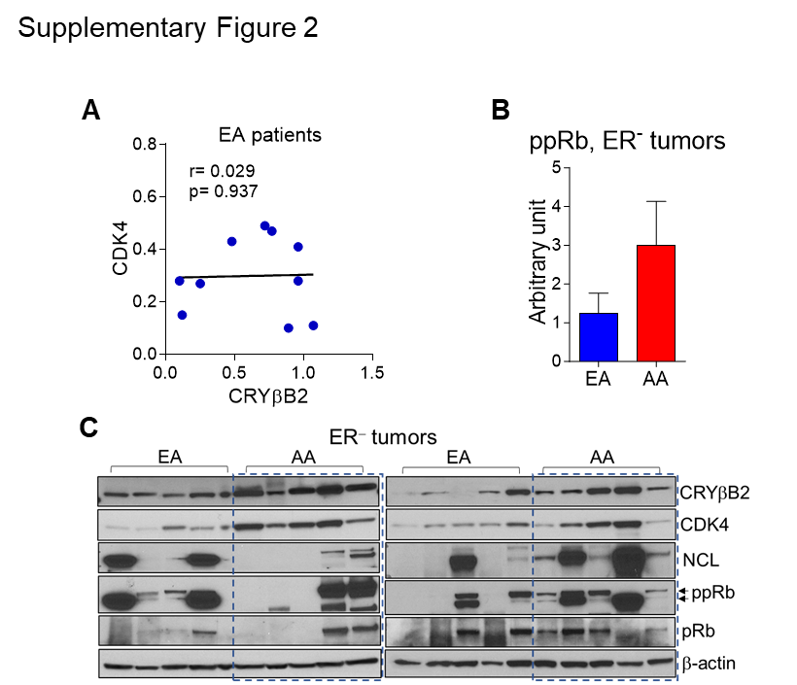

Supplementary Fig. 2. CRYβB2 activates CDK4/ pRb pathway in ER⁻ and ER⁺ breast tumors of AA and EA women. A. Correlation of CRYβB2 and CDK4 proteins in ER⁻ tumors from EA women (n=10 each). B. Image J quantification of ppRb protein in ER⁻ tumors of AA and EA women. C. Western blot analysis of CRYβB2 and proteins involved in cell cycle progression in ER⁻ tumors of AA and EA women. Arrows indicate hyper- (upper band) and hypo- (lower band) phosphorylated forms of pRb. * p < 0.05, ** p< 0.01 and *** p< 0.001.
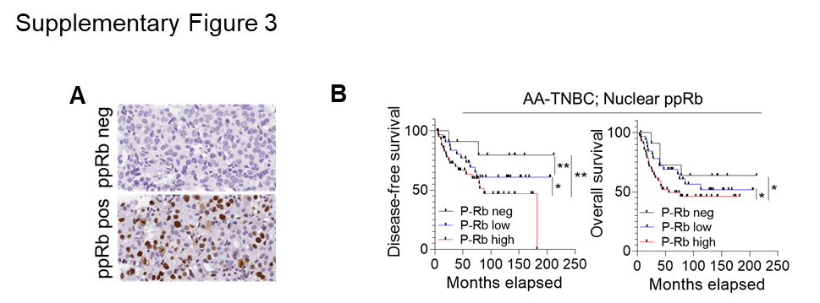
Supplementary Fig. 3. CRYβB2 and ppRb associate with poor TNBC outcome in AA women. A. Representative images of phosphorylated pRb (ppRb) IHC showing ppRb negative and positive tumors using TNBC from AA women (n=102). B. Kaplan Meier curves for disease-free and overall survival among AA- TNBC patients(n=86) according to ppRb negative, low and high expression.

