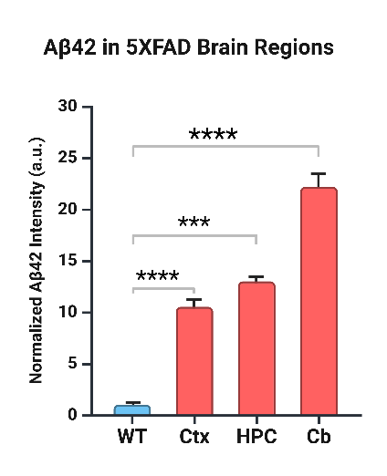

Figure 1 Normalized Aβ42 intensity in different brain regions of 5XFAD mice compared to (WT) controls. Quantitative analysis of Aβ42 immunoreactivity (expressed in arbitrary units, a.u.) was performed in the cortex (Ctx), hippocampus (HPC), and cerebellum (Cb). 5XFAD mice exhibited significantly elevated Aβ42 levels in all regions compared to WT controls. Among the analyzed regions, the cerebellum showed the highest accumulation, followed by the hippocampus and cortex. Data are presented as mean ± s.e.m. Statistical analysis was conducted using unpaired Welch’s t-tests. Significant differences were observed in the cortex (t (8.72) = -20.22, p < 0.0001, Cohen’s d = 9.53), hippocampus (t(9.43) = -8.49, p < 0.0001, Cohen’s d = 4.00), and cerebellum (t(8.12) = -10.45, p < 0.0001, Cohen’s d = 4.93). Effect sizes indicate extremely large differences between WT and 5XFAD groups in all regions analyzed. *p < 0.05, **p < 0.01, ***p < 0.001, ****p < 0.0001.

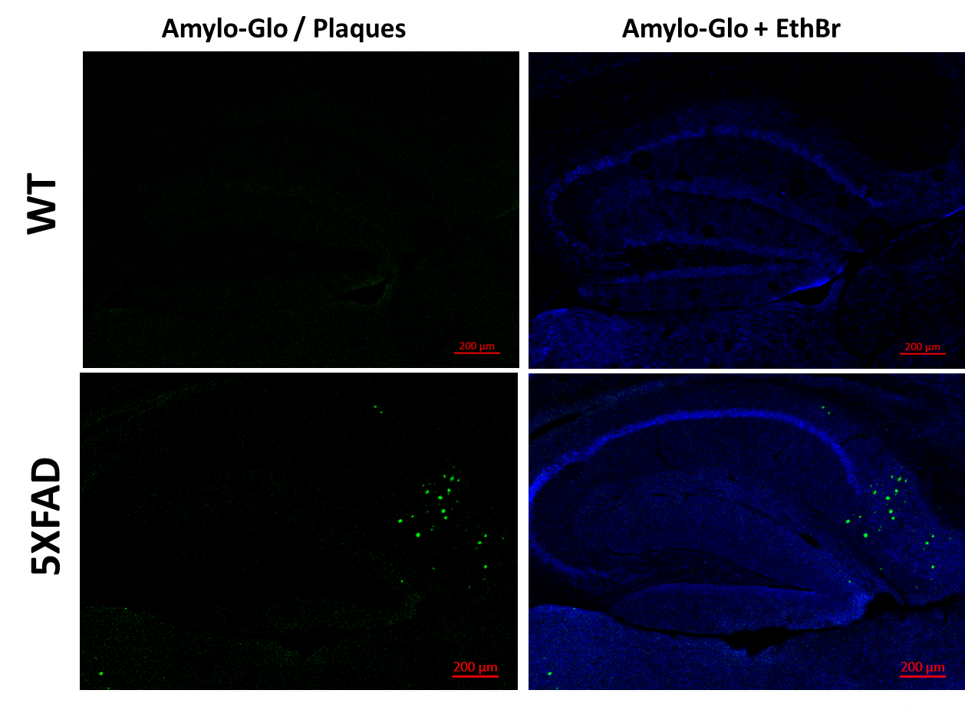
Figure 2 Amylo-Glo Fluorescence Staining for Amyloid Plaques in 5XFAD and WT Mice (Left panels) Hippocampal fluorescence images of WT (top) and 5XFAD (bottom) mice, showing significantly increased plaque burden in 5XFAD mice. (Right panels) Higher magnification of the subiculum (Sub) in WT vs. 5XFAD mice, demonstrating intense plaque accumulation in 5XFAD brains, whereas WT sections lack amyloid deposits. Blue (DAPI staining) highlights cell nuclei, while green Amylo-Glo fluorescence marks amyloid plaques.

