Supplementary Information for
Correlations between Human Alveolar Macrophage Particulate Matter Load, Air Pollution Particulate Matter Levels, and Systemic Inflammation Markers in Mexico City

Yeongkwon Son¹*, Claudia Carranza², Sanjana Subramhanya³, Carol Gardner³, Kathleen Black⁴, Laura Jones³, Qingyu Meng¹, Martha Torres², Alvaro Osornio Vargas⁵, Junfeng (Jim) Zhang^{6,7}, Marie S. O'Neill^{8,9}, Pamela Ohman Strickland¹⁰, and Stephan Schwander^{3,11,12}

¹Desert Research Institute, Reno, NV, USA
²Laboratory of Immunobiology of Tuberculosis, National Institute of Respiratory Diseases "Ismael Cosío Villegas," México City, México
³Department of Environmental and Occupational Health and Justice, School of Public Health, Rutgers University, Piscataway, New Jersey, USA
⁴Environmental and Occupational Health Science Institute-Clinical Research and Occupational Medicine, Rutgers University, Piscataway, New Jersey, USA
⁵Department of Pediatrics, University of Alberta, Edmonton, Alberta, Canada
⁶Duke Global Health Institute, Duke University, Durham, North Carolina, USA
⁷Nicholas School of the Environment, Duke University, Durham, North Carolina, USA
⁸Department of Epidemiology, School of Public Health, University of Michigan, Ann Arbor, Michigan, USA
⁹Department of Environmental Health Sciences, School of Public Health, University of Michigan, Ann Arbor, Michigan, USA
¹⁰Department of Biostatistics and Epidemiology, School of Public Health, Rutgers University, Piscataway, New Jersey, USA
¹¹Department of Urban-Global Public Health, School of Public Health, Rutgers University, New Brunswick, New Jersey, USA
¹²Division of Global Environmental Health, Environmental and Occupational Health Sciences Institute, Piscataway, NJ 08854

*Corresponding author.

S1. Cell profiler Flow chart for AM PM load analysis
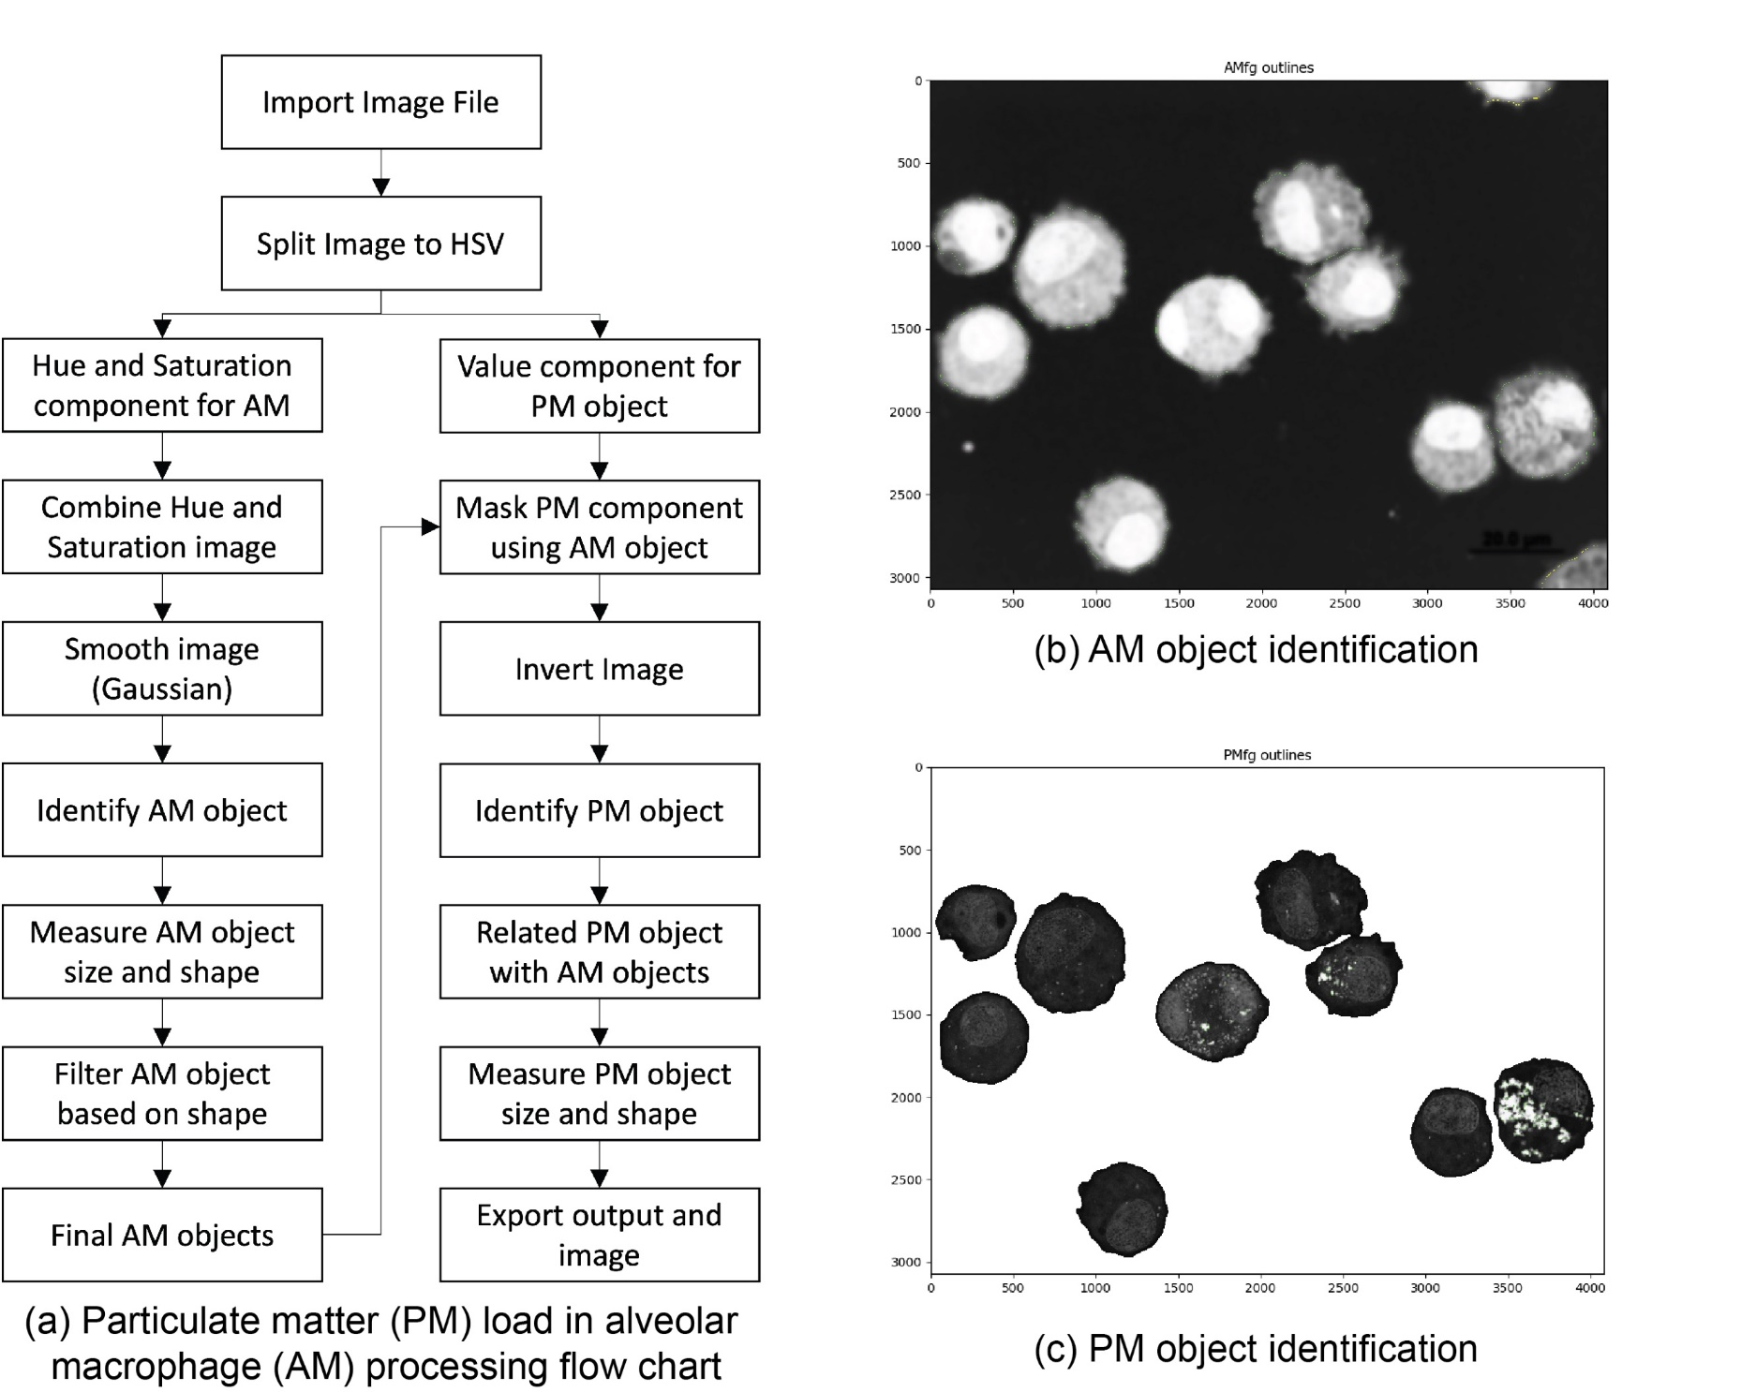

Figure S1. Flow chart of the steps involved with the determination of particulate matter (PM) load in alveolar macrophage (AM) (a). First, AM objects with typical diameters of 10 µm and round shape (form factor>0.5, eccentricity<0.8) were identified; (b) and (c) then PM objects (0.4 µm diameter resolution) within the identified AM objects were identified.
S2. The MexAir sampling suitcase configuration
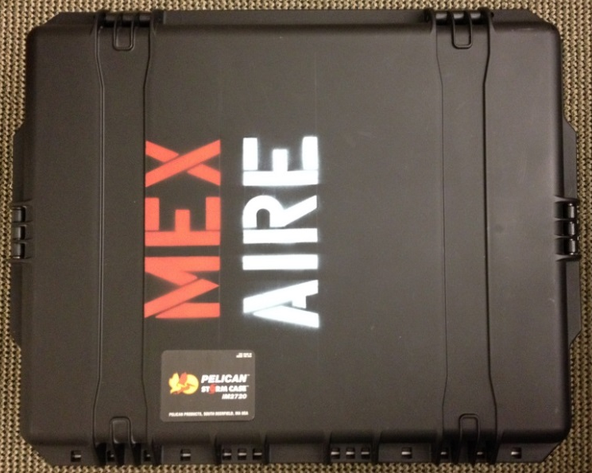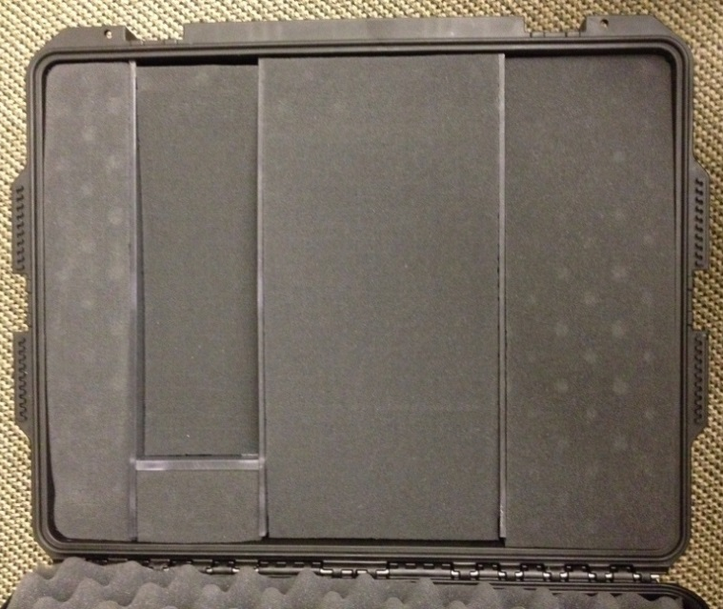
a
a
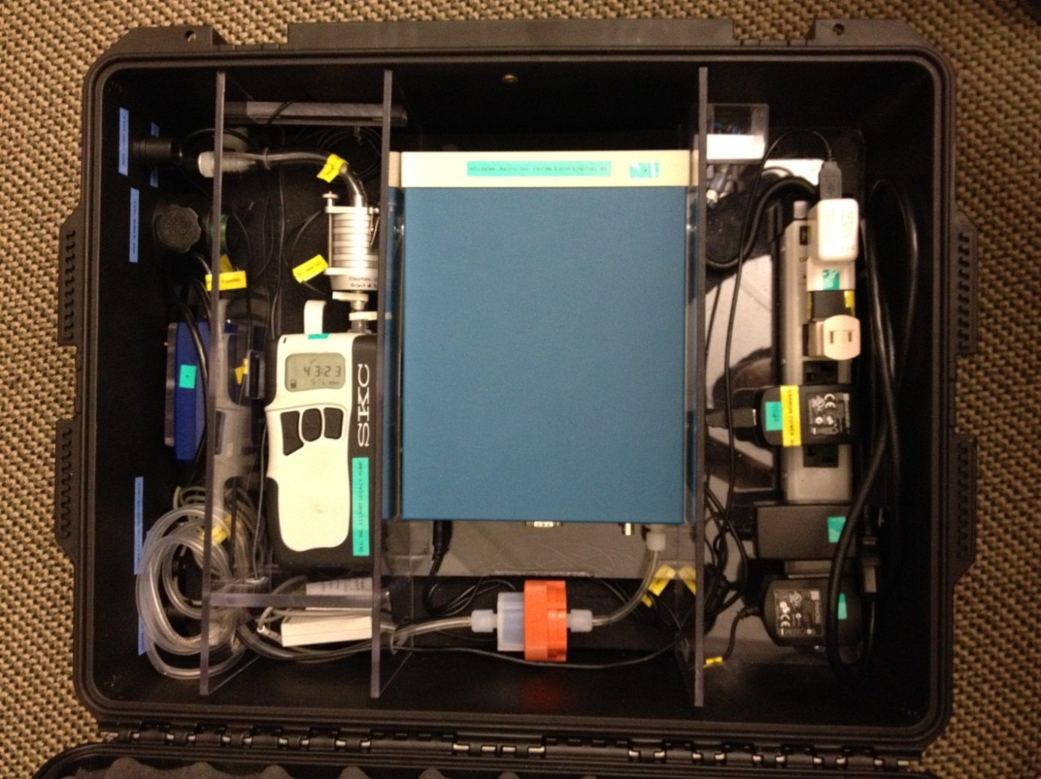
f
l
m
n
o
k
j
i
h
g
e
d
c
b
Figure S2. The MexAir sampling case configuration for roof monitoring.
The MexAir sampling suitcase is designed to collect comprehensive air quality information from the participant’s homes (indoor and outdoor). Figure S2 shows configuration of the MexAir sampling suitcase. PM_{2.5} data (24 hours average outdoor concentration) were collected using the Sioutas impact (Figure S2, f) and the SKC Leland Legacy sample pump (Figure S2, g).

  - The MexAir sampling case
  - Air inlet for the Sample Pump (e) and power cable outlet for the NO₂ monitor (b)
  - CairPol CairClip NO₂ monitor
  - microAeth Model AE51 Personal Black Carbon Exposure Monitor
  - Air inlet for the Black Carbon Monitor (c) and the ozone monitor (g)
  - Sioutas impactor
  - SKC Leland Legacy Sample Pump
  - HOBO U12 Temperature/Relative Humidity/2 External Channel Data Logger
  - 2B Tech model 205 Ozone monitor
  - External filter for the 205 ozone monitor
  - Main power inlet
  - Power cable for the NO₂ monitor (b)
  - Power cable for the Black Carbon Monitor (c)
  - Power cable for the Sample Pump (e)
  - Power for the ozone monitor (g)

S3. Land Use Regression Model Evaluation
Our modified LUR model equation (Equation S1) shows that humidity, traffic density, urban land use area, and elevation are significant variables. The humidity variable was negatively correlated with ambient PM_{2.5} concentrations, which could indicate seasonal variances of these measures in the MCMA. Increased traffic and urban area variables showed positive correlations with PM_{2.5} concentrations. The elevation variable was negatively associated with ambient PM_{2.5} concentrations.
$ln⁡({PM}_{2.5})=ℇ_{pm2.5_i}-0.002RH+0.164TD+0.294L_{U}-0.249DEM+3.389$ (Equation S1)
where, ln(PM_{2.5}): log normalized observed daily PM_{2.5} concentration (µg/m³), ε_{pm2.5_i}: random error term, RH: relative humidity (%), TD: traffic density (unitless), Lu: urban land use area (km²), DEM: elevation (km)
Figure S3. Simulated and observed daily PM_{2.5} concentrations in our current (black dots and red regression line) and our previous study (grey dots and line, Son et al., 2018)

Table S1. Performance of the LUR model for daily ambient PM_{2.5}
 | R² | NSE | RMSE | PBIAS
Current study | 0.810 | 0.778 | 5.2 | -0.080
Son et al., 2018 | 0.490 | 0.388 | 8.7 | 0.135

Model performance parameters were estimated for the LUR model developed in our previous study and the current study (Table S1). In comparison with our previous LUR model data [1], the LUR model in this current study showed improved performance estimates after adding more outdoor air quality monitoring data collected at the home locations of the study participants.

S4. Biomarker analysis results
Table S2. Bronchoalveolar lavage fluid (BALF, n=53), plasma (n=27), serum (n=53), urine (n=53), and other (n=53) biomarker levels for All, Low, Medium, and High AMPM load participant groups (median [1Q-3Q])
Media | Parameter | All | Low AMPM load | Medium AMPM load | High AMPM load
Serum | Leukocyte | 6.30 (5.70-7.60) | 6.30 (5.80-8.18) | 6.10 (5.50-7.30) | 6.90 (5.7-7.375)
 | Neutrophil | 3.40 (3.00-4.40) | 3.35 (3.00-4.70) | 3.30 (3.00-4.00) | 3.55 (3.12-4.52)
 | Lymphocyte | 2.20 (1.90-2.60) | 2.30 (1.95-2.58) | 1.90 (1.70-2.60) | 2.45 (1.98-2.78)
 | Platelet | 214 (195-254) | 215 (204.7-252.7) | 220 (186-254) | 208.5 (195.5-260.7)
 | PT | 11.3 (10.8-11.8) | 11.3 (10.9-11.7) | 11.4 (10.9-11.5) | 11.2 (10.4-12.3)
 | PTT | 30.0 (27.9-31.7) | 29.8 (28.6-31.4) | 30.0 (27.0-31.7) | 29.8 (28.0-31.8)
 | TGO (U/L) | 21 (17-24) | 19.5 (17-24.7) | 21 (18-22) | 22 (17.2-24.7)
 | TGP (U/L) | 20 (17-26) | 19 (17.2-27.5) | 18 (17-23) | 24 (18.2-29.5)
Urine | OHPhen (ng/mg creatinine) | 0.275 (0.144-0.639) | 0.185 (0.114-0.395) | 0.439 (0.203-1.126) | 0.305 (0.155-0.47)
 | AmNaph (ng/mg creatinine) | 101.4 (1.416-359.9) | 144.2 (1.353-322.2) | 121.3 (2.185-359.9) | 103.1 (1.608-401.5)
 | OHPyre (ng/mg creatinine) | 89.34 (4.392-162.5) | 97.69 (4.314-161.4) | 84.68 (4.845-115.7) | 84.09 (2.525-160.0)
Other | IGRA (%positive) | 14.0 | 4.5 | 17.6 | 16.7
PT: Prothrombin time; PTT: Partial thromboplastin time; TGO: Serum glutamic oxaloacetic transaminase; TGP: Serum glutamic pyruvic transaminase; OHPhen: sum of phenanthrene metabolites (2-, 3-, 1&9-, and 4-hydroxyphenanthrene); AmNaph: sum of naphthalene metabolites (1- and 2-aminonaphthalene); OHPyre: 1-hydroxypyrene; IGRA: interferon-gamma release assay
S5. Altered associations between ambient PM_{2.5} and urinary biomarkers by AMPM load
Table S3. Regression analysis for urinary biomarkers and ambient PM_{2.5} concentration
Urinary marker | Parameter | Intercept | PM_{2.5} | r | p
Malondialdehyde  (lag days=4) | All | 0.112 | 2.96×10⁻⁰⁵ | 0.004 | 0.96
 | Low AMPM load (n=22) | 0.136 | -8.04×10⁻⁰⁴ | -0.118 | 0.42
 | Medium AMPM load (n=17) | 0.143 | -8.87×10⁻⁰⁴ | -0.114 | 0.38
 | High AMPM load (n=18) | 0.068 | 1.32×10⁻⁰³ | 0.216 | 0.11
8OHdG | All | 15.4 | -0.013 | -0.008 | 0.91
(lag days=3) | Low AMPM load (n=22) | 13.2 | 0.007 | 0.006 | 0.96
 | Medium AMPM load (n=17) | 22.2 | -0.326 | -0.204 | 0.10
 | High AMPM load (n=18) | 10.5 | 0.289 | 0.168 | 0.20

Malondialdehyde and 8OHdG (two urinary oxidative stress markers) were associated with short-term (<4 days) ambient PM_{2.5} concentrations (Table 4). Urine sample data from three collection time points were used for the analysis. Stronger, but not significant, positive associations between ambient PM_{2.5} and both urinary markers were observed in the high AMPM load group than low/medium groups. Urinary malondialdehyde concentration of the high PM load group showed a stronger association with four-day averaged PM_{2.5} concentration (p=0.11) than low and medium PM load groups. The high PM load group also showed a stronger positive association between urinary 8OHdG concentration and three-day averaged PM_{2.5} concentration (p=0.20). Such associations were not observed in medium and low groups.

S6. Key behavioral characteristics of Low, Medium, and High AMPM load groups
Study participant questionnaires explored air pollution exposure-relevant behaviors and environmental factors with potential impact on PM exposures and AMPM load.

Table S4. Behavioral characteristics (median [1Q-3Q]) of low, medium, and high PM load groups
Parameter | Low AMPM load (n=18) | Medium AMPM load (n=17) | High AMPM load (n=18)
Working day (n) | 5 (5-5) | 5 (3.75-5) | 5 (4.25-5)
Distance to work (km) | 10 (3-15) | 10 (1-13) | 5.5 (3.25-10)
Commute time (min) | 40 (20-50) | 40 (15-60) | 40 (17.5-60)
Travel time, non-work (min) | 90 (60-120) | 60 (30-150) | 60 (41.25-120)
Travel method (n)
Walk | 3 | 1 | 4
Car | 1 | 1 | 0
Bus | 8 | 6 | 10
Subway | 5 | 1 | 1
Motorcycle | 1 | 1 | 0
Bicycle | 2 | 1 | 0
Multi-mode | 1 | 5 | 3
Not specified | 1 | 1 | 0
Outdoor activity (hr) | 6 (4-14.25) | 8 (3.5-12.75) | 5 (4-8.75)
Smoking status (n) | 1 | 2 | 1
Environmental tobacco smoke (n) | 10 | 3 | 5

References
1. Son, Y., et al., Land use regression models to assess air pollution exposure in Mexico City using finer spatial and temporal input parameters. Science of The Total Environment, 2018. 639: p. 40-48.

