Supporting Information Text
Section S1. Additional information on utilized climate scenarios
We use projected changes in precipitation and temperature from Cal-Adapt, dividing projections into three temperature groups: cool, medium, and hot; and three precipitation groups: dry, moderate, and wet, to obtain nine possible combinations of scenarios. We utilize two combinations: moderate, cool and dry, 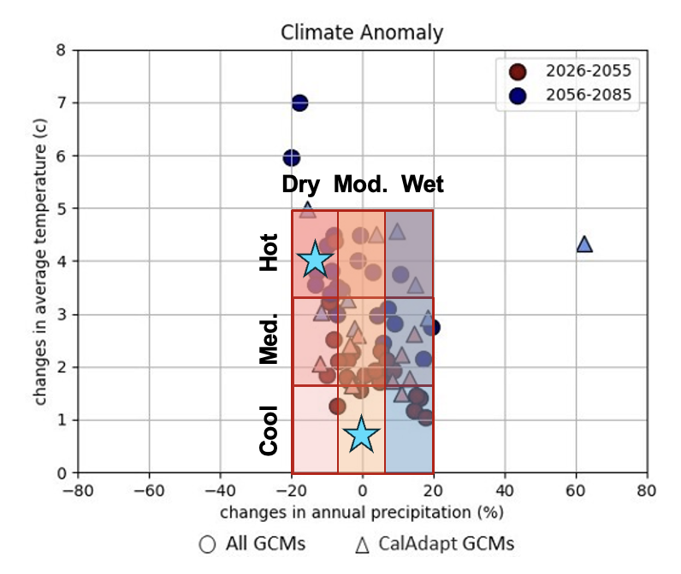

Fig. S1. Assessment of projected changes in precipitation and temperature in the San Lorenzo River watershed. Projected changes shown for the 2040s (2026-2055) and 2070s (2056-2085) from Cal-Adapt.¹ Colored gridded boxes show the delineation into nine climate scenarios. In this work, we test two climate scenarios: the moderate, cool climate (0-1℃ of temperature increase and 100% of average annual precipitation) and dry, hot climate (4-5℃ of temperature increase and 80-90% of average annual precipitation), both of which are highlighted with stars. This figure is adapted from Hydrosystems 2021.²

Section S2. Boxplots highlighting water supplies, demands, and bills under varying climate impacts
The two figures below compare the distributions of water supplies, demands, and bills under the baseline scenario vs varying climate impacts with adaptation to provide additional context for Figure 4 in the text.
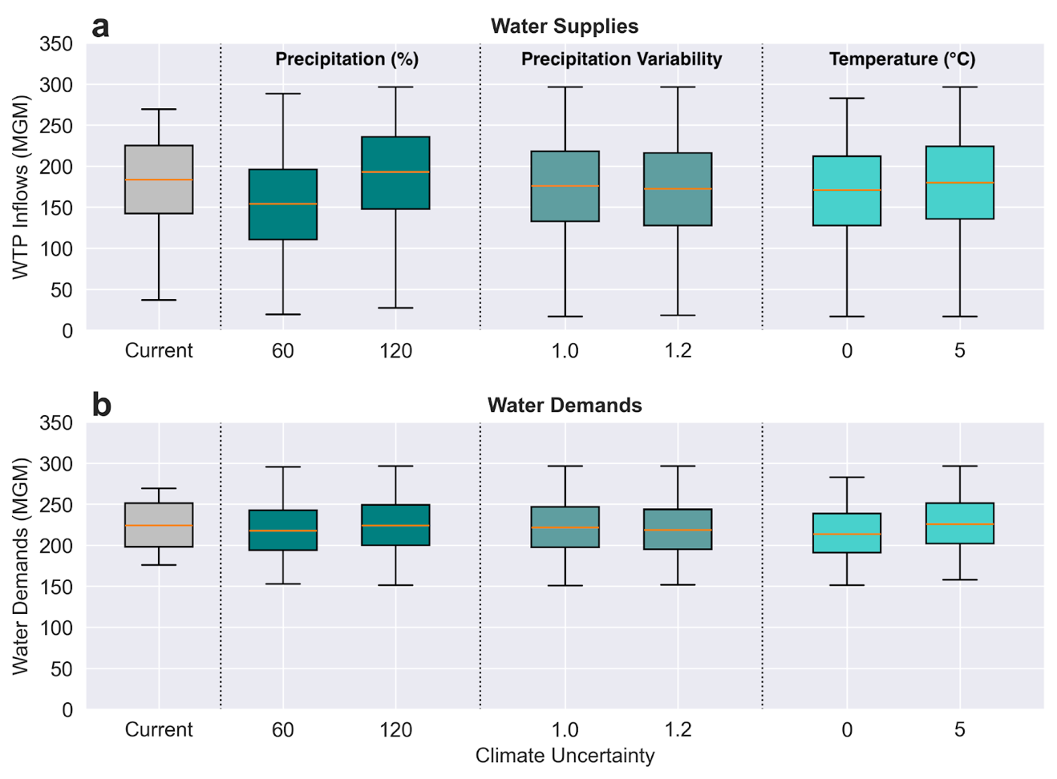
Fig. S2. Boxplots comparing the distribution of a) available inflows to the Graham Hill Water Treatment Plant and b) total water demands under the baseline scenario vs varying climate impacts with adaptation. Climate impacts include: average precipitation (percentage of historical average), precipitation variability (multiplier relative to historical average), and temperature (change from historical average in degrees Celsius). Distributions show monthly values across each subset of sampled climate simulations.

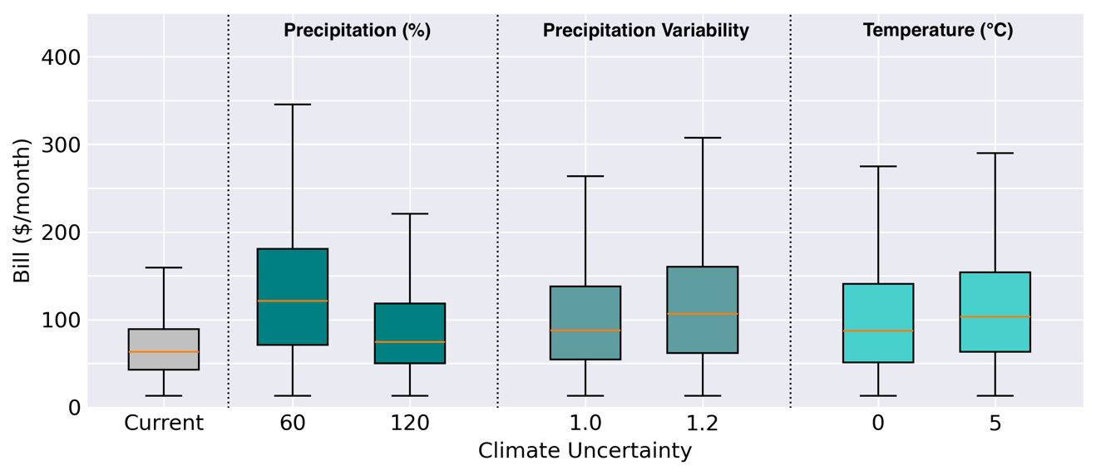

Fig. S3. Boxplots comparing the distribution of monthly water bills between the baseline scenario vs varying climate impacts with adaptation. Climate impacts include: average precipitation (percentage of historical average), precipitation variability (multiplier relative to historical average), and temperature (change from historical average in degrees Celsius). Distributions show monthly values for all households across each subset of sampled climate simulations.

Section S3. Comparison of minimum annual reliability levels across infrastructure planning strategies
The below figure compares the distribution of minimum annual reliability levels across the three infrastructure planning strategies compared in Figure 5.
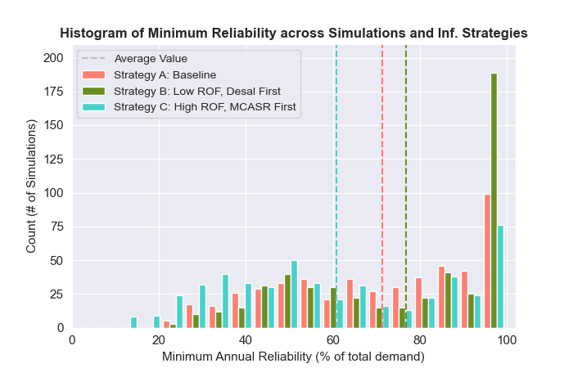
Fig. S4. Histogram of minimum annual reliability levels. Plotted across 500 climate simulations for three infrastructure planning strategies. Dashed lines indicate the average minimum annual reliability level for each planning strategy.

Section S4. Watershed map for study area

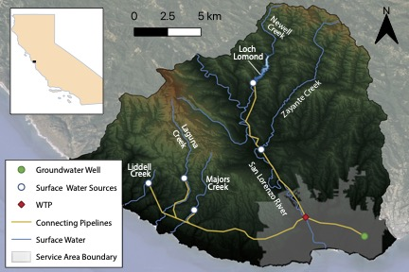

Fig. S5. Watershed map for study area in Santa Cruz, California. Reproduced from Rachunok and Fletcher 2023.³
Section S5. Details on water billing dataset processing and model data
We use a subset of accounts for household water demand model parameterization based on data quality. We use only single-family dwellings, as the majority of multi-family units are not submetered and do not pay their own bills. We remove outliers in water use including bills and water use below zero and use above 55 ccf/month (the 99.9th percentile). We only use bills with lengths between 28 and 31 days to more accurately capture monthly usage patterns. We also remove duplicate bills and accounts with incomplete or outlier housing characteristics data, such as values less than zero or having greater than ten bathrooms. We deidentify account holder names, as well as billing and service addresses.

For developing a set of accounts to use in the household water demand component of the simulation model, we use a similar process to that for parameterization with one exception: we only keep households with at least 12 bills to ensure we capture seasonal variability in computing each household’s direct bias correction factor. We compute the direct bias correction factor as the average difference between measured and modeled water use (in real scale) for each household. When we merge accounts with complete housing characteristics and at least 12 bills, we obtain 12,685 single-family households from 56,613. The water billing dataset is included in our list of all data sources in Table S1.

Table S1. A list of data sources and attributes
Data Sources | Purpose | Attributes | Units | Source
Water Billing Dataset | Household water demand model | Bill start and end dates | Date | Santa Cruz Water Department
Water Billing Dataset | Household water demand model | Water quantity consumed by tier | CCF | Santa Cruz Water Department
Water Billing Dataset | Household water demand model | Volumetric costs, including consumption, infrastructure reinvestment, rate stabilization, and elevation surcharge costs | $/CCF | Santa Cruz Water Department
Housing Characteristics | Household water demand model | Home tax value | $ | 2021 property and tax data from the County of Santa Cruz tax assessor's database
Housing Characteristics | Household water demand model | Home Main Area | Square Feet
Housing Characteristics | Household water demand model | Number of bathrooms | -
Housing Characteristics | Household water demand model | Number of bedrooms | -
Housing Characteristics | Household water demand model | Pool presence/absence | Boolean
Environmental Data | Household water demand model | Monthly precipitation | mm | National Land Data Assimilation System
Environmental Data | Household water demand model | Monthly average temperature | deg. Celsius | National Land Data Assimilation System
Environmental Data | Household water demand model | Monthly actual evapotranspiration | mm | Global Land Data Assimilation System
Census data | Household income estimation | Block group income distributions | 16 bins, ranging from $10,000/yr to $250,000/yr | 2019 5-year American Community (ACS) Survey Data
Public use microdata | Household income estimation | Income | $ | 2019 5-year ACS Public Use Microdata Sample (PUMS) data
Public use microdata | Household income estimation | Property value | $ | 2019 5-year ACS Public Use Microdata Sample (PUMS) data
Public use microdata | Household income estimation | Number of bedrooms | - | 2019 5-year ACS Public Use Microdata Sample (PUMS) data
Public use microdata | Household income estimation | Annual water costs | $ | 2019 5-year ACS Public Use Microdata Sample (PUMS) data
Utility long-range financial planning attributes | Infrastructure financing and rate design | Water Rates | $/CCF | 2016 and 2020 Santa Cruz Long-Range Financial Report
Utility long-range financial planning attributes | Infrastructure financing and rate design | Operational costs | $ | 2016 and 2020 Santa Cruz Long-Range Financial Report
Utility long-range financial planning attributes | Infrastructure financing and rate design | Loan interest rates | % | 2016 and 2020 Santa Cruz Long-Range Financial Report
Utility long-range financial planning attributes | Infrastructure financing and rate design | Loan payback periods | years | 2016 and 2020 Santa Cruz Long-Range Financial Report
Utility long-range financial planning attributes | Infrastructure financing and rate design | Loan principal amounts | $ | 2016 and 2020 Santa Cruz Long-Range Financial Report
Systemwide water use data | Household and other water demands | Annual water use by user type | MG | 2020 Santa Cruz Urban Water Management Plan
Gridded temperature and precipitation data for water resources model | Water supply balance model | Temperature daily minimum and maximum | deg. Celsius | Maurer et al. 2002
 | Water supply balance model | Precipitation | mm | Maurer et al. 2002
Streamflow data | Hydrology model | Streamflow | cfs | USGS Streamflow Gage Data
Climate projections data | Climate change scenarios | Temperature | deg. Celsius | Cal-Adapt
Climate projections data | Climate change scenarios | Precipitation | % difference | Cal-Adapt

Section S6. Details on water supply balance model
We use the Santa Cruz Water System Model (SCWSM) to estimate water allocations. SCWSM is the Santa Cruz Water Department (SCWD)’s new water supply planning model that replaced the Confluence model the SCWD used for planning for over three decades.⁴ SCWSM runs at a daily timestep to accurately represent the system operations (including the water rights and water quality constraints). We run the model for 50 years, for water years 2021-2070. The model uses linear programming to determine water allocations based on a least-cost approach, where we assign costs to each water supply source based on realistic operating conditions (the costs assigned to each water source and stored in Loch Lomond are used to set the dispatch order, or the priority to which each source is used to supply demand). The model includes important system facilities, including Loch Lomond, the only reservoir; water diversions; pump stations; treatment plants; and groundwater wells. Loch Lomond falls last in the dispatch order when providing water to the service area, although reservoir water is used to satisfy local transfers and minimum flow requirements below the dam. The model captures various water rights, which dictate the system’s operation mainly to ensure adequate ecological flows and maximum annual and daily diversions from the different sources. Additionally, the model includes new plausible water supply infrastructure options, with the ability to turn various options on or off within a single simulation. Model boundary conditions include the inflow hydrology, precipitation and evaporation rates over the reservoir, and water demands. Model outputs include reservoir volumes; water supplies through major pumps, pipelines, and diversions; and water deliveries.⁵ The model has been validated against the Confluence model using historical data from 1937-2015.⁵

Section S7. Details on climate scenario generation

Climate scenario generation involves two key steps: first, developing stochastic weather simulations that reflect historical climate characteristics; and second, altering simulations from the previous step to capture different climate characteristics using the range from climate models.

First, the data for stochastic simulations includes monthly temperature and precipitation records (raw and reconstructed) spanning 1936 to 2015 from an extended version of Maurer et al. (2002),⁶ described in Hydrosystems (2021).² Since raw gridded data is only available from 1949-2000, k-nearest neighbors (KNN) resampling (K=1) with nearby gage data is used to reconstruct missing data for 1936-1949 and 2001-2015. Trends are removed prior to resampling. A wavelet auto-regressive model is then applied to reproduce low-frequency signals from the observed record, generating 100-year long annual time series, following a simplified version of Steinschneider and Brown (2013).⁷ Monthly-scale data are subsequently resampled from the annual data using a KNN approach (K=3) to obtain thousands of 100-year monthly stochastic simulations. From these, ten simulations are selected that best match the historical climate based on a KNN approach using sixteen statistical metrics for precipitation and temperature. These metrics capture long-term averages, seasonal variability, persistence, frequency of water year types, and annual rainfall distribution. The selected simulations are run through a lumped water balance model, described in Section S8, to generate corresponding streamflow time series and compared to historical USGS streamflow gage data (ID: 11160500)⁸ to ensure performance aligns with the observed records.⁵

Second, Global Coupled Model Intercomparison Project phase 5 (CMIP5) climate projections are used to inform the range of climate characteristics for water system stress testing, as shown in Figure S1. Climate projections focus on Global Circulation Model (GCM) radiative concentration pathway 8.5, which results in the greatest warming and may also have the largest impacts on precipitation. The CMIP5 GCM ensemble estimates that precipitation may change from -20 to 20% compared to baseline values, and that temperatures may rise by 2-5℃ by 2070. Since the goal is to understand how the range of possible climates may impact water system vulnerability, the moderate, cool scenario reflects moderate precipitation (100% of historical), historical precipitation variability (factor of 1.0), and cool temperatures (+0 to 1℃); while the dry, hot scenario reflects decreased precipitation (80-90% of historical), higher precipitation variability (factor of 1.2), and increased temperatures (+4 to +5℃). The full range of analysis includes average annual precipitation changes between 60 and 120%, precipitation variability between 1.0 and 1.2, and average annual temperature changes ranging from 0 to +5℃.⁵ Lastly, stochastic realizations are combined with climate scenarios using multiplicative and additive factors for average precipitation and temperature, respectively, and quantile mapping and downscaling for precipitation variability.
Section S8. Details on hydrological model
We use a lumped hydrological model based on a single streamflow location within SCWD’s watershed area, shown in Figure S6 and discussed in detail in Appendix D-1 of the Santa Cruz Water Rights Project’s Environmental Impact Report.⁹ The base streamflow location is on the San Lorenzo River at Big Trees utilizing USGS streamflow gage data (ID: 11160500)⁸ and is chosen because it has the longest continuous streamflow record from 1936 to the present and is a primary water source for the city. Overlapping flow records are used to develop regression models between the San Lorenzo River and other important streamflow locations. Other streamflow data comes from USGS gages and the city with streamflow records ranging from 7 to 28 years. Streamflow is modeled at a daily timestep to provide a reasonable measure of ecological conditions and to more realistically evaluate water supply reliability. Accurate representation of the system diversion operations also requires daily resolution to ensure compliance with water rights. Flow withdrawals are made to account for ecological requirements for fish habitation. Calibration periods have daily streamflow errors less than 5%. While this model does not capture all of the variance in historical data, it does calculate low flow periods to an acceptable level, which is the goal of the model. Full validation data are available on page 6 in Appendix D-1.⁹ To use the hydrological model under climate change scenarios, the time series generated in S7 are input here.⁹
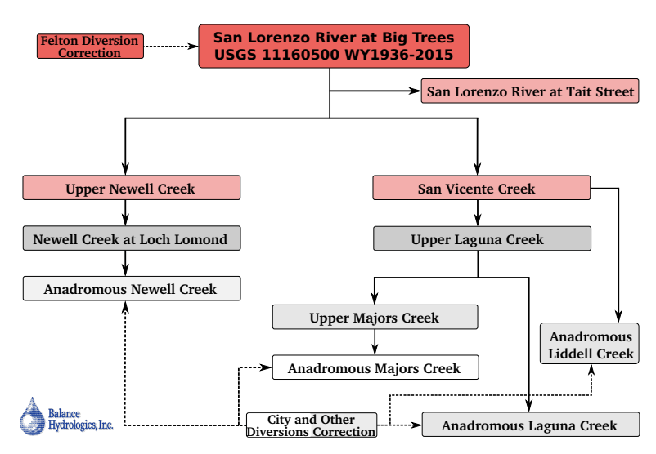
Fig. S6. Workflow for base hydrology model. Illustrates the regression relationships between streamflow locations. Lines between boxes indicate regression relationships and dashed lines indicate flow correction estimates. Adapted from Balance Hydrologics, Inc. (2020).⁹

Section S9. Techno-economic details on infrastructure costs
Table S2. Infrastructure options, operations, and cost assumptions. All costs are in 2020 real dollars (converted from 2024 real dollars).
Supply Option | Capacity (MGD) | Capital Cost ($M) | Annual Operating Cost ($M/yr) | Max. capacity (MGD) | Operating conditions description | Deployment time (years)
Aquifer storage and recovery (Mid-county GWB) | 2.3 (5 wells) | 56 | 1.3 | 2.3 extract, 1.6 inject | Inject Nov.-April, except dry months  Extract May-Nov. | 2
Transfers to/from Soquel Water District | 0.5 | 0 | 0.6 | To city: 0.5 To Soquel: 0 | Constant supply, as needed | 1
Transfers to/from Scotts Valley Water District (SVWD) | 1.0 | 3.3 | 0.2 | To city: 1.0 To SV: 1.0 | Constant supply, as needed; no transfers to SVWD during dry months | 1
DPR | 2.0 | 144.7 | 3.8 | 2.0 | Winter capacity: 1 MGD  Summer capacity: 2 MGD | 5
Desalination Plant | 4.0 | 212.4 | 10.0 | 4.0 | Winter capacity: 1.33 MGD; Summer capacity: 2.67 MGD;  Drought: 4.0 MGD | 10

Section S10. Details on risk-of-failure (ROF) table development
We develop risk-of-failure (ROF) lookup tables by running many two-year simulations to approximate the risk of reservoir levels dropping below a minimum operating level in the upcoming two-year period.¹⁰ The ROF triggers are based on three dimensions: initial reservoir storage level, infrastructure options that have already been planned or implemented, and annual water demand levels. For initial storage levels, we use values between 40% and 100% of total storage capacity, as SCWD’s target for minimum operating level is ~36%. For infrastructure options, we look at all combinations of options between zero and three of the five options. For annual total water demands, we look at a range of 2400-3100 MG/year (in 100 MG increments; Santa Cruz’s 2020 water usage is 2,606 MG¹¹). We determine this range by testing the sensitivity of residential demands in our econometric model and by randomly sampling from our multi-family and non-residential demand scenarios.
Section S11. Details on Borg multiobjective evolutionary algorithm
We use the Multi-master Borg multiobjective evolutionary algorithm to determine Pareto-approximate infrastructure strategies.¹² We run Borg on Sherlock, a High-Performance Computing cluster, using 50 nodes and 10 tasks per node. Using four random seeds and 25,000 function evaluations, the model converges in approximately five days per seed. Figure S7 shows optimization performance across seeds.
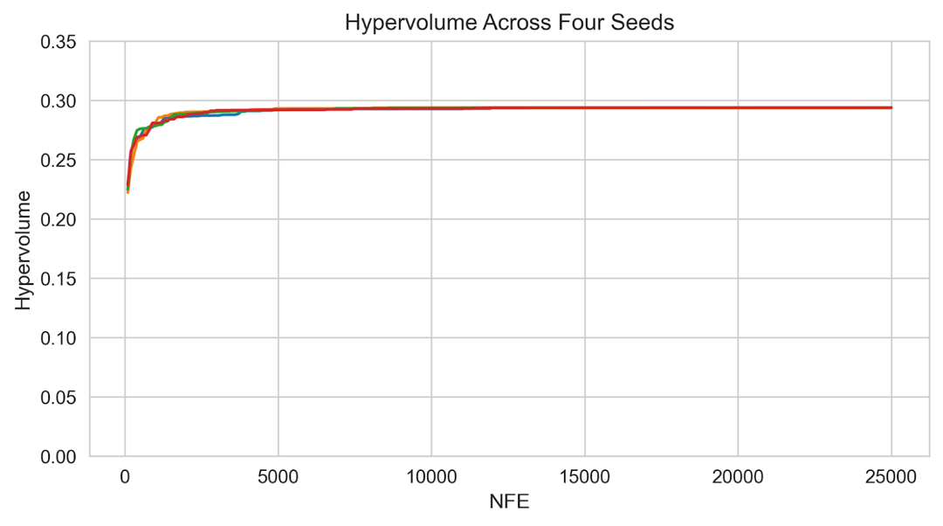
Fig. S7. Hypervolume vs. number of function evaluations (NFEs). Hypervolume shown for four seeds showing convergence by around 10,000 function evaluations

Section S12. Simulations for baseline planning strategy water reliability levels
The below figure shows reservoir storage, total water demands, unmet demands, and reliability under ten climate simulations with historical climate characteristics to check that our baseline infrastructure planning strategy (ROF=0.65, first infrastructure option deployed: desalination) matches historic water reliability levels in Santa Cruz.
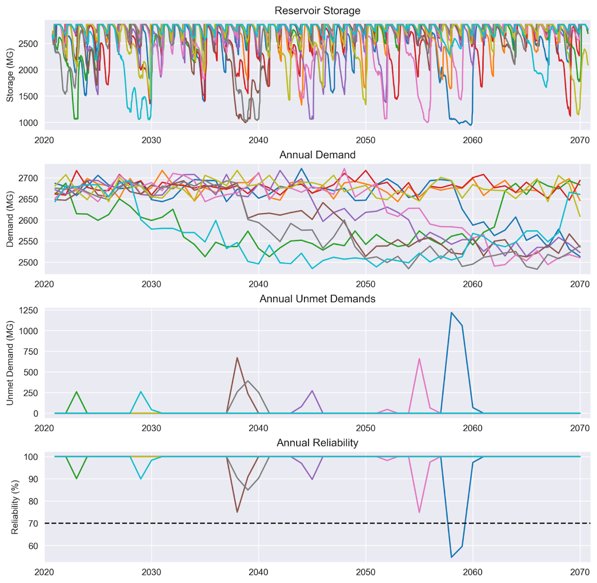
Fig. S8. Baseline infrastructure planning strategy water supply results. The baseline infrastructure planning strategy utilizes an ROF threshold of 0.65 and deploys the desalination plant first. Includes reservoir storage, total water demands, unmet demands, and reliability under historical climate characteristics. Each color represents a different stochastic simulation. We pick this baseline strategy so that annual reliability almost always stays above 70%, which is consistent with reliability levels during the 2013 California drought and is highlighted with the dashed black line.
Section 13. Details on water demand econometric model
A Discrete/Continuous Choice (DCC) model is used to estimate residential water demand under the increasing block tariff (IBT) prevailing in Santa Cruz. Water demand estimation under an IBT faces the challenge of price endogeneity, where the quantity demanded depends on the price of water, but the price of water under the tariff structure in turn depends on the consumption quantity. The approach addresses this challenge by simultaneously modeling the discrete selection of a tariff block and the continuous choice of a water demand consumption quantity. The approach uses maximum likelihood estimation (MLE) to determine demand function coefficients. The full set of MLE equations can be found in Olmstead et al. (2007) or Klassert et al. (2018).^{13,14} The model includes the following housing characteristics as coefficients: home tax value, main area size, number of bathrooms (and bathrooms squared), and pool presence. We use home tax value as a proxy for household wealth instead of income,¹⁵ since tax value data is available at the household level. We assume all housing characteristics are constant over the billing data and model simulation periods. In addition, the model includes environmental characteristics, which vary monthly, including: precipitation, average temperature, and actual evapotranspiration. Besides coefficients reflecting housing and environmental characteristics, the model also estimates the price elasticity of water demand. The underlying marginal water prices (in dollars per hundred cubic feet of water) for every bill are determined based on the tariff rate applicable in the highest used tier of the IBT. All model coefficients are in Table S3.
Table S3. DCC model estimated coefficient values
Parameter Name (Unit) | Coefficient Value
Intercept (-) | 0.516
Log(marginal price) ($) | -0.246
Log(home tax value) ($) | 0.058
Home main area (sqft.) | 1.97E-04
Number of bathrooms (count) | 0.071
Number of bathrooms squared (count²) | -5.09E-03
Pool presence/absence (boolean) | 0.212
Monthly actual evapotranspiration (mm) | -7.50E-05
Monthly precipitation (mm) | -5.20E-06
Monthly temperature (°C) | 0.031
Eta error term (-) | 0.580
Epsilon error term (-) | 0.458

Section S14. Details on household income estimation
To estimate household affordability ratios, we develop household-level income estimates by disaggregating block-group income data. We use multivariate regression and quantile mapping similar to estimation methods in other studies.^{16,17} We use household-level water utility billing data, tax assessor housing characteristics data, and American Community Survey (ACS) Public Use Microdata Sample (PUMS) data for housing units and block group-level income data. First, we develop a log-log multivariate regression model using all available single-family PUMS data (1009 single-family households) to predict household-level income given the number of bedrooms, property value, and total annual water cost (R² = 0.072). Next, we use this model to predict household-level income for all households in Santa Cruz. For each household, we extract total annual water cost from the water utility billing data, and number of bedrooms and property value from the housing characteristic data. To model uncertainty given the low R², we sample the regression model error term ten times and add the error term to the predicted income values, resulting in ten household-level income estimates. Then, we use quantile mapping to ensure that household-level income estimates match city-level income distributions. Here, we map each household-level predicted income to one of sixteen discrete census block group income bins. We ensure that different income estimates do not change our results in Figures S9-S12.
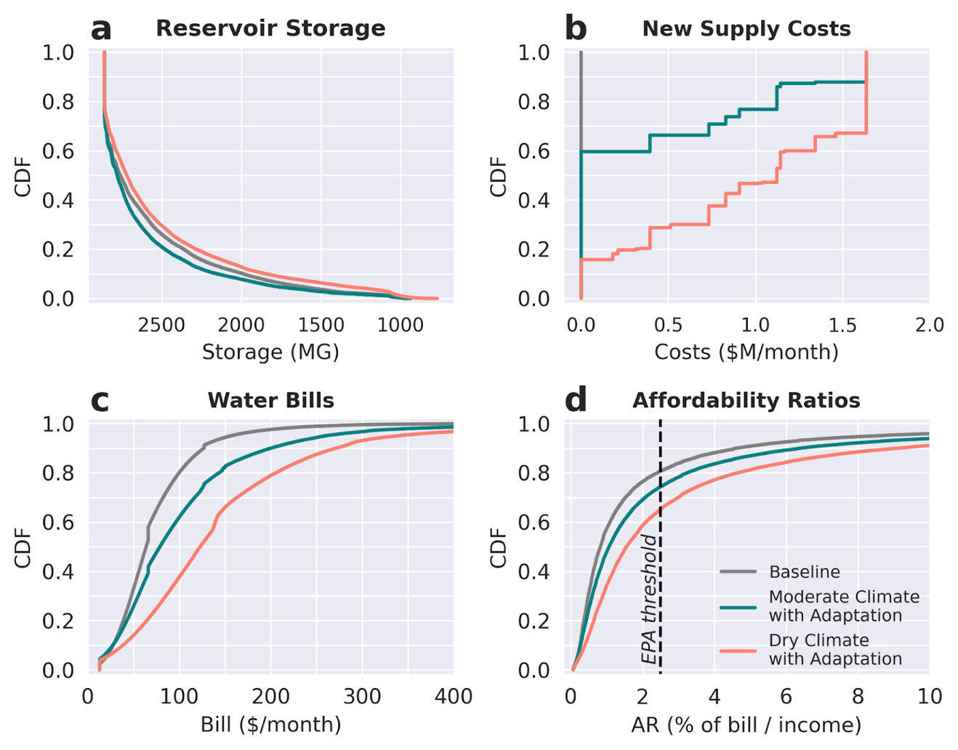
Fig. S9. Version of Figure 2 with different income estimate. Differences are in panel d only.

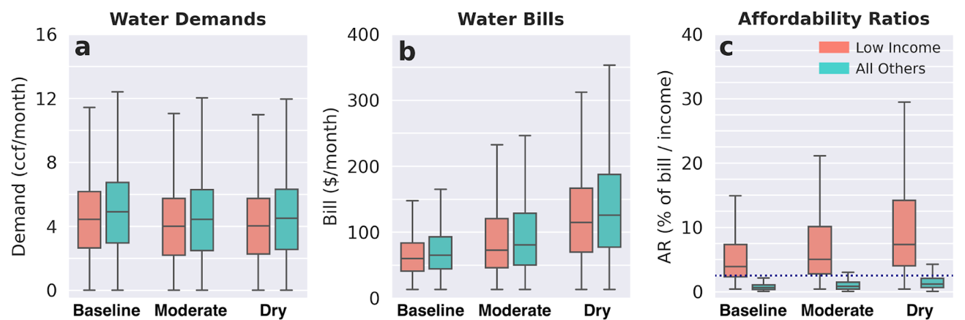
Fig. S10. Version of Figure 3 with different income estimate. Differences across all boxplots.

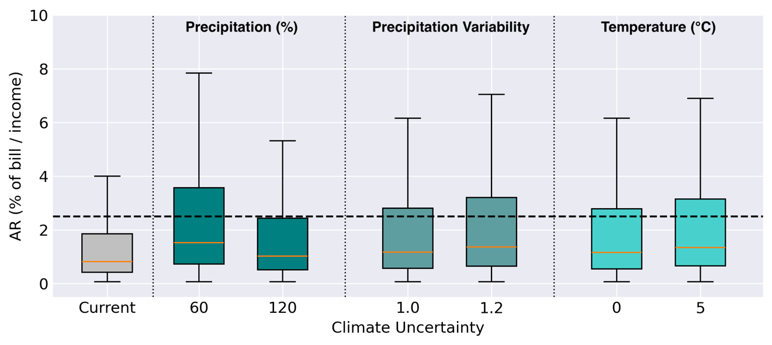
Fig. S11. Version of Figure 4 with different income estimate. Differences across all boxplots.

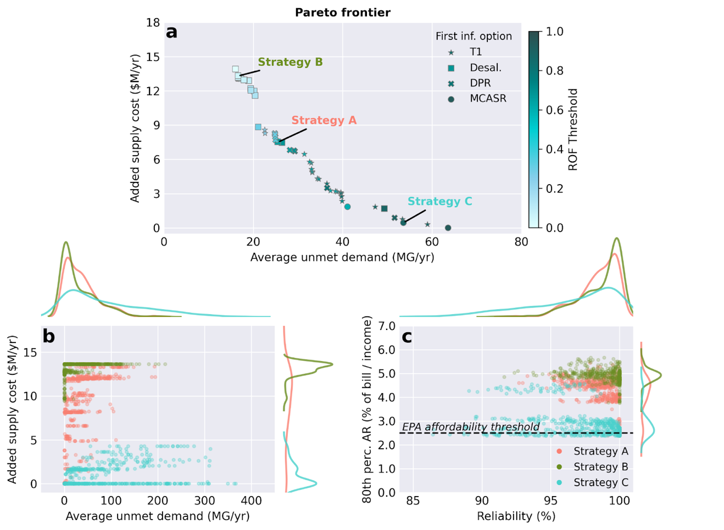
Fig. S12. Version of Figure 5 with different income estimate. Differences in panel c only.

Section S15. Multi-family and non-residential water demand scenarios
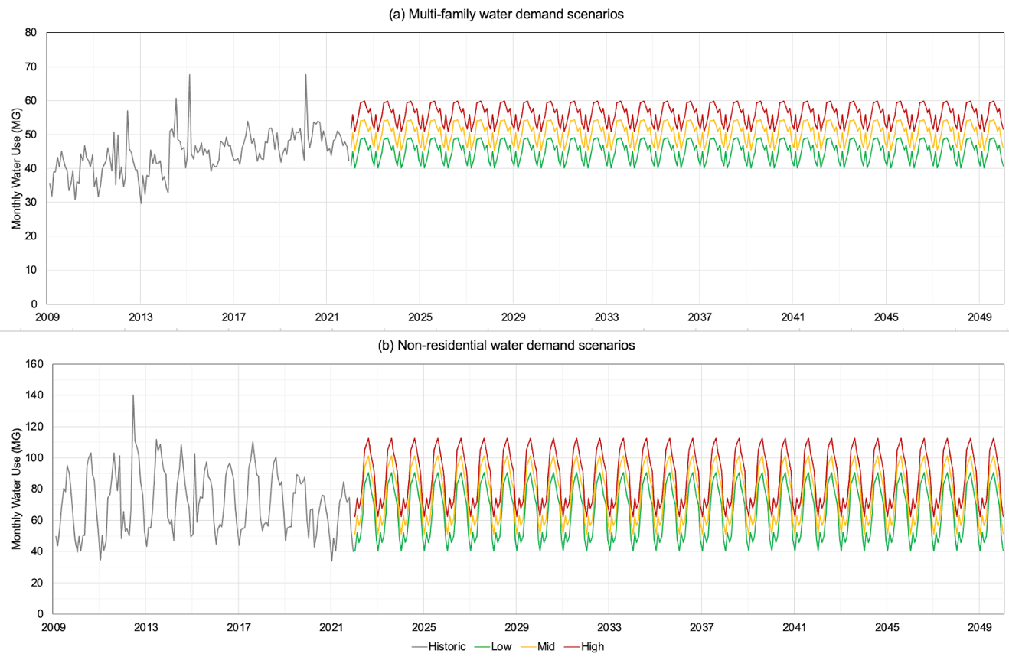
Fig. S13. Monthly low, medium, and high water demand scenarios for (a) multi-family and (b) non-residential establishments. We determine annual average values using 2020 Urban Water Management Plan 2025-2045 projected values. Monthly anomalies, which remain the same across low, medium, and high scenarios, are calculated by averaging the difference between monthly water use and average annual water use for each year and each month of the year within each water demand category.

Section S16. Details on operation and maintenance scenario
We develop an assumption about future operations and maintenance (O&M) costs based on Santa Cruz’s 2016 and 2020 Long-Range Financial Plans, to capture the proportion of total utility costs that O&M represents.^{18,19} Our scenario assumes current (2020), stationary conditions, with all costs in 2020 real dollars. Revenue is sourced from four water bill charges: elevation surcharges and rate stabilization fees (both assumed constant), fixed fees, and volumetric charges. Ten percent of total remaining revenue is fixed, with each household paying a constant monthly amount. The remaining revenue is collected through volumetric charges, with the ratio of consumption to IRF charges based on 2020 data.¹⁸ Using the same methodology as for rate increases, we calculate baseline tiered water rates and validate the results against 2022 proposed rates.¹⁹ Required revenue and computed rates are detailed in Table S4.
Table S4. Fixed and volumetric water rates based on O&M cost assumptions
Scenario | Baseline
Year | 2020
Revenue parameters
Total revenue required ($M) | 45.1
Revenue from fixed fees ($M) | 4.0
Revenue from volumetric consumption charges ($M) | 28.1
Revenue from volumetric IRF charges ($M) | 10.2
Rates
Fixed fee ($/month/household) | 12.24
Consumption tier 1 ($/ccf) | 7.33
Consumption tier 2 ($/ccf) | 9.90
Consumption tier 3 ($/ccf) | 12.10
IRF tier 1 ($/ccf) | 2.30
IRF tier 2 ($/ccf) | 4.37
IRF tier 3 ($/ccf) | 6.90

Section S17. Additional assumptions for financing and rate design model
Table S5 includes ratios used to calculate tier 2+ quantity and Infrastructure Reinvestment Fee (IRF) volumetric charges based on tier 1 costs, using historical water rates data in Santa Cruz. Table S6 includes additional infrastructure financing assumptions.
Table S5. Cost ratios between tier 1 and tiers 2+
Tier | Quantity Charge | IRF Charge
2 | 1.35 | 1.9
3 | 1.65 | 3.0

Table S6. Infrastructure financing assumptions
Assumption Name | Value
Loan interest rate | 3%
Loan amortization period | 30 years
Pay-as-you-go proportion of capital costs | 15%
Debt-financed proportion of capital costs | 85%

SI References

- Cal-Adapt. LOCA Downscaled CMIP5 Climate Projections. (2018).
- Hydrosystems Research Group, University of Massachusetts Amherst. Vulnerability Assessment and Adaptation Planning for Santa Cruz Water Department. (2021).
- Rachunok, B. & Fletcher, S. Socio-hydrological drought impacts on urban water affordability. Nat Water 1, 83–94 (2023).
- Kennedy Jenks & Hydrosystems Research Group, University of Massachusetts Amherst. Water Supply Augmentation Implementation Plan. (2025).
- Hydrosystems Research Group, University of Massachusetts Amherst. Vulnerability Assessment and Adaptation Planning for Santa Cruz Water Department. (2023).
- Maurer, E. P., Wood, A. W., Adam, J. C., Lettenmaier, D. P. & Nijssen, B. A Long-Term Hydrologically Based Dataset of Land Surface Fluxes and States for the Conterminous United States. (2002).
- Steinschneider, S. & Brown, C. A semiparametric multivariate, multisite weather generator with low-frequency variability for use in climate risk assessments. Water Resources Research 49, 7205–7220 (2013).
- United States Geological Survey. San Lorenzo R a Big Trees CA. (2024).
- Balance Hydrologics, Inc. Appendix D-1 Baseflow Hydrology and Climate Change Affects Modeling. https://www.cityofsantacruz.com/home/showpublisheddocument/86975/637731703715270000 (2020).
- Palmer, R. N. & Characklis, G. W. Reducing the costs of meeting regional water demand through risk-based transfer agreements. Journal of Environmental Management 90, 1703–1714 (2009).
- Perez, S. E. 2020 Urban Water Management Plan. https://www.cityofsantacruz.com/home/showpublisheddocument/87122/637739611535800000 (2021).
- Hadka, D. & Reed, P. Borg: An Auto-Adaptive Many-Objective Evolutionary Computing Framework. Evolutionary Computation 21, 231–259 (2013).
- Olmstead, S. M., Michael Hanemann, W. & Stavins, R. N. Water demand under alternative price structures. Journal of Environmental Economics and Management 54, 181–198 (2007).
- Klassert, C., Sigel, K., Klauer, B. & Gawel, E. Increasing Block Tariffs in an Arid Developing Country: A Discrete/Continuous Choice Model of Residential Water Demand in Jordan. Water 10, 248 (2018).
- Worthington, A. C. & Hoffman, M. An Empirical Survey of Residential Water Demand Modelling. Journal of Economic Surveys 22, 842–871 (2008).
- California Public Utilities Commission. 2021/2022 Annual Affordability Report. https://www.cpuc.ca.gov/-/media/cpuc-website/divisions/energy-division/documents/affordability-proceeding/2021-2022/2021-and-2022-annual-affordability-report.pdf (2023).
- Azizi, K., Barnes, J. L., Anderies, J. M. & Garcia, M. Equity implications of efficient water conservation programs. Environ. Res. Lett. 19, 094015 (2024).
- Menard, R. Long Range Financial Plan (WT). (2016).
- Menard, R. 2021 Water Department Long-Range Financial Plan and Water Rate Schedule for FY 2023 to FY 2027 (WT). (2021).

