Functional and Structural Shifts in the Rhizosphere and Tuberosphere of Potato Under Combined Microbial Inoculation and Reduced Fertilization
Irene Ollio ^{a,b}*, Raúl Zornoza ^{a,b} , Josefa Contreras Gallego^{a,b}, Catalina Egea-Gilabert ^{a,b}, Juan A. Fernández ^{a,b} , Eva Lloret ^{a,b}
ªDepartamento de Ingeniería Agronómica, Universidad Politécnica de Cartagena, Cartagena, Spain
^{b}Instituto de Biotecnología Vegetal (IBV), Campus Muralla del Mar, Edificio I+D+I, Universidad Politécnica de Cartagena, Cartagena, Spain

Supplementary Tables and Figures

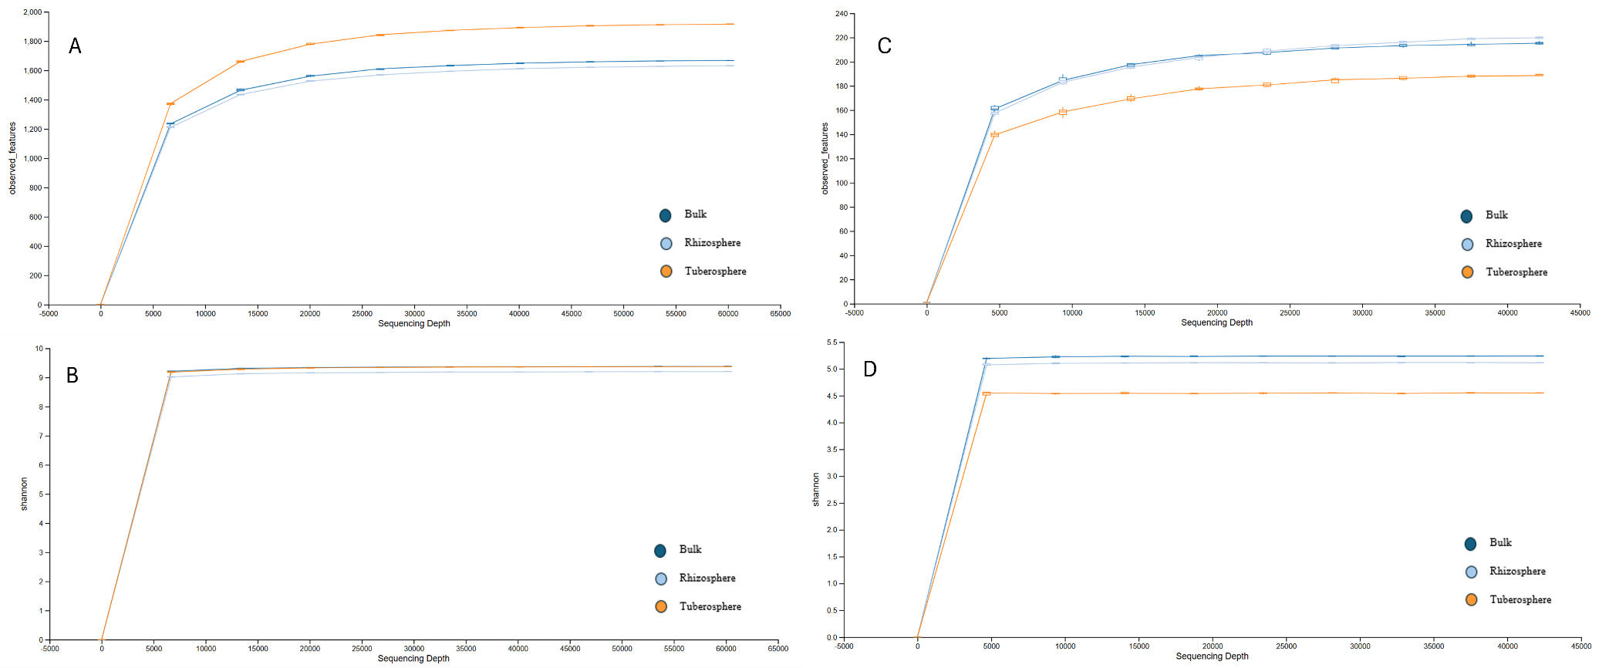
Figure S1. Rarefaction curves for bulk, rhizosphere, and tuberosphere soils at different sampling times. Rarefaction curves were determined for prokaryote number of observed ASVs (A) and Shannon index (B), and fungal number of observed ASVs (C) and Shannon index (D).

Table S1. Prokaryotic and fungal phyla (Prok_p_ and Fun_p_ respectively) and genera (Prok_g_ and Fun_g_ respectively) with statistically significantly different estimated absolute abundances (EAA) between treatments. Abbreviations are: 1) F100, inorganic fertilizer applied at crop nutritional requirements; 2) F50, reduced F100 fertilization by 50%; 3) F50+BA, F50 plus a microbial inoculant containing Azospirillum, Pseudomonas, and Bacillus; 4) F50+BAFU, F50 plus microbial inoculant containing Bacillus, Azotobacter, and non-mycorrhizal fungi. Different letters indicate significant differences among treatments (p value < 0.05) within each sampling month.
Sampling time | Taxa | F50+BAFU | F50+BA | F50 | F100 | F-value
 |  | Estimated absolute abundance (copies g^{‒1} soil)
April (Rhizosphere) | Prok_p__Gemmatimonadota | 6.75E+06 ± 3.38E+06 ab | 6.65E+06 ± 3.33E+06 ab | 8.72E+06 ± 4.36E+06 a | 5.00E+06 ± 2.50E+06 b | 2.051
April (Rhizosphere) | Prok_p__Planctomycetota | 4.20E+06 ± 2.10E+06 ab | 4.60E+06 ± 2.30E+06 ab | 5.94E+06 ± 2.97E+06 a | 2.61E+06 ± 1.30E+06 b | 3.039
April (Rhizosphere) | Fung_p__Ascomycota | 9.98E+06 ±1.36E+06 bc | 7.29E+06 ±9.59E+05 c | 1.22E+07 ±7.37E+05 ab | 1.52E+07 ±1.48E+06 a | 8.196
April (Rhizosphere) | Prok_g__67-14 | 7.24E+06 ± 3.62E+06 ab | 5.95E+06 ± 2.97E+06 ab | 8.05E+06 ± 4.02E+06 a | 5.23E+06 ± 2.62E+06 b | 2.550
April (Rhizosphere) | Prok_g__Bacillus | 1.74E+07 ± 8.70E+06 a | 1.06E+07 ± 5.32E+06 ab | 1.72E+07 ± 8.58E+06 a | 1.30E+07 ± 6.52E+06 b | 3.521
April (Rhizosphere) | Prok_g__Lysobacter | 4.83E+06 ± 2.41E+06 a | 1.72E+06 ± 8.60E+05 ab | 2.04E+06 ± 1.02E+06 ab | 2.17E+06 ± 1.09E+06 b | 2.913
April (Rhizosphere) | Prok_g__Massilia | 7.08E+06 ± 3.54E+06 a | 4.46E+06 ± 2.23E+06 ab | 5.03E+06 ± 2.51E+06 ab | 3.55E+06 ± 1.78E+06 b | 3.298
April (Rhizosphere) | Prok_g__Paenibacillus | 3.03E+06 ± 1.52E+06 a | 1.42E+06 ± 7.12E+05 ab | 3.94E+06 ± 1.97E+06 a | 8.22E+05 ± 4.11E+05 b | 3.897
April (Rhizosphere) | Prok_g__Solirubrobacter | 4.18E+06 ± 2.09E+06 ab | 3.12E+06 ± 1.56E+06 ab | 4.87E+06 ± 2.44E+06 a | 3.23E+06 ± 1.61E+06 b | 2.516
April (Rhizosphere) | Prok_g__Sphingomonas | 7.64E+06 ± 3.82E+06 a | 4.58E+06 ± 2.29E+06 ab | 6.43E+06 ± 3.21E+06 ab | 4.85E+06 ± 2.43E+06 b | 2.563
April (Rhizosphere) | Prok_g__Streptomyces | 9.01E+06 ± 4.50E+06 a | 4.27E+06 ± 2.14E+06 ab | 7.19E+06 ± 3.60E+06 ab | 4.86E+06 ± 2.43E+06 b | 3.713
April (Rhizosphere) | Fung_g__Cladosporium | 5.68E+05 ±1.28E+05 ab | 3.47E+05 ±8.84E+04 b | 1.18E+06 ±3.76E+05 a | 4.14E+05 ±1.46E+05 ab | 3.068
April (Rhizosphere) | Fung_g__Humicola | 4.36E+05 ±9.30E+04 b | 4.40E+05 ±6.30E+04 b | 5.36E+05 ±1.44E+05 a | 9.79E+05 ±2.23E+05 ab | 3.214
April (Rhizosphere) | Fung_g__Botryotrichum | 3.41E+05 ±9.14E+04 b | 4.44E+05 ±1.02E+05 b | 1.20E+06 ±4.51E+05 a | 4.90E+05 ±8.96E+04 ab | 2.707
April (Rhizosphere) | Fung_g__Verticillium | 1.16E+06 ±4.37E+05 ab | 4.09E+05 ±1.97E+05 b | 1.11E+06 ±4.07E+05 ab | 2.40E+06 ±7.45E+05 a | 2.888
April (Rhizosphere) | Fung_g__Gibellulopsis | 2.65E+05 ±6.97E+04 b | 1.51E+05 ±4.30E+04 b | 6.87E+05 ±1.39E+05 a | 2.52E+05 ±4.01E+04 b | 8.150
April (Rhizosphere) | Fung_g__Emericellopsis | 1.97E+05 ±4.96E+04 ab | 9.08E+04 ±8.14E+03 b | 2.66E+05 ±4.69E+04 a | 1.59E+05 ±5.73E+04 ab | 2.675
April (Rhizosphere) | Fung_g__Phialophora | 7.68E+04 ±1.94E+04 ab | 5.73E+04 ±1.94E+04 b | 1.81E+05 ±6.69E+04 a | 6.85E+04 ±1.44E+04 ab | 2.399
May (Rhizosphere) | Fung_g__Clonostachys | 3.18E+04 ±1.34E+04 b | 8.36E+04 ±9.78E+03 a | 3.07E+04 ±1.79E+04 b | 1.51E+04 ±3.41E+03 b | 5.874
May (tuberosphere) | Prok_g__Devosia | 8.97E+05 ± 4.48E+05 a | 4.05E+05 ± 2.02E+05 ab | 0.00E+00 ± 0.00E+00 b | 1.37E+05 ± 6.83E+04 b | 3.791
May (tuberosphere) | Prok_g__Allorhizobium | 1.43E+06 ± 7.15E+05 a | 4.27E+05 ± 2.14E+05 ab | 6.58E+05 ± 2.84E+05 ab | 2.75E+05 ± 1.37E+05 b | 2.516
May (tuberosphere) | Prok_g__Paenibacillus | 0.00E+00 ± 0.00E+00 b | 0.00E+00 ± 0.00E+00 b | 1.45E+05 ± 7.21E+04 ab | 3.79E+05 ± 1.90E+05 a | 3.413

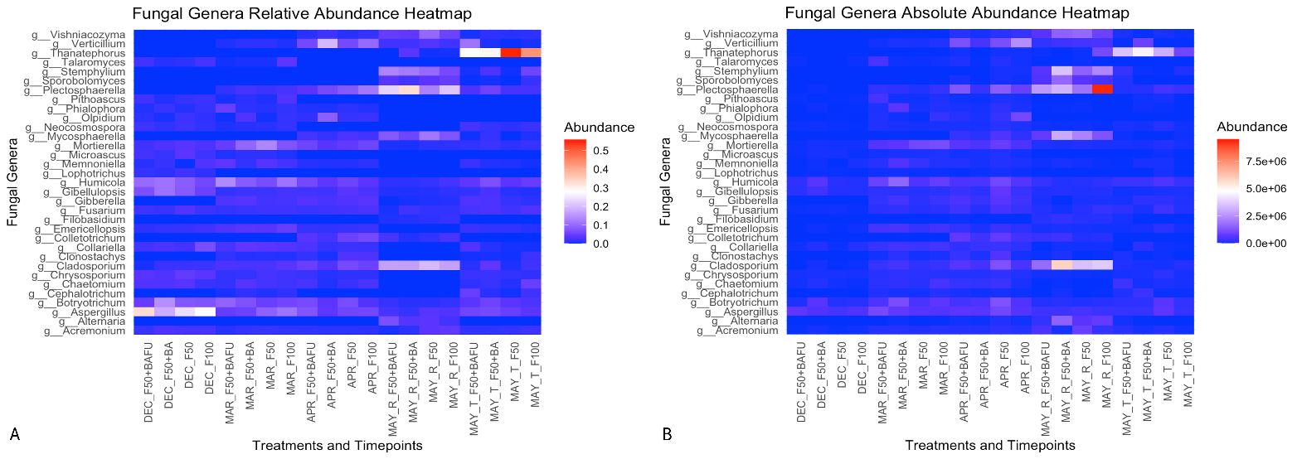
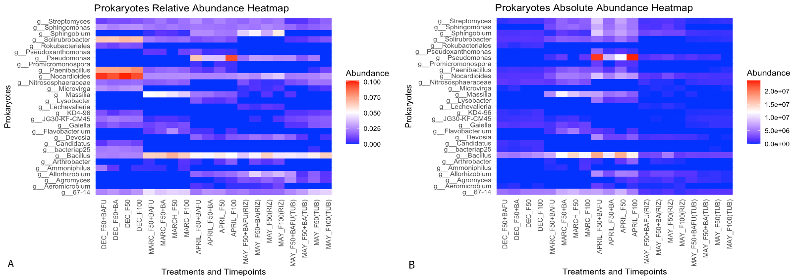
Figure S3. Heat maps of fungal genera for relative abundance (A) and estimated absolute abundance (EAA) (B). Treatment abbreviations: (1) F100, inorganic fertilizer applied at crop nutritional requirements; (2) F50, reduced F100 fertilization by 50%; (3) F50+BA, F50 plus a microbial inoculant containing Azospirillum, Pseudomonas, and Bacillus; (4) F50+BAFU, F50 plus a microbial inoculant containing Bacillus, Azotobacter, and non-mycorrhizal fungi. Sampling time abbreviations: DEC, December; MAR, March; APR, April; MAY(RIZ), May rhizosphere; MAY(TUB), May tuberosphere.
Figure S2. Heatmaps of prokaryotic genera for relative abundance (A) and estimated absolute abundance (EAA) (B). Treatment abbreviations: (1) F100, inorganic fertilizer applied at crop nutritional requirements; (2) F50, reduced F100 fertilization by 50%; (3) F50+BA, F50 plus a microbial inoculant containing Azospirillum, Pseudomonas, and Bacillus; (4) F50+BAFU, F50 plus a microbial inoculant containing Bacillus, Azotobacter, and non-mycorrhizal fungi. Sampling time abbreviations: DEC, December; MAR, March; APR, April; MAY(RIZ), May rhizosphere; MAY(TUB), May tuberosphere.
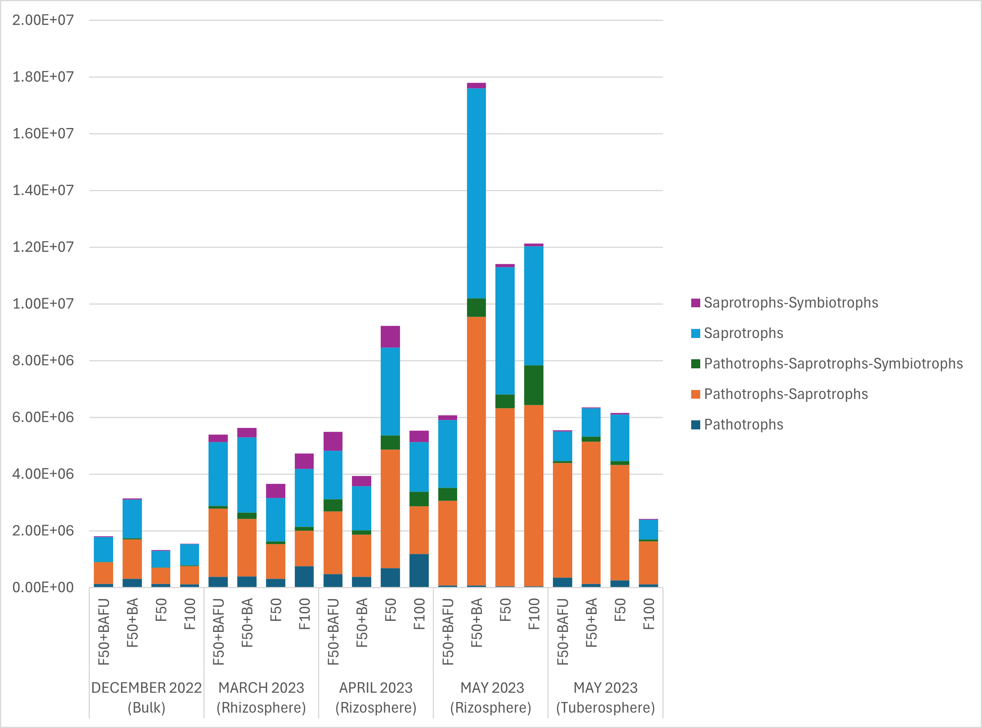
Figure S4. Estimated absolute abundance (EAA) of the most abundant genera (>1%) fungal guilds across the different treatments, soil types and sampling times. Abbreviations are: 1) F100, inorganic fertilizer applied at crop nutritional requirements; 2) F50, reduced F100 fertilization by 50%; 3) F50+BA, F50 plus a microbial inoculant containing Azospirillum, Pseudomonas, and Bacillus; 4) F50+BAFU, F50 plus microbial inoculant containing Bacillus, Azotobacter, and non-mycorrhizal fungi.

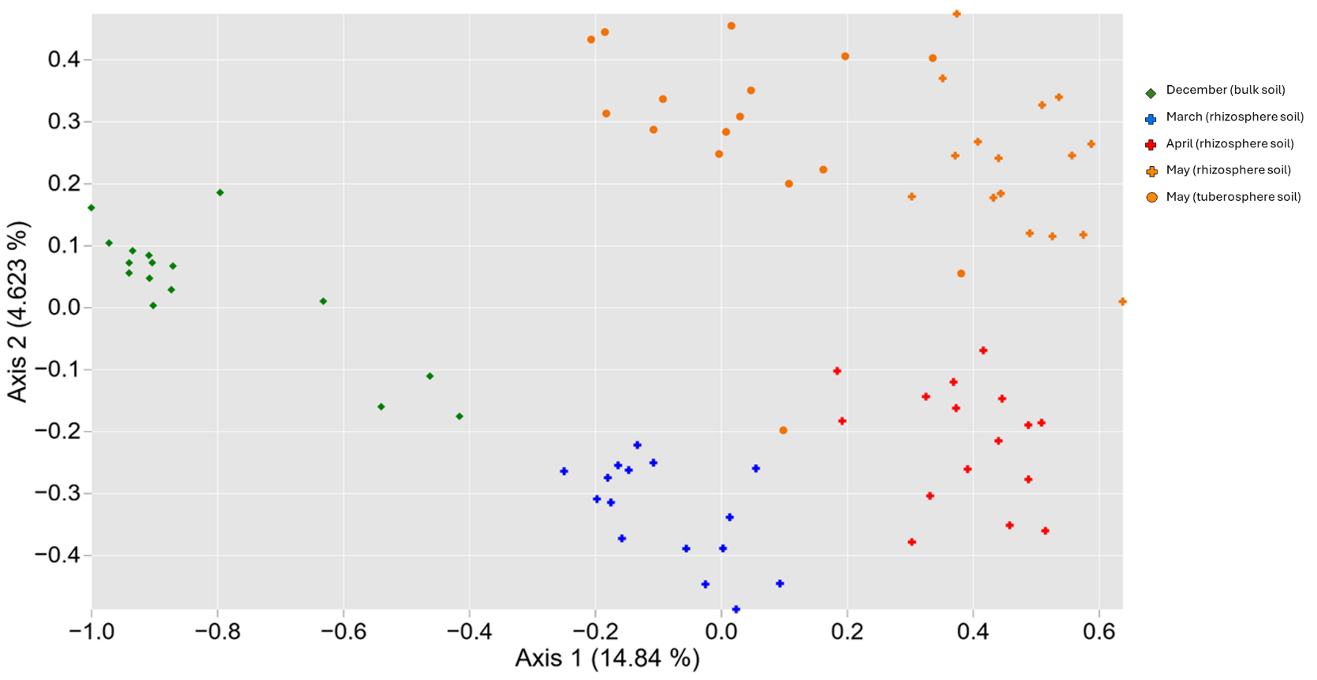
Supplementary Figure S5. Principal coordinate analysis (PCoA) depicting the variability of the prokaryotic community composition for bulk, rhizosphere and tuberosphere soils at different sampling times. Shapes represent different soil types indicating diamonds bulk soil, crosses the rhizosphere, and circles the tuberosphere. Colors denote sampling months being green for December 2022, blue for March 2023, red for April 2023, and orange for May 2023.

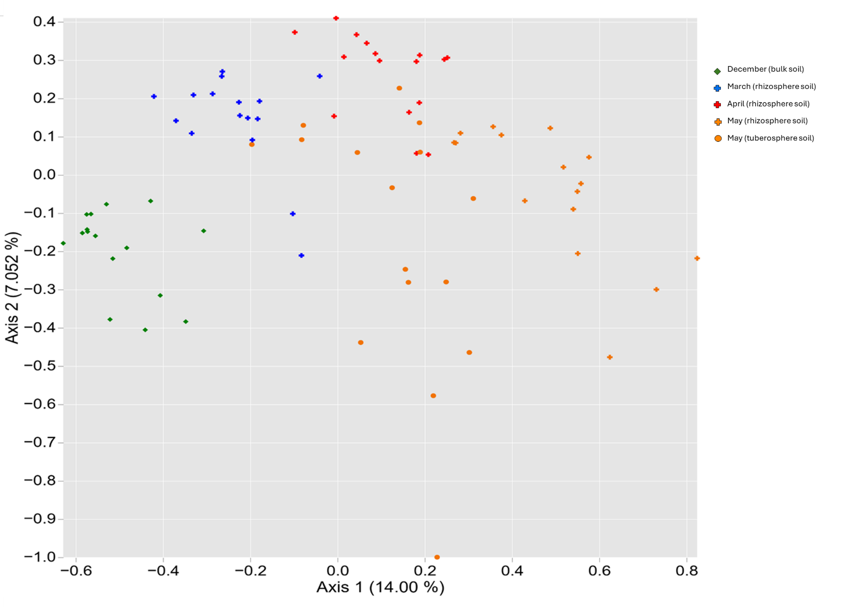
Supplementary Figure S6. Beta diversity of the fungal microbiota analyzed using a weighted Jaccard distance-based principal coordinate analysis (PCoA). The shapes of the dots represent different soil types: diamonds indicate bulk soil, crosses represent the rhizosphere, and circles correspond to the tuberosphere. Colors denote sampling months: green for December 2022, blue for March 2023, red for April 2023, and orange for May 2023.

