SUPPLEMENTARY FIGURES

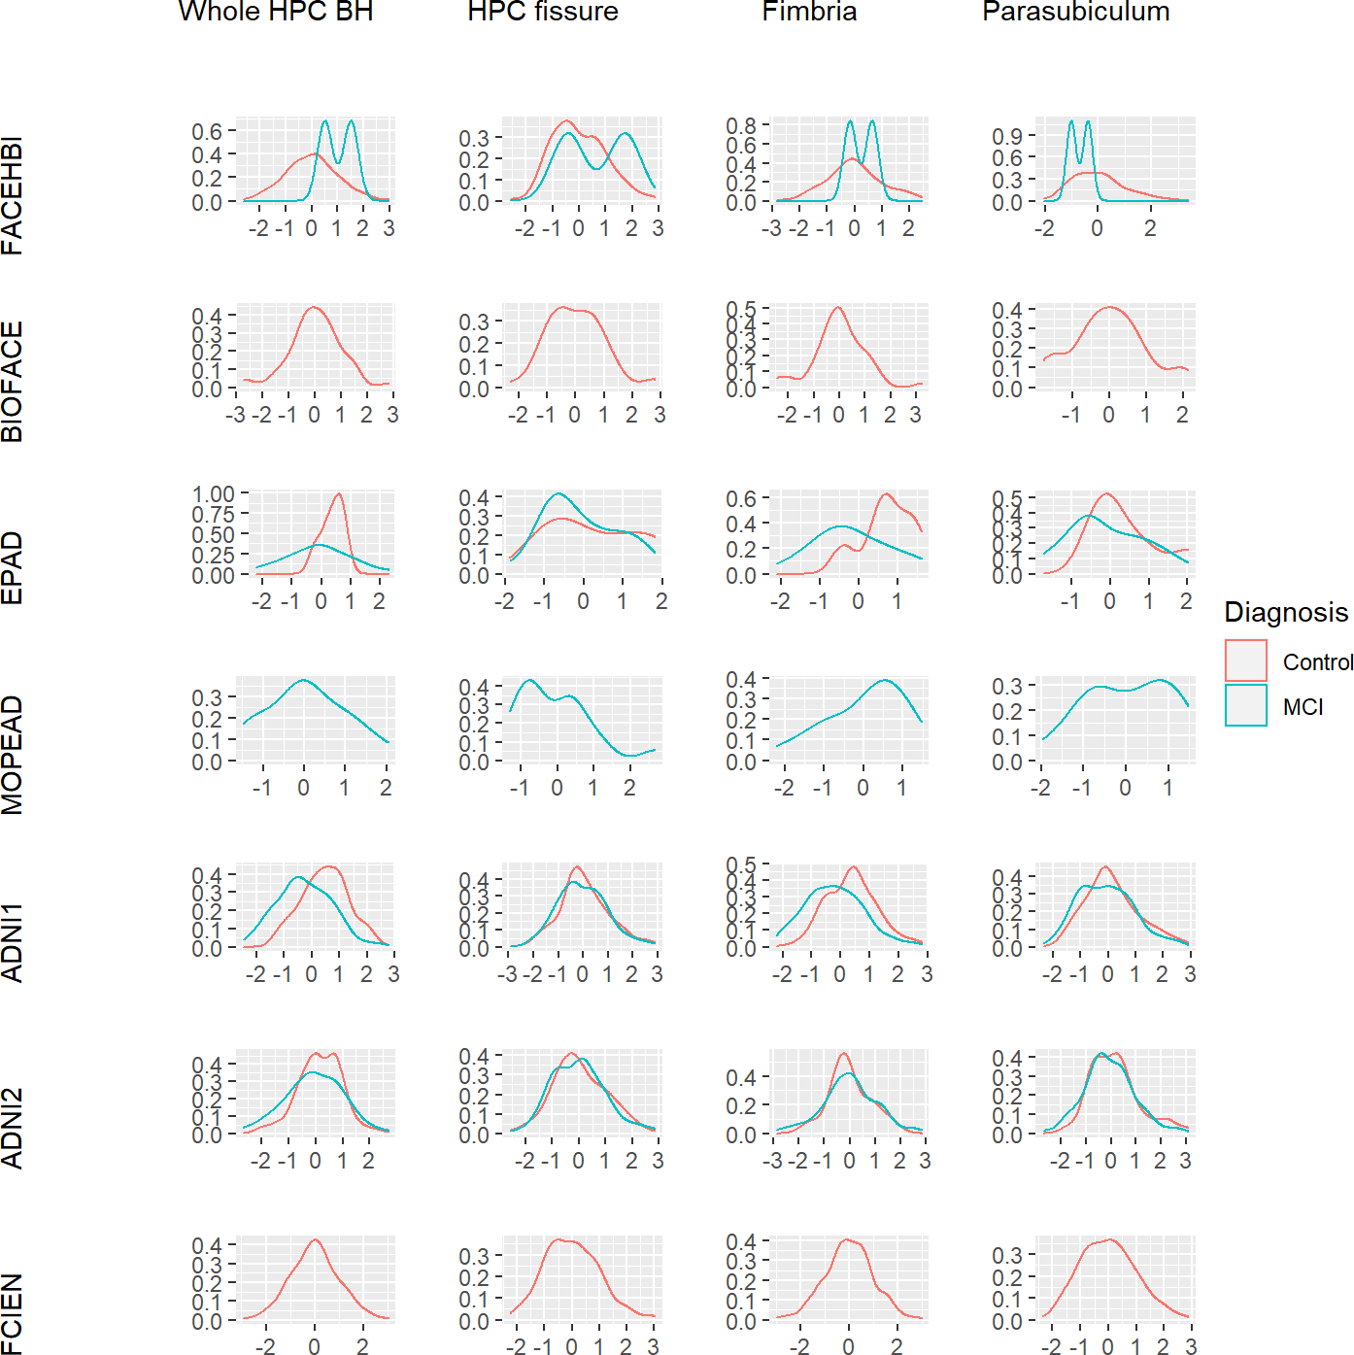

Supplementary Figure 1. Distribution of the scaled HS-by-proxy phenotypic variables by
project and clinical status. HPC (Hippocampal), BH (body and head), MCI (Mild Cognitive
Impairment).

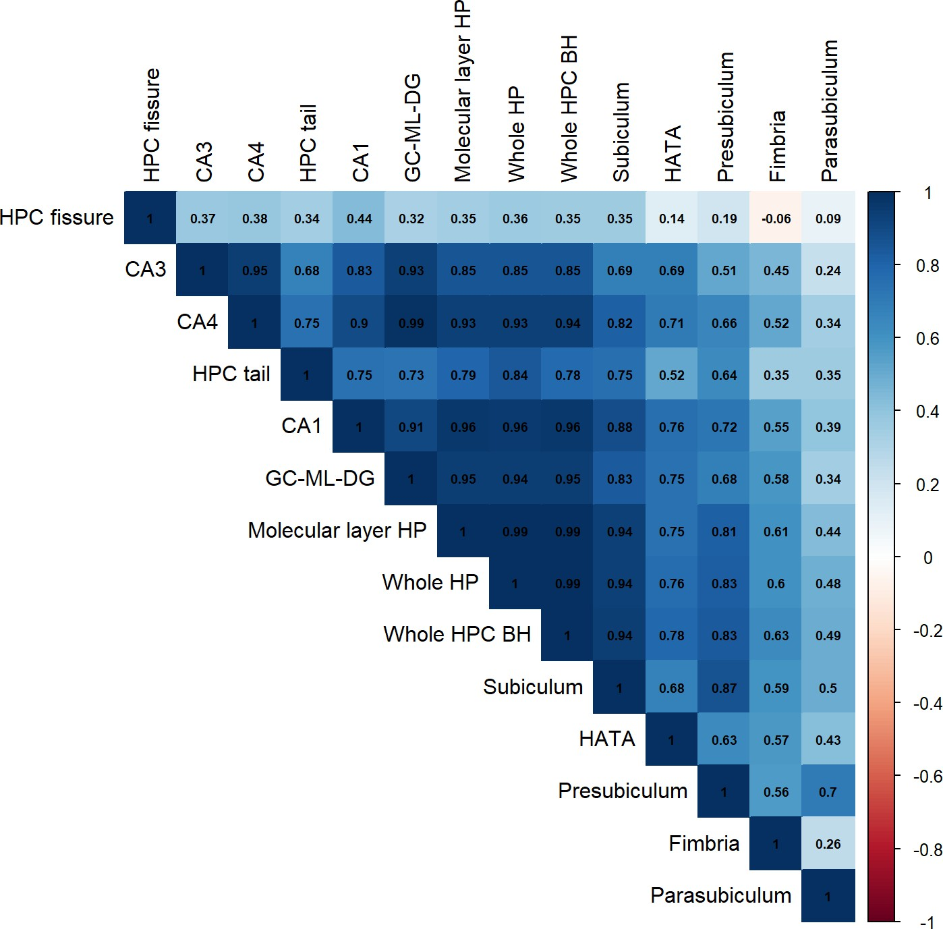

Supplementary Figure 2. Hippocampal subregions correlations. HP (Hippocampus), BH (body
and head), HPC (Hippocampal), HATA (hippocampus-amygdala-transition-area), GC-ML-DG
(Granule Cell and Molecular Layer of the Dentate Gyrus), CA (Cornu ammonis).

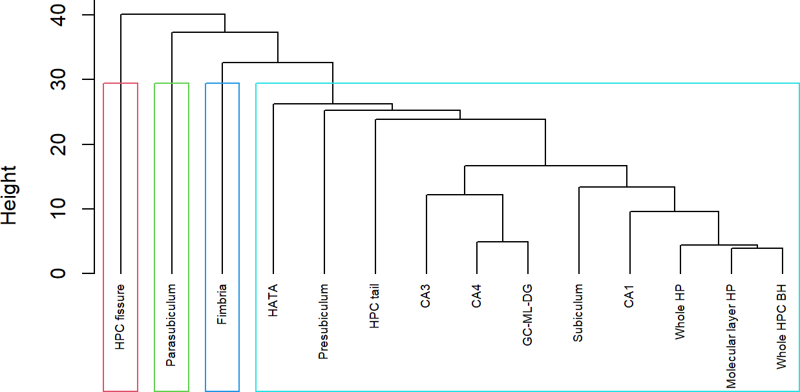

Supplementary Figure 3. Cluster dendrogram for hippocampal subfields. HP (Hippocampus),
BH (body and head), HPC (Hippocampal), HATA (hippocampus-amygdala-transition-area), GC-
ML-DG (Granule Cell and Molecular Layer of the Dentate Gyrus), CA (Cornu ammonis).

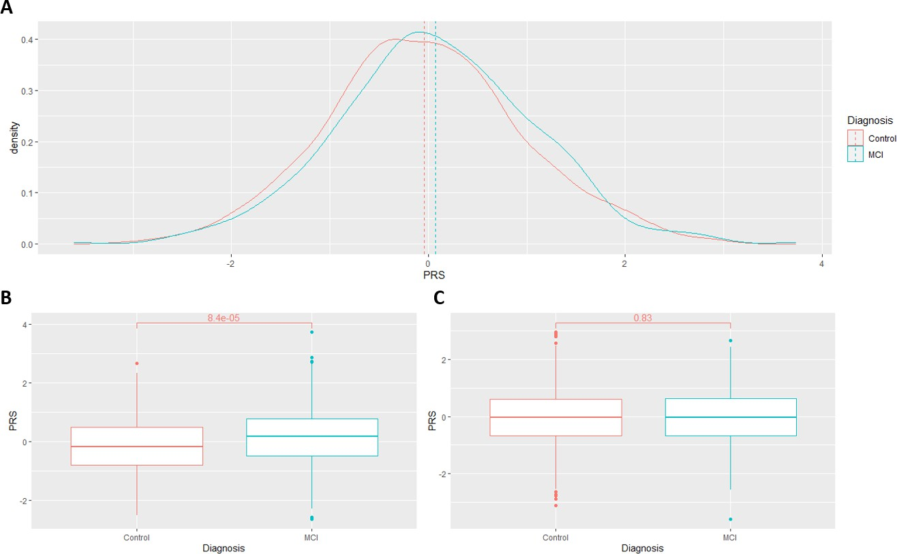

Supplementary Figure 4. Distribution of AD-PRS values in mild cognitive impairment (MCI)
compared with control individuals (A). In APOE ɛ4 carriers (B) and APOE ɛ4 non-carriers (C).

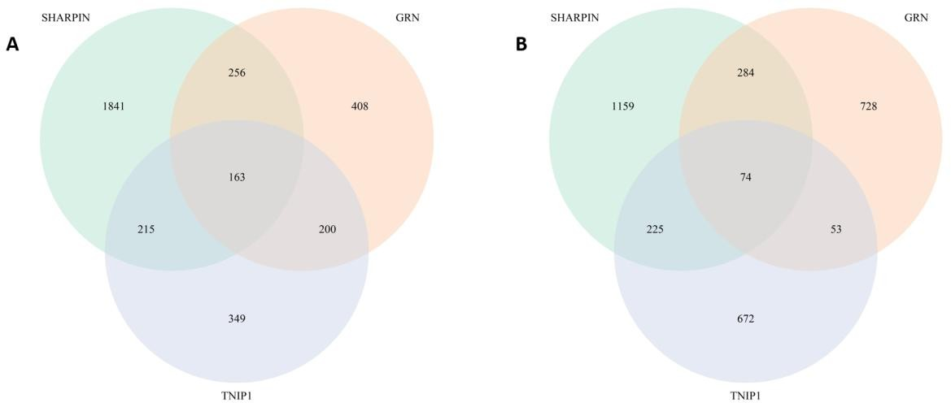

Supplementary Figure 5. Venn diagram of the co-expressed genes between SHARPIN, GRN and TNIP1 in brain (A) and neuron (B).

SUPPLEMENTARY TABLES

Supplementary Table 1. Impact of covariates in the statistical model for the association of
the AD-PRS with hippocampal BH.
 | Estimate | SE | p -value
(Intercept) | 6.8627344 | 1.7681677 | 0.000108
PRS | -0.0842782 | 0.0187226 | 7.18E-06
PC1 | -0.3458448 | 0.6330494 | 0.584916
PC2 | 0.9129954 | 0.6608337 | 0.16727
PC3 | -0.6613513 | 0.6011743 | 0.271434
PC4 | 1.5058116 | 0.635283 | 0.017877
PC5 | -0.8285646 | 0.6340329 | 0.19144
PC6 | -0.7289584 | 0.6260938 | 0.244457
PC7 | -0.6808985 | 0.6319018 | 0.281382
PC8 | -0.2904233 | 0.6324686 | 0.646152
PC9 | 0.5739908 | 0.6231629 | 0.357124
PC10 | 0.2735863 | 0.627776 | 0.663032
Age | -0.0782817 | 0.0478843 | 0.102262
Age2 | 0.0001048 | 0.000328 | 0.749274
Sex | -0.2269309 | 0.0478285 | 2.25E-06
Education | -0.0047679 | 0.0043629 | 0.274616
Diagnosis | -0.7307481 | 0.0575022 | < 2e-16
EstimatedTotalIntraCranialVol | 0.3899171 | 0.0229901 | < 2e-16
CohortADNI2 | -0.1373313 | 0.0581838 | 0.018365
CohortBIOFACE | -0.5668226 | 0.1286176 | 1.11E-05
CohortEPAD | -0.1561474 | 0.1559392 | 0.316798
CohortFACEHBI | -0.8814088 | 0.0904961 | < 2e-16
CohortFCIEN | -0.4404407 | 0.064014 | 8.18E-12
CohortMOPEAD | 0.1346365 | 0.1860851 | 0.469453
* AD-PRS (Alzheimer's Disease Polygenic Risk Score), BH (body and head), SE (standard error), PC (Principal Component)

Supplementary Table 2. Impact of covariates in the statistical model for the association of
the AD-PRS with fimbria.
 | Estimate | SE | p-value
(Intercept) | 7.3080599 | 1.9837879 | 0.000236
PRS | -0.069157 | 0.0210276 | 0.001025
PC1 | -0.9339095 | 0.7104256 | 0.188817
PC2 | 1.1491311 | 0.7419849 | 0.121621
PC3 | 0.1857082 | 0.6737084 | 0.782848
PC4 | -0.1148797 | 0.7129228 | 0.872002
PC5 | 0.5518891 | 0.7116173 | 0.43812
PC6 | -0.0037581 | 0.702996 | 0.995735
PC7 | -0.2322511 | 0.709413 | 0.743414
PC8 | -0.8244041 | 0.7097222 | 0.245555
PC9 | 0.776818 | 0.6993964 | 0.266845
PC10 | -0.4668388 | 0.7047037 | 0.50776
Age | -0.0955454 | 0.0537231 | 0.075492
Age2 | 0.0001592 | 0.000368 | 0.665351
Sex | -0.0340669 | 0.0537976 | 0.526655
Education | -0.0067138 | 0.0048999 | 0.170793
Diagnosis | -0.5389243 | 0.0645266 | < 2e-16
EstimatedTotalIntraCranialVol | 0.1210715 | 0.0258564 | 3.04E-06
CohortADNI2 | -0.197091 | 0.0652525 | 0.002559
CohortBIOFACE | -0.8358005 | 0.1451733 | 1.00E-08
CohortEPAD | -0.2820212 | 0.1749988 | 0.107231
CohortFACEHBI | -0.9464415 | 0.1015777 | < 2e-16
CohortFCIEN | -0.3892324 | 0.0719203 | 7.06E-08
CohortMOPEAD | -0.0097748 | 0.2088322 | 0.962672
* AD-PRS (Alzheimer's Disease Polygenic Risk Score), SE (standard error), PC (Principal Component)

Supplementary Table 3. Biological processes enriched by loci in cluster A identified with STRING.
term ID | term description | observed gene count | background gene count | strength | false discovery rate
GO:0048519 | Negative regulation of biological process | 12 | 5313 | 0.53 | 0.0229
GO:0097039 | Protein linear polyubiquitination | 2 | 3 | 3 | 0.0314

Supplementary Table 4. Biological processes enriched by loci in cluster B identified with STRING.
term ID | term description | observ  ed gene count | backgrou  nd gene count | strengt h | false  discove ry rate
GO:00018 19 | Positive regulation of cytokine production | 7 | 482 | 1.46 | 9.79E-  06
GO:00326 75 | Regulation of interleukin-6 production | 4 | 151 | 1.72 | 0.0029
GO:00192  20 | Regulation of phosphate metabolic  process | 7 | 1405 | 0.99 | 0.003
GO:00026  84 | Positive regulation of immune system  process | 6 | 874 | 1.13 | 0.0031
GO:00099  67 | Positive regulation of signal  transduction | 7 | 1525 | 0.96 | 0.0031
GO:00313 99 | Regulation of protein modification process | 7 | 1560 | 0.95 | 0.0031
GO:00459 37 | Positive regulation of phosphate metabolic process | 6 | 912 | 1.11 | 0.0031
GO:00507  31 | Positive regulation of peptidyl-tyrosine  phosphorylation | 4 | 194 | 1.61 | 0.0031
GO:00512  47 | Positive regulation of protein metabolic  process | 7 | 1512 | 0.96 | 0.0031
GO:19029  96 | Regulation of neurofibrillary tangle  assembly | 2 | 3 | 3.12 | 0.0031
GO:00314  01 | Positive regulation of protein  modification process | 6 | 1018 | 1.06 | 0.0033
GO:00421 16 | Macrophage activation | 3 | 62 | 1.98 | 0.0033
GO:00712 16 | Cellular response to biotic stimulus | 4 | 232 | 1.53 | 0.0033
GO:00512  39 | Regulation of multicellular organismal  process | 8 | 2749 | 0.76 | 0.0037
GO:00019  32 | Regulation of protein phosphorylation | 6 | 1108 | 1.03 | 0.0038
GO:00513  47 | Positive regulation of transferase  activity | 5 | 586 | 1.23 | 0.0038
GO:00615  18 | Microglial cell proliferation | 2 | 8 | 2.69 | 0.0065
GO:00324 96 | Response to lipopolysaccharide | 4 | 314 | 1.4 | 0.0072
GO:00019  34 | Positive regulation of protein  phosphorylation | 5 | 747 | 1.12 | 0.0083
GO:00027  32 | Positive regulation of dendritic cell  cytokine production | 2 | 11 | 2.55 | 0.0083
GO:00327  55 | Positive regulation of interleukin-6  production | 3 | 98 | 1.78 | 0.0083
GO:00458  07 | Positive regulation of endocytosis | 3 | 99 | 1.78 | 0.0083
GO:00517  07 | Response to other organism | 6 | 1328 | 0.95 | 0.0083
GO:00435 49 | Regulation of kinase activity | 5 | 778 | 1.1 | 0.0086
GO:00022  52 | Immune effector process | 4 | 375 | 1.32 | 0.0093

GO:00106  46 | Regulation of cell communication | 8 | 3355 | 0.67 | 0.0093
GO:00230  51 | Regulation of signaling | 8 | 3367 | 0.67 | 0.0093
GO:19029  47 | Regulation of tau-protein kinase activity | 2 | 13 | 2.48 | 0.0093
GO:19059 07 | Negative regulation of amyloid fibril formation | 2 | 13 | 2.48 | 0.0093
GO:00601 00 | Positive regulation of phagocytosis, engulfment | 2 | 14 | 2.45 | 0.0097
GO:00096  05 | Response to external stimulus | 7 | 2355 | 0.77 | 0.0099
GO:00507  76 | Regulation of immune response | 5 | 844 | 1.07 | 0.0099
GO:01500  78 | Positive regulation of  neuroinflammatory response | 2 | 15 | 2.42 | 0.0099
GO:00106  04 | Positive regulation of macromolecule  metabolic process | 8 | 3533 | 0.65 | 0.0103
GO:00432 54 | Regulation of protein-containing complex assembly | 4 | 413 | 1.28 | 0.0104
GO:00027 05 | Positive regulation of leukocyte mediated immunity | 3 | 138 | 1.63 | 0.0112
GO:00313  33 | Negative regulation of protein-  containing complex assembly | 3 | 142 | 1.62 | 0.0116
GO:00440  93 | Positive regulation of molecular  function | 6 | 1587 | 0.87 | 0.0116
GO:19024  30 | Negative regulation of amyloid-beta  formation | 2 | 18 | 2.34 | 0.0116
GO:00022 81 | Macrophage activation involved in immune response | 2 | 19 | 2.32 | 0.0118
GO:00303 34 | Regulation of cell migration | 5 | 927 | 1.03 | 0.0118
GO:19002  21 | Regulation of amyloid-beta clearance | 2 | 19 | 2.32 | 0.0118
GO:00321  03 | Positive regulation of response to  external stimulus | 4 | 453 | 1.24 | 0.0124
GO:19002  25 | Regulation of NLRP3 inflammasome  complex assembly | 2 | 20 | 2.29 | 0.0124
GO:00025  77 | Regulation of antigen processing and  presentation | 2 | 21 | 2.27 | 0.0131
GO:00326 80 | Regulation of tumor necrosis factor production | 3 | 164 | 1.56 | 0.0143
GO:19025 31 | Regulation of intracellular signal transduction | 6 | 1726 | 0.84 | 0.0143
GO:19025  33 | Positive regulation of intracellular  signal transduction | 5 | 997 | 0.99 | 0.0143
GO:00336  74 | Positive regulation of kinase activity | 4 | 494 | 1.2 | 0.0151
GO:00485  83 | Regulation of response to stimulus | 8 | 3931 | 0.6 | 0.0151
GO:00303 35 | Positive regulation of cell migration | 4 | 529 | 1.17 | 0.0184
GO:00066 22 | Protein targeting to lysosome | 2 | 28 | 2.15 | 0.0187

GO:00606  27 | Regulation of vesicle-mediated transport | 4 | 551 | 1.16 | 0.0211
GO:00017  74 | Microglial cell activation | 2 | 31 | 2.1 | 0.0219
GO:00714  02 | Cellular response to lipoprotein particle  stimulus | 2 | 31 | 2.1 | 0.0219
GO:00712 19 | Cellular response to molecule of bacterial origin | 3 | 205 | 1.46 | 0.0229
GO:00453 21 | Leukocyte activation | 4 | 574 | 1.14 | 0.023
GO:00457  32 | Positive regulation of protein catabolic  process | 3 | 214 | 1.44 | 0.0244
GO:00327  33 | Positive regulation of interleukin-10  production | 2 | 40 | 1.99 | 0.031
GO:00508  50 | Positive regulation of calcium-mediated  signaling | 2 | 42 | 1.97 | 0.0324
GO:00327  35 | Positive regulation of interleukin-12  production | 2 | 43 | 1.96 | 0.0335
GO:00458 59 | Regulation of protein kinase activity | 4 | 663 | 1.07 | 0.034
GO:00434 08 | Regulation of MAPK cascade | 4 | 668 | 1.07 | 0.0341
GO:00069  55 | Immune response | 5 | 1321 | 0.87 | 0.0366
GO:00511  29 | Negative regulation of cellular  component organization | 4 | 691 | 1.06 | 0.038
GO:00071  65 | Signal transduction | 8 | 4714 | 0.52 | 0.0408
GO:00069 52 | Defense response | 5 | 1394 | 0.85 | 0.0447
GO:00482 60 | Positive regulation of receptor-mediated endocytosis | 2 | 55 | 1.86 | 0.0484
GO:00486  78 | Response to axon injury | 2 | 56 | 1.85 | 0.0497

Supplementary Table 5. Biological processes enriched by loci in cluster C identified with STRING.
term ID | term description | observ ed gene  count | backgro und gene  count | stren gth | false discov ery  rate
GO:0010 813 | Neuropeptide catabolic process | 3 | 4 | 2.42 | 0.0064
GO:0050  435 | Amyloid-beta metabolic process | 4 | 18 | 1.89 | 0.0064
GO:0030 334 | Regulation of cell migration | 13 | 927 | 0.69 | 0.0087
GO:0002 252 | Immune effector process | 8 | 375 | 0.88 | 0.0095
GO:0002  684 | Positive regulation of immune system process | 12 | 874 | 0.68 | 0.0095
GO:0006  897 | Endocytosis | 9 | 447 | 0.85 | 0.0095
GO:0007  166 | Cell surface receptor signaling pathway | 18 | 2040 | 0.49 | 0.0095
GO:0010 815 | Bradykinin catabolic process | 3 | 7 | 2.18 | 0.0095
GO:0023 052 | Signaling | 30 | 5057 | 0.32 | 0.0095
GO:0030  335 | Positive regulation of cell migration | 10 | 529 | 0.82 | 0.0095
GO:0043  085 | Positive regulation of catalytic activity | 14 | 1191 | 0.62 | 0.0095
GO:0044  093 | Positive regulation of molecular function | 16 | 1587 | 0.55 | 0.0095
GO:0045  807 | Positive regulation of endocytosis | 5 | 99 | 1.25 | 0.0095
GO:0048 518 | Positive regulation of biological process | 34 | 6207 | 0.28 | 0.0095
GO:0051 094 | Positive regulation of developmental process | 14 | 1332 | 0.57 | 0.0095
GO:0051  239 | Regulation of multicellular organismal  process | 21 | 2749 | 0.43 | 0.0095
GO:0051  240 | Positive regulation of multicellular  organismal process | 16 | 1505 | 0.57 | 0.0095
GO:0060  100 | Positive regulation of phagocytosis,  engulfment | 3 | 14 | 1.88 | 0.0095
GO:0060 627 | Regulation of vesicle-mediated transport | 10 | 551 | 0.81 | 0.0095
GO:0150 094 | Amyloid-beta clearance by cellular catabolic process | 3 | 8 | 2.12 | 0.0095
GO:1902 959 | Regulation of aspartic-type endopeptidase activity involved in amyloid precursor protein catabolic process | 3 | 11 | 1.98 | 0.0095
GO:1902  991 | Regulation of amyloid precursor protein  catabolic process | 4 | 44 | 1.5 | 0.0095
GO:0065 009 | Regulation of molecular function | 22 | 3085 | 0.4 | 0.0097
GO:0007  165 | Signal transduction | 28 | 4714 | 0.32 | 0.0106

GO:2000  026 | Regulation of multicellular organismal  development | 14 | 1389 | 0.55 | 0.0127
GO:1902  430 | Negative regulation of amyloid-beta  formation | 3 | 18 | 1.77 | 0.0128
GO:0030  100 | Regulation of endocytosis | 6 | 209 | 1 | 0.0143
GO:1900 221 | Regulation of amyloid-beta clearance | 3 | 19 | 1.74 | 0.0143
GO:0002 682 | Regulation of immune system process | 14 | 1438 | 0.53 | 0.0165
GO:0007  154 | Cell communication | 29 | 5165 | 0.3 | 0.0171
GO:0051  345 | Positive regulation of hydrolase activity | 9 | 589 | 0.73 | 0.0171
GO:1901  076 | Positive regulation of engulfment of apoptotic  cell | 2 | 2 | 2.55 | 0.018
GO:0010  646 | Regulation of cell communication | 22 | 3355 | 0.36 | 0.0233
GO:0043 410 | Positive regulation of MAPK cascade | 8 | 481 | 0.77 | 0.0233
GO:0043 549 | Regulation of kinase activity | 10 | 778 | 0.66 | 0.0233
GO:0045  785 | Positive regulation of cell adhesion | 8 | 485 | 0.76 | 0.0233
GO:0048  522 | Positive regulation of cellular process | 30 | 5584 | 0.28 | 0.0233
GO:0050  790 | Regulation of catalytic activity | 18 | 2370 | 0.43 | 0.0233
GO:0002 274 | Myeloid leukocyte activation | 5 | 150 | 1.07 | 0.0239
GO:0010 628 | Positive regulation of gene expression | 12 | 1146 | 0.57 | 0.0239
GO:0010  814 | Substance P catabolic process | 2 | 3 | 2.37 | 0.0239
GO:0010  875 | Positive regulation of cholesterol efflux | 3 | 26 | 1.61 | 0.0239
GO:0065  005 | Protein-lipid complex assembly | 3 | 26 | 1.61 | 0.0239
GO:1902 960 | Negative regulation of aspartic-type endopeptidase activity involved in amyloid  precursor protein catabolic process | 2 | 3 | 2.37 | 0.0239
GO:0051  049 | Regulation of transport | 15 | 1763 | 0.48 | 0.0253
GO:0050  865 | Regulation of cell activation | 9 | 658 | 0.68 | 0.0272
GO:0050 730 | Regulation of peptidyl-tyrosine phosphorylation | 6 | 259 | 0.91 | 0.0273
GO:0097 066 | Response to thyroid hormone | 3 | 29 | 1.56 | 0.0273
GO:0043  408 | Regulation of MAPK cascade | 9 | 668 | 0.68 | 0.0285
GO:0045  595 | Regulation of cell differentiation | 14 | 1582 | 0.49 | 0.0285
GO:0051  716 | Cellular response to stimulus | 32 | 6357 | 0.25 | 0.0285

GO:0002  316 | Follicular B cell differentiation | 2 | 4 | 2.25 | 0.0292
GO:0050  776 | Regulation of immune response | 10 | 844 | 0.62 | 0.0292
GO:0050  793 | Regulation of developmental process | 18 | 2492 | 0.4 | 0.0292
GO:0050 794 | Regulation of cellular process | 45 | 11025 | 0.16 | 0.0292
GO:0051 336 | Regulation of hydrolase activity | 11 | 1011 | 0.58 | 0.0292
GO:0051  604 | Protein maturation | 6 | 275 | 0.89 | 0.0315
GO:0050  867 | Positive regulation of cell activation | 7 | 401 | 0.79 | 0.0326
GO:0019  222 | Regulation of metabolic process | 33 | 6784 | 0.23 | 0.0339
GO:1902  905 | Positive regulation of supramolecular fiber  organization | 5 | 175 | 1 | 0.0339
GO:0038 027 | Apolipoprotein A-I-mediated signaling pathway | 2 | 5 | 2.15 | 0.0343
GO:0045 917 | Positive regulation of complement activation | 2 | 5 | 2.15 | 0.0343
GO:0051  130 | Positive regulation of cellular component  organization | 11 | 1049 | 0.57 | 0.0343
GO:0045  597 | Positive regulation of cell differentiation | 10 | 876 | 0.6 | 0.0347
GO:0043  254 | Regulation of protein-containing complex  assembly | 7 | 413 | 0.78 | 0.0355
GO:0032 879 | Regulation of localization | 16 | 2103 | 0.43 | 0.036
GO:1902 107 | Positive regulation of leukocyte differentiation | 5 | 181 | 0.99 | 0.036
GO:0050  777 | Negative regulation of immune response | 5 | 185 | 0.98 | 0.0378
GO:0061  097 | Regulation of protein tyrosine kinase activity | 4 | 99 | 1.15 | 0.0383
GO:0010  647 | Positive regulation of cell communication | 14 | 1693 | 0.46 | 0.0389
GO:0023  051 | Regulation of signaling | 21 | 3367 | 0.34 | 0.0389
GO:0045 321 | Leukocyte activation | 8 | 574 | 0.69 | 0.0389
GO:0048 523 | Negative regulation of cellular process | 26 | 4736 | 0.29 | 0.0389
GO:0048  584 | Positive regulation of response to stimulus | 16 | 2131 | 0.42 | 0.0389
GO:0050  789 | Regulation of biological process | 46 | 11655 | 0.14 | 0.0389
GO:0051  246 | Regulation of protein metabolic process | 18 | 2622 | 0.38 | 0.0389
GO:1903 898 | Negative regulation of PERK-mediated unfolded protein response | 2 | 6 | 2.07 | 0.0389
GO:0031 334 | Positive regulation of protein-containing complex assembly | 5 | 193 | 0.96 | 0.0392

GO:0016  192 | Vesicle-mediated transport | 12 | 1298 | 0.51 | 0.0397
GO:0050  731 | Positive regulation of peptidyl-tyrosine  phosphorylation | 5 | 194 | 0.96 | 0.0397
GO:0051  347 | Positive regulation of transferase activity | 8 | 586 | 0.68 | 0.0398
GO:0070 050 | Neuron cellular homeostasis | 3 | 41 | 1.41 | 0.0409
GO:0051 247 | Positive regulation of protein metabolic process | 13 | 1512 | 0.48 | 0.0413
GO:1902  531 | Regulation of intracellular signal transduction | 14 | 1726 | 0.46 | 0.0413
GO:0052  547 | Regulation of peptidase activity | 7 | 446 | 0.74 | 0.0422
GO:0002  694 | Regulation of leukocyte activation | 8 | 601 | 0.67 | 0.0448

Supplementary Table 6. Top ten pathways ranked based on FDR threshold enriched by co-
expressed genes between SHARPIN, GRN and TNIP1 in brain (N = 163) identified by ORA with WebGestalt.
Gene Set | Description | Expect | Ratio | P-value | FDR
hsa0414 1 | Protein processing in endoplasmic reticulum | 1.82 | 7.16 | 2.22 × 10-08 | 7.25 × 10-06
hsa0051 1 | Other glycan degradation | 0.20 | 20.20 | 3.70 × 10-05 | 6.03 × 10-03
hsa0414 2 | Lysosome | 1.35 | 5.91 | 5.59 × 10-05 | 6.07 × 10-03
hsa0516  9 | Epstein-Barr virus  infection | 2.21 | 4.07 | 3.34 × 10-04 | 2.73 × 10-02
hsa0516  3 | Human cytomegalovirus  infection | 2.48 | 3.64 | 7.61 × 10-04 | 4.96 × 10-02
hsa0466  2 | B cell receptor signaling  pathway | 0.78 | 6.40 | 1.05 × 10-03 | 5.70 × 10-02
hsa0517 0 | Human immunodeficiency virus 1 infection | 2.33 | 3.43 | 2.19 × 10-03 | 1.02 × 10-01
hsa0516 2 | Measles | 1.45 | 4.13 | 3.20 × 10-03 | 1.20 × 10-01
hsa0465  8 | Th1 and Th2 cell  differentiation | 1.01 | 4.94 | 3.31 × 10-03 | 1.20 × 10-01
hsa0513  1 | Shigellosis | 0.72 | 5.59 | 5.53 × 10-03 | 1.71 × 10-01
* Significant FDR (FDR ≤ 0.05) in bold.
† Expect (number of expected genes in the pathway), Ratio (enrichment ratio), FDR (False Discovery Rate).

Supplementary Table 7. KEGG pathways significantly enriched by co-expressed genes between SHARPIN, GRN and TNIP1 in brain (N = 163) found in the STRING
database.
Term ID | Description | Strength | FDR
hsa00511 | Other glycan degradation | 1.43 | 3.00E-03
hsa00600 | Sphingolipid metabolism | 1.02 | 2.60E-02
hsa04141 | Protein processing in endoplasmic reticulum | 0.99 | 6.84E-07
hsa04142 | Lysosome | 0.89 | 2.20E-03
hsa04662 | B cell receptor signaling pathway | 0.89 | 2.45E-02
hsa05162 | Measles | 0.80 | 9.80E-03
hsa05164 | Influenza A | 0.78 | 5.30E-03
hsa05169 | Epstein-Barr virus infection | 0.76 | 3.30E-03
hsa05163 | Human cytomegalovirus infection | 0.65 | 2.45E-02
hsa05131 | Shigellosis | 0.65 | 2.45E-02
* Strength (Enrichment Effect = log10(observed / expected)), FDR (False Discovery Rate).

SUPPLEMENTARY METHODS

The Vallecas Project
The Vallecas Project is a single-centre longitudinal community-based study, currently in its eighth year. Genetic testing was conducted at baseline visit, and yearly clinical, neuropsychological, and MRI assessments remain ongoing. Inclusion and exclusion criteria have been described previously. From a pool of 1213 participants, additional criteria were set, including only those with MRI scanning and without a diagnosis of MCI or dementia, leaving a total of 916 participants on the first visit for cross-sectional analyses, of which 729 had GAWAS data or polymorphisms of interest. All participants provided written informed consent. The Vallecas project was approved by the Ethics Committee of the Instituto de Salud Carlos III.

ADNI 1
The ADNI was launched in 2003 as a public-private partnership, led by Principal Investigator Michael W. Weiner, MD. The primary goal of ADNI has been to test whether serial MRI, positron emission tomography (PET), other biological markers, and clinical and neuropsychological assessment can be combined to measure the progression of MCI and early AD.
The first phase of ADNI was designed to find more sensitive and accurate biomarkers for the early detection and tracking of AD. This study was based on thousands of brain scans, genetic profiles, blood and cerebrospinal fluid biomarkers and brain imaging measures including structural MRI and PET from a total of 800 individuals diagnosed with mild cognitive impairment (MCI), early AD and elderly control subjects including 200 elderly control subjects, 400 individuals diagnosed with mild cognitive impairment (MCI) and 200 with early Alzheimer’s disease (AD). This study developed improved methods that create uniform standards for acquiring longitudinal, multi-site MRI and PET data on patients with AD, MCI and elderly controls and therefore provides maximum power to determine treatment effects. Moreover, it acquired a generally accessible data repository which describes longitudinal changes in brain structure and metabolism as well as clinical/cognitive and biomarker data for the validation of imaging surrogates.

ADNI GO
The ADNI GO study followed the ADNI1 project defining and characterizing the stage of the AD spectrum that precedes MCI by enrolling 200 subjects in the mildest symptomatic phase of AD (EMCI). It includes 500 elderly controls and MCI (rollover from ADNI1), 200 subjects in the mildest symptomatic phase of AD (EMCI) (new for ADNI GO). This study performed F18 amyloid imaging on the CN and LMCI subjects from ADNI1 and the newly enrolled EMCI subjects. FDG PET was performed in association with F18 amyloid imaging. ADNI GO

established a national network for F18 amyloid imaging and test hypotheses concerning the prevalence and severity of brain amyloid accumulation and its relationship to current and previous changes of clinical state, MRI, FDG-PET, CSF and plasma biomarkers from ADNI1. Collected 3T MRI on all newly enrolled subjects at Baseline, Month 3, Month 6, and Month 12. Continued longitudinal clinical/cognitive and 1.5T MRI studies of approximately 500 LMCI and Cognitively Normal subjects from ADNI1 for an additional 2 years. Collected and analyzed blood and CSF biomarkers from all newly enrolled EMCI and follow-up subjects. Collected blood samples for DNA and RNA extraction. Newly enrolled subjects will also have samples collected for Cell Immortalization and APOE genotyping.

ADNI2
The purpose of ADNI2 was to examine how brain imaging and other biomarkers can be used to measure the progression of mild cognitive impairment (MCI) and early Alzheimer's disease. Together with previous studies ADNI1 and ADNI-GO, ADNI2 seek to determine the relationships among brain imaging results, biomarkers, and clinical, cognitive, and genetic characteristics of the entire spectrum of Alzheimer's as it evolves from normal aging through dementia. The overall goals are increased knowledge concerning the sequence and timing of events leading to MCI and Alzheimer's disease, better methods for early detection of these conditions, and data that informs clinical trials aimed at slowing disease progression. This study includes 150 normal controls (new for ADNI2), 450-500 CN and MCI (rollover from ADNI1), 150 Early Mild Cognitive Impairment (EMCI; new for ADNI2), 200 EMCI (rollover from ADNI GO), 150 Late Mild Cognitive Impairment (LMCI; new for ADNI2) and 200 mild AD (new for ADNI2).

This study determined the relationships among clinical, imaging, genetic, and biochemical biomarker characteristics of the entire spectrum of Alzheimer’s disease (AD) as the pathology evolves. Informed the neuroscience of AD, identified diagnostic and prognostic markers and outcome measures that can be used in clinical trials, and helped develop the most effective clinical trial scenarios. Developed uniform standards for acquiring longitudinal multisite MRI and PET data on patients with AD, MCI, and elderly controls. Performed longitudinal clinical, cognitive, MRI, PET (18F-Florbetapir and FDG), and blood and CSF biomarker studies on 550 newly enrolled subjects in addition to continuing these studies for approximately 700 subjects from ADNI1 and ADNI GO for an additional 5 years. Collected blood samples for DNA and RNA extraction. Newly enrolled subjects will also have samples collected for Cell Immortalization and APOE genotyping. Validated the clinical diagnoses and imaging and biomarker surrogates through neuropathological examination of ADNI1, ADNI GO, and ADNI2 participants who come to autopsy.

BIOFACE
BIOFACE is a two-year study of clinical, cognition, and biomarkers in individuals with early- onset mild cognitive impairment (age <65-yo) carried out at Ace Alzheimer Center Barcelona. The study goal is to characterize the different phenotypes from a clinical, neuropsychological, and biomarker point of view and to investigate the cerebrospinal fluid (CSF) and plasma proteomics as well as the role of neuronal-derived plasma exosomes (NPEs) as early biomarkers of AD. Participants underwent extended neurological and neuropsychological batteries, multimodal biomarkers including brain MRI, blood, saliva, CSF, anthropometric, and neuro- ophthalmological examinations.

EPAD
The European Prevention of Alzheimer's Dementia (EPAD) is a European collaborative research to expand knowledge about the first stages of Alzheimer's and thus prevent dementia before symptoms appear. EPAD is made up of 38 European institutions, including research centers, universities, European pharmaceutical laboratories and patient associations. The objective of EPAD is to develop an infrastructure that allows carrying out concept tests to accelerate early decision making in the development of candidate drugs and their possible combinations to prevent Alzheimer's disease.

FACEHBI
Fundació ACE Healthy Brain Initiative (FACEHBI) is a longitudinal study of biomarkers, risk factors, lifestyle and cognition in a cohort of 200 individuals with Subjective Cognitive Decline (SCD) carried out a Ace Alzheimer Center Barcelona since 2014. SCD refers to the self- perception of cognitive problems, including memory loss, without impairment on standardized cognitive tests (Jessen et al. 2014, Mitchell et al. 2014). Participants undergo annual follow-ups with comprehensive neurological exam and cognitive battery. Additionally, at v0, v2, v5 and v8 a longer assessment is performed including self-administered questionnaires, neuroimaging with brain MRI, amyloid positron emission tomography (PET) and retinal optical coherence tomography (OCT) and blood, cerebrospinal fluid and fecal sample collection.

MOPEAD
The MOPEAD (Models of Patient Engagement for Alzheimer's Disease) project is a European initiative that aimed to give the citizen an active role in the early detection of Alzheimer's disease. MOPEAD was funded by IMI (Innovative Medicines Initiative) - public-private partnership between the EU and the European Federation of Pharmaceutical Industry Associations (EFPIA). MOPEAD was led by ACE and included the participation of Eli Lilly Company Ltd, ASDM Consulting, and AstraZeneca AB. The European Institute of Women's Health, GMV Soluciones

Globales Internet SAU, Karolinska Institute, KITE Innovation (Europe) Ltd, Spomincica- Alzheimer Slovenia, Cologne University Hospital, Ljubljana University Medical Center, Vall D'Hebron-Institut University Hospital Recerca, Stichting VUmc and Alzheimer Europe. The objective of MOPEAD was to sensitize citizens and increase their participation in the diagnostic process of AD, which also helped in identifying unknown cases. In particular, the project tested the effectiveness of four different models of citizen participation (an online questionnaire, ACE´s Open House Initiative, a test conducted by primary care physicians and a cognitive test for patients diagnosed with type 2 diabetes).
NTB-Clinic-FRCB-IDIBAPS

The Neurological Tissue Bank (NTB) at Hospital Clínic-FRCB-IDIBAPS (Fundació de Recerca Clínic Barcelona-Institut d’Investigacions Biomèdiques August Pi i Sunyer) contains a repository of preserved nervous tissue samples that are sourced from deceased patients throughout Catalonia. It is focused on neurodegenerative diseases and currently holds nervous tissue from over 2,300 donors. This study included 332 patients with neuropathological confirmation of Alzheimer's disease.

