Growth of Candidate Phyla Radiation bacteria in groundwater incubations reveals widespread adaptations to oxic conditions
Ekaterine Gabashvili^{1,2}, Kirsten Küsel^{1,2,3}, Akbar Adjie Pratama^{1,4}, He Wang¹, Martin Taubert^{1,2 *}

¹Aquatic Geomicrobiology, Institute of Biodiversity, Friedrich Schiller University Jena, Dornburger Str. 159, Jena 07743, Germany
²Cluster of Excellence Balance of the Microverse, Friedrich Schiller University Jena, Jena, Germany
³German Center for Integrative Biodiversity Research (iDiv) Halle-Jena-Leipzig, Puschstrasse 4, 04103, Leipzig, Germany
⁴Department of Microbiology, Ohio State University, Columbus, OH, 43210, USA
* Correspondence:
Dr. Martin Taubert
Email: martin.taubert@uni-jena.de

Keywords: Candidate Phyla Radiation, Patescibacteria, groundwater, autotrophy, methylotrophy

Supplementary methods

Overview of groundwater incubations
The groundwater incubations used served to investigate a range of different microbial processes and were therefore prepared employing slightly different methods. The following is therefore a generic description of how such an experiment was set up. Groundwater was collected from two wells of the Hainich Critical Zone Exploratory (CZE) [1] using a submersible pump (Grundfos MP1, Grundfos, Bjerringbro, Denmark). Well H41 (51.1150842N, 10.4479713E) accesses an aquifer assemblage at 48 m depth in a trochite limestone stratum. Groundwater of this well is sourced by a beech forest (Fagus sylvatica) recharge area and features mean dissolved oxygen concentrations of 5.0 ± 1.55 mg L⁻¹, < 0.1 mg L⁻¹ ammonium, 1.9 ± 1.5 mg L⁻¹ dissolved organic carbon, 70.8 ± 12.7 mg L⁻¹ total inorganic carbon, and a pH of 7.2 [2,3]. Well H52 accesses an aquifer assemblage in the Meissner formation of the Upper Muschelkalk (Middle Triassic), dominated by mudstone and limestone, at 65 m depth. The groundwater is characterized by anoxic conditions, 1.0 ± 4.0 mg L⁻¹ nitrate, 90.0 ± 9.9 mg L⁻¹ sulfate, around 1 mg L⁻¹ dissolved organic carbon, 85.1 + 6.0 mg L⁻¹ total inorganic carbon and a pH of 7.3 ± 0.1 (Lehmann and Totsche, 2020). Due to the low cell numbers in the oligotrophic groundwater, for some of the experiments, biomass was enriched by filtration through 0.3 µm glass fiber filters and parts of these filters were included in the incubations, as previously described (Taubert et al. 2018). For other experiments, incubation volumes were scaled up to 10 L. Furthermore, different supplements were added to selectively promote certain microbial processes (see Table S1 for details). Owing to the logistics of sampling and transporting groundwater from the field site to the lab, incubation experiments were typically started several days after the groundwater was pumped from the wells. In the manuscript, samples obtained directly from the field are named “In situ”, while samples from the start of the incubation experiments some time later are named “start”. All incubations were carried out in glass bottles with butyl rubber stoppers. For incubations with groundwater from well H52, anoxic conditions were ensured by flushing with N₂. Individual incubations were carried out for several days to several years (see Table S1 for details) with rotational shaking (100 rpm) at 15 °C in the dark.

DNA extraction and sequencing
After incubation, the biomass was collected on 0.2 µm filters, and DNA extraction was conducted as previously described [4], followed by amplification of bacterial 16S rRNA genes with Bakt341F/Bakt785R primers [5]. 16S rRNA Illumina sequencing was carried out in-house on a MiSeq platform (Illumina, Eindhoven, The Netherlands) with v3 chemistry [6]. For some of the samples, the number of bacterial 16S rRNA gene copies per liter of water sample had been determined via quantitative PCR using the primer combination Bac8Fmod (5′-AGAGTTTGATYMTGGCTCAG-3′) [7] and Bac338Rabc (5′-GCW GCC WCC CGT AGG WGT-3′) [8]. Quantitative PCR was conducted using the Brilliant II SYBR Green QPCR Mastermix (Agilent Technologies, Waldbronn, Germany) on a Mx3000P cycler (Agilent Technologies) as previously described [9].

Supplementary Figures
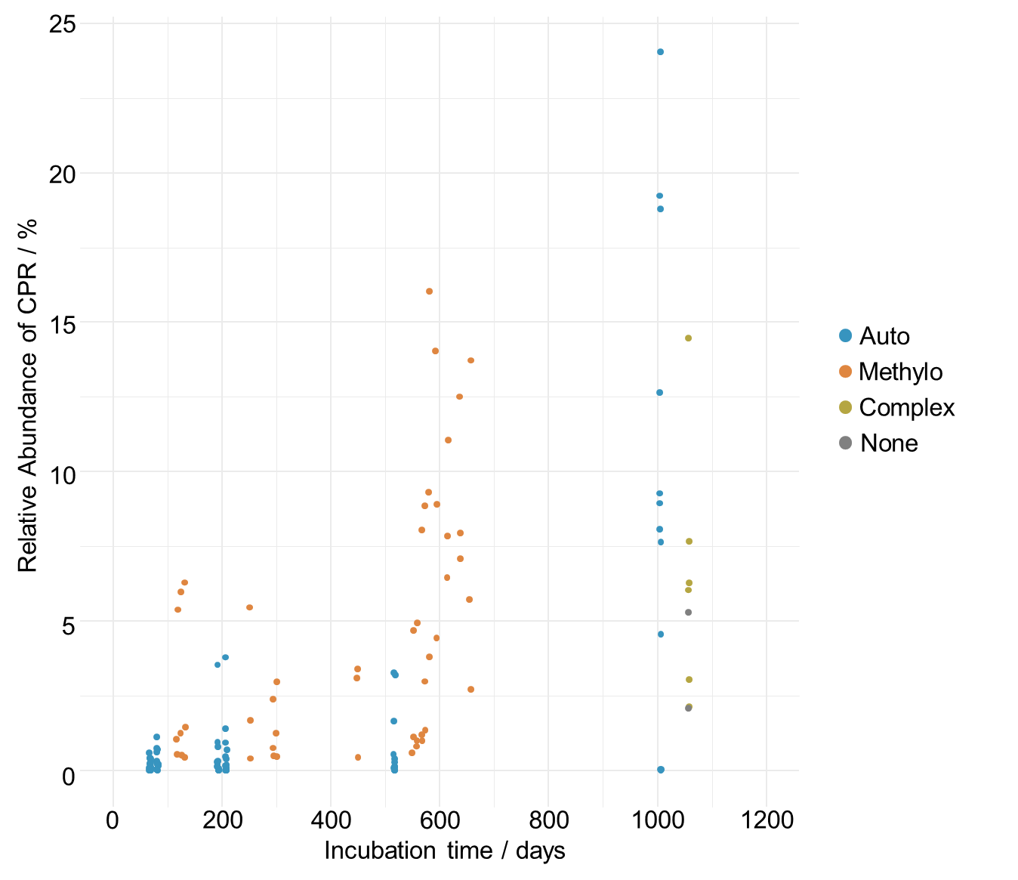
Figure S1: Abundance of CPR in long term enrichments. Only data from experiments running for more than 1 year are shown. Dots represent the relative abundances of CPR based on 16S rRNA gene amplicon sequencing in individual samples from long term enrichments with up to 3 years of incubation time. Blue dots represent samples under conditions stimulating chemolithoautotrophs (auto treatment), orange dots represent samples under conditions stimulating methylotrophs (methylo treatment), beige dots represent samples where leaf leachate was added to groundwater (complex treatment) and grey dots represent two samples of untreated groundwater incubated for 1059 days.
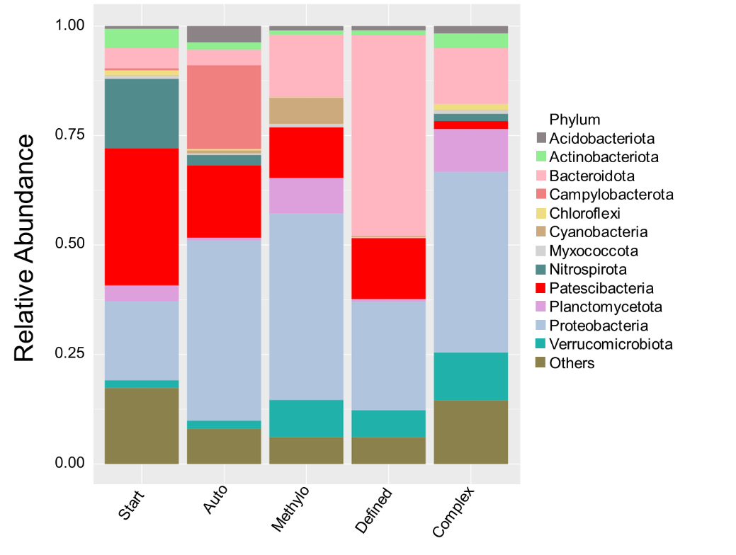
Figure S2: Averaged community compositions in groundwater incubations. Data is based on relative abundances of bacterial phyla from 16S rRNA gene amplicon sequencing. Bars represent average of all samples per treatment. Start includes samples from the start of incubation experiments; Auto and methylo include samples from enrichments with conditions favoring chemolithoautotrophs and methylotrophs, respectively. Defined and Complex include samples from enrichments with conditions favoring heterotrophs by adding chemically defined or complex carbon sources, respectively.

Supplementary Table legends
Table S1: Overview of samples from groundwater incubation experiments. Rows depict sets of incubations with specific conditions. Given are the treatment the set was assigned to, the well the groundwater used for the incubations was derived from, whether the incubations were conducted under oxic or anoxic conditions, a summary of the supplements added at the start of the incubations, the number of samples included in the set, the reference under which the data was originally published (if applicable), and the BioProject accession under which the raw data was deposited at NCBI.
Table S2: Presence of oxygen-dependent genes in CPR MAGs. The genes shown were derived from the oxic reaction subnetwork, as described previously [10]. Given are the KEGG Orthology (KO) number of the gene, the gene abbreviation, product name, EC number, the metabolic category the genes is assigned to, the category the gene was placed in (see Figure 7B in the main manuscript), as well as the number of MAGs and percentage of MAGs featuring this gene for six classes of CPR.
Table S3: Genes significantly enriched in CPR with preference for oxic incubations. Given is the functional category of the genes (see Figure 8 in the main manuscript), the gene abbreviation(s), the gene’s function or product name, the affiliated Kegg Orthology (KO) numbers, as well as the number of MAGs and percentage of MAGs featuring this gene for six classes of CPR. Bold text indicates that the respective genes are significantly enriched in the Cand. Saccharimonadia or Cand. Berkelbacteria which showed preferences for oxic incubations.

References
1. Küsel K, Totsche KU, Trumbore SE, Lehmann R, Steinhäuser C, Herrmann M. How deep can surface signals be traced in the critical zone? Merging biodiversity with biogeochemistry research in a central German Muschelkalk landscape. Frontiers in Earth Science. 2016;4:32.
2. Kohlhepp B, Lehmann R, Seeber P, Küsel K, Trumbore SE, Totsche KU. Aquifer configuration and geostructural links control the groundwater quality in thin-bedded carbonate–siliciclastic alternations of the Hainich CZE, central Germany. Hydrol Earth Syst Sci. 2017;21:6091–116.
3. Schwab VF, Herrmann M, Roth V-N, Gleixner G, Lehmann R, Pohnert G, et al. Functional diversity of microbial communities in pristine aquifers inferred by PLFA- and sequencing-based approaches. Biogeosciences. 2017;14:2697–714.
4. Taubert M, Stöckel S, Geesink P, Girnus S, Jehmlich N, von Bergen M, et al. Tracking active groundwater microbes with D ₂ O labelling to understand their ecosystem function. Environmental Microbiology. 2018;20:369–84.
5. Herlemann DPR, Labrenz M, Jürgens K, Bertilsson S, Waniek JJ, Andersson AF. Transitions in bacterial communities along the 2000 km salinity gradient of the Baltic Sea. The ISME Journal. 2011;5:1571–9.
6. Krüger M, Potthast K, Michalzik B, Tischer A, Küsel K, Deckner FFK, et al. Drought and rewetting events enhance nitrate leaching and seepage-mediated translocation of microbes from beech forest soils. Soil Biology and Biochemistry. 2021;154:108153.
7. Daims H, Brühl A, Amann R, Schleifer K-H, Wagner M. The Domain-specific Probe EUB338 is Insufficient for the Detection of all Bacteria: Development and Evaluation of a more Comprehensive Probe Set. Systematic and Applied Microbiology. 1999;22:434–44.
8. Loy A, Lehner A, Lee N, Adamczyk J, Meier H, Ernst J, et al. Oligonucleotide Microarray for 16S rRNA Gene-Based Detection of All Recognized Lineages of Sulfate-Reducing Prokaryotes in the Environment. Appl Environ Microbiol. 2002;68:5064–81.
9. Herrmann M, Hädrich A, Küsel K. Predominance of thaumarchaeal ammonia oxidizer abundance and transcriptional activity in an acidic fen. Environmental Microbiology. 2012;14:3013–25.
10. Raymond J, Segrè D. The Effect of Oxygen on Biochemical Networks and the Evolution of Complex Life. Science. 2006;311:1764–7.

