Appendices
Supplementary methods
Participants
Participants were outpatients between the ages of 18-65 with a diagnosis of unipolar MDD confirmed using the Mini International Neuropsychiatric Interview (MINI) ¹. They met the following inclusion criteria: current major depressive episode scoring ≥18 on the 17-item Hamilton Depression Rating Scale (HDRS-17) ²; lack of response to at least one adequate or two inadequate antidepressant trials during the current episode; a maximum of 3 failed adequate trials of antidepressant medication; and receiving stable dosages of psychotropic medications for at least four weeks prior to screening. The exclusion criteria were: substance dependence/abuse < 3 months preceding study entry; unstable medical/neurologic illness; acute suicidality; MINI diagnosis of bipolar I or II disorder, primary psychotic disorder, or psychotic symptoms in the current episode; any repetitive transcranial magnetic stimulation (rTMS) contraindication (e.g., history of seizures; intracranial implant); lifetime history of failure to respond to an adequate course of ECT; previous rTMS treatment; receiving lorazepam >2 mg/day; receiving any anticonvulsant; pregnancy; or significant laboratory abnormalities. Randomization of participants was stratified by degree of medication resistance (>1 adequate vs 1 or fewer medication trials). While the design of the study did not allow the rTMS technician or patient to be blinded during treatment, outcome assessors were blinded to treatment allocation.
Symptom clusters
Our prior confirmatory factor analysis (CFA) on the Hamilton Depression Rating Scale (HDRS) item scores from the THREE-D has revealed a four-factor model consisting of mood, anxiety, somatic and insomnia symptom clusters ³. The sum scores of all the items from each cluster were calculated with positive factor loadings for all items with the exception of psychomotor agitation and psychomotor retardation which loaded negatively onto the mood and anxiety factor, respectively³. These sum scores were then scaled using the proportion of maximum possible scaling method to facilitate comparisons between symptom clusters. The symptom scores in the present study were these scale sum scores (range: 0-1).
Single-trajectory analyses
We first determined the best fitting number of response trajectories with all polynomials fixed at cubic, as previous work has demonstrated that depressive symptoms typically follow linear, quadratic, or cubic trajectories in response to treatment ^{4,5}. After determining the number of trajectories that best fit the observed data, we then determined the optimal polynomial degree for each trajectory by systematically reducing the polynomial degree with the smallest point estimate until all trajectories consisted of linear polynomials. The polynomial combination of linear, quadratic, and cubic degrees that best fit the observed response trajectories (i.e., lowest BIC) was considered the best-fitting model. Our prior work has demonstrated that this four-symptom cluster model of the HDRS also demonstrates longitudinal measurement invariance ³.
Supplementary discussion
Our findings further highlighted the notion that different symptoms may correspond to different rTMS targets ⁸. Recent evidence has implicated that different symptoms might be mapped to different brain circuits ⁸. Even though the clinical trial analyzed here leveraged a relatively precise heuristic (an MNI stereotaxic coordinate that was reversed to the individual space), this target is a “one-site-fits-all” group target without accounting for individual variation. The left DLPFC is a large area that is highly heterogeneous anatomically and functionally across individuals ⁸. It is possible that the rTMS targets were located in different symptom networks in different patients, leading to heterogeneity in the symptom responses. Specifically, our results suggest that existing excitatory rTMS protocols over the left DLPFC might not be optimal for younger patients with higher mood symptoms but lower anxiety symptoms and benzodiazepine use. Ongoing clinical trials comparing different treatment protocols and targets are to better understand the heterogeneity of rTMS protocols for unipolar depression ²⁸. In this manner, the efficacy of rTMS can be improved simply by targeting different cortical regions (e.g., dorsomedial prefrontal cortex) or tailoring the targets within the DLPFC at the individual level as the DLPFC contains a range of potential target neural circuits that may be identified by symptom profile presentations ⁸.
Although high-frequency rTMS over the left dorsal lateral prefrontal cortex (DLPFC) has been proven safe and well-established, more potential targets and protocols have emerged recently ^{6,7}. Future work will be required to extend our findings to other rTMS protocols (low-frequency rTMS) ³² or targets (e.g., dorsal medial prefrontal cortex, DMPFC) ³³
Specifically designed unidimensional clinical assessments usually benefit from better internal consistency and test-retest replicability than multi-dimensional measurements such as HDRS. As for the symptom clusters considered in the present study, some available unidimensional assessments could be considered for future research, such as the 6-item HDRS for mood ⁸, the Generalized Anxiety Disorder-7 (GAD-7) for anxiety ⁹, the Pittsburgh Sleep Quality Index (PSQI) for sleep ¹⁰, and the Somatic Symptom Scale–8 (SSS-8) for somatic symptoms ¹¹

Supplemental Table 1. BIC scores for each symptom cluster as number of groups increase
Number of Groups | Anxiety | Mood | Insomnia | Somatic
1 | -3,952.722 | -4,810.492 | -3,652.148 | -3,550.885
2 | -3,734.007 | -4,548.610 | -3,462.454 | -3,322.594
3 | -3,683.848 | -4,443.799 | -3,393.678 | -3,253.544
4 | -3,681.423 | -4,427.516 | -3,381.396 | -3,244.357
5 |  | -4,436.240 | -3,380.026 | -3,237.405
6 |  |  |  | -3,240.401

Supplemental Table 2. Model fit for anxiety symptom cluster
Trajectory Group Number | Average Posterior  Probability of Assignment | Trajectory  Membership (%) | Odds of Correct  Classification
1 | 0.86 | 29.90 | 14.89
2 | 0.87 | 51.29 | 6.43
3 | 0.91 | 18.81 | 41.20

Supplemental Table 3. Model fit for mood symptom cluster
Trajectory Group Number | Average Posterior  Probability of Assignment | Trajectory  Membership (%) | Odds of Correct  Classification
1 | 0.92 | 13.66 | 74.37
2 | 0.83 | 39.95 | 7.35
3 | 0.85 | 35.31 | 10.53
4 | 0.92 | 11.08 | 92.28

Supplemental Table 4. Model fit for insomnia symptom cluster
Trajectory Group Number | Average Posterior  Probability of Assignment | Trajectory  Membership (%) | Odds of Correct  Classification
1 | 0.87 | 18.56 | 29.22
2 | 0.87 | 49.23 | 6.77
3 | 0.81 | 27.32 | 11.39
4 | 0.88 | 4.90 | 141.14

Supplemental Table 5. Model fit for somatic symptom cluster
Trajectory Group Number | Average Posterior  Probability of Assignment | Trajectory  Membership (%) | Odds of Correct  Classification
1 | 0.92 | 15.21 | 62.51
2 | 0.85 | 42.01 | 8.09
3 | 0.80 | 25.26 | 12.06
4 | 0.75 | 6.19 | 46.28
5 | 0.86 | 11.34 | 48.84

Supplemental Table 7. Model fit for multiple trajectory cluster
Trajectory Group Number | Average Posterior  Probability of Assignment | Trajectory  Membership (%) | Odds of Correct  Classification
1 | 0.94 | 30.67 | 33.98
2 | 0.88 | 32.99 | 15.37
3 | 0.90 | 23.45 | 28.81
4 | 0.93 | 12.89 | 91.93
Supplementary Table 8. Guidelines for Reporting on Latent Trajectory Studies (GRoLTS Checklist)
Checklist items | Response
1. Is the metric of time used in the statistical model reported? | Yes. See page 5.
2. Is information presented about the mean and variance of time within a wave? | Yes. See page 5.
3a. Is the missing data mechanism reported? | Yes. See page 6.
3b. Is a description provided of what variables are related to attrition/missing data? | Yes. See page 6.
3c. Is a description provided of how missing data in the analyses were dealt with? | Yes. See page 6.
4. Is information about the distribution of the observed variables included? | Yes. See Supplemental Figure 2.
5. Is the software mentioned? | Yes. See page 6.
6a. Are alternative speciﬁcations of within-class heterogeneity considered (e.g., LGCA vs. LGMM) and clearly documented? If not, was sufﬁcient justiﬁcation provided as to eliminate certain speciﬁcations from consideration? | Yes. See page 7.
6b. Are alternative speciﬁcations of the between-class differences in variance–covariance matrix structure considered and clearly documented? If not, was sufﬁcient justiﬁcation provided as to eliminate certain speciﬁcations from consideration? | Yes. See page 7.
7. Are alternative shape/functional forms of the trajectories described? | Yes. See page 7.
8. If covariates have been used, can analyses still be replicated? | NA. No covariate was used.
9. Is information reported about the number of random start values and ﬁnal iterations included? | Yes. See page 8.
10. Are the model comparison (and selection) tools described from a statistical perspective? | Yes. See page 6.
11. Are the total number of ﬁtted models reported, including a one-class solution? | Yes. See page 8.
12. Are the number of cases per class reported for each model (absolute sample size, or proportion)? | Yes. See page 8.
13. If classiﬁcation of cases in a trajectory is the goal, is entropy reported? | Yes. We have reported average posterior probability instead of entropy.
14a. Is a plot included with the estimated mean trajectories of the ﬁnal solution? | Yes. See Figure 1.
14b. Are plots included with the estimated mean trajectories for each model? | No.
14c. Is a plot included of the combination of estimated means of the ﬁnal model and the observed individual trajectories split out for each latent class? | No.
15. Are characteristics of the ﬁnal class solution numerically described (i.e., means, SD/SE, n, CI, etc.)? | Yes. See Table 2.
16. Are the syntax ﬁles available (either in the appendix, supplementary materials, or from the authors)? | No, but they could be made available upon reasonable request due to data policy.

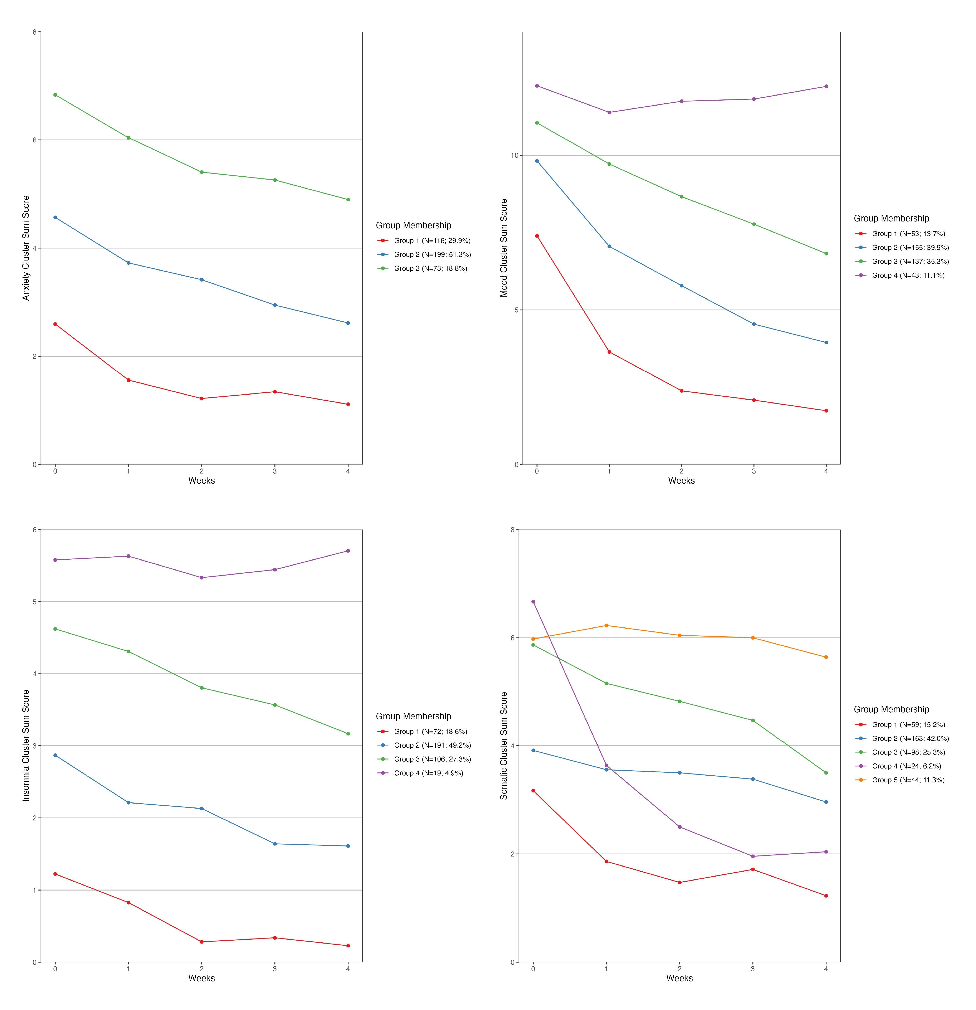
Supplemental Figure 1. Response trajectories of (a) anxiety, (b) mood, (c) insomnia, and (c) somatic symptom clusters over 4 weeks of treatment with repetitve transcranial magnetic stimulation.

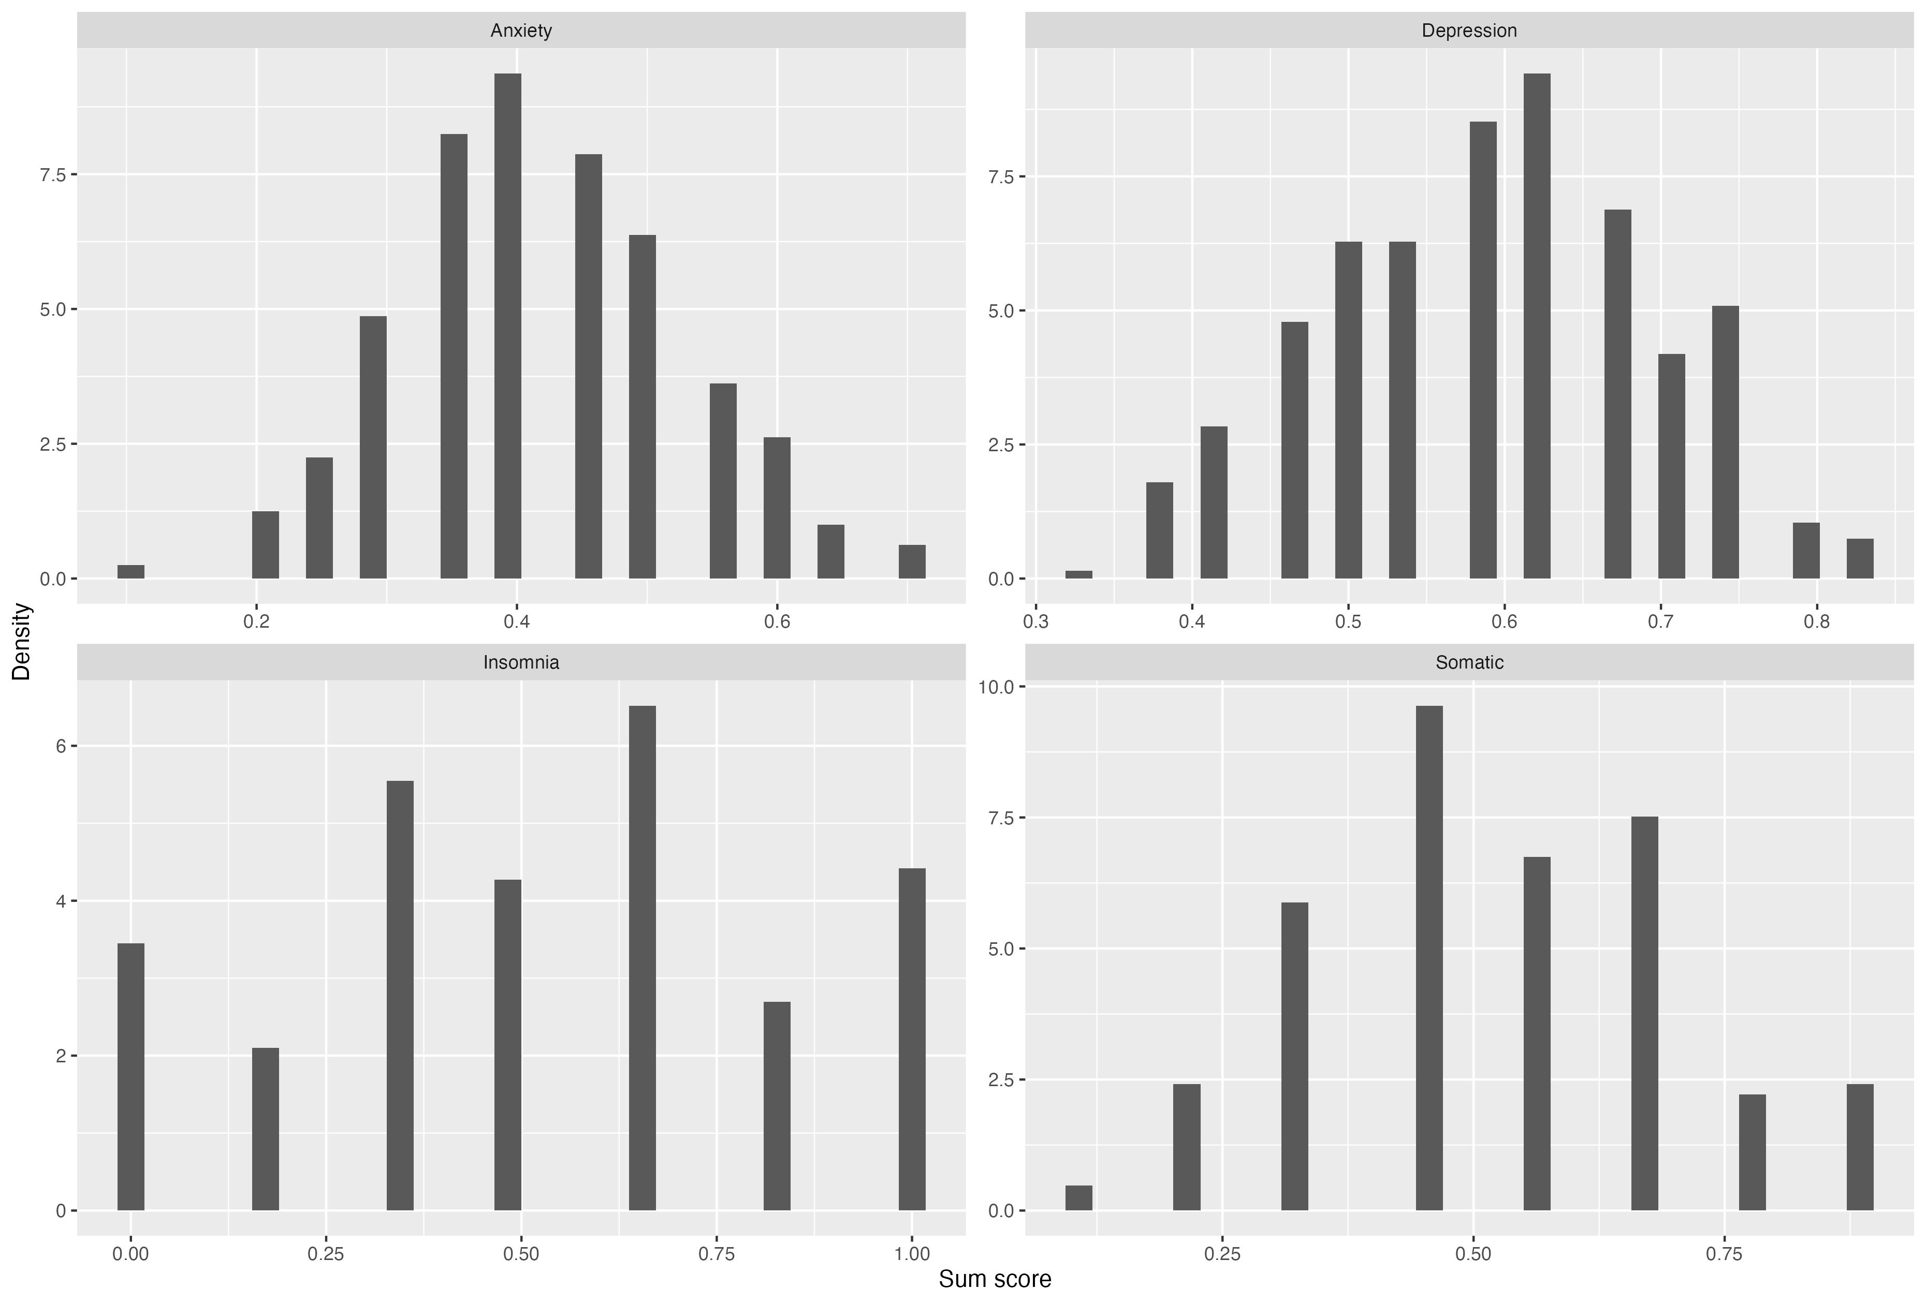
Supplemental Figure 2. The distribution of the sum score of each symptom cluster

Reference:

1. Sheehan DV, Lecrubier Y, Sheehan KH, et al. The Mini-International Neuropsychiatric Interview (M.I.N.I.): the development and validation of a structured diagnostic psychiatric interview for DSM-IV and ICD-10. J Clin Psychiatry 1998; 59 Suppl 20: 22-33;quiz 4-57.

2. Hamilton M. A rating scale for depression. Journal of neurology, neurosurgery, and psychiatry 1960; 23(1): 56-62.

3. Kaster TS, Downar J, Vila-Rodriguez F, et al. Differential symptom cluster responses to repetitive transcranial magnetic stimulation treatment in depression. EClinicalMedicine 2023; 55: 101765.

4. Kaster TS, Downar J, Vila-Rodriguez F, et al. Trajectories of Response to Dorsolateral Prefrontal rTMS in Major Depression: A THREE-D Study. Am J Psychiatry 2019; 176(5): 367-75.

5. Smagula SF, Butters MA, Anderson SJ, et al. Antidepressant Response Trajectories and Associated Clinical Prognostic Factors Among Older Adults. JAMA psychiatry 2015; 72(10): 1021-8.

6. Downar J, Daskalakis ZJ. New targets for rTMS in depression: a review of convergent evidence. Brain Stimul 2013; 6(3): 231-40.

7. Siddiqi SH, Khosravani S, Rolston JD, Fox MD. The future of brain circuit-targeted therapeutics. Neuropsychopharmacology 2023.

8. Timmerby N, Andersen JH, Søndergaard S, Østergaard SD, Bech P. A Systematic Review of the Clinimetric Properties of the 6-Item Version of the Hamilton Depression Rating Scale (HAM-D6). Psychother Psychosom 2017; 86(3): 141-9.

9. Spitzer RL, Kroenke K, Williams JB, Löwe B. A brief measure for assessing generalized anxiety disorder: the GAD-7. Arch Intern Med 2006; 166(10): 1092-7.

10. Buysse DJ, Reynolds CF, 3rd, Monk TH, Berman SR, Kupfer DJ. The Pittsburgh Sleep Quality Index: a new instrument for psychiatric practice and research. Psychiatry Res 1989; 28(2): 193-213.

11. Gierk B, Kohlmann S, Kroenke K, et al. The somatic symptom scale-8 (SSS-8): a brief measure of somatic symptom burden. JAMA Intern Med 2014; 174(3): 399-407.

