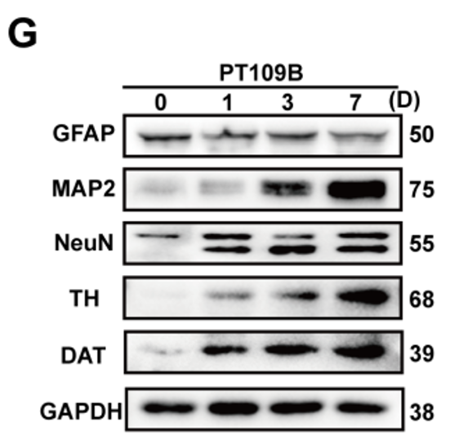
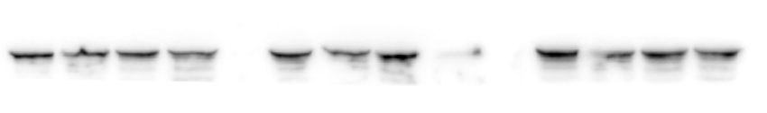
Fig.1G
GFAP
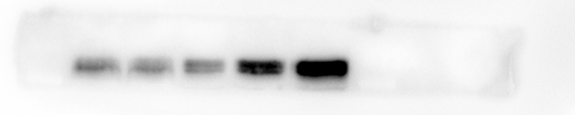
MAP2
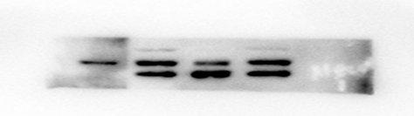
NeuN
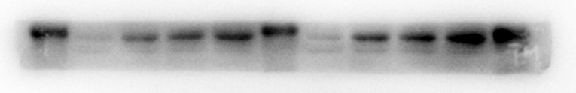
TH
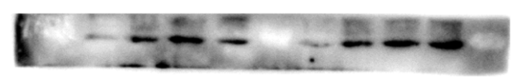
DAT
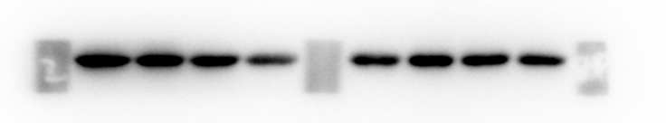
GAPDH

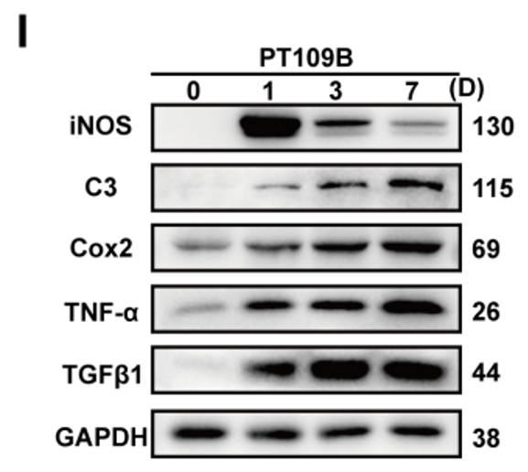
Fig.1I
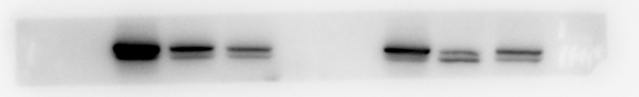
iNOS
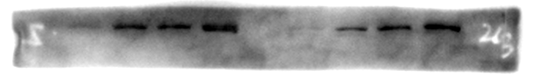
C3
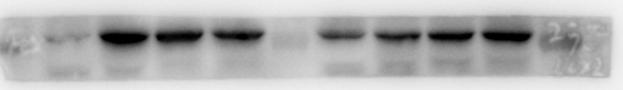
Cox2
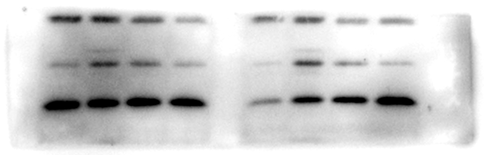

TNF-α

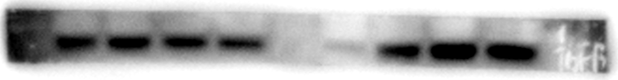
TGFβ1
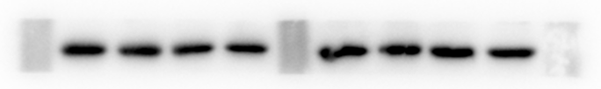
GAPDH
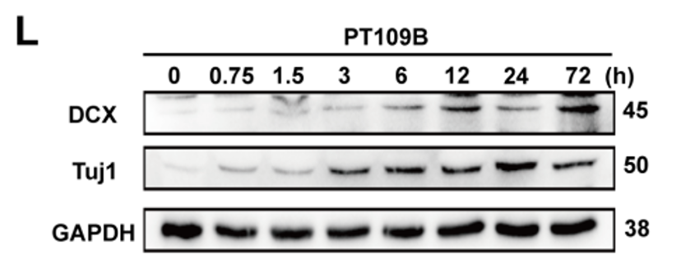
Fig.1L
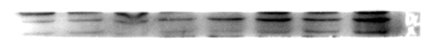
DCX
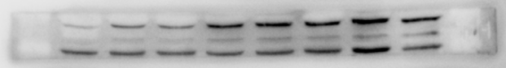
Tuj1
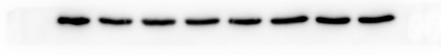

GAPDH

Figure 1. PT109B rapidly reprogrammed As into induced neurons.
(G) Westernblot analysis the protein level of As maker (GFAP), mature neuron maker (MAP2, NeuN) and dopaminergic neuron makers (DAT and TH) on As at the treatment of PT109B for 1,3 and 7 days. (I) Westernblot analysis the protein level of activated As maker (C3, TGF-β1), oxidative stress (iNOS, COX2) and inflammatory factors (TNF-α). (L) Westernblot analysis the protein level of immature neuron maker DCX and Tuj-1.

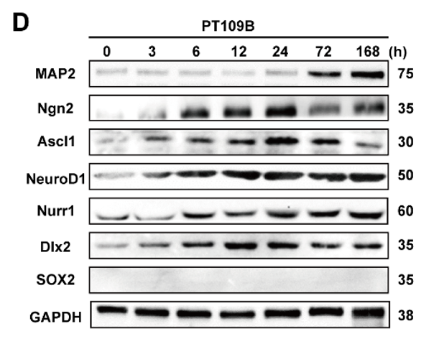
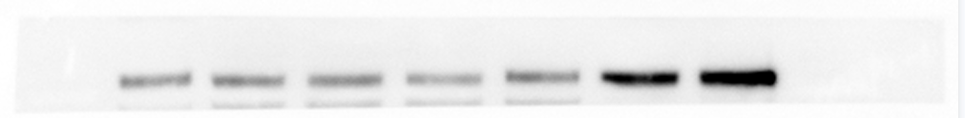
Fig.3D

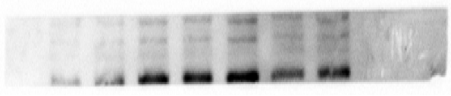
MAP2

Ngn2

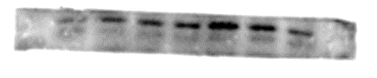

Ascl1
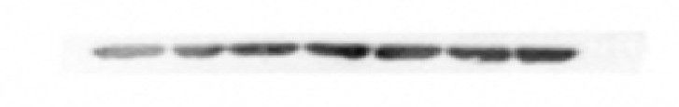

NeuroD1
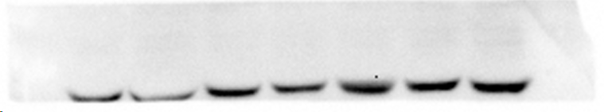
Nurr1

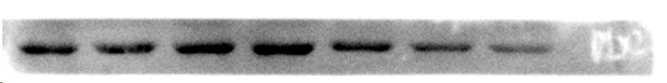
Dlx2

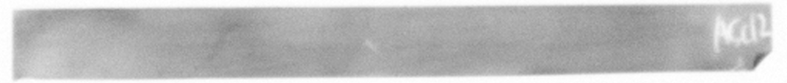
SOX2
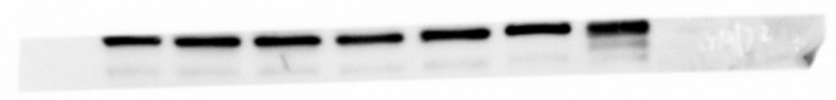

GAPDH
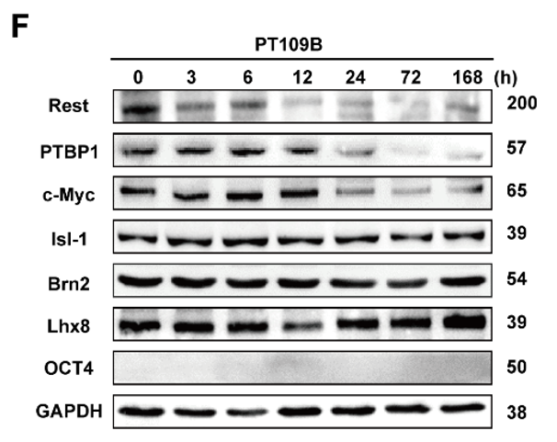
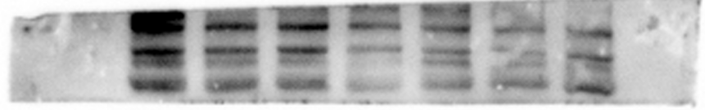
Fig.3F

Rest
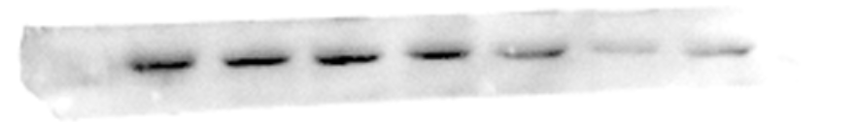

PTBP-1
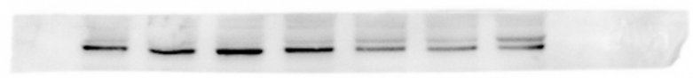

c-Myc

Isl-1

Brn2
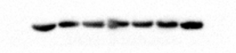

Lhx8
OCT4

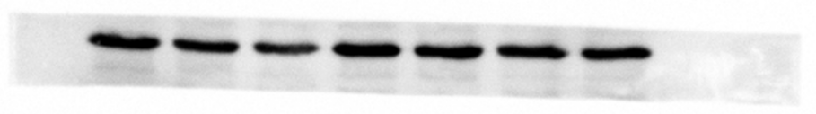
GAPDH

Figure 3. PT109B enhances b-HLH family transcription factors to drive neuronal reprogramming.
(D) Western blot analysis of the MAP2, Dlx2, Ngn2, Ascl1, Nurr1 and NeuroD1. (F) Western blot analysis of REST/PTBP1 pathway-related proteins (REST, PTBP1) and other transcription factors (Brn2, c-Myc, Lhx8, Isl-1, OCT4) involved in neuronal reprogramming.

