Graphic abstract
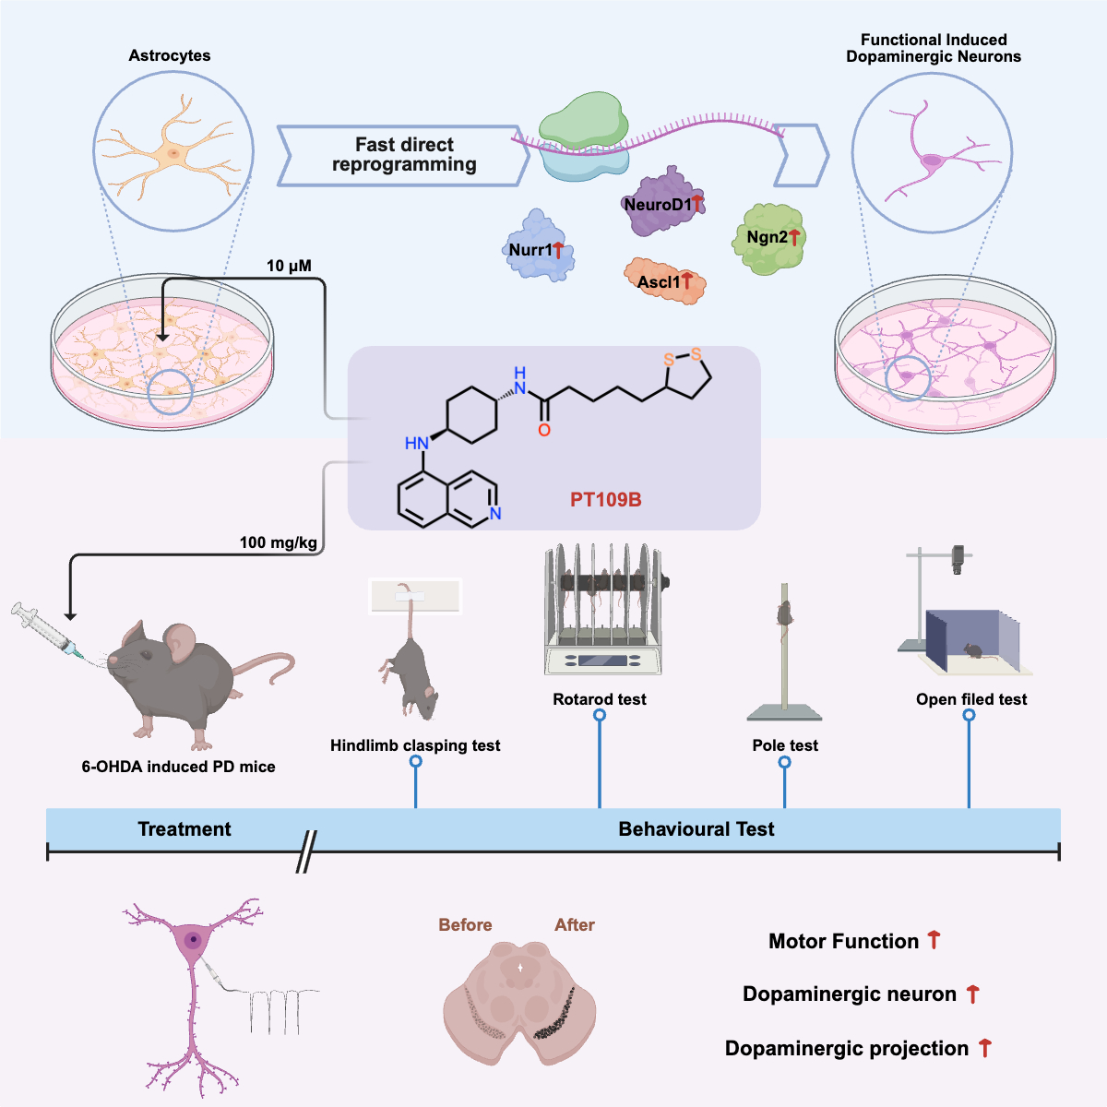
Highlights
- PT109B acts as a single agent to efficiently reprogram astrocytes into functional iDNAs .
- iDNAs induced by PT109B exhibit long-term survival with synchronous and electrophysiology activities.
- PT109B induces reprogramming through cell cycle arrest, astrocytic activation, and upregulation of b-HLH family factors.
- Oral administration of PT109B enhances motor function and increases DANs in the striatum and substantia nigra of PD mice.

