Supplemental Information

PT109B, a Multikinase Inhibitor, Converts Astrocytes into Dopaminergic Neurons and Alleviates Parkinson's Disease in Mice.
Cailv Wei, Yang Yang, Tszhei Fong, Yuan Liu, Shisong Wang, Chao Ding, Zeyu Zhu, Jianwen Zhou, Kang Jia, Zhixian Zhang, Qianhui Shen, Yu Ren, Zhi Liang, Yanping Chen, Yalin Tu, Cheng Long, Wenbin Deng, Qiang Zhou, Karl Wah-Keung Tsim, Rongbiao Pi,

Fig. S1
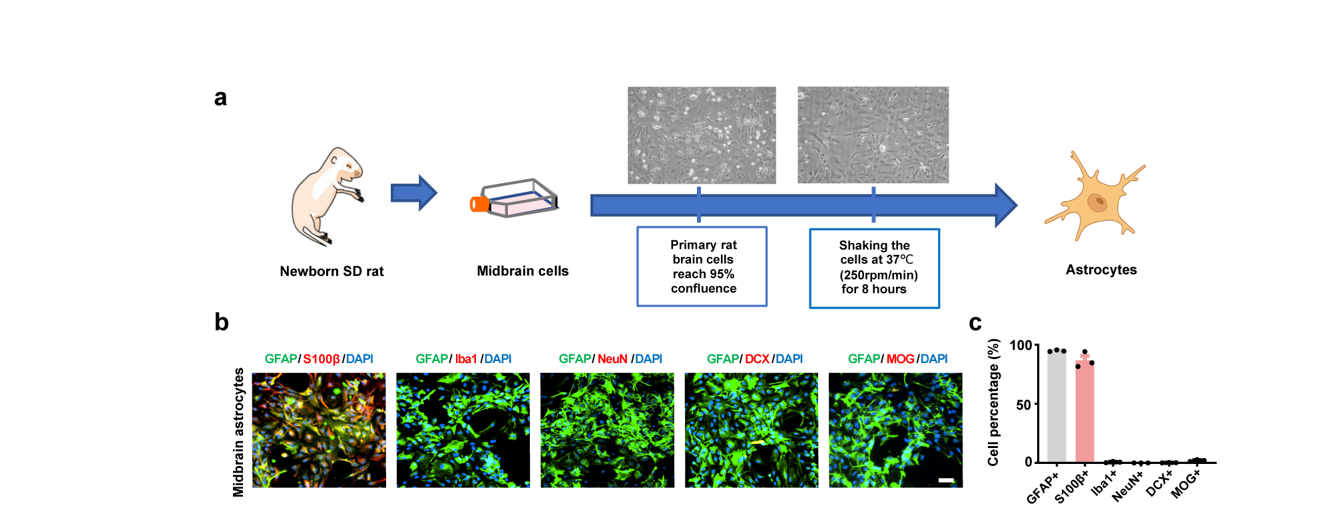
Figure S1 Extraction and purity identification of primary rat midbrain astrocytes.
a Flow chart of astrocytes extraction from midbrain. Primary midbrain astrocytes were cultured for 7 days in vitro, and shaken to obtain higher purity cells. b (B) Detection of cell types including astrocytes (GFAP, S100β), neuroblast (DCX), neuron (NeuN), microglia (Iba1) and oligodendrocyte (MOG) by immunofluorescence. c Quantification of the cultured cell types of midbrain in vitro. n = 3, Scale bars = 10 μm. Data are represented as Mean ± SEM.

Fig. S2
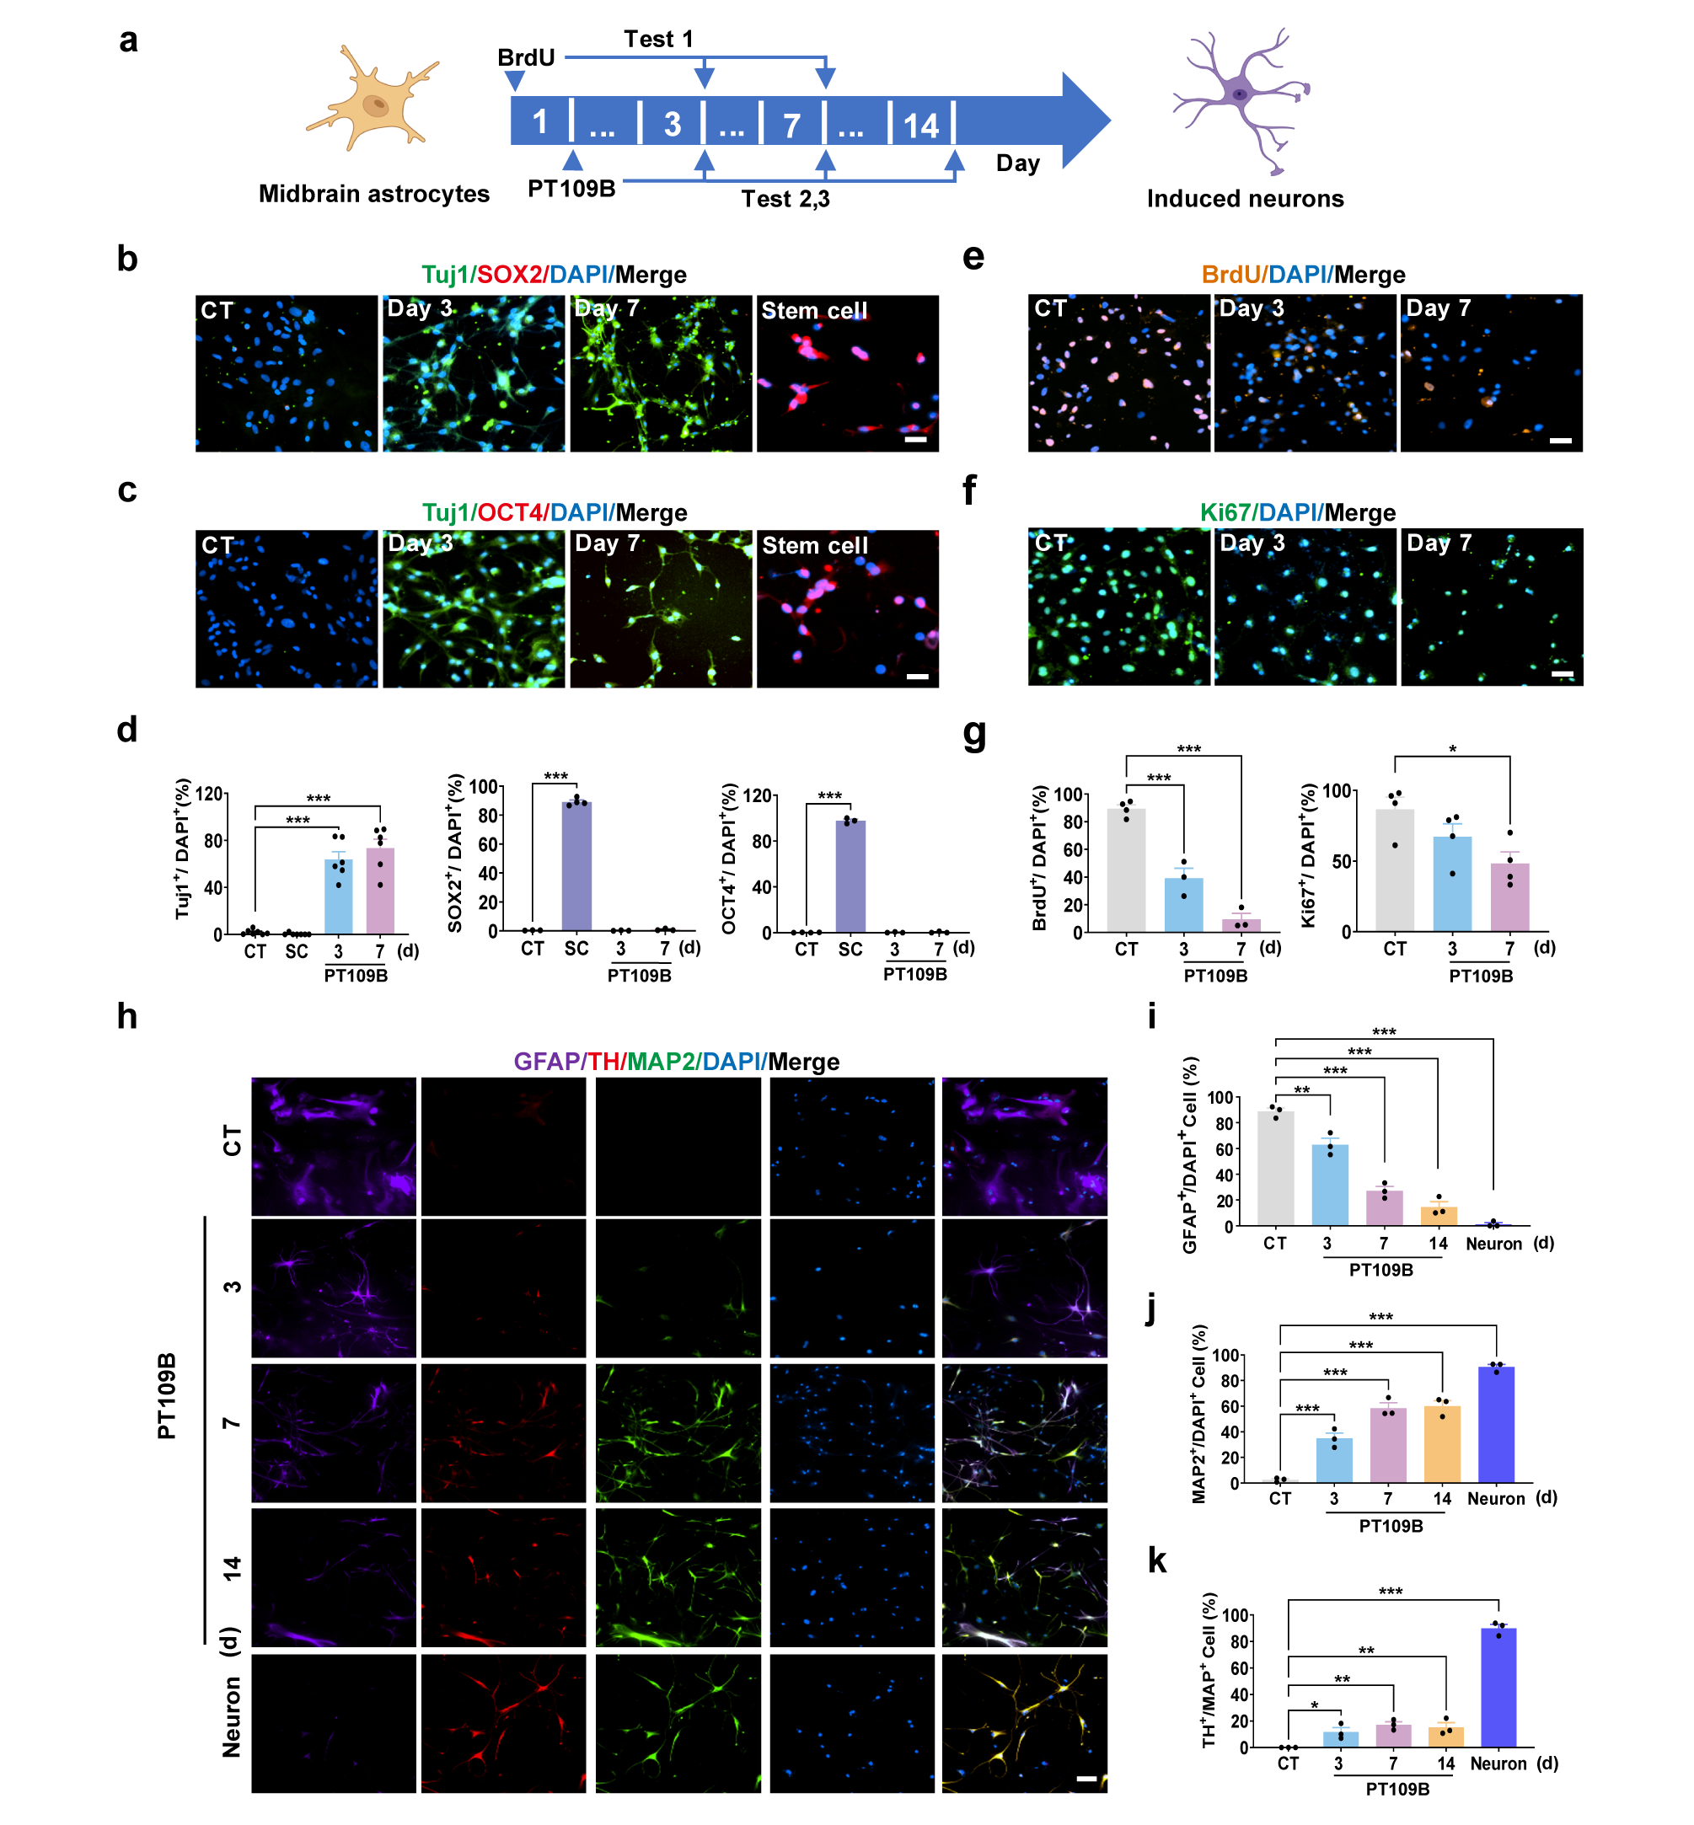
Figure S2 PT109B directly reprogramed astrocytes into induced neurons.
a Schematic of the experimental design. Test 1: assessment of cell proliferation capacity; Test 2: detection of neural stem cell markers; Test 3: evaluation of astrocytes and neuronal markers following PT109B (10 μM) treatment. b, c Representative images of the expression of NPCs makers (B) SOX2 and (C) OCT4, and immature neuron maker Tuj1 in the primary astrocytes post-PT109B induction at 3 and 7 days. d Quantification of Tuj1⁺, SOX2⁺, and OCT4⁺ cells in PT109B-induced cells. (n=3-7). e Immunostaining of BrdU labeled with BrdU 24 hours prior to PT109B treatment. f Representative images of Ki67⁺ cells following PT109B induction for 3 and 7 days. g Quantification of Brdu⁺ and Ki67⁺ cells. (n=3-4). h Immunofluorescence analysis of astrocytes treated with PT109B for 0, 3, 7, and 14 days. Markers for astrocytes (GFAP), mature neurons (MAP2), and dopaminergic neurons (TH) were assessed. i-k Statistical analysis of the ratio of (I) GFAP⁺, (J) MAP2⁺ and (K) TH⁺ cell in each group. Scale bar=20 μm. (n=3). Data are reported as mean ± SEM; *P< 0.05, **P< 0.01, ***P< 0.001 vs. control group (CT).

Fig. S3
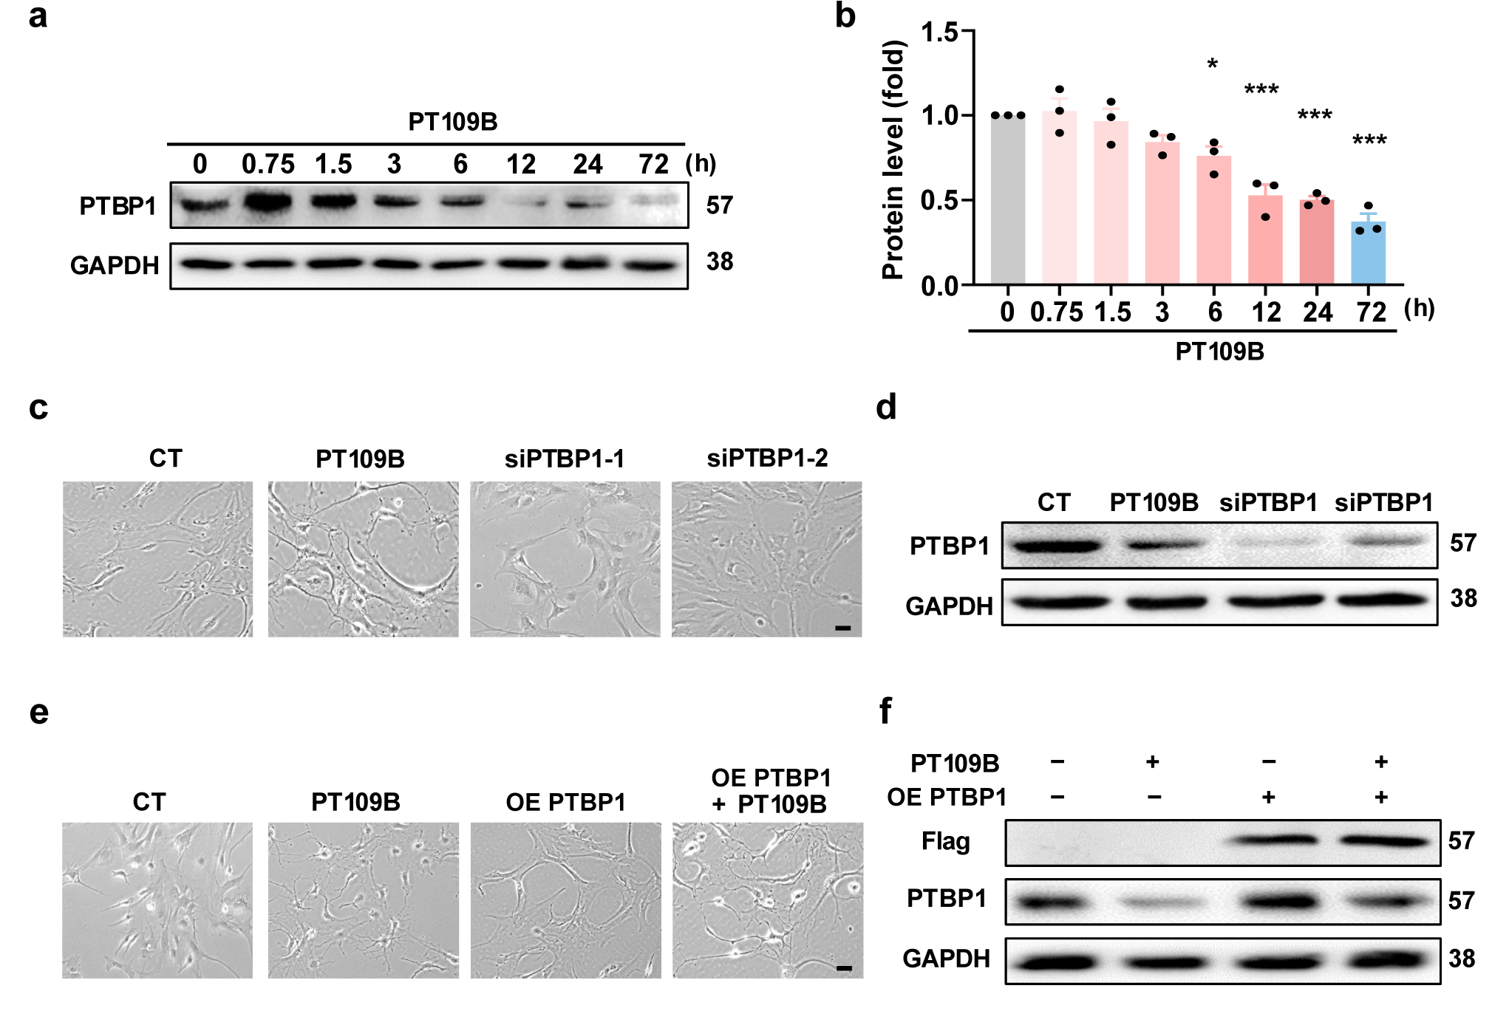
Figure S3 PTBP1 overexpression does not alter PT109B-induced morphological changes in astrocytes.
a Western blot analysis of PTBP1 protein levels in astrocytes following PT109B (10 μM) treatment for 0.75, 1.5, 3, 6, 12, 24 and 72 hours. b Quantification of PTBP1 protein level. (n=3). c Phase-contrast microscopy images of astrocytes treated with siPTBP1 and PT109B for 48 hours. d Western blot analysis of PTBP1 protein levels in astrocytes following siPTBP1 and PT109B treatment. e Phase-contrast microscopy images of astrocytes transfected with a PTBP1 expression plasmid and treated with PT109B (10 μM) for 48 hours. f Western blot analysis confirming the overexpression of PTBP1 and detection of the plasmid label (Flag) in transfected astrocytes. Scale bar=10 μm. Data are reported as mean ± SEM; *P< 0.05, **P< 0.01, ***P< 0.001 vs. control group (CT).
Fig. S4
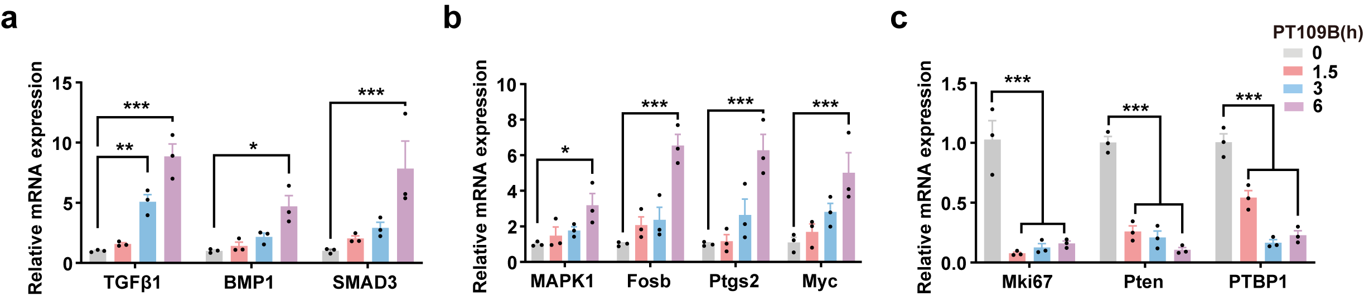
Figure S4 Relative mRNA expression levels of key genes by PT109B reprogramming.
Cells were treated with PT109B for durations of 0, 1.5, 3, and 6 hours, followed by qPCR analysis to assess the relative mRNA expression levels of key genes. a-c The investigated genes included those associated with (a) the TGFβ/BMP signaling pathway (TGF-β1, BMP1, SMAD3), (b) the MAPK signaling pathway (MAPK1, Fosb, Ptgs2, MYC), (c) cell cycle regulation (Mki67, Pten), and PTBP1. (n=3). Data are reported as mean ± SEM; *P< 0.05, **P< 0.01, ***P< 0.001 vs. control group (CT).
Fig. S5
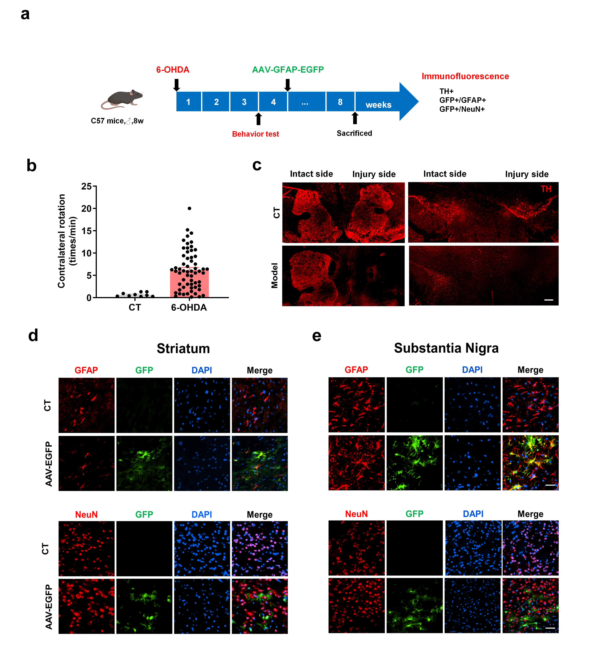
Figure S5 Establishment and validation of a 6-OHDA induced PD mice model.
Mice were injected unilaterally with 6-OHDA in the right MFB. AAV5-GFAP-EGFP (1×10¹² vg/mL) was injected into the cortex of mice at a constant rate of 0.2 µL/min for 5 minutes.
a Experimental workflow. b Apomorphine-induced rotation test was conducted to evaluate the rotational behavior of mice. (CT, n=9; 6-OHDA, n=60). c Immunofluorescence detection of dopaminergic neurons (TH, red) in the striatum and substantia nigra of control (CT) and 6-OHDA-lesioned (Model) mice. 6-OHDA induced significant denervation of TH+ neurons in the model group. Scale bar = 100 μm. d, e Mice were injected unilaterally with AAV5-GFAP-EGFP in the striatum and substantia nigra to label astrocytes. After 3 weeks, co-immunostaining of (d) virus-labeled astrocytes (GFAP, red; GFP, green) and (e) neurons (NeuN, red) was performed. Scale bar = 20 μm.

Fig. S6
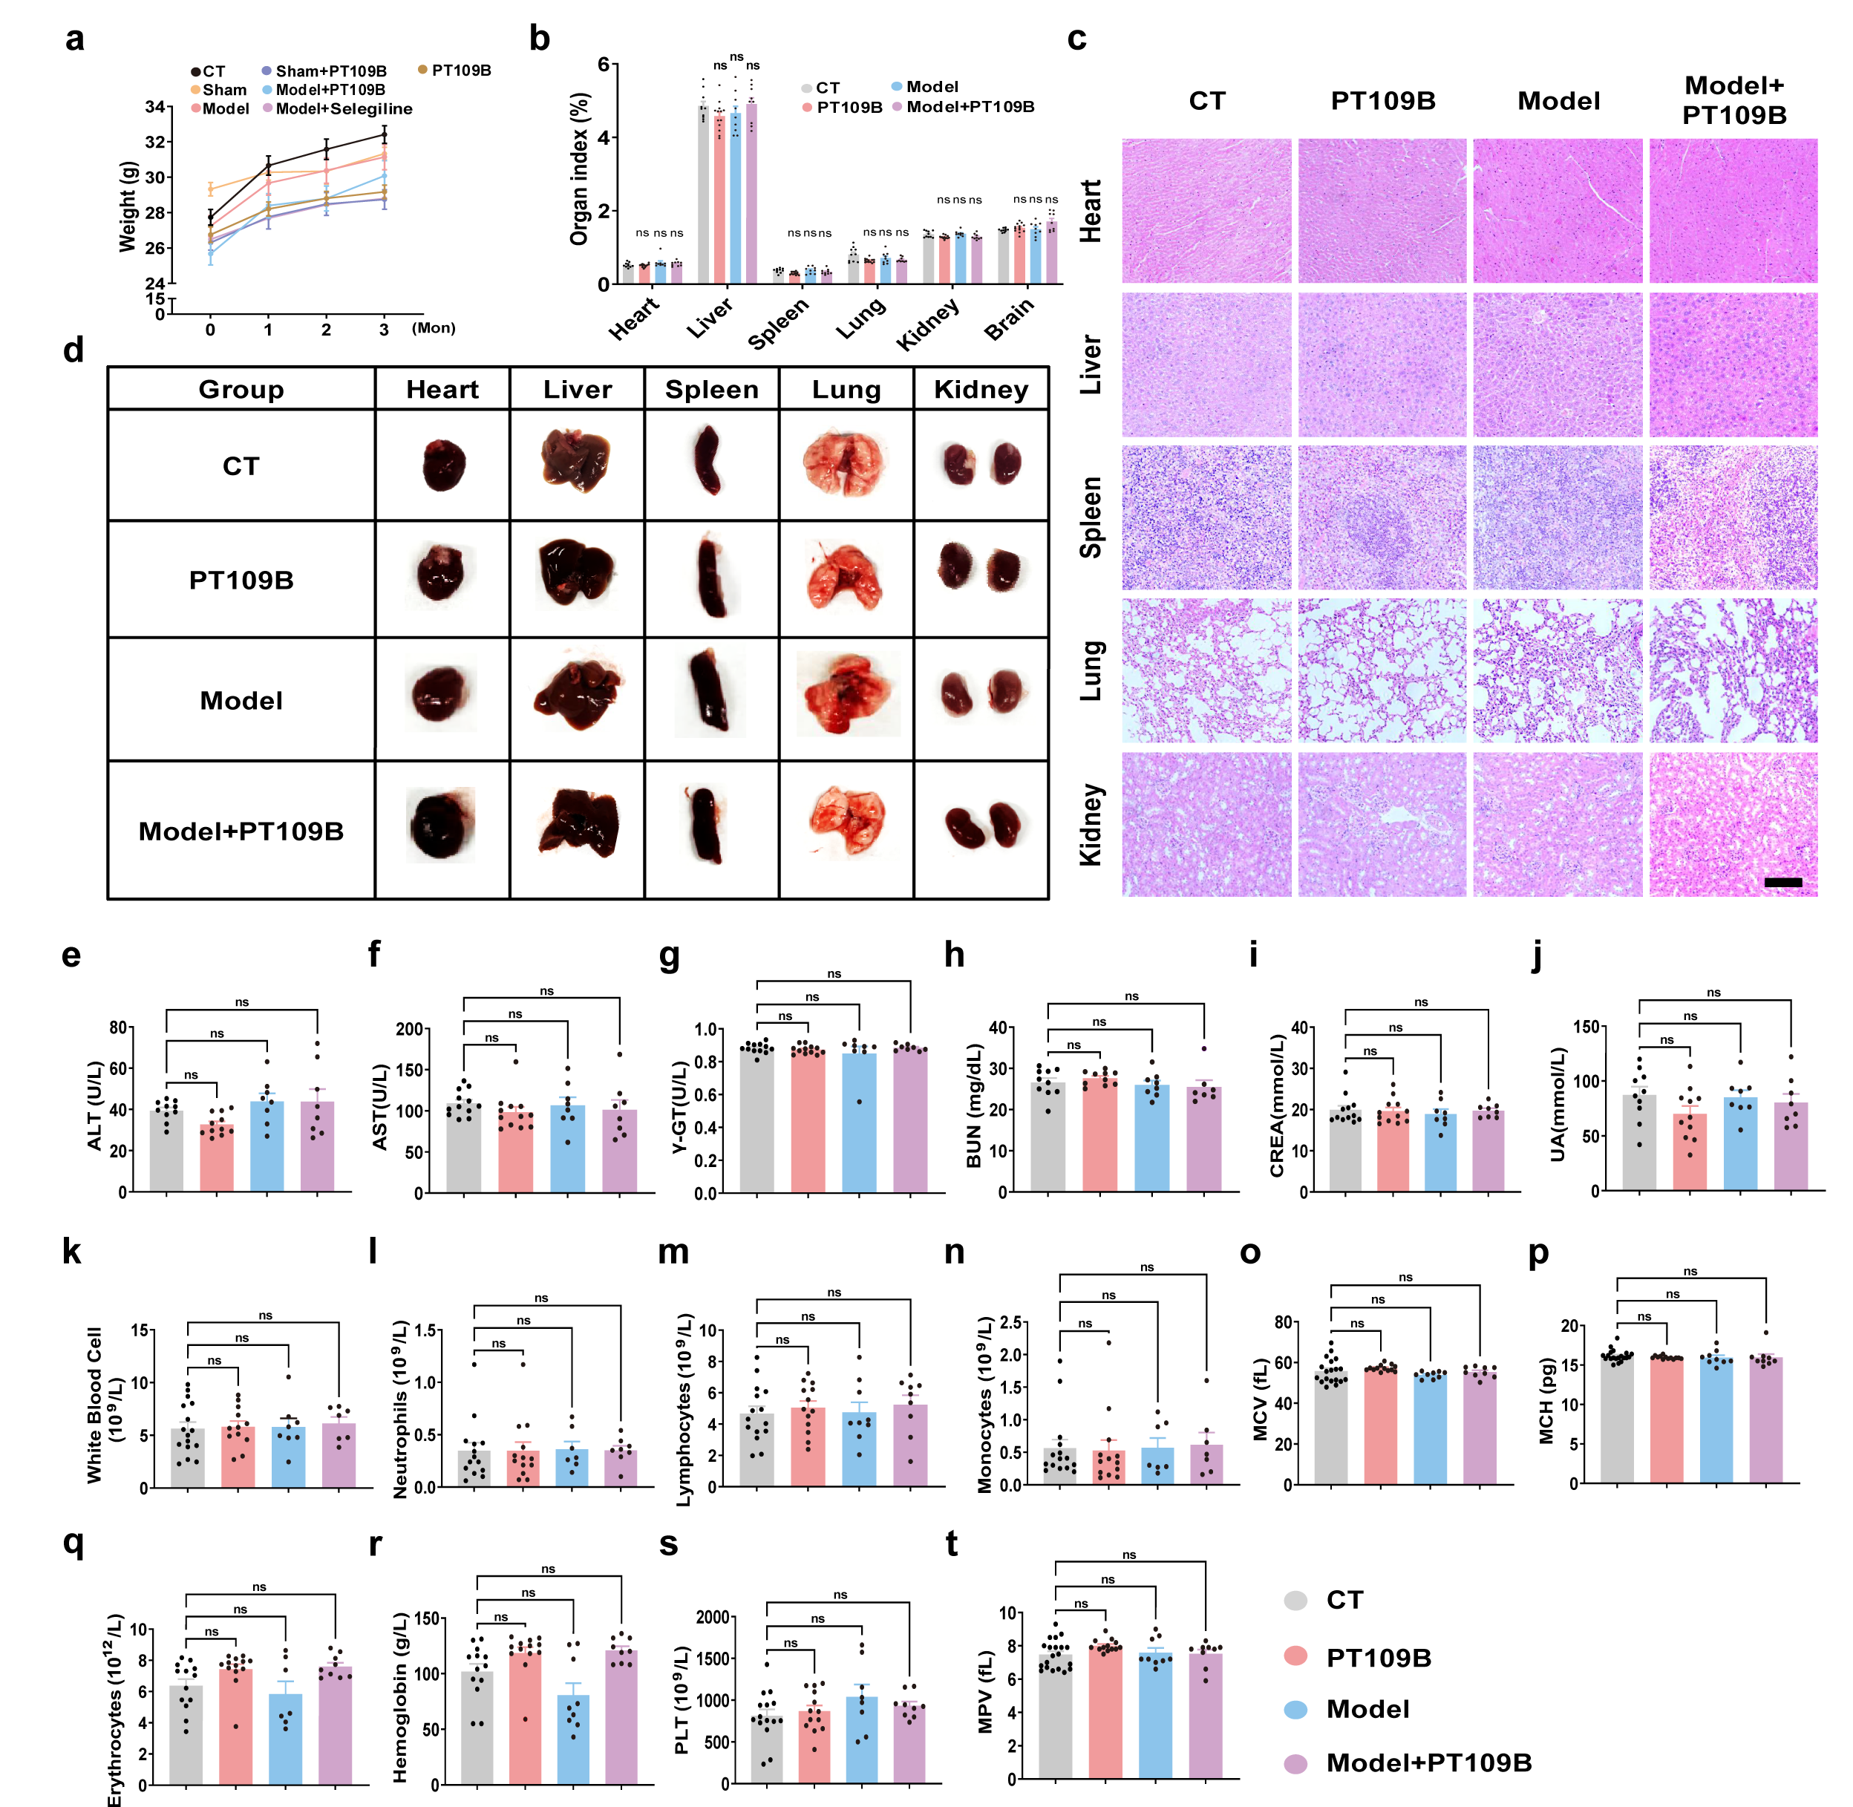
Figure S6 PT109B shows no pathological effect on tissues and organs of mice.
Control and PD mice were orally administered PT109B (100 mg/kg) for 3 months, followed by comprehensive assessment of physiological and biochemical parameters to evaluate safety and tolerability. a, b Monitoring of (a) body weight and (b) organ indices. c, d Histopathological evaluation of major organs (liver, kidney, heart, lung, and spleen) using hematoxylin and eosin (H&E) staining. Representative images (c) and quantitative analysis (d) revealed no observable pathological changes in PT109B-treated mice. Scale bar = 200 µm. e-g Assessment of liver function markers: (e) alanine aminotransferase (ALT), (f) aspartate aminotransferase (AST), and (g) gamma-glutamyl transferase (γ-GT). h-j Evaluation of kidney function markers: (h) blood urea nitrogen (BUN), (i) creatinine (CREA), and (j) uric acid (UA). k-t Hematological profiling, including (k) white blood cells count, (l) neutrophils, (m) lymphocytes, (n) monocytes, (o) mean corpuscular volume, (p) mean corpuscular hemoglobin, (q) erythrocytes count, (r) hemoglobin levels, (s) platelet count, and (t) mean platelet volume. Data are presented as mean ± SEM (n = 8-10). Two-way (A) or one-way (B, E-T) ANOVA, followed by Tukey’s multiple comparisons test.

