Supplementary material for

The application of Schweizer's reagent with FTIR imaging spectroscopic solutions for microplastics advanced analysis of feces samples

Miloš Ilić¹, Tamara Mutić¹, Dragana Stanić-Vučinić¹, Mirjana Turkalj^{2,3,4}, Ivana Banić², Jelena Mutić^{1*}, and Tanja Ćirković Veličković^{1,5*}

¹ University of Belgrade - Faculty of Chemistry, Studentski trg 12-16, 11000 Belgrade, Serbia
²Srebrenjak Children’s Hospital, Zagreb, Croatia
³Faculty of Medicine, Josip Juraj Strossmayer University of Osijek, HR-31000 Osijek, Croatia
⁴School of Medicine, Catholic University of Croatia, HR-10000 Zagreb, Croatia
⁵ Serbian Academy of Sciences and Arts, Knez Mihajlova 35, 11000 Belgrade, Serbia

Content of Supplementary material:

Tables:
Table S1. Physical properties of polymer standards: particle size and density range.

Figures:
Figure S1. Optical microscope image of the polystyrene standard after digestion using Protocol D. The image was captured with an Olympus Microscope BX51M Metallurgical under UV light to assess digestion's effect on the standard's surface.
Figure S2. An optical microscope image of the polystyrene standard after digestion using Protocol D. The image was captured with an Olympus Microscope BX51M Metallurgical under visible light to assess the effect of digestion on the standard's surface.

Figure S3. Microscopic Analysis of a Silicone Filter Containing Digested Fecal Material. (A, B). Optical microscope images acquired under visible and UV light, respectively.
(C) Micro-FTIR image of the entire filter, illustrating the uniform distribution of particles.
(D) Chemical mapping of the filter using micro-FTIR.

Table S1. Physical properties of polymer standards: particle size and density range.
No. | Polymer | Name | Size (µm) | Density (g/ml)
1 | PP | Polypropylene | 500 | 0.89-0.91
2 | HDPE | High-density polyethylene | 500 | 0.95-0.97
3 | LDPE | Low-density polyethylene | 500 | 0.91-0.94
4 | PVC | Polyvinyl chloride | 100 | 1.20-1.45
5 | PS | Polystyrene | 120 | 0.94-1.11
6 | PET | Polyethylene terephthalate | 120 | 1.38-1.39
7 | PA6 | Polycaprolactam | 120 | 1.13-1.50

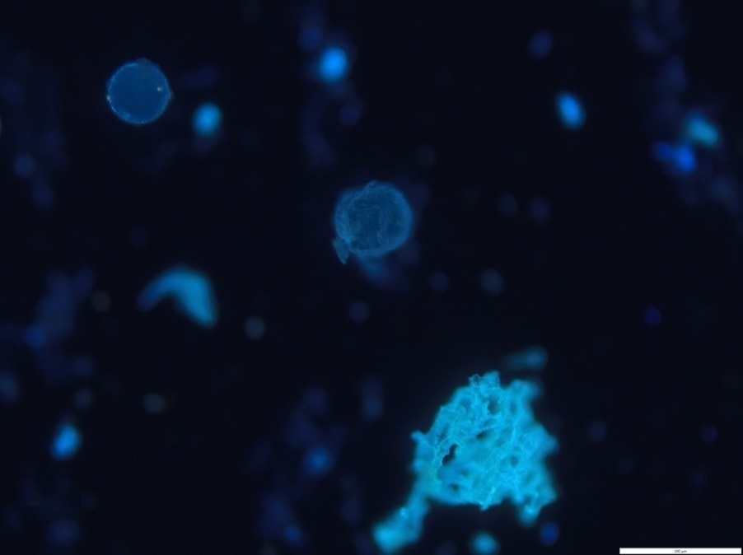
Figure S1. Optical microscope image of the polystyrene standard after digestion using Protocol D. The image was captured with an Olympus Microscope BX51M Metallurgical under UV light to assess digestion's effect on the standard's surface.

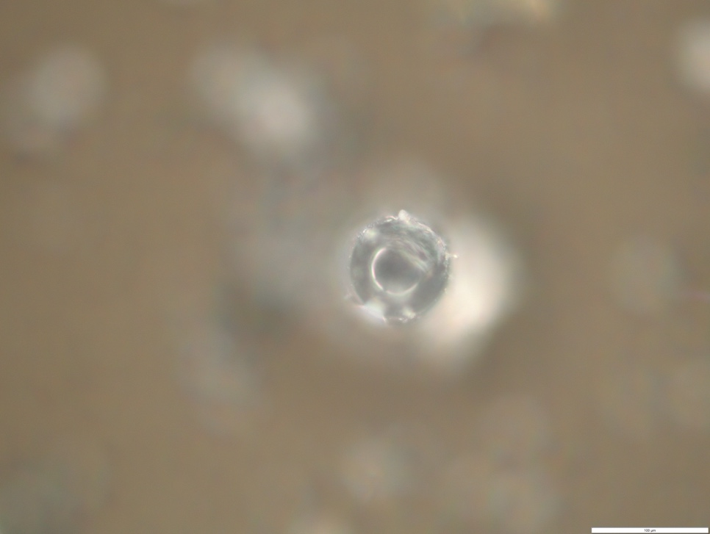
Figure S2. An optical microscope image of the polystyrene standard after digestion using Protocol D. The image was captured with an Olympus Microscope BX51M Metallurgical under visible light to assess the effect of digestion on the standard's surface.

A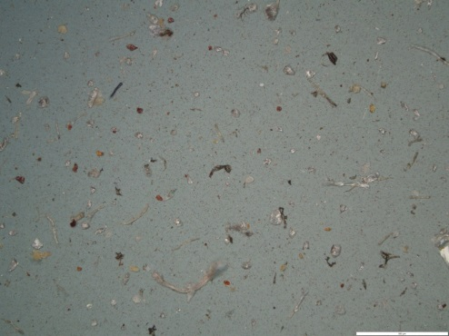 | B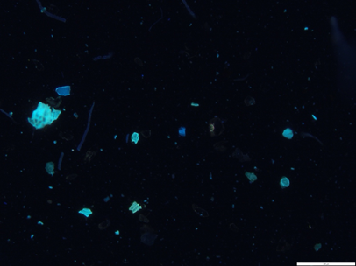
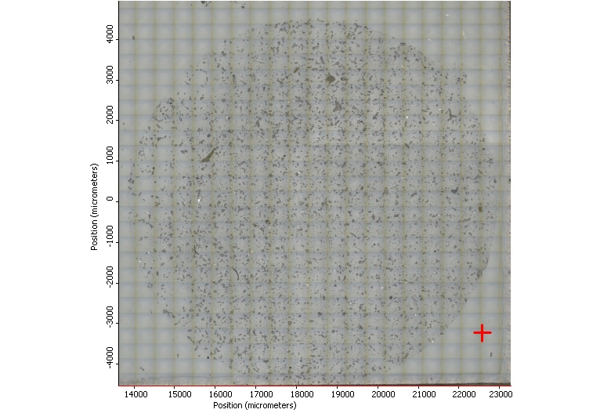 | 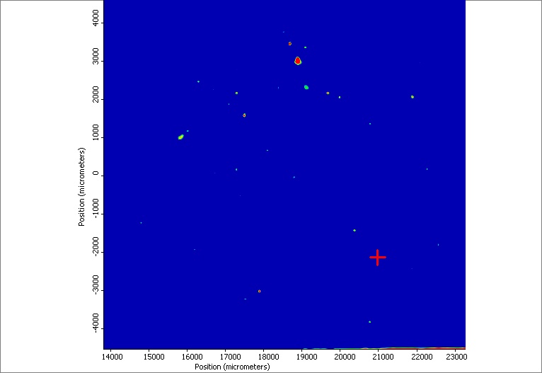
Figure S3. Microscopic Analysis of a Silicone Filter Containing Digested Fecal Material. (A, B). Optical microscope images acquired under visible and UV light, respectively.
(C) Micro-FTIR image of the entire filter, illustrating the uniform distribution of particles.
(D) Chemical mapping of the filter using micro-FTIR.

