Supplementary Material for
Patterns, drivers and potential biodiversity consequences of widespread tree-cover expansion in Europe
Wanben Wu*, Jens-Christian Svenning, Tobias Kuemmerle, Alexander V. Prishchepov, Matthias Baumann, Robert Buitenwerf
*Corresponding author: wanben.wu@bio.au.dk
Table of contents
Table S1: Accuracy assessment for annual cropland extent maps in Europe 6
Fig. S1: Tree dynamic modes across biogeographic regions and countries. 7
Fig. S2: The relationship between TC and TCI, THI 8
Fig. S3: Sub-metrics of tree metrics trends from 2001 to 2021 9
Fig. S4: Average tree cover, tree cover connectivity index, and tree heterogeneity index, 2001-2021 10
Fig. S5: Two sub-metrics of tree heterogeneity trends across different land managements. 10
Fig. S6: Partial dependence plots for the factors affecting the TC trend from 2001 to 2021 11
Fig. S7: Partial dependence plots for the factors affecting the TCI trend from 2001 to 2021 11
Fig. S8: Partial dependence plots for the factors affecting the THI trend from 2001 to 2021 12
Fig. S9: Distribution of former cropland and its comparison with cropland area reduction 13
Fig. S10: Correlation coefficients among different tree metrics metrics trends 14
Fig. S11: Correlation coefficients among determinant factors 15
Fig. S12: Workflow for assessing tree dynamics and their determinants across Europe. 16

Table S1: Accuracy assessment for annual cropland extent maps in Europe
Derived from ESA-CCI-LC data using GLANCE training data. Here, OA, PA, and UA denote overall accuracy, producer accuracy, and user accuracy, respectively. Where n represents the number of crop samples utilized for the assessment, an equivalent sample size of non-crop samples has also been employed.
Year | OA | PA | UA | n
1999 | 0.85 | 0.90 | 0.82 | 2422
2000 | 0.86 | 0.91 | 0.82 | 2527
2001 | 0.85 | 0.91 | 0.82 | 2568
2002 | 0.85 | 0.91 | 0.81 | 2624
2003 | 0.86 | 0.91 | 0.82 | 2678
2004 | 0.85 | 0.91 | 0.82 | 2688
2005 | 0.85 | 0.91 | 0.82 | 2723
2006 | 0.85 | 0.91 | 0.81 | 2695
2007 | 0.85 | 0.91 | 0.82 | 2691
2008 | 0.86 | 0.90 | 0.83 | 2689
2009 | 0.90 | 0.95 | 0.86 | 30481
2010 | 0.86 | 0.90 | 0.83 | 2822
2011 | 0.86 | 0.91 | 0.83 | 2707
2012 | 0.89 | 0.96 | 0.85 | 40333
2013 | 0.86 | 0.91 | 0.83 | 2641
2014 | 0.86 | 0.91 | 0.82 | 2632
2015 | 0.87 | 0.94 | 0.83 | 43488
2016 | 0.85 | 0.91 | 0.82 | 2619
2017 | 0.86 | 0.91 | 0.82 | 2604
2018 | 0.85 | 0.94 | 0.80 | 39529
2019 | 0.81 | 0.89 | 0.77 | 444
2020 | 0.80 | 0.89 | 0.76 | 386
mean | 0.86 | 0.91 | 0.82 | -
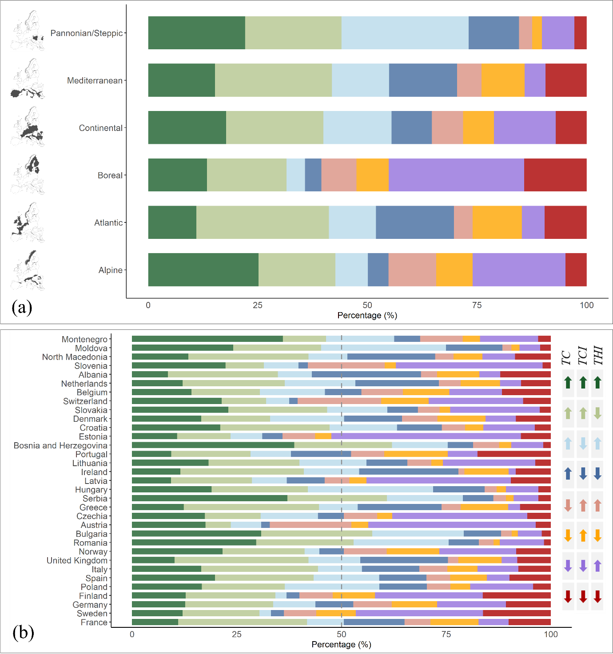

Fig. S1: Tree dynamic modes across biogeographic regions and countries.
(a) shows the fraction of each dynamic mode for different biogeographic regions, while (b) presents the corresponding fractions for individual countries.

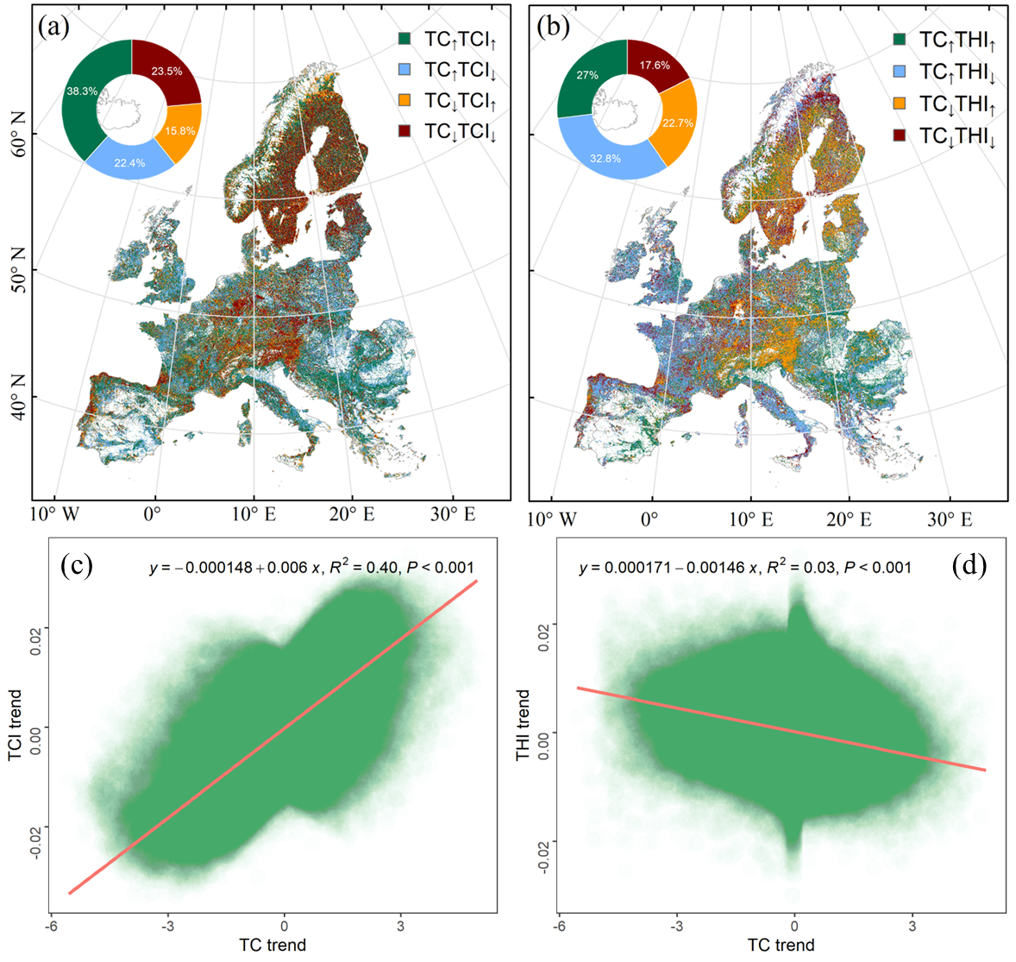

Fig. S2: The relationship between TC and TCI, THI
(a) four tree dynamic modes based on the trends of TC and TCI, (b) four tree dynamic modes based on the trends of TC and THI. (c) the linear relationship between trends in TC and TCI, (d) TC and THI.

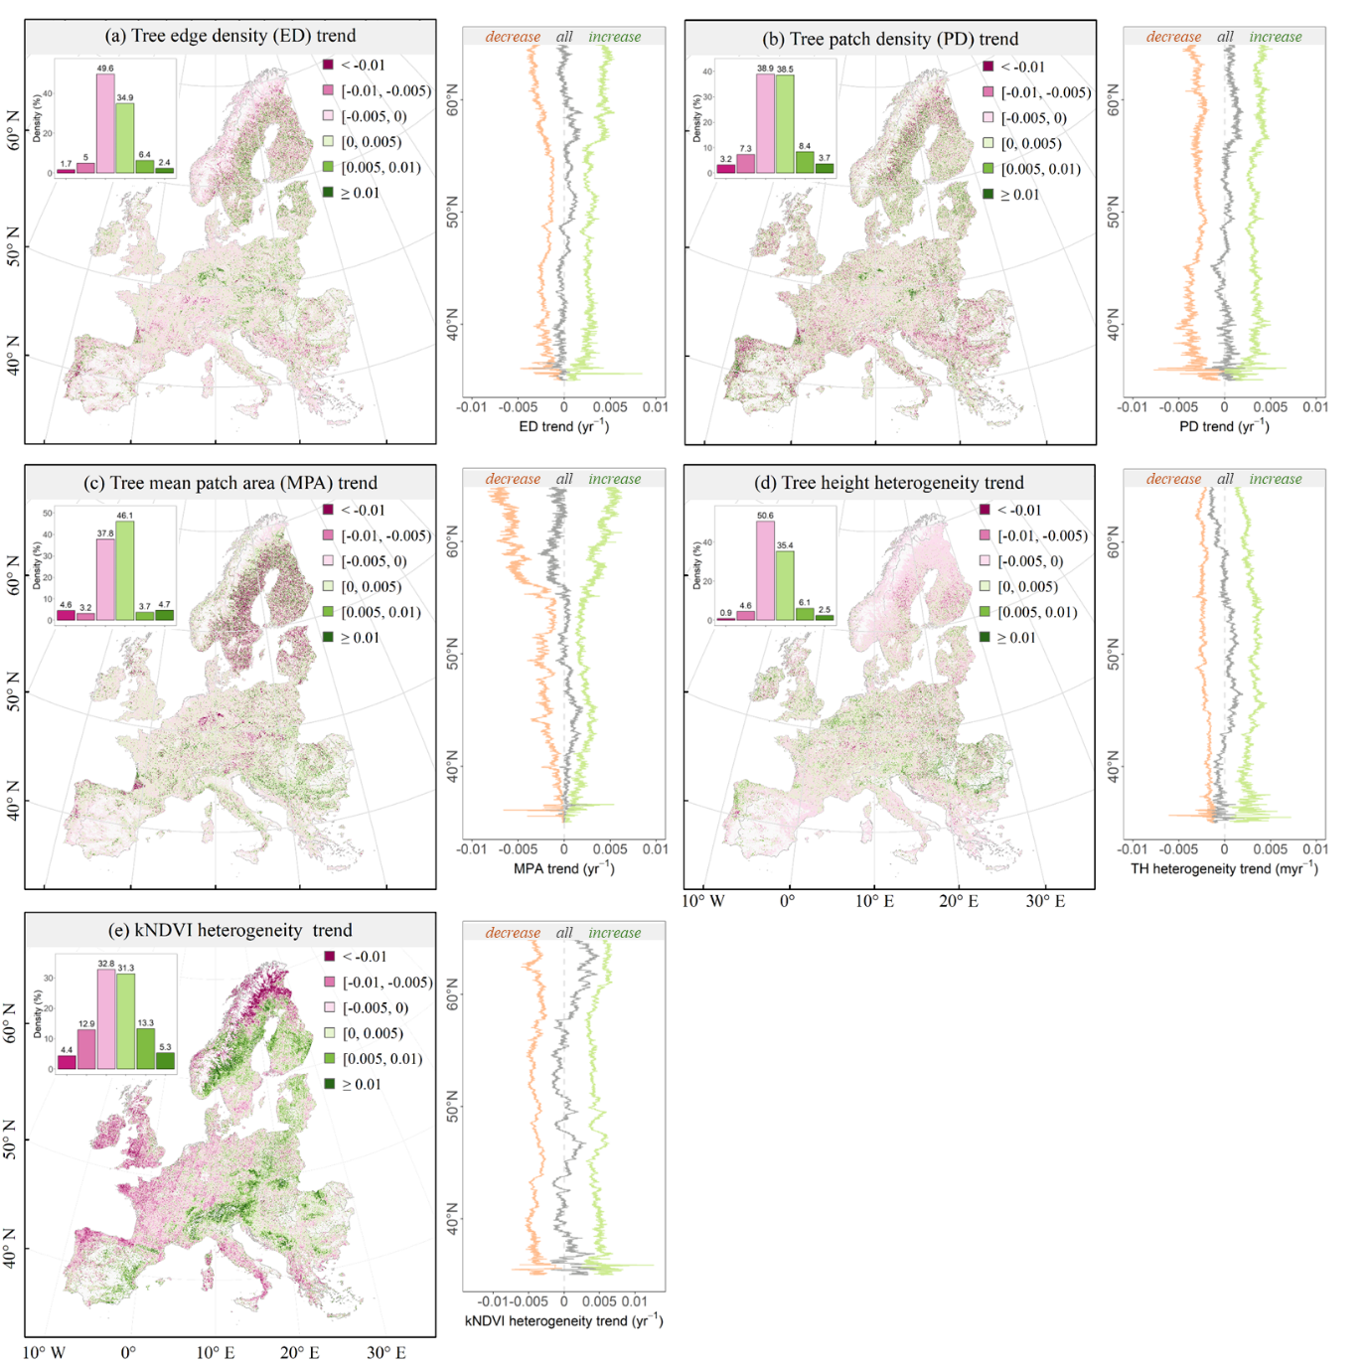

Fig. S3: Sub-metrics of tree metrics trends from 2001 to 2021
(a) tree edge density trend, (b) tree patch density trend, (c) tree mean patch area trend, (d) tree height heterogeneity trend, and (e) kNDVI heterogeneity trend. The tree structure dynamics within the 1 km x 1 km grid were examined for trends using the Partitioned Autoregressive Time Series (PART) approach¹. Both significant and non-significant results are presented here to provide a comprehensive assessment of the observed pattern.

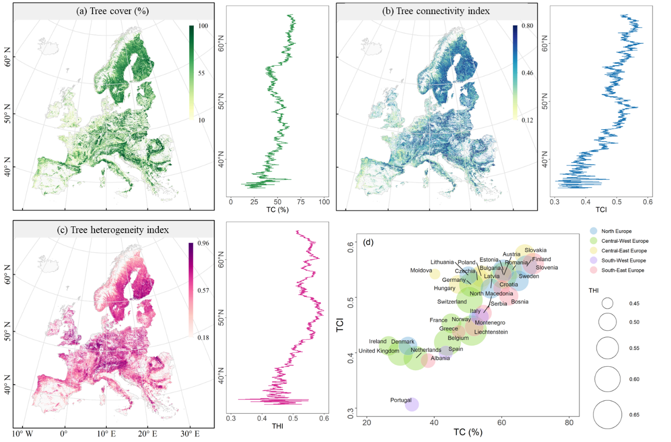Fig. S4: Average tree cover, tree cover connectivity index, and tree heterogeneity index, 2001-2021

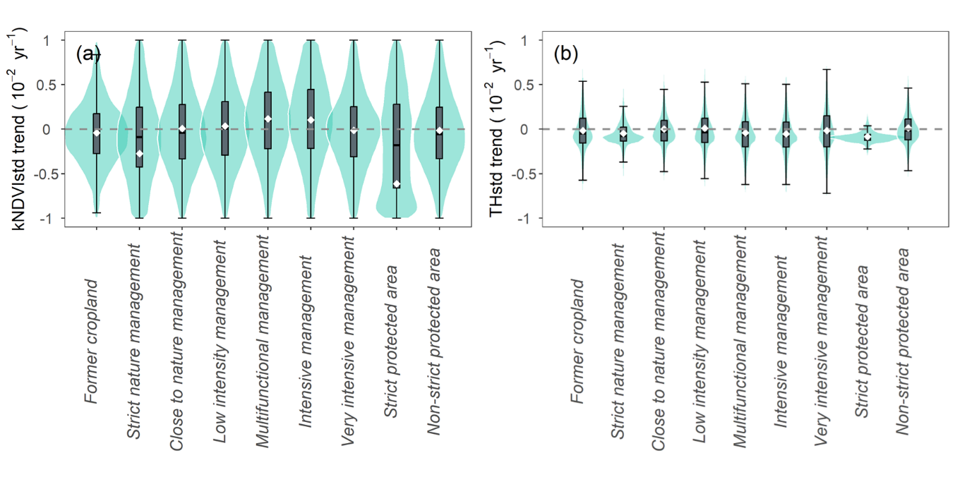Fig. S5: Two sub-metrics of tree heterogeneity trends across different land managements.
(a) kNDVI-based spectral heterogeneity trends, (b) tree height based structural heterogeneity trends.

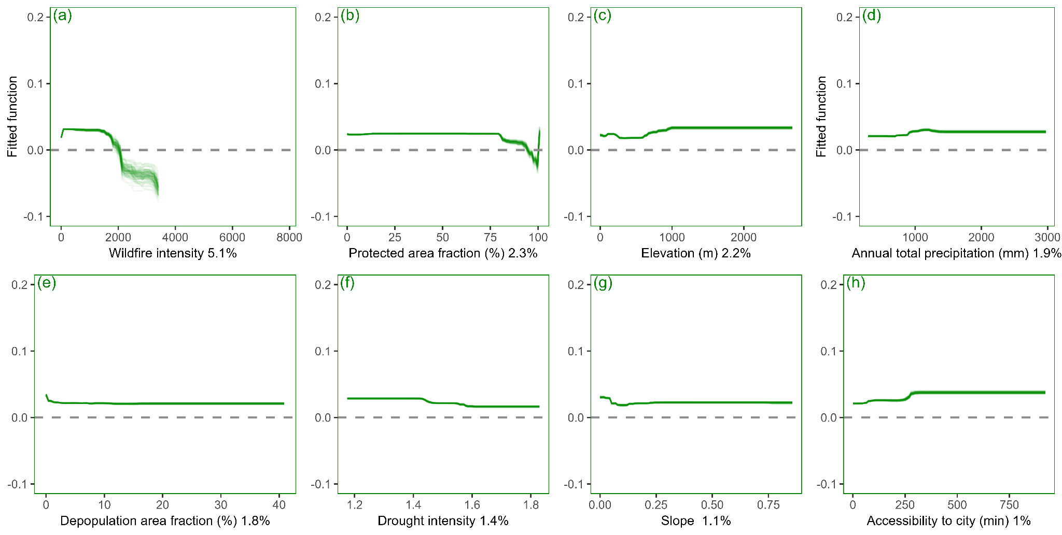Fig. S6: Partial dependence plots for the factors affecting the TC trend from 2001 to 2021
Each line denotes the fitted function for one of the 99 runs.

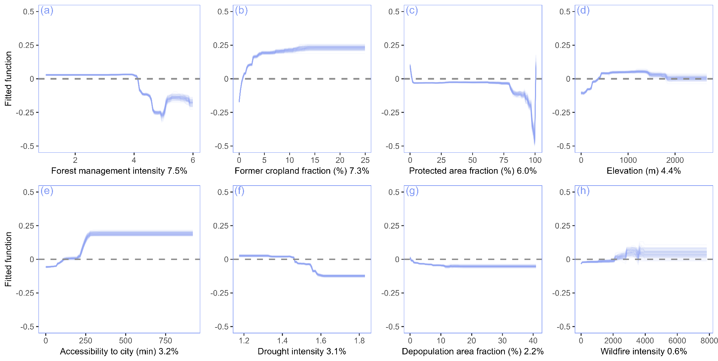Fig. S7: Partial dependence plots for the factors affecting the TCI trend from 2001 to 2021
Each line denotes the fitted function for one of the 99 runs.

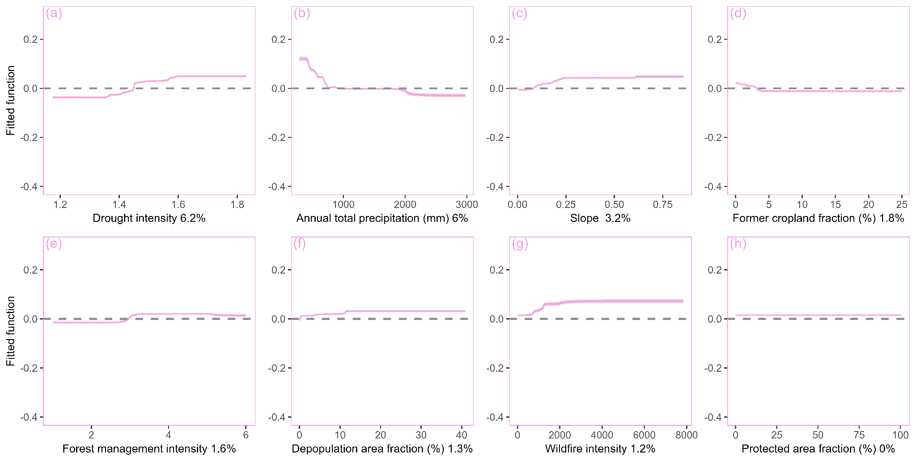Fig. S8: Partial dependence plots for the factors affecting the THI trend from 2001 to 2021
Each line denotes the fitted function for one of the 99 runs.

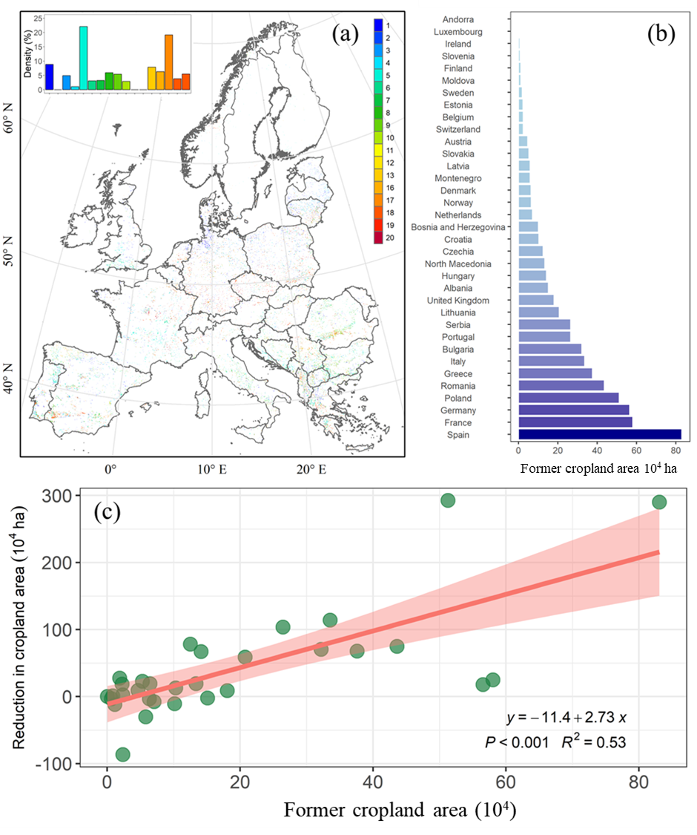

Fig. S9: Distribution of former cropland and its comparison with cropland area reduction
(a) illustrates the fraction of former cropland in 5 km × 5 km grid size (the original former cropland map was in 300 m resolution, here we use 5 km former cropland area fraction for better visualization), and (b) displays the areas per country scale of former cropland. (c) relationship between former cropland from 1996 to 2021 and the decrease in cropland during the same period at a national level.

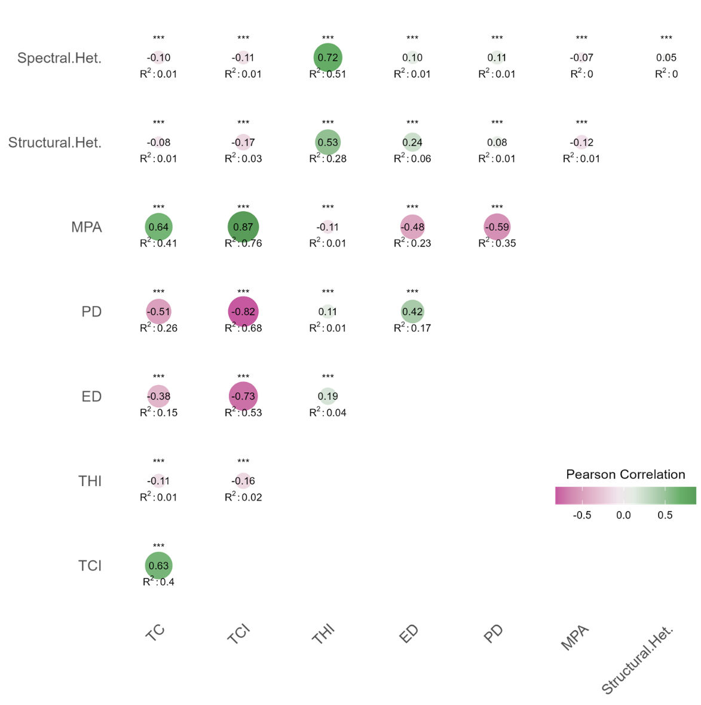

Fig. S10: Correlation coefficients among different tree metrics metrics trends
Including tree cover (TC), tree connectivity index (TCI), tree heterogeneity index (THI), tree edge density (ED), tree patch density (PD), tree mean patch area (MPA), tree height-based structural heterogeneity (Structural Het.), and kNDVI-based spectral heterogeneity (Spectral Het.).

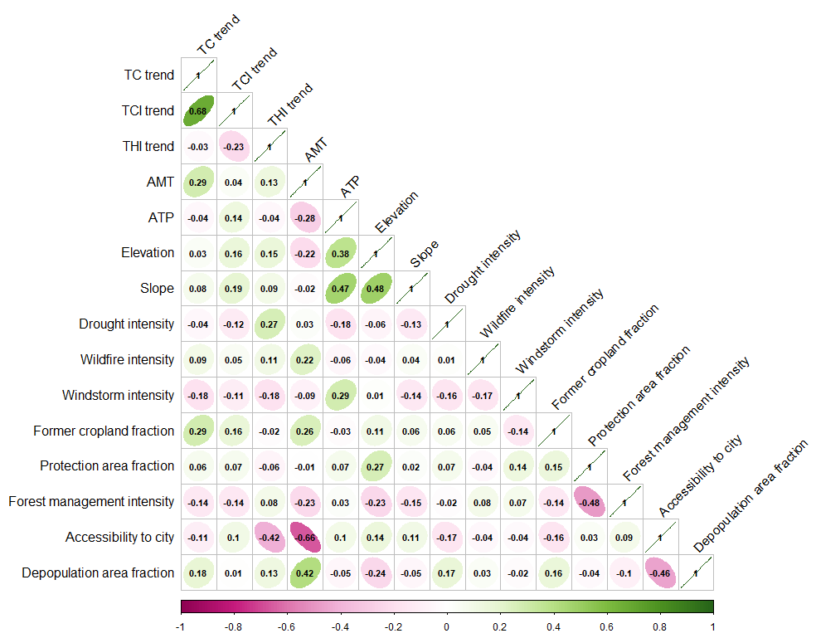Fig. S11: Correlation coefficients among determinant factors

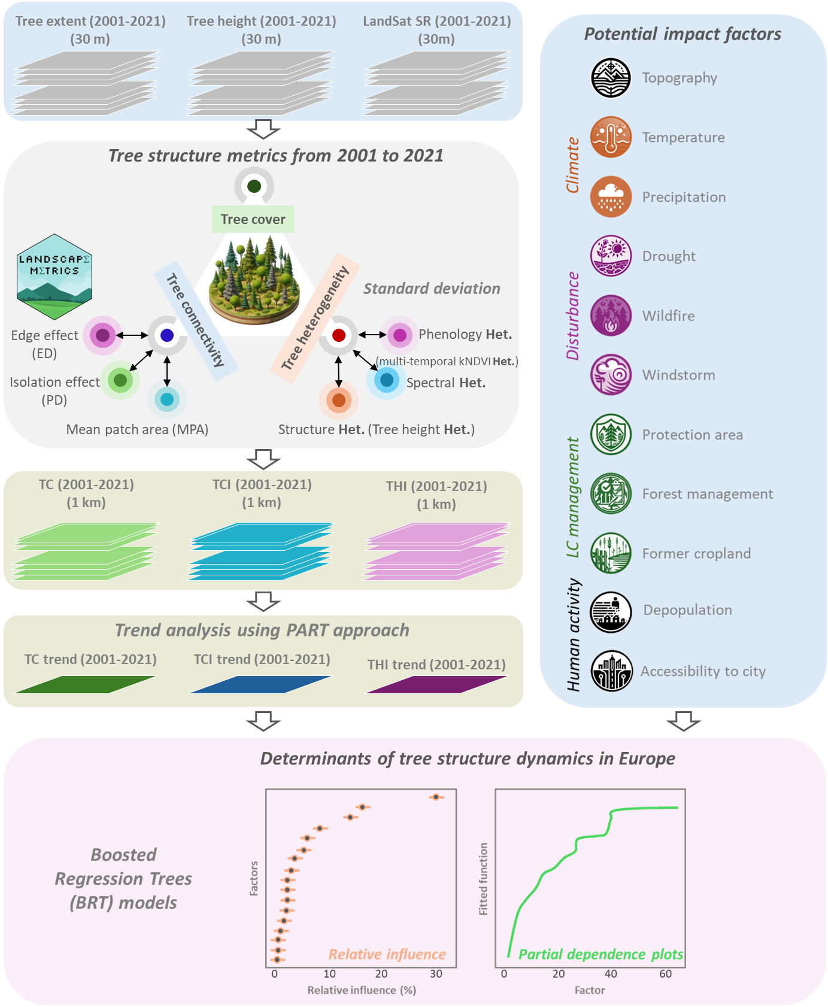Fig. S12: Workflow for assessing tree dynamics and their determinants across Europe.

Reference for supplementary material
1 Ives, A. R. et al. Statistical inference for trends in spatiotemporal data. Remote Sensing of Environment 266, 112678 (2021).

