Table 1 Baseline characteristics of participants according to the tertiles of DNAmTIMP1
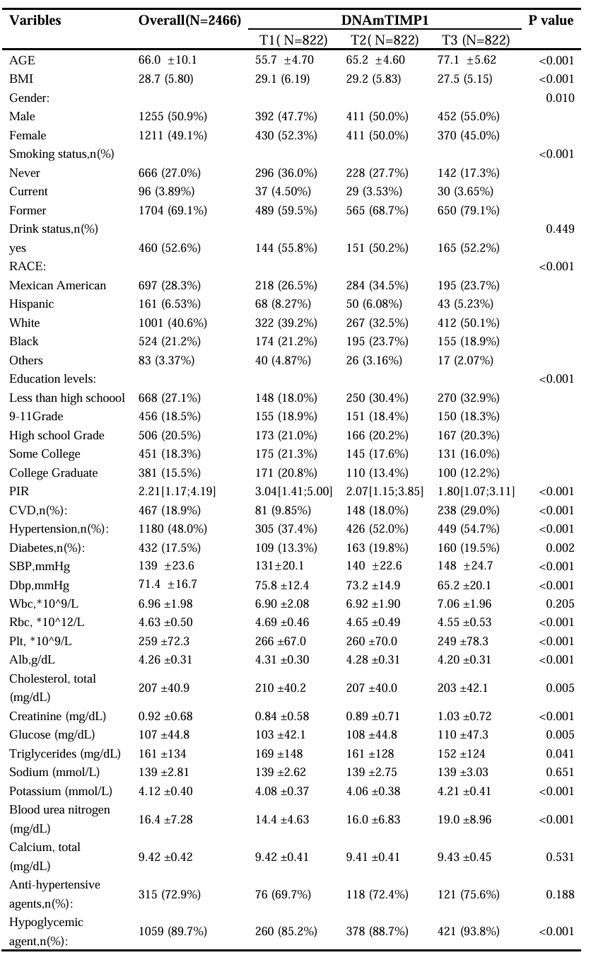
CVD: cardiovascular disease, BMI: body mass index, SBP: systolic blood pressure, DBP: diastolic blood pressure, PIR: poverty income ratio
Table 2 Association between the risk of CVD and DNAmTIMP1
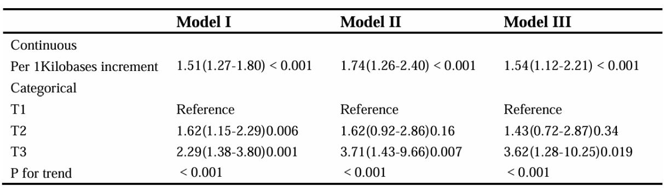
Data were shown as OR, 95% CI, and P value
Model I was adjusted for age, Model II was adjusted for gender, race/ethnicity, BMI, PIR, education, alcohol intake, smoking status, Model III was further adjusted for hypertension, diabetes, total cholesterol, triglycerides, systolic and diastolic blood pressure, creatinine, and the use of medications including antihypertensives and hypoglycemics.

Table 3 Association between mortality and the DNAmTIMP1
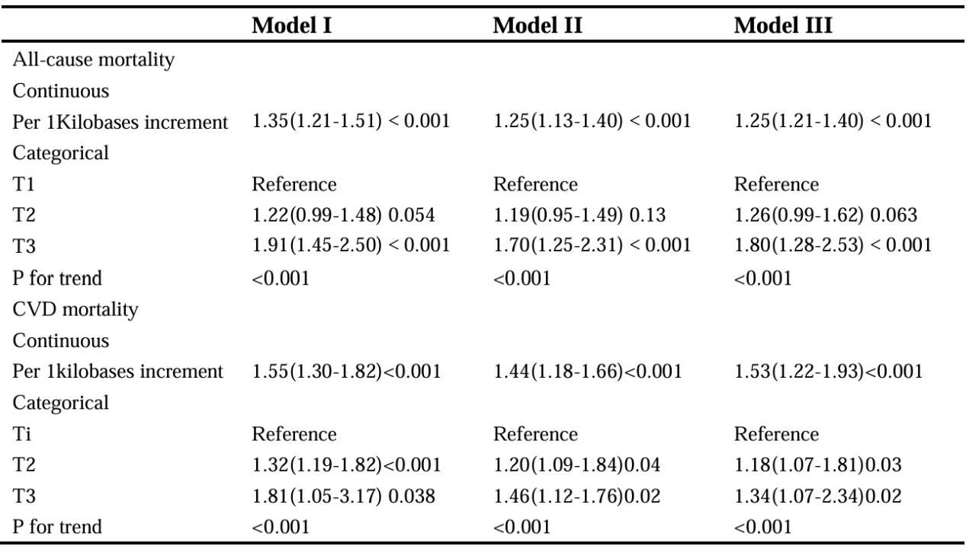
Data were shown as HR, 95% CI, and P value
Model I was adjusted for age, Model II was adjusted for gender, race/ethnicity, BMI, PIR, education, alcohol intake, smoking status, Model III was further adjusted for hypertension, diabetes, total cholesterol, triglycerides,
systolic and diastolic blood pressure, creatinine, and the use of medications including antihypertensives and hypoglycemics.

Table4 Association between mortality and the DNAmTIMP1
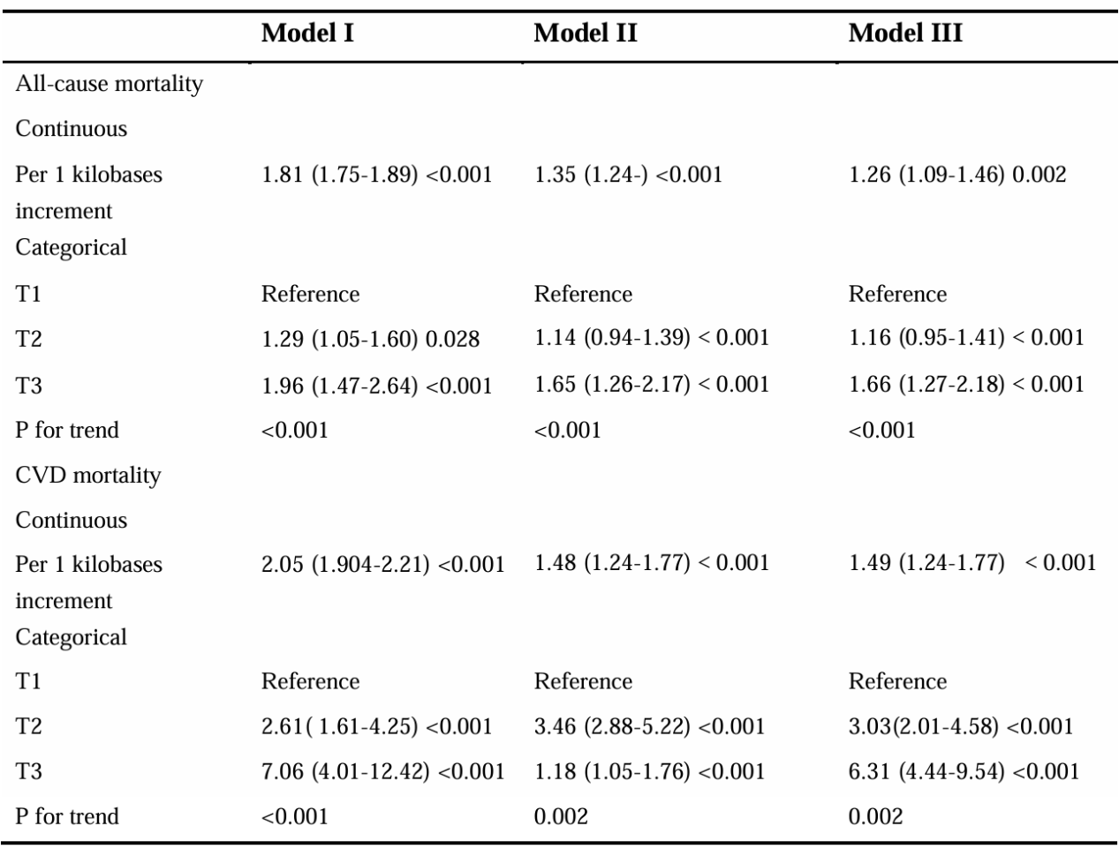
Data were shown as HR, 95% CI, and P value
Model I was adjusted for age; Model II was adjusted for gender, race/ethnicity, BMI, PIR, education, alcohol intake, smoking status;
Model III was further adjusted for hypertension, diabetes, total cholesterol, triglycerides,
systolic and diastolic blood pressure, creatinine, and the use of medications including antihypertensives and hypoglycemics.(Individuals who died within 2 years had been excluded)

