Comprehensive Analysis of ¹⁷⁷Lu-lilotomab Satetraxetan in Lymphoma Cell Lines: Implications for Precision Radioimmunotherapy and Combination Schemes
Sebastian Patzke¹, Luciano Cascione²,³, Katrine B Melhus⁴, Nicolas Munz², Alberto J. Arribas^{2,3}, Eugenio Gaudio², Roman Generalov⁵, Ada HV Repetto-Llamazares⁶, Jostein Dahle⁷, Francesco Bertoni^{2,8}
¹SpinChip Diagnostics AS, Hoffsveien 21-23, 0275 Oslo, Norway; ²Institute of Oncology Research, Faculty of Biomedical Sciences, USI, Bellinzona, Switzerland; ³ SIB Swiss Institute of Bioinformatics, Lausanne, Switzerland; ⁴Institute for Energy Technology, Kjeller, Norway; ⁵Artbio AS, Kjelsåsveien 168B, Oslo, Norway; ⁶Nuclithera, Kjelsåsveien 168B, Oslo, Norway; ⁷Department of Oncology, Akershus University Hospital, Lørenskog, Norway; ⁸Oncology Institute of Southern Switzerland, Bellinzona, Switzerland.

*Corresponding author:
Dr Jostein Dahle, Department of Oncology, Akershus University Hospital, Lørenskog, Norway. Phone +47 98 45 88 50. Email: jostein.dahle@ahus.no

Supplementary Figures and Tables

Figure S1. Distribution of CD37 expression between B- and T-cell derived lymphoma cell lines.
A) CD37 surface expression between B- and T-cell lymphoma cell lines. B-C) CD37 RNA expression values measured via microarray between B- and T-cell lymphoma cell lines. ****, P<0.0001 as determined by the Mann-Whitney test.

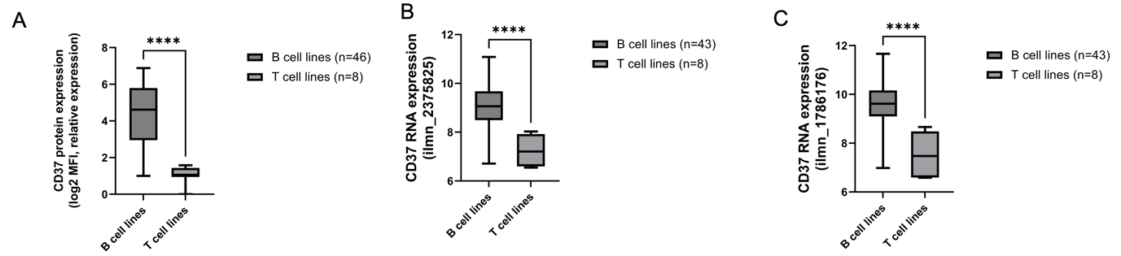

Figure S2. Correlation between in vitro cytotoxic activities of ¹⁷⁷Lu-lilotomab satetraxetan and the anti-CD37 ADC naratuximab emtansine in cell lines derived from 54 B- and T- cell lymphomas (A) and in 46 derived only from B-cell lymphomas (B). Pearson correlations between log2 IC50 of the two agents. Data obtained with naratuximab emtansine were previously presented (1).

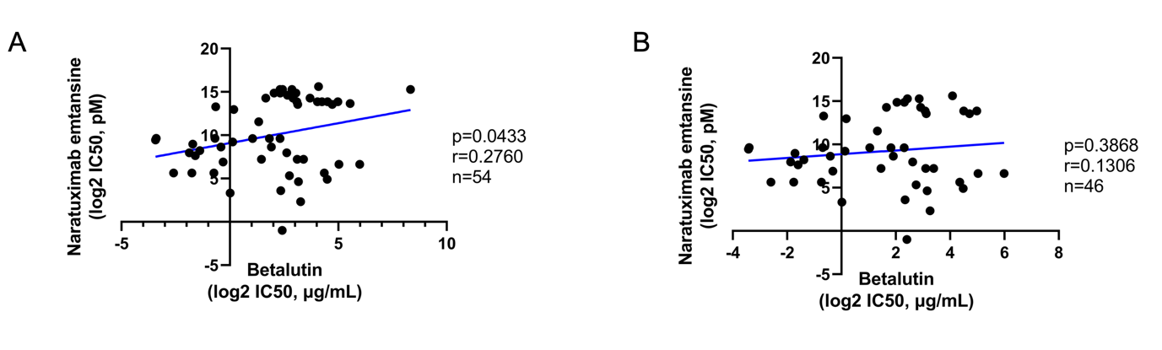

Figure S3. Correlation between the activity of ¹⁷⁷Lu-lilotomab satetraxetan and R-CHOP in 27 DLBCL cell lines. Pearson correlations between log2 IC50 obtained with ¹⁷⁷Lu-lilotomab satetraxetan or with R-CHOP. Data obtained with R-CHOP were previously presented (2).
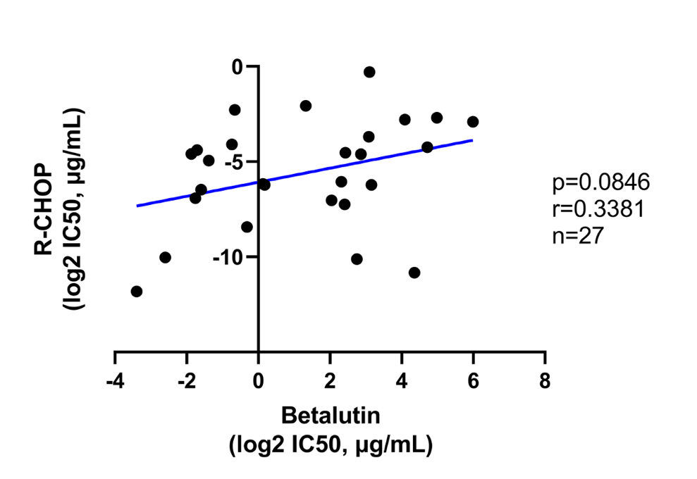

Supplementary Table 1. Anti-tumor activity of ¹⁷⁷Lu-lilotomab satetraxetan based in lymphoma cell lines after 144 hours of exposure. Data in ABC-DLBCL has been previously presented (3).
Cell line | Histology | IC50  (µg/ml) | Inactive TP53 | BCL2  transloc. | MYC transloc. | MYC + BCL2 transloc.
DB | GCB-DLBCL | 0.305 | yes | yes | no | no
DOHH2 | GCB-DLBCL | 4.985 | no | yes | yes | yes
ESKOL | MZL | 3.760 | . | . | no | .
FARAGE | GCB-DLBCL | 6.722 | yes | no | no | no
FE-PD | PTCL-NOS | 6.287 | . | . | . | .
GRANTA519 | MCL | 3.532 | yes | no | no | no
H9 | SS | 16.420 | . | . | . | .
HAIR-M | MZL | 6.158 | . | . | no | .
HBL-1 | ABC-DLBCL | 0.599 | yes | no | no | no
HC1 | MZL | 2.059 | . | . | no | .
HH | CTCL | 713.600 | . | . | . | .
HUT-78 | SS | 46.590 | . | . | . | .
JEKO1 | MCL | 22.400 | yes | no | no | no
JVM2 | MCL | 0.752 | no | no | no | no
KARPAS 1106P | PMBCL | 0.093 | . | . | no | .
KARPAS 1718 | MZL | 1.011 | yes | . | no | .
KARPAS 299 | ALCL | 320.900 | yes | . | . | .
KARPAS 422 | GCB-DLBCL | 0.383 | yes | yes | no | no
KI-JK | ALCL | 4.960 | . | . | . | .
L-82 | ALCL | 12.930 | yes | . | . | .
MAC1 | ALCL | 19.020 | . | . | . | .
MAVER1 | MCL | 0.621 | yes | . | yes | .
MEC1 | CLL | 22.650 | yes | . | no | .
MINO | MCL | 2.746 | yes | . | yes | .
OCI-LY-1 | GCB-DLBCL | 5.313 | yes | yes | no | no
OCI-LY-18 | GCB-DLBCL | 26.350 | yes | yes | yes | yes
OCI-LY-19 | GCB-DLBCL | 4.117 | no | yes | yes | yes
OCI-LY-3 | ABC-DLBCL | 1.096 | no | no | no | no
OCI-LY-7 | GCB-DLBCL | 0.296 | yes | no | yes | no
OCI-LY-8 | GCB-DLBCL | 20.500 | yes | yes | yes | yes
OCILY10 | ABC-DLBCL | 0.274 | no | no | no | no
PCL-12 | CLL | 8.728 | . | . | no | .
PFEIFFER | GCB-DLBCL | 17.040 | yes | yes | no | no
RCK8 | GCB-DLBCL | 5.383 | no | no | no | no
REC1 | MCL | 32.620 | yes | . | no | .
RI-1 | ABC-DLBCL | 8.593 | yes | no | yes | no
SP49 | MCL | 5.079 | . | . | no | .
SP53 | MCL | 4.969 | . | . | no | .
SSK41 | MZL | 10.510 | . | . | no | .
SU-DHL-1 | ALCL | 8.257 | yes | . | . | .
SU-DHL-10 | GCB-DLBCL | 0.165 | yes | yes | yes | yes
SU-DHL-16 | GCB-DLBCL | 63.490 | yes | yes | no | no
SU-DHL-2 | ABC-DLBCL | 2.506 | no | no | no | no
SU-DHL-4 | GCB-DLBCL | 0.330 | yes | yes | no | no
SU-DHL-5 | GCB-DLBCL | 8.931 | . | no | no | no
SU-DHL-6 | GCB-DLBCL | 0.804 | yes | yes | no | no
SUDHL8 | GCB-DLBCL | 7.270 | . | no | yes | no
TMD8 | ABC-DLBCL | 1.131 | no | no | no | no
TOLEDO | GCB-DLBCL | 8.476 | yes | yes | yes | yes
U2932 | ABC-DLBCL | 31.580 | yes | no | no | no
UPN1 | MCL | 9.598 | yes | . | no | .
VAL | GCB-DLBCL | 0.095 | no | yes | yes | yes
VL51 | MZL | 3.148 | . | . | no | .
WSU-DLCL2 | GCB-DLBCL | 0.635 | yes | yes | no | no
Z138 | MCL | 7.534 | . | . | yes | .

Supplementary Table 2. Supervised analysis of resistant versus sensitive ABC- and GCB-DLBCL cell lines. Limma analysis of the dataset GSE94669 (4) obtained with the HTG EdgeSeq Oncology Biomarker panel.
[Excel file]

Supplementary Table 3. Combinatorial effect of adding the BCL2 inhibitor venetoclax to ¹⁷⁷Lu-lilotomab satetraxetan in two DLBCL cell lines. Red: synergistic, orange: additive, green: antagonistic, black: no effect).

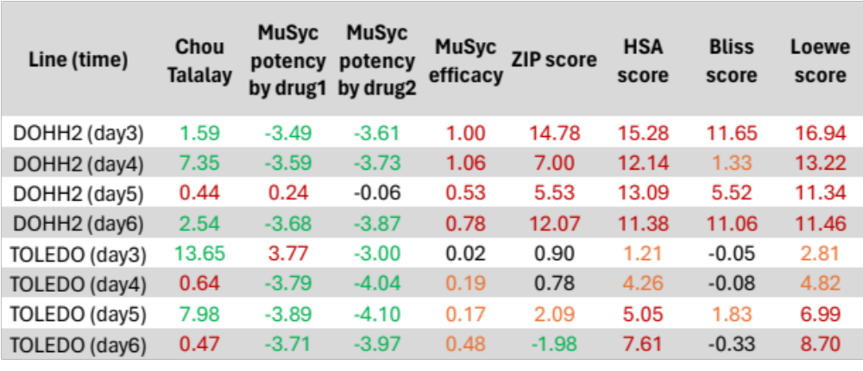

References
1. Arribas AJ, Napoli S, Gaudio E, Herbaux C, Cannas E, Tarantelli C, et al. PI3Kdelta activation, IL-6 overexpression, and CD37 loss cause resistance to naratuximab emtansine in lymphomas. Blood Adv 2024;8(24):6268-81.
2. Tarantelli C, Wald D, Munz N, Spriano F, Bruscaggin A, Cannas E, et al. Targeting CD19-positive lymphomas with the antibodydrug conjugate loncastuximab tesirine: preclinical evidence of activity as a single agent and in combination therapy. Haematologica 2024;109(10):3314-26.
3. Rodland GE, Melhus K, Generalov R, Gilani S, Bertoni F, Dahle J, et al. The Dual Cell Cycle Kinase Inhibitor JNJ-7706621 Reverses Resistance to CD37-Targeted Radioimmunotherapy in Activated B Cell Like Diffuse Large B Cell Lymphoma Cell Lines. Front Oncol 2019;9:1301.
4. Tarantelli C, Gaudio E, Arribas AJ, Kwee I, Hillmann P, Rinaldi A, et al. PQR309 Is a Novel Dual PI3K/mTOR Inhibitor with Preclinical Antitumor Activity in Lymphomas as a Single Agent and in Combination Therapy. Clin Cancer Res 2018;24(1):120-9.

