Down-regulate of brassinosteroid-biosynthetic gene
EpDWF4 in Echinacea purpurea by RNA interference reveals DWARF phenotype
Jin Zhao^{1, 2*}, Jing Liu¹, Yihan He¹, Yuanyuan Fu^{2, 3*}

1College of Agriculture, Guizhou University, Guiyang, 550025, China
2Department of Genetic Engineering and Graduate School of Biotechnology, Kyung Hee University, Yongin 17104, Korea
3 Basic Experimental Teaching Center of Life Sciences, Yangzhou University, Yangzhou 22509, China

*Corresponding author
Jin Zhao. E-mail: jzhao6@gzu.edu.cn. Tel: +86 18985183317. ORCID: 0009-0000-4632-4770
Yuanyuan Fu. E-mail: fyyyzu@yzu.edu.cn. Tel: +86 15952705610. ORCID: 0009-0006-4574-6684

Supplementary information:

Table S1.

Table S1 Primers used for gene amplification and quantitative analysis.
Primer purpose | Name | Sequence (5’- 3’)
Degenerate primers | EpDWF4-DF | GGAAAGAAAACTCACCTTTTTGTGCCC
Degenerate primers | EpDWF4-DR | TCAACCAATTCCCACTCGTATTTTAGGACC
5’-RACE primers | EpDWF4-5’GSP | TCTTGGGCACAAAAAGGTGAGTTTTCTTTCC
3’-RACE primers | EpDWF4-3’GSP | GGGTGGAAAGTGCTGCCAGTGATTGCAGCCGCGCATTTGG
Full-length DWF4 cloning primers | EpDWF4-FF | ATCCCCTCACATACACTACAAGAATTTAAC
Full-length DWF4 cloning primers | EpDWF4-FR | TATTAGAAAACAAGTATATTTGTGAGAGG
Universal primers for RACE | AAP | GGCCACGCGTGGACTAGTACGGGIIGGGIIGGGIIG
Universal primers for RACE | AUAP | GGCCACGCGTCGACTAGTAC
Flanking sequence analysis | LP primer | AAAAGTTGTGCTGGTACCGT
Flanking sequence analysis | BP primer | CGGCGGTTCATCAACTTAGAG
Flanking sequence analysis | RP primer | TGCCAAGGAAAATCAAACCCT
Sense and antisense primers for RNAi | Sense-F | GGCGCGCCTATAAAGGTTATGACATTCC
Sense and antisense primers for RNAi | Sense-R | ATTTAAATAAATGGTGGATAAATATCGCC
Sense and antisense primers for RNAi | Antisense-F | TCTAGAAAATGGTGGATAAATATCGCC
Sense and antisense primers for RNAi | Antisense-R | CCCGGGTATAAAGGTTATGACATTCC
EpDWF4 ORF amplification primers | DWF4 ORF-F | AGATCTGCTATGGCTTCTGATCTTGAGTTCTTCCTCCATGATTCTTTC
EpDWF4 ORF amplification primers | DWF4 ORF-R | GTCGACACACATTTGTTTTCGGTGACAGAC
Genomic DNA PCR and RT PCR primers | CHSA-F | CCATTCCTTAACTAGTAAATAC
Genomic DNA PCR and RT PCR primers | CHSA-R | TCTAGACTCACCTAGGATCC
Genomic DNA PCR and RT PCR primers | Ep18s rRNA-F | GGATGGGTCGGCCGGTC
Genomic DNA PCR and RT PCR primers | Ep18s RNA-R | CAGGCTGAGGTCTCGTTC
Genomic DNA PCR and RT PCR primers | O/T HPT-F | ACACAGCCATCGGTCCAGAC
Genomic DNA PCR and RT PCR primers | O/T HPT-R | ATCTTAGCCAGACGAGCGGG
Genomic DNA PCR and RT PCR primers | AtActin-F | TCTCACACTGTGCCAATCTACG
Genomic DNA PCR and RT PCR primers | AtActin-R | GAGATCCACATCTGCTGGAATGT
Southern blot analysis | EpDWF4 probe-F | CGGCGGTTCATCAACTTAGAG
Southern blot analysis | EpDWF4 probe-R | CACATTTGTTTTCGGTGACAG
Southern blot analysis | HPT probe-F | ACACAGCCATCGGTCCAGAC
Southern blot analysis | HPT probe-R | ATCTTAGCCAGACGAGCGGG
qRT-PCR primers | EpDWF4-qRT-F | ATGTCTGATCTTGAGTTCTTCCTC
qRT-PCR primers | EpDWF4-qRT-R | ACACATTTGTTTTCGGTGAC
qRT-PCR primers | Eptubulin-F | CCGCTAACCTCACGTGGGTCCC
qRT-PCR primers | Eptubulin-R | GCCTTCCTCCTGAACATAGC

Table S2.

Table S2 Morphometric analysis of wild-type and transgenic Echinacea purpurea suppressing EpDWF4
 | Wild-type (WT) | Transgenic (Tg)
Plant height (cm) | 91 (±7.6) | 53.5 (± 3.8)
Internode size (cm) | 13.3 (± 2.7) | 7.7 (± 2.9)
Leaf size (cm) | 23.1 (± 2.01) | 15.33 (± 1.69)
Flower diameter (cm) | 9.43 (± 0.61) | 8.56 (± 1.07)
Petal number (per plant) | 17(± 3) | 15(± 2)
Capitulum diameter (cm) | 3.16 (± 0.53) | 2.46 (± 0.65)

Table S3.

Table S3 Morphometric analysis of wild-type and homozygous transgenic A. thaliana overexpressing EpDWF4

 | Wild-type | Transgenic (Tg)
Plant height (cm) | 35.0 (± 4.0) | 47.6 (±3.9 )
Rosette length (cm) | 6.4 (±1.0) | 8.0 (± 0.7)
Rosette width (cm) | 2.1 (±0.5) | 2.2 (±0.5)
Rosette diameter at bolting (cm) | 14.9 (± 2.3) | 16.4 (± 1.6)
Silique petiole length (cm) | 0.8 (± 0.2) | 0.9 (± 0.1)
Silique length (cm) | 0.96 (± 0.2) | 1.31 (± 0.1)

Figure S1.

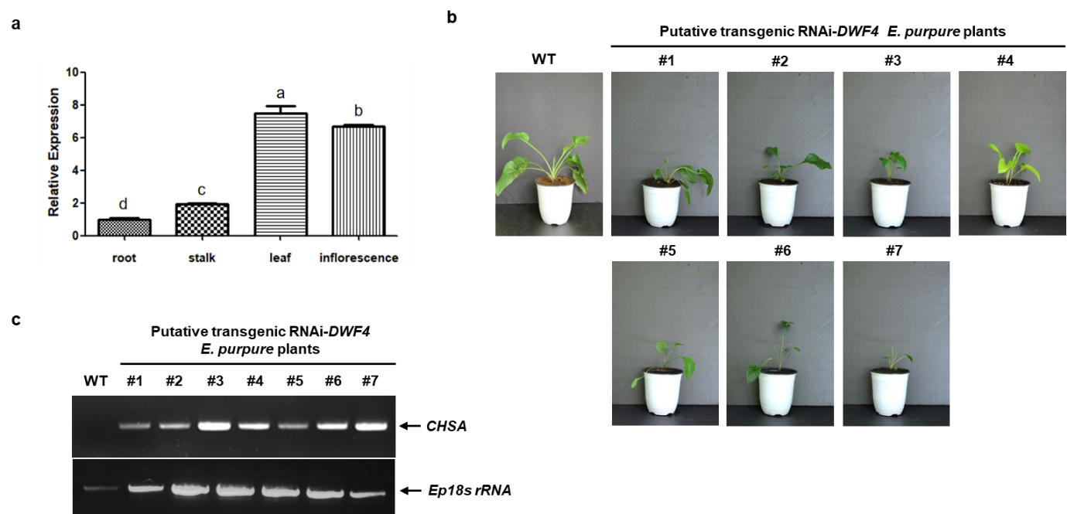

Fig S1. a Expression level of EpDWF4 in root, stalk, leaf and inflorescence of E. purpurea. Means with different letters are significantly different at P＜0.05. b Wild - type and putative transgenic E. purpurea plants suppression EpDWF4. Scale bar = 10 cm. c Genomic DNA PCR for determining the presence of pFGC5941/shEpDWF4 construct in genomic DNA of putative transgenic E. purpurea plants suppression EpDWF4.

Figure S2.

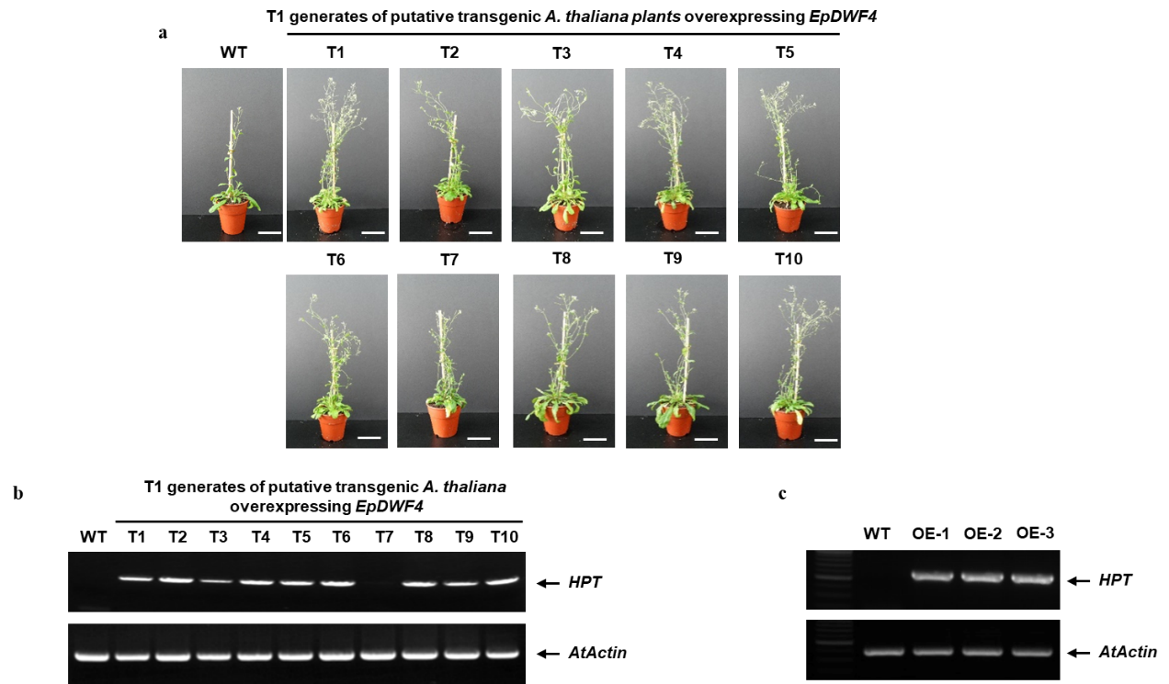

Fig S2 Identification of EpDWF4 transgenic A. thaliana plants. a The phenotype of 10 T1 putative transgenic A. thaliana plants lines. b Genomic DNA PCR to determine A. thaliana plants which carrying 35S:EpDWF4. c RT-PCR to determine the transcription of EpDWF4 in T3 generates of transgenic A. thaliana, scale bar = 7cm.

Figure S3.

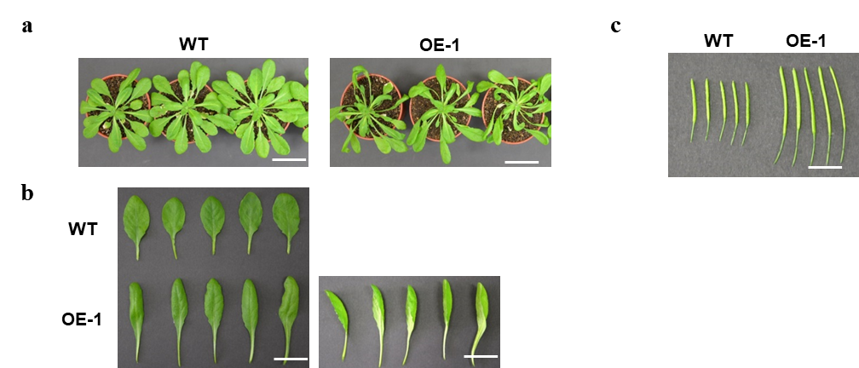

Fig S3 a The phenotype of WT and phenotypic consequence of OE-1 homozygous transgenic A. thaliana plant overexpressing EpDWF4, scale bar = 2 cm. b The rosette leaves of WT and OE-1. c The silique of WT and OE-1, scale bar = 0.5 cm.

