Supplementary Information

Conformational mapping of GPCR activation: dynamic allosteric site discovery in V2R through MD-MSM and mutual information analysis

Xin Qiao^{1,2,#}, Chunhao Zhu^{2,#}, Xiaobing Lan², Mingyu Li¹, Nuan Li¹, Jianxiang Huang¹, Ning Liu², Jian Zhang^{1,2,*} Shaoyong Lu^{1,2,*}

¹Medicinal Chemistry and Bioinformatics Center, Shanghai Jiao Tong University School of Medicine, Shanghai 200025, China
²Key Laboratory of Protection, Development and Utilization of Medicinal Resources in Liupanshan Area, Ministry of Education, Peptide & Protein Drug Research Center, School of Pharmacy, Ningxia Medical University, Yinchuan 750004, China

#These authors contributed equally to this work.
*To whom correspondence should be addressed:
Dr. Shaoyong Lu; E-mail: lushaoyong@sjtu.edu.cn
Dr. Jian Zhang; E-mail: jian.zhang@sjtu.edu.cn

Figure S1. The structure generated by Swiss Model was superimposed with the highest pLDDT-scoring AlphaFold2 structure from the database (The RMSD between two structure is 0.93 Å when the ICL3 is removed). Swiss Model-derived structure is colored cyan, while the AlphaFold2 database structure is shown in red.

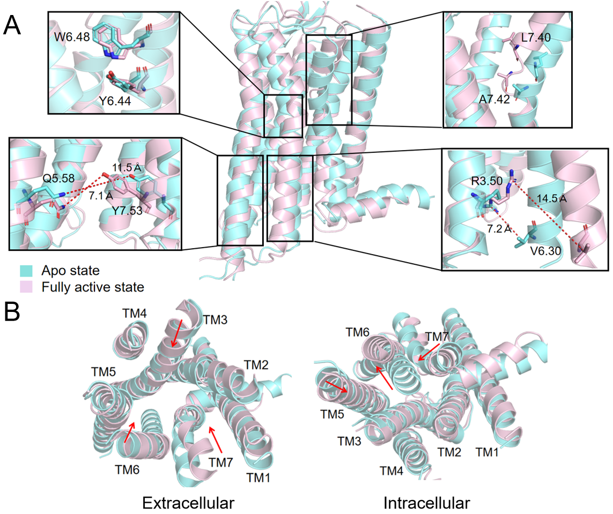

Figure S2. (A) The comparison of the receptor portion in the apo inactive state and the fully active state, along with four crucial regions that manifest the differences. The distances between the residues are marked with red dashed lines. (B) The conformational differences of the extracellular and intracellular ends between the apo inactive state and the fully active state. The red arrow indicates the direction of movement of the receptor in the fully active state.

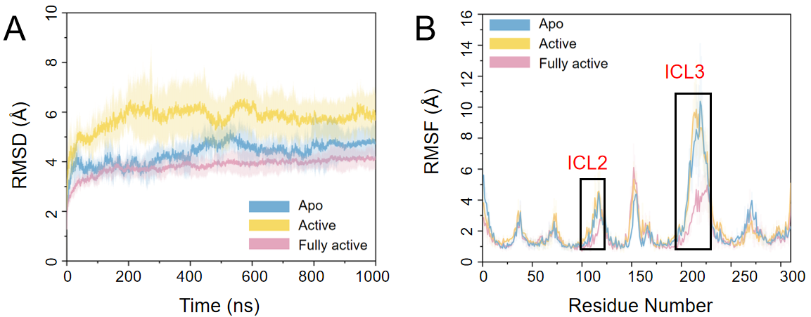

Figure S3. (A) The root-mean square deviation (RMSD) of Cα atoms of the receptor portion in three distinct states along the 1 μs simulation time. (B) The per-residue root-mean-square fluctuation (RMSF) of the heavy atoms in the backbone of the receptor portion in three distinct states. The apo inactive state (V2R) is represented in blue, the intermediate active state (AVP−V2R) is represented in yellow, and the fully active state (AVP−V2R−Gs) is represented in pink. The shade represents the standard deviation of the five independent runs.

Figure S4. (A, B) The polar interactions between the ICL2 and the Gs protein. The hydrogen bonds are indicated with red dotted lines. (C, D) Hydrophobic interactions between the ICL2 and the Gs protein. The table lists the residues involved in the interactions.

Figure S5. (A, B) The polar interactions between the ICL3 and the Gs protein. The hydrogen bonds are indicated with red dotted lines. (C, D) Hydrophobic interactions between the ICL3 and the Gs protein. The table lists the residues involved in the interactions.

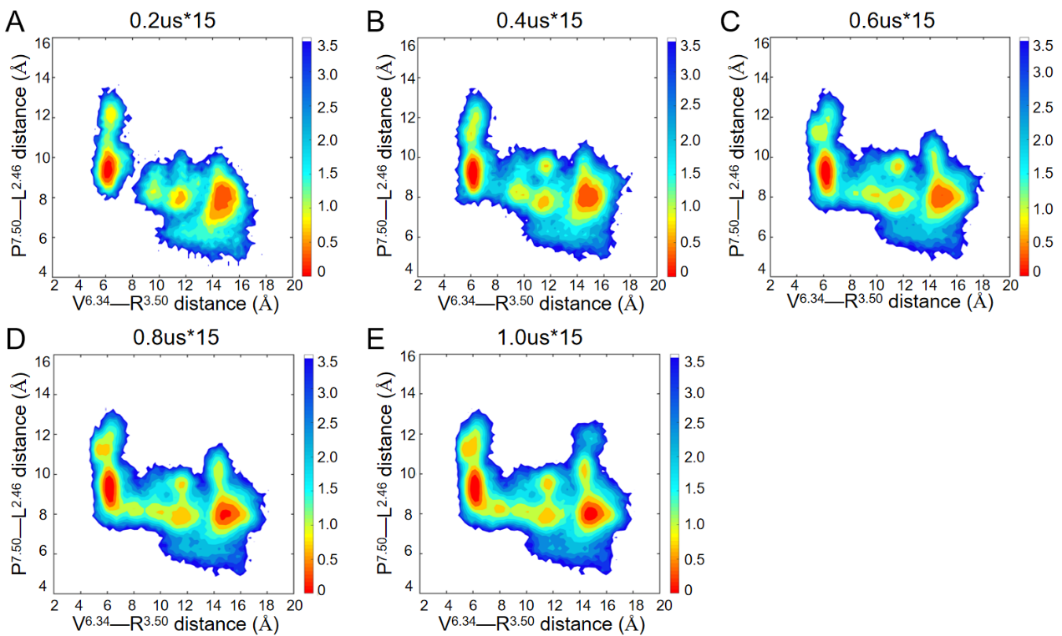

Figure S6. The convergence of both the free energy landscapes and transition pathways was confirmed through systematic projection of MD conformations sampled at progressively increasing simulation durations (3.0 μs [A], 6.0 μs [B], 9.0 μs [C], 12.0 μs [D], and 15.0 μs [E]) onto the two-dimensional reaction coordinate space.

Figure S7. The convergence test results are presented through free energy landscapes corresponding to progressively increasing simulation rounds. (A) one round, (B) three rounds, and (C) five rounds.

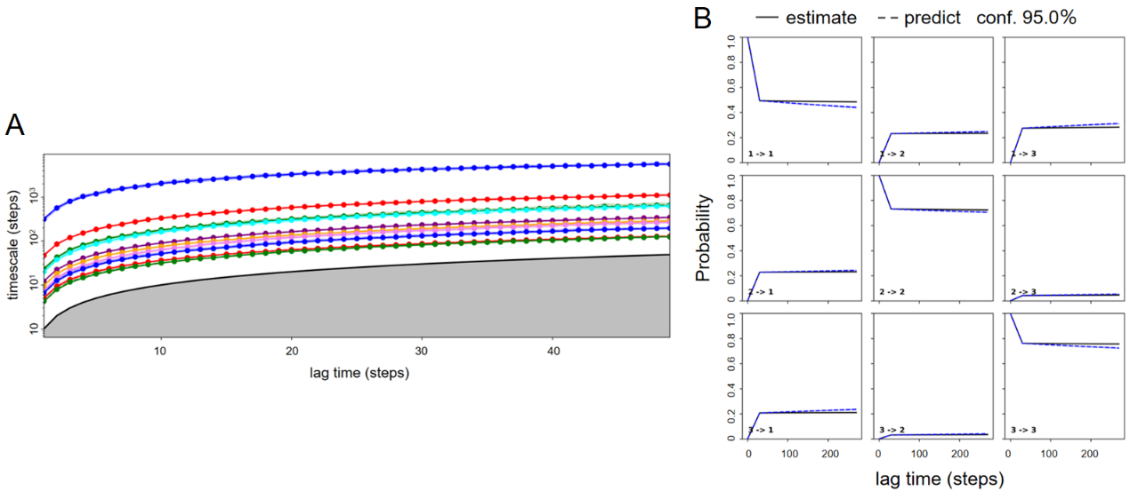

Figure S8. The validation of MSMs accomplished by PyEMMA. (A) The implied timescale test in which the timescale τi was shown as a function of lag time. (B) The results of the Chapman-Kolmogorov test. Estimate lines (solid) are probability calculated by MSMs, while predict lines (dotted) are probability observed in trajectories. One step equals 0.002 ps.

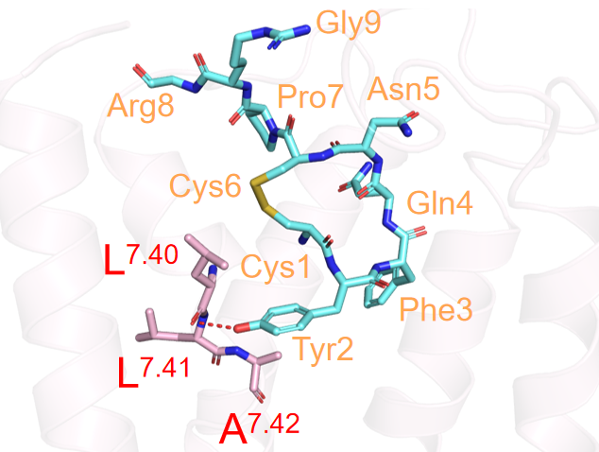

Figure S9. Tyr2 of AVP forms a hydrogen bond with the carbonyl group of L^{7.40} on the TM7 of V2R, causing a bend at the L^{7.40}−A^{7.42} region, with the hydrogen bond marked by a red dashed line.

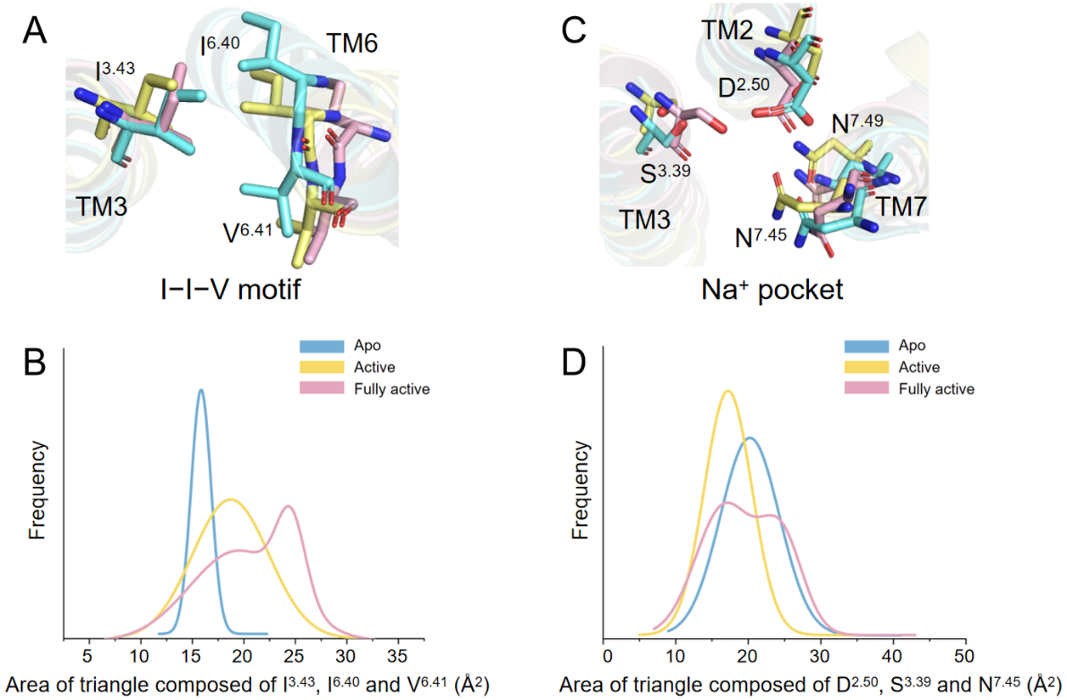

Figure S10. Compare the differences of key motifs and residues among the apo inactive (blue), intermediate active (yellow), and fully active (pink) states of the V2R. (A) The hydrophobic lock composed of I^{3.43}, I^{6.40}, and V^{6.41}. (B) The probability distribution of the area of triangle among the Cβ atoms of I^{3.43}, I^{6.40}, and V^{6.41} throughout the simulation trajectory. (C) The Na⁺ pocket composed of D^{2.50}, S^{3.39}, N^{7.45}, N^{7.49}. (D) The probability distribution of the area of triangle among the Cγ atom of D^{2.50}, the Cβ atom of S^{3.39}, and the Cγ atom of N^{7.45} throughout the simulation trajectory.

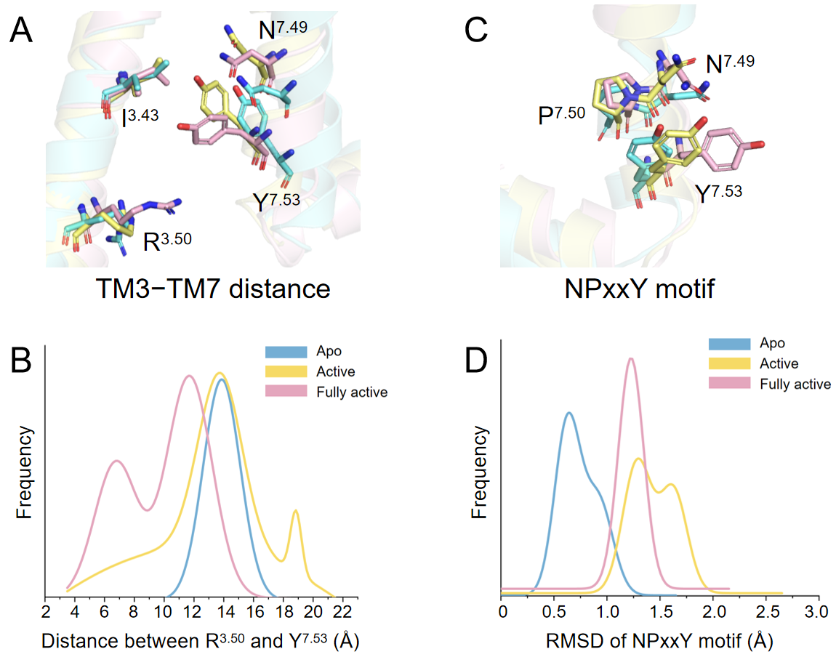

Figure S11. Compare the differences of key motifs and residues among the apo inactive (blue), intermediate active (yellow), and fully active (pink) states of the V2R. (A) The comparison of the proximity between R^{3.50} and Y^{7.53}. (B) The probability distribution of the distance between the guanidino carbon atom of R^{3.50} and the centroid of the benzene ring of Y^{7.53} throughout the simulation trajectory. (C) The comparison of fluctuations of the NPxxY motif. (D) The probability distribution of the RMSD of the Cα atoms of N^{7.49}, P^{7.50}, Y^{7.53} throughout the simulation trajectory.

Figure S12. Construction of MSMs based on residue side chain fluctuations. The implied timescale test in which the timescale τi was shown as a function of lag time. One step equals 0.002 ps.

Figure S13. Rank the predicted allosteric sites based on eigenvector centrality as (A), (B), (C), (D), and (E), respectively, after discretizing the side-chain deviation intervals into 6, 7, 8, 9, and 10 categories.

Figure S14. (A−C) Sites 1, Site 2, and Site 4 are visualized using surface representations, with colors yellow, cyan, and orange, respectively. These sites are located in the crevice between the middle portions of TM6 and TM7, the lipid-facing side of the mid-regions of TM3 and TM5, and the cavity between the intracellular portions of TM5 and TM6, respectively. (D) The position of Site 4 on the receptor and the schematic diagrams of the three regions of the receptor, namely the extracellular region, the transmembrane region, and the intracellular region. The extracellular and intracellular regions are marked in cyan color, the transmembrane region is marked in pink color, and Site 4 is presented as orange sticks.

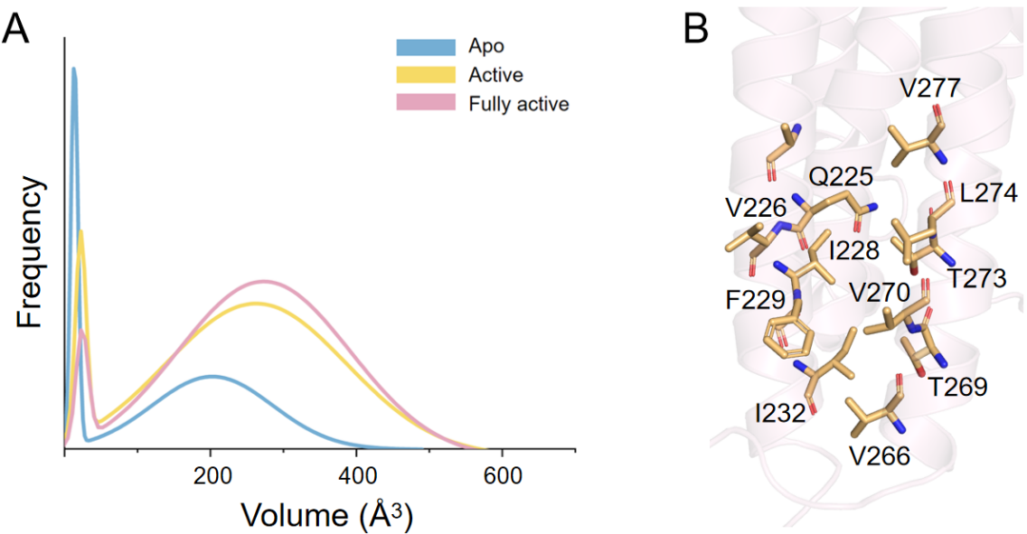

Figure S15. (A) The probability distribution of the volume of dynamic Site 4 throughout the simulation trajectory in the apo inactive, intermediate active, and fully active states. (B) The stick representation diagram of the residues constituting Site 4, colored orange. The Site 4 consists of 10 residues, including Q225^{5.58}, V226^{5.59}, I228^{5.61}, F229^{5.62}, I232^{5.65}, V266^{6.30}, T269^{6.33}, V270^{6.34}, T273^{6.37}, and L274^{6.38}.

Figure S16. (A, B) The spherical schematic diagram of the distribution of Site 7 and Site 10 in the receptor, with the colors being cyan and pink respectively. (C, D) The schematic diagram of the stick structure of Site 7 and Site 10 in the receptor, respectively.

Figure S17. Schematic diagrams of the local stick structure (A) and surface structure (B) at Site 10. Two examples of Site 10 located at the cavity formed by TM3, TM4, and ICL2. (C) The crystal structures of TAK-875 agonist-bound GPR40 (PDB code 4PHU) and compound 1 allosteric agonist-bound GPR40 (PDB code 5KW2). TAK-875-bound receptor is shown in pink, compound 1-bound receptor in cyan, and compound 1 in yellow. (D) The crystal structures of carazolol antagonist-bound β2AR (PDB code 2RH1) and BI167107 agonist/Cmpd-6FA PAM-bound β2AR (PDB code 6N48). Inactive receptor is shown in pink, active receptor in cyan, and Cmpd-6FA in yellow.

Figure S18. The membrane expression levels of ten mutants. The membrane expression levels of all mutants showed no significant difference compared with those of the wild type.

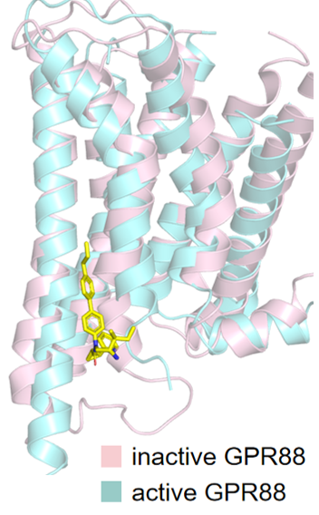

Figure S19. The cryo-EM structures of the apo inactive state GPR88 and 2-PCCA allosteric agonist-bound active GPR88 (PDB code 7EJX). The apo inactive state receptor is shown in pink, and the active receptor in cyan, and 2-PCCA in yellow.

Table S1. Physicochemical properties and structural parameters of the top five sites.
 | Site 1 | Site 2 | Site 3 | Site 4 | Site 5
Druggability Score | 0.004 | 0.005 | 0.001 | 0.855 | 0.414
Total SASA (Å²) | 59.020 | 47.374 | 24.496 | 139.272 | 152.333
Polar SASA (Å²) | 10.715 | 8.572 | 18.458 | 16.094 | 41.964
Apolar SASA (Å²) | 48.305 | 38.802 | 6.038 | 123.178 | 110.369
Apolar alpha sphere proportion | 0.542 | 0.889 | 0.160 | 0.750 | 0.667
Volume (Å³) | 193.225 | 201.744 | 115.889 | 515.912 | 578.766
Alpha sphere density (Å⁻³) | 1.920 | 2.059 | 1.760 | 4.178 | 5.205

