Supporting information
NPJ science of food

Standardized rice bran supplement ameliorates depressive-like behaviors in stress hormone-treated mice via GR/FKBP5 complex regulation

Minji Kim^{1, 2}, Haeun Lee^{1, 2}, Changho Lee¹, Suengmok Cho³, and Min Young Um^{1, 2*}

¹Food Functionality Research Division, Korea Food Research Institute, Wanju 55365, Republic of Korea
²Department of Food Biotechnology, University of Science & Technology, Daejeon 34113, Republic of Korea
³Department of Food Science and Technology/Institute of Food Science, Pukyong National University, Busan 48513, Republic of Korea

*Corresponding author
Min Young Um, Ph.D., Prof.
Food Functionality Research Division, Korea Food Research Institute, Wanju 55365, Republic of Korea
Department of Food Biotechnology, University of Science & Technology, Daejeon 34113, Republic of Korea
Tel.: +82-63-219-9409; Fax: +82-63-219-9876
E-mail address: myum@kfri.re.kr

Supplementary Figure 1
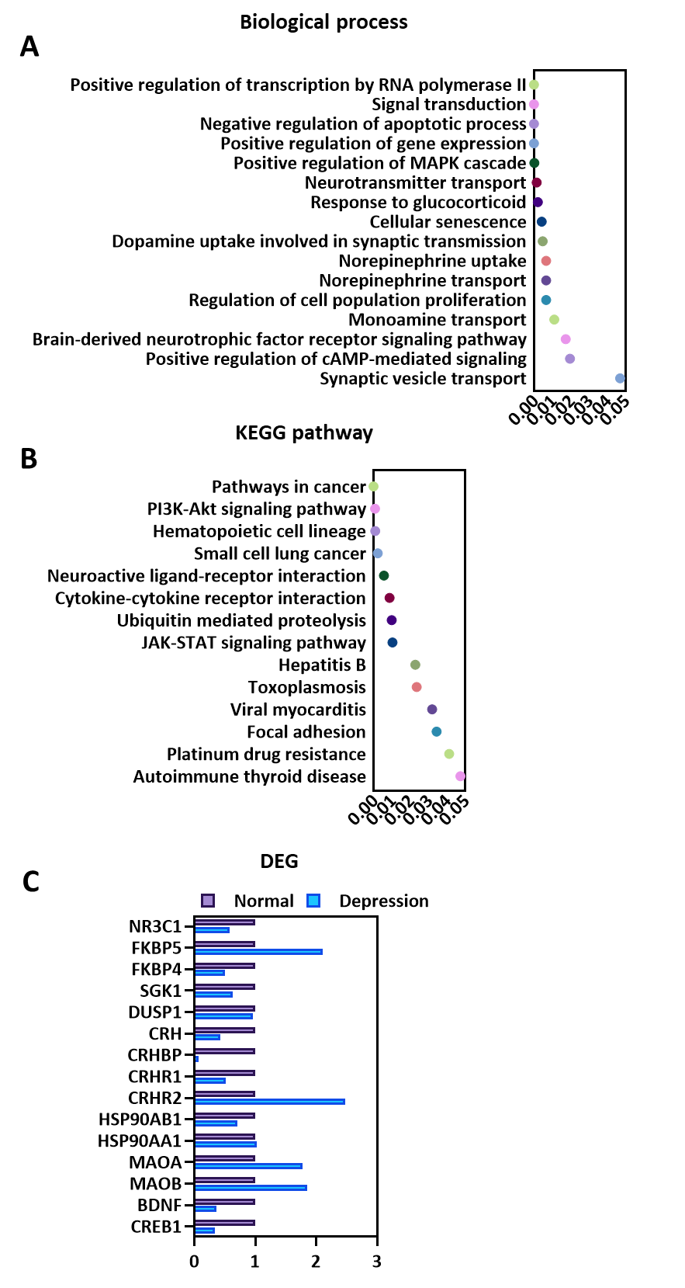
Supplementary figure 1. Gene Ontology (GO) analysis of differential gene (DEG) expression in the human prefrontal cortex between control and depression groups (GSE12654). Gene expression data from the human prefrontal cortex were obtained from the GSE12654 dataset (control, n=15; depression, n=11). (A) Biological process: GO analysis of DEG between the control and depression group revealed several significantly enriched biological processes. (B) KEGG pathway: GO analysis of the DEG identifies significant pathway altered in depression. (C) Specific genes related to critical signaling pathway, including the HPA axis, MAPK signaling, and the neurotransmitter system.

