Appendix I
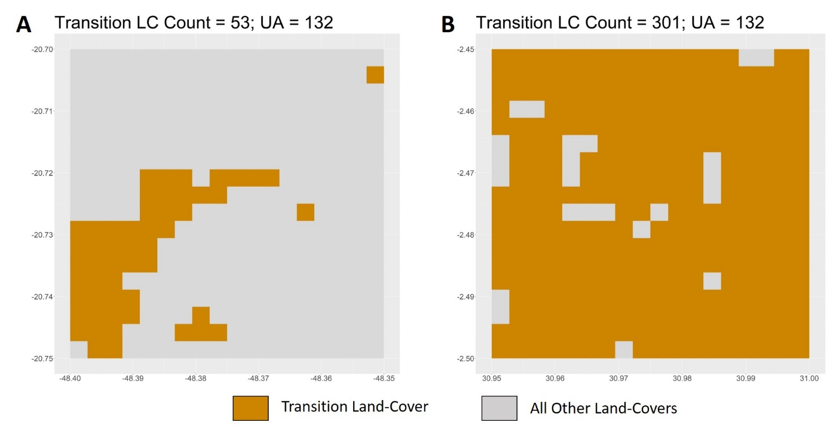
  - Figure 1: Landscapes showing the same value of unlike-adjacency (UA = 132) for low (53 pixels; plot A) and high (301 pixels; plot B) amounts of the transition LC. This figure highlights the problem of using the raw unlike-adjacency values as a measure of spatial arrangement, since similar values of UA can be got from vastly different spatial arrangements of the transition LC.

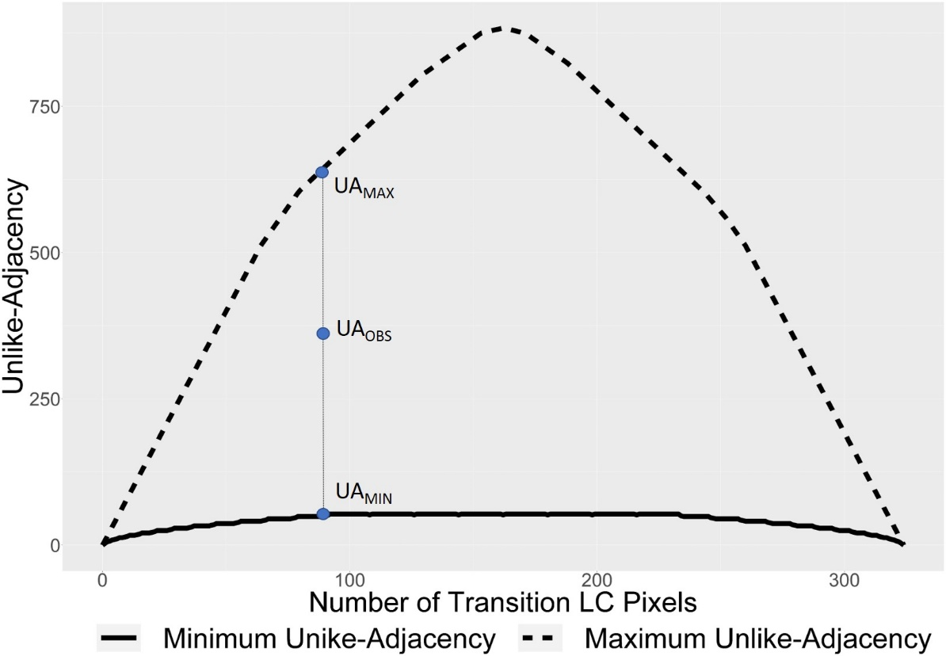
  - Figure 2: Plot of maximum (UA_{max}) and minimum (UA_{min}) unlike-adjacency for all number of transition LC pixels possible in the grid cell (i.e. 0-324). These values represent theoretical spatial distributions that tend to maximize and minimize the fragmentation for a given number of pixels in the landscape. We use these values to normalize our observed unlike-adjacency (UA_{obs}) and construct the Land Cover Configuration (LCI) index which scales between 0 and 1.
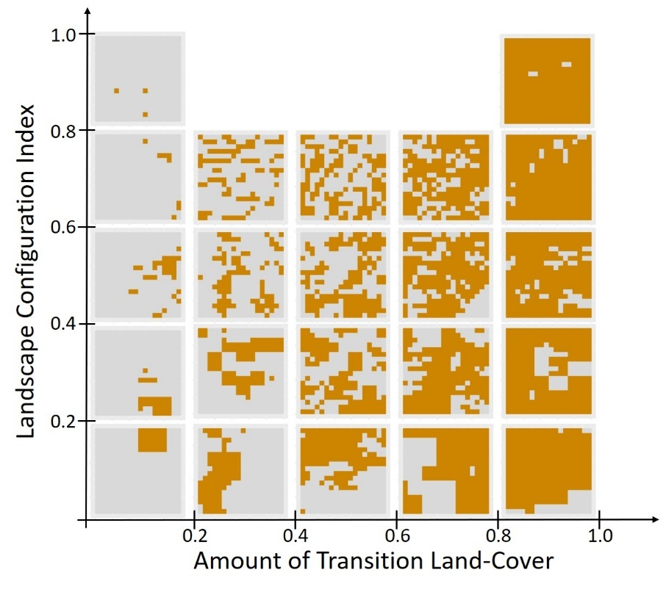
  - Figure 3: Sample arrangements of the transition LC for varying amounts and LCI values. We provide this figure to illustrate types of starting landscape arrangements that can be had by varying values of the amount and LCI.

  - Note on Filters Applied to Select Grids Suitable for Analysis
  - Initially, we had 1,995,644 grids where forests constituted a part of the dominant LC transition. However, we applied additional filters to select grids suitable for our analysis based on the following criteria:
- We excluded 43,294 grids (~2%) where the number of LC pixels was less than 324. These grids were mostly overlying the continental coastline and were removed to ensure that all grids had the same size (see Figure 4 below).
- We removed 1,037,035 grids (~52%) where less than 17 forest pixels were lost and gained between 1992 and 2020. This amounts to less than or equal to 5% of forest change. This was done to reduce the likelihood of including misclassified pixels and focus our analysis on landscapes that have experienced a substantial amount of forest change.
- We removed 47,323 (~2%) grids for which the transition LC at the start of the interval of forest transition is either absent or occupies the entire grid. These grids were removed because calculating the unlike-adjacency (and the LCI) would not be valid for these cases (see Figure 5 below).
- We removed 370,496 (~19%) grids that exhibited non-persistent trajectories of forest change. This was done because the amount and rate of change, as conventionally measured, fail to capture the complexity of changes exhibited by these trajectories – such as fluctuations or reversals in trend – making their interpretation less meaning without additional context or analysis.

  - 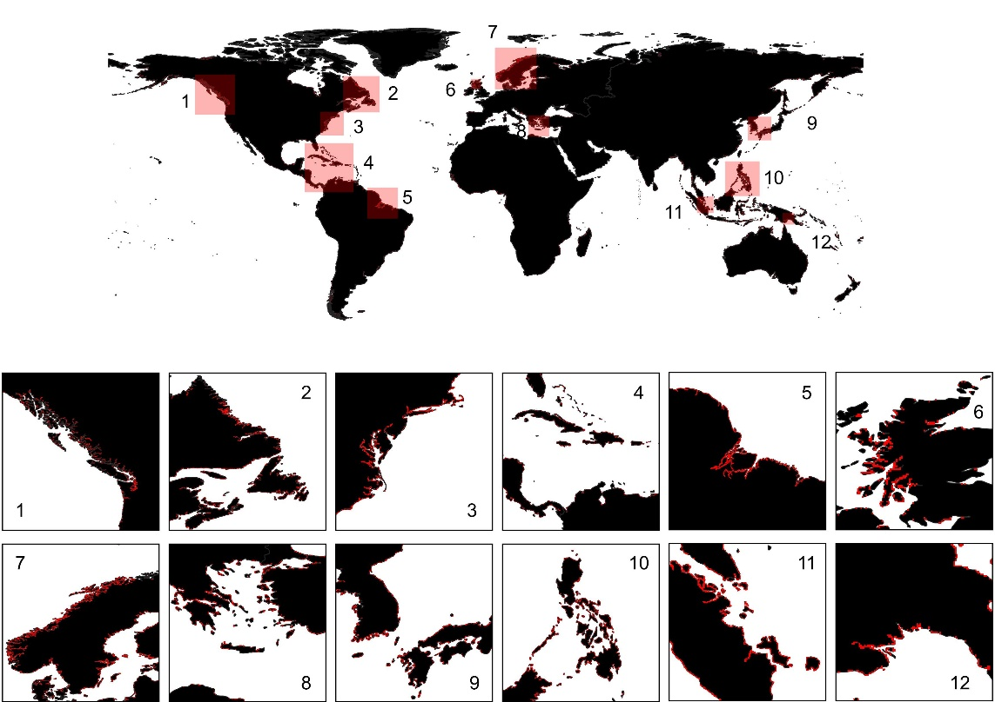
  - Figure 4: Grids (shown in ‘Red’) where the total number of pixels is not equal to 324. These grids were excluded from the analysis as they do not conform to the grid size that been used as a standard in evaluating the proportional amount and spatial arrangement of the transition LCs. Large-Scale Insets [1-12] showing coastlines near Vancouver Island, Canada (1), Newfoundland and Labrador provinces of Canada (2), New York, Delaware and Virginia of the United States of America (3), Caribbean Islands (4), the Amazon Delta (5), North-Western Scotland (6), the Scandinavian Peninsula (7), Greece and Turkey (8), Kyushu, Japan and South Korea (9), the Philippines (10), Southern Malaysia and Sumatra, Indonesia (11), and the South-East Coast of Papua New Guinea (12)
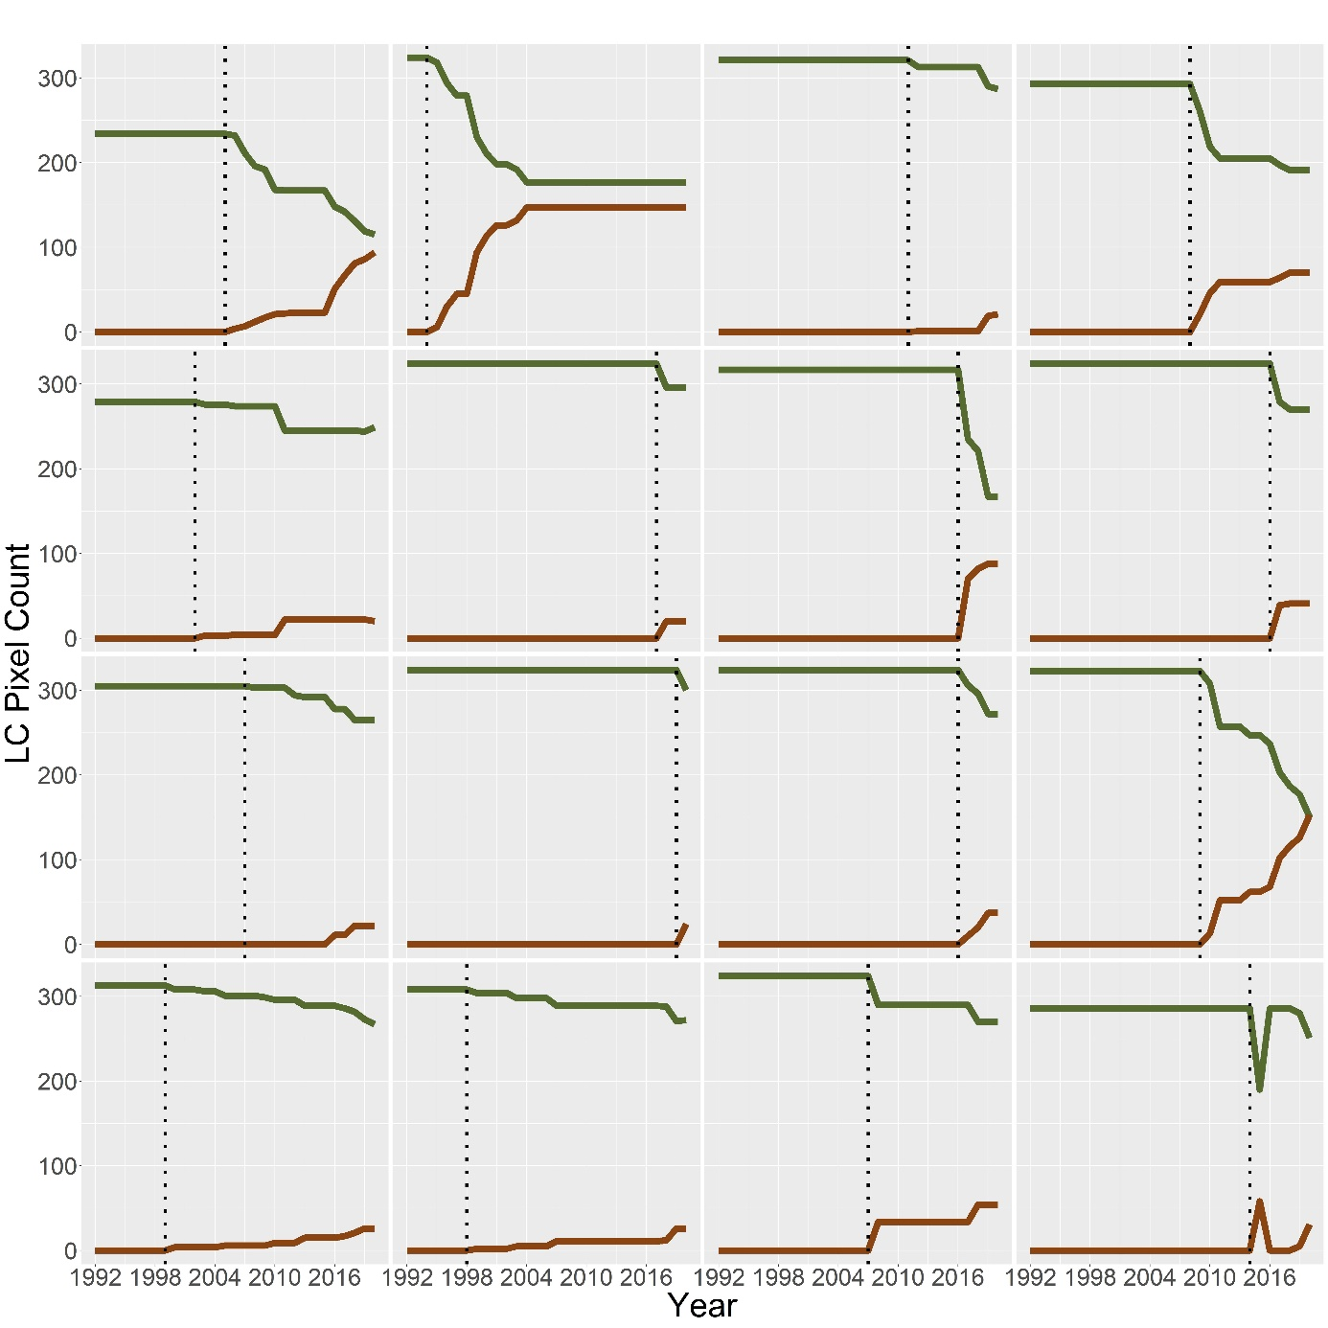
  - Figure 5: Time-Series for 16 grids showing the pixel-amount of forest (shown in Green) and the transition LC (shown in Red). For each of these grids, the value of the transition LC at the starting point of the interval of forest transition is zero. The starting point of the interval of transition is shown with a dotted vertical line. These grids (47,323 in all) were excluded from our analysis since it would be invalid to consider their starting amount and spatial arrangement.

Table 1: Test Statistics for the Anderson-Darling Test
Forest Loss/Gain | Variable | Group | Test-Statistic | P-value
Gain | Amount of Forest Change | Bare | 1506.337 | 3.70E-24
Gain | Amount of Forest Change | Cropland | 4739.98 | 3.70E-24
Gain | Amount of Forest Change | Grassland | 2091.102 | 3.70E-24
Gain | Amount of Forest Change | Shrubland | 4265.733 | 3.70E-24
Gain | Amount of Forest Change | Water | 185.1354 | 3.70E-24
Gain | Amount of Forest Change | Wetland | 1761.526 | 3.70E-24
Loss | Amount of Forest Change | Bare | 632.2017 | 3.70E-24
Loss | Amount of Forest Change | Settlement | 162.2217 | 3.70E-24
Loss | Amount of Forest Change | Cropland | 6121.063 | 3.70E-24
Loss | Amount of Forest Change | Grassland | 1955.374 | 3.70E-24
Loss | Amount of Forest Change | Shrubland | 4686.663 | 3.70E-24
Loss | Amount of Forest Change | Water | 632.6612 | 3.70E-24
Loss | Amount of Forest Change | Wetland | 2155.561 | 3.70E-24
Gain | Rate of Forest Change | Bare | 2894.132 | 3.70E-24
Gain | Rate of Forest Change | Cropland | 9107.627 | 3.70E-24
Gain | Rate of Forest Change | Grassland | 2469.461 | 3.70E-24
Gain | Rate of Forest Change | Shrubland | 6061.488 | 3.70E-24
Gain | Rate of Forest Change | Water | 353.2299 | 3.70E-24
Gain | Rate of Forest Change | Wetland | 3817.599 | 3.70E-24
Loss | Rate of Forest Change | Bare | 1114.933 | 3.70E-24
Loss | Rate of Forest Change | Settlement | 852.5421 | 3.70E-24
Loss | Rate of Forest Change | Cropland | 12525.15 | 3.70E-24
Loss | Rate of Forest Change | Grassland | 3110.627 | 3.70E-24
Loss | Rate of Forest Change | Shrubland | 7152.545 | 3.70E-24
Loss | Rate of Forest Change | Water | 2926.513 | 3.70E-24
Loss | Rate of Forest Change | Wetland | 2264.345 | 3.70E-24

Table 2: Test Statistics for the Levene’s Test
Forest Loss/Gain | Group | DF1 | DF2 | F-Value | P-Value
Gain | Frch | 5 | 251316 | 125.7415 | 1.87E-133
Gain | Rofc | 5 | 251316 | 161.9006 | 1.94E-172
Loss | Frch | 6 | 246167 | 1211.006 | 0
Loss | Rofc | 6 | 246167 | 422.8487 | 0

Appendix II
Calculating the Theoretical Maximum and Minimum UA:
The following document details the steps taken in order to calculate the theoretical maximum and minimum Unlike-Adjacency (UA) for all possible values of pixel-count in a 18x18 landscape. Here, we assume that our landscape can be occupied by two classes only – a transition class ‘A’ that is expanding in a landscape previously occupied by LC ‘B’. The assumption of a binary landscape implies that the pixel-counts for the two classes are complementary and exhaustive, i.e., the sum of the number of pixels of the two classes will be 324 which is equal to the size of our grid.
Before we detail the steps taken to calculate the maximum and minimum UA, it is important to bear in mind that pixels lying in the 4 corners of our grid have 3 neighboring pixels, those lying along the edges of the grid and not in the corners have 5 neighboring pixels and those lying in the ‘core’ of the grid have 8 neighboring pixels.
Calculating Maximum Unlike-Adjacency:
In order to calculate maximum UA, we start with the configuration that is shown in Figure 1 below. This configuration would apply when we have less than or equal to 64 pixels of LC ‘A’ to distribute relative to LC ‘B’ for maximizing the UA between the two LCs. Here LC ‘A’ is represented by ▲, and LC ‘B’ is represented by ‘blank’ cells. In Figure 1 we can see that each pixel of LC ‘A’ is surrounded by 8 pixels of LC ‘B’. Therefore, given n pixels of LC ‘A’, where n should range between 1 and 64, the overall maximum UA = 8 x n.
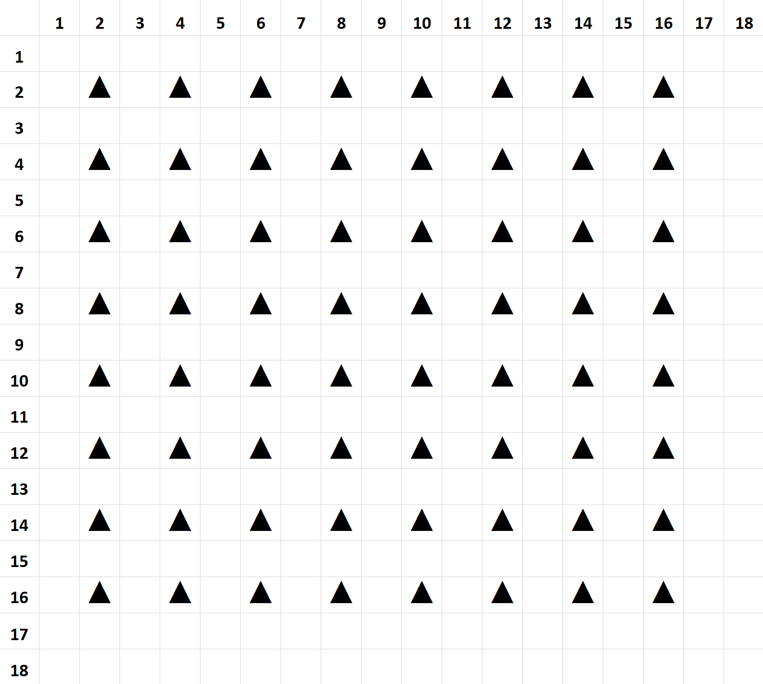
  - Figure 1: Starting Configuration to Maximize UA
Beyond this starting configuration, we observe that there are two differing sorting strategies for positioning pixels of class ‘A’ relative to class ‘B’ with the objective of maximizing UA. These sorting schemes produce slightly varying estimates of maximum UA for different values of the pixel-count of class ‘A’ and have been illustrated in Figures 2 and 3 shown below.
Each of the figures shown below are accompanied by a legend which indicates the different levels of grid-positions (indicated by symbols like ▲, ●, etc.) that should be sequentially occupied with the objective of maximizing the UA. For each legend-unit, we have also indicated the increment to overall UA that would be contributed by every additional pixel (Adjacency/Pixel), the number of pixels available at each level (Number of Pixels), the total UA increment possible if all available positions were to be occupied (Total Adjacency), and finally a column to indicate the cumulative sum of pixels up to that level (Total Number of Pixels).
To illustrate the utility of this sorting schema, consider the following two examples as they would apply to the sorting scheme represented in Figure 2 below.
Example 1: If we wanted to distribute 70 pixels of class ‘A’ in the landscape, then we would occupy the 64 positions indicated by ▲ and thereafter, the 6 remaining pixels should be slotted in any 6 out of the 16 positions indicated by ●.
Example 2: If we wanted to distribute 160 pixels of class ‘A’ in the landscape, then we would occupy the 64 positions indicated by ▲, followed by the 16 positions indicated by ●, followed by the 64 positions indicated by ■, followed by the 9 positions indicated by ֎, and finally, the 7 remaining pixels should be slotted in any 7 out of the 9 positions indicated by ♣.
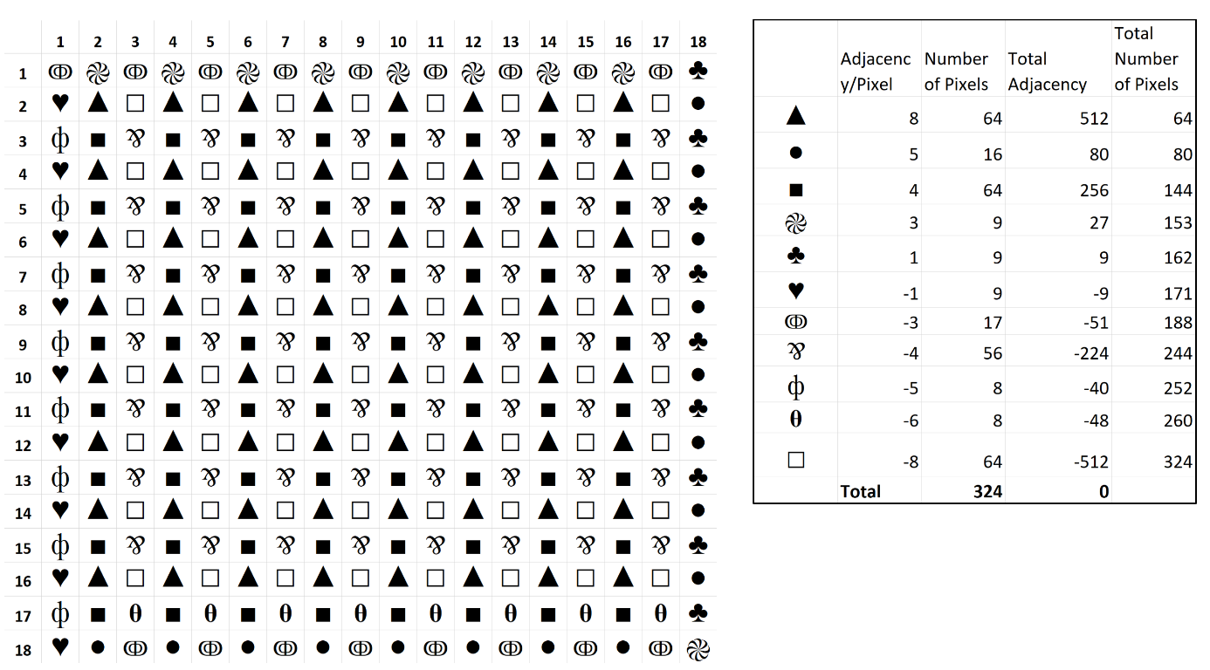
  - Figure 2: Schematic Representation for the Sorting Algorithm 1 for Maximizing UA

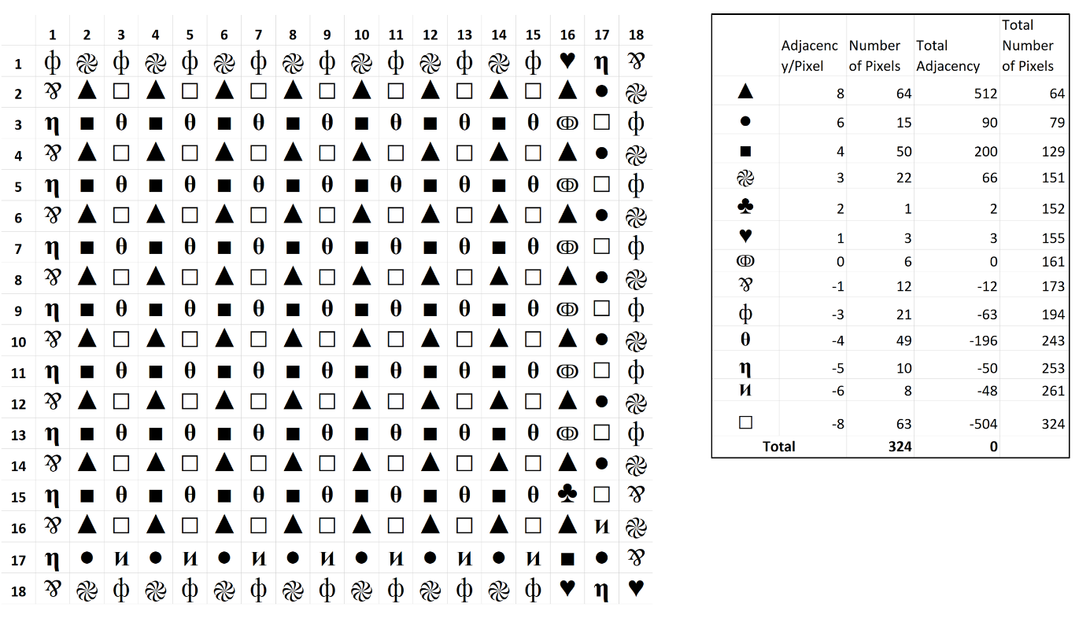
  - Figure 3: Schematic Representation for the Sorting Algorithm 2 for Maximizing UA
These two sorting schemas produce comparable but slightly differing estimates of UA. In Figure 4, we plotted the difference between these two estimates against all values of the pixel-count of class ‘A’. These differences arise due to boundary or edge effects and depend on whether the optimization of maximum UA is desired in the short run (when the amount of LC ‘A’ is small) or in the long-run (when the amount of LC ‘A’ is large). Here, we can see that sorting algorithm 2 produces larger estimates of UA when the pixel-count of class ‘A’ lies between 65 and 144 pixels, while sorting algorithm 1 produces larger estimates of UA when the pixel-count of class ‘A’ lies between 145 and 261 pixels. At all other points on the interval the two sorting schemes produce equivalent estimates of UA. We use the maximum of the two values at each pixel-count of class ‘A’ to estimate our theoretical maximum UA.
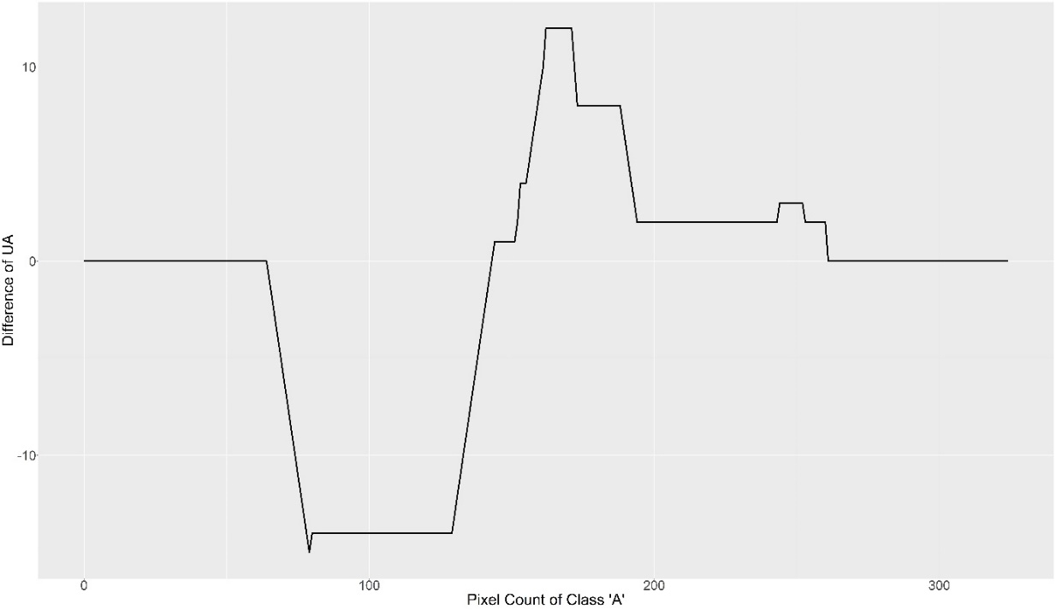
  - Figure 4: Difference between maximum estimates of UA for sorting algorithm 1 and 2
Calculating Minimum Unlike-Adjacency:
Here, we would like to start by introducing the spatial configuration shown in Figure 5 below. Here LC ‘A’ occupies positions demarcated by symbols (■, ●, ▲), while LC ‘B’ occupies ‘blank’ cells. We start with this configuration because we believe it is intuitively understood that such a spatial distribution minimizes the number of shared edges between the two LCs, and hence the overall UA. Here, we see that the edge pixels of LC ‘A’ represented by ■ and ● are lying adjacent to 2 and 3 pixels each of LC ‘B’ respectively. Further pixels of LC ‘A’ represented by ▲ share no edges with LC ‘B’. Therefore, the overall UA for such a configuration would be (2 x 2) + ((18-2) x 3) = 52. If an additional pixel of class ‘A’ were to be added to the configuration of Figure 5, and be placed at position Row=1, Column=6, the overall UA would increase to a value of 53. Thereafter, all additional pixels if sequentially placed in Column=6 and at Row positions 2-17 will maintain the overall UA at a constant value of 53. The final pixel of Column=6 when added at Row=18 would return us back to the configuration shown in Figure 5 above, albeit with one added column, and to an overall UA of 52.
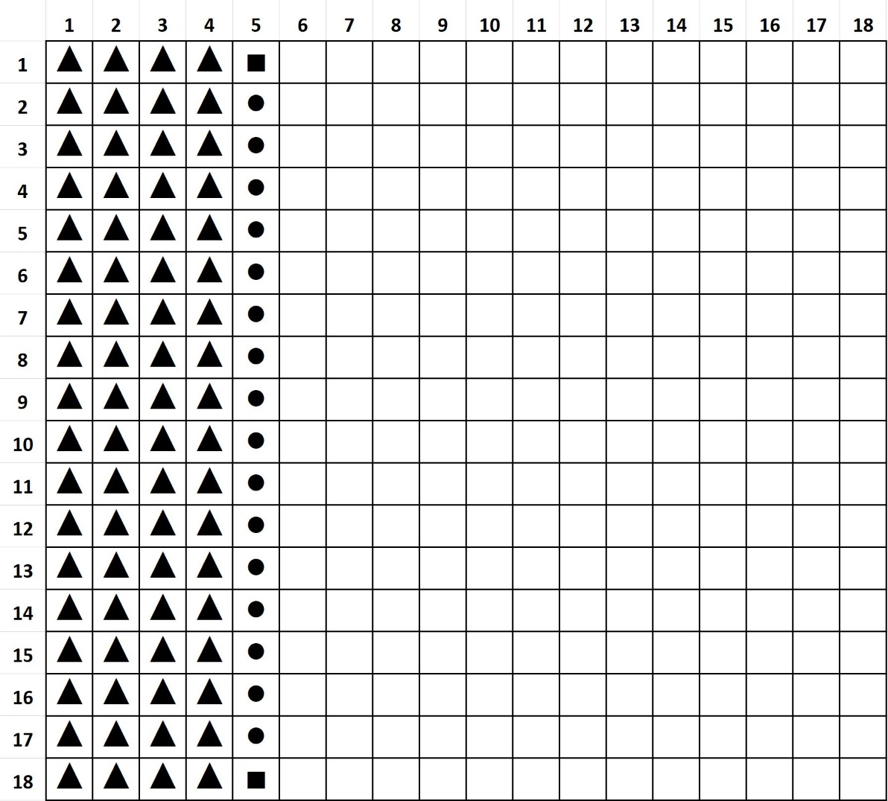
  - Figure 5: Configurational Representation of Theoretical Segmentation between two LCs that minimizes UA
Now, in order to even have the starting configuration as shown in Figure 5, we require a minimum of 18 pixels of LC ‘A’ to occupy an entire row or column in our 18 x 18 grid. Therefore, we now consider the optimum spatial configurations of the two LCs starting from extremely small values of LC ‘A’.
The spatial configuration in order to minimize the UA when we have 1 pixel of LC ‘A’ is shown in Figure 6 below. In this configuration the UA between the two classes would be equal to the minimum possible value of 3.
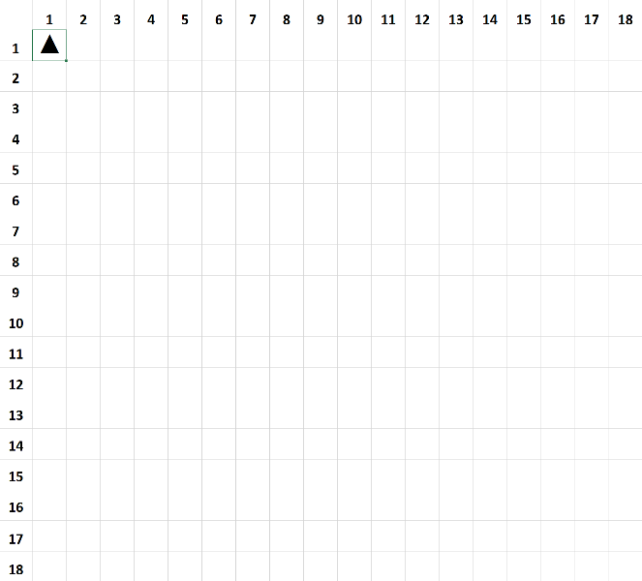
  - Figure 6: Starting Configuration to Minimize UA
Thereafter, as the number of pixels of class ‘A’ keeps increasing in the landscape, the configuration of class ‘A’ starts tracing a ‘step-wise’ pattern in the landscape, which accomplishes the objective of minimizing the overall UA. This ‘step-wise’ pattern is shown in Figure 7 below for when the count of class ‘A’ increases from 1 to 36 pixels.
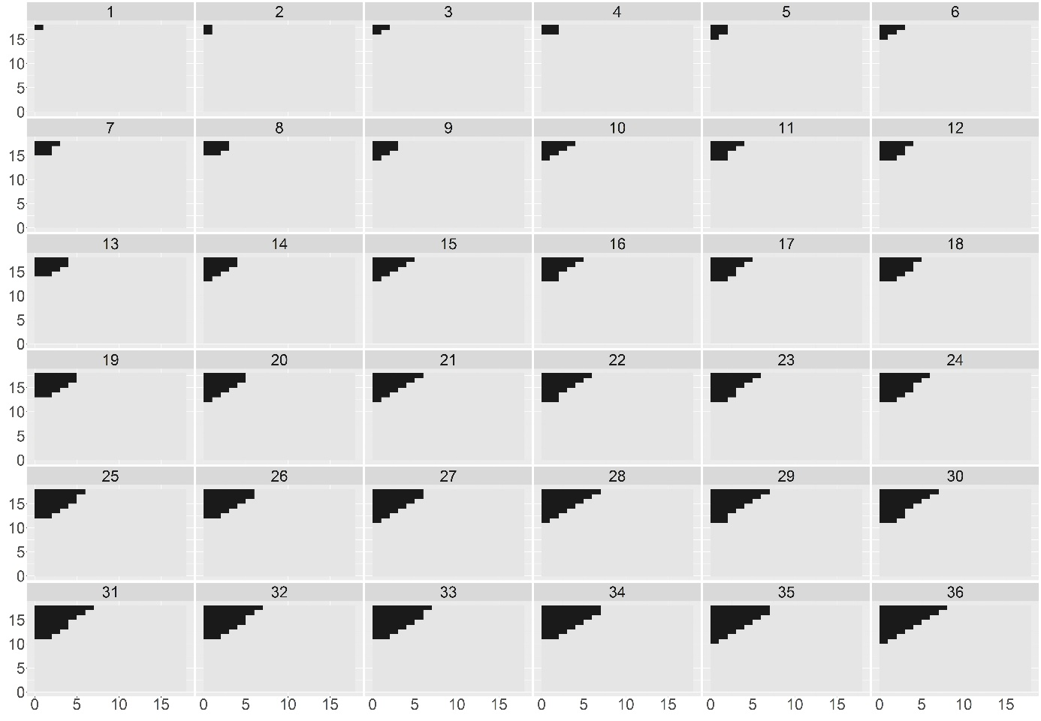
  - Figure 7: Configuration of Class ‘A’ to Minimize UA for Pixel-Count between 1 and 36 pixels
Now, in order to find the distribution pattern that would minimize the overall UA for all pixel-counts of LC ‘A’, we need to locate the threshold of pixel-count at which the UA generated from this ‘step-wise’ pattern exceeds the theoretical limit of UA = 52 that was explained in the context of Figure 5. To this end, we observe that a perfect ‘step-wise’ pattern can be represented as a sum of n consecutive natural numbers as shown in Figure 8 below.
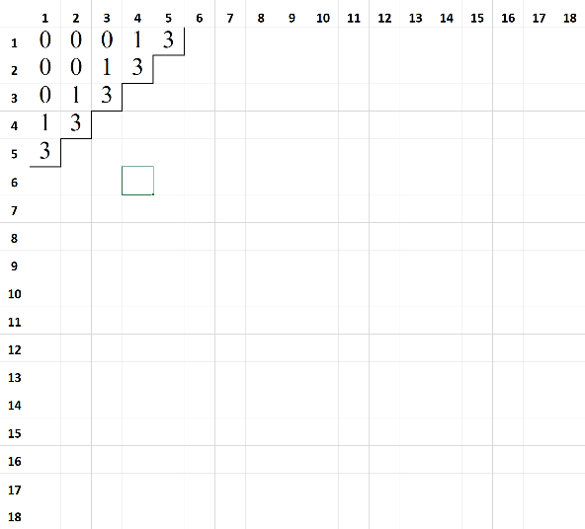 | 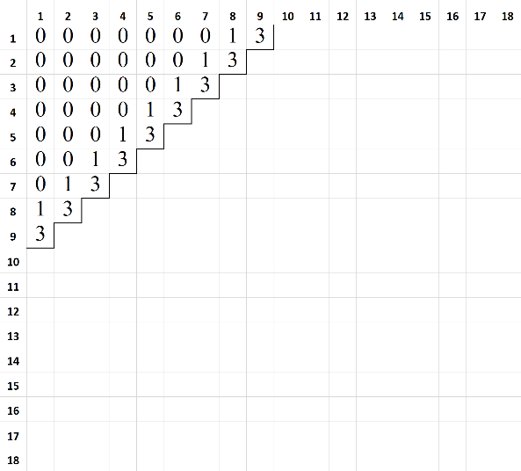
  - Figure 8: Representation of the UA for a 5-step and a 9-step pattern
In Figure 8, we see a perfect ‘step-wise’ pattern of 5 and 9 steps that accounts for the distribution of 15 and 45 pixels respectively. The UA of each pixel is annotated at the pixel positions shown in the figure, and provides illustrative proof that the overall UA of a perfect ‘step-wise’ pattern of n steps is equal to (3 x n) + (n - 1). Now, perfect ‘step-wise’ patterns are applicable when pixel counts form a sum of n consecutive natural numbers, i.e., when pixel-count is an element of the set of P = [1,3,6,10,15,21,28,36,45,55…]. For when the pixel-count is an intermediary value - lying in-between the numbers of set P - the overall UA can be estimated by using the following procedure:
- Identify the pixel-count in set P that is closest to, but smaller than, the pixel-count for which the overall UA needs to be estimated.
- Calculate the corresponding number of steps (NSteps), and the UA for the pixel-count (Base UA) identified in Step 1.
- Calculate the difference between the pixel-count under consideration, and the pixel-count identified from set P.
- If the difference in Step 3 is less than or equal to (NSteps -1) then overall UA is equal to Base UA + 2, else overall UA is equal to Base UA + 3.
Using this procedure to calculate the overall UA for ‘step-wise’ distributions of pixels of LC ‘A’, we can identify the threshold value at which the overall UA would surpass the theoretical limit of UA=52. In the case of 18 x 18 grids, this threshold value of pixel-count = 91 pixels. This means that when pixel-count of LC ‘A’ lies between 1-91 pixels, LC ‘A’ should be distributed in a manner closely approximating a ‘step-wise’ pattern as illustrated in Figure 7. Furthermore, it is important to bear in mind that given limitations of a binary landscape the hypothetical distribution of pixels in the landscape (with the objective of minimizing the overall UA) would be symmetrical in nature. This implies that when pixel-count of LC ‘A’ lies between 91 and 233 (324 - 91) pixels, the pixels of LC ‘A’ should be distributed in a manner similar to what is described in association with Figure 5, with the overall UA fluctuating between values of 52 and 53. At all other values of pixel-counts, i.e., when pixel-count of LC ‘A’ lies between 1-91 or between 234-323 the spatial distribution of LC ‘A’ should follow a ‘step-wise’ pattern.

Appendix III
Table 1: Test Statistics for the Dunn-Sidak Test (with Holm adjustment for p-value correction)
Group | Comparison | Z | Un-adjusted p-value | Adjusted p-value
Amount of Forest Gain | Bare - Cropland | -3.965 | 0.000 | 0.000
Amount of Forest Gain | Bare - Grassland | 13.097 | 0.000 | 0.000
Amount of Forest Gain | Cropland - Grassland | 20.525 | 0.000 | 0.000
Amount of Forest Gain | Bare - Shrubland | -5.899 | 0.000 | 0.000
Amount of Forest Gain | Cropland - Shrubland | -2.840 | 0.005 | 0.018
Amount of Forest Gain | Grassland - Shrubland | -22.149 | 0.000 | 0.000
Amount of Forest Gain | Bare - Water | -0.726 | 0.468 | 0.468
Amount of Forest Gain | Cropland - Water | 0.743 | 0.458 | 0.916
Amount of Forest Gain | Grassland - Water | -6.464 | 0.000 | 0.000
Amount of Forest Gain | Shrubland - Water | 1.516 | 0.130 | 0.389
Amount of Forest Gain | Bare - Wetland | -18.940 | 0.000 | 0.000
Amount of Forest Gain | Cropland - Wetland | -19.760 | 0.000 | 0.000
Amount of Forest Gain | Grassland - Wetland | -33.496 | 0.000 | 0.000
Amount of Forest Gain | Shrubland - Wetland | -17.049 | 0.000 | 0.000
Amount of Forest Gain | Water - Wetland | -7.362 | 0.000 | 0.000
Rate of Forest Gain | Bare - Cropland | 8.762 | 0.000 | 0.000
Rate of Forest Gain | Bare - Grassland | -27.964 | 0.000 | 0.000
Rate of Forest Gain | Cropland - Grassland | -44.132 | 0.000 | 0.000
Rate of Forest Gain | Bare - Shrubland | -15.049 | 0.000 | 0.000
Rate of Forest Gain | Cropland - Shrubland | -33.220 | 0.000 | 0.000
Rate of Forest Gain | Grassland - Shrubland | 18.454 | 0.000 | 0.000
Rate of Forest Gain | Bare - Water | 2.678 | 0.007 | 0.022
Rate of Forest Gain | Cropland - Water | -0.528 | 0.598 | 0.598
Rate of Forest Gain | Grassland - Water | 14.936 | 0.000 | 0.000
Rate of Forest Gain | Shrubland - Water | 8.545 | 0.000 | 0.000
Rate of Forest Gain | Bare - Wetland | 4.657 | 0.000 | 0.000
Rate of Forest Gain | Cropland - Wetland | -3.671 | 0.000 | 0.001
Rate of Forest Gain | Grassland - Wetland | 34.557 | 0.000 | 0.000
Rate of Forest Gain | Shrubland - Wetland | 22.188 | 0.000 | 0.000
Rate of Forest Gain | Water - Wetland | -0.718 | 0.473 | 0.946
Amount of Forest Loss | Bare - Cropland | 18.347 | 0.000 | 0.000
Amount of Forest Loss | Bare - Grassland | -6.788 | 0.000 | 0.000
Amount of Forest Loss | Cropland - Grassland | -39.623 | 0.000 | 0.000
Amount of Forest Loss | Bare - Settlement | -3.053 | 0.002 | 0.007
Amount of Forest Loss | Cropland - Settlement | -14.267 | 0.000 | 0.000
Amount of Forest Loss | Grassland - Settlement | 0.937 | 0.349 | 0.349
Amount of Forest Loss | Bare - Shrubland | 1.312 | 0.189 | 0.379
Amount of Forest Loss | Cropland - Shrubland | -34.222 | 0.000 | 0.000
Amount of Forest Loss | Grassland - Shrubland | 12.937 | 0.000 | 0.000
Amount of Forest Loss | Settlement - Shrubland | 4.208 | 0.000 | 0.000
Amount of Forest Loss | Bare - Water | -16.535 | 0.000 | 0.000
Amount of Forest Loss | Cropland - Water | -44.753 | 0.000 | 0.000
Amount of Forest Loss | Grassland - Water | -13.254 | 0.000 | 0.000
Amount of Forest Loss | Settlement - Water | -7.965 | 0.000 | 0.000
Amount of Forest Loss | Shrubland - Water | -24.550 | 0.000 | 0.000
Amount of Forest Loss | Bare - Wetland | -23.711 | 0.000 | 0.000
Amount of Forest Loss | Cropland - Wetland | -65.647 | 0.000 | 0.000
Amount of Forest Loss | Grassland - Wetland | -23.080 | 0.000 | 0.000
Amount of Forest Loss | Settlement - Wetland | -11.744 | 0.000 | 0.000
Amount of Forest Loss | Shrubland - Wetland | -39.168 | 0.000 | 0.000
Amount of Forest Loss | Water - Wetland | -6.003 | 0.000 | 0.000
Rate of Forest Loss | Bare - Cropland | 12.870 | 0.000 | 0.000
Rate of Forest Loss | Bare - Grassland | 3.471 | 0.001 | 0.001
Rate of Forest Loss | Cropland - Grassland | -13.857 | 0.000 | 0.000
Rate of Forest Loss | Bare - Settlement | 74.972 | 0.000 | 0.000
Rate of Forest Loss | Cropland - Settlement | 77.101 | 0.000 | 0.000
Rate of Forest Loss | Grassland - Settlement | 79.457 | 0.000 | 0.000
Rate of Forest Loss | Bare - Shrubland | 7.327 | 0.000 | 0.000
Rate of Forest Loss | Cropland - Shrubland | -10.855 | 0.000 | 0.000
Rate of Forest Loss | Grassland - Shrubland | 5.334 | 0.000 | 0.000
Rate of Forest Loss | Settlement - Shrubland | -79.717 | 0.000 | 0.000
Rate of Forest Loss | Bare - Water | 26.014 | 0.000 | 0.000
Rate of Forest Loss | Cropland - Water | 22.443 | 0.000 | 0.000
Rate of Forest Loss | Grassland - Water | 28.909 | 0.000 | 0.000
Rate of Forest Loss | Settlement - Water | -60.083 | 0.000 | 0.000
Rate of Forest Loss | Shrubland - Water | 27.900 | 0.000 | 0.000
Rate of Forest Loss | Bare - Wetland | -0.012 | 0.990 | 0.990
Rate of Forest Loss | Cropland - Wetland | -18.794 | 0.000 | 0.000
Rate of Forest Loss | Grassland - Wetland | -4.633 | 0.000 | 0.000
Rate of Forest Loss | Settlement - Wetland | -81.061 | 0.000 | 0.000
Rate of Forest Loss | Shrubland - Wetland | -10.477 | 0.000 | 0.000
Rate of Forest Loss | Water - Wetland | -32.077 | 0.000 | 0.000
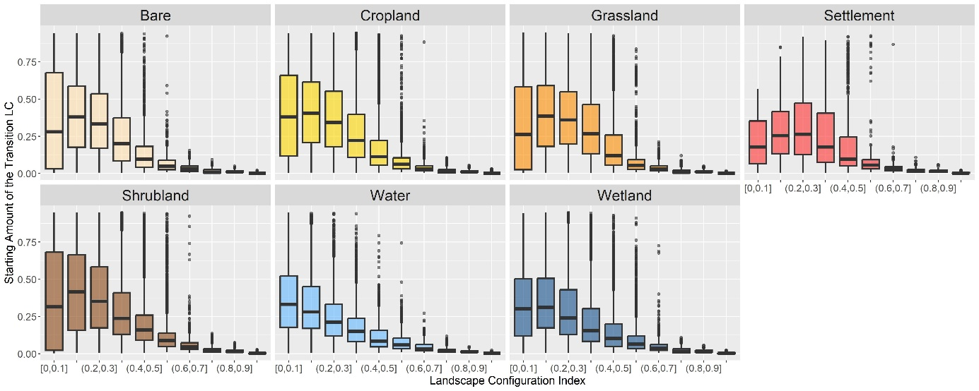
  - Figure 1: Boxplots depicting the distribution of the starting LC amount for different levels of starting LCI for grids with persistent forest loss. The LCI values, depicted on the x-axis, have been binned using the following thresholds: [0, 0.1, 0.2, 0.3, 0.4, 0.5, 0.6, 0.7, 0.8, 0.9, 1.0].
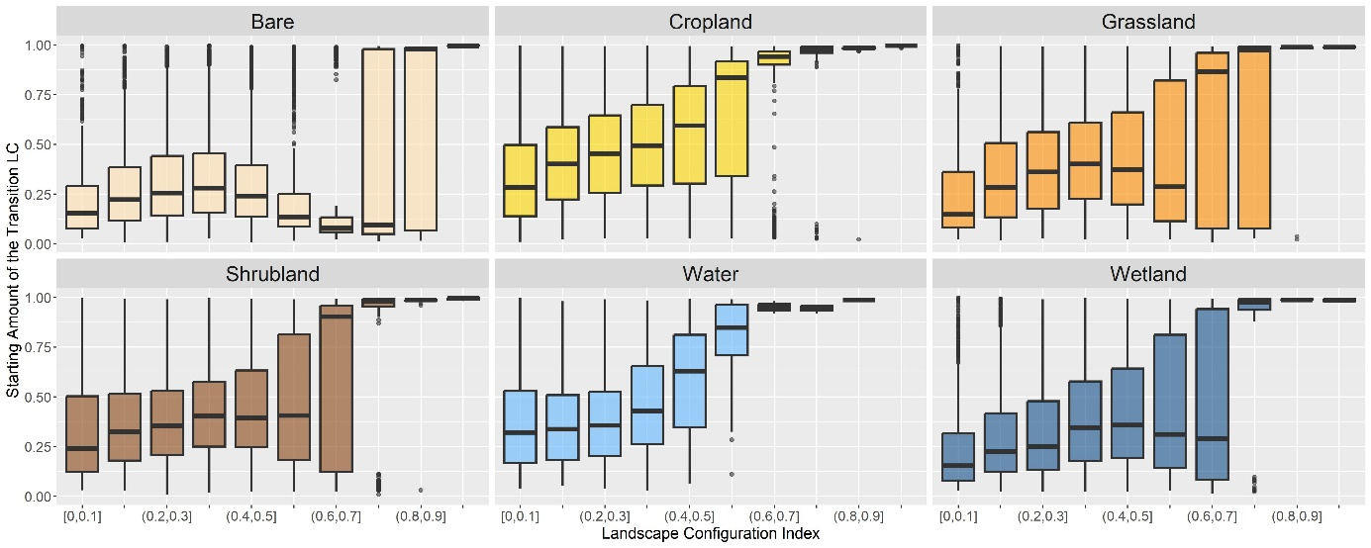
  - Figure 2: Boxplots depicting the distribution of the starting LC amount for different levels of starting LCI for grids with persistent forest gain. The LCI values, depicted on the x-axis, have been binned using the following thresholds: [0, 0.1, 0.2, 0.3, 0.4, 0.5, 0.6, 0.7, 0.8, 0.9, 1.0].
GAM Statistics for the Effect of Starting Amount on the Mean Amount of Forest Loss
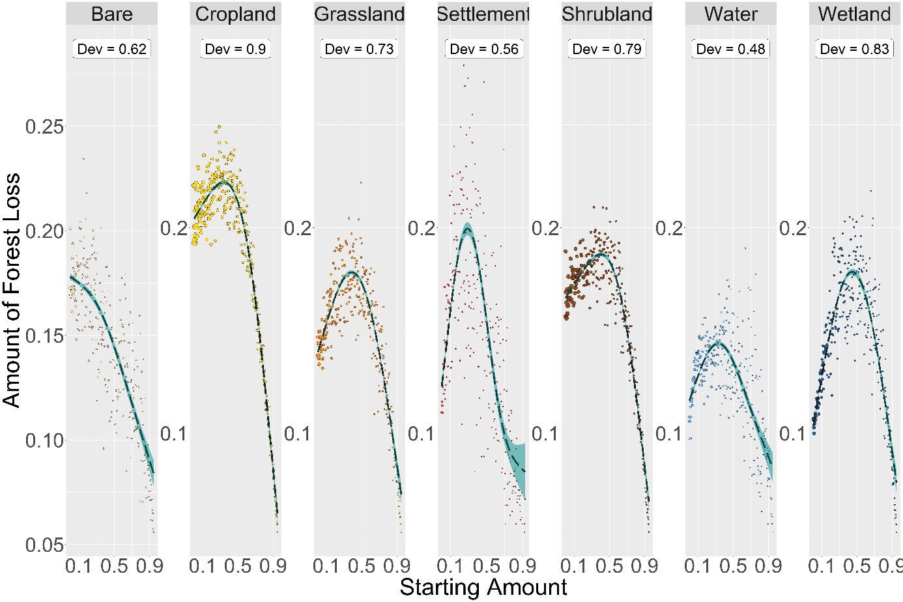
Figure 3: GAMs for the mean effect of the starting amount (expressed as a percentage of the grid size) on the mean amount of forest loss. Dev = the proportion of deviance explained.

Table 2: GAM Statistics for Effects of Starting Amount on Mean Amount of Forest Loss
Land-Cover | Number of Grids | EDF | Deviance | Fitted Values: Minimum | Fitted Values: Maximum | Mean of the Real Rate of Change | Mean of Absolute Rate of Change
Bare | 10770 | 2.639 | 0.617 | 0.944 | 0.003 | -0.1 | 0.1
Cropland | 93752 | 2.99 | 0.896 | 0.948 | 0.34 | -0.152 | 0.189
Grassland | 29969 | 2.979 | 0.734 | 0.948 | 0.386 | -0.073 | 0.155
Settlement | 3484 | 2.97 | 0.564 | 0.926 | 0.287 | -0.045 | 0.219
Shrubland | 67101 | 2.987 | 0.787 | 0.948 | 0.401 | -0.105 | 0.15
Water | 14771 | 2.926 | 0.478 | 0.948 | 0.33 | -0.034 | 0.093
Wetland | 26327 | 2.981 | 0.832 | 0.948 | 0.444 | -0.029 | 0.188
EDF = Effective Degrees of Freedom; Deviance = The proportion of the null deviance explained by the model
GAM Statistics for the Effect of Starting Amount on the Mean Rate of Forest Loss
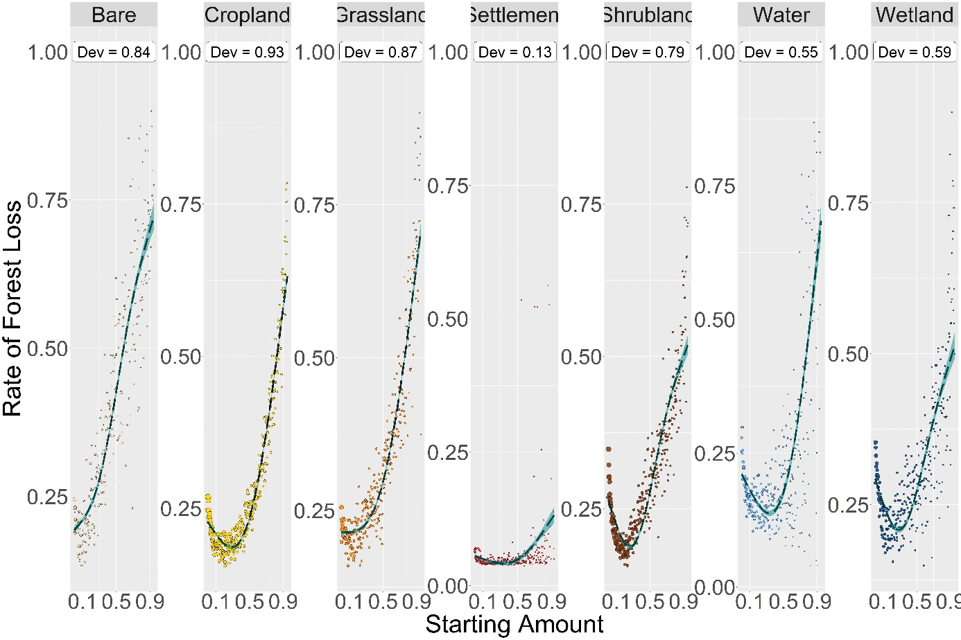
Figure 4: GAMs for the mean effect of the starting amount (expressed as a percentage of the grid size) on the mean rate of forest loss. Dev = the proportion of deviance explained.
Table 3: GAM Statistics for Effects of Starting Amount on Mean Rate of Forest Loss
Land-Cover | Number of Grids | EDF | Deviance | Fitted Values: Minimum | Fitted Values: Maximum | Mean of Average Rate of Change | Mean of Absolute Rate of Change
Bare | 10770 | 2.903 | 0.844 | 0.003 | 0.944 | 0.562 | 0.562
Cropland | 93752 | 2.99 | 0.931 | 0.284 | 0.948 | 0.427 | 0.515
Grassland | 29969 | 2.966 | 0.875 | 0.003 | 0.948 | 0.52 | 0.52
Settlement | 3484 | 2.674 | 0.132 | 0.333 | 0.926 | 0.075 | 0.107
Shrubland | 67101 | 2.979 | 0.79 | 0.262 | 0.948 | 0.269 | 0.431
Water | 14771 | 2.954 | 0.55 | 0.333 | 0.948 | 0.498 | 0.653
Wetland | 26327 | 2.954 | 0.593 | 0.284 | 0.948 | 0.233 | 0.412
EDF = Effective Degrees of Freedom; Deviance = The proportion of the null deviance explained by the model

GAM Statistics for the Effect of Starting Configuration on the Mean Amount of Forest Loss
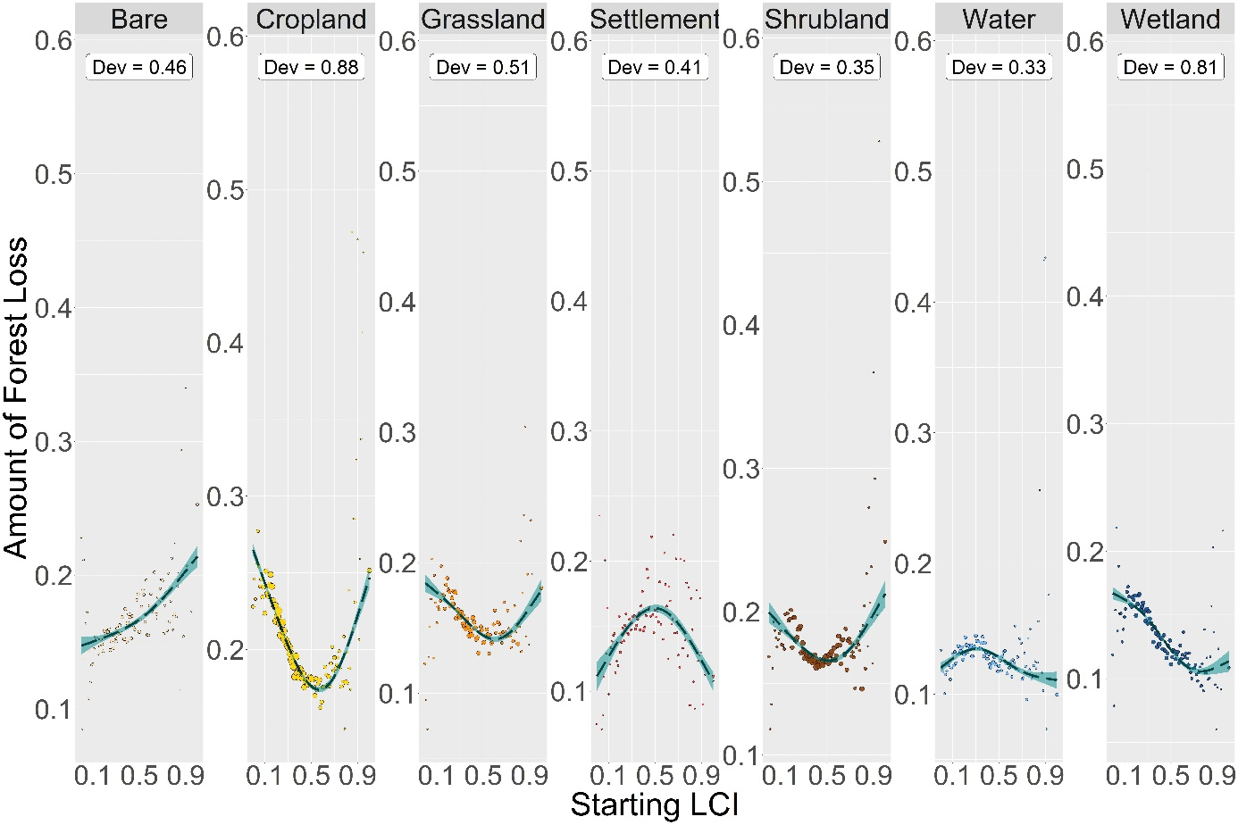
Figure 5: GAMs for the mean effect of the starting configuration on the mean amount of forest loss. Dev = the proportion of deviance explained.

Table 4: GAM Statistics for Effects of Starting Configuration on Mean Amount of Forest Loss
Land-Cover | Number of Grids | EDF | Deviance | Fitted Values: Minimum | Fitted Values: Maximum | Mean of Average Rate of Change* | Mean of Absolute Rate of Change*
Bare | 10770 | 2.177 | 0.464 | 0 | 1 | 0.044 | 0.044
Cropland | 93752 | 2.969 | 0.882 | 0.57 | 0 | -0.151 | 0.153
Grassland | 29969 | 2.844 | 0.506 | 0.6 | 0 | -0.072 | 0.072
Settlement | 3484 | 2.773 | 0.412 | 1 | 0.5 | 0.079 | 0.09
Shrubland | 67101 | 2.795 | 0.353 | 0.51 | 1 | -0.053 | 0.059
Water | 14771 | 2.811 | 0.33 | 1 | 0.31 | 0.003 | 0.044
Wetland | 26327 | 2.857 | 0.807 | 0.76 | 0 | -0.092 | 0.092
EDF = Effective Degrees of Freedom; Deviance = The proportion of the null deviance explained by the model
*The metrics for the mean of the real and absolute average rate of change have been calculated over the LCI interval between 0 and 0.6 only.

GAM Statistics for the Effect of Starting Configuration on the Mean Rate of Forest Loss
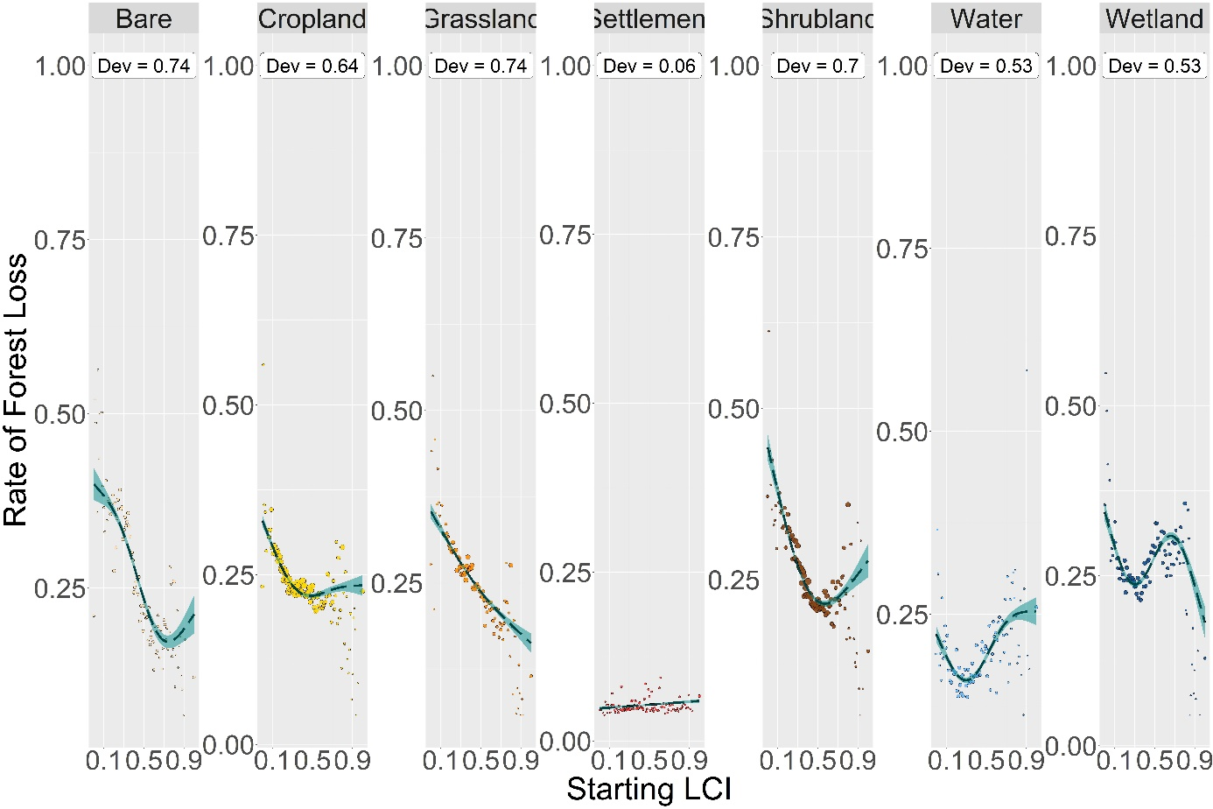
Figure 6: GAMs for the mean effect of the starting configuration on the mean rate of forest loss. Dev = the proportion of deviance explained.

Table 5: GAM Statistics for Effects of Starting Configuration on Mean Rate of Forest Loss
Land-Cover | Number of Grids | EDF | Deviance | Fitted Values: Minimum | Fitted Values: Maximum | Mean of Average Rate of Change* | Mean of Absolute Rate of Change*
Bare | 10770 | 2.861 | 0.737 | 0.74 | 0 | -0.341 | 0.341
Cropland | 93752 | 2.885 | 0.637 | 0.48 | 0 | -0.178 | 0.191
Grassland | 29969 | 2.118 | 0.741 | 1 | 0 | -0.224 | 0.224
Settlement | 3484 | 1 | 0.059 | 0 | 1 | 0.011 | 0.011
Shrubland | 67101 | 2.883 | 0.697 | 0.57 | 0 | -0.379 | 0.381
Water | 14771 | 2.922 | 0.535 | 0.3 | 1 | -0.007 | 0.204
Wetland | 26327 | 2.97 | 0.526 | 1 | 0 | -0.067 | 0.288
EDF = Effective Degrees of Freedom; Deviance = The proportion of the null deviance explained by the model
*The metrics for the mean of the real and absolute average rate of change have been calculated over the LCI interval between 0 and 0.6 only.

GAM Statistics for the Effect of Starting Amount on the Mean Amount of Forest Gain
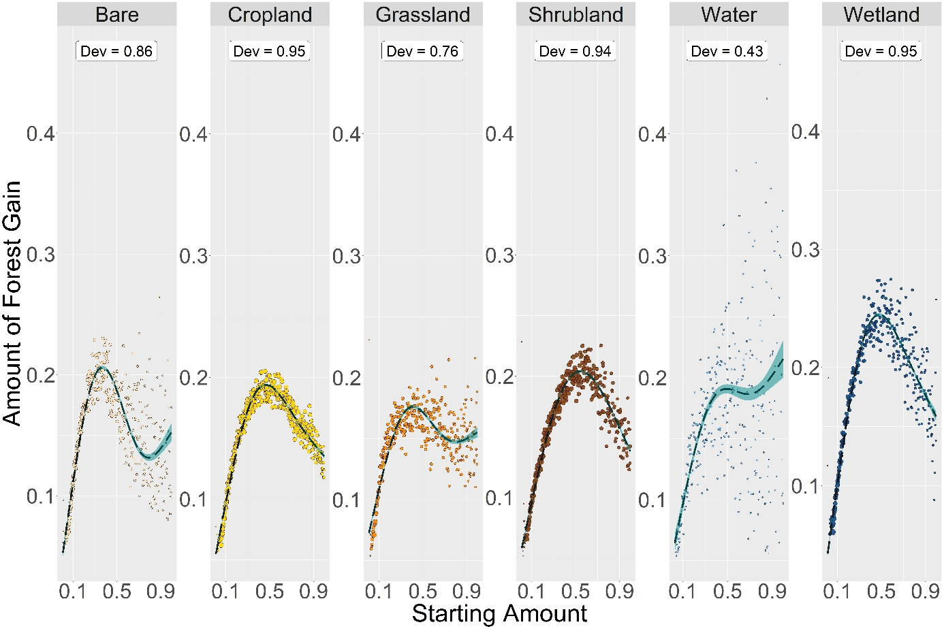
Figure 7: GAMs for the mean effect of the starting amount (expressed as a percentage of the grid size) on the mean amount of forest gain. Dev = the proportion of deviance explained.

Table 6: GAM Statistics for Effects of Starting Amount on Mean Amount of Forest Gain
Land-Cover | Number of Grids | EDF | Deviance | Fitted Values: Minimum | Fitted Values: Maximum | Mean of Average Rate of Change | Mean of Absolute Rate of Change
Bare | 27019 | 2.995 | 0.862 | 0.006 | 0.367 | 0.099 | 0.25
Cropland | 84722 | 2.998 | 0.948 | 0.009 | 0.466 | 0.077 | 0.197
Grassland | 30413 | 2.99 | 0.757 | 0.006 | 0.41 | 0.08 | 0.139
Shrubland | 71533 | 2.995 | 0.942 | 0.009 | 0.54 | 0.078 | 0.212
Water | 3014 | 2.897 | 0.429 | 0.028 | 0.997 | 0.153 | 0.163
Wetland | 34621 | 2.995 | 0.948 | 0.012 | 0.478 | 0.116 | 0.291
EDF = Effective Degrees of Freedom; Deviance = The proportion of the null deviance explained by the model

GAM Statistics for the Effect of Starting Amount on the Mean Rate of Forest Gain
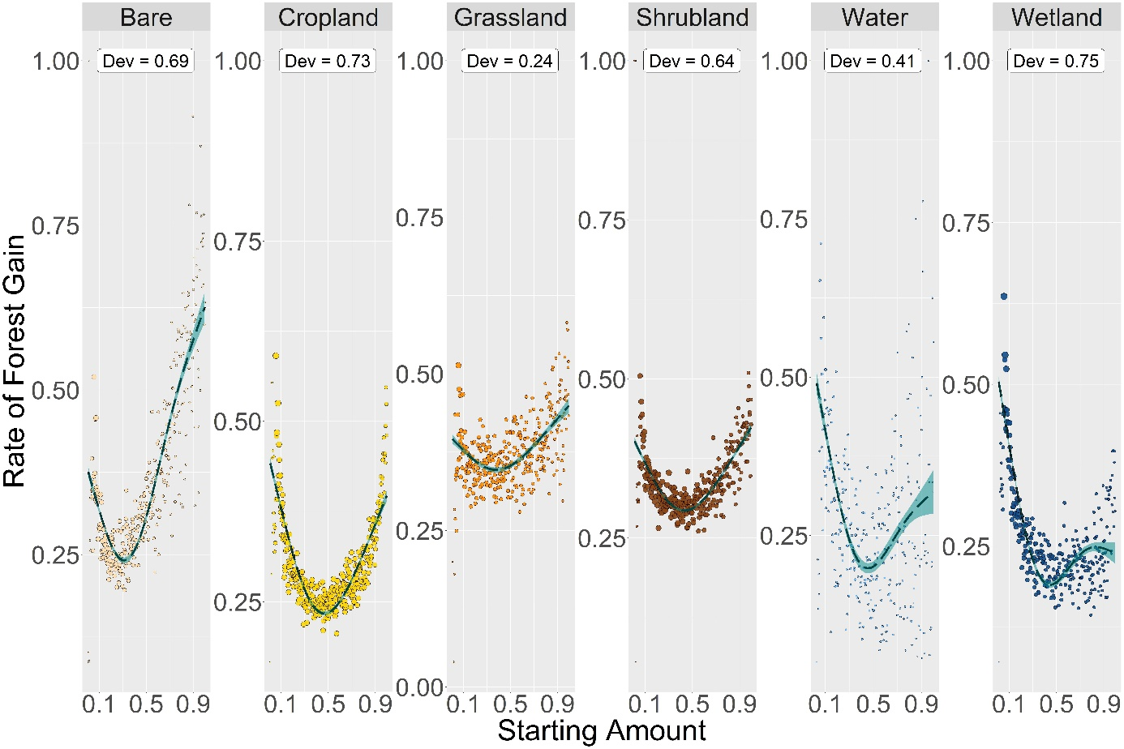
Figure 8: GAMs for the mean effect of the starting amount (expressed as a percentage of the grid size) on the mean rate of forest gain. Dev = the proportion of deviance explained.
Table 7: GAM Statistics for Effects of Starting Amount on Mean Rate of Forest Gain
Land-Cover | Number of Grids | EDF | Deviance | Fitted Values: Minimum | Fitted Values: Maximum | Mean of Average Rate of Change | Mean of Absolute Rate of Change
Bare | 27019 | 2.974 | 0.695 | 0.312 | 0.997 | 0.255 | 0.523
Cropland | 84722 | 2.983 | 0.729 | 0.469 | 0.009 | -0.039 | 0.373
Grassland | 30413 | 2.83 | 0.239 | 0.38 | 0.997 | 0.056 | 0.153
Shrubland | 71533 | 2.972 | 0.64 | 0.432 | 0.997 | 0.024 | 0.241
Water | 3014 | 2.917 | 0.405 | 0.457 | 0.028 | -0.179 | 0.427
Wetland | 34621 | 2.979 | 0.751 | 0.444 | 0.012 | -0.265 | 0.384
EDF = Effective Degrees of Freedom; Deviance = The proportion of the null deviance explained by the model

GAM Statistics for the Effect of Starting Configuration on the Mean Amount of Forest Gain
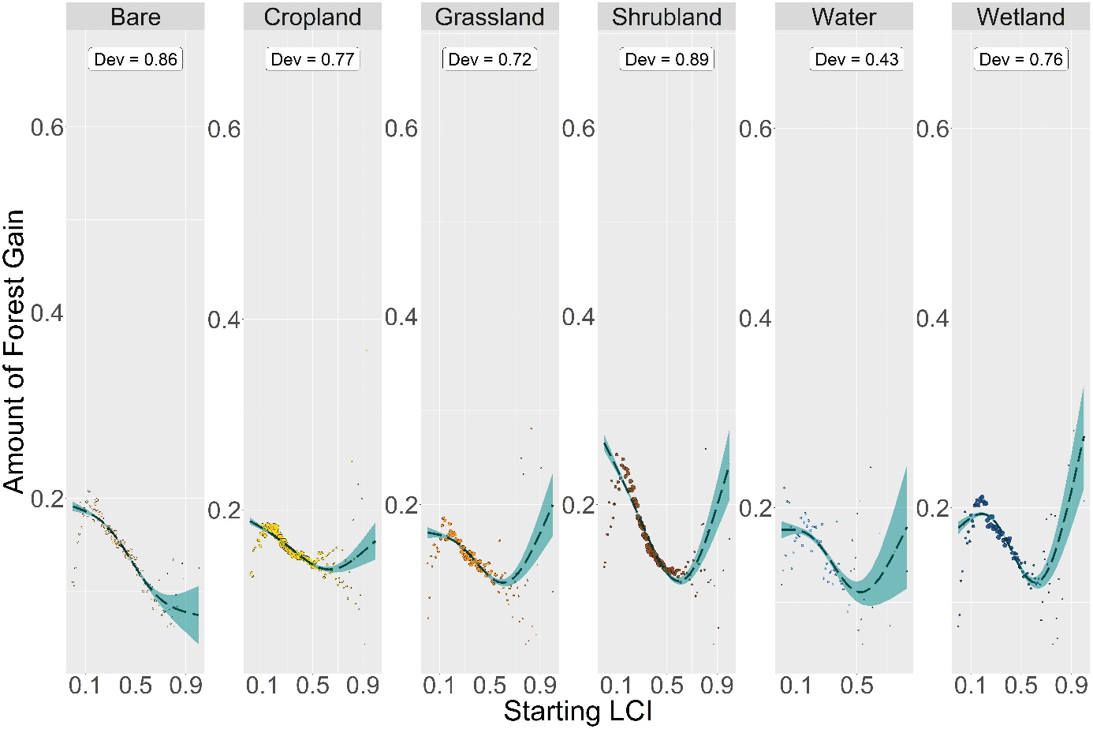
Figure 9: GAMs for the mean effect of the starting configuration on the mean amount of forest gain. Dev = the proportion of deviance explained.

Table 8: GAM Statistics for Effects of Starting Configuration on Mean Amount of Forest Gain
Land-Cover | Number of Grids | EDF | Deviance | Fitted Values: Minimum | Fitted Values: Maximum | Mean of Average Rate of Change* | Mean of Absolute Rate of Change*
Bare | 27019 | 2.713 | 0.864 | 1 | 0 | -0.142 | 0.142
Cropland | 84722 | 2.79 | 0.771 | 0.63 | 0 | -0.084 | 0.084
Grassland | 30413 | 2.878 | 0.72 | 0.6 | 1 | -0.089 | 0.089
Shrubland | 71533 | 2.915 | 0.886 | 0.6 | 0 | -0.244 | 0.244
Water | 3014 | 2.687 | 0.435 | 0.53 | 0.83 | -0.11 | 0.121
Wetland | 34621 | 2.929 | 0.761 | 0.61 | 1 | -0.096 | 0.144
EDF = Effective Degrees of Freedom; Deviance = The proportion of the null deviance explained by the model
*The metrics for the mean of the real and absolute average rate of change have been calculated over the LCI interval between 0 and 0.6 only.

GAM Statistics for the Effect of Starting Configuration on the Mean Rate of Forest Gain
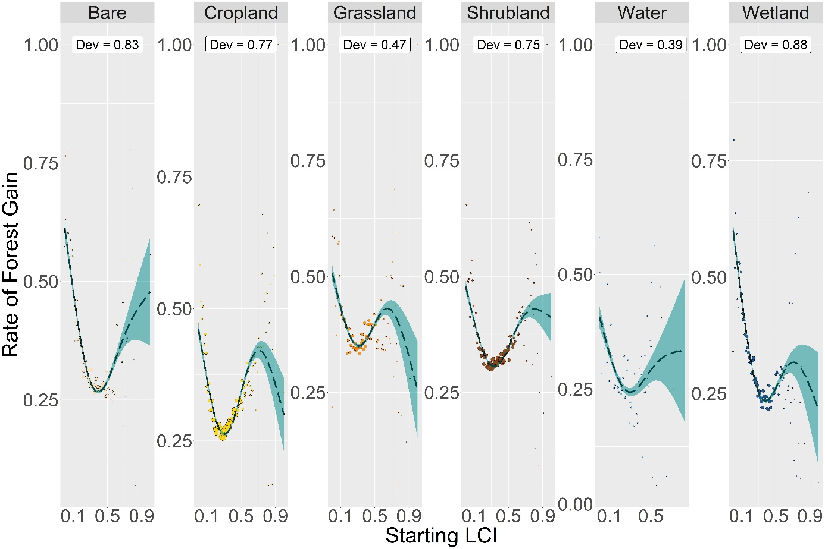
Figure 10: GAMs for the mean effect of the starting configuration on the mean rate of forest gain. Dev = the proportion of deviance explained.
Table 9: GAM Statistics for Effects of Starting Configuration on Mean Rate of Forest Gain
Land-Cover | Number of Grids | EDF | Deviance | Fitted Values: Minimum | Fitted Values: Maximum | Mean of Average Rate of Change* | Mean of Absolute Rate of Change*
Bare | 27019 | 2.912 | 0.832 | 0.39 | 0 | -0.458 | 0.696
Cropland | 84722 | 2.97 | 0.771 | 0.3 | 0 | -0.107 | 0.554
Grassland | 30413 | 2.903 | 0.473 | 1 | 0 | -0.135 | 0.392
Shrubland | 71533 | 2.956 | 0.75 | 0.33 | 0 | -0.147 | 0.425
Water | 3014 | 2.547 | 0.391 | 0.3 | 0 | -0.171 | 0.403
Wetland | 34621 | 2.931 | 0.881 | 1 | 0 | -0.503 | 0.721
EDF = Effective Degrees of Freedom; Deviance = The proportion of the null deviance explained by the model
*The metrics for the mean of the real and absolute average rate of change have been calculated over the LCI interval between 0 and 0.6 only.

