Street Children Exposure to Ambient Fine Particulate Matter (PM_{2.5}) and Environmental Noise: An Exposure Assessment and Health Risk Analysis Study
Mahdi Nassri Nassrabadiª, Sasan Faridi^{b, c}, Kazem Naddafi^{a, b}, Masud Yunesianª, Mohammad Sadegh Hassanvand^{a, b, *}
ª Department of Environmental Health Engineering, School of Public Health, Tehran University of Medical Sciences, Tehran, Iran
b Center for Air Pollution Research (CAPR), Institute for Environmental Research (IER), Tehran University of Medical Sciences, Tehran, Iran
^{c} Department of Research Methodology and Data Analysis, Institute for Environmental Research, Tehran University of Medical Sciences, Tehran, Iran
*Corresponding author. Department of Environmental Health Engineering, School of Public Health, Tehran University of Medical Sciences, Center for Air Pollution Research (CAPR), Institute for Environmental Research (IER), Tehran University of Medical Sciences.
E-mail addresses: hassanvand@tums.ac.ir (M.S. Hassanvand)

- Calibration Method for Low-Cost Sensors by high volume device

  - Air Volume Measurement
  - The air volume was determined by multiplying the flow rate of the low-cost sensors (11 L/min) by the sampling duration (in minutes).
  - Formula:
$$Air Volume = Flow Rate × Sampling Duration$$
1.2 Filter Weight Measurements
- Filters were weighed before and after exposure.
- After exposure, filters were dried for 24 hours to remove moisture, and their weight was measured again.
- The net particle weight was calculated as:
$$Net Particle Weight = Weight After Sampling - Initial Filter Weight$$
1.3 Particle Concentration
- The particle concentration in the sampled air was calculated by dividing the net particle weight by the air volume.
- Formula:
$$Particle Concentration =\frac{ Net Particle Weight }{Air Volume}$$
  - Results were converted to µg/m³ if necessary.
Calibration of Low-Cost Sensors
- The particle concentrations measured by the low-cost sensors were compared against those measured by high-volume air samplers, which served as the reference devices.
- Calibration factors were applied to correct any deviation in the low-cost sensor readings.
Table S1
Comparison of Particulate Matter Concentrations Measured by High Volume Air Sampler and Low-Cost Sensors with Calibration Factors.
*LC: Low-cost sensor
*CF= Calibration factor

Sample ID | Air Volume (m³) | Net Particle Weight (mg) | Concentration (LC) (µg/m³) | High volume (µg/m³) | CF**
LC1* | 0.66 | 13.27 | 20.1 | 21.7 | 0.93
LC2 | 0.66 | 13.4 | 20.3 | 21.7 | 0.94
LC3 | 0.66 | 13.72 | 20.8 | 21.7 | 0.96
LC4 | 0.66 | 21.98 | 33.3 | 34.6 | 0.96
LC5 | 0.66 | 22.04 | 33.4 | 34.6 | 0.97
LC6 | 0.66 | 22.09 | 33.5 | 34.6 | 0.97

Table S1
Correlation between intersections and measurement stations.

Table S2
The risk assessment calculations of noise and PM_{2.5}.
Intersections | PM_{2.5} |  |  |  |  |  |  |  | Noise
Intersections | HQ |  |  |  |  |  |  |  | %HA | %PI (reading) | %PI (recall)
Intersections | Male or Female |  | Male |  |  | Female |  |  | %HA | %PI (reading) | %PI (recall)
Intersections | 3-5 | 6-8 | 9-11 | 12-14 | 15-18 | 9-11 | 12-14 | 15-18 | %HA | %PI (reading) | %PI (recall)
In_01 | 2.36 | 1.97 | 1.99 | 1.54 | 1.32 | 1.85 | 1.25 | 1.10 | 22.31 | 43.9 | 18
In_02 | 2.96 | 2.47 | 2.50 | 1.93 | 1.66 | 2.32 | 1.57 | 1.38 | 24.24 | 44.35 | 19.1
In_03 | 3.55 | 2.96 | 2.99 | 2.31 | 1.98 | 2.78 | 1.89 | 1.65 | 26.51 | 44.65 | 19.4
In_04 | 3.26 | 2.72 | 2.75 | 2.12 | 1.82 | 2.55 | 1.73 | 1.52 | 27.89 | 44.85 | 19.6
In_05 | 3.73 | 3.11 | 3.15 | 2.43 | 2.09 | 2.92 | 1.98 | 1.74 | 24.43 | 44.45 | 19.2
In_06 | 2.93 | 2.44 | 2.47 | 1.90 | 1.64 | 2.29 | 1.55 | 1.36 | 28.71 | 46 | 19.65
In_07 | 3.17 | 2.64 | 2.67 | 2.06 | 1.77 | 2.48 | 1.68 | 1.47 | 29.15 | 50 | 19.7
In_08 | 3.17 | 2.65 | 2.68 | 2.06 | 1.77 | 2.48 | 1.68 | 1.47 | 25.68 | 44.5 | 19.25
In_09 | 5.61 | 4.68 | 4.73 | 3.65 | 3.13 | 4.39 | 2.98 | 2.61 | 26.61 | 44.75 | 19.5
In_10 | 4.40 | 3.67 | 3.71 | 2.87 | 2.46 | 3.45 | 2.34 | 2.05 | 28.19 | 44.9 | 19.65
In_11 | 5.85 | 4.88 | 4.94 | 3.81 | 3.27 | 4.58 | 3.11 | 2.72 | 38.48 | 67 | 20.3
In_12 | 3.42 | 2.85 | 2.88 | 2.23 | 1.91 | 2.68 | 1.82 | 1.59 | 23.61 | 44.15 | 18.5
In_13 | 4.06 | 3.38 | 3.42 | 2.64 | 2.27 | 3.18 | 2.15 | 1.88 | 24.37 | 44.4 | 19.15
In_14 | 2.58 | 2.15 | 2.18 | 1.68 | 1.44 | 2.02 | 1.37 | 1.20 | 28.20 | 44.95 | 19.65
In_15 | 5.20 | 4.34 | 4.39 | 3.38 | 2.91 | 4.07 | 2.76 | 2.42 | 32.78 | 62 | 19.75
In_16 | 2.13 | 1.78 | 1.80 | 1.39 | 1.19 | 1.67 | 1.13 | 0.99 | 23.89 | 44.2 | 18.5
In_17 | 2.20 | 1.84 | 1.86 | 1.43 | 1.23 | 1.72 | 1.17 | 1.02 | 23.43 | 44.1 | 18.5
In_18 | 2.56 | 2.13 | 2.16 | 1.67 | 1.43 | 2.00 | 1.36 | 1.19 | 25.97 | 44.6 | 19.35
In_19 | 3.41 | 2.85 | 2.88 | 2.22 | 1.91 | 2.67 | 1.81 | 1.59 | 25.88 | 44.55 | 19.3
In_20 | 4.02 | 3.35 | 3.39 | 2.62 | 2.25 | 3.15 | 2.14 | 1.87 | 27.60 | 44.8 | 19.55
In_21 | 2.88 | 2.40 | 2.43 | 1.87 | 1.61 | 2.26 | 1.53 | 1.34 | 26.58 | 44.7 | 19.45
In_22 | 4.62 | 3.85 | 3.89 | 3.00 | 2.58 | 3.62 | 2.45 | 2.15 | 24.16 | 44.3 | 19.05
In_23 | 2.64 | 2.20 | 2.23 | 1.72 | 1.48 | 2.07 | 1.40 | 1.23 | 28.83 | 47 | 19.65
In_24 | 2.78 | 2.32 | 2.34 | 1.81 | 1.55 | 2.18 | 1.48 | 1.29 | 34.50 | 63 | 19.85
In_25 | 3.81 | 3.18 | 3.21 | 2.48 | 2.13 | 2.99 | 2.02 | 1.77 | 34.03 | 62.5 | 19.8
In_26 | 2.94 | 2.45 | 2.48 | 1.91 | 1.64 | 2.30 | 1.56 | 1.37 | 36.14 | 64 | 20
In_27 | 3.10 | 2.58 | 2.61 | 2.02 | 1.73 | 2.43 | 1.65 | 1.44 | 38.90 | 67.5 | 20.4
In_28 | 4.06 | 3.38 | 3.42 | 2.64 | 2.27 | 3.18 | 2.15 | 1.88 | 37.83 | 66 | 20.2
In_29 | 1.87 | 1.56 | 1.58 | 1.22 | 1.05 | 1.47 | 0.99 | 0.87 | 35.99 | 63.5 | 19.9
In_30 | 1.66 | 1.38 | 1.40 | 1.08 | 0.93 | 1.30 | 0.88 | 0.77 | 36.25 | 65.5 | 20.1

Table S3
Mont-Carlo simulation in health risk analysis for PM_{2.5} and Noise.
Factor | PM_{2.5} (HQ) |  |  |  |  |  |  |  |  | Noise
Factor | Male or Female |  | Male |  |  | Female
Factor | 3-5 | 6-8 | 9-11 | 12-14 | 15-18 | 9-11 | 12-14 | 15-18 | %HA |  | %PI-Reading | %PI-Recall
Analysis frequency | 100,000 | 100,000 | 100,000 | 100,000 | 100,000 | 100,000 | 100,000 | 100,000 | 100,000 |  | 100,000 | 100,000
Standard deviation | 0.16 | 0.14 | 0.14 | 0.11 | 0.09 | 0.13 | 0.09 | 0.08 | 0.63 |  | 1.06 | 0.15
Minimum | 2.92 | 2.49 | 2.51 | 1.95 | 1.66 | 2.30 | 1.58 | 1.39 | 24.77 |  | 48.54 | 18.15
Mean | 3.62 | 3.02 | 3.06 | 2.37 | 2.03 | 2.84 | 1.93 | 1.68 | 27.67 |  | 53.62 | 19.16
Maximum | 4.33 | 3.65 | 3.69 | 2.82 | 2.40 | 3.34 | 2.28 | 2.04 | 30.32 |  | 58.40 | 19.77
5th percentile | 3.36 | 2.8 | 2.83 | 2.19 | 1.88 | 2.63 | 1.78 | 1.55 | 26.63 |  | 51.88 | 18.90
95th percentile | 3.89 | 3.25 | 3.29 | 2.54 | 2.18 | 3.05 | 2.07 | 1.80 | 28.72 |  | 55.37 | 19.41
90th percentile | 3.83 | 3.20 | 3.24 | 2.50 | 2.14 | 3.00 | 2.04 | 1.77 | 28.48 |  | 54.98 | 19.35

Table S4
PM_{2.5} exposure factors used for uptake through the respiratory system.
Factor | Exposure Frequency  (EF)(Days/year) | Exposure Duration  (ED)(Years) | Averaging Time  (AT)(Days)
Value | 350 | Depend on age | Depend on age

Table S5
Body weight and inhalation in the different age groups of children.
Age (years) | Body Weight (BW) Kg | Inhalation Rate (IR) (m³/day) | IR/BW
3-5 | 18 | 8.3 | 0.46
6-8 | 26 | 10 | 0.38
Male
9-11 | 36 | 14 | 0.39
12-14 | 50 | 15 | 0.30
15-18 | 66 | 17 | 0.26
Female
9-11 | 36 | 13 | 0.36
12-14 | 49 | 12 | 0.24
15-18 | 56 | 12 | 0.21

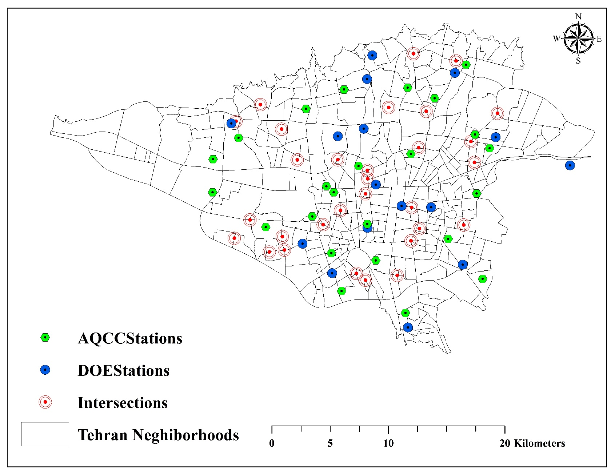
Figure S1. Placement of intersections and measurement stations.

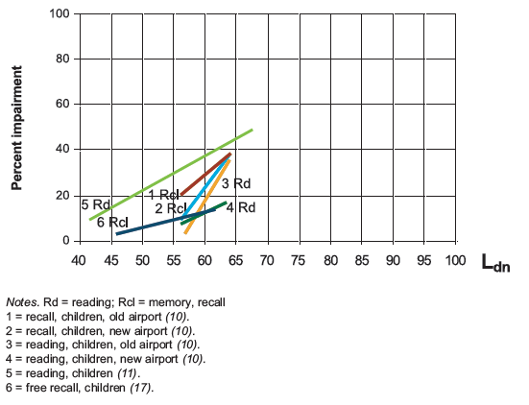
Figure S2. Exposure–response curves from different epidemiological studies.

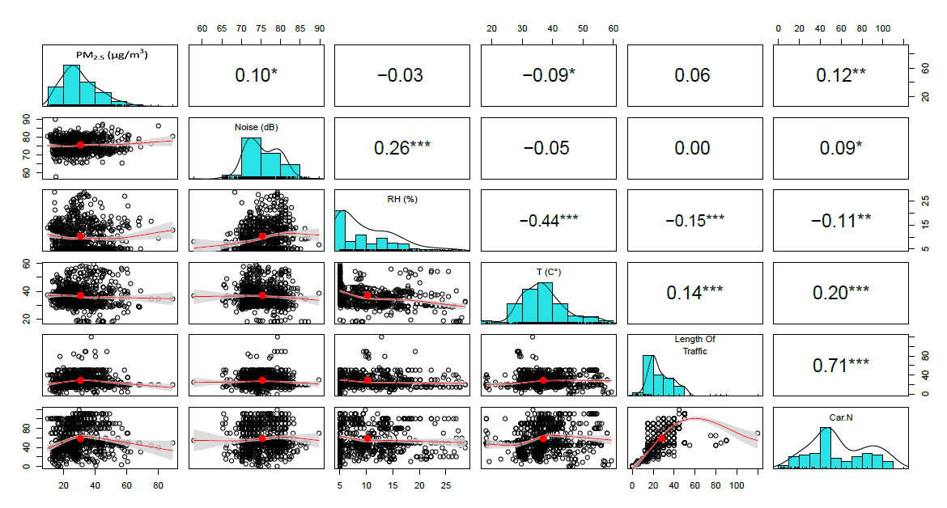
Figure S3. Correlation plot between Noise level, PM_{2.5}, Cars number, Length of traffic, Temperature and Relative humidity.

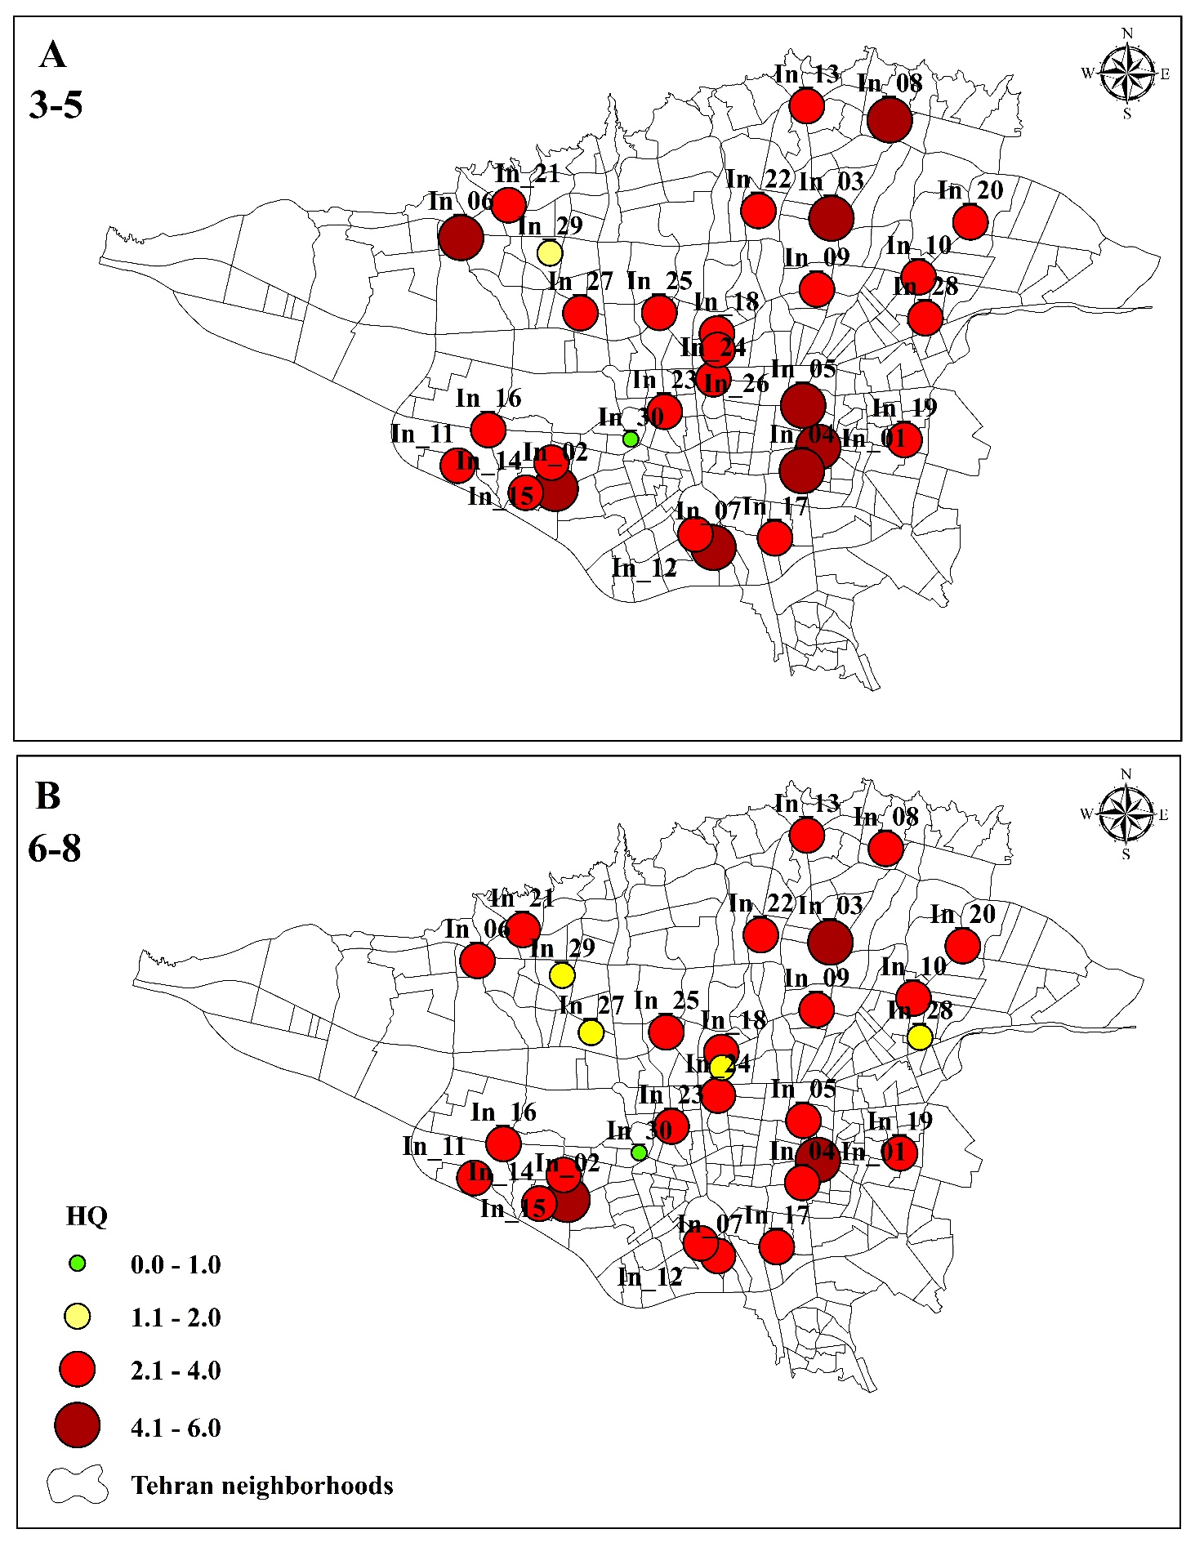
Figure S4. The amount of HQ at the ages of 3-5(A) and 6-8(B) years.

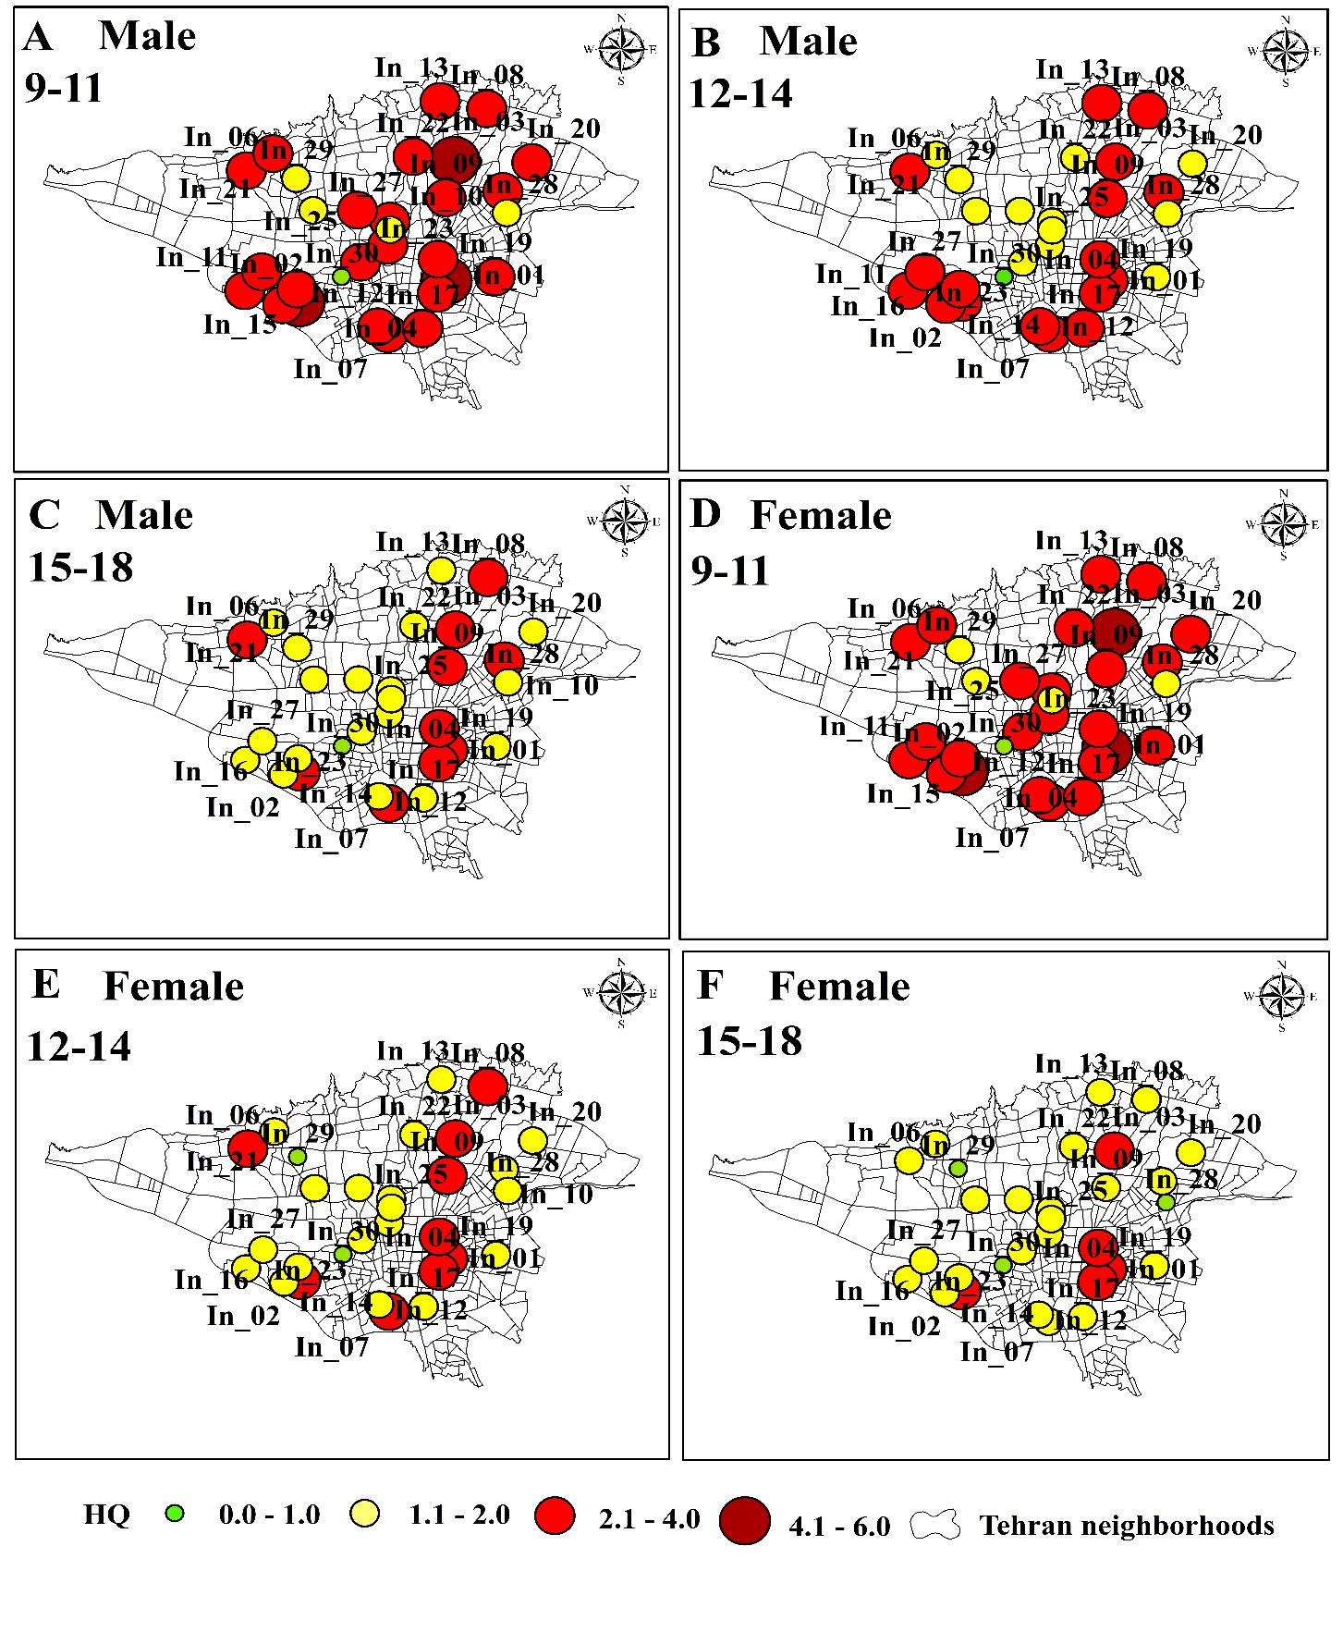
Figure S5. The amount of HQ at the ages of 9-11(A), 12-14(B), 15-18(C) (Male) and 9-11(D), 12-14(E), 15-18(F) (Female) years.

Table S6
Variation in PM_{2.5} and Noise across intersections.
Intersections | PM_{2.5} (µg/m³) |  |  |  |  |  |  | Intersections | Noise (dB)
Intersections | Q1 | Median | Q3 | Mean | SD | Min | Max | Intersections | Q1 | Median | Q3 | Mean | SD | Min | Max
In_01 | 15.01 | 21.55 | 25.14 | 20.83 | 5.85 | 12.93 | 34.48 | In_01 | 68.40 | 70.50 | 72.40 | 70.82 | 5.45 | 57.80 | 89.80
In_02 | 23.95 | 26.51 | 29.87 | 27.06 | 4.29 | 19.97 | 37.53 | In_02 | 70.50 | 71.70 | 72.50 | 72.16 | 3.37 | 65.50 | 80.30
In_06 | 16.79 | 27.19 | 38.98 | 27.73 | 11.90 | 12.86 | 56.72 | In_05 | 71.10 | 72.30 | 73.90 | 72.37 | 3.10 | 65.30 | 78.90
In_07 | 24.08 | 28.75 | 29.93 | 29.04 | 7.37 | 17.22 | 51.30 | In_08 | 71.10 | 72.10 | 74.50 | 73.10 | 2.99 | 70.10 | 81.90
In_03 | 25.85 | 31.65 | 34.26 | 30.95 | 5.54 | 21.43 | 43.92 | In_03 | 70.80 | 73.30 | 75.60 | 73.52 | 3.22 | 68.50 | 80.20
In_04 | 26.10 | 30.40 | 33.20 | 31.56 | 7.63 | 22.71 | 51.21 | In_09 | 72.30 | 73.10 | 75.40 | 74.16 | 2.96 | 70.50 | 83.10
In_08 | 25.67 | 27.44 | 36.63 | 33.43 | 13.49 | 20.09 | 68.71 | In_04 | 72.30 | 74.10 | 75.40 | 74.38 | 2.68 | 71.00 | 80.90
In_05 | 23.55 | 31.93 | 45.23 | 34.54 | 11.76 | 20.15 | 57.00 | In_07 | 72.10 | 74.00 | 77.00 | 75.03 | 3.48 | 70.30 | 81.30
In_10 | 33.86 | 38.90 | 45.32 | 41.46 | 11.04 | 27.60 | 80.11 | In_06 | 73.90 | 74.50 | 76.90 | 75.10 | 2.76 | 71.10 | 84.30
In_09 | 41.99 | 45.97 | 55.84 | 49.56 | 10.09 | 30.54 | 75.54 | In_10 | 76.60 | 77.90 | 80.50 | 78.66 | 3.26 | 73.50 | 86.50
In_16 | 17.35 | 18.39 | 21.57 | 19.24 | 3.46 | 14.46 | 28.32 | In_16 | 70.20 | 71.20 | 72.30 | 71.26 | 2.58 | 66.00 | 76.70
In_18 | 20.90 | 23.17 | 24.84 | 23.12 | 2.98 | 16.96 | 28.55 | In_20 | 70.50 | 71.80 | 72.40 | 71.87 | 2.17 | 68.30 | 79.30
In_17 | 17.10 | 19.98 | 32.97 | 24.94 | 11.72 | 14.65 | 60.62 | In_12 | 70.30 | 72.10 | 73.20 | 71.90 | 2.26 | 65.20 | 75.20
In_12 | 24.36 | 31.05 | 37.53 | 31.14 | 8.14 | 19.62 | 48.19 | In_13 | 71.50 | 72.20 | 74.10 | 72.66 | 1.68 | 69.80 | 76.40
In_14 | 20.03 | 30.59 | 41.61 | 31.34 | 12.50 | 12.49 | 58.50 | In_17 | 71.20 | 72.40 | 75.60 | 73.66 | 3.42 | 69.70 | 84.30
In_19 | 24.70 | 29.47 | 36.32 | 32.06 | 9.60 | 21.96 | 56.50 | In_18 | 72.10 | 73.20 | 75.20 | 73.86 | 3.01 | 68.10 | 81.20
In_13 | 29.68 | 31.99 | 36.01 | 34.62 | 7.85 | 25.80 | 54.38 | In_19 | 72.30 | 73.20 | 74.80 | 74.12 | 2.64 | 71.50 | 82.30
In_20 | 25.12 | 28.50 | 43.14 | 34.65 | 12.54 | 21.13 | 62.51 | In_14 | 73.30 | 74.80 | 75.60 | 74.81 | 1.96 | 70.10 | 79.30
In_15 | 38.22 | 44.26 | 51.30 | 41.82 | 13.76 | 16.23 | 60.80 | In_15 | 73.10 | 75.40 | 80.10 | 76.85 | 4.96 | 70.10 | 87.10
In_11 | 38.00 | 44.57 | 50.65 | 47.60 | 14.29 | 26.04 | 89.18 | In_11 | 77.10 | 80.00 | 80.40 | 78.38 | 4.28 | 68.30 | 86.20
In_30 | 13.25 | 14.49 | 15.38 | 14.64 | 1.87 | 11.40 | 19.37 | In_28 | 71.20 | 73.90 | 78.40 | 74.63 | 4.15 | 66.00 | 81.20
In_29 | 12.69 | 14.53 | 16.55 | 16.18 | 5.04 | 9.75 | 28.44 | In_21 | 73.40 | 75.60 | 77.50 | 75.48 | 2.52 | 71.40 | 79.20
In_23 | 21.15 | 22.94 | 25.37 | 23.14 | 3.33 | 17.10 | 30.71 | In_30 | 72.10 | 74.80 | 79.20 | 75.74 | 4.26 | 68.70 | 83.40
In_24 | 22.94 | 25.16 | 26.92 | 25.37 | 4.03 | 19.23 | 40.46 | In_23 | 77.10 | 78.10 | 80.10 | 78.35 | 2.65 | 74.30 | 83.40
In_26 | 18.39 | 26.17 | 30.71 | 25.83 | 8.35 | 13.36 | 44.31 | In_27 | 77.20 | 79.10 | 81.20 | 78.92 | 2.80 | 73.90 | 83.40
In_21 | 21.64 | 23.70 | 33.83 | 27.22 | 7.68 | 18.30 | 43.19 | In_26 | 78.40 | 79.20 | 80.20 | 79.06 | 1.82 | 74.30 | 81.40
In_27 | 26.17 | 28.13 | 29.85 | 29.28 | 5.79 | 22.80 | 46.64 | In_25 | 78.40 | 79.20 | 81.10 | 79.44 | 1.84 | 74.30 | 83.20
In_28 | 28.93 | 34.08 | 40.21 | 33.98 | 8.01 | 17.71 | 47.44 | In_24 | 78.30 | 80.00 | 81.10 | 79.62 | 2.26 | 73.90 | 85.10
In_25 | 30.71 | 33.22 | 36.28 | 34.65 | 7.10 | 26.35 | 60.80 | In_22 | 79.10 | 79.60 | 80.30 | 79.64 | 1.69 | 74.30 | 83.20
In_22 | 37.44 | 40.90 | 44.07 | 42.18 | 7.37 | 32.76 | 60.57 | In_29 | 79.10 | 79.40 | 81.20 | 79.70 | 1.73 | 74.30 | 83.20

Table S7
Correlations between variables (PM_{2.5}, Noise, %RH, T, L.T, C.N).
 |  |  | PM_{2.5} (µg/m³) | Noise (dB) | RH (%) | T (C°) | Length Of  Traffic | Car.N
Spearman's rho | PM_{2.5} (µg/m³) | Correlation Coefficient | 1.000 | .095* | -0.035 | -.088* | 0.063 | .119**
Spearman's rho | PM_{2.5} (µg/m³) | P-value | * | 0.011 | 0.349 | 0.018 | 0.091 | 0.001
Spearman's rho | PM_{2.5} (µg/m³) | N | 720 | 720 | 720 | 720 | 720 | 720
Spearman's rho | Noise (dB) | Correlation Coefficient | .095* | 1.000 | .257** | -0.055 | 0.005 | .086*
Spearman's rho | Noise (dB) | P-value | 0.011 | * | 0.000 | 0.143 | 0.901 | 0.020
Spearman's rho | Noise (dB) | N | 720 | 720 | 720 | 720 | 720 | 720
Spearman's rho | RH (%) | Correlation Coefficient | -0.035 | .257** | 1.000 | -.439** | -.155** | -.107**
Spearman's rho | RH (%) | P-value | 0.349 | 0.000 | * | 0.000 | 0.000 | 0.004
Spearman's rho | RH (%) | N | 720 | 720 | 720 | 720 | 720 | 720
Spearman's rho | T (C°) | Correlation Coefficient | -.088* | -0.055 | -.439** | 1.000 | .140** | .196**
Spearman's rho | T (C°) | P-value | 0.018 | 0.143 | 0.000 | * | 0.000 | 0.000
Spearman's rho | T (C°) | N | 720 | 720 | 720 | 720 | 720 | 720
Spearman's rho | Length Of  Traffic | Correlation Coefficient | 0.063 | 0.005 | -.155** | .140** | 1.000 | .713**
Spearman's rho | Length Of  Traffic | P-value | 0.091 | 0.901 | 0.000 | 0.000 | * | 0.000
Spearman's rho | Length Of  Traffic | N | 720 | 720 | 720 | 720 | 720 | 720
Spearman's rho | Car.N | Correlation Coefficient | .119** | .086* | -.107** | .196** | .713** | 1.000
Spearman's rho | Car.N | P-value | 0.001 | 0.020 | 0.004 | 0.000 | 0.000 | *
Spearman's rho | Car.N | N | 720 | 720 | 720 | 720 | 720 | 720

*. Correlation is significant at the 0.05 level (2-tailed).
**. Correlation is significant at the 0.01 level (2-tailed).

