Supplementary Materials
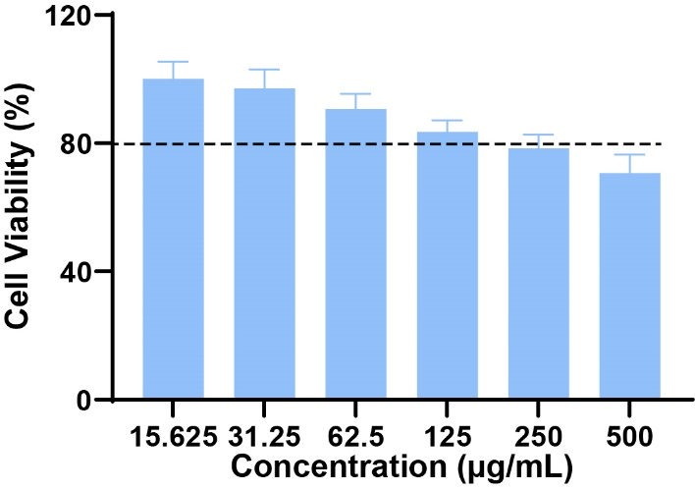
Fig S1 Infrared spectra of nanoparticles.
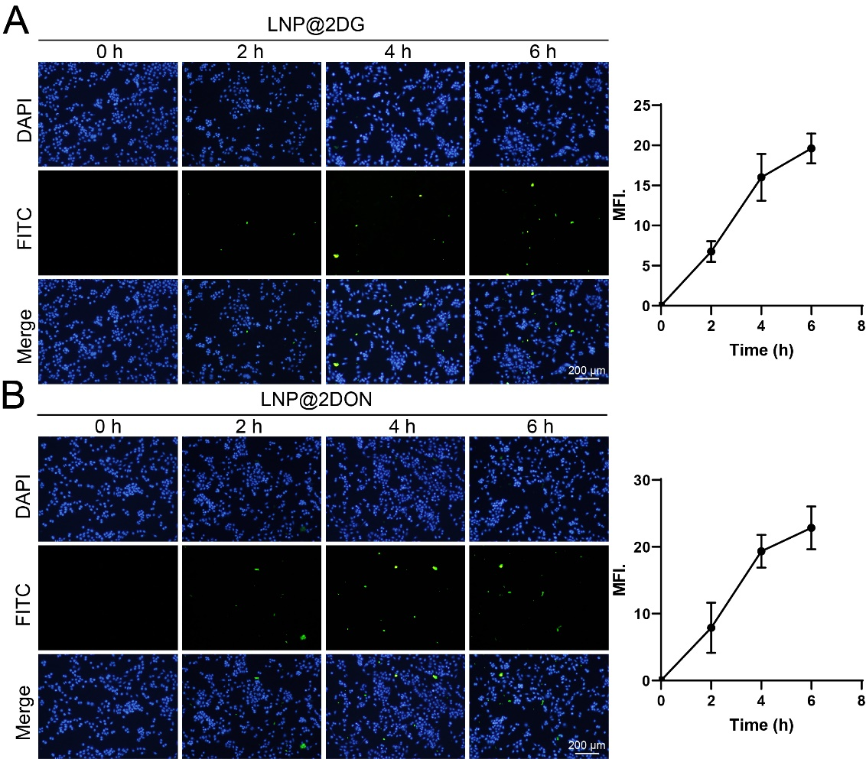
Fig S2 Time changes of FITC immunofluorescence staining of ASPC-1 cells. A) FITC immunofluorescence staining of ASPC-1 cells treated with LNP@2DG. B) FITC immunofluorescence staining of ASPC-1 cells treated with LNP@DON.
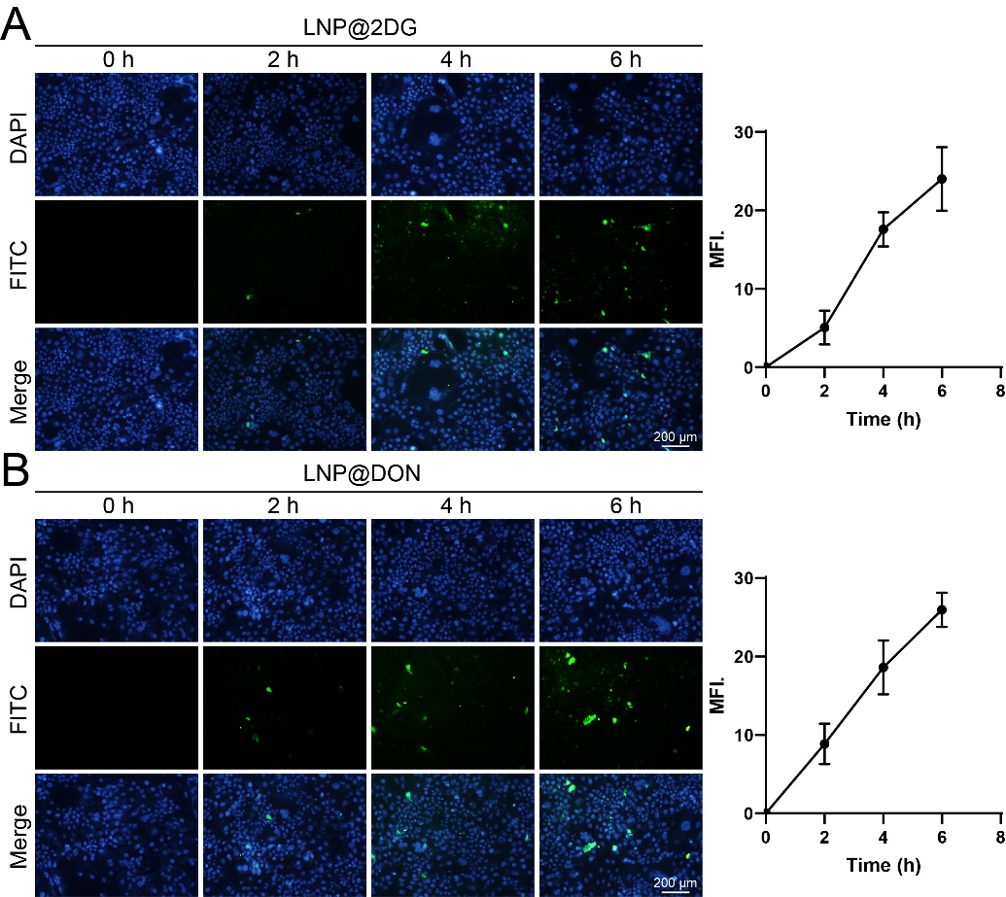
Fig S3 Time changes of FITC immunofluorescence staining of PANC-1 cells. A) FITC immunofluorescence staining of PANC-1 cells treated with LNP@2DG. B) FITC immunofluorescence staining of PANC-1 cells treated with LNP@DON.
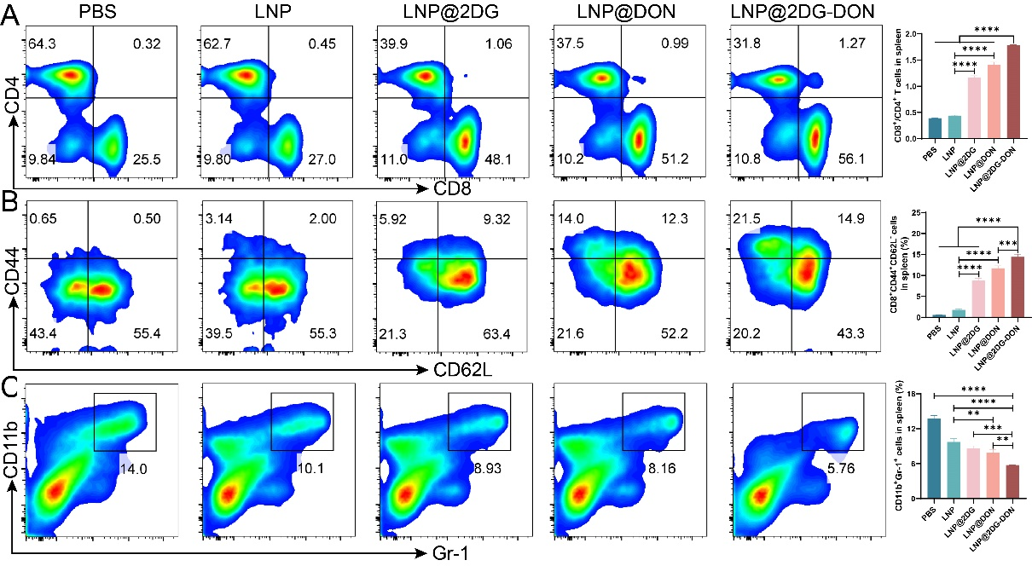
Fig. S4 In Vitro Anti-Tumor Immune Mechanism of LNP. A) Tumor infiltration of CD4+CD8+ T cells. B) CD8+CD44+CD62L+cells in the tumor tissue. C) CD11b+Gr-1+ cells in the tumor tissue.
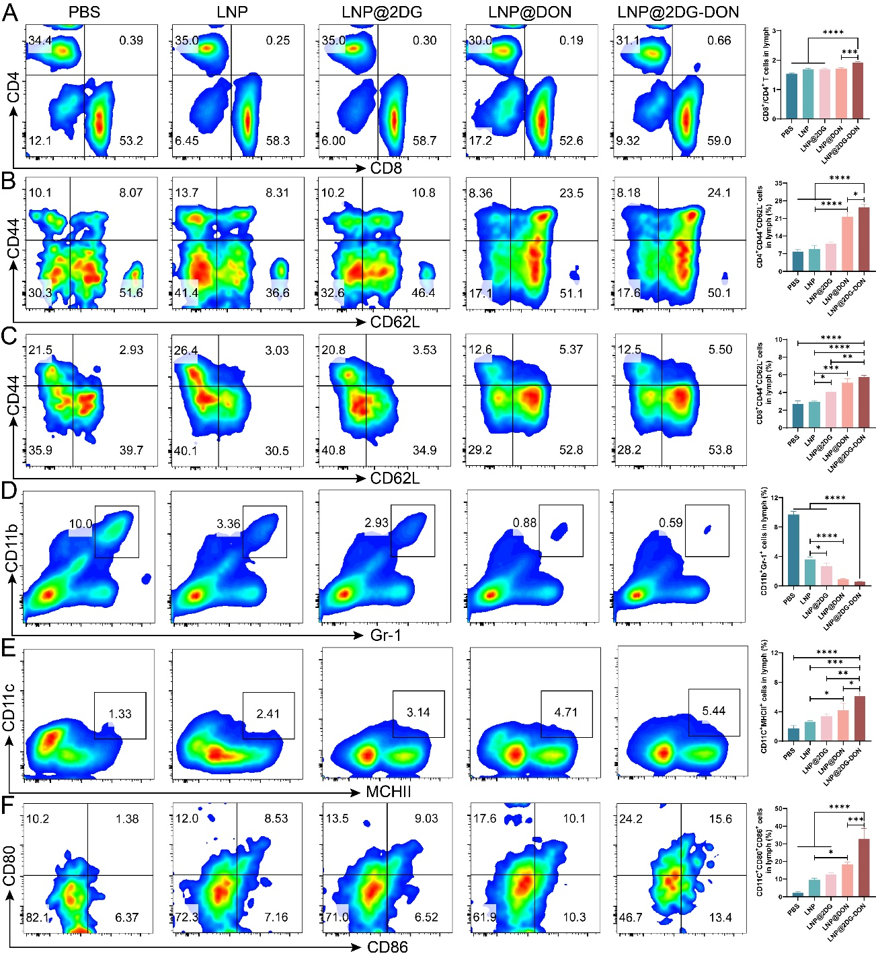
Fig. S5 Flow cytometry analysis of immune cells in the lymph of mice. A) Tumor infiltration of CD8+CD4+T cells. B) CD4+ CD44+CD62L+ cells in the tumor tissue. C) CD8+CD44+ CD62L+ cells in the tumor tissue. D) CD11b+ Gr-1+ cells in the tumor tissue. E) CD11c+ MCHII+ cells in the tumor tissue. F) CD80+ CD86+ cells in the tumor tissue.

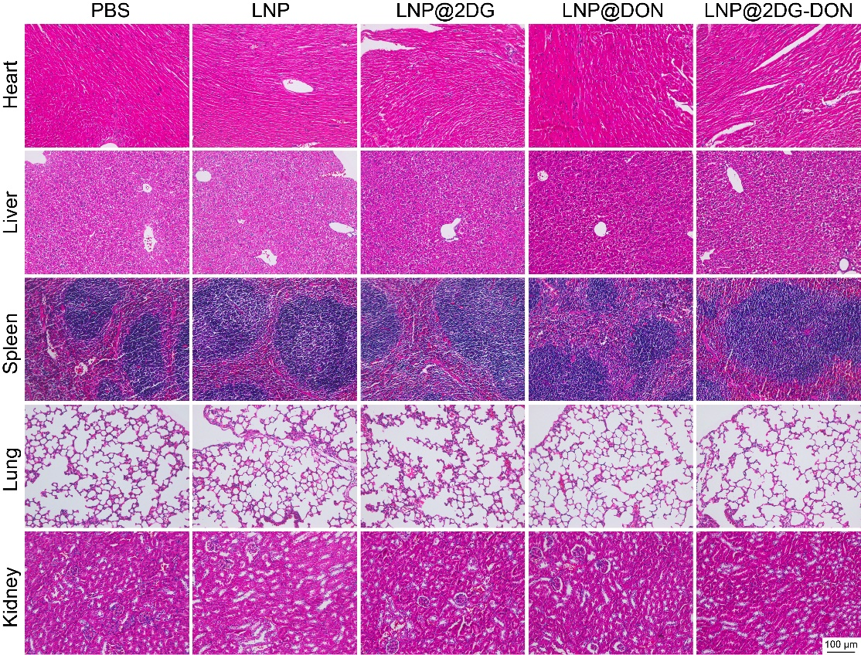
Fig. S6 H&E staining of heart, liver, spleen, lung, and kidney.

