Supplementary material

Assimilation of high-resolution Ocean Color Monitor (OCM) aerosol optical depth in WRF-Chem improves PM₂.₅ forecasts over the Indian region.

Prafull P. Yadav^{1, 2*}, Sachin D.Ghude^{1*}, Gaurav Govardhan^{1, 3}, Rajesh Kumar⁴, Rajmal Jat¹, Shivani Shah⁵, B. P. Shukla⁵, Manoj K. Mishra⁵, Deepak Putrevu⁵, Imran Girach⁵, P. K. Thapliyal⁵, Rashmi Sharma⁵

¹Indian Institute of Tropical Meteorology, Ministry of Earth Sciences, Pune, India
²Dept. of Atmospheric and Space Sciences, Savitribai Phule Pune University, Pune, India
³National Center for Medium Range Weather Forecasting, Ministry of Earth Sciences, Noida, UP, India
⁴National Science Foundation National Center for Atmospheric Research, Boulder, Colorado, USA
⁵Space Applications Centre, Ahmedabad, India
*Corresponding Authors: Sachin D. Ghude, Prafull P. Yadav
E-mail address: sachinghude@tropmet.res.in, prafull.yadav@tropmet.res.in

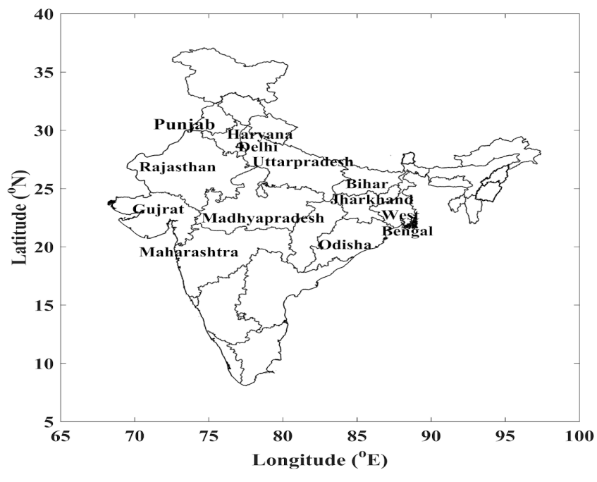

Figure S1. Geographic locations of the twelve selected Indian states considered in this study.

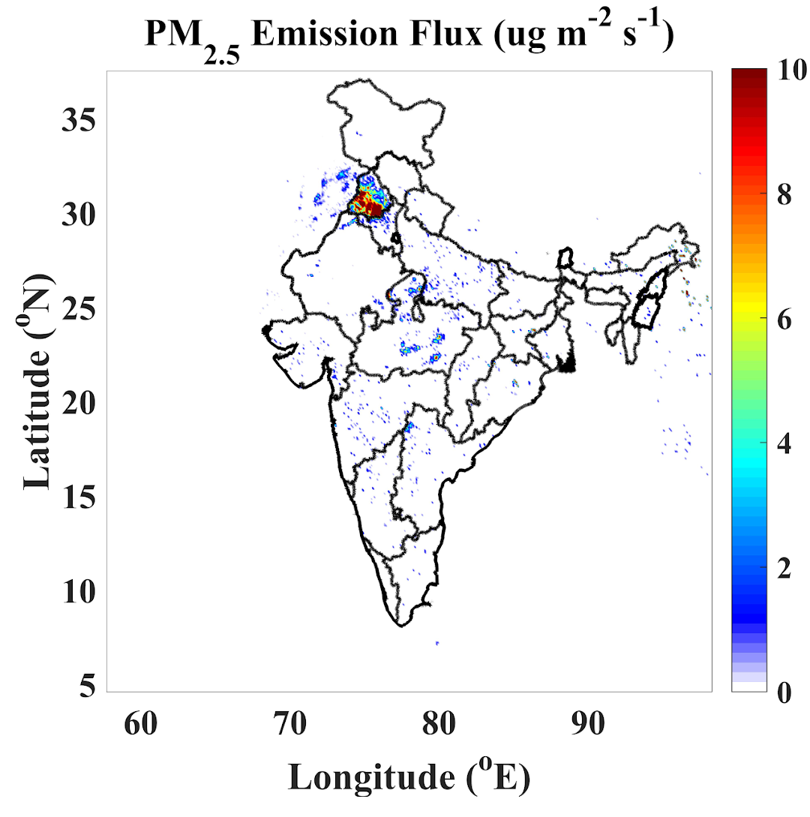
Figure S2: PM_{2.5} emission flux from fires (averaged over 13 days).

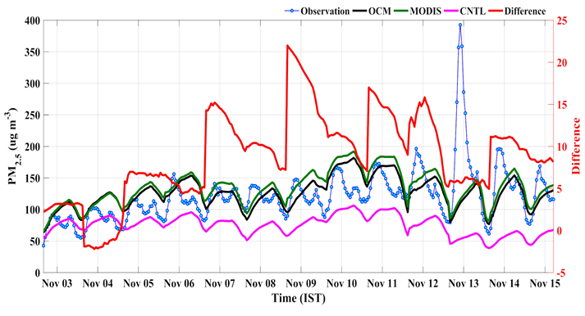
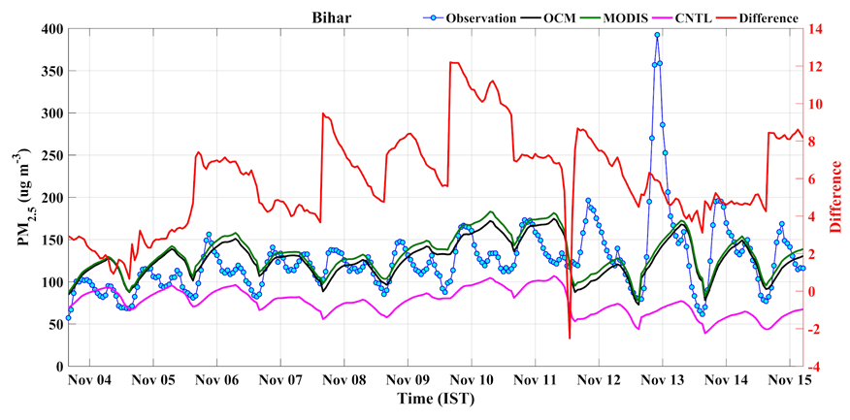
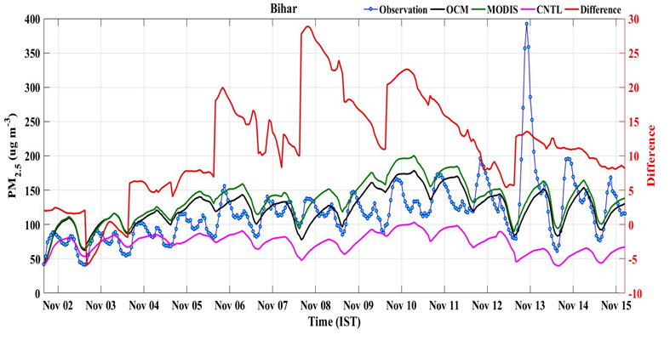
(b)
(c)
(a)

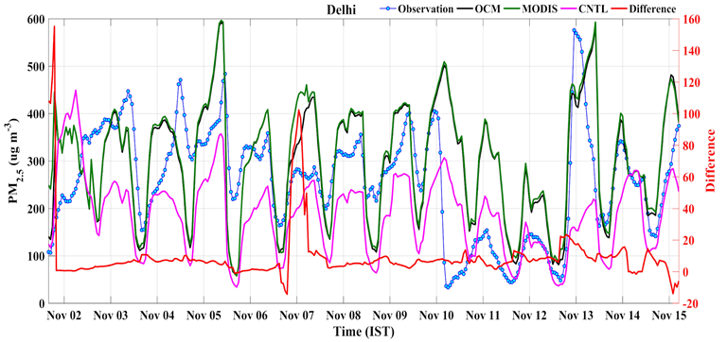
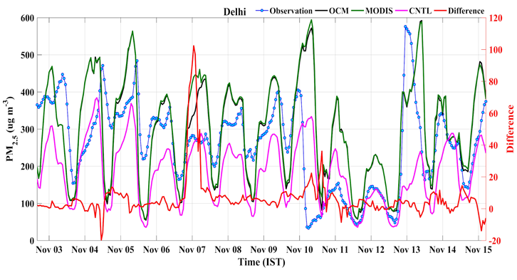
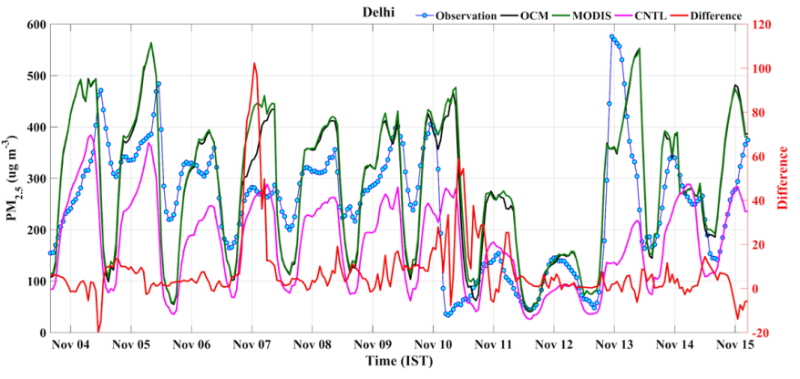
Figure S3. Time series of observed and WRF-Chem forecasted hourly PM₂.₅ mass concentrations in Bihar for the (a) first, (b) second, and (c) third forecast days. The left Y-axis represents PM₂.₅ concentrations (µg m⁻³), while the right Y-axis indicates the absolute difference between MODISDA and OCMDA forecasts. The line plots show observations (blue), CNTL (pink), MODIS (MODISDA, green), and OCM (OCMDA, black). The red line represents the MODISDA–OCMDA difference.
(a)
(b)
(c)

Figure S4. Time series of observed and WRF-Chem forecasted hourly PM₂.₅ mass concentrations in Delhi for the (a) first, (b) second, and (c) third forecast days. The left Y-axis represents PM₂.₅ concentrations (µg m⁻³), while the right Y-axis indicates the absolute difference between MODISDA and OCMDA forecasts. The line plots show observations (blue), CNTL (pink), MODIS (MODISDA, green), and OCM (OCMDA, black). The red line represents the MODISDA–OCMDA difference.

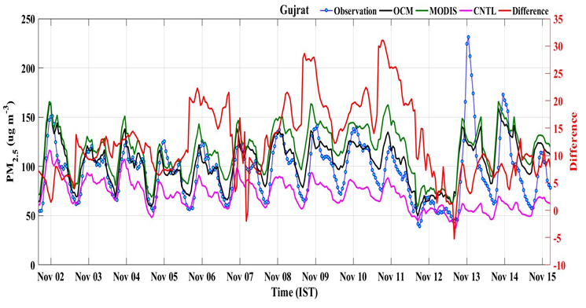
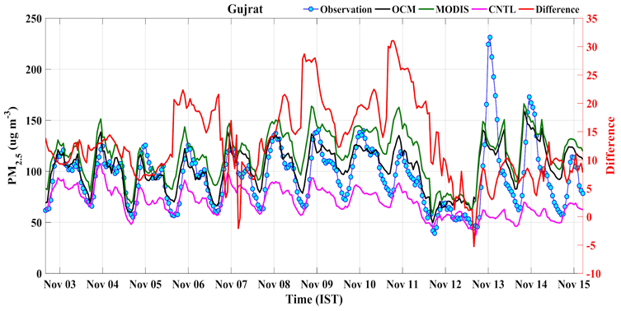
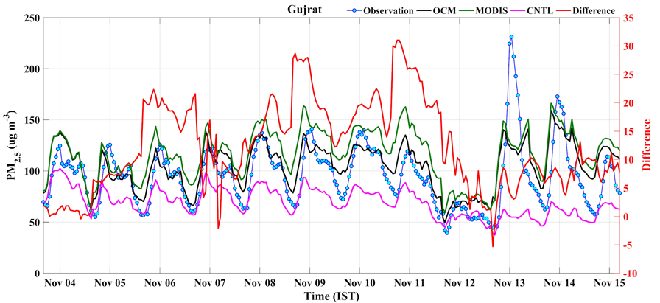
(a)
(b)
(c)

Figure S5. Time series of observed and WRF-Chem forecasted hourly PM₂.₅ mass concentrations in Gujrat for the (a) first, (b) second, and (c) third forecast days. The left Y-axis represents PM₂.₅ concentrations (µg m⁻³), while the right Y-axis indicates the absolute difference between MODISDA and OCMDA forecasts. The line plots show observations (blue), CNTL (pink), MODIS (MODISDA, green), and OCM (OCMDA, black). The red line represents the MODISDA–OCMDA difference.

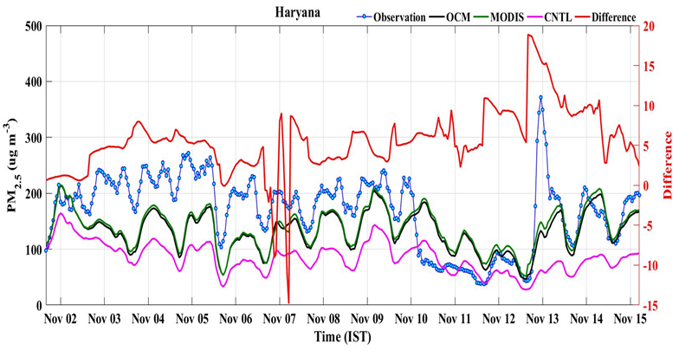
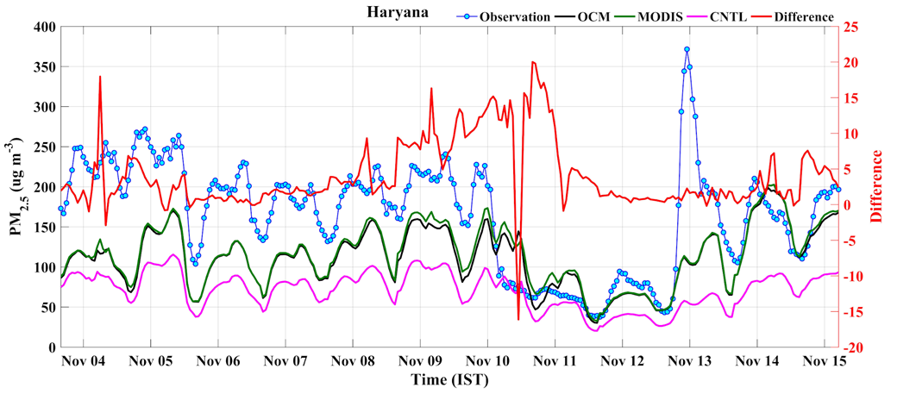
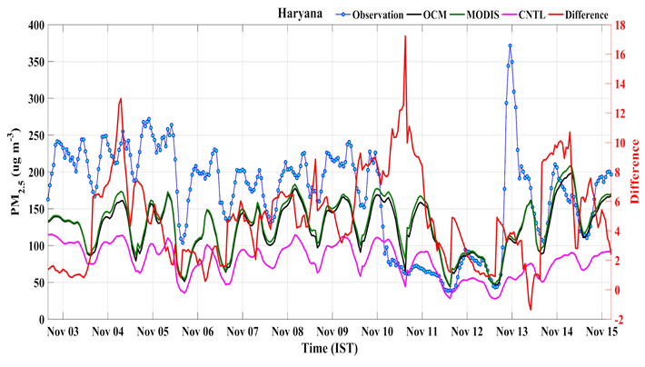
(a)
(c)
(b)
(b)

Figure S6. Time series of observed and WRF-Chem forecasted hourly PM₂.₅ mass concentrations in Haryana for the (a) first, (b) second, and (c) third forecast days. The left Y-axis represents PM₂.₅ concentrations (µg m⁻³), while the right Y-axis indicates the absolute difference between MODISDA and OCMDA forecasts. The line plots show observations (blue), CNTL (pink), MODIS (MODISDA, green), and OCM (OCMDA, black). The red line represents the MODISDA–OCMDA difference.

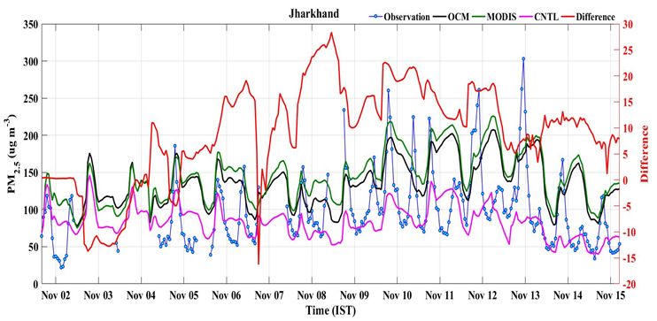
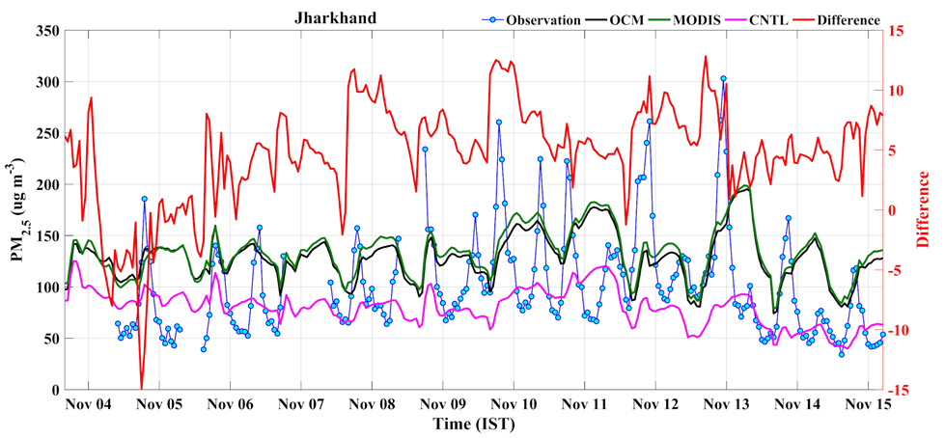
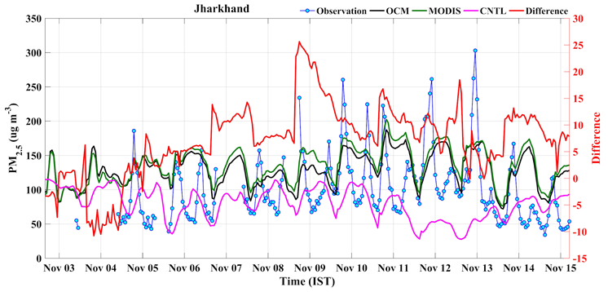
(a)
(c)
(b)
(b)

Figure S7. Time series of observed and WRF-Chem forecasted hourly PM₂.₅ mass concentrations in Jharkhand for the (a) first, (b) second, and (c) third forecast days. The left Y-axis represents PM₂.₅ concentrations (µg m⁻³), while the right Y-axis indicates the absolute difference between MODISDA and OCMDA forecasts. The line plots show observations (blue), CNTL (pink), MODIS (MODISDA, green), and OCM (OCMDA, black). The red line represents the MODISDA–OCMDA difference.

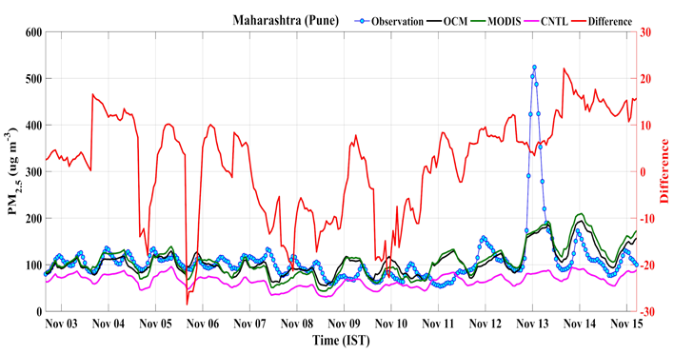
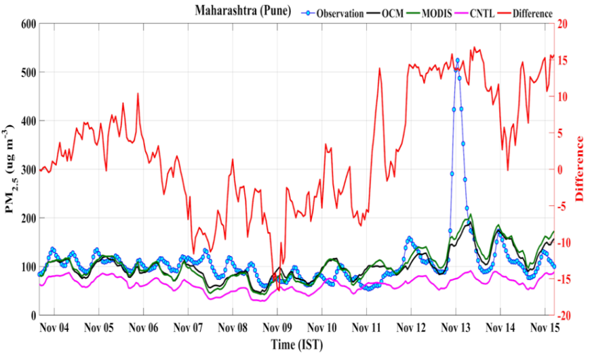
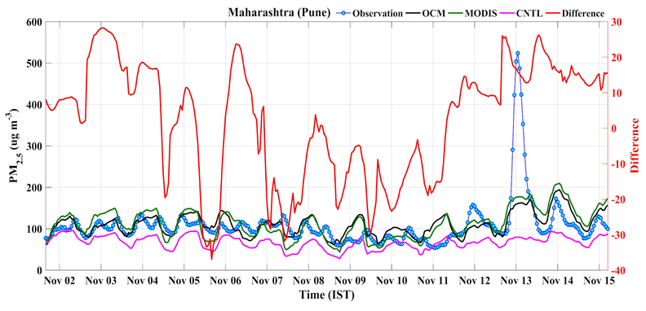
(b)
(c)
(a)
(a)

Figure S8. Time series of observed and WRF-Chem forecasted hourly PM₂.₅ mass concentrations in Maharashtra (Pune) for the (a) first, (b) second, and (c) third forecast days. The left Y-axis represents PM₂.₅ concentrations (µg m⁻³), while the right Y-axis indicates the absolute difference between MODISDA and OCMDA forecasts. The line plots show observations (blue), CNTL (pink), MODIS (MODISDA, green), and OCM (OCMDA, black). The red line represents the MODISDA–OCMDA difference.

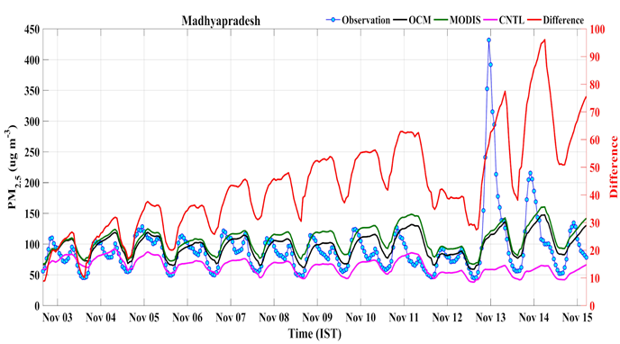
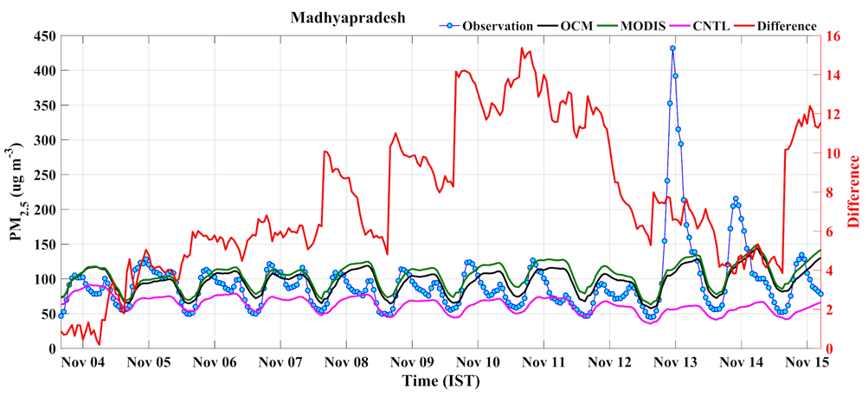
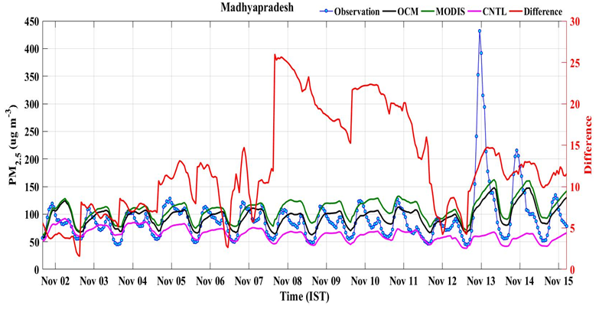
(b)
(c)
(a)
(a)

Figure S9. Time series of observed and WRF-Chem forecasted hourly PM₂.₅ mass concentrations in Madhyapradesh for the (a) first, (b) second, and (c) third forecast days. The left Y-axis represents PM₂.₅ concentrations (µg m⁻³), while the right Y-axis indicates the absolute difference between MODISDA and OCMDA forecasts. The line plots show observations (blue), CNTL (pink), MODIS (MODISDA, green), and OCM (OCMDA, black). The red line represents the MODISDA–OCMDA difference.

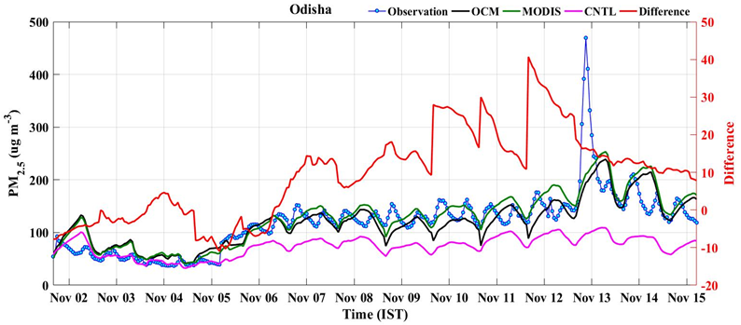
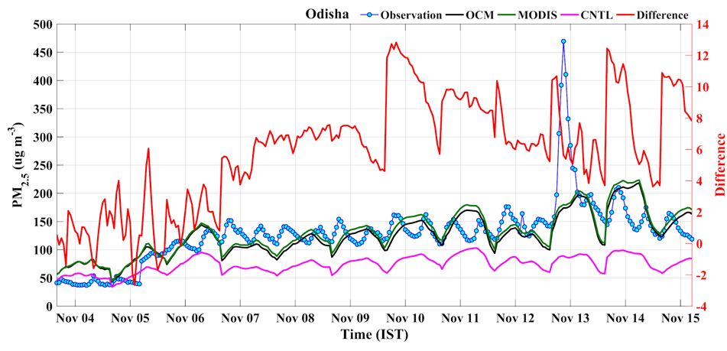
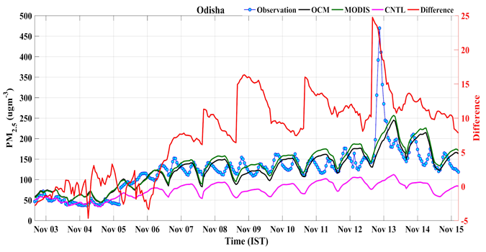
(a)
(c)
(b)
(b)

Figure S10. Time series of observed and WRF-Chem forecasted hourly PM₂.₅ mass concentrations in Odisha for the (a) first, (b) second, and (c) third forecast days. The left Y-axis represents PM₂.₅ concentrations (µg m⁻³), while the right Y-axis indicates the absolute difference between MODISDA and OCMDA forecasts. The line plots show observations (blue), CNTL (pink), MODIS (MODISDA, green), and OCM (OCMDA, black). The red line represents the MODISDA–OCMDA difference.

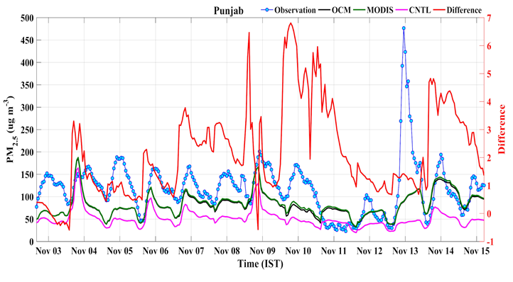
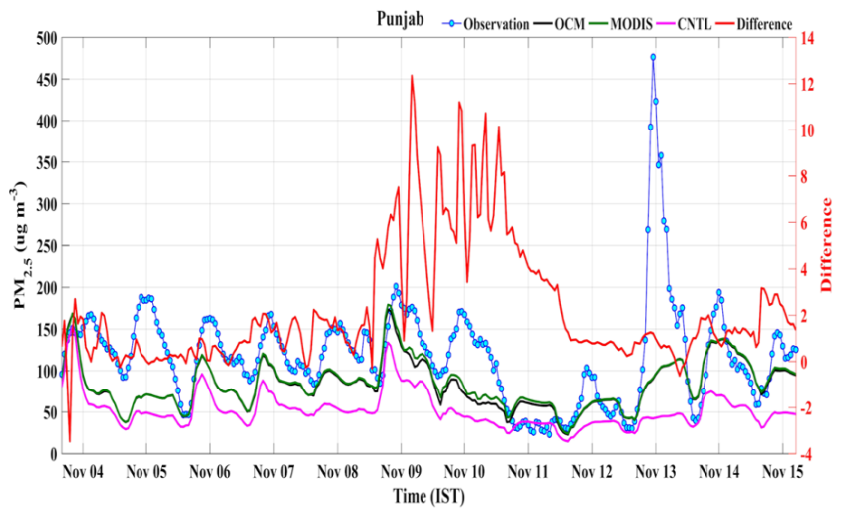
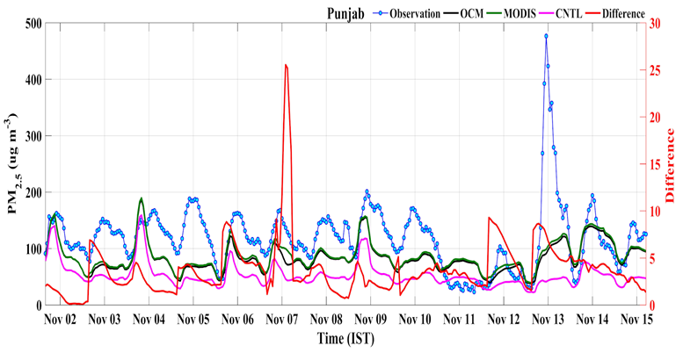
(b)
(c)
(a)
(a)

Figure S11. Time series of observed and WRF-Chem forecasted hourly PM₂.₅ mass concentrations in Punjab for the (a) first, (b) second, and (c) third forecast days. The left Y-axis represents PM₂.₅ concentrations (µg m⁻³), while the right Y-axis indicates the absolute difference between MODISDA and OCMDA forecasts. The line plots show observations (blue), CNTL (pink), MODIS (MODISDA, green), and OCM (OCMDA, black). The red line represents the MODISDA–OCMDA difference.

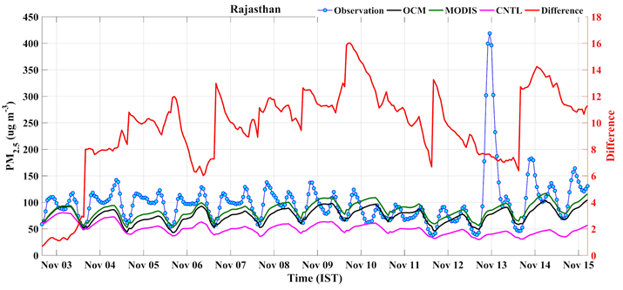
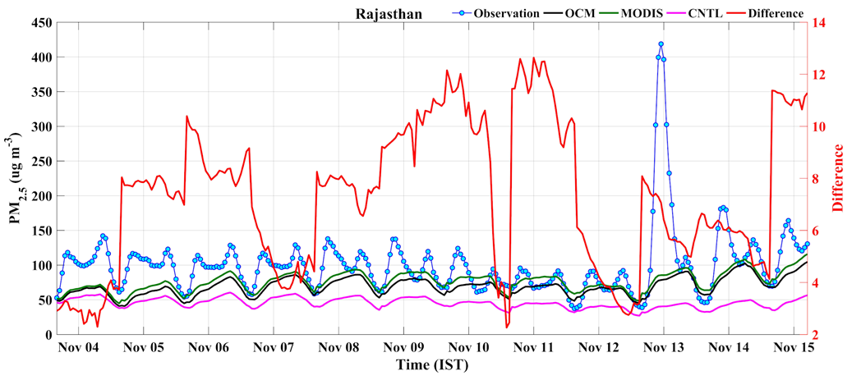
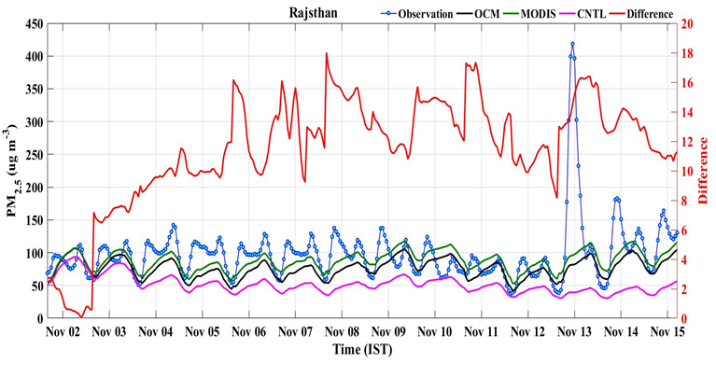
(b)
(c)
(a)
(a)

Figure S11. Time series of observed and WRF-Chem forecasted hourly PM₂.₅ mass concentrations in Rajasthan for the (a) first, (b) second, and (c) third forecast days. The left Y-axis represents PM₂.₅ concentrations (µg m⁻³), while the right Y-axis indicates the absolute difference between MODISDA and OCMDA forecasts. The line plots show observations (blue), CNTL (pink), MODIS (MODISDA, green), and OCM (OCMDA, black). The red line represents the MODISDA–OCMDA difference.

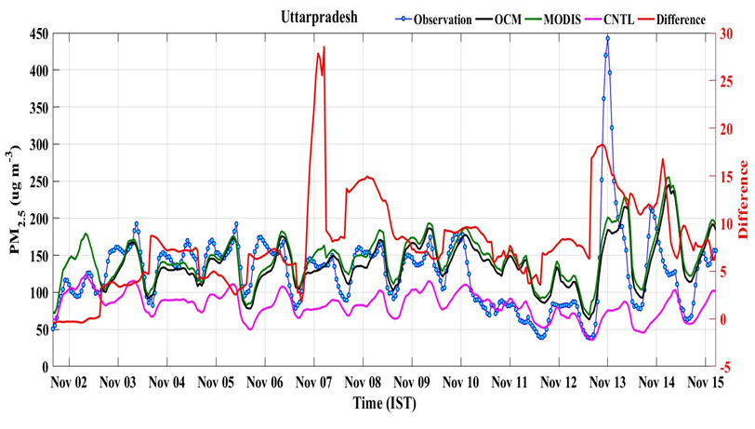
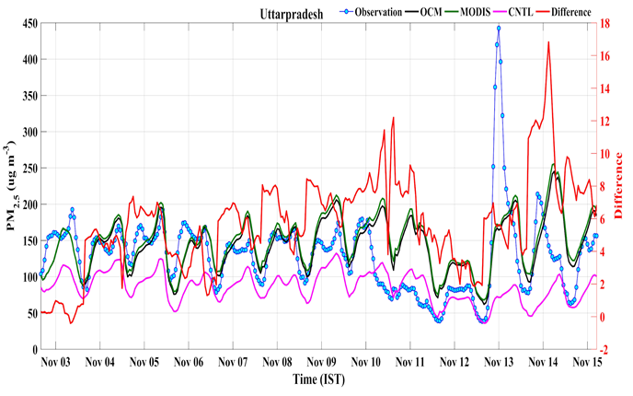
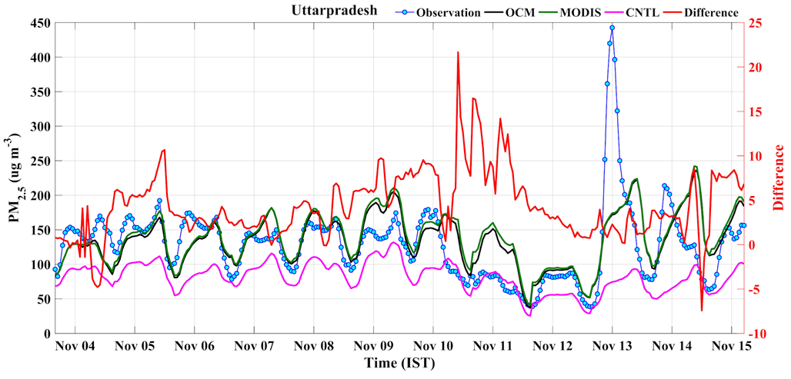
(a)
(b)

s
(c)

Figure S12. Time series of observed and WRF-Chem forecasted hourly PM₂.₅ mass concentrations in Uttarpradesh for the (a) first, (b) second, and (c) third forecast days. The left Y-axis represents PM₂.₅ concentrations (µg m⁻³), while the right Y-axis indicates the absolute difference between MODISDA and OCMDA forecasts. The line plots show observations (blue), CNTL (pink), MODIS (MODISDA, green), and OCM (OCMDA, black). The red line represents the MODISDA–OCMDA difference.

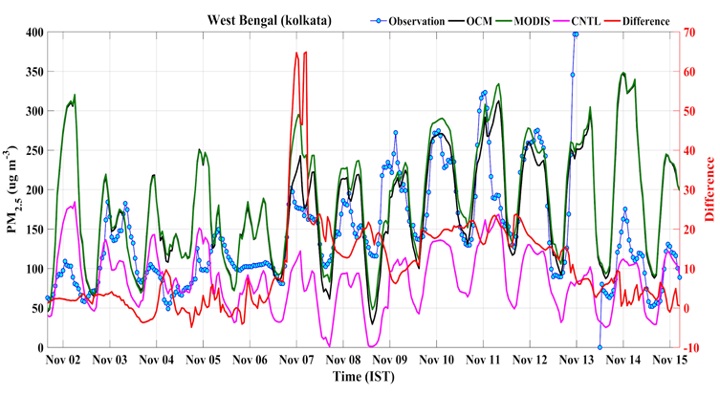
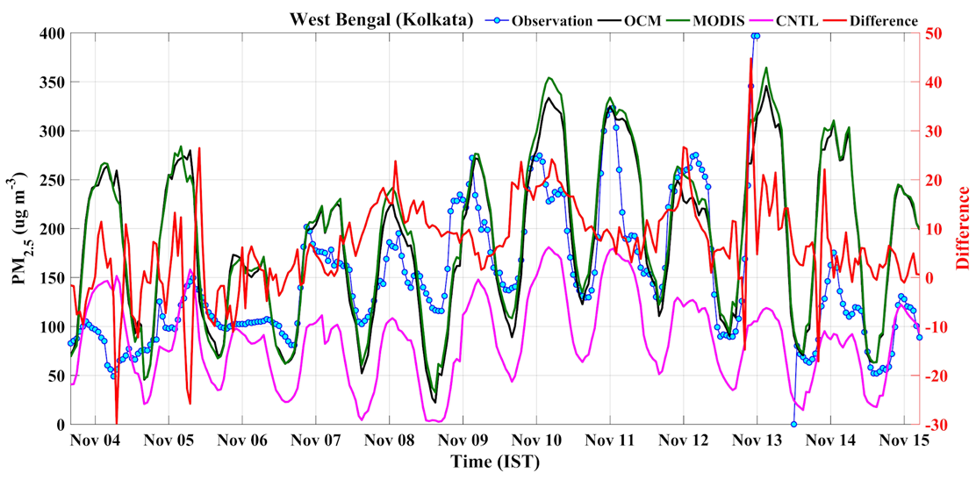
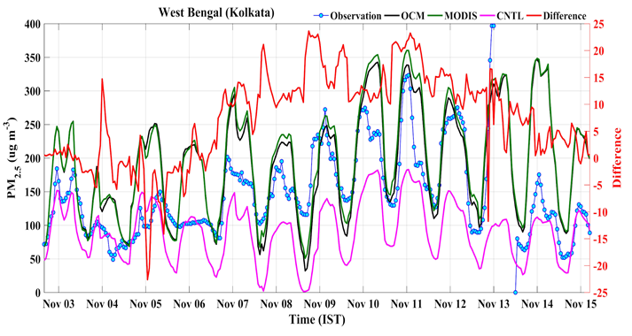
(a)
(c)
(b)
(b)

Figure S13. Time series of observed and WRF-Chem forecasted hourly PM₂.₅ mass concentrations in West Bengal (Kolkata) for the (a) first, (b) second, and (c) third forecast days. The left Y-axis represents PM₂.₅ concentrations (µg m⁻³), while the right Y-axis indicates the absolute difference between MODISDA and OCMDA forecasts. The line plots show observations (blue), CNTL (pink), MODIS (MODISDA, green), and OCM (OCMDA, black). The red line represents the MODISDA–OCMDA difference.

