Adolescent public stigma and help seeking intention are associated with later service use: A five-year follow-up study using annual self-report surveys and medical records

Shinsuke Koike, Sakine Shinohara, Kei-Ichiro Watanabe, Shintaro Yanagimoto, Shuntaro Ando, Sosei Yamaguchi, Norihito Oshima

Supplementary Materials

Table of Contents
Supplementary Methods 2
Scales for temperament and psychological assessment in admission 2
References 3
Supplementary Figures 5
Supplementary Figure S1. ROC curve for psychiatric and psychological service use after admission. 5
Supplementary Figure S2. ROC curve for psychiatric service use after admission. 6
Supplementary Tables 7
Supplementary Table S1. Cross-sectional logistic regression models for the experience of psychiatric service use. 7
Supplementary Table S2. Logistic regression models for psychiatric service use after admission. 8
Supplementary Table S3. Thresholds and predictive metrics of the ROC curve analysis for psychiatric and psychological service use. 9
Supplementary Table S4. Thresholds and predictive metrics of the ROC curve analysis for psychiatric service use after admission. 9

Supplementary Methods

Scales for temperament and psychological assessment in admission
The health checkup on admission was also assessed using the NEO Five-Factor Inventory (NEO-FFI), depressive symptoms using the Kessler 6 scale (K6), psychotic experiences (PEs), autistic spectrum using the 10-item short version of the Autism Spectrum Quotient Scale (AQ-10), and evaluation of social support using the Social Support Questionnaire Short Form (SSQ6).
The NEO-FFI is a widely used self-report questionnaire to assess the Big Five personality traits [1]. The Revised NEO Personality Inventory was originally developed with 240 items [1], followed by the 60-item short version, the NEO-FFI. The inventory was composed of 12 items using a 5-point Likert scale (1 = strongly disagree to 5 = strongly agree) for each personality trait. Each item response was scored for one trait, and the total scores for the traits of Neuroticism, Extraversion, Openness, Agreeableness, and Conscientiousness were calculated.
The K6 is widely used to screen for depressive symptoms [2, 3], and is composed of six items using five frequency responses for each item (4 = all of the time, 3 = most of the time, 2 = some of the time, 1 = a little of the time, and 0 = none of the time; range 0―24). Higher scores indicate more severe depressive symptoms.
PEs were assessed using four items adopted from the schizophrenia section of the Diagnostic Interview Schedule for Children (DISC-C) [4], which are widely used in population-based surveys and birth cohorts [5, 6]. The items were, ‘Have you ever thought that people are following you or spying on you?’ ‘Have you ever heard voices other people cannot hear?’; ‘Have other people ever read your mind?’ and ‘Have you ever had messages sent just to you through television or radio?’. The response to each item was measured on a three-point Likert scale (‘never,’ ‘yes, within six months,’ and ‘yes over six months ago’). We defined one or more positive responses as any PEs and all negative responses as no PE (reference).
The AQ is widely used to assess autistic traits and is composed of 50 items rated on a 4-point Likert scale (1 = definitely agree to 4 = definitely disagree) [7, 8]. If the answer “definitely” or “slightly agreed” about the presence of an autistic traits, 1 point was scored for that question; otherwise, the question was scored as 0 point. The original AQ consists of five factors, and the AQ-10 consists of two items from each factor, with a total of 10 items (range: 0―10) [9].
The SSQ was developed to evaluate social support, and is composed of 27 items [10]. Each item has two parts: the number of available others the individual feels he or she can turn to in times of need in various situations and the individual's degree of satisfaction with the perceived support available in that particular situation. The options for Number are seven-point Likert scale (0 = ‘no person’ to 6 = ‘more than 5 persons’) and for Satisfaction are six-point (1 = ‘very dissatisfied’ to 6 = ‘very satisfied’). The total score was used for each part. The 6-item short version of the SSQ was developed [11] and used in this study (Ranges of Number: 0―36, Satisfaction: 6―36).

References
1. Costa PT, McCrae RR (1992) Revised NEO Personality Inventory (NEO-PI-R) and NEO Five-Factor Inventory (NEO-FFI) professional manual. Psychological Assessment Resources, Odessa, FL
2. Kessler RC, Barker PR, Colpe LJ, et al (2003) Screening for serious mental illness in the general population. Arch Gen Psychiatry 60:184–189. https://doi.org/10.1001/archpsyc.60.2.184
3. Furukawa TA, Kawakami N, Saitoh M, et al (2008) The performance of the Japanese version of the K6 and K10 in the World Mental Health Survey Japan. Int J Methods Psychiatr Res 17:152–158. https://doi.org/10.1002/mpr.257
4. Costello AJ, Edelbrock CS, Kalas R, et al (1982) NIMH Diagnostic Interview Schedule for Children: Child Version. National Institute of Mental Health, Rockville, MD
5. Poulton R, Caspi A, Moffitt TE, et al (2000) Children’s self-reported psychotic symptoms and adult schizophreniform disorder: a 15-year longitudinal study. Arch Gen Psychiatry 57:1053–1058. https://doi.org/10.1001/archpsyc.57.11.1053
6. Nishida A, Tanii H, Nishimura Y, et al (2008) Associations between psychotic-like experiences and mental health status and other psychopathologies among Japanese early teens. Schizophr Res 99:125–133. https://doi.org/10.1016/j.schres.2007.11.038
7. Baron-Cohen S, Wheelwright S, Skinner R, et al (2001) The Autism-spectrum Quotient (AQ): evidence from Asperger syndrome/high-functioning autism, males and females, scientists and mathematicians. J Autism Dev Disord 31:5–17. https://doi.org/10.1023/a:1005653411471
8. Wakabayashi A, Tojo Y, Baron-Cohen S, Wheelwright S (2004) [The Autism-Spectrum Quotient (AQ) Japanese version: evidence from high-functioning clinical group and normal adults]. Shinrigaku Kenkyu 75:78–84. https://doi.org/10.4992/jjpsy.75.78
9. Allison C, Auyeung B, Baron-Cohen S (2012) Toward brief “Red Flags” for autism screening: The Short Autism Spectrum Quotient and the Short Quantitative Checklist for Autism in toddlers in 1,000 cases and 3,000 controls. J Am Acad Child Adolesc Psychiatry 51:202-212.e7. https://doi.org/10.1016/j.jaac.2011.11.003
10. Sarason IG, Levine HM, Basham RB, Sarason BR (1983) Assessing social support: The Social Support Questionnaire. Journal of Personality and Social Psychology 44:127–139. https://doi.org/10.1037/0022-3514.44.1.127
11. Furukawa TA, Harai H, Hirai T, et al (1999) Social Support Questionnaire among psychiatric patients with various diagnoses and normal controls. Soc Psychiatry Psychiatr Epidemiol 34:216–222. https://doi.org/10.1007/s001270050136

Supplementary Figures
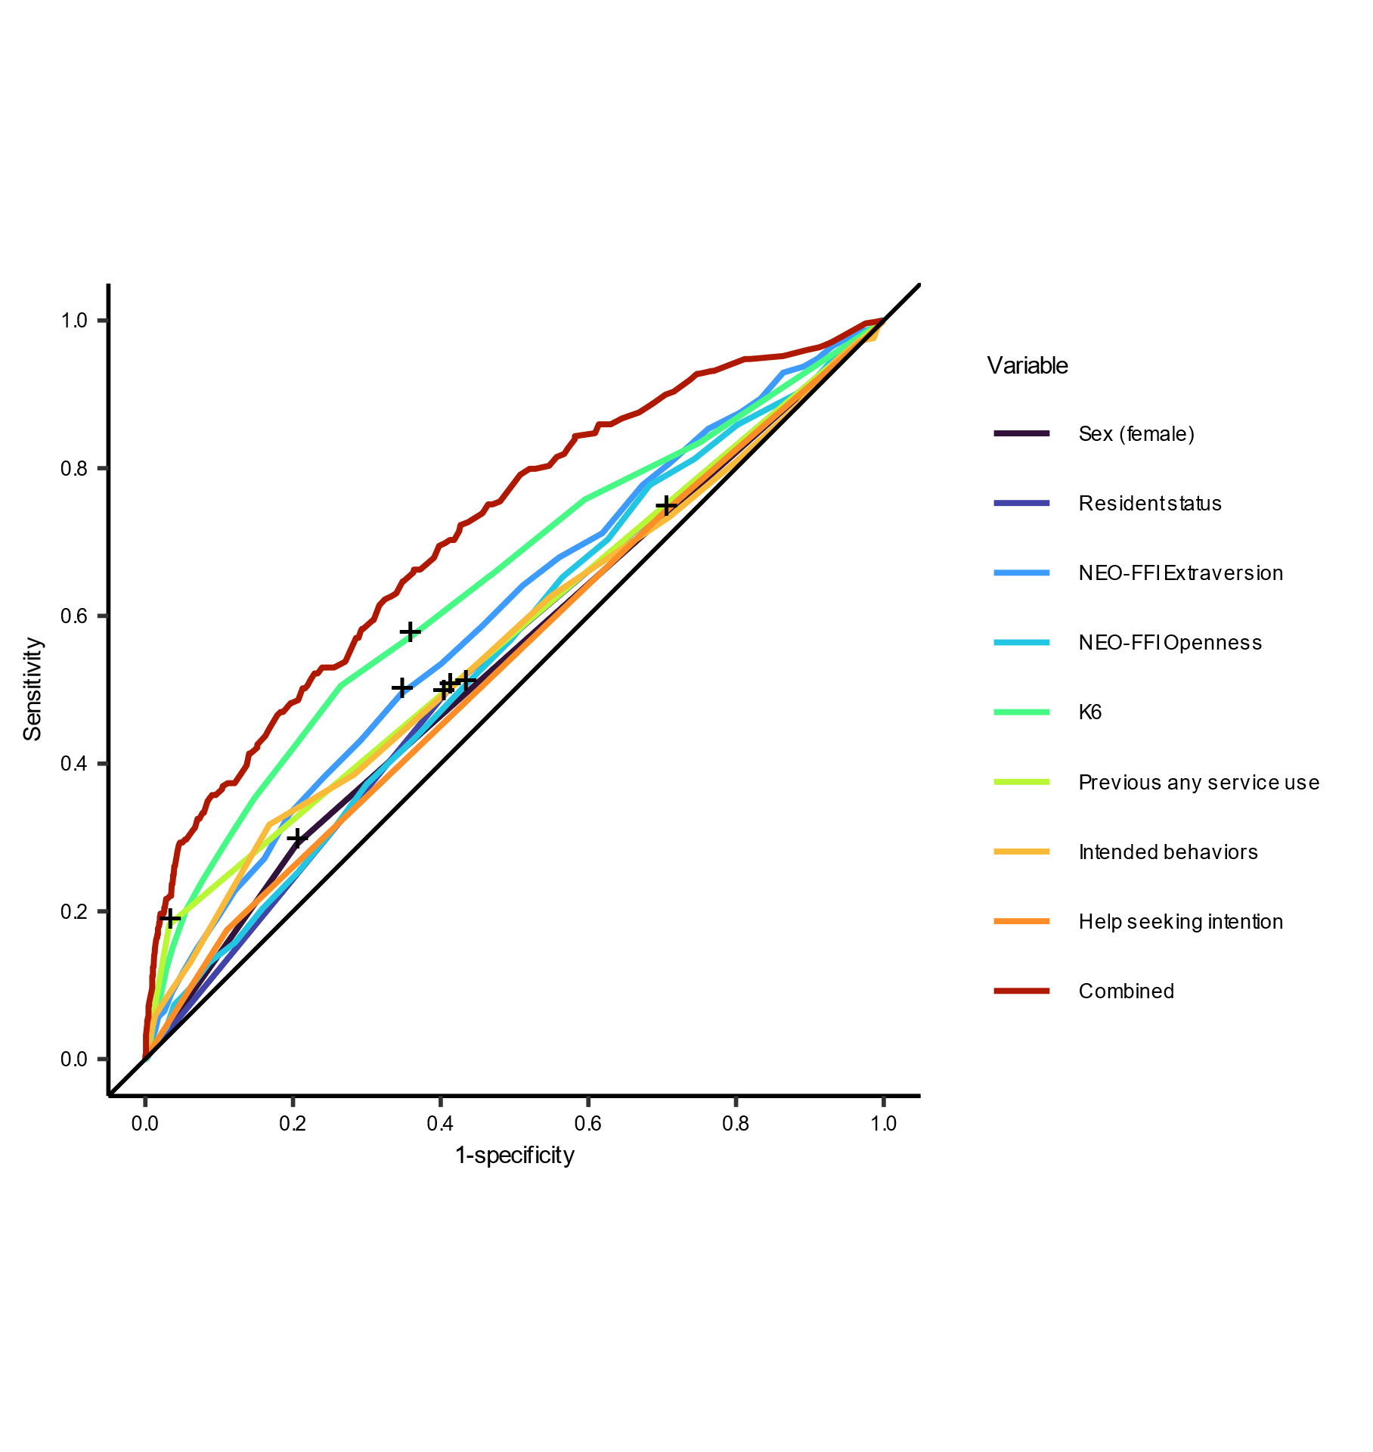

Supplementary Figure S1. ROC curve for psychiatric and psychological service use after admission.
Cross dots show the threshold for each variable using the top left criteria. The thresholds and predictive metrics of ROC curve analysis are shown in Supplementary Table S3.
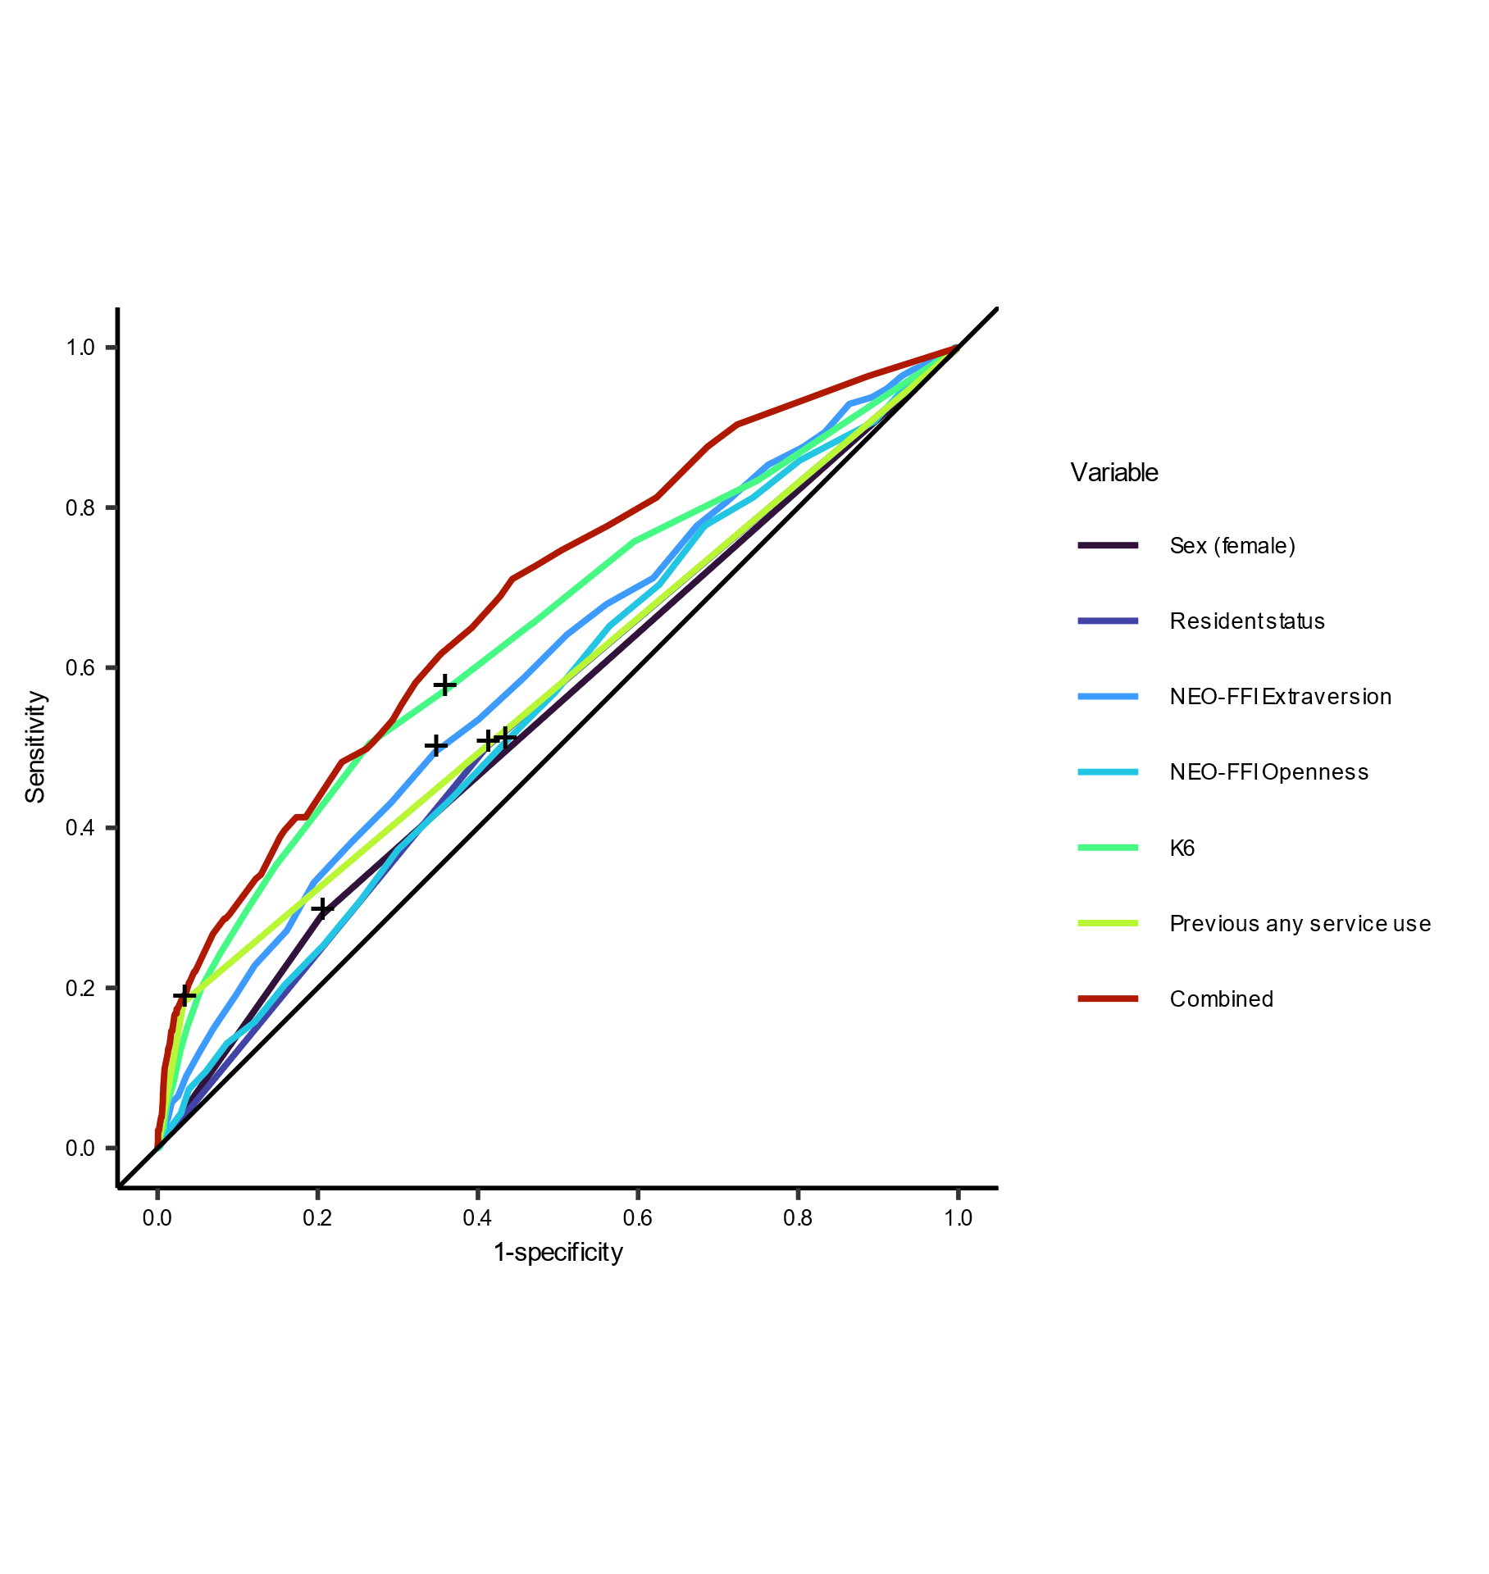

Supplementary Figure S2. ROC curve for psychiatric service use after admission.
Cross dots show the threshold for each variable using the top left criteria. The thresholds and predictive metrics of ROC curve analysis are shown in Supplementary Table S4.

Supplementary Tables

Supplementary Table S1. Cross-sectional logistic regression models for the experience of psychiatric service use.
 | Crude |  |  |  | Stepwise adjusted
 | OR | 95% CI |  | p | OR | 95% CI |  | p
Female (n, %) | 1.630 | 1.008 | 2.636 | 0.047 | 1.861 | 0.958 | 3.617 | 0.067
Age (mean, SD) | 1.708 | 1.377 | 2.119 | < 0.001 | 1.421 | 1.012 | 1.997 | 0.043
Students from abroad (n, %) | 0.835 | 0.114 | 6.141 | 0.86
Resident status (n, %)
Living with family and/or relatives | (ref)
Living alone or in dormitory | 1.208 | 0.778 | 1.874 | 0.40
Sleep time on weekdays (n, %)
Less than 6 hours | 1.118 | 0.648 | 1.931 | 0.69
Between 6 and 8 hours | (ref)
8 or more hours | 1.689 | 0.795 | 3.586 | 0.17
Sleep time on holidays (n, %)
Less than 6 hours | 0.901 | 0.277 | 2.924 | 0.86
Between 6 and 8 hours | (ref)
8 or more hours | 1.287 | 0.815 | 2.031 | 0.28
Exercise (n, %)
No exercise | 2.363 | 1.397 | 3.996 | 0.001 | 1.571 | 0.898 | 2.747 | 0.11
Once a month | 0.794 | 0.426 | 1.480 | 0.47 | 0.656 | 0.343 | 1.256 | 0.20
Once a week | (ref) |  |  |  | (ref)
Everyday | 1.352 | 0.625 | 2.929 | 0.44 | 1.273 | 0.556 | 2.915 | 0.57
NEO-FFI (mean, SD)
Neuroticism | 1.129 | 1.096 | 1.163 | < 0.001 | 1.069 | 1.017 | 1.124 | 0.009
Extraversion | 0.945 | 0.917 | 0.975 | < 0.001 | 0.946 | 0.904 | 0.990 | 0.017
Openness | 1.035 | 0.998 | 1.073 | 0.061
Agreeableness | 0.960 | 0.928 | 0.993 | 0.017
Conscientiousness | 0.952 | 0.924 | 0.981 | 0.001 | 0.977 | 0.936 | 1.019 | 0.28
K6 score (mean, SD) | 1.242 | 1.189 | 1.297 | < 0.001 | 1.124 | 1.039 | 1.216 | 0.004
Any PLE (n, %) | 4.811 | 2.721 | 8.507 | < 0.001 | 2.475 | 1.110 | 5.519 | 0.027
AQ-10 score (mean, SD) | 1.173 | 1.061 | 1.297 | 0.002 | 0.803 | 0.686 | 0.939 | 0.006
SSQ6 (mean, SD)
Number | 0.967 | 0.947 | 0.987 | 0.001
Satisfaction | 0.946 | 0.919 | 0.974 | < 0.001 | 0.958 | 0.916 | 1.002 | 0.060
Stigma measures
Feasible knowledge | 0.922 | 0.883 | 0.962 | < 0.001 | 0.969 | 0.924 | 1.016 | 0.195
Reported behaviors | 2.089 | 1.512 | 2.886 | < 0.001 | 1.691 | 1.124 | 2.545 | 0.012
Intended behaviors | 1.100 | 1.000 | 1.210 | 0.049
Help-seeking intension | 1.742 | 1.205 | 2.517 | 0.003 | 1.950 | 1.322 | 2.876 | 0.001
Easy to talk to others | 0.997 | 0.841 | 1.180 | 0.96
Bold shows significant (p < .05).

Supplementary Table S2. Logistic regression models for psychiatric service use after admission.
 | Crude |  |  |  | Stepwise adjusted
 | OR | 95% CI |  | p | OR | 95% CI |  | p
Female (n, %) | 1.260 | 0.943 | 1.682 | 0.12 | 1.461 | 0.996 | 2.144 | 0.053
Age (mean, SD) | 1.116 | 0.936 | 1.332 | 0.22
Students from abroad (n, %) | 1.458 | 0.598 | 3.553 | 0.41
Resident status (n, %)
Living with family and/or relatives | (ref) |  |  |  | (ref)
Living alone or in dormitory | 1.565 | 1.216 | 2.014 | < 0.001 | 1.667 | 1.197 | 2.320 | 0.002
Sleep time on weekdays (n, %)
Less than 6 hours | 1.452 | 1.077 | 1.957 | 0.014
Between 6 and 8 hours | (ref)
8 or more hours | 1.583 | 0.976 | 2.568 | 0.063
Sleep time on holidays (n, %)
Less than 6 hours | 1.728 | 0.995 | 3.002 | 0.052
Between 6 and 8 hours | (ref)
8 or more hours | 1.125 | 0.856 | 1.479 | 0.40
Exercise (n, %)
No exercise | 1.603 | 1.166 | 2.205 | 0.004
Once a month | 0.925 | 0.671 | 1.275 | 0.63
Once a week | (ref)
Everyday | 1.25 | 0.79 | 1.97 | 0.33
NEO-FFI (mean, SD)
Neuroticism | 1.074 | 1.057 | 1.092 | < 0.001 | 1.033 | 1.006 | 1.060 | 0.017
Extraversion | 0.945 | 0.928 | 0.963 | < 0.001 | 0.961 | 0.937 | 0.984 | 0.001
Openness | 1.033 | 1.011 | 1.055 | 0.004 | 1.051 | 1.021 | 1.082 | < 0.001
Agreeableness | 0.965 | 0.946 | 0.985 | 0.001
Conscientiousness | 0.962 | 0.945 | 0.979 | < 0.001 | 0.977 | 0.953 | 1.001 | 0.063
K6 score (mean, SD) | 1.160 | 1.126 | 1.195 | < 0.001 | 1.056 | 1.005 | 1.109 | 0.031
Any PEs (n, %) | 2.882 | 1.875 | 4.431 | < 0.001 | 1.611 | 0.918 | 2.826 | 0.096
AQ-10 score (mean, SD) | 1.160 | 1.093 | 1.231 | < 0.001
SSQ6 (mean, SD)
Number | 0.979 | 0.967 | 0.991 | 0.001
Satisfaction | 0.964 | 0.945 | 0.983 | < 0.001
The experience of service use | 10.926 | 6.503 | 18.358 | < 0.001 | 7.299 | 3.622 | 14.712 | < 0.001
Stigma measures
Feasible knowledge | 0.966 | 0.942 | 0.990 | 0.007
Reported behaviors | 1.310 | 1.016 | 1.688 | 0.037
Intended behaviors | 1.063 | 1.007 | 1.123 | 0.028
Help-seeking intension | 1.068 | 0.898 | 1.269 | 0.46
Easy to talk to others | 0.978 | 0.888 | 1.078 | 0.65
Bold shows significant (p < .05).

Supplementary Table S3. Thresholds and predictive metrics of the ROC curve analysis for psychiatric and psychological service use.
 | Threshold | TPR | FPR | TNR | FNR | NPV | PPV | AUC
Sex | 1.5 | 0.29 | 0.20 | 0.80 | 0.71 | 0.85 | 0.22 | 0.543
Resident status | 1.5 | 0.50 | 0.41 | 0.59 | 0.50 | 0.85 | 0.20 | 0.545
Extraversion | 22.5 | 0.49 | 0.35 | 0.65 | 0.51 | 0.86 | 0.22 | 0.598
Openness | 31.5 | 0.51 | 0.43 | 0.57 | 0.49 | 0.85 | 0.19 | 0.555
K6 | 3.8 | 0.57 | 0.36 | 0.64 | 0.43 | 0.88 | 0.24 | 0.642
Previous service use | 0.5 | 0.18 | 0.03 | 0.97 | 0.82 | 0.85 | 0.53 | 0.575
Behavioral intention | 13.5 | 0.49 | 0.40 | 0.60 | 0.51 | 0.85 | 0.21 | 0.564
Help-seeking intention | 3.5 | 0.74 | 0.70 | 0.30 | 0.26 | 0.84 | 0.18 | 0.539
Combined | 0.153 | 0.66 | 0.36 | 0.64 | 0.34 | 0.90 | 0.27 | 0.713
Abbreviations: TPR, true positive rate; FPR, false positive rate; TNR, true negative rate; FNR, false negative rate; NPV, negative predictive value; PPV, positive predictive value; AUC, area under the curve.

Supplementary Table S4. Thresholds and predictive metrics of the ROC curve analysis for psychiatric service use after admission.
 | Threshold | TPR | FPR | TNR | FNR | NPV | PPV | AUC
Resident status | 1.5 | 0.52 | 0.41 | 0.59 | 0.48 | 0.89 | 0.16 | 0.556
Neuroticism | 29.5 | 0.56 | 0.32 | 0.68 | 0.44 | 0.91 | 0.21 | 0.660
Extraversion | 22.5 | 0.51 | 0.35 | 0.65 | 0.49 | 0.90 | 0.18 | 0.608
Openness | 31.5 | 0.51 | 0.44 | 0.56 | 0.49 | 0.89 | 0.15 | 0.551
Conscientiousness | 25.5 | 0.54 | 0.41 | 0.59 | 0.46 | 0.90 | 0.16 | 0.581
K6 | 4.5 | 0.55 | 0.27 | 0.73 | 0.45 | 0.92 | 0.23 | 0.656
Previous psychiatric service use | 0.5 | 0.13 | 0.01 | 0.99 | 0.87 | 0.88 | 0.59 | 0.559
Combined | 0.118 | 0.64 | 0.32 | 0.68 | 0.35 | 0.93 | 0.23 | 0.715
Abbreviations: TPR, true positive rate; FPR, false positive rate; TNR, true negative rate; FNR, false negative rate; NPV, negative predictive value; PPV, positive predictive value; AUC, area under the curve.

