Supplementary Information for “Impact of coupled extreme water and heat stress on global crop yield under future climate change”

Supplementary Figures
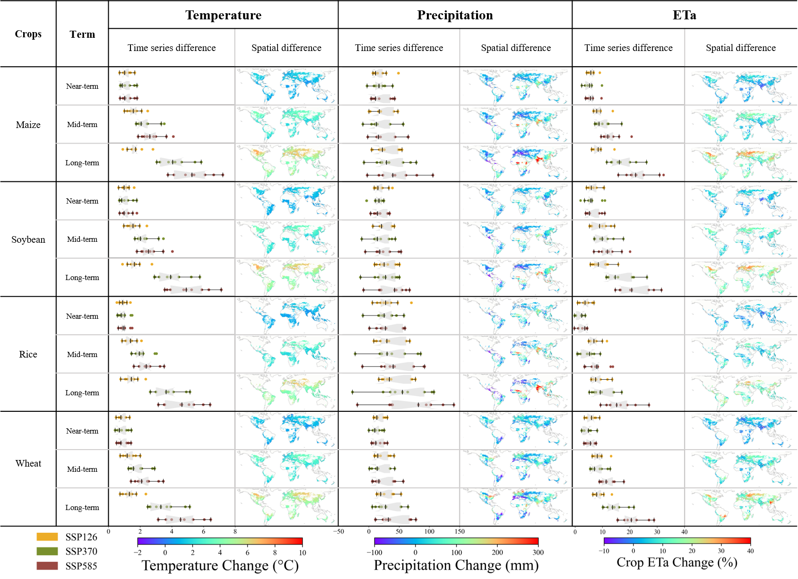

Figure. S1 Future climate change during the growing seasons of the four major global crops. Three future time periods were considered: Near-term (2020 - 2040), Mid-term (2040 - 2070), and Long-term (2070 - 2100) with the Base-term (1990 - 2020). The box plot indicates the confidence intervals around the median, while the scatter points represent individual values from different General Circulation Models (GCMs). The spatial difference map shows the mean differences between the future time periods and the Base-term across the GCMs.

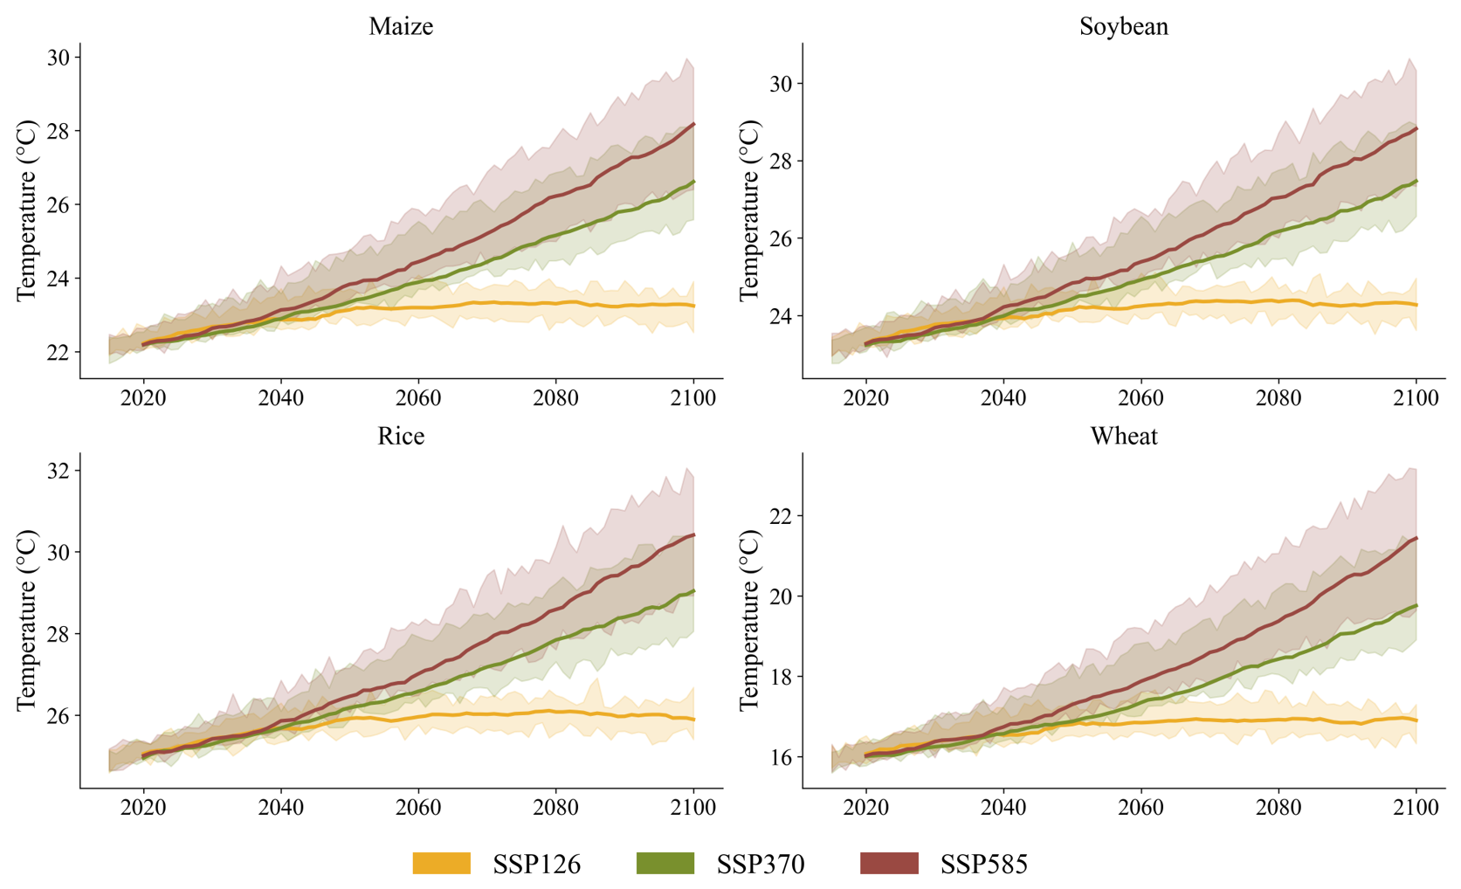

Fig S2: Temperature Change Differences Across Crops Under Three Climate Scenarios. This figure depicts the average annual temperature changes from 2020 to 2100 for four key crops under three climate scenarios: SSP 1-26 (yellow), SSP 3-70 (green), and SSP 5-85 (red). The shaded areas represent the range of values from different GCMs, while the solid lines indicate the median smoothed averages with a 6-year rolling window.
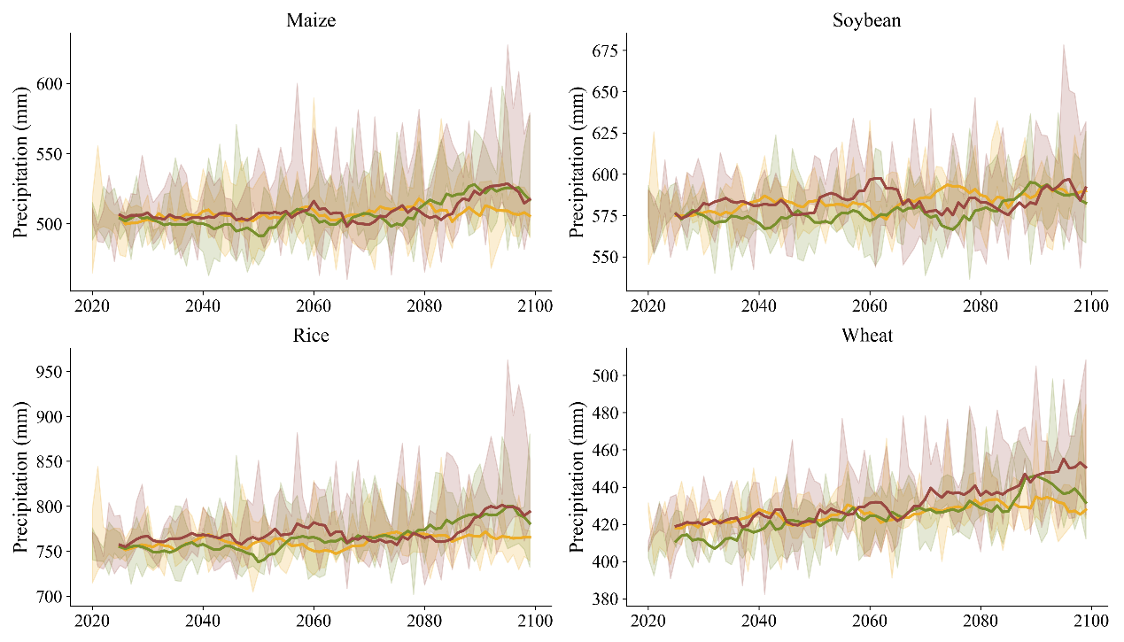
Fig S3: Precipitation Change Differences Across Crops Under Three Climate Scenarios. Similar to Figure S1 but for precipitation
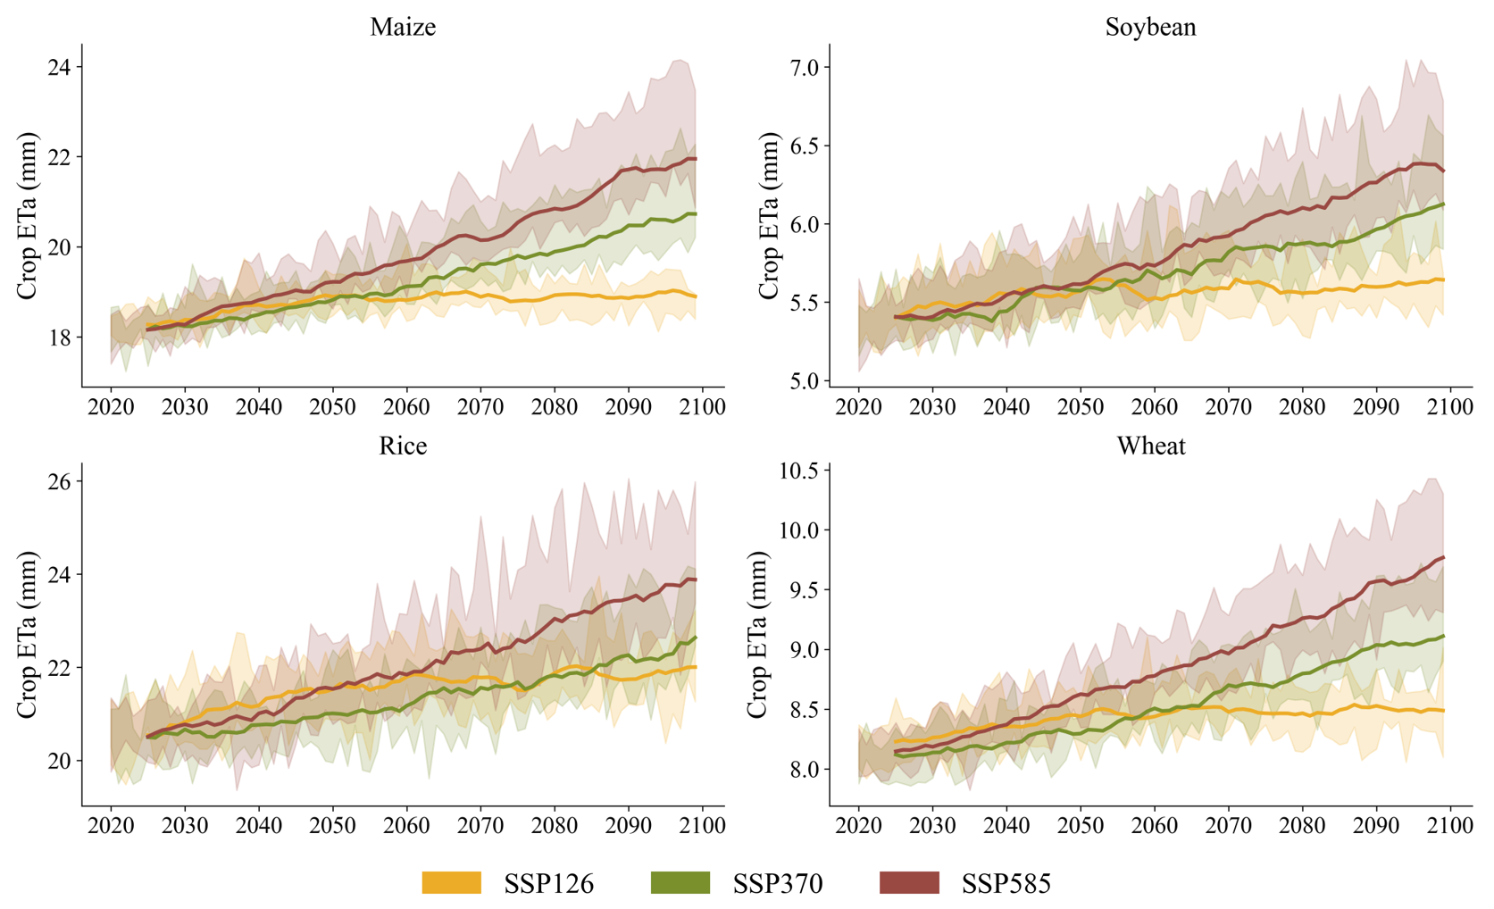
Fig S4: Actual evapotranspiration (ETa) Change Differences Across Crops Under Three Climate Scenarios. Similar to Figure S1 but for crop ETa.
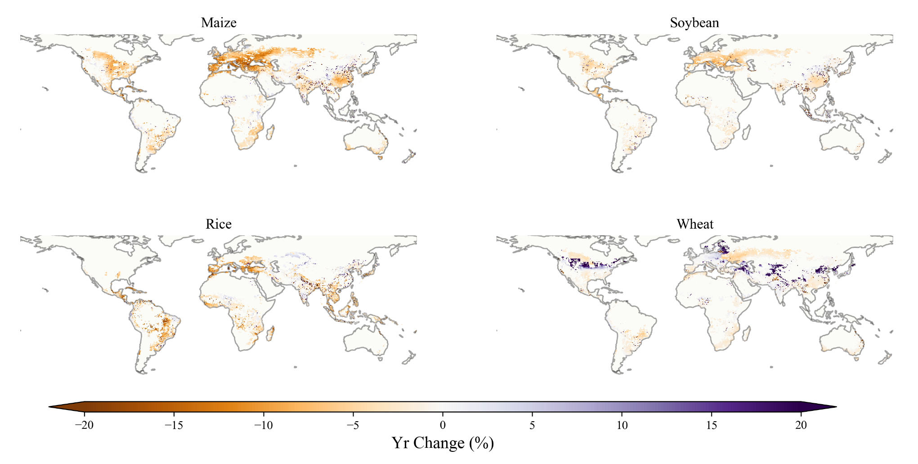

Fig S5: Global relative yield change in long term (2070 - 2100). Median GCM projections under SSP 5-85 scenario. 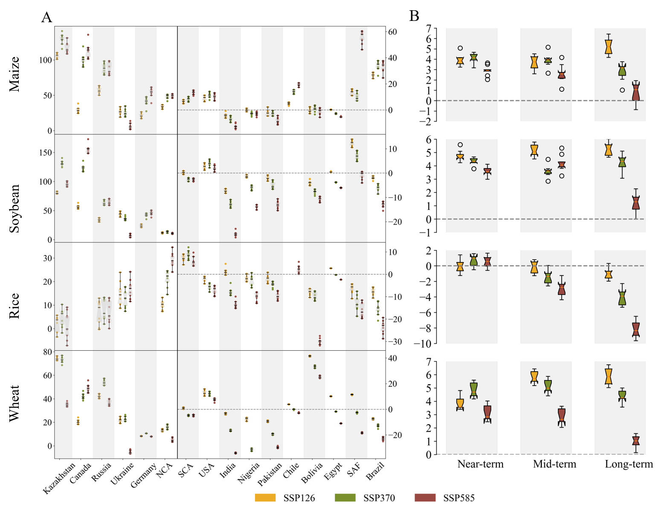
Figure S6: Yield relative Changes for Four Major Crops. A shows regional yield relative change in 2070 - 2100 compared with historical baseline(1980 - 2019). On each boxplot, the left side corresponds to the selected mid- to high-latitude countries. In this context, China is divided into North China (NCA) and South China (SCA) based on the 40°N latitude,and SAF represents South Africa. B presents the boxplots of yield changes for the four major crops under three future scenarios, with the horizontal line within the box indicating the median GCM.
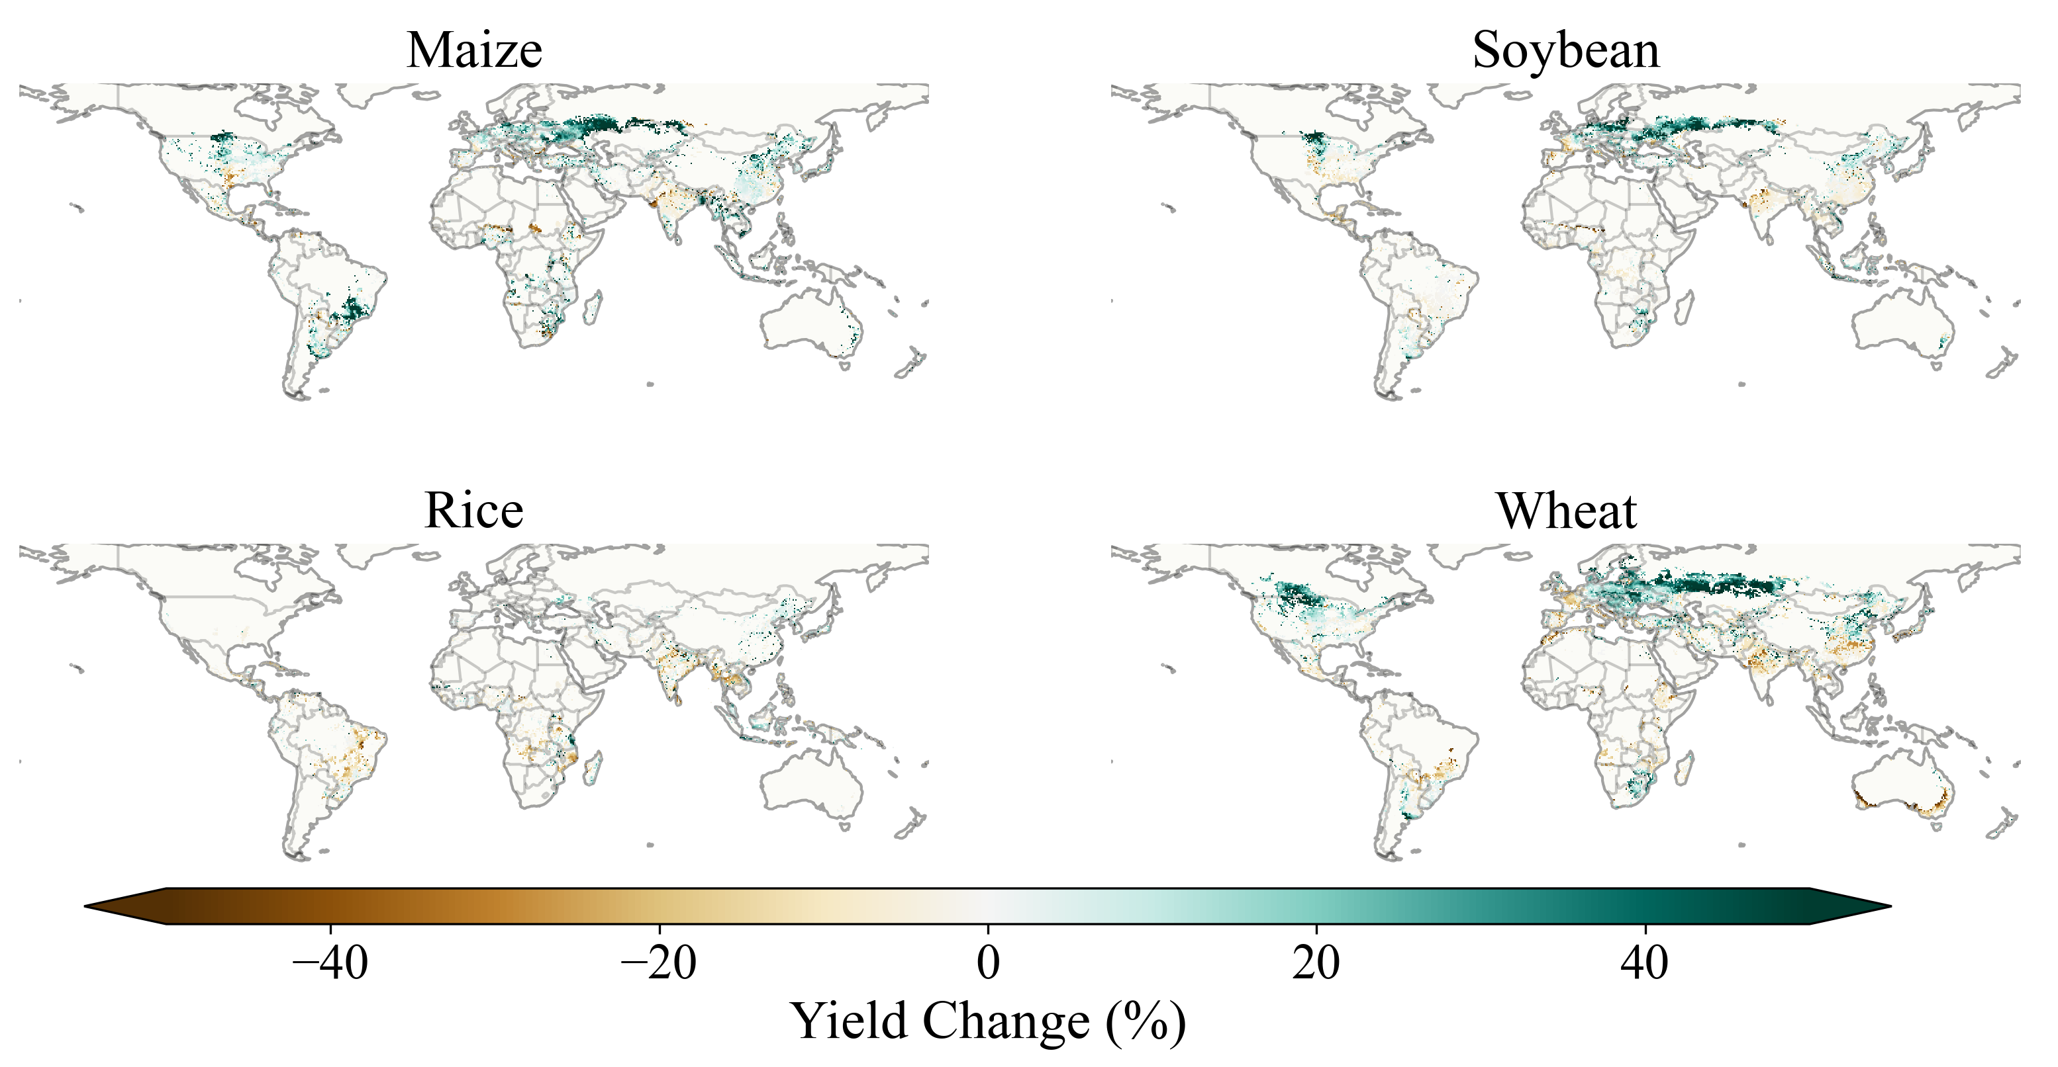 Fig S7: Global yield change in near term (2020 - 2040). Median GCM projections under SSP 1-26 scenario.
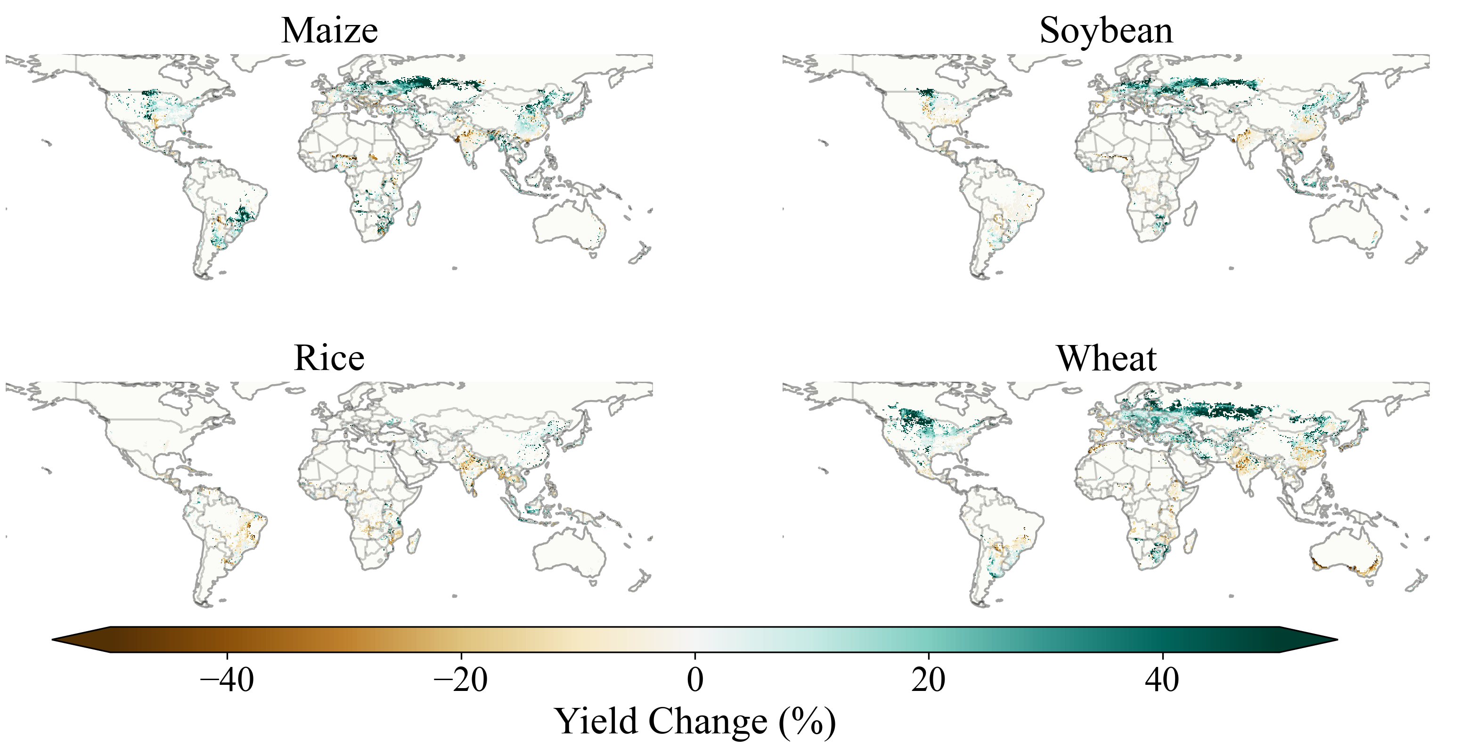 Fig S8: Global yield change in mid term(2040 - 2070). Median GCMs projections under SSP 1-26 scenario.
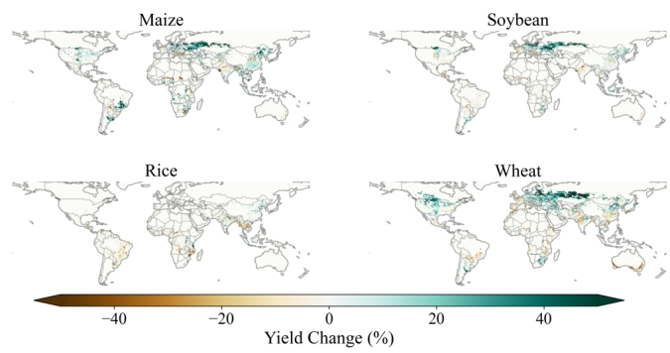
Fig S9: Global yield change in long term. Median GCMs projections under SSP 1-26 scenario. 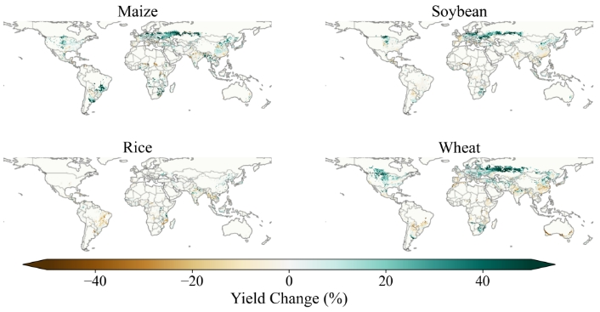
Fig S10 Global yield change in near term. Median GCMs projections under SSP 3-70 scenario.
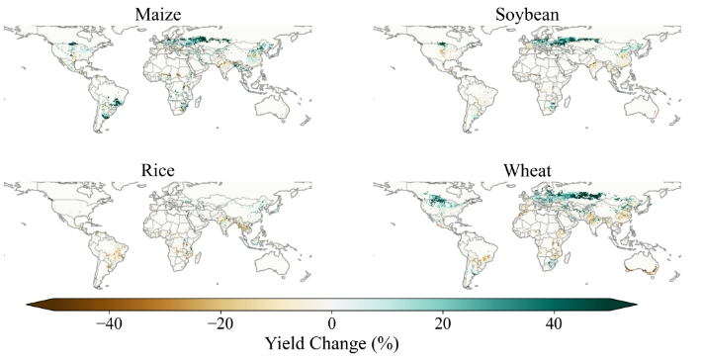
Fig S11: Global yield change in mid term. Median GCMs projections under SSP 3-70 scenario.
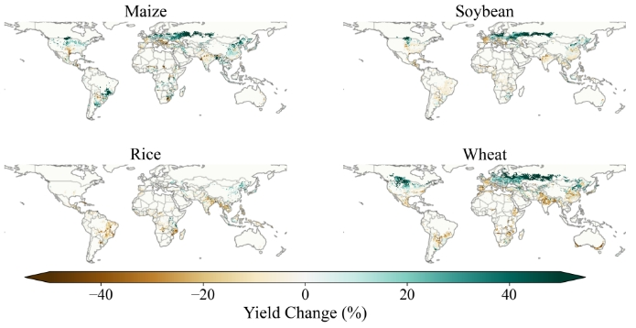
Fig S12: Global yield change in long term. Median GCMs projections under SSP 3-70 scenario.
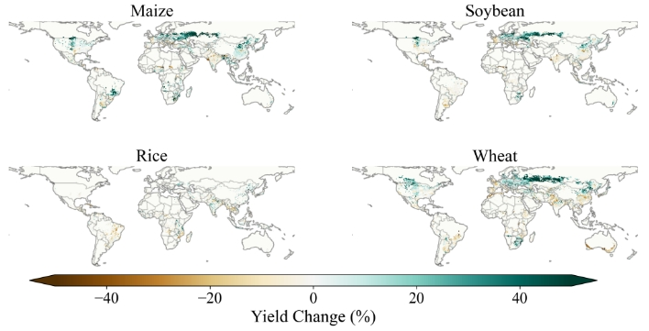
Fig S13: Global yield change in near term. Median GCMs projections under SSP 5-85 scenario.

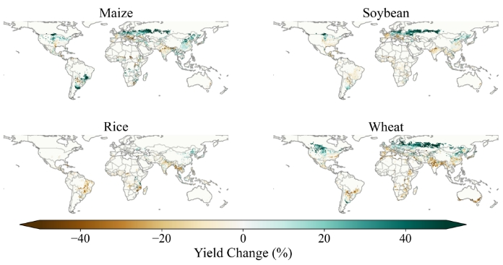
Fig S14: Global yield change in mid term. Median GCMs projections under SSP 5-85 scenario.
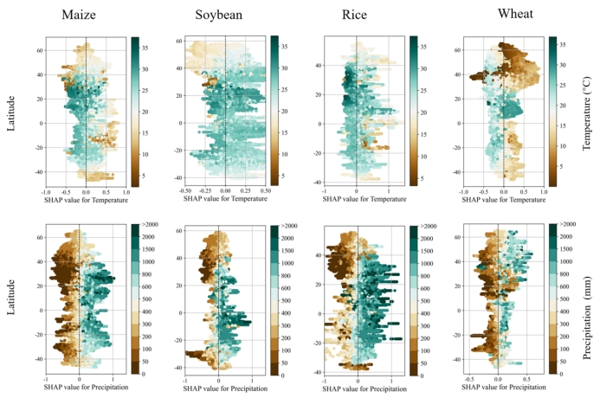
Fig S15: Observed vs. simulated yield anomalies. Similar to Figure 4 but for SSP 1-26.

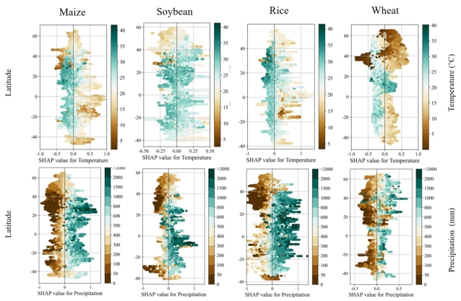
Fig S16: Observed vs. simulated yield anomalies. Similar to Figure 4 but for SSP 3-70.
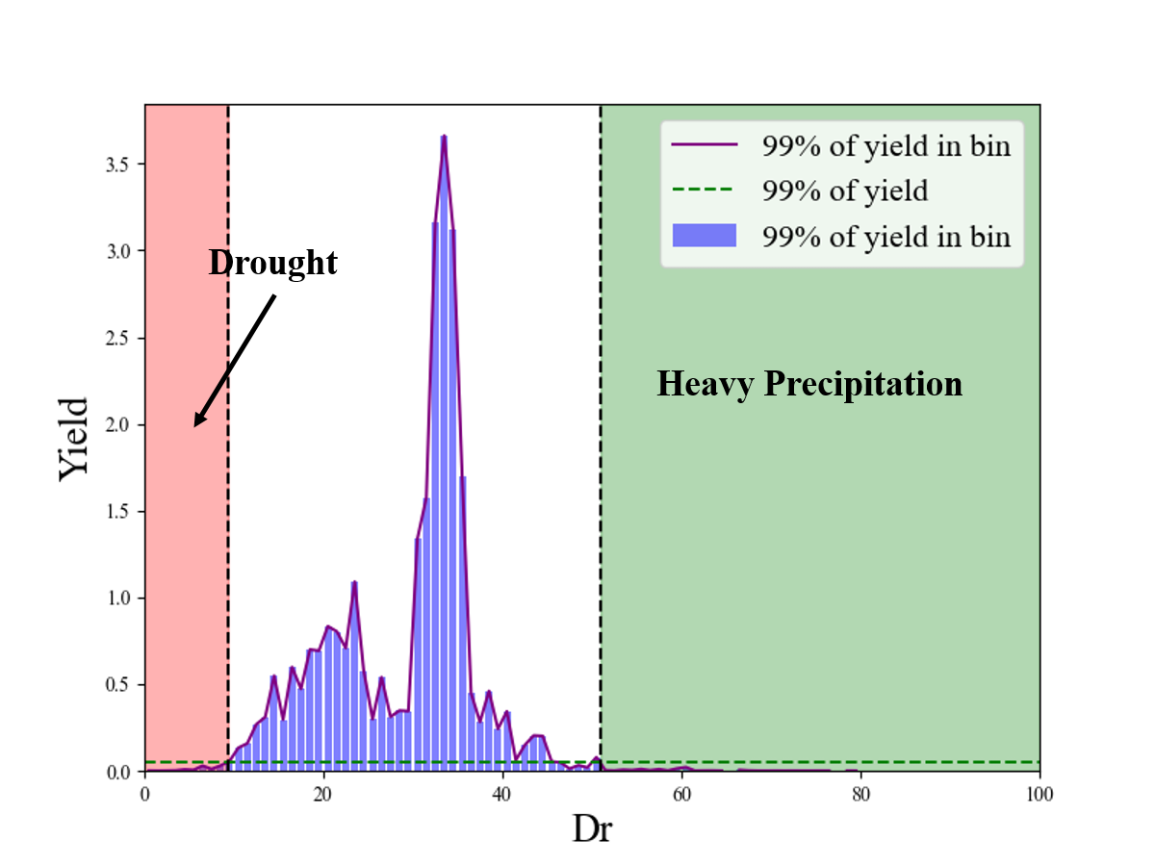
Fig S17: A sample of characterizing extreme weather events. The figure shows the relationship between the daily drought index and crop yield for a specific grid point in Northeast China during the period 1990 - 2019. The horizontal green dashed line represents the average yield, while the vertical black dashed line divides the crop growing season into three states based on the drought index: from left to right, these states are drought, normal, and heavy precipitation. The purple line shows the relationship between the drought index and yield within each drought index range(bin=0.1).
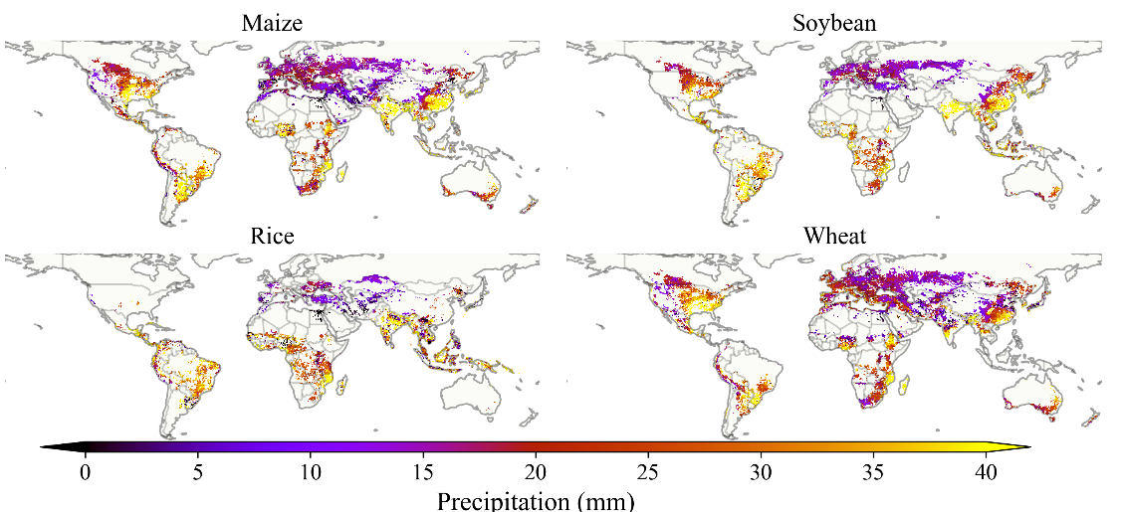
Fig S18: Spatial Averaged Distribution of Daily Precipitation during Extreme Heavy Precipitation Events under Historical baseline.
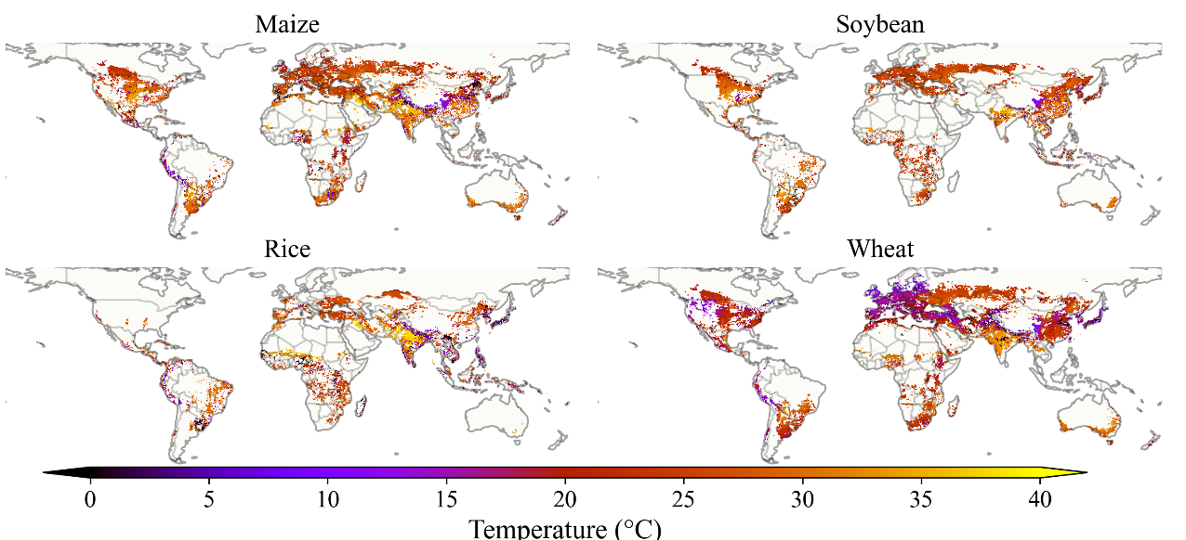
Fig S19: Spatial Averaged Distribution of Daily Temperature during Extreme Drought Events under Historical baseline.
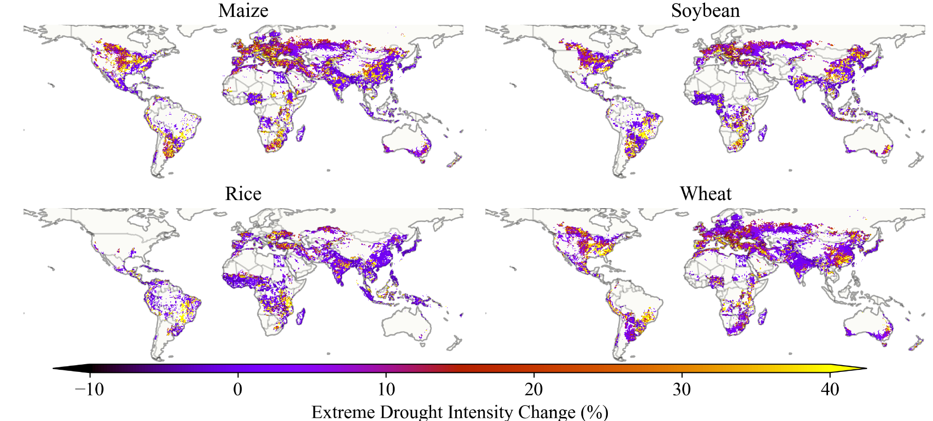
Fig S20: Spatial Distribution of Extreme Drought Intensity Change in long term under SSP 5-85 Scenario.

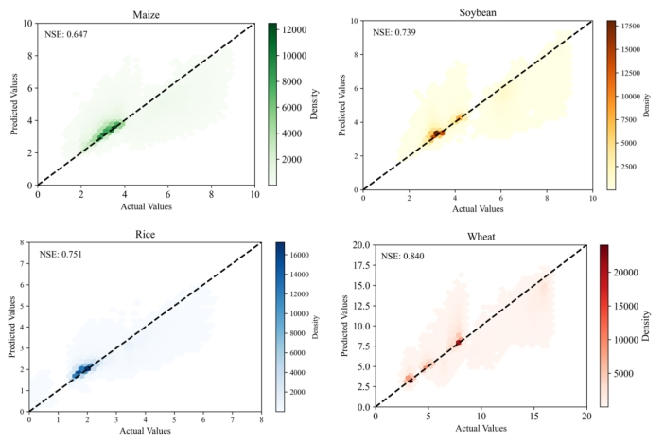
Fig S21: Hexbin plot of the test set fitted using the LightGBM model for four crops. The dataset was divided into training (70%), validation (10%), and testing (20%) subsets. The Nash-Sutcliffe Efficiency (NSE) values for all four crops exceed 0.6, demonstrating strong performance. In the hexbin plot, the intensity of the colors represents the density of data points within each hexagonal bin. Darker shades indicate a higher concentration of observations, while lighter shades signify lower concentrations.
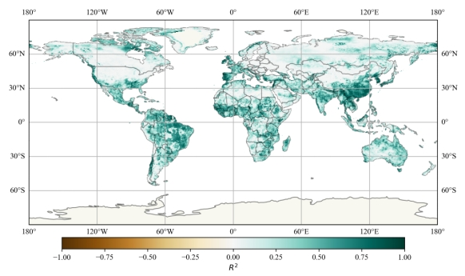
Fig S22: Spatial Distribution of Runoff Validation.
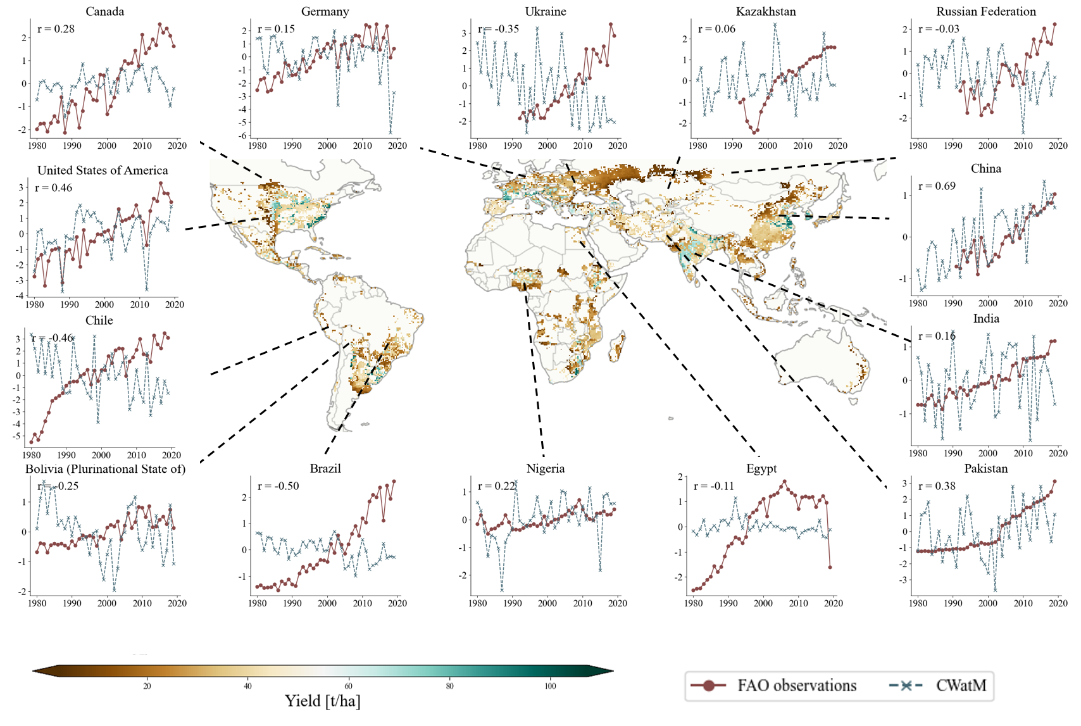
Fig S23: Observed vs. simulated yield anomalies for Maize in 1990 - 2019.
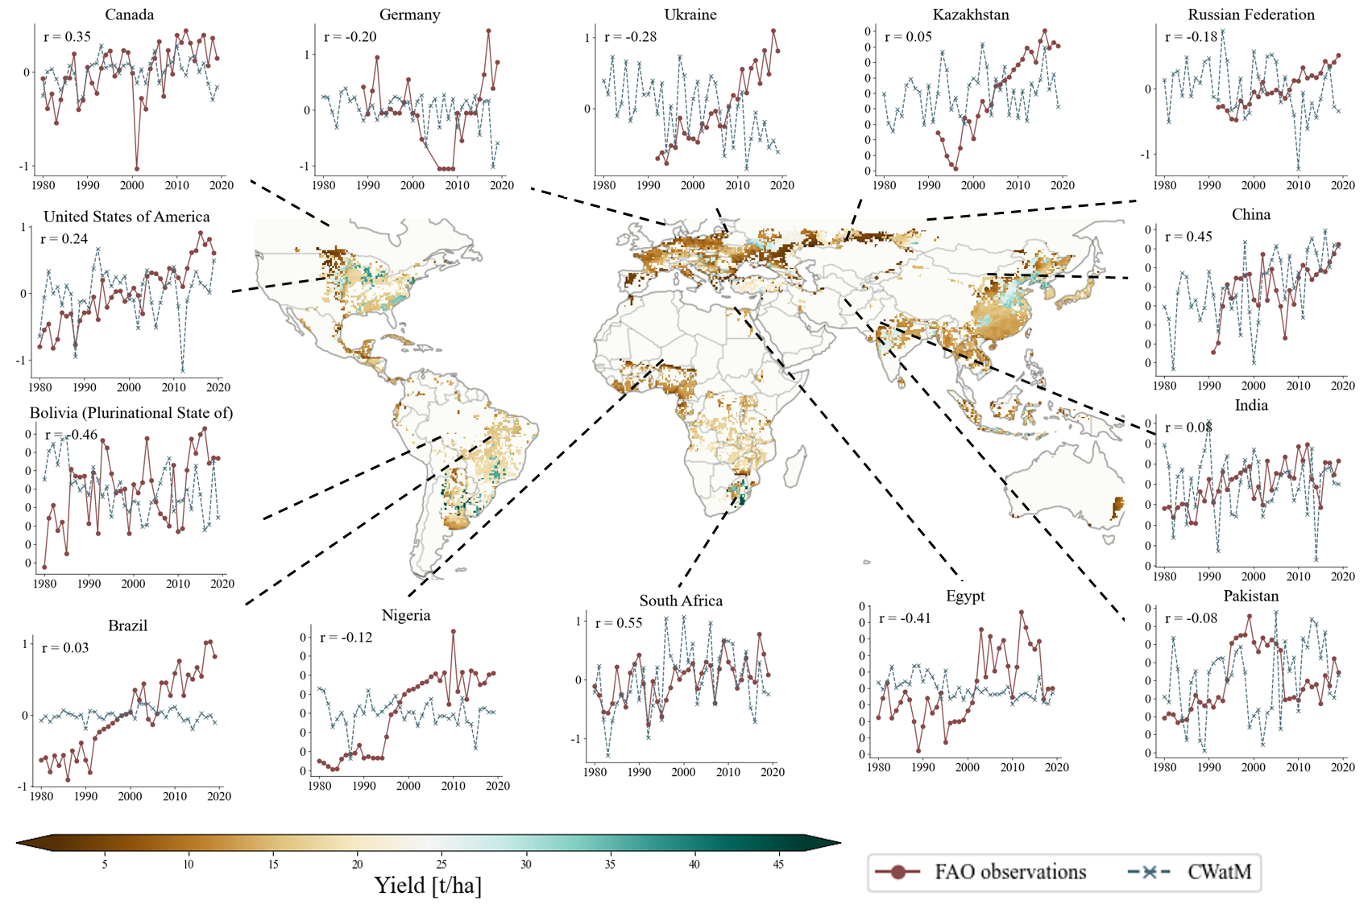
Fig S24: Observed vs. simulated yield anomalies for soybean.
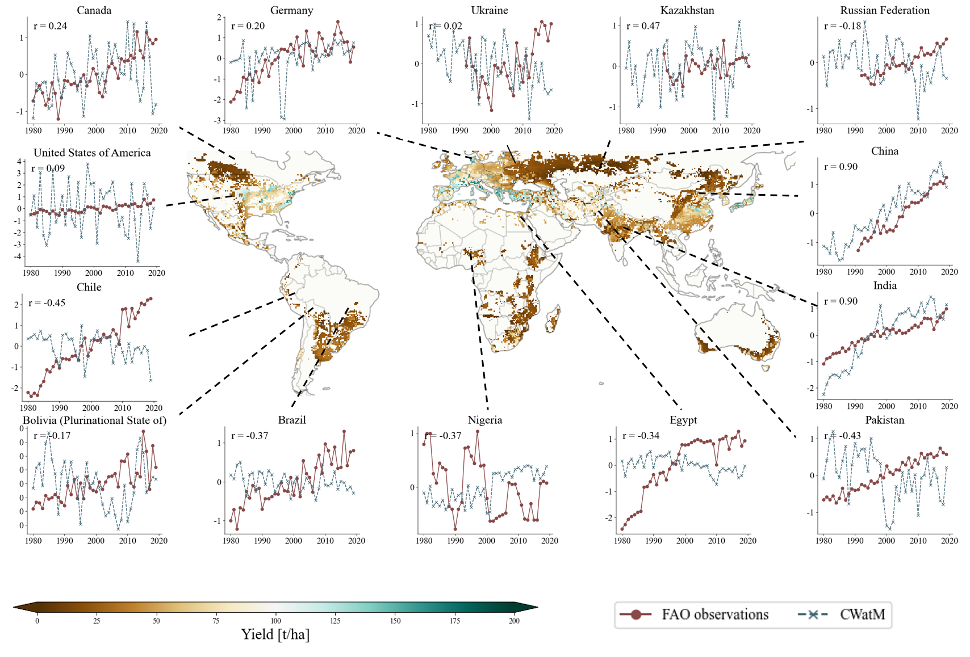
Fig S25: Observed vs. simulated yield anomalies for wheat.

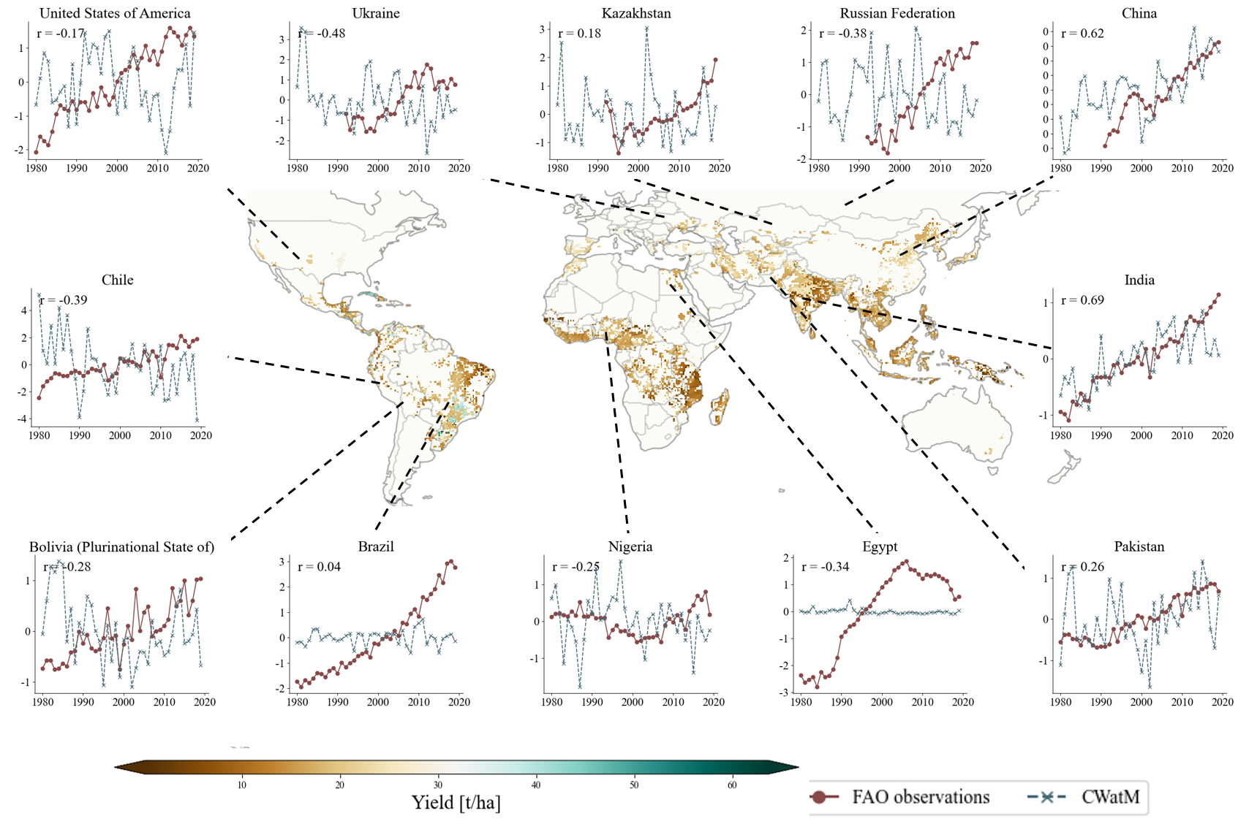
Fig S26: Observed vs. simulated yield anomalies for rice.

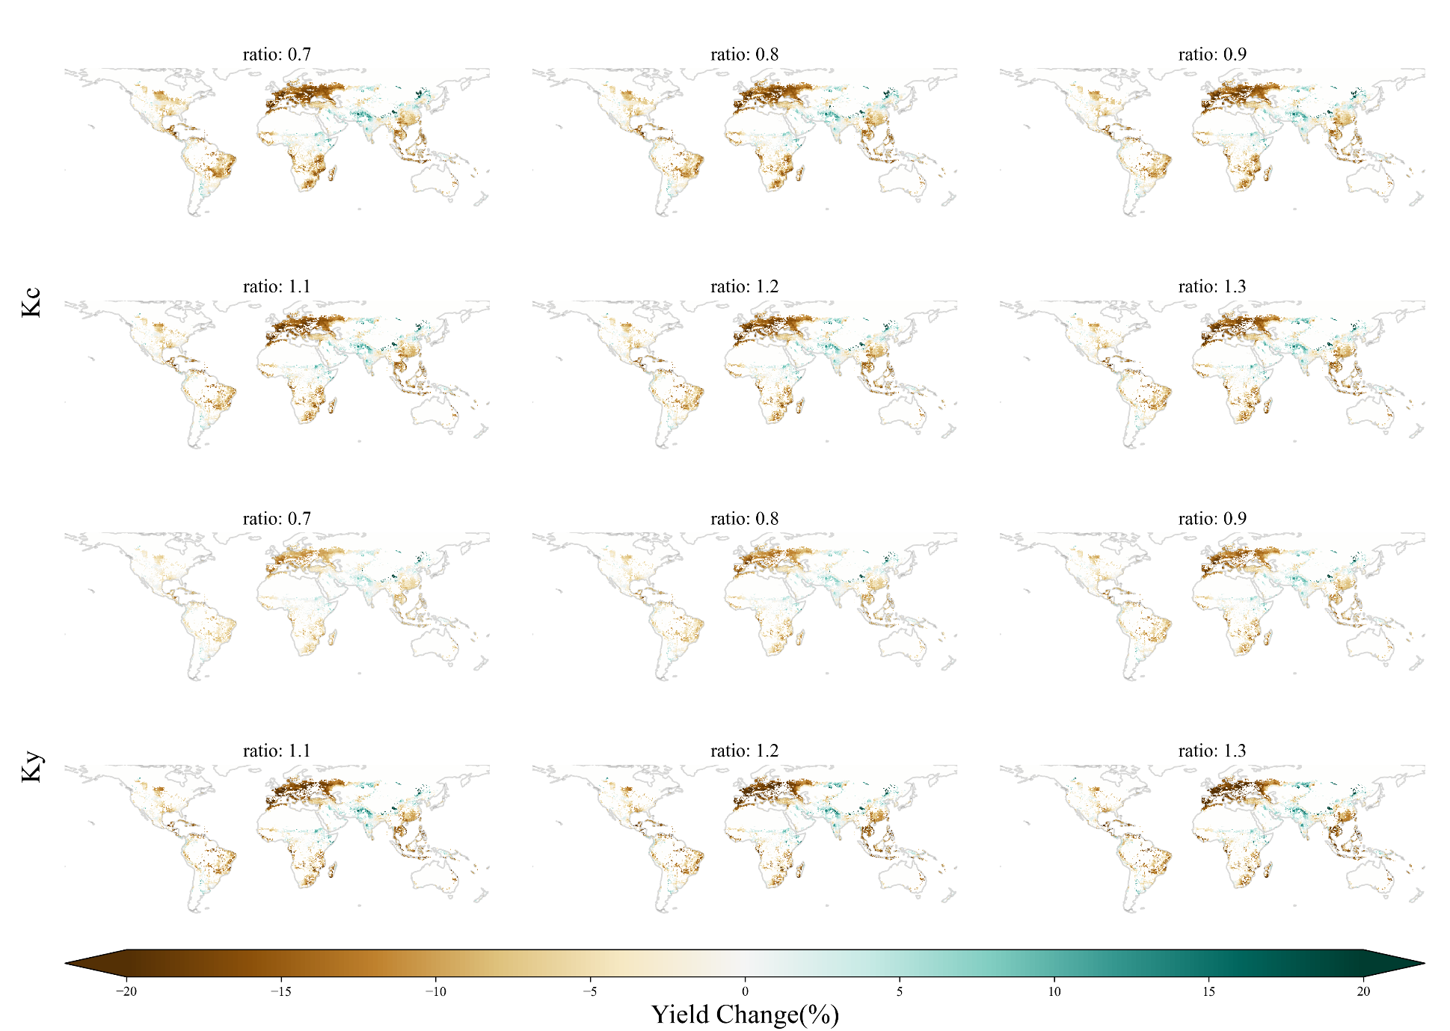
Fig S27:. Spatial distribution of crop yield changes under different multiples of two coefficients.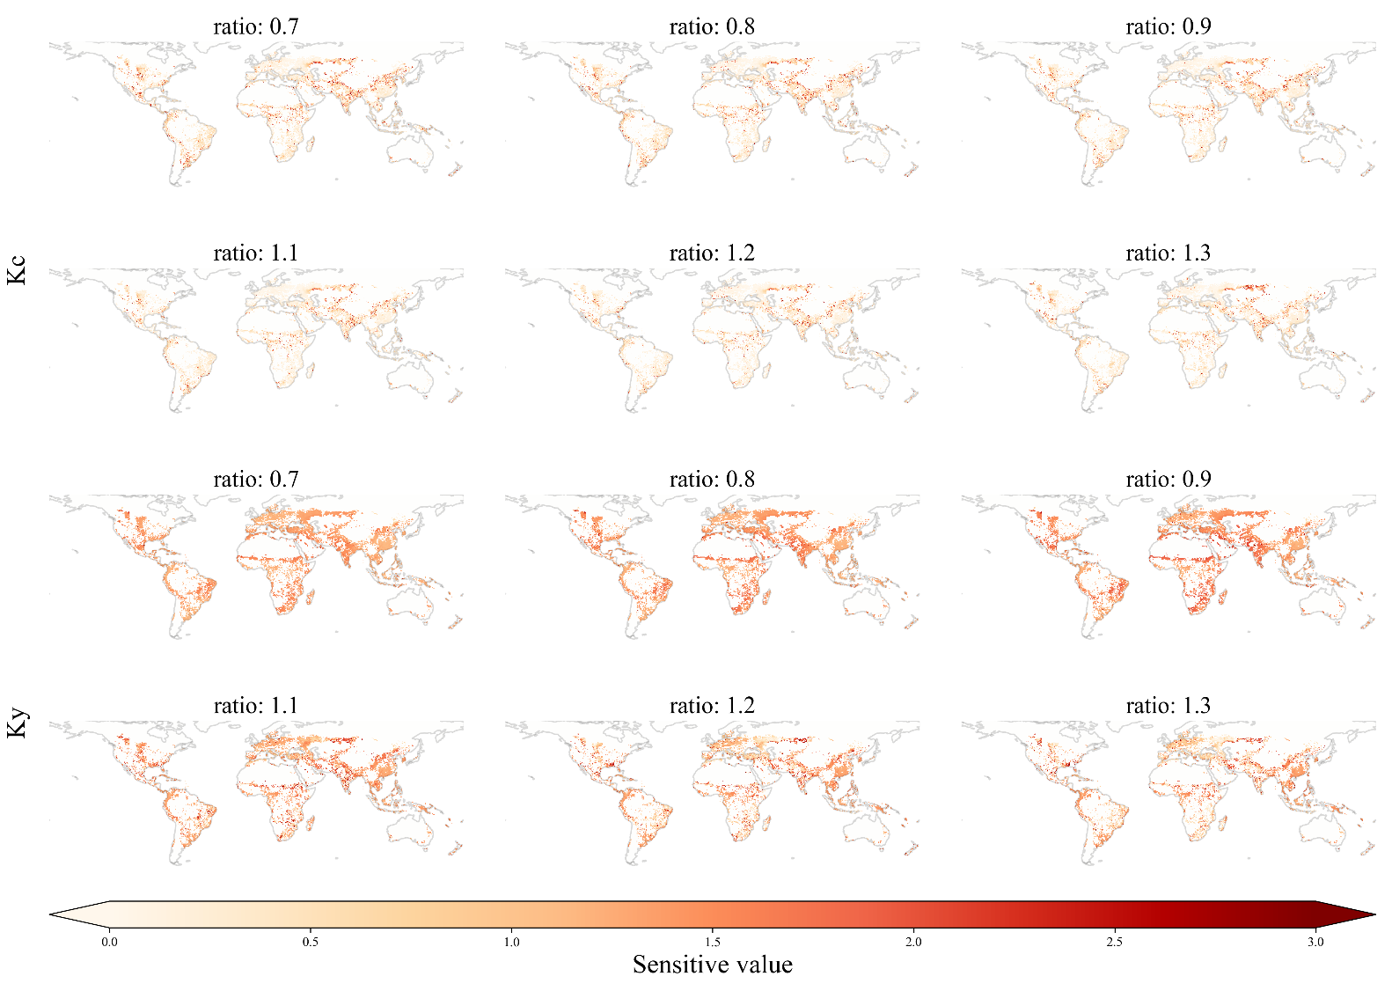
Fig S28: Spatial distribution diagram of sensitivity changes of two coefficients at different ratios.

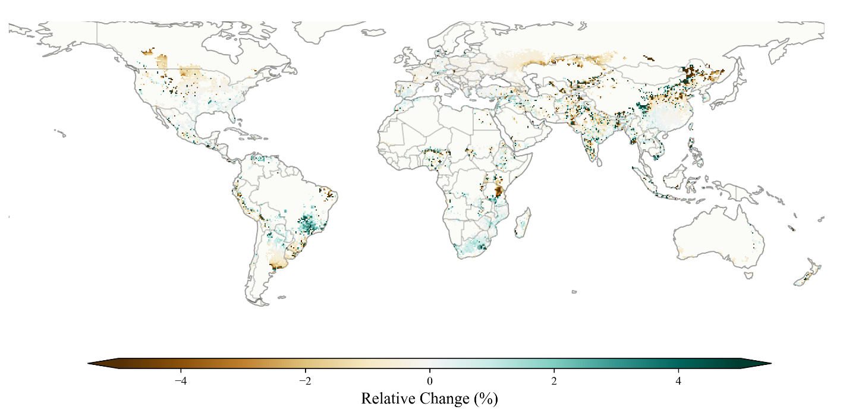
Fig S29: Spatial distribution of relative yield changes when the growth cycle changes by 1 month.

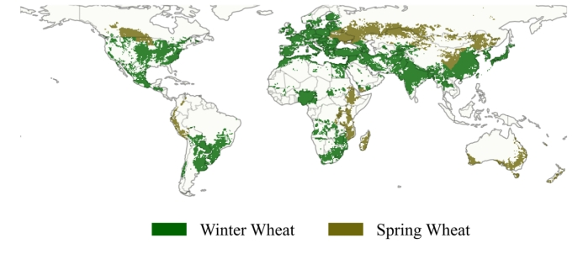
Fig S30: Spatial distribution map of spring and winter wheat.
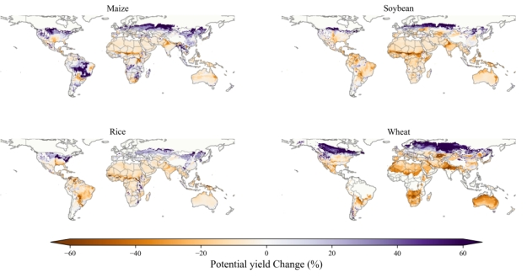
Fig S31: Projected Changes in Potential Crop Yields under High Input Levels in the RCP 8.5 Scenario.
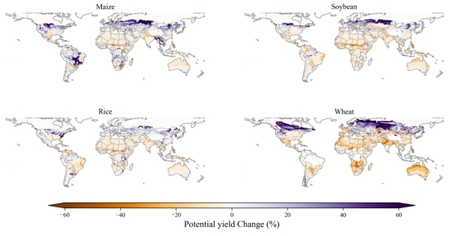
Fig S32: Projected Changes in Potential Crop Yields under High Input Levels in the RCP 6.0 Scenario.
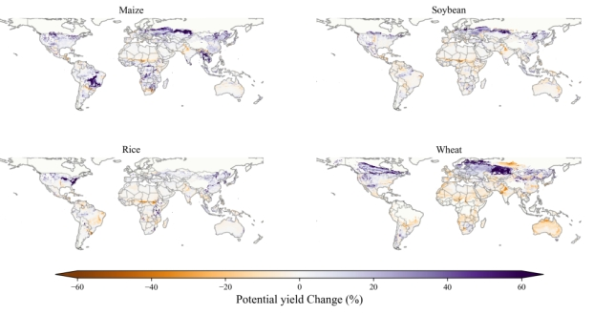
Fig S33: Projected Changes in Potential Crop Yields under High Input Levels in the RCP 2.6 Scenario.

Supplementary Tables
Table S1: Overview of CMIP6 General Circulation Models (GCMs) and the observed GWSP3 dataset used in this Study. GCMs are downscaled and bias-adjusted by ISIMIP (ISIMIP3BASD v2.5.0 and W5E5 v2.0).
GCM | Member | Data Coverage | Spin up
GSWP3 | - | 1975-2019 | 5 year
CanESM5 | r1i1p1f1 | 2015-2100 | 5 year
CNRM-CM6-1 | r1i1p1f2 | 2015-2100 | 5 year
CNRM-ESM2-1 | r1i1p1f2 | 2015-2100 | 5 year
EC-Earth3 | r1i1p1f1 | 2015-2100 | 5 year
GFDL-ESM4 | r1i1p1f1 | 2015-2100 | 5 year
IPSL-CM6A-LR | r1i1p1f1 | 2015-2100 | 5 year
MIROC6 | r1i1p1f1 | 2015-2100 | 5 year
MPI-ESM1-2-HR | r1i1p1f1 | 2015-2100 | 5 year
UKESM1-0-LL | r1i1p1f2 | 2015-2100 | 5 year

Table S2: Parameters for Selected Crops. By FAO and GAFZ and many other crop model.
Crop | Planting month | GS1 | GS2 | GS3 | GS4 | KC1 | KC2 | KC3 | KC4 | KY1 | KY2 | KY3 | KY4
wwh_sou | 6 | 2 | 2 | 1 | 1 | 0.4 | 0.775 | 1.15 | 0.25 | 0.2 | 0.2 | 0.65 | 0.2
wwh_nor_1 | 10 | 3 | 0 | 0 | 0 | 0.4 | 0 | 0 | 0 | 0.2 | 0 | 0 | 00
wwh_nor_2 | 1 | 1 | 2 | 1 | 1 | 0.4 | 0.775 | 1.15 | 0.25 | 0.2 | 0.2 | 0.65 | 0.2
swh_nor | 5 | 1 | 1 | 1 | 1 | 0.4 | 0.775 | 1.15 | 0.25 | 0.2 | 0.2 | 0.65 | 0.2
swh_sou_1 | 10 | 2 | 1 | 0 | 0 | 0.4 | 0.775 | 0 | 0 | 0.2 | 0.2 | 0 | 0
swh_sou_2 | 1 | 1 | 1 | 0 | 0 | 1.15 | 0.25 | 0 | 0 | 0.65 | 0.2 | 0 | 0
rice_nor | 5 | 1 | 2 | 1 | 1 | 1.1 | 1.1 | 1.2 | 1.05 | 1.2 | 2.5 | 0.4 | 0.2
rice_sou_1 | 11 | 1 | 1 | 0 | 0 | 1.1 | 1.1 | 0 | 0 | 1.2 | 2.5 | 0 | 0
rice_sou_2 | 1 | 1 | 1 | 1 | 0 | 1.1 | 1.2 | 1.05 | 0 | 2.5 | 0.4 | 0.2 | 0
maiz_nor | 5 | 1 | 1 | 2 | 1 | 0.3 | 0.75 | 1.2 | 0.5 | 0.4 | 0.4 | 1 | 0.2
maiz_sou_1 | 11 | 1 | 1 | 0 | 0 | 0.3 | 0.75 | 1.2 | 0.5 | 0.4 | 0.4 | 1 | 0.2
maiz_sou_2 | 1 | 2 | 1 | 0 | 0 | 1.2 | 0.5 | 0 | 0 | 1 | 0.2 | 0 | 0
soyb_nor | 5 | 1 | 1 | 1 | 1 | 0.5 | 0.8 | 1.15 | 0.5 | 0.2 | 0.2 | 0.9 | 0.2
soyb_sou_1 | 11 | 1 | 1 | 0 | 0 | 0.5 | 0.8 | 1.15 | 0.5 | 0.2 | 0.2 | 0.9 | 0.2
soyb_sou_2 | 1 | 1 | 1 | 1 | 0 | 0.8 | 1.15 | 0.5 | 0 | 0.2 | 0.9 | 0.2 | 0
Notes: wwh stands for winter wheat, swh stands for spring wheat, maiz stands for maize, and soyb stands for soybean; sou denotes the Southern Hemisphere, nor denotes the Northern Hemisphere; the numbers (1 and 2) indicate separate growth stages by year.

