Supplementary
The non-estrous eye temperature of 12 adult female giant pandas was collected in November-December 2023, while the temperature and humidity in the cage were also recorded. During the sampling process, the average environmental temperature was 12.43±4.19℃and the average environmental humidity was 63.66±13.26%. The spearman correlation was used to determine whether the environmental temperature and humidity affected the eye temperature. The eye temperature of female giant panda and the environmental temperature and humidity were not significantly correlate (p>0.05). Therefore, we did not consider the influence of environmental temperature and humidity on eye temperature.
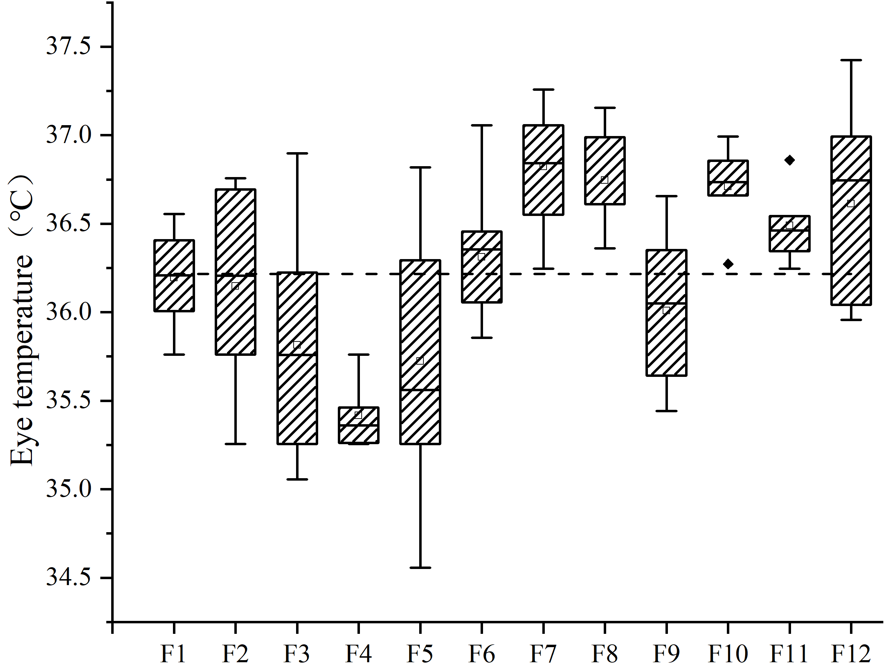
Appendix1 Eye temperature box plot of 12 individuals in non-estrus period

Appendix 2 Correlation analysis between eye temperature and environmental temperature and humidity in 12 individuals during non-oestrus period
panda | temperature |  | humidity
panda | r | p | r | p
F1 | 0.262 | 0.531 | -0.084 | 0.844
F2 | -0.039 | 0.905 | -0.181 | 0.574
F3 | -0.333 | 0.420 | -0.277 | 0.506
F4 | -0.067 | 0.951 | 0.165 | 0.671
F5 | -0.042 | 0.915 | 0.241 | 0.531
F6 | -0.143 | 0.714 | 0.479 | 0.192
F7 | 0.413 | 0.183 | -0.119 | 0.713
F8 | -0.527 | 0.117 | 0.460 | 0.181
F9 | -0.301 | 0.431 | -0.168 | 0.666
F10 | -0.095 | 0.823 | 0.214 | 0.610
F11 | 0.578 | 0.080 | -0.018 | 0.960
F12 | 0.535 | 0.111 | -0.326 | 0.358
Note: r: correlation coefficient; p<0.05 significantly correlated

