Table 1. Baseline Characteristics
Abbreviations: ECOG PS, Eastern Cooperative Oncology Group Performance Status; TKI, tyrosine kinase inhibitor.
*Percentages are based on N = 9. ** Percentages are based on N = 4.
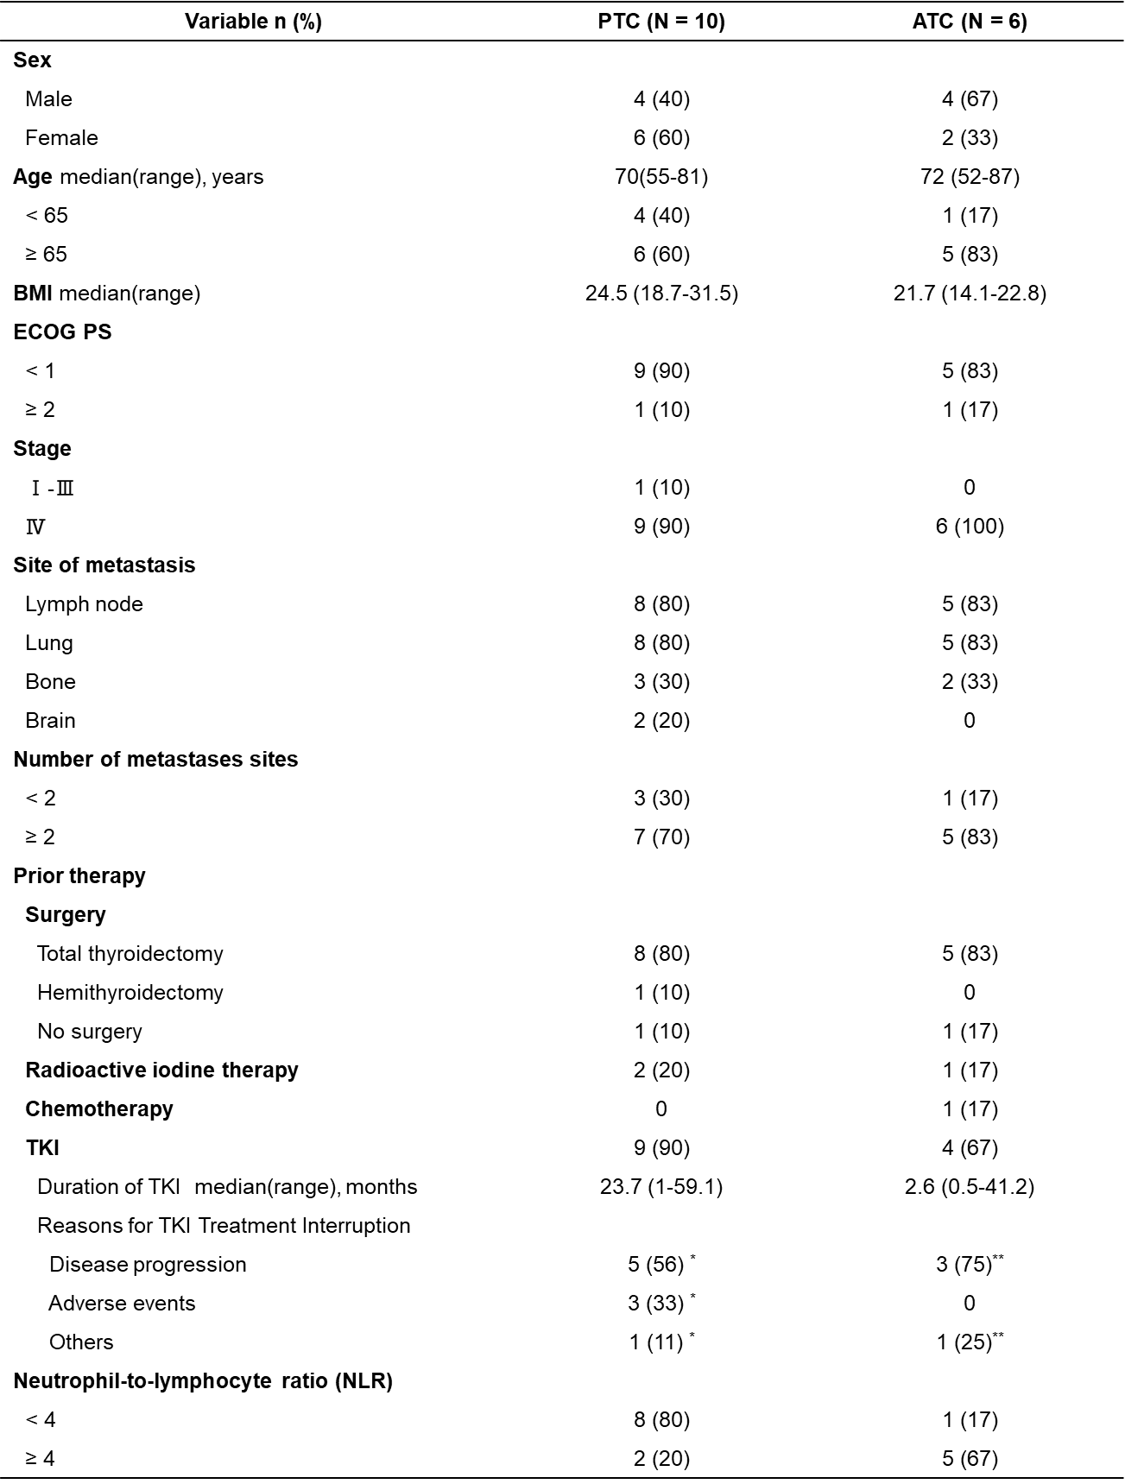

Table 2. Summary of Adverse Events and Treatment Outcomes
Abbreviations: AE, adverse events.
*Percentages are based on N = 14. ** Percentages are based on N = 5.
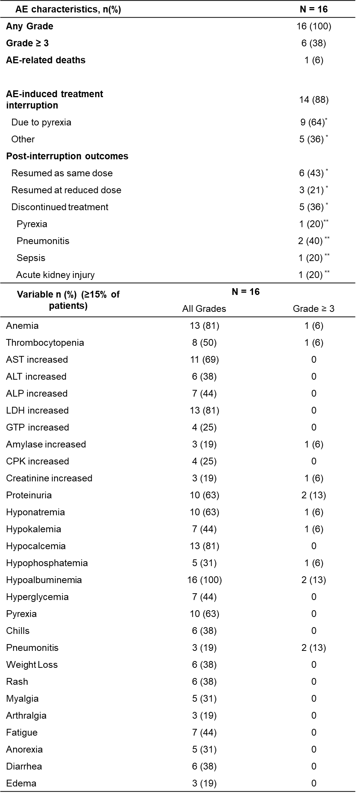
Table 3. Characteristics of Pyrexia Episodes
