Supplemental Material

Atrial Fibrillation Induces Sarcomere Remodeling,
Enhanced Sarcomere Contractility, and Loss of Atrial Identity

Delligatti et al.

Supplemental Methods
Supplemental Figure 1-5
Supplemental Tables 1-3

Supplemental Methods
Human Heart Tissue Procurement
Left ventricle (LV), left atria (LA), and right atria (RA) were obtained via the Loyola Cardiovascular Research Institute Biorepository. Tissue from nonfailing (NF) donors (no history of coronary artery disease or heart failure) was collected postpartum and flash frozen in liquid nitrogen or isopentane. Age, sex, and race distribution was not significantly different between normal, sinus rhythm (SR; n=6) and atrial fibrillation (AF; n=3) hearts (Table 1). Failing hearts (heart failure; HF) were from dilated (non-ischemic) cardiomyopathy patients and were collected with informed patient consent during LVAD implantation and frozen as nonfailing tissue.

Tension-Calcium Experiments
LV or LA were isolated from human donor tissue (Gift of Hope, Table 1) and homogenized for single myocyte isolation and tension-calcium curve generation as previously (1). Briefly, frozen LA and LV tissue was sliced and homogenized at 7000 RPM (Omni GLH 850) in three one-second pulses while in ice cold “Isolation” buffer (5.85mM ATP (Sigma-Aldrich), 2.04mM EGTA (Sigma-Aldrich), 7.11mM MgCl2 (Sigma-Aldrich), 10mM Imidazole (Sigma-Aldrich), 108mM KCl (Sigma-Aldrich)) with 0.3% Triton-X 100 (Millipore), 10mM 1,4-dithiothreitol (DTT, Millipore), and 1:100 ratio protease and phosphatase inhibitors (Fisher Scientific). The homogenate incubated on ice (20 min) to allow “skinning” (permeabilization) to occur. Homogenate was filtered (Corning, 352350) to retain single cells and centrifuged at 120xg for 2 minutes, then washed in Isolation solution (without Triton) twice, (centrifuging as described between washes). Supernatant was aspirated and discarded. After final wash, cells were resuspended in Isolation solution without Triton.
For functional assessment, a UV-curing glue (NOA61; NOA68, Thorlabs) was used to attach cells to a force transducer pin (AE-801, Kronex) and a high-speed piezo length controller pin (Thorlabs). The cell is bathed in increasing concentrations of calcium generated by mixing Activating (10mM Ca²⁺-EGTA, 28.12mM K⁺ Propionate, 100 mM BES (Sigma-Aldrich), 6.2 mM MgCl₂, ATP, and phosphocreatine (Sigma-Aldrich)) and Relaxing (10mM EGTA (Sigma-Aldrich), 47.58mM K⁺ Propionate, 100mM BES, 6.54mM MgCl₂, 6.24mM ATP, 10mM phosphocreatine) solutions, yielding points that can be plotted as a tension curve using the equation as follows:
T([Ca²⁺]) = T_{max} * ( ([Ca²⁺]*h) / (EC₅₀*h + [Ca²⁺]*h) )
Where F equals These measurements were conducted at room temperature with a sarcomere length of 2.1μm as determined via Fast Fourier Transform. From there, the maximal calcium activated tension (T_{max}) and EC₅₀ (calcium sensitivity; calcium concentration required to each half maximal tension) were determined.

Western Blotting
pTnI/TnI, MYBPC Blots: Tissues from all 14 human heart samples were homogenized in RIPA buffer (150 mM NaCl, 1% triton X-100, 0.5% Sodium Deoxycholate, 0.1% SDS, 50 mM Tris [pH 8]) containing protease inhibitor cocktail (Millipore Sigma, 11836170001). Protein concentration was determined using a Bradford protein assay and samples were standardized to 90 µg/uL in 2x Laemmli buffer (0.75 mM Tris- HCl [pH 8.8], 5% SDS, 20% glycerol, 0.01% bromophenol blue; supplemented with 10% β-mercaptoethanol). Samples were heated to 75°C for 5 minutes and then ran on 4 – 20% Mini-PROTEAN TGX Precast Protein Gels (Bio-Rad, 4561096) at 120 V for 1.5 hours loaded with 7 µL of chameleon ladder (Licor, 928-60000) and 12 µL of each sample. Gels were then transferred onto PVDF membranes (Thermo Fisher, 88520) at 300 mA for 3 hours in 1x TG-M buffer (25 mM Tris, 192 mM Glycine, 10% Methanol). Membranes were blocked with 1x tris buffered saline (TBS) with 1% casein blocker (Bio-Rad, 1610782) for one hour and then incubated overnight at room temperature in blocking buffer with primary antibodies: TnI 1:2000 (Santa Cruz, 365446); P-TnI 1:2000 (Cell Signaling, 4004S); cMyBPC 1:2000 (Santa Cruz, 137180). Membranes were washed 3x for 10 minutes each with 1x TBS buffer with 0.1% Tween-20 and then incubated in blocking buffer with secondary antibodies: Goat anti-Rabbit 800 1:1000 (Licor, 925-32211); Goat anti-Mouse 700 1:1000 (Azure Biosystems, AC2129); Goat anti-Mouse HRP 1:2500 (Jackson Immuno Research, 115-035-003) and imaged using near infra-red imaging on an Azure Biosystems c600 imager. After imaged, blots were stained for total protein with a reversible blue stain (ThermoFisher, 24585). Densitometry analysis was performed using ImageJ version 2.9 and data was analyzed via GraphPad Prism.
α/β Myosin Blots: Myofilament fractions were prepared from frozen LV or LA of humans, adult rats, and neonatal rats. Razor cut samples of myocardium were homogenized at 7000 RPM (Omni GLH 850) in standard rigor buffer (75mM KCl, 10mM Imidazole (pH 7.2), 2mM MgCl₂, 2mM EDTA (Sigma-Aldrich)) and 0.3% Triton-X 100, then centrifuged down at 1,200xg for 2 minutes, and washed 2 times with standard rigor buffer (centrifugation as before in between). After myofilament was isolated, it was solubilized in industrial sample buffer (ISB; 8M urea (Fisher Scientific), 2M thiourea (Sigma-Aldrich), 50mM Tris (pH 6.8) (Trizma; Sigma-Aldrich), 75mM DTT, 3% sodium dodecyl sulfate (SDS; Sigma-Aldrich), 0.005% bromophenol blue (Abcam)). Myofilament fractions were run on a 1-D polyacrylamide SDS-PAGE gel (30% acrylamide (Bio-Rad), 2.66% diallyltartardiamide (DATD, Sigma-Aldrich), 1.5M Tris (pH 8.8), 50% glycerol (Sigma-Aldrich), 10% SDS, 10% ammonium persulfate (APS, Sigma-Aldrich), 0.1% TEMED (Thermo Fisher Scientific) resolving gel, with 10% acrylamide, 15% DATD, 0.5M Tris (pH 6.8), 50% glycerol, 10% SDS, 10% APS, 0.6% stacking dye, 0.5% TEMED stacking gel). After 50 ug protein loading, gels were run and then stained with Coomassie Brilliant Blue R-250 Staining Solution (Bio-Rad) and destained overnight.
BAG3 Blots: Myofilament preparations of human LA and RA were prepared as described above. 10-12ug of protein were prepared with SDS Tris Glycine Buffer (Invitrogen) with BOLT Sample Reducing agent (Invitrogen) and boiled at 95°C to denature prior to loading onto 4-12% Tris-glycine gels (Invitrogen/Fisher Scientific). After gel run, proteins were transferred onto nitrocellulose (Thermo Fisher). After transfer, total protein was stained with “Revert” total protein stain (LI-COR) and blocked with Intercept Blocking Buffer (LI-COR) in TBS (Tris-buffered saline). Primary antibodies were incubated overnight in blocking buffer. BAG3 antibody used was Proteintech 10599-1-AP.

Label-Free Mass Spectrometry
Hearts were homogenized in 8M urea as described, sonicated (three, one-second pulses, Omni GLH 850, 7000 RPM) and clarified by centrifugation at 18,000xg. Supernatant was moved into a new tube and frozen until use. Prior to the experiment, concentrations of samples were determined via BCA kit (Thermo Fisher) according to manufacturer’s protocol. 20ug of sample was used at start of experiment. Samples were reduced in 5mM DTT at room temperature 45min. After this, alkylation with 10mM iodoacetamide (IAA, Sigma-Aldrich) occurred at room temperature in the dark for 30min. Samples were then digested with Trypsin/LysC (Thermo Fisher) for 18h at 37°C, after which reaction was halted by acidification with trifluoroacetic acid (TFA; Sigma-Aldrich) desalted using C-18 spin columns (G Biosciences) according to manufacturer’s protocol. Samples were dried and reconstituted in 0.1% formic acid (FA; Millipore) and then clarified for 10 minutes at 20,000xg and supernatant was collected in fresh tube. A peptide quantification via a kit (Thermo Fisher) was done via manufacturer’s protocol prior to analyzation via liquid chromatography tandem mass spectrometry (LC-MS/MS).

Multi-Reaction-Monitoring Mass Spectrometry
Calibration Curve: The calibration curve is fundamental to ensuring the reliability and accuracy of protein quantification in MRM assays. For preparation, a series of known concentrations of the light isotope-labeled standard (SIS) peptide were prepared, while the concentration of the heavy SIS peptide was held constant. The pairs of light and heavy isotope-labeled AQUA1 peptides for MHY7 and N2BA Titin were synthesized by Thermo Fisher Scientific with 98% and 99% HPLC purity, respectively.
A 1 µL aliquot of each calibration solution was injected into the TSQ Altis Plus Triple Quadrupole Mass Spectrometer coupled with the Ultimate 3000 system, to measure instrument response for each standard solution. The TSQ Altis system, equipped with a heated trap and elute workflow, used a PepMap™ Neo UHPLC Column (PN ES902) 5 mm, 5 µm trap column, 2 µm, 100 Å, 75 µm x 25 cm, with 98% buffer A and 2% buffer B, and a column oven set at 35 °C. Peptides were eluted over a 60-minute gradient. The global settings included a positive ion spray voltage of 1700 volts, a negative ion spray voltage of 600 volts, and an ion transfer tube temperature of 600°C for all acquisition methods.
The MRM properties were set to positive polarity with a cycle time of 1.5 sec. The Q1 resolution (FWHM) was set to 0.7 as well as the Q3 resolution (FWHM). The collision gas pressure was at 1.5 mTorr. The appropriate optimized methods of each peptide pair (heavy and light) were used.
Calibration curves were generated by plotting the light/heavy ratios (y-values) against the light peptide concentrations (x-values). Linear regression analysis was performed using Excel to evaluate the quality of the standard curves. This calibration curve was subsequently used to determine the concentration of target peptides in samples based on their signal intensities.
Spike-In and Absolute Quantification: After enzymatic digestion of 50 µg of sample, the heavy SIS peptide was spiked in at a final concentration of 2 pmol/µL. Peptide samples were then dried by vacuum centrifugation and resuspended in appropriate amounts volume of buffer A (5% acetonitrile, 0.1% formic acid in HPLC water). Peptide concentrations were determined using the Pierce Quantitative Colorimetric Peptide Assay kit. A total of 500 ng per µL was loaded onto the TSQ Altis Plus Triple Quadrupole Mass Spectrometer coupled with the Ultimate 3000 system. The PepMap™ Neo UHPLC Column (PN ES902) 5 mm, 5 µm trap column, 2 µm, 100 Å, 75 µm x 25 cm was employed. Chromatography gradients and scanning parameters matched those used for the standard curve. Each sample was run in triplicate. Raw data were processed using Skyline 23.1 software to determine the ratio between tissue endogenous peptides and heavy-labeled peptides, which was then exported to Excel to calculate endogenous peptide concentrations according to standard curve equations.
Data analysis was conducted using Microsoft Excel, Skyline 23.1, and GraphPad Prism 9.0. Experiments were performed with at least three independent biological replicates, and results are presented as mean ± SD (n=3) or SEM (n>3). For datasets with three or more groups, one-way ANOVA was used. For comparisons between two groups, a two-tailed Student's t-test was employed. Statistical significance was defined as p < 0.05 (ns P > 0.05, * P ≤ 0.05, ** P ≤ 0.01, *** P ≤ 0.001, **** P ≤ 0.0001).

IPSC-CM culturing and Seeding of Engineered Heart Tissue (EHTs)
hiPSC Culture and Engineered Heart Tissue (EHT) Fabrication: For hiPSC differentiation into cardiomyocytes, biphasic Wnt signaling was used as previously described(2,3). WT (PGP1/GM23338) hiPSCs (Coriell Institute) were maintained in mTeSR 1 (Stemcell Technologies) and passaged using ReLeSR. For differentiation, hiPSCs were cultured in 12-well plates and allowed to grow to 95%-98% confluency. On day 0, 12.5 µM CHIR99021 was added in RPMI/B27 minus insulin. Exactly 24 h later, CHIR99021 was removed. On day 3, cells were treated with 5 µM IWP4 for exactly 48 h. 0.75 µM retinoic acid was added on days 4, 5, and 6 to enrich the atrial cardiomyocyte population. On day 9, media was changed to RPMI/B27, and cells began to beat spontaneously. Lactate selection (4 mM in RPMI/-glucose) was used to purify cardiomyocytes from days 12-15.
To create EHTs, 150-µm slices were cryo-sectioned from porcine LV free wall and laser-cut in 2 mm x 10 mm rectangles parallel to fiber orientation. Slices were affixed to laser-cut Teflon cassettes by means of a press-fit tab; subject to hypotonic lysis (10 mM Tris-Cl (pH 7.4), 0.1% EDTA) for 2 h; decellularized in 0.5% SDS in PBS with gentle shaking for 45 min; and incubated overnight in DMEM with 10% FBS and 2% pen-strep. Spontaneously beating cardiomyocytes were detached with TrypLE Select and seeded on decellularized porcine scaffolds in seeding media (DMEM with 10% FBS, 1% NEAA, 1% L-glutamine, 1% sodium pyruvate, with 1% pen-strep and 1 µM Y-26732). Each EHT contained 1,350,000 cardiomyocytes and 150,000 adult human cardiac fibroblasts. The next day, EHTs were transferred to DMEM/B27 (with insulin) and cultured for 1 week before being moved to the mechanical strain bioreactor.
Dynamic Bioreactor: A custom-built, voice coil-driven (Ingenia) bioreactor was used to impose strain transients on atrial EHTs at 1 Hz(4,5). The reservoir, conduit, and booster strains were set to 17%, 8%, and 9% and interpolated with piecewise sine functions. These values were chosen to fit within the constraints of the bioreactor. Electrical pacing (10 V, 1 Hz) was coordinated with the timing of the booster phase. Pacing and strain were controlled by an MSP430 microprocessor and digital-to-analog converter (Texas Instruments). Tissues were electromechanically conditioned in the bioreactor for 1 week in DMEM/B27 or were loaded in the bioreactor and paced at 1 Hz, but not mechanically manipulated. For consistency, the average strain over 1 cycle in the mechanically conditioned group exactly matched the length of an isometric tissue.
EHT Testing: EHTs were tested on a custom-built apparatus containing a force transducer (WPI) and linear actuator. Tissues were perfused at 36ºC with Tyrode’s solution (140mM NaCl, 5.4mM KCl, 1.8mM CaCl₂, 1mM MgCl₂, 25mM HEPES, 10mM glucose (pH 7.3)). Tissues were subject to 0%, 5%, and 10% strain to measure length-dependent activation and were paced at 1 Hz (5 V). Contractile properties (peak force, TTP, RT50) were calculated using custom Matlab software.

Development of atrial fibrillation model
The anatomical model used for this study was generated from an ECG-gated CT of a 74-year-old male with atrial fibrillation. The end-diastolic image was automatically segmented using a neural network (6). The resulting segmentation was post-processed with a previously developed pipeline (7) and used to generate a mesh with linear tetrahedra. Myofiber orientation was assigned to the ventricles using a Laplace-Dirichlet rule-based method by Bayer et al (8), with fiber and sheet angles varying from +60° to -60°, and from -65° to +25° from endocardium to epicardium, respectively. Atrial fibers were mapped from the Labarthe fiber atlas [https://pubmed.ncbi.nlm.nih.gov/25362166/] with the universal atrial coordinates (9), with epicardial and endocardial fibers assigned based on a transmural Laplace solution.
A reaction-eikonal model (10) was used to simulate the electrical activation of the heart. Atrial activation was initiated at the sinoatrial node. Ventricular activation was initiated at 5 points of early activation [https://link.springer.com/article/10.1007/s10439-021-02825-9], where the His-Purkinje system emerges into the ventricular myocardium, with an atrioventricular delay of 100 ms. To prevent unphysiological activation spreading from the atria to the ventricles, we defined an electrically insulating atrioventricular plane. The atrial and ventricular myocardium were modelled as transversely isotropic, with increased conduction velocities in the direction of the local myofiber orientation. Additional regions for the Bachmann’s bundle in the atria and a fast endocardial conduction area in the ventricular endocardium were also defined to account for fast conducting regions of the heart.
For the mechanics model, the atria and the ventricles were modelled as a transversely isotropic, hyperelastic and nearly incompressible material with the Guccione law (11). The material parameters for the atrial and ventricular myocardium were based on (7). Unloading pressures, systemic and pulmonary resistances were then calibrated to achieve a physiological ejection fraction (LV EF > 50%). To account for their higher collagen content (12), the atria were assigned with a higher stiffness compared to the LV. All other tissues were modelled as neo-Hookean and the material parameters were set according to previous studies (7,13). For all tissue types, incompressibility was enforced using a penalty method. The pericardium was modelled as an additional constraint using normal spring boundary conditions to limit the motion of the outer shell of the heart, with a spatially varying map to represent the local constraints that the pericardium and the surrounding organs exert on the heart (13,14). The mechanics model was coupled with a closed-loop circulatory system based on CircAdapt to provide preload and afterload for all four chambers (15).
The Land model (16) was used to simulate active tension in the atrial and ventricular myocardium. Reference tension in the LV and RV was set to 180 kPa to achieve physiological LV ejection fraction. For the baseline simulation, the reference tension in the atria (Tref) was set to 100 kPa in both atria in agreement with previous studies (14). To investigate the effect of stronger atrial contraction on whole heart function, the simulation was repeated with Tref increased by 25%, 50%, 75% and 100%. For each simulation, the LV ejection fraction, peak pressure, end-diastolic volume and end-systolic volume were calculated, in addition to the ejection fraction of the left atrium during atrial active contraction.

Statistics
Data are all presented as mean ± SEM analyzed on GraphPad Prism 9-10. Experiments were performed with 3+ biological replicates and datasets with 3+ groups were analyzed via one-way analysis of variance (ANOVA) with appropriate post-hoc tests if significance was determined. In cases of two groups, data were analyzed with a two-tailed Student’s t-test. In all cases, a p-value <0.05 was considered threshold for significance, though trending (p-value<0.1) and clarifying (p-value>0.1) numbers are occasionally shown above graphs.

Supplemental References
1. Papadaki M, Holewinski RJ, Previs SB et al. Diabetes with heart failure increases methylglyoxal modifications in the sarcomere, which inhibit function. JCI Insight 2018;3.
2. Schwan J, Kwaczala AT, Ryan TJ et al. Anisotropic engineered heart tissue made from laser-cut decellularized myocardium. Sci Rep 2016;6:32068.
3. Shen S, Sewanan LR, Shao S et al. Physiological calcium combined with electrical pacing accelerates maturation of human engineered heart tissue. Stem Cell Reports 2022;17:2037-2049.
4. Ng R, Sewanan LR, Brill AL et al. Contractile work directly modulates mitochondrial protein levels in human engineered heart tissues. Am J Physiol Heart Circ Physiol 2020;318:H1516-H1524.
5. Ng R, Sewanan LR, Stankey P, Li X, Qyang Y, Campbell S. Shortening Velocity Causes Myosin Isoform Shift in Human Engineered Heart Tissues. Circ Res 2021;128:281-283.
6. Xu H, Niederer, S.A., Williams S.E. Whole Heart Anatomical Refinement from CCTA using Extrapolation and Parcellation. arXiv 2021.
7. Strocchi M, Augustin CM, Gsell MAF et al. A publicly available virtual cohort of four-chamber heart meshes for cardiac electro-mechanics simulations. PLoS One 2020;15:e0235145.
8. Bayer JD, Blake RC, Plank G, Trayanova NA. A novel rule-based algorithm for assigning myocardial fiber orientation to computational heart models. Ann Biomed Eng 2012;40:2243-54.
9. Roney CH, Bayer JD, Cochet H et al. Variability in pulmonary vein electrophysiology and fibrosis determines arrhythmia susceptibility and dynamics. PLoS Comput Biol 2018;14:e1006166.
10. Neic A, Campos FO, Prassl AJ et al. Efficient computation of electrograms and ECGs in human whole heart simulations using a reaction-eikonal model. J Comput Phys 2017;346:191-211.
11. Guccione JM, McCulloch AD, Waldman LK. Passive material properties of intact ventricular myocardium determined from a cylindrical model. J Biomech Eng 1991;113:42-55.
12. Oken DE, Boucek RJ. Quantitation of collagen in human myocardium. Circ Res 1957;5:357-61.
13. Strocchi M, Gsell MAF, Augustin CM et al. Simulating ventricular systolic motion in a four-chamber heart model with spatially varying robin boundary conditions to model the effect of the pericardium. J Biomech 2020;101:109645.
14. Strocchi M, Longobardi S, Augustin CM et al. Cell to whole organ global sensitivity analysis on a four-chamber heart electromechanics model using Gaussian processes emulators. PLoS Comput Biol 2023;19:e1011257.
15. Augustin C, Gsell, M., Karabelas, E., et al. Validation of a 3d–0d closed-loop model of the heart and circulation - modeling the experimental assessment of diastolic and systolic
ventricular properties. arXiv: Tissues and Organs 2020.
16. Land S, Park-Holohan SJ, Smith NP, Dos Remedios CG, Kentish JC, Niederer SA. A model of cardiac contraction based on novel measurements of tension development in human cardiomyocytes. J Mol Cell Cardiol 2017;106:68-83.

Excel Spreadsheets

Supplemental Table 1: All proteins detected in human SR and AF atria; All Proteins Detected in SR Atria and Ventricles
Supplemental Table 2: Dysregulated Biological Processes and Molecular Function Pathways from human SR vs AF samples
Supplemental Table 3: Proteins Found in Analysis of EHTs and EHT Pathway Analysis

Supplemental Figures

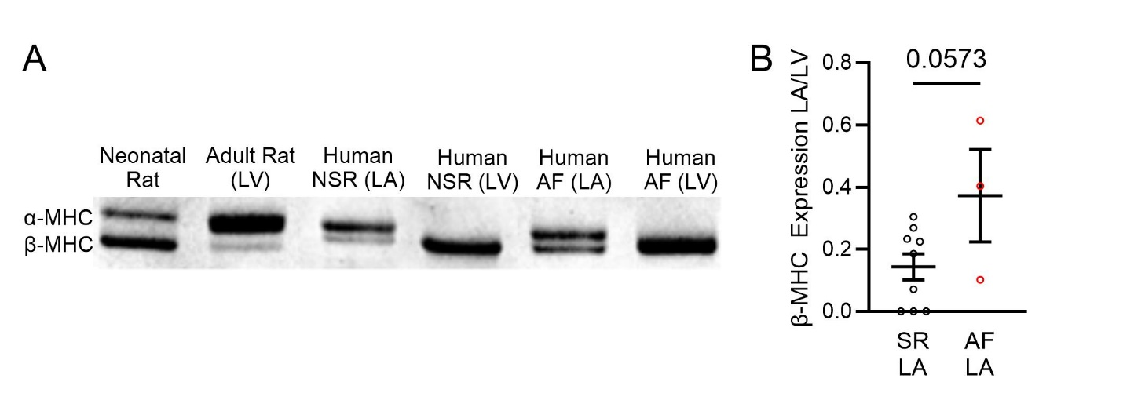
Figure S1. Confirmation of myosin isoform expression. (A) Gel electrophoresis for α and β myosin heavy chain (MHC) in neonatal rat, adult rat LV, human SR (LA), human SR (LV), human AF (LA), human AF (LV) samples. (B) Quantification of β-MHC expression in LA of SR (n = 9) vs AF (n = 3) humans from gel shown in panel A.

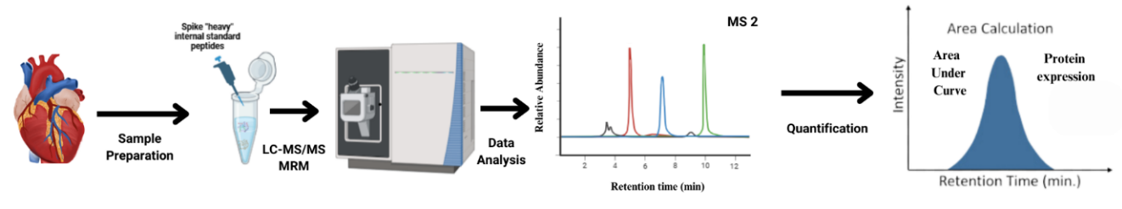
Figure S2. Workflow for Multiple Reaction Monitoring (MRM) Assays. Assay development for αMHC and β MHC, N2B titin, and N2BA titin absolute quantification (AQUA) assays.

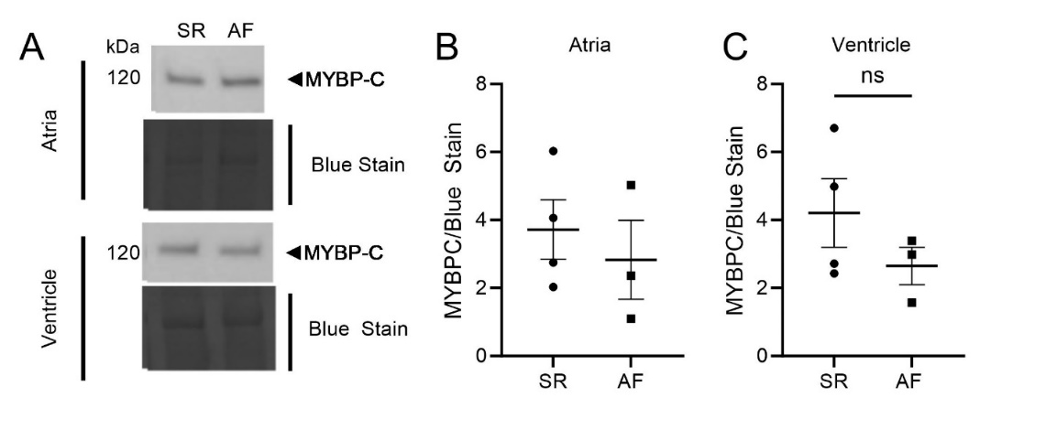
Figure S3. Cardiac MyBP-C Expression is Unchanged by Disease State. (A) Gel for cMyBP-C in human LA NF, SR (n=4) and NF, AF (n=3) tissue with total protein stain (top); cMyBP-C in LV NF, SR (n=4) and NF, AF (n=3) tissue with total protein stain (bottom) (B) Quantification of panel A (top), normalizing cMYBP-C to total protein (C) Quantification of panel A (bottom), normalizing cMYBP-C to total protein. All data presented as mean ± SEM and analyzed by two-tailed t-test.
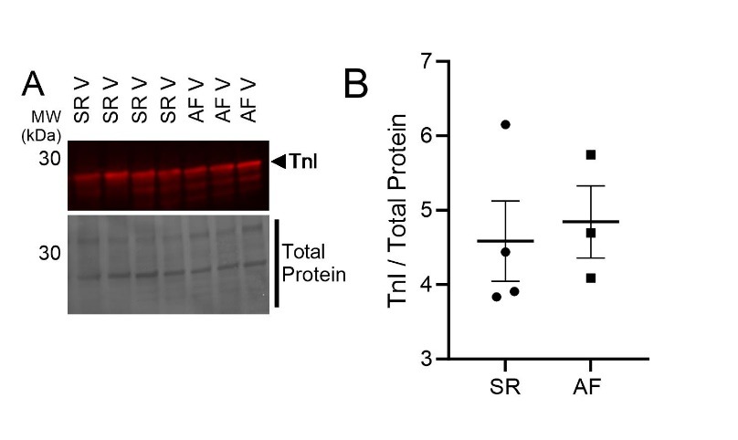
Figure S4. Total LV cTnI Unchanged by Western Blot Between Groups. (A) Gel for total cardiac Troponin I in human LA NF, SR (n=4) and NF, AF (n=3) tissue with total protein stain (B) Quantification of panel A, normalizing cTnI to total protein. Data presented as mean ± SEM and analyzed by two-tailed t-test.

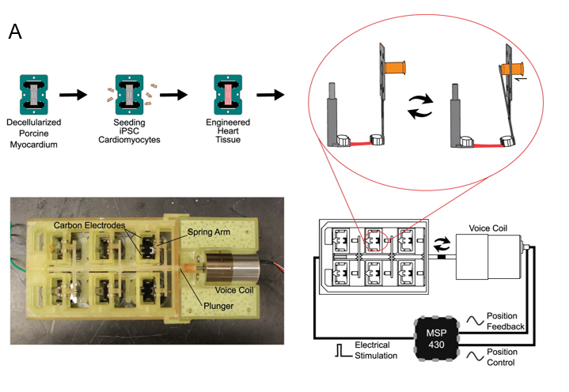
Figure S5. Experimental Design for hiPSC-CMs. (A) Schematic of atrial EHT workflow. hiPSC-derived, retinoic acid-enriched atrial-like cardiomyocytes are seeded onto decellularized porcine myocardium, cultured for two weeks, then placed in electro-mechanical dynamic bioreactor for a further 1 week of culture. Dynamic bioreactor consists of voice coil providing cyclical mechanical stimulation with electrical pacing at 1.5 Hz.

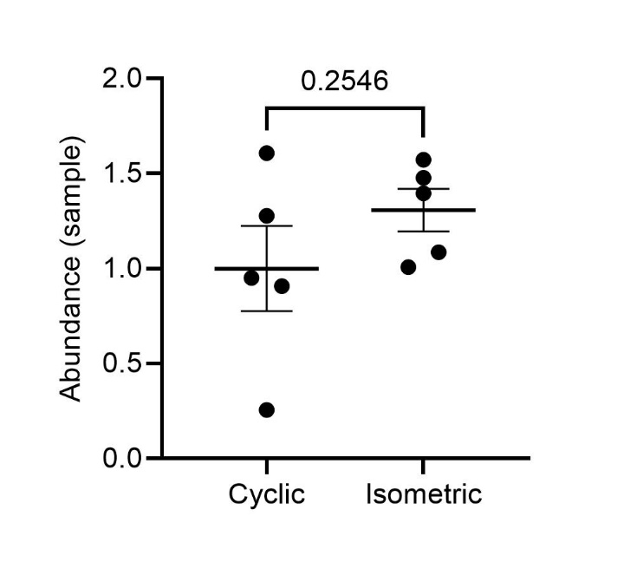
Figure S6. Abundance of β-Myosin in Isometric EHTs. Showing abundance per sample normalized to average of cyclic (control) group

