Myosin Gels:
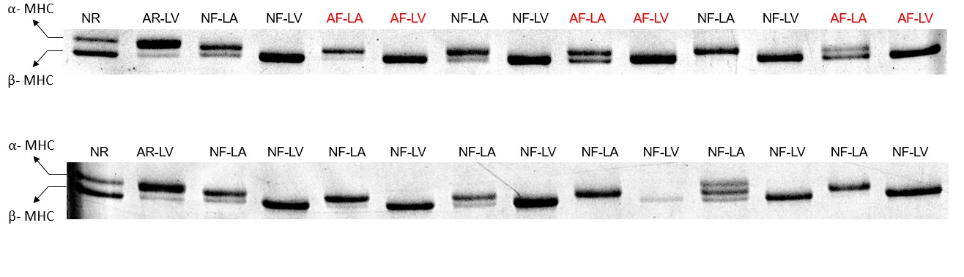

Pro-Q / Sypro Stain
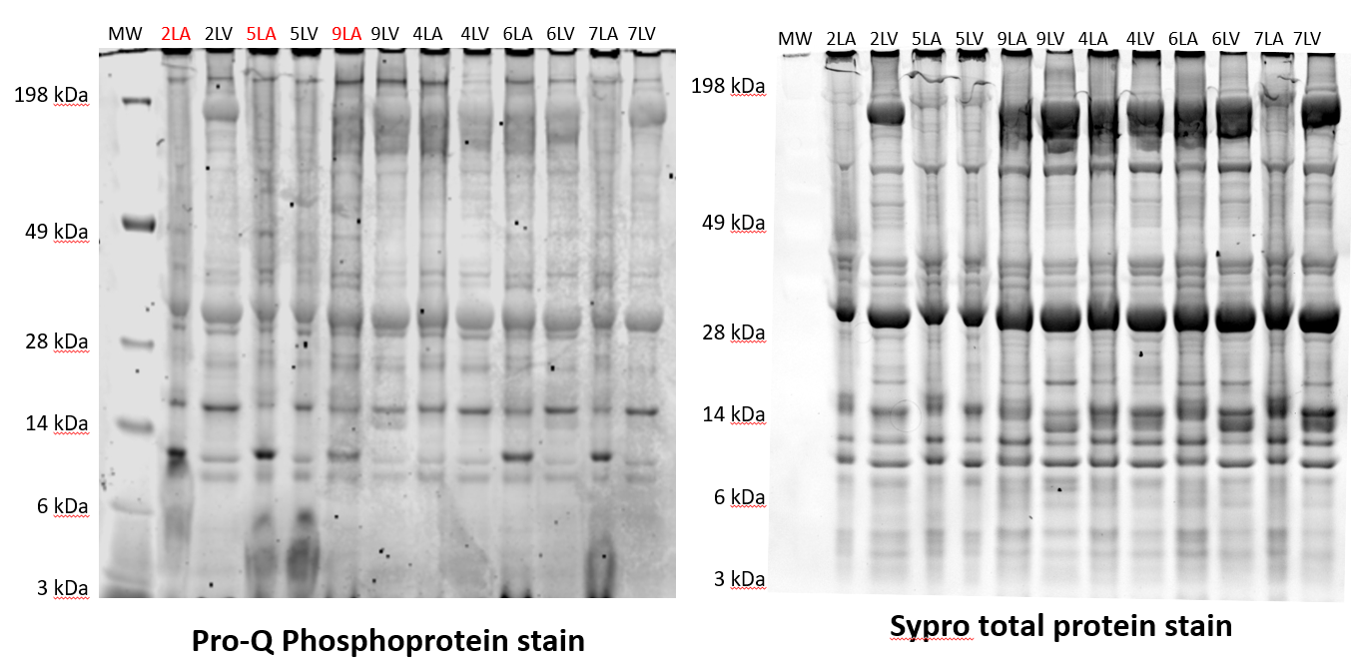
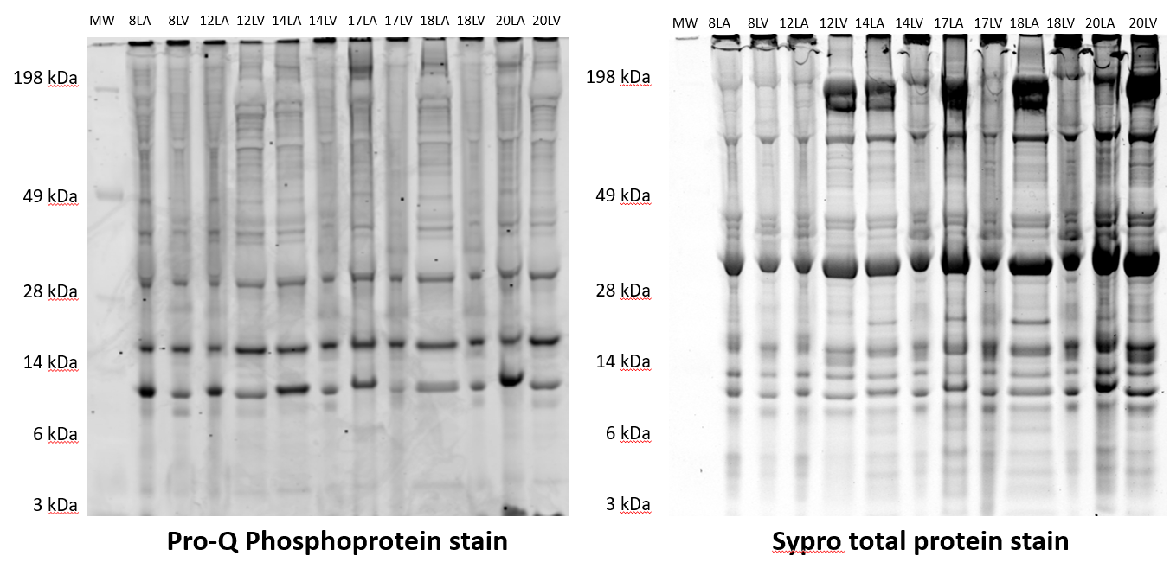

MYBPC
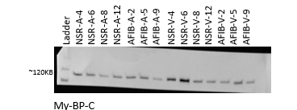
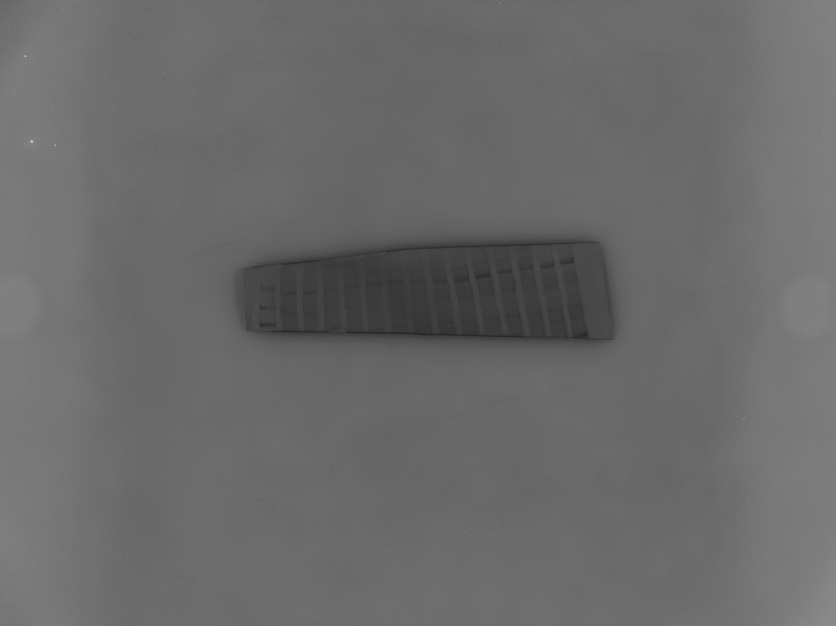
Blue stain

BAG3 NSR / AF Blot

BAG3 NSR NF / NSR HF

Troponin I:
FIG5A: Full, Uncropped Blot Shown in Figure

