Supplementary information for

Coccolithophore blooms boost particle fluxes in the Nordic Seas

R. Rasse¹ and G. Neukermans^{1,2}

¹Ghent University, Biology Department, MarSens Research Group, Krijgslaan 281 – S8, 9000 Ghent, Belgium
²Flanders Marine Institute (VLIZ), InnovOcean Site, Wandelaarkaai 7, 8400 Ostend, Belgium

1S. Hydrography of the Norwegian and Lofoten basins.
Figures 1S and 2S respectively describe the hydrography of longitudinal sections of the Norwegian and Lofoten basins between July and September. These two longitudinal sections highlight that sub-surface water layers (1-400 m) become warmer and less dense from west to east in both cases (Fig. 1S and 2S). For instance, the isopycnals 27.6 kg m⁻³ and 27.7 kg m⁻³ become deeper from west to east due to the physical intrusions of warmer waters masses of the North Atlantic (6-10 °C, Fig. 1S and 2S)¹.

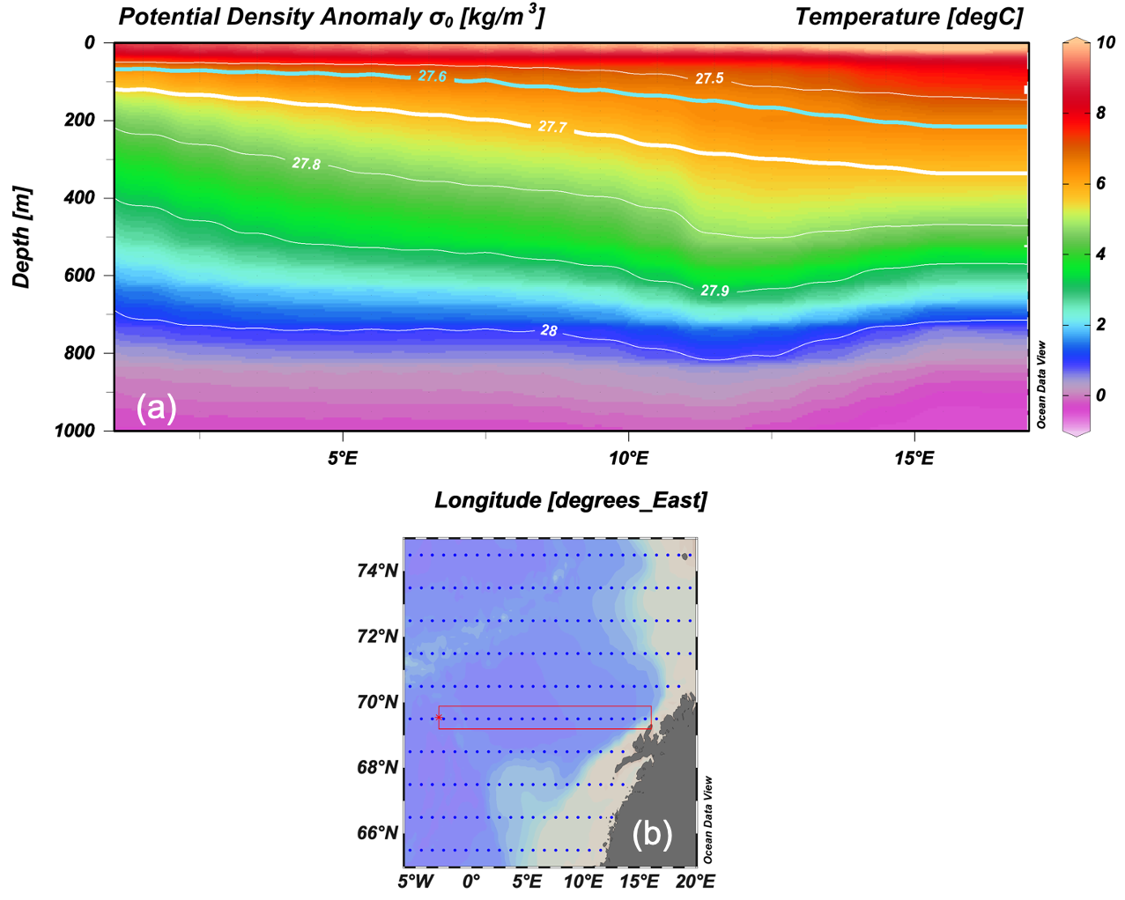
Fig. 1S. (a) Longitudinal section of climatological temperature and potential density (isolines) in the Lofoten basin between July and September. The red square in (b) defines the selected section (data source: https://odv.awi.de/data/ocean/world-ocean-atlas-2023/ ).

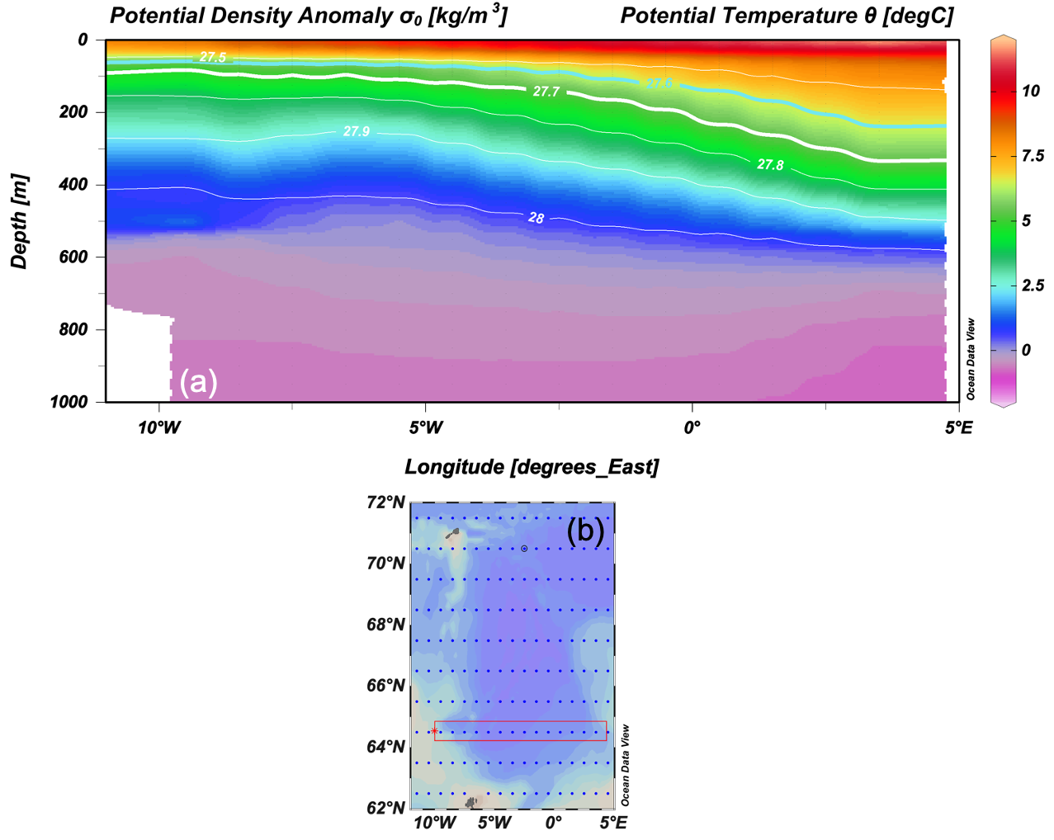
Fig. 2S. (a) Longitudinal section of climatological temperature and potential density (isolines) in the Norwegian basin between July and September. The red square in (b) defines the selected section (data source: https://odv.awi.de/data/ocean/world-ocean-atlas-2023/).

Table 1S. List of the floats used in this study and their sampled periods
WMO | Sampled period used
 | Start day | end day
6900798 | 02-07-2010 | 13-09-2015
6900799 | 05-11-2010 | 20-09-2015
6902545 | 23-01-2014 | 27-12-2017
6902547 | 22-01-2014 | 29-12-2015
6902548 | 03-01-2015 | 27-12-2017
6902549 | 02-01-2015 | 27-12-2017
6902550 | 04-08-2014 | 09-12-2021
6903273 | 03-02-2016 | 19-07-2022
6903550 | 22-05-2019 | 15-05-2021
6903553 | 20-05-2019 | 28-12-2019
Table 1S. Continuation
6903569 | 17-05-2020 | 30-12-2021
6903574 | 26-08-2018 | 18-05-2023
6903577 | 09-06-2021 | 26-09-2023
6903578 | 01-05-2021 | 08-092023

2S. Small and large components of chl and b_{bp} signals
Figures 3S and 4S respectively describe the main components of the bulk signals of chlorophyll (chl) and of particle backscattering (b_{bp}) computed after applying the smoothing functions to a vertical profile of the float 6903578 by following Briggs et al., 2011. Fig. 4S indicates that b_{bp} due to large participles (b_{bpL}) declines with depth because large particles are converted into smaller ones (b_{bpS}) by fragmentation. As a result, b_{bpS} reached maximum values in the upper mesopelagic layers (60-400 m) and declined with depth.
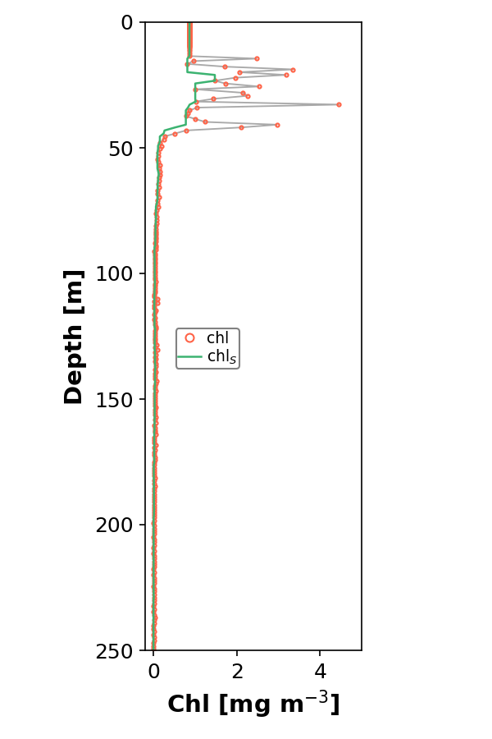
Fig. 3S. Vertical profile of chl (grey line) computed for float 6903578 to describe the methodology applied to subtract the small particle component of this signal. The baseline (green line) refers to small particles of chlorophyll (chl_{S}) after applying the smoothing function as we described in the main text.

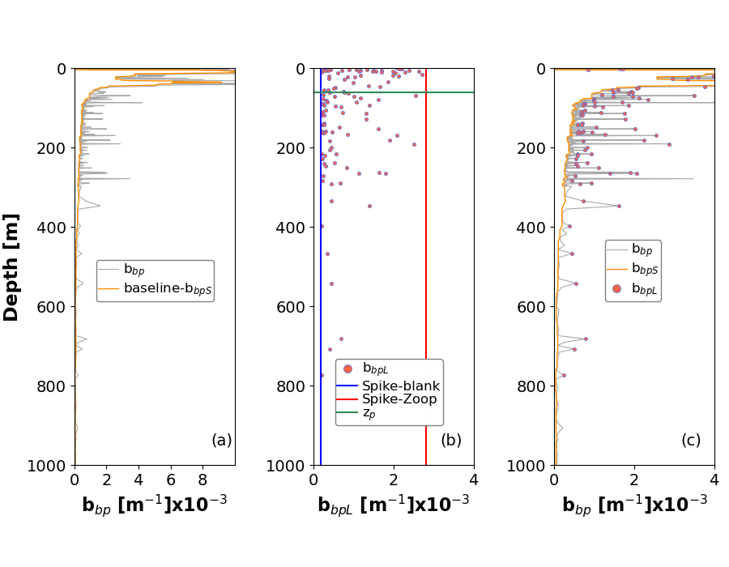
Fig. 4S. Vertical profile of b_{bp} computed for float 6903578 to describe the two components subtracted from this signal. (a) b_{bp} (grey line) and baseline due to small particles (b_{bpS,} yellow line). (b) b_{bp} due to large participles (b_{bpL}) was calculated as the difference between b_{bp} and b_{bpS.} b_{bpL} refers to the values found above the spike-blank (vertical blue line) and beneath the vertical red line (spikes due to zooplankton)³. The horizontal green line is the base of the productive layer (z_{p}). (c) b_{bp} and its respective components of b_{bpS}, and b_{bpL}.

3S. Sensitivity analysis of POC estimates
Particulate organic carbon (POC) is commonly estimated using empirical relationships with b_{bpS}, but these relationships vary significantly across studies^{4–6}. This variability arises from methodological differences in POC and b_{bpS} measurements, differences in particle properties (e.g., size, shape, and composition)⁷, and methodological errors in POC and b_{bpS} estimation^{4,8}. Additionally, current empirical models do not account for depth-dependent variations in POC:b_{bpS} ratios due to organic matter degradation in the mesopelagic zone. These discrepancies can ultimately cause significant errors in the estimates of POC stocks and fluxes.
We conducted an intercomparison of various POC estimation models that either assumed constant POC:b_{bpS} ratios (i.e. constant models)^{5,6} or used mechanistic parameterizations to account for vertical changes in POC:b_{bpS} ratios (i.e. non-constant models)^{9,10}. The main goal of this sensitivity analysis was to assess the accuracy of both constant and non-constant POC estimation models and propose a combined approach to reduce discrepancies and improve prediction accuracy, especially in mesopelagic waters. This step is crucial for enhancing the accuracy of oceanic POC stock and flux estimates, as these are derived from POC concentrations and are central to our study.
To conduct this sensitivity analysis, we used concentrations of POC data collected in the North Atlantic, as this dataset is representative of the environmental conditions in our study area (i.e. intense spring phytoplankton bloom and presence of coccolithophores). We selected three models with constant POC:b_{bpS} ratios (Table 2S) and two with depth-dependent ratios (Equations 1S-2S), and used b_{bpS} data recorded by three floats to predict POC from these models.The equations and parameters used for each model are summarized in Table 2S. Errors in predicted POC were computed using Eq. 3S.
The two non-constant models effectively captured the expected vertical decline in POC:b_{bpS} ratios. However, their predictions were consistent only between 50 and 150 m depth (3 ± 3% difference). Below 150 m, the model by Gali et al. (2022) predicted steeper declines than Bol et al. (2018), with a slope approximately twice as steep as that reported by Bol et al. (2018) (Fig. 5S). As a result, the predicted POC:b_{bpS} values differed significantly, with mean differences of 48% (±16) between 150–500 m and 85% (±7) between 500–1000 m, ultimately affecting the accuracy of these models in estimating reference POC values, as discussed below.
POC estimates differed significantly between constant and non-constant models across depth layers. Between 50–150 m, both models underestimated POC, with non-constant models showing a stronger negative bias (-27% ±11) than constant models (-9% ±9) relative to reference values (Fig. 6S). Below 150 m, discrepancies increased as POC:b_{bpS} ratios declined more steeply. In the 150–500 m range, constant models overestimated POC by up to 110%, while non-constant models underestimated it by as much as 65% (Fig. 6S). At 500–1000 m, constant models overestimated POC by 88% ±9, while non-constant models underestimated it by 92% ±18 (Fig. 6S), with biases consistent across all vertical profiles of b_{bpS} analyzed (Fig. 7S).
To address these discrepancies and improve POC predictions, we introduced the combined model that averages both approaches, which significantly reduced errors in the deeper water layers. For float 6902550, mean errors were -27% (50–150 m), -13% (150–500 m), and -43% (500–1000 m). Compared to individual models, it lowered absolute errors by 36–83% (150–500 m) and 44–48% (500–1000 m, Fig. 8S). However, all models performed similarly in the 50–150 m layer. The improved accuracy likely results from offsetting biases between the constant and non-constant models in mesopelagic waters, with similar results observed for floats 6900799 and 6903550 (Fig. 8S).
The effect of applying constant, non-constant, and combined models in estimating POC stocks and fluxes was finally assessed (see Section 4.5.2 of the methods). As expected, the constant and non-constant models predicted POC stocks that were 5 (±2) and 3 (±1.5) times higher and lower, respectively, than those predicted by the combined model (Fig. 9S). Similarly, the constant and non-constant models predicted net fluxes that were, on average, 84% (±30) and 31% (±16) higher and lower, respectively, than the combined model. Therefore, we applied the combined model to compute POC concentrations, as more accurate predictions of POC lead to more reliable estimates of POC stocks and net fluxes.

$\frac{POC}{b_{bpS}}=ae^{-b}$ [Eq.1S]

$\frac{POC}{b_{bpS}}=ae^{-b(z-zi)}$ [Eq.2S]

Equations 1S–2S. Non-constant models applied to predict vertical profiles of POC from b_{bpS}. In both equations, a is the constant value of the surface POC:b_{bpS} ratio computed by the constant models, while b is the slope of non-constant models. In Eq. 2S, z₁ refers to the mixed layer depth, while z defines all sampled depths beneath z₁ (z > z₁).

$\frac{{{POC}_{b_{bpS} }- POC}_{m }}{{POC}_{m}}x100$ [Eq.3S]

Equation 3S. Estimates of the error in the predictions of POC derived from b_{bpS} (POC_{bbpS}). POC_{m} refers to the reference values of measured POC.

Table 2S. Coefficients of the constant and non-constant models applied to conduct the sensitivity analysis of POC estimates.
constant models
Sampled regions | Geographical zones | POC:b_{bpS} ratio ± std  [ mgC m⁻²] | Intercepts ± std  [mgC] | Refs.
Atlantic and Pacific | Tropics and subtropics zones | 53606.7 | 2.47 | Stramski et al. 2008
North Atlantic | Temperate zone | 43317 ± 2092 | -18.4 ± 5.8 | Cetinić et al. 2012
Atlantic | Tropics, subtropics and temperate zones | 58229 ± 3302 | -7.6 ± 3.4 | Rasse et al. 2017*
Non-constant models
Sampled regions | Geographical zones | bx10⁻³ | a = POC:b_{bp} ratio  [ mgC m⁻²] | Refs.
North Atlantic | Temperate zone | -3.47 ± 0.46 | 40800 ± 1100 ** | Bol et al. 2018
North Atlantic | Temperate zone | -6.57 | ** | Gali et al. 2022
The linear constant models are expressed in the form of: POC = mb_{bpS} + b. Where m is the POC:b_{bpS} ratio at the surface.
* This is the linear regression of Rasse et al. 2017. Personal communication.
** We applied POC:b_{bpS} ratios of the constant models.
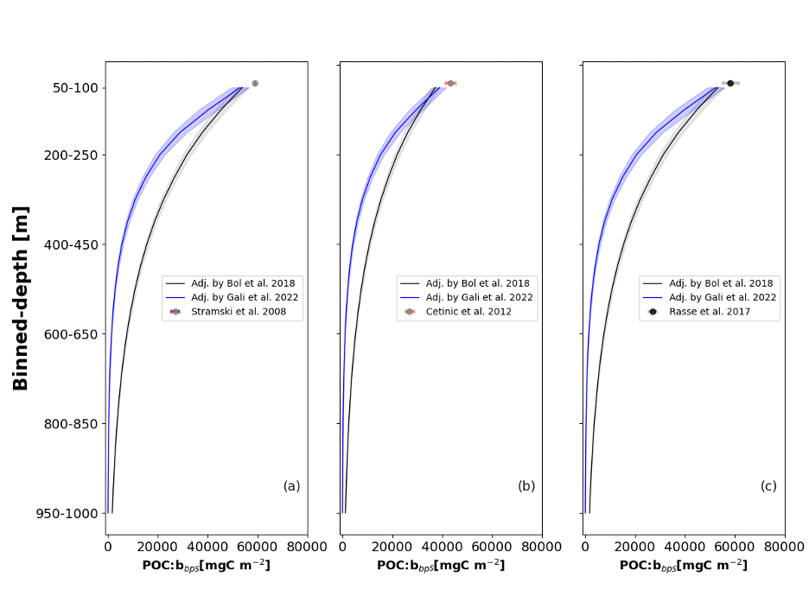
Fig. 5S. Binned-depth variations of POC:b_{bpS} ratios computed from Bol et al. 2018 and Gali et al. 2022 models for the float 6902550. The gray circles in (a-c) are the surface values of POC:b_{bpS} ratios (see Table 2S).

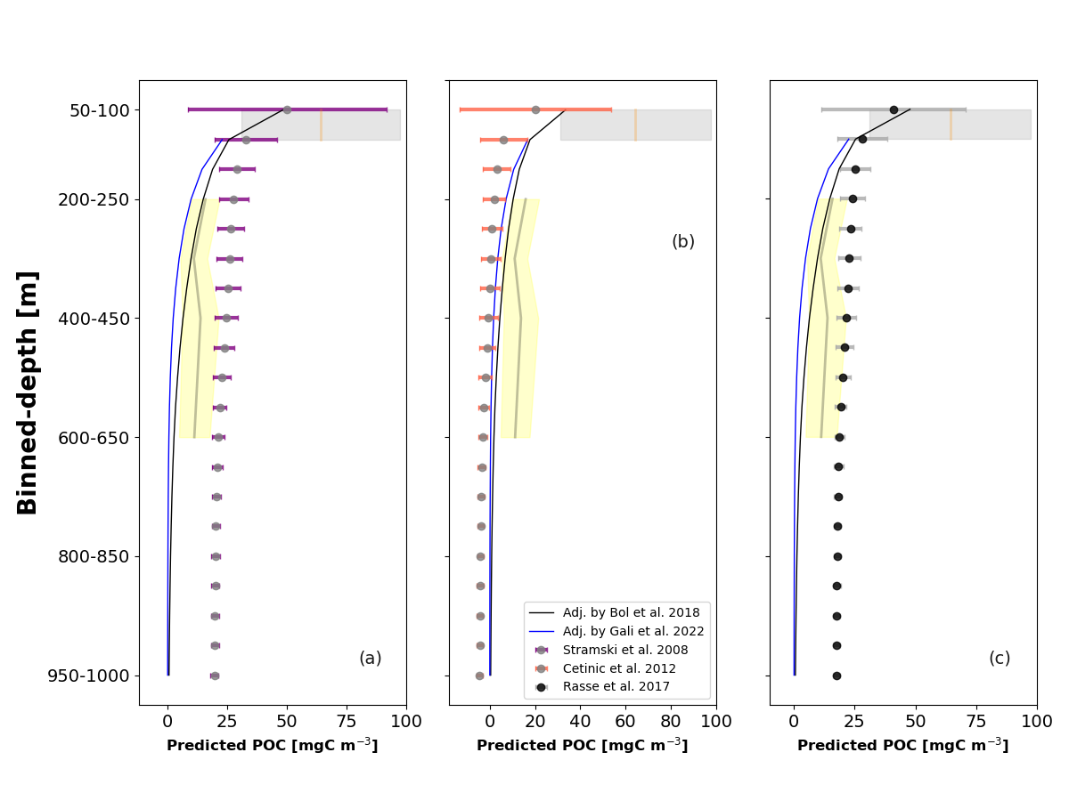
Fig. 6S. Vertical profiles of POC predicted by the constant model (circles) and non-constant models (solid black and blue lines) for float 6902550. The vertical orange line and gray shading represent the mean and standard deviation of reference POC values computed between 50 and 150 m depth. The vertical gray line and yellow shading indicate the mean and standard deviation of reference POC values computed between 200 and 600 m depth.

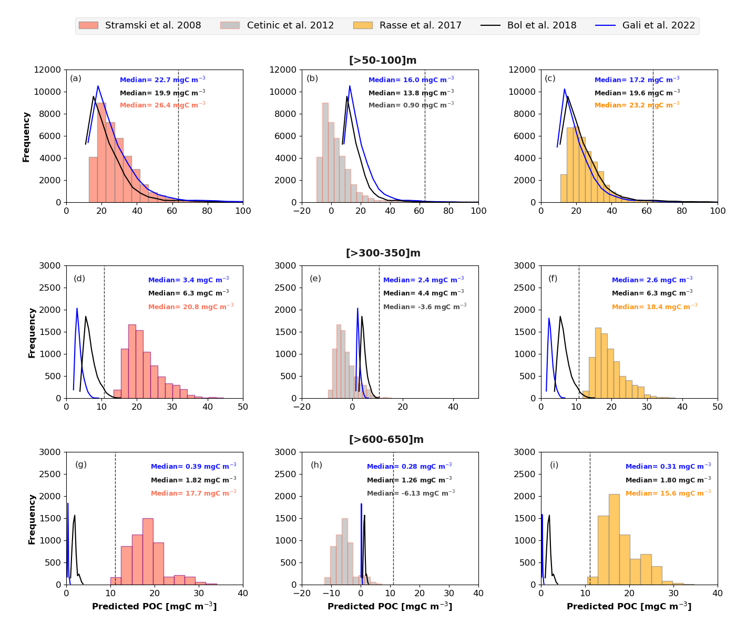

Fig. 7S. Histogram showing the distribution of POC estimates derived from b_{bpS} measurements recorded by the float fleet used in this study (Table S1), at binned depths of (a–c) 50–100 m (n = 38,054), (d–f) 300–350 m (n = 7,776), and (g–i) 600–650 m (n = 5,277). Vertical dashed lines indicate the mean values of reference POC measured at 50–100 m (64 ± 32 mg C m⁻³, n = 100), 300 m (10.9 ± 5.6 mg C m⁻³, n = 29), and 600 m (11.0 ± 6.4 mg C m⁻³, n = 9) (source: https://www.bco-dmo.org/?flag=view&id=102&sortby=project).

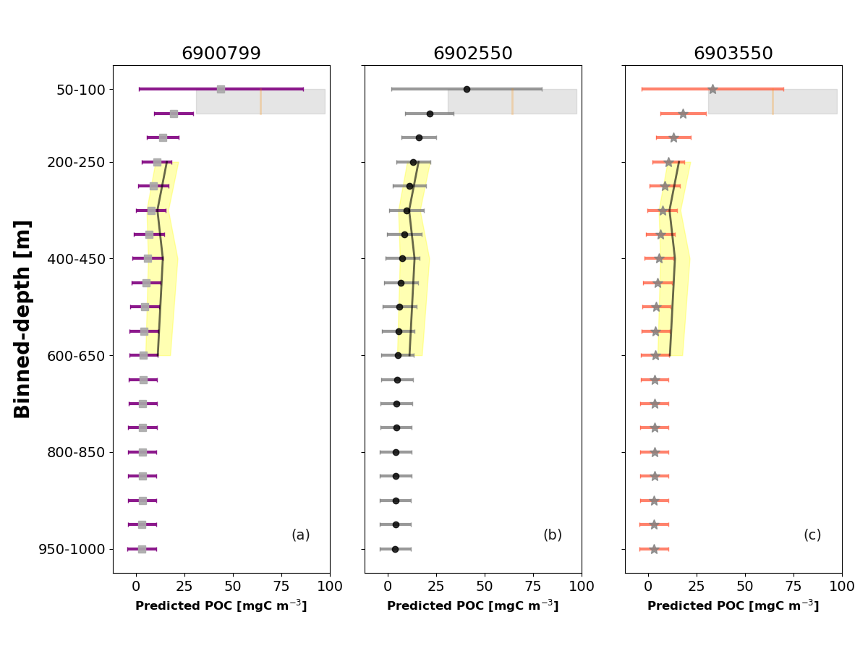
Fig. 8S. Mean vertical profiles of POC (circles, squares, and stars) ± standard deviation (colored horizontal lines), computed at binned depths by combining constant and non-constant models for floats 6900799, 6902550, and 6903550. The vertical orange line and gray shading represent the mean and standard deviation of reference POC values computed between 50–150 m depth. The vertical black line and yellow shading represent the mean and standard deviation of reference POC values measured between 200–600 m depth.

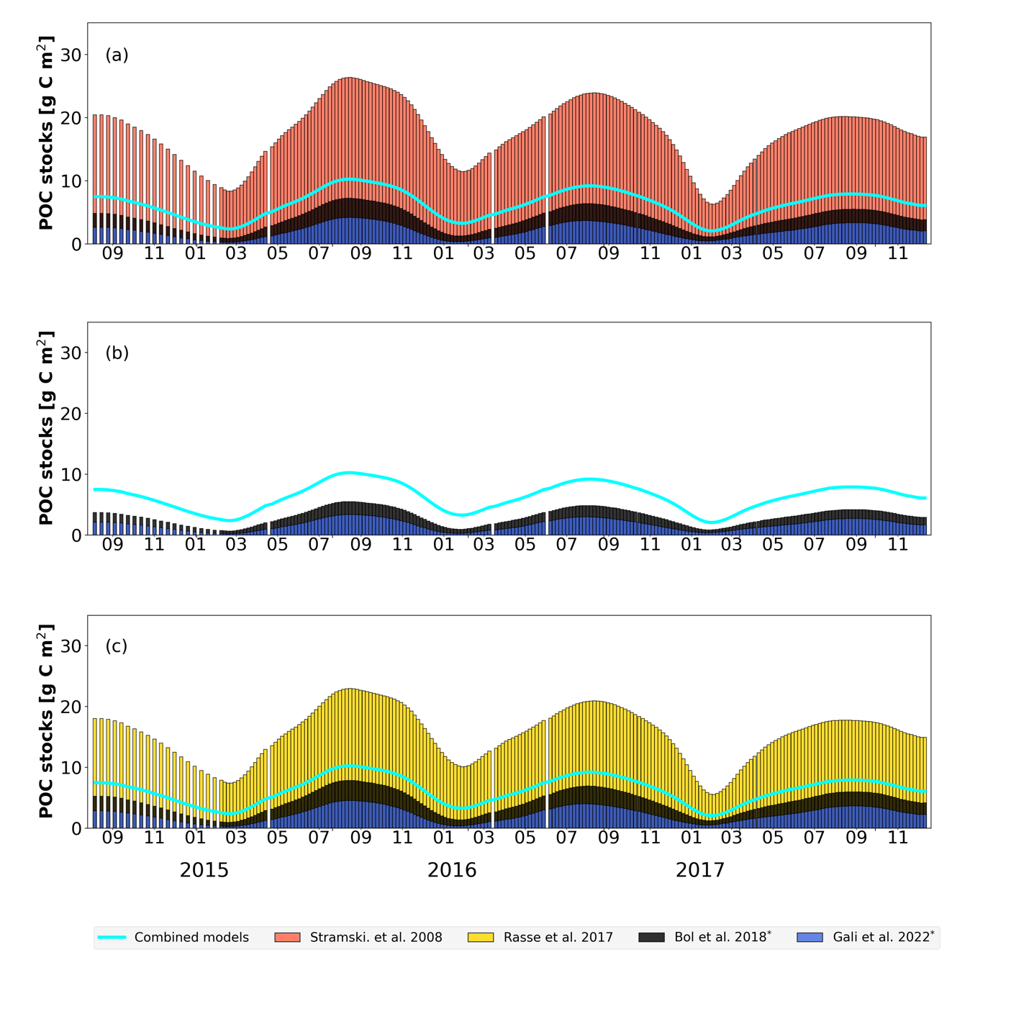
Fig. 9S. Smoothed POC stocks calculated by applying constant, non-constant, and combined models to the entire time series of b_{bpS} recorded by float 6902550. POC stocks were calculated from the base of the productive layer (z_{p}) to 1000 m depth (Section 4.5.2 of the methods). The black and blue bars represent the stocks modeled by Bolt et al. (2018) and Gali et al. (2022), using the respective POC:b_{bpS} ratios from (a) Stramski et al. (2008), (b) Cetinić et al. (2012), and (c) Rasse et al. (2017). The red and yellow bars in (a) and (c) represent the stocks computed by the constant models of Stramski et al. (2008) and Rasse et al. (2017), respectively.

Table 3S. Years of the biological gravitational pump events influenced by weak and intense coccolithophore blooms, as well as by physical intrusions.

WMO numbers | year
Weak blooms
6900798 | 2011
6900798 | 2014
6900799 | 2011
6900799 | 2013
6902549 | 2015
6902550 | 2017
6903273 | 2019
6903549 | 2020
6903550 | 2019
6903553 | 2019
6903569 | 2021
6903574 | 2021
6903574 | 2022
6903577 | 2023
6903578 | 2022
Intense blooms
6900799 | 2012
6902550 | 2015
6902550 | 2016
6903273 | 2017
6903578 | 2023
Physical intrusions
6900798 | 2012
6900798 | 2013
6902547 | 2015
6902548 | 2016
6903273 | 2018
6903273 | 2020
6902549 | 2017
6903549 | 2021
6903550 | 2020

4S. Coccolithophores blooms periods and intensity
Figures spanning from 10S to 22S show the start and end of coccolithophore bloom periods for each float in this study (indicated by yellow shading), as defined by the criteria presented in the main text. These figures highlight two main features for each float: (1) the overlap of coccolithophore blooms with the BGP events, and (2) the identification of intense and weak blooms and their respective influence on both the intensity and the depth reached by small particle pulses beneath z_{p}, as described by the mesopelagic time series of particle backscattering from small particles (b_{bpS}). Table 3S summarizes the years of the BGP events with intense and weak blooms recorded by each float.
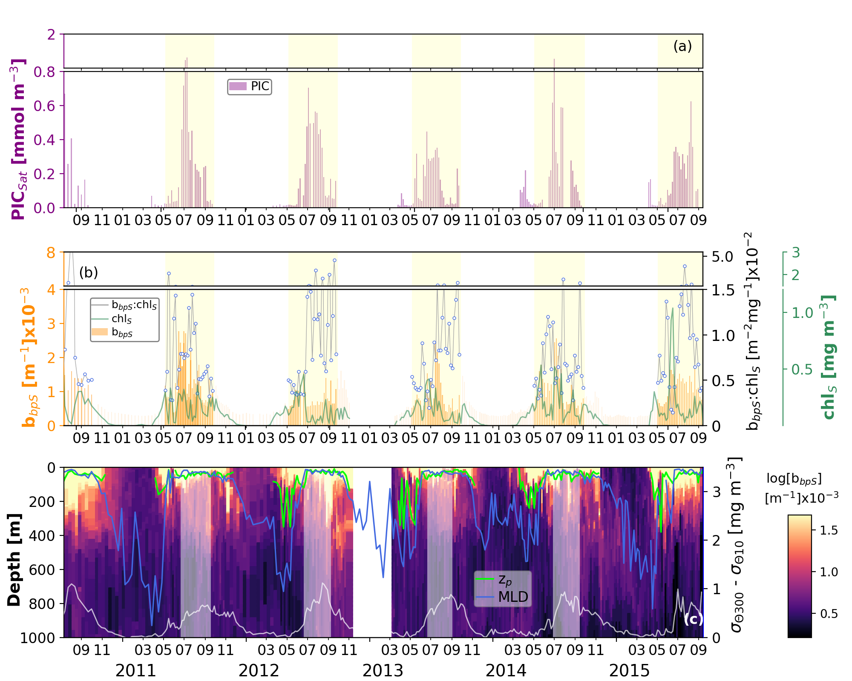
Fig. 10S. Matchups of satellite data and bio-optical parameters recorded by float 6900798. (a) Matchups of satellite PIC (purple bars). (b) chl_{S}, particle backscattering (b_{bpS,} orange bars) and b_{bpS}:chl_{S} ratios (grey line with circles) recorded by the float at the surface. (c) Time series of b_{bpS} in the entire water column. Gray line in (c) describes the temporal evolution of the stratification index (Δσ_{θ} = σ_{θ300 -} σ_{θ10}). Shaded areas demarcate the start and end of coccolithophore blooms in (a-b) and BGP periods in (c). (c) blue line is the MLD, green line is the productive layer (z_{p})..

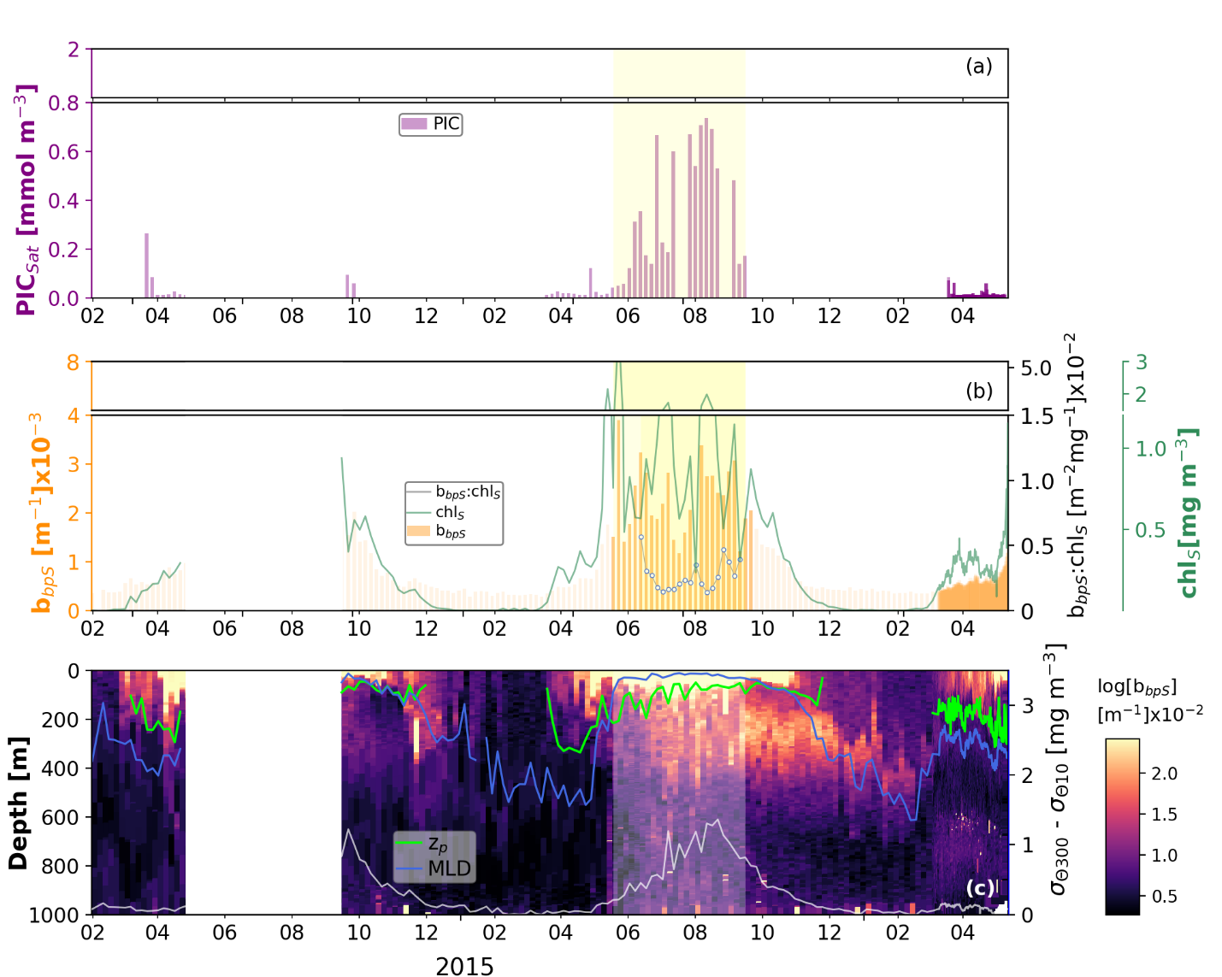
Fig. 11S. Same as Fig. 10S but for the data recorded by float 6902547.

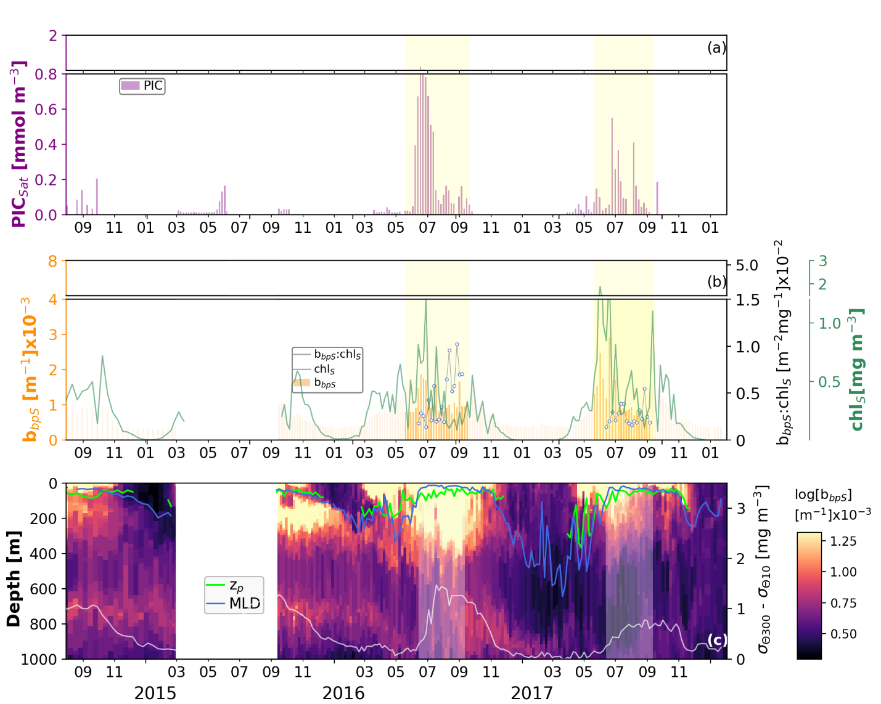
12S. Same as Fig. 10S but for the data recorded by float 6902548.

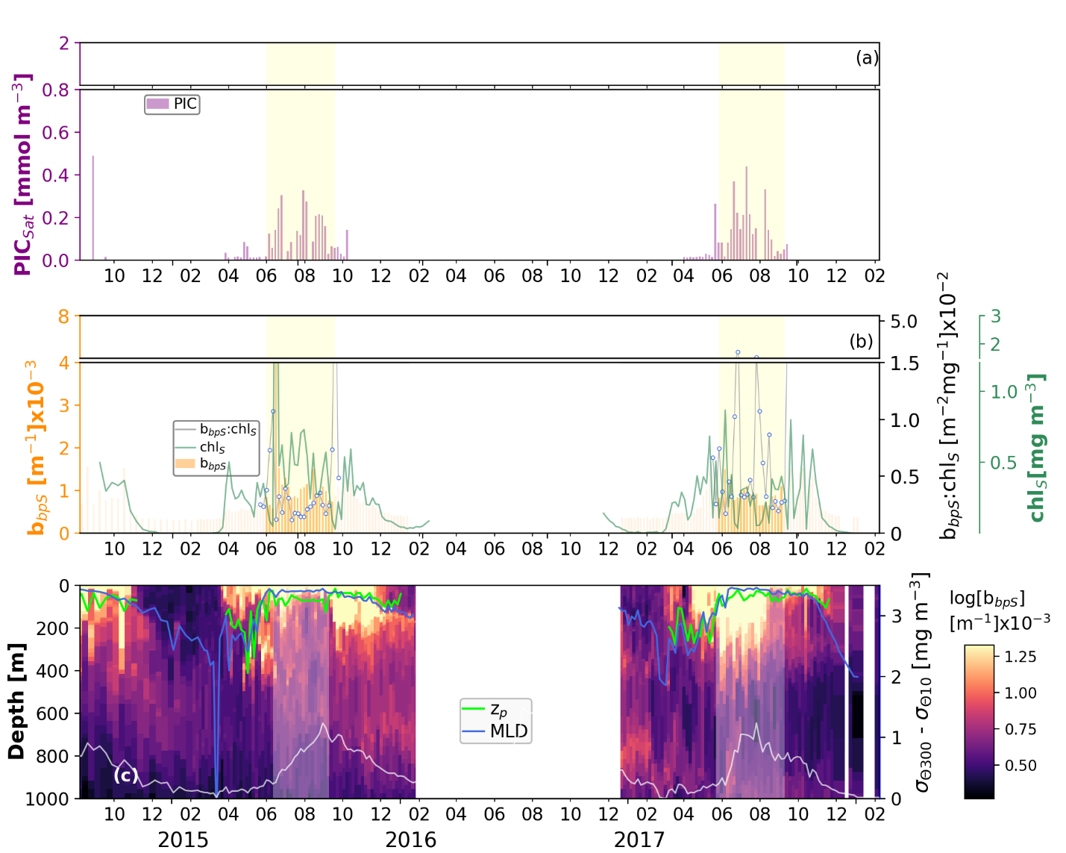

Fig. 13S. Same as Fig. 10S but for the data recorded by float 6902549.

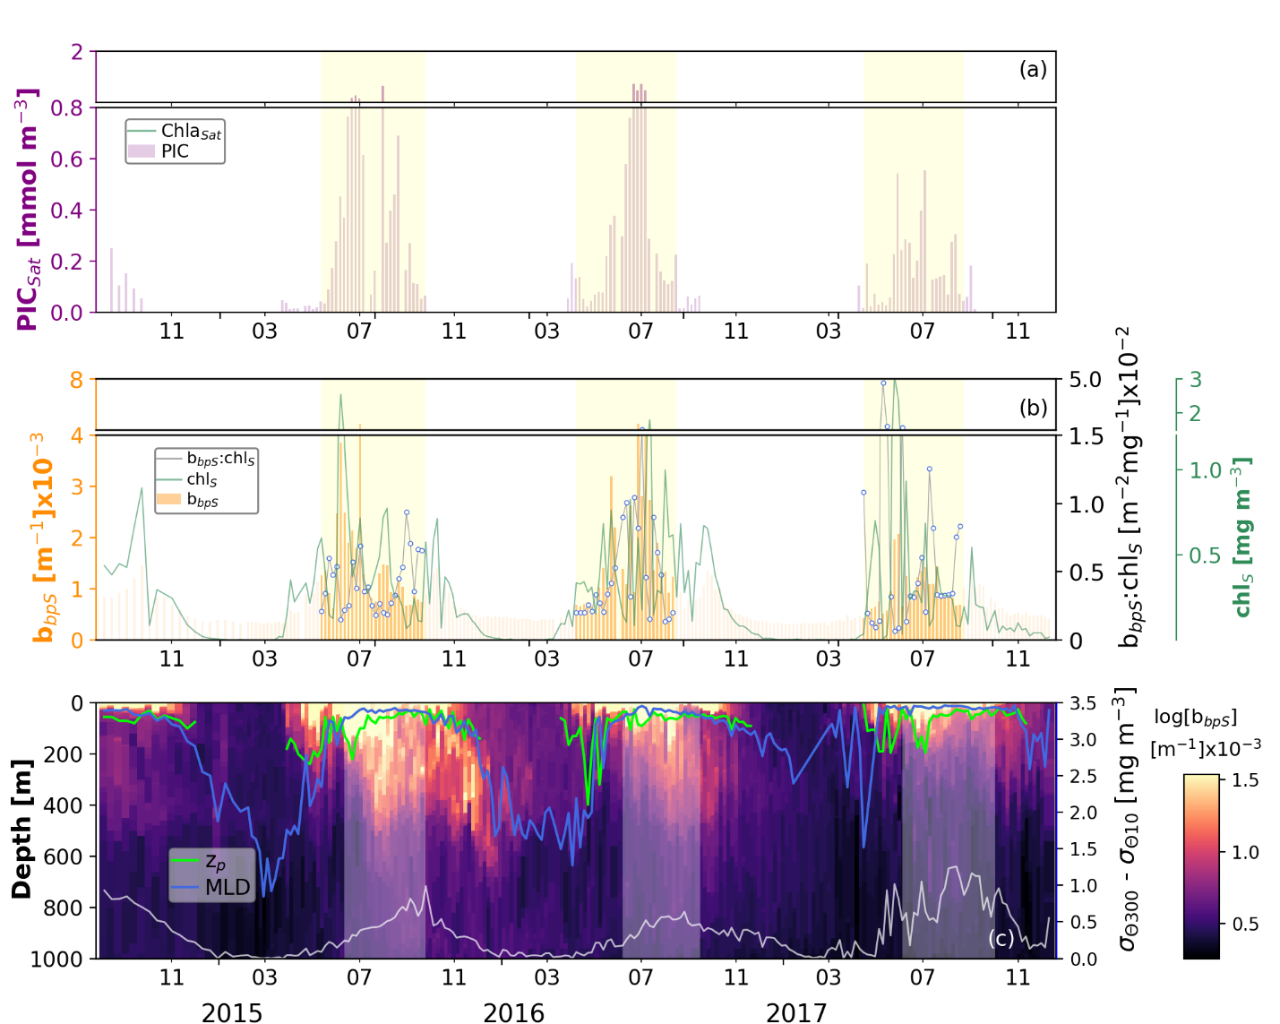
Fig. 14S. Same as Fig. 10S but for the data recorded by float 6902550.

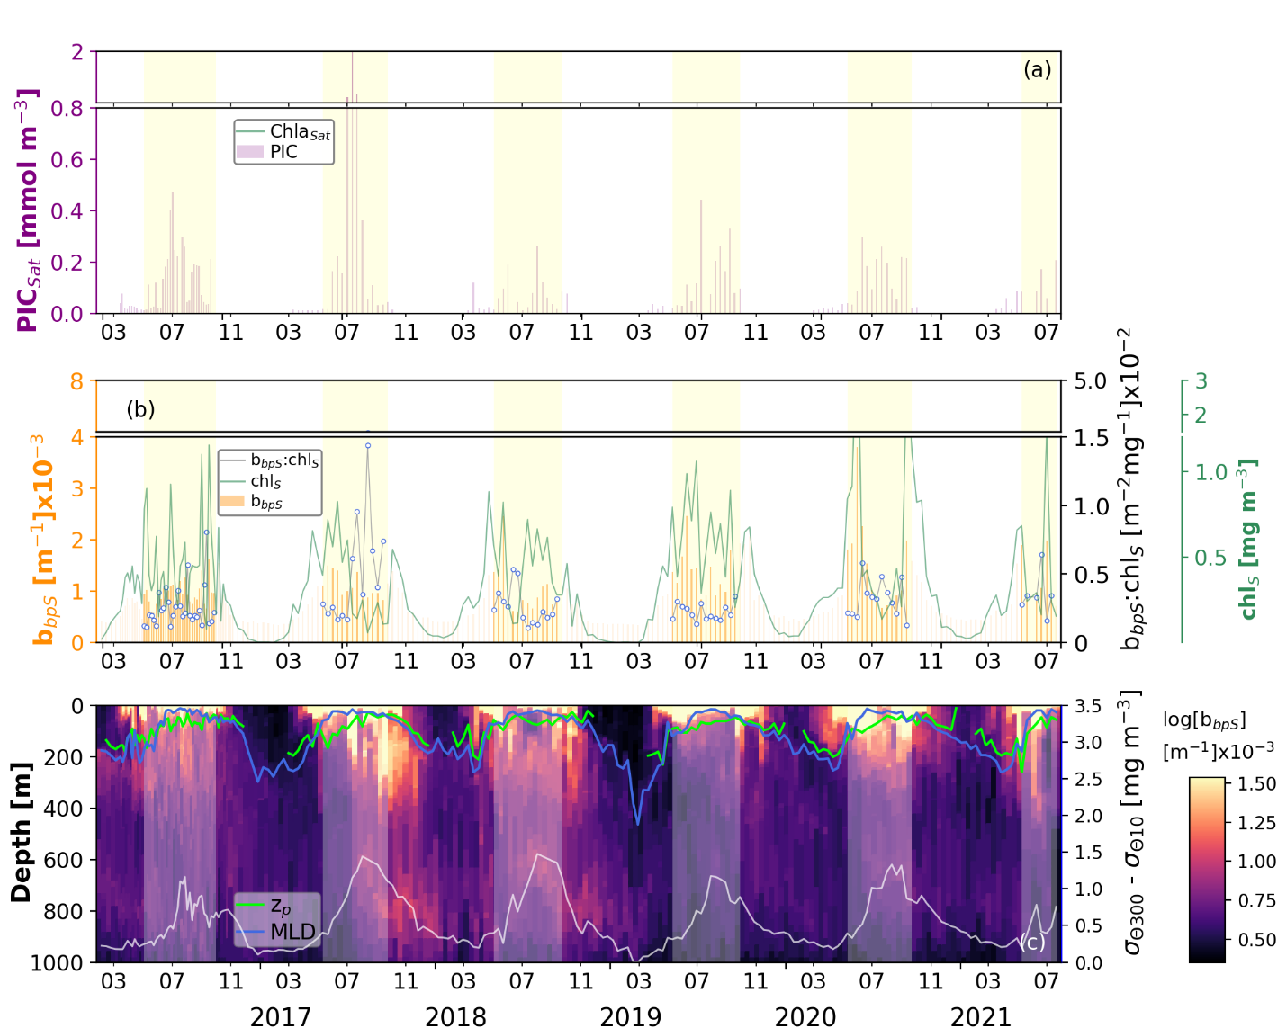

Fig. 15S. Same as Fig. 10S but for the data recorded by float 6903273.

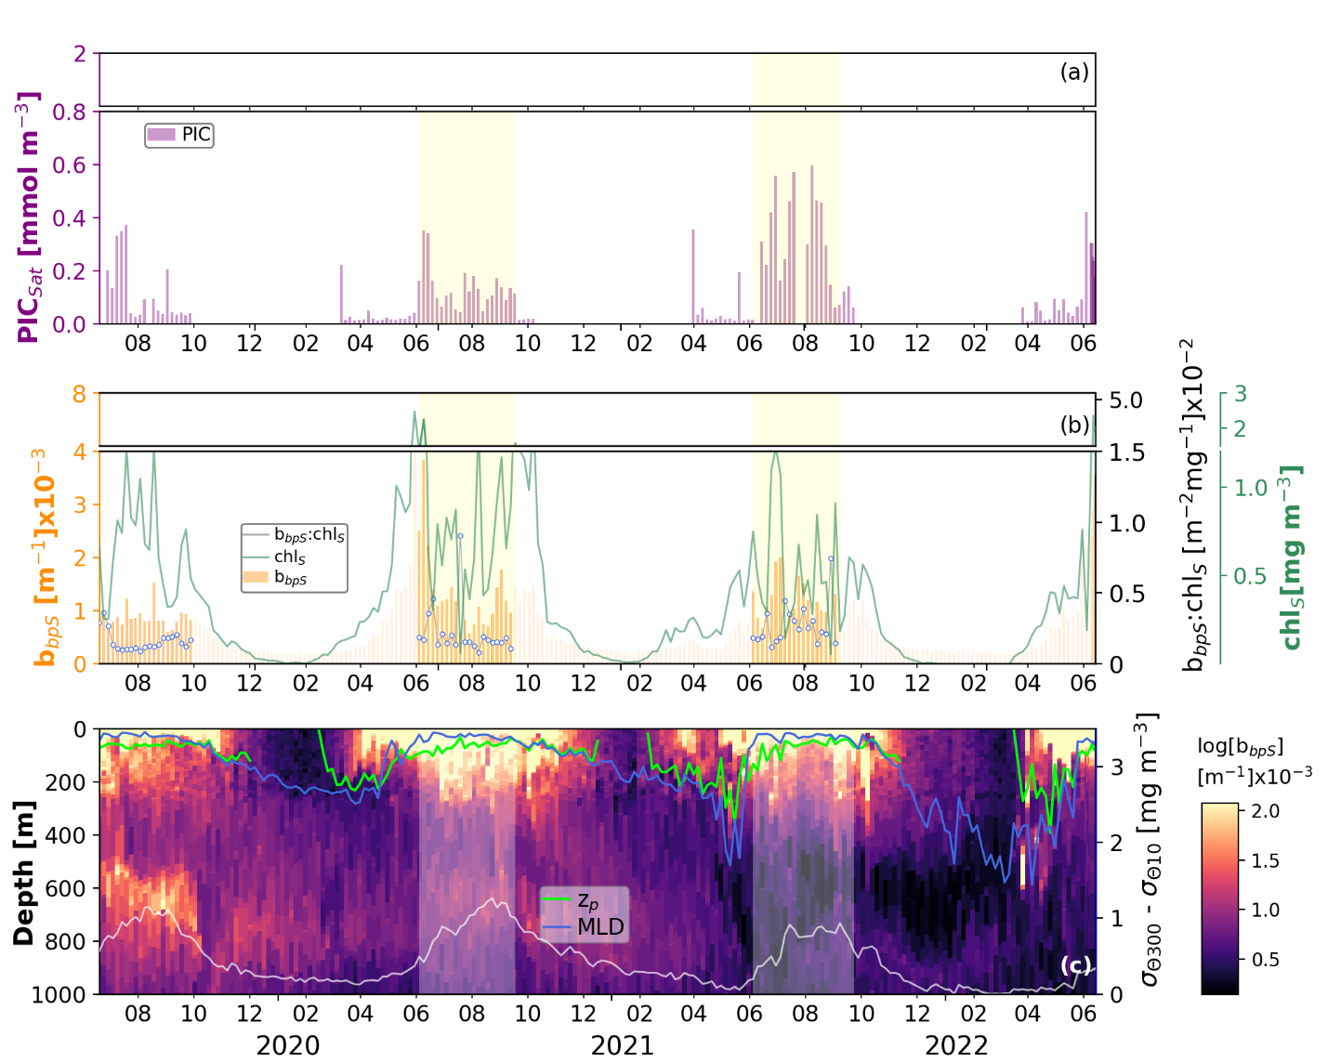
Fig. 16S. Same as Fig. 10S but for the data recorded by float 6903549
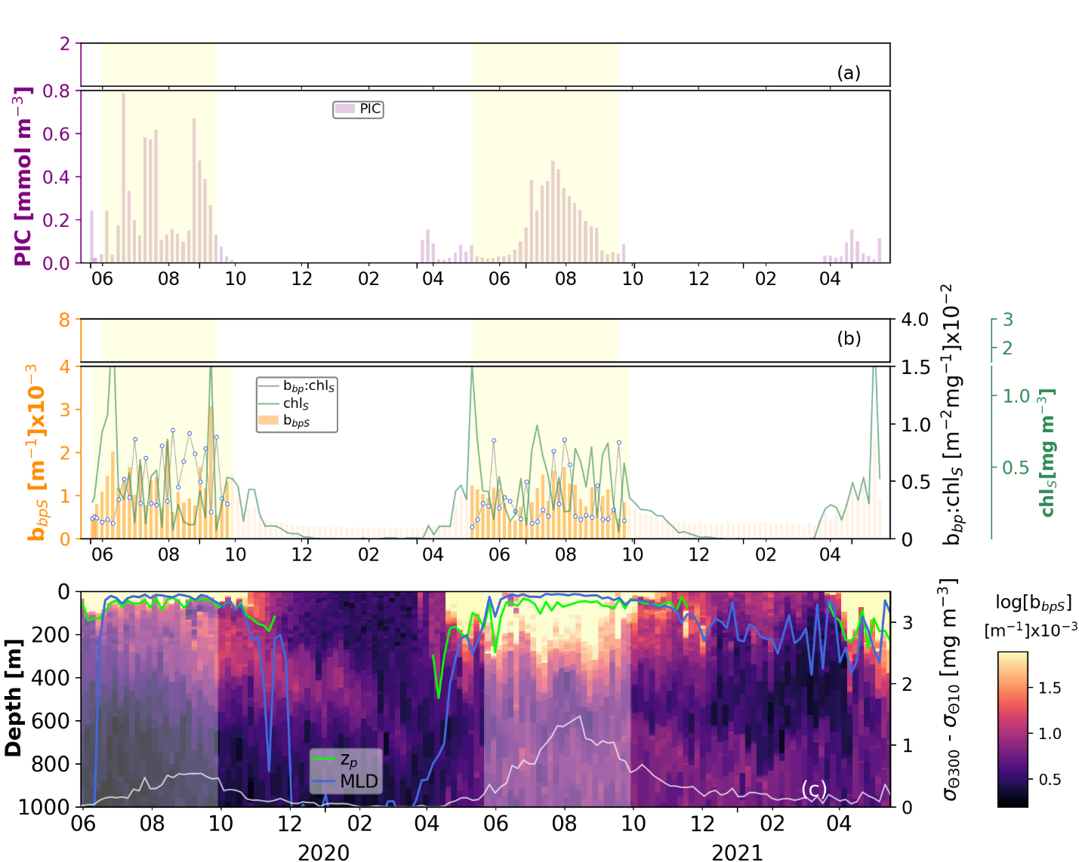

Fig. 17S. Same as Fig. 10S but for the data recorded by float 6903550.
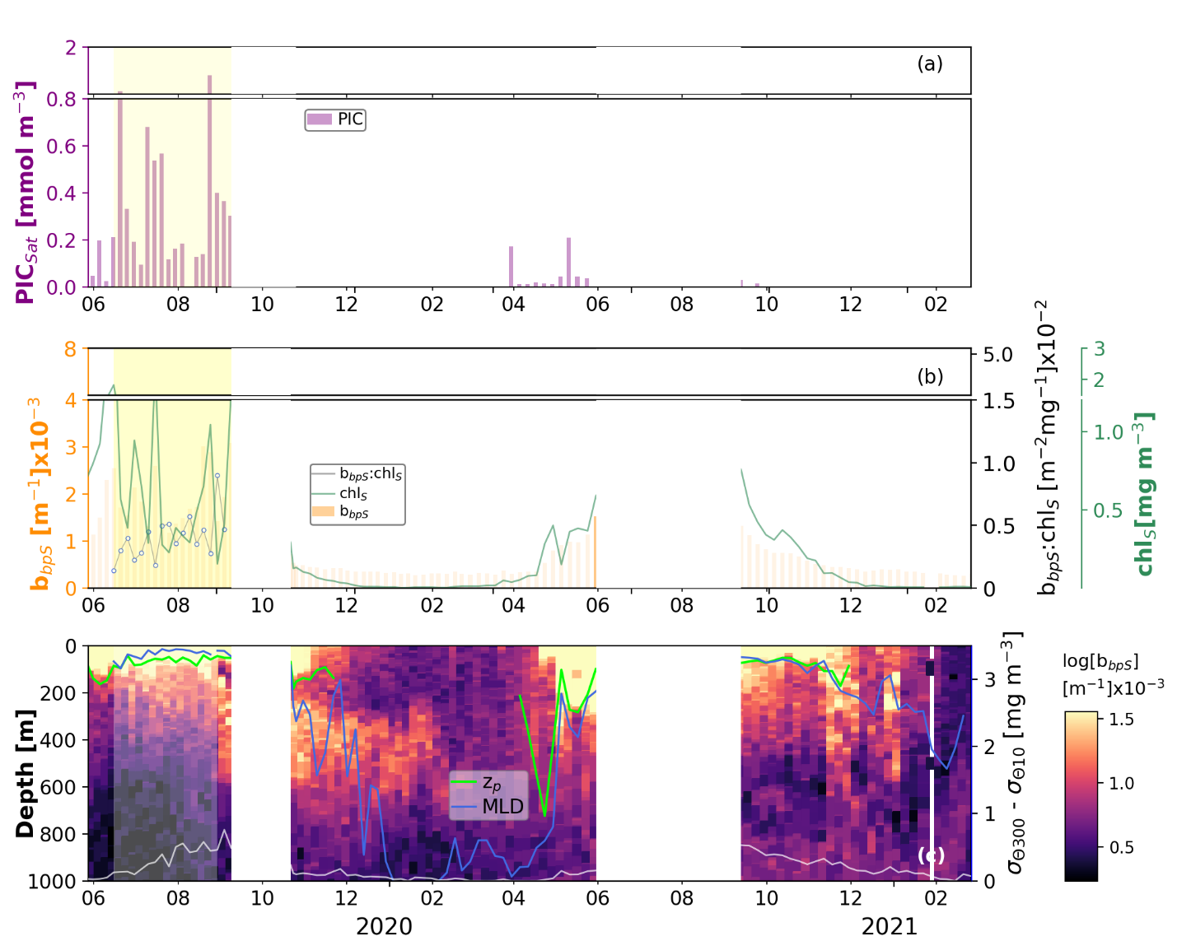
Fig. 18S. Same as Fig. 10S but for the data recorded by float 6903553.

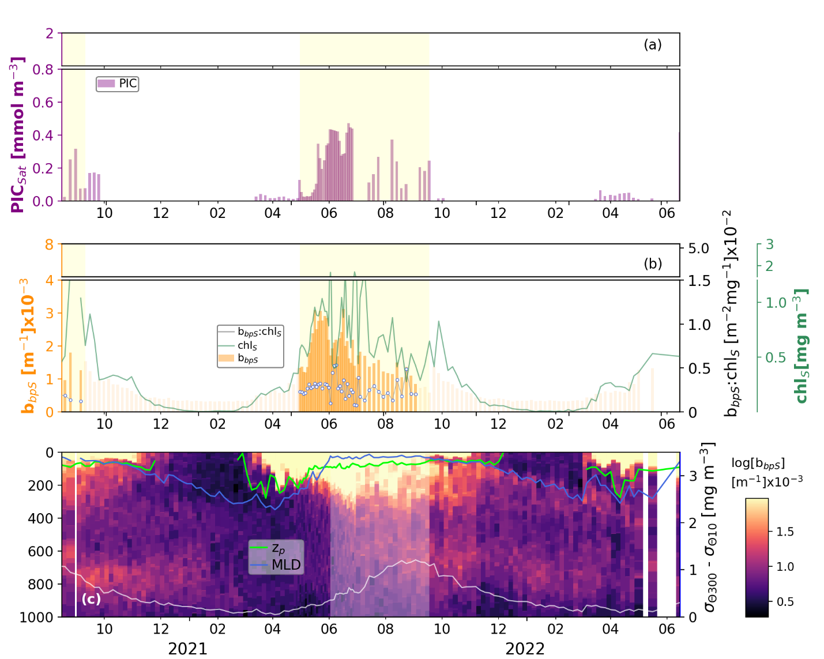Fig. 19S. Same as Fig. 10S but for the data recorded by float 6903569.

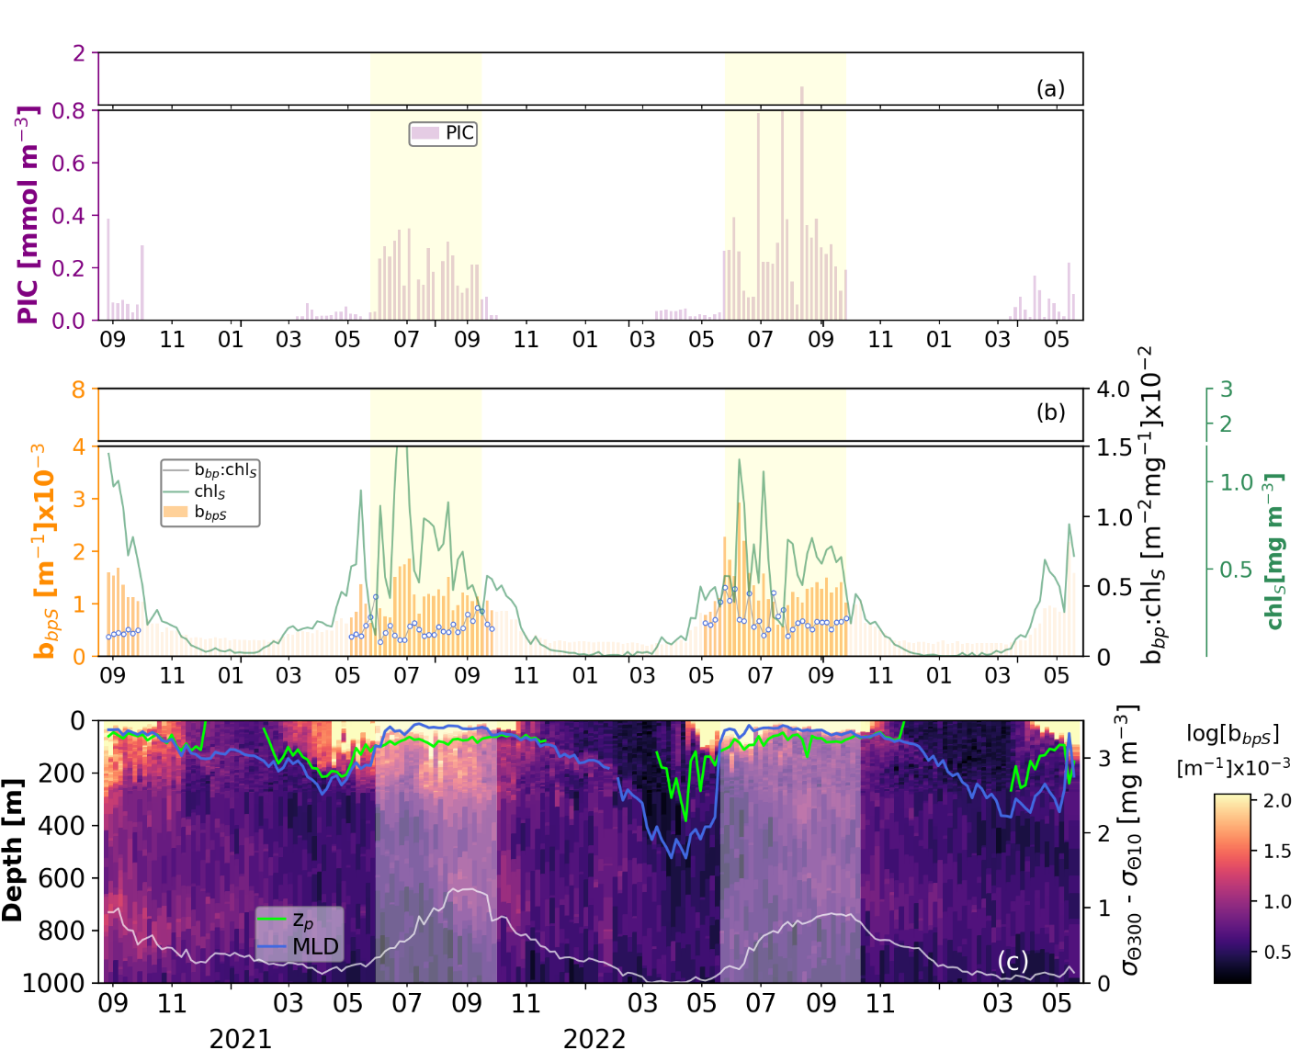
Fig. 20S. Same as Fig. 10S but for the data recorded by float 6903574.

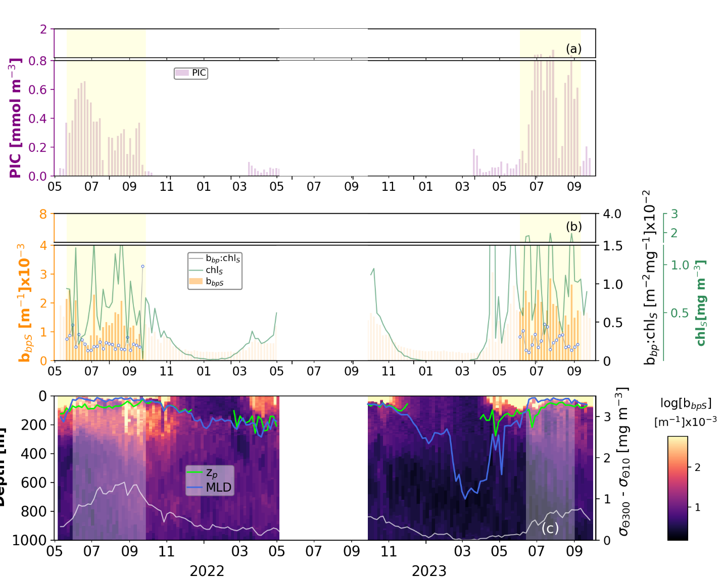
Fig. 21S. Same as Fig. 10S but for the data recorded by float 6903577.

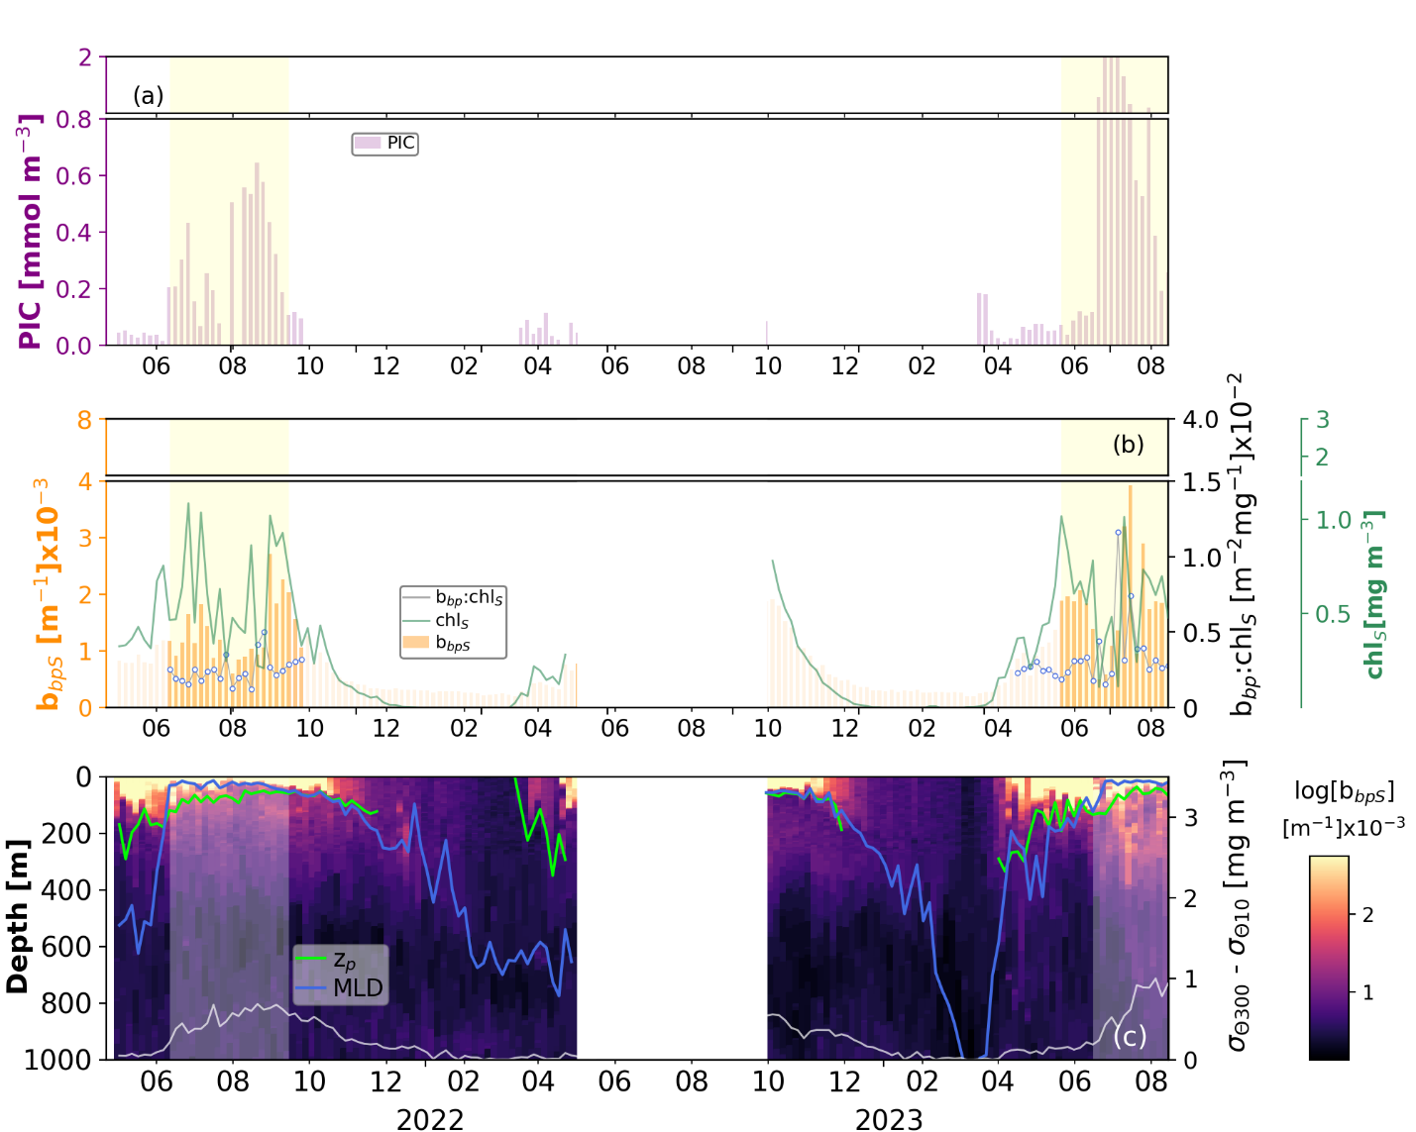
Fig. 22S. Same as Fig. 10S but for the data recorded by float 6903578.

5S. Chlorophyll-a stocks in the productive layer
Figure 23S shows the frequency distribution of chlorophyll-a stocks computed within the productive layer (z_{p}) for each category of the biological gravitational pump (BGP) events. These stocks were calculated by multiplying the mean concentration of chlorophyll-a due to small particles (chl_{S}) by the thickness of z_{p}. Figure 23S highlights that chlorophyll-a stocks are equivalent across all BGP categories, indicating that organic matter production within z_{p} was similar during these periods. Thus, the differences observed in fluxes beneath z_{p} between BGP categories were driven by mechanisms other than organic matter production. These mechanisms include the physical intrusion of North Atlantic waters and the structural composition of particles, influenced by the presence of intense and weak coccolithophore blooms, as described in detail in the main text.

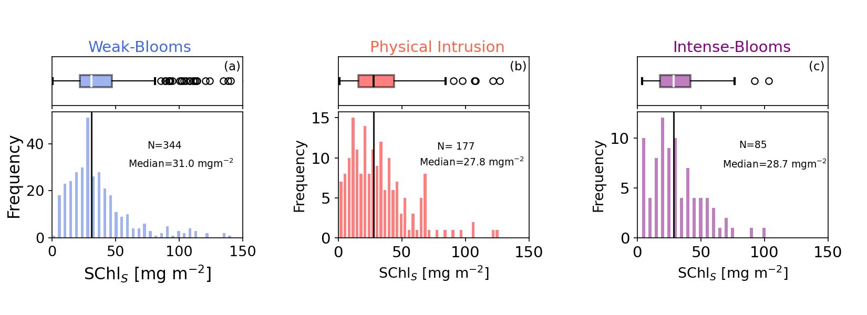
Fig. 23S. Frequency distribution of chlorophyll-a stocks (Schl_{S}) within the productive layer across the three categories of biological gravitational pump events.

References
1. Bosse, A., Fer, I., Søiland, H. & Rossby, T. Atlantic Water Transformation Along Its Poleward Pathway Across the Nordic Seas. J Geophys Res Oceans 123, (2018).
2. Briggs, N. et al. High-resolution observations of aggregate flux during a sub-polar North Atlantic spring bloom. Deep Sea Res 1 Oceanogr Res Pap (2011) doi:10.1016/j.dsr.2011.07.007.
3. Haëntjens, N. et al. Detecting Mesopelagic Organisms Using Biogeochemical-Argo Floats. Geophys Res Lett 47, (2020).
4. Cetinić, I. et al. Particulate organic carbon and inherent optical properties during 2008 North Atlantic bloom experiment. J Geophys Res Oceans (2012) doi:10.1029/2011JC007771.
5. Rasse, R. et al. Evaluating optical proxies of particulate organic carbon across the surface Atlantic ocean. Front Mar Sci 4, (2017).
6. Stramski, D. et al. Relationships between the surface concentration of particulate organic carbon and optical properties in the eastern South Pacific and eastern Atlantic Oceans. Biogeosciences 5, (2008).
7. Boss, E. et al. Optical techniques for remote and in-situ characterization of particles pertinent to GEOTRACES. Prog Oceanogr 133, (2015).
8. Strubinger Sandoval, P., Dall’Olmo, G., Haines, K., Rasse, R. & Ross, J. Uncertainties of particulate organic carbon concentrations in the mesopelagic zone of the Atlantic ocean. Open Research Europe 1, (2021).
9. Bol, R., Henson, S. A., Rumyantseva, A. & Briggs, N. High-Frequency Variability of Small-Particle Carbon Export Flux in the Northeast Atlantic. Global Biogeochem Cycles 32, (2018).
10. Galí, M., Falls, M., Claustre, H., Aumont, O. & Bernardello, R. Bridging the gaps between particulate backscattering measurements and modeled particulate organic carbon in the ocean. Biogeosciences 19, (2022).

