Supplemental Online Content
Metabolomic Signatures Linking Depressive Symptoms to Atherosclerotic Cardiovascular Disease Comorbidity: Evidence from the UK Biobank
Angela Koloi1,2,3, Kevin Dobretz4,5, Dafne Broquetas Damman3, Rick Quax6, Dimitris Zaridis1,7,8 Costas Papaloukas1,2,8, Dimitrios I. Fotiadis1,8 and Jos A. Bosch3,9
¹Unit of Medical Technology and Intelligent Information Systems, Department of Materials Science and Engineering, University of Ioannina.
²Department of Biological Applications and Technology, University of Ioannina.
³Department of Clinical Psychology, University of Amsterdam.
⁴Cardiology Department, Geneva University Hospitals.
⁵Department of Medicine, University of Geneva.
⁶Computational Science Lab, Institute of Informatics, University of Amsterdam.
⁷Biomedical Engineering Laboratory, School of Electrical & Computer Engineering, National Technical University of Athens, 9 Iroon Polytechniou St., 15780 Athens, Greece.
⁸Biomedical Research Institute, Foundation for Research and Technology - Hellas (FORTH).
⁹Department of Medical Psychology, Amsterdam University Medical Centre.

Correspondence should be addressed to a.koloi@uva.nl, Von Zesenstraat 453, 1093 DM Amsterdam, The Netherlands.

This document contributes as supplemental information regarding the work “Metabolomic signatures linking depressive symptoms to cardiovascular disease comorbidity”. This document includes Supplemental Figures and Supplemental Tables.

Tables
Supplementary Table 1.
Individual symptoms of depression in UK Biobank
Symptoms | Instrument | Item | Coding
Anhedonia | PHQ-9 | Recent lack of interest or pleasure in doing things | Range 0-3, ≥1 Endorsed
Depressed mood | PHQ-9 | Recent feelings of depression | Range 0-3, ≥1 Endorsed
Sleep problems | PHQ-9 | Trouble sleeping, or sleeping too much | Range 0-3, ≥1 Endorsed
Fatigue | PHQ-9 | Recent feelings of tiredness or low energy | Range 0-3, ≥1 Endorsed
Appetite changes | PHQ-9 | Recent poor appetite or overeating | Range 0-3, ≥1 Endorsed
Feelings of inadequacy | PHQ-9 | Recent feelings of inadequacy | Range 0-3, ≥1 Endorsed
Cognitive problems | PHQ-9 | Recent trouble concentration | Range 0-3, ≥1 Endorsed
Psychomotor changes | PHQ-9 | Recent changes in moving/speaking | Range 0-3, ≥1 Endorsed
Suicidal ideation | PHQ-9 | Recent thoughts of suicide or self-harm | Range 0-3, ≥1 Endorsed

Supplementary Table 2.
UK Biobank ICD-10 codes for cardiovascular disease endpoints included in analysis: code definitions and categories.
ICD-10 | Meaning | Category
G463 | Brain stem stroke syndrome | G46 Vascular syndromes of brain in cerebrovascular diseases
G464 | Cerebellar stroke syndrome | G46 Vascular syndromes of brain in cerebrovascular diseases
I200 | Unstable angina | I20 Angina pectoris
I201 | Angina pectoris with documented spasm | I20 Angina pectoris
I208 | Other forms of angina pectoris | I20 Angina pectoris
I209 | Angina pectoris, unspecified | I20 Angina pectoris
I210 | Acute transmural myocardial infarction of anterior wall | I21 Acute myocardial infarction
I211 | Acute transmural myocardial infarction of inferior wall | I21 Acute myocardial infarction
I212 | Acute transmural myocardial infarction of other sites | I21 Acute myocardial infarction
I213 | Acute transmural myocardial infarction of unspecified site | I21 Acute myocardial infarction
I214 | Acute subendocardial myocardial infarction | I21 Acute myocardial infarction
I219 | Acute myocardial infarction, unspecified | I21 Acute myocardial infarction
I220 | Subsequent myocardial infarction of anterior wall | I22 Subsequent myocardial infarction
I221 | Subsequent myocardial infarction of inferior wall | I22 Subsequent myocardial infarction
I228 | Subsequent myocardial infarction of other sites | I22 Subsequent myocardial infarction
I229 | Subsequent myocardial infarction of unspecified site | I22 Subsequent myocardial infarction
I230 | Haemopericardium as current complication following acute myocardial infarction | I23 Certain current complications following acute myocardial infarction
I231 | Atrial septal defect as current complication following acute myocardial infarction
I232 | Ventricular septal defect as current complication following acute myocardial infarction
I233 | Rupture of cardiac wall without haemopericardium as current complication following acute myocardial infarction
I234 | Rupture of chordae tendineae as current complication following acute myocardial infarction
I235 | Rupture of papillary muscle as current complication following acute myocardial infarction
I236 | Thrombosis of atrium, auricular appendage, and ventricle as current complications following acute myocardial infarction
I238 | Other current complications following acute myocardial infarction
I240 | Coronary thrombosis not resulting in myocardial infarction | I24 Other acute ischaemic heart diseases
I248 | Other forms of acute ischaemic heart disease | I24 Other acute ischaemic heart diseases
I249 | Acute ischaemic heart disease, unspecified | I24 Other acute ischaemic heart diseases
I252 | Old myocardial infarction | I25 Chronic ischaemic heart disease
I255 | Ischaemic cardiomyopathy | I25 Chronic ischaemic heart disease
I258 | Other forms of chronic ischaemic heart disease | I25 Chronic ischaemic heart disease
I259 | Chronic ischaemic heart disease, unspecified | I25 Chronic ischaemic heart disease
I630 | Cerebral infarction due to thrombosis of precerebral arteries | I63 Cerebral infarction
I632 | Cerebral infarction due to unspecified occlusion or stenosis of precerebral arteries | I63 Cerebral infarction
I633 | Cerebral infarction due to thrombosis of cerebral arteries | I63 Cerebral infarction
I635 | Cerebral infarction due to unspecified occlusion or stenosis of cerebral arteries | I63 Cerebral infarction
I700 | Atherosclerosis of aorta | I70 Atherosclerosis
I7000 | Atherosclerosis of aorta (without gangrene) | I70 Atherosclerosis
I7001 | Atherosclerosis of aorta (with gangrene) | I70 Atherosclerosis
I701 | Atherosclerosis of renal artery | I70 Atherosclerosis
I7010 | Atherosclerosis of renal artery (without gangrene) | I70 Atherosclerosis
I7011 | Atherosclerosis of renal artery (with gangrene) | I70 Atherosclerosis
I702 | Atherosclerosis of arteries of the extremities | I70 Atherosclerosis
I7020 | Atherosclerosis of arteries of extremities (without gangrene) | I70 Atherosclerosis
I7021 | Atherosclerosis of arteries of extremities (with gangrene) | I70 Atherosclerosis
I708 | Atherosclerosis of other arteries | I70 Atherosclerosis
I7080 | Atherosclerosis of other arteries (without gangrene) | I70 Atherosclerosis
I7081 | Atherosclerosis of other arteries (with gangrene) | I70 Atherosclerosis
I709 | Generalised and unspecified atherosclerosis | I70 Atherosclerosis
I7090 | Generalized and unspecified atherosclerosis (without gangrene) | I70 Atherosclerosis
I7091 | Generalized and unspecified atherosclerosis (with gangrene) | I70 Atherosclerosis
Z951 | Presence of aortocoronary bypass graft | Z95 Presence of cardiac and vascular implants and grafts
Z955 | Presence of coronary angioplasty implant and graft | Z95 Presence of cardiac and vascular implants and grafts

Supplementary Table 3.
Antidepressants use in UK Biobank.
Class | UKB Coding | Generic Name | Brand Name(s)
Tricyclic Antidepressants (TCAs) | 1140879616 | Amitriptyline | -
Tricyclic Antidepressants (TCAs) | 1140879620 | Clomipramine | Anafranil
Tricyclic Antidepressants (TCAs) | 1140879628 | Dothiepin | -
Tricyclic Antidepressants (TCAs) | 1140909806 | Dosulepin | Prothiaden
Tricyclic Antidepressants (TCAs) | 1140879630 | Imipramine | -
Tricyclic Antidepressants (TCAs) | 1140867726 | Lofepramine | -
Tricyclic Antidepressants (TCAs) | 1140867818 | Nortriptyline | Allegron
Tricyclic Antidepressants (TCAs) | 1140867756 | Trimipramine | Surmontil
Tricyclic Antidepressants (TCAs) | 1140867640 | Doxepin | Sinequan
Tricyclic Antidepressants (TCAs) | 1140867948 | Amitriptyline + Perphenazine | Triptafen
Tricyclic Antidepressants (TCAs) | 1140867624 | Dosulepin | Prothiaden 25mg capsule
Tricyclic Antidepressants (TCAs) | 1140867690 | Clomipramine | Anafranil 10mg capsule
Tricyclic Antidepressants (TCAs) | 1140867820 | Nortriptyline | Allegron 10mg tablet
Tricyclic Antidepressants (TCAs) | 1140867668 | Amitriptyline | Tryptizol 10mg tablet
Tricyclic Antidepressants (TCAs) | 1140867938 | Amitriptyline + Chlordiazepoxide | -
Tricyclic Antidepressants (TCAs) | 1140867940 | Fluphenazine + Nortriptyline | -
Selective Serotonin Reuptake Inhibitors (SSRIs) | 1140921600 | Citalopram | Cipramil
Selective Serotonin Reuptake Inhibitors (SSRIs) | 1141180212 | Escitalopram | Cipralex
Selective Serotonin Reuptake Inhibitors (SSRIs) | 1140879540 | Fluoxetine | Prozac
Selective Serotonin Reuptake Inhibitors (SSRIs) | 1140879544 | Fluvoxamine | Faverin
Selective Serotonin Reuptake Inhibitors (SSRIs) | 1140867888 | Paroxetine | Seroxat
Selective Serotonin Reuptake Inhibitors (SSRIs) | 1140867878 | Sertraline | Lustral
Selective Serotonin Reuptake Inhibitors (SSRIs) | 1140867876 | Fluoxetine | Prozac 20mg capsule
Selective Serotonin Reuptake Inhibitors (SSRIs) | 1140882236 | Paroxetine | Seroxat 20mg tablet
Selective Serotonin Reuptake Inhibitors (SSRIs) | 1141190158 | Escitalopram | Cipralex 5mg tablet
Selective Serotonin Reuptake Inhibitors (SSRIs) | 1141151946 | Citalopram | Cipramil 10mg tablet
Selective Serotonin Reuptake Inhibitors (SSRIs) | 1140867884 | Sertraline | Lustral 50mg tablet
Selective Serotonin Reuptake Inhibitors (SSRIs) | 1140867860 | Fluvoxamine | Faverin 50mg tablet
Serotonin-Norepinephrine Reuptake Inhibitors (SNRIs) | 1141200564 | Duloxetine | Cymbalta
Serotonin-Norepinephrine Reuptake Inhibitors (SNRIs) | 1140916282 | Venlafaxine | -
Serotonin-Norepinephrine Reuptake Inhibitors (SNRIs) | 1141201834 | Duloxetine | Cymbalta 30mg gastro-resistant capsule
Serotonin-Norepinephrine Reuptake Inhibitors (SNRIs) | 1141200570 | Duloxetine | Yentreve 20mg gastro-resistant capsule
Noradrenergic and Specific Serotonergic Antidepressants (NaSSAs) | 1141152732 | Mirtazapine | Zispin
 | 1140879556 | Mianserin | -
 | 1141152736 | Mirtazapine | Zispin 30mg tablet
Monoamine Oxidase Inhibitors (MAOIs) | 1140867850 | Phenelzine | Nardil
Monoamine Oxidase Inhibitors (MAOIs) | 1140867914 | Tranylcypromine | -
Monoamine Oxidase Inhibitors (MAOIs) | 1140867856 | Isocarboxazid | -
Monoamine Oxidase Inhibitors (MAOIs) | 1140867920 | Moclobemide | Manerix
Monoamine Oxidase Inhibitors (MAOIs) | 1140910820 | Tranylcypromine | MAOI - Tranylcypromine
Monoamine Oxidase Inhibitors (MAOIs) | 1140867852 | Phenelzine | Nardil 15mg tablet
Monoamine Oxidase Inhibitors (MAOIs) | 1140867922 | Moclobemide | Manerix 150mg tablet
Monoamine Oxidase Inhibitors (MAOIs) | 1140867944 | Tranylcypromine + Trifluoperazine | -
Other Antidepressants | 1140879634 | Trazodone | Molipaxin
Other Antidepressants | 1141151978 | Reboxetine | Edronax
Other Antidepressants | 1140917460 | Nefazodone | -
Other Antidepressants | 1140882244 | Trazodone | Molipaxin 50mg capsule
Other Antidepressants | 1141151982 | Reboxetine | Edronax 4mg tablet
Other Antidepressants | 1140882312 | Doxepin | Sinequan 10mg capsule
Other Antidepressants | 1140867784 | Maprotiline | Ludiomil 10mg tablet
Other Antidepressants | 1140867812 | Mianserin | Norval 10mg tablet

Supplementary Table 4.
The NMR metabolites and C-reactive protein (CRP) measured in the UK Biobank, their respective groupings, and associated units.
Category | Biomarker | Units
NMR-Measured Metabolites
Amino acids | Alanine | mmol/L
Amino acids | Glutamine | mmol/L
Amino acids | Histidine | mmol/L
Amino acids | Isoleucine | mmol/L
Amino acids | Leucine | mmol/L
Amino acids | Phenylalanine | mmol/L
Amino acids | Tyrosine | mmol/L
Amino acids | Valine | mmol/L
Apolipoproteins | Apolipoprotein A1 | g/L
Apolipoproteins | Apolipoprotein B | g/L
Cholesterol | Total Esterified Cholesterol | mmol/L
Cholesterol | Total Free Cholesterol | mmol/L
Cholesterol | HDL Cholesterol | mmol/L
Cholesterol | LDL Cholesterol | mmol/L
Cholesterol | Remnant Cholesterol | mmol/L
Cholesterol | Total Cholesterol | mmol/L
Cholesterol | VLDL Cholesterol | mmol/L
Fatty acids | Docosahexaenoic Acid | mmol/L
Fatty acids | Linoleic Acid | mmol/L
Fatty acids | Monounsaturated Fatty Acids | mmol/L
Fatty acids | Omega-3 Fatty Acids | mmol/L
Fatty acids | Omega-6 Fatty Acids | mmol/L
Fatty acids | Polyunsaturated Fatty Acids | mmol/L
Fatty acids | Saturated Fatty Acids | mmol/L
Fluid balance | Albumin | g/L
Fluid balance | Creatinine | µmol/L
Glycerides and phospholipids | Phosphatidylcholines | mmol/L
Glycerides and phospholipids | Total Triglycerides | mmol/L
Glycerides and phospholipids | Total Cholines | mmol/L
Glycerides and phospholipids | Sphingomyelins | mmol/L
Glycerides and phospholipids | Phosphoglycerides | mmol/L
Glycerides and phospholipids | Triglycerides in HDL | mmol/L
Glycerides and phospholipids | Triglycerides in LDL | mmol/L
Glycerides and phospholipids | Triglycerides in VLDL | mmol/L
Glycolysis related metabolites | Citrate | mmol/L
Glycolysis related metabolites | Glucose | mmol/L
Glycolysis related metabolites | Lactate | mmol/L
Inflammation | Glycoprotein Acetyls | mmol/L
Ketone bodies | 3-Hydroxybutyrate | mmol/L
Ketone bodies | Acetate | mmol/L
Ketone bodies | Acetoacetate | mmol/L
Lipoprotein particle size | Average Diameter for HDL Particles | nm
Lipoprotein particle size | Average Diameter for LDL Particles | nm
Lipoprotein particle size | Average Diameter for VLDL Particles | nm
Total fatty acids and saturation measures | Degree of Unsaturation | Ratio
Total fatty acids and saturation measures | Total Fatty Acids | mmol/L
Particle-enhanced immunoturbidimetric assay
Inflammation | CRP | mg/L

Supplementary Table 5.
Descriptive statistics in UK Biobank (PHQ-9 assessment).
 | UK Biobank
Characteristics | PHQ-9 |  |  |  | Missing, %
 | not at all (%) | several days (%) | more than half the days (%) | nearly every day (%)
Anhedonia | 81.03 | 14.93 | 2.23 | 1.53 | 0.28
Depressed mood | 77.46 | 18.84 | 1.99 | 1.34 | 0.37
Sleep problems | 50.92 | 33.91 | 7.87 | 7.04 | 0.26
Fatigue | 49.77 | 39.20 | 5.58 | 5.21 | 0.25
Appetite changes | 81.85 | 12.81 | 2.88 | 2.30 | 0.17
Feelings of inadequacy | 80.22 | 15.14 | 2.06 | 2.04 | 0.53
Cognitive problems | 81.76 | 14.60 | 2.00 | 1.50 | 0.14
Psychomotor changes | 94.38 | 4.06 | 0.74 | 0.59 | 0.22
Suicidal ideation | 95.16 | 3.38 | 0.43 | 0.29 | 0.74

Supplementary Table 6.
Detailed mediation analysis results examining the relationship between depressive symptoms and ACVD, with metabolites as mediators. Results are stratified by three covariate adjustment models: (1) age and gender, (2) age, gender, TDI, alcohol, smoking, physical activity, and antidepressant use, and (3) additional adjustment for BMI. Metrics include average causal mediation effect (ACME), average direct effect (ADE), total effect, and proportion mediated, with corresponding p-values.
 |  |  |  | Covariate Adjustments
 |  |  |  | Age & Gender |  | Age, Gender, TDI, Alcohol, Smoker, Physical activity & Antidepressant use |  | Age, Gender, TDI, Alcohol, Smoker, Physical activity, Antidepressant use & BMI
Exposure | Mediator | Outcome | Metrics | Estimate | P-value | Estimate | P-value | Estimate | P-value
Appetite changes | CRP | CVD | ACME (control) | 0.000217 | <.001 | 0.000162 | 0.06 | 3.76E-05 | 0.18
Appetite changes | CRP | CVD | ACME (treated) | 0.000255 | <.001 | 0.000183 | 0.06 | 4.13E-05 | 0.18
Appetite changes | CRP | CVD | ADE (control) | 0.007204 | <.001 | 0.005483 | <.001 | 0.004266 | 0.06
Appetite changes | CRP | CVD | ADE (treated) | 0.007242 | <.001 | 0.005504 | <.001 | 0.00427 | 0.06
Appetite changes | CRP | CVD | Total effect | 0.00746 | <.001 | 0.005666 | <.001 | 0.004307 | 0.06
Appetite changes | CRP | CVD | Prop. mediated (control) | 0.02742 | <.001 | 0.029405 | 0.06 | 0.009203 | 0.16
Appetite changes | CRP | CVD | Prop. mediated (treated) | 0.032917 | <.001 | 0.032811 | 0.06 | 0.010246 | 0.16
Appetite changes | CRP | CVD | ACME (average) | 0.000231 | <.001 | 0.000172 | 0.06 | 3.94E-05 | 0.18
Appetite changes | CRP | CVD | ADE (average) | 0.007223 | <.001 | 0.005494 | <.001 | 0.004268 | 0.06
Appetite changes | CRP | CVD | Prop. mediated (average) | 0.030181 | <.001 | 0.031208 | 0.06 | 0.00975 | 0.16
Exposure | Mediator | Outcome | Metrics | Estimate | P-value | Estimate | P-value | Estimate | P-value
Appetite changes | Creatinine | CVD | ACME (control) | 0.000149 | <.001 | 0.000138 | <.001 | 4.2E-05 | 0.18
Appetite changes | Creatinine | CVD | ACME (treated) | 0.000175 | <.001 | 0.000157 | <.001 | 4.62E-05 | 0.18
Appetite changes | Creatinine | CVD | ADE (control) | 0.007151 | <.001 | 0.005773 | <.05 | 0.004356 | <.001
Appetite changes | Creatinine | CVD | ADE (treated) | 0.007177 | <.001 | 0.005792 | <.05 | 0.004361 | <.001
Appetite changes | Creatinine | CVD | Total effect | 0.007326 | <.001 | 0.00593 | <.001 | 0.004403 | <.001
Appetite changes | Creatinine | CVD | Prop. mediated (control) | 0.019302 | <.001 | 0.022161 | <.001 | 0.008675 | 0.18
Appetite changes | Creatinine | CVD | Prop. mediated (treated) | 0.02353 | <.001 | 0.025449 | <.001 | 0.009678 | 0.18
Appetite changes | Creatinine | CVD | ACME (average) | 0.000192 | <.001 | 0.000143 | <.05 | 4.41E-05 | 0.18
Appetite changes | Creatinine | CVD | ADE (average) | 0.007164 | <.001 | 0.005782 | <.05 | 0.004359 | <.001
Appetite changes | Creatinine | CVD | Prop. mediated (average) | 0.021583 | <.001 | 0.023907 | <.001 | 0.009151 | 0.18
Exposure | Mediator | Outcome | Metrics | Estimate | P-value | Estimate | P-value | Estimate | P-value
Appetite changes | Glycoprotein Acetyls | CVD | ACME (control) | 0.000891 | <.001 | 0.000613 | <.001 | 0.000236 | <.001
Appetite changes | Glycoprotein Acetyls | CVD | ACME (treated) | 0.001033 | <.001 | 0.000697 | <.001 | 0.00026 | <.001
Appetite changes | Glycoprotein Acetyls | CVD | ADE (control) | 0.006433 | <.001 | 0.00564 | <.001 | 0.004442 | <.05
Appetite changes | Glycoprotein Acetyls | CVD | ADE (treated) | 0.006575 | <.001 | 0.005724 | <.001 | 0.004466 | <.05
Appetite changes | Glycoprotein Acetyls | CVD | Total effect | 0.007466 | <.001 | 0.006337 | <.001 | 0.004702 | <.001
Appetite changes | Glycoprotein Acetyls | CVD | Prop. mediated (control) | 0.121036 | <.001 | 0.095058 | <.001 | 0.048954 | <.001
Appetite changes | Glycoprotein Acetyls | CVD | Prop. mediated (treated) | 0.138771 | <.001 | 0.108588 | <.001 | 0.05431 | <.001
Appetite changes | Glycoprotein Acetyls | CVD | ACME (average) | 0.000962 | <.001 | 0.000655 | <.001 | 0.000248 | <.001
Appetite changes | Glycoprotein Acetyls | CVD | ADE (average) | 0.006504 | <.001 | 0.005682 | <.001 | 0.004454 | <.05
Appetite changes | Glycoprotein Acetyls | CVD | Prop. mediated (average) | 0.129266 | <.001 | 0.101878 | <.001 | 0.051449 | <.001
Exposure | Mediator | Outcome | Metrics | Estimate | P-value | Estimate | P-value | Estimate | P-value
Fatigue | Glucoprotein Acetyls | CVD | ACME (control) | 0.000411 | <.001 | 0.000282 | <.001 | 0.000153 | <.001
Fatigue | Glucoprotein Acetyls | CVD | ACME (treated) | 0.000517 | <.001 | 0.000345 | <.001 | 0.000188 | <.001
Fatigue | Glucoprotein Acetyls | CVD | ADE (control) | 0.008394 | <.001 | 0.007713 | <.001 | 0.007788 | <.001
Fatigue | Glucoprotein Acetyls | CVD | ADE (treated) | 0.0085 | <.001 | 0.007776 | <.001 | 0.007822 | <.001
Fatigue | Glucoprotein Acetyls | CVD | Total effect | 0.008911 | <.001 | 0.008058 | <.001 | 0.007975 | <.001
Fatigue | Glucoprotein Acetyls | CVD | Prop. mediated (control) | 0.044749 | <.001 | 0.034009 | <.001 | 0.018672 | <.001
Fatigue | Glucoprotein Acetyls | CVD | Prop. mediated (treated) | 0.056638 | <.001 | 0.041471 | <.001 | 0.023016 | <.001
Fatigue | Glucoprotein Acetyls | CVD | ACME (average) | 0.000484 | <.001 | 0.000314 | <.001 | 0.00016 | <.001
Fatigue | Glucoprotein Acetyls | CVD | ADE (average) | 0.008447 | <.001 | 0.007744 | <.001 | 0.007805 | <.001
Fatigue | Glucoprotein Acetyls | CVD | Prop. mediated (average) | 0.050774 | <.001 | 0.037528 | <.001 | 0.020916 | <.001
Exposure | Mediator | Outcome | Metrics | Estimate | P-value | Estimate | P-value | Estimate | P-value
Appetite changes | Monounsaturated Fatty Acids | CVD | ACME (control) | 0.000398 | <.001 | 0.000311 | <.001 | 8.3E-05 | <.05
Appetite changes | Monounsaturated Fatty Acids | CVD | ACME (treated) | 0.000468 | <.001 | 0.000352 | <.001 | 9.21E-05 | <.05
Appetite changes | Monounsaturated Fatty Acids | CVD | ADE (control) | 0.007172 | <.001 | 0.005494 | <.001 | 0.004654 | <.05
Appetite changes | Monounsaturated Fatty Acids | CVD | ADE (treated) | 0.007242 | <.001 | 0.005535 | <.001 | 0.004663 | <.05
Appetite changes | Monounsaturated Fatty Acids | CVD | Total effect | 0.00764 | <.001 | 0.005845 | <.001 | 0.004746 | <.05
Appetite changes | Monounsaturated Fatty Acids | CVD | Prop. mediated (control) | 0.050325 | <.001 | 0.049969 | <.001 | 0.016561 | 0.06
Appetite changes | Monounsaturated Fatty Acids | CVD | Prop. mediated (treated) | 0.059315 | <.001 | 0.056721 | <.001 | 0.018162 | 0.06
Appetite changes | Monounsaturated Fatty Acids | CVD | ACME (average) | 0.000443 | <.001 | 0.000321 | <.001 | 0.000112 | <.05
Appetite changes | Monounsaturated Fatty Acids | CVD | ADE (average) | 0.007207 | <.001 | 0.005514 | <.001 | 0.004658 | <.05
Appetite changes | Monounsaturated Fatty Acids | CVD | Prop. mediated (average) | 0.055182 | <.001 | 0.053408 | <.001 | 0.017323 | 0.06
Exposure | Mediator | Outcome | Metrics | Estimate | P-value | Estimate | P-value | Estimate | P-value
Sleep problems | Monounsaturated Fatty Acids | CVD | ACME (control) | 0.000154 | <.001 | 0.000118 | <.05 | 6.15E-05 | <.05
Sleep problems | Monounsaturated Fatty Acids | CVD | ACME (treated) | 0.000169 | <.001 | 0.000128 | <.05 | 6.65E-05 | <.05
Sleep problems | Monounsaturated Fatty Acids | CVD | ADE (control) | 0.004153 | <.001 | 0.003897 | <.001 | 0.003529 | <.001
Sleep problems | Monounsaturated Fatty Acids | CVD | ADE (treated) | 0.004168 | <.001 | 0.003908 | <.001 | 0.003534 | <.001
Sleep problems | Monounsaturated Fatty Acids | CVD | Total effect | 0.004322 | <.001 | 0.004026 | <.001 | 0.003595 | <.001
Sleep problems | Monounsaturated Fatty Acids | CVD | Prop. mediated (control) | 0.033235 | <.001 | 0.028218 | <.05 | 0.015941 | <.05
Sleep problems | Monounsaturated Fatty Acids | CVD | Prop. mediated (treated) | 0.037111 | <.001 | 0.031044 | <.05 | 0.017329 | <.05
Sleep problems | Monounsaturated Fatty Acids | CVD | ACME (average) | 0.000168 | <.001 | 0.000123 | <.001 | 6.4E-05 | <.05
Sleep problems | Monounsaturated Fatty Acids | CVD | ADE (average) | 0.00416 | <.001 | 0.003903 | <.001 | 0.003531 | <.001
Sleep problems | Monounsaturated Fatty Acids | CVD | Prop. mediated (average) | 0.035173 | <.001 | 0.029527 | <.05 | 0.016677 | <.05

Figure Legends
Supplementary Figure 1.
Distribution plots of metabolites and CRP, each color correspond to a distinct group.
Supplementary Figure 2.
Boxplots showing the distribution of metabolite concentrations (y-axis) across the study population, with individual metabolites on the x-axis. Outliers are highlighted to identify extreme values or data quality issues.
Supplementary Figure 3. Network stability analysis of symptom-metabolite pairs.
(A) Scatter plot of symptom-metabolites connections, with stable edges (red) defined as those appearing in ≥75% of bootstrap samples. The x-axis represents the frequency of occurrence, and the y-axis shows the mean weight of each connection. (B) Visualization of stable symptom-metabolite pairs, displaying their mean weights (y-axis) and standard deviations (color-coded legend)
Supplementary Figure 4.
(A) Scatter plot of ACVD-metabolites connections, with stable edges (red) defined as those appearing in ≥75% of bootstrap samples. The x-axis represents the frequency of occurrence, and the y-axis shows the mean weight of each connection. (B) Visualization of stable ACVD-metabolite pairs, displaying their mean weights (y-axis) and standard deviations (color-coded legend)
Supplementary Figure 5. Betweenness Centrality Results.
Nodes with significant betweenness centrality (highlighted in red) following permutation testing (p < 0.05).

Figures
Supplementary Figure 1.
Supplementary Figure 2.

Supplementary Figure 3. 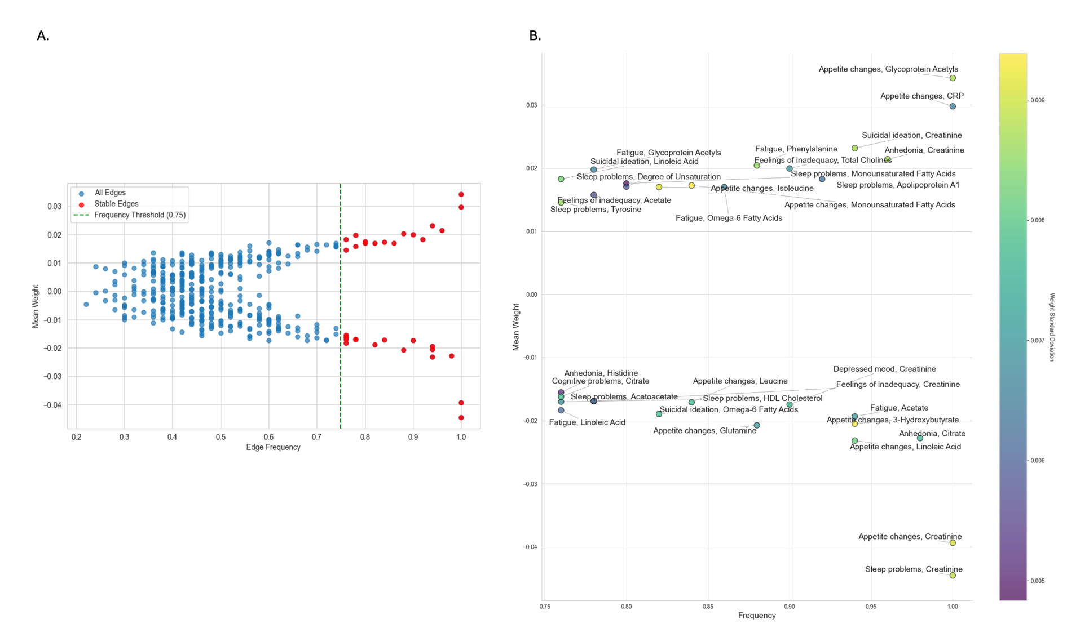

Supplementary Figure 4.
.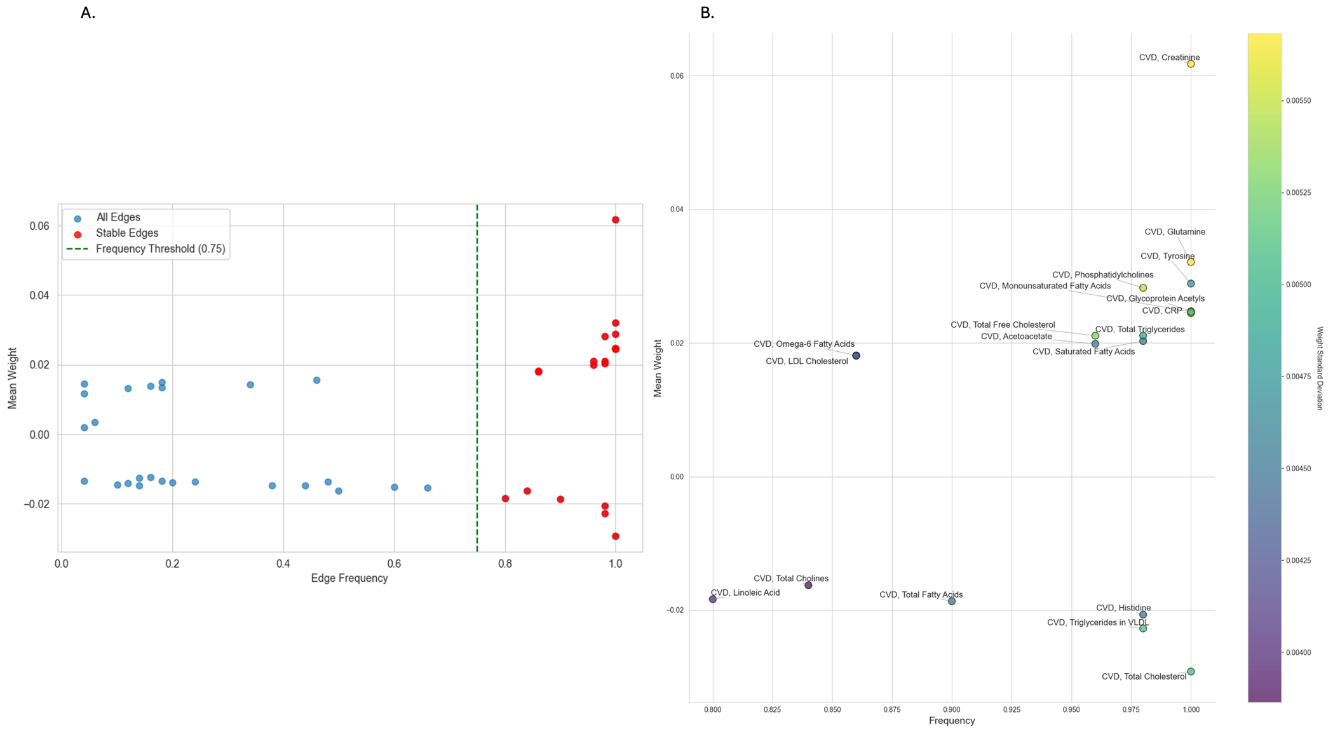

Supplementary Figure 5.

